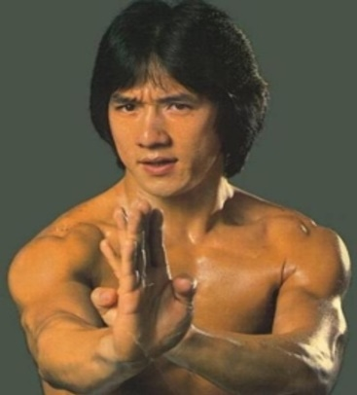

PERSONAAA

**Pain Points:**

* **Physical Injuries:** Due to the physically demanding nature of his work, Jackie often faces injuries and needs quick and effective medical care.
* **Time Constraints:** His busy schedule often leaves him with limited time for personal pursuits and relaxation.
* **Privacy:** As a public figure, he sometimes struggles with maintaining his privacy.

**Behaviors:**

* **Active on Social Media:** Jackie Chan uses social media to engage with his fans and share updates about his projects and philanthropic efforts.
* **Travels Frequently:** His work takes him to different parts of the world, and he requires a well-organized travel plan.
* **Lifelong Learner:** He constantly seeks opportunities for personal and professional growth, attending workshops and collaborating with other industry professionals.

Jackie Chan

**Goals and Needs:**

1. **Physical Well-being:** Jackie Chan values his physical health and well-being. He needs access to top-notch healthcare and fitness facilities to maintain his active lifestyle.
2. **Creativity:** As a film director, he is always looking for creative inspiration and opportunities to create unique and engaging action sequences.
3. **Global Impact:** He aims to continue making films that entertain and inspire audiences worldwide. He needs access to a global platform to promote his work.

**Interests:**

* **Martial Arts:** Jackie Chan is passionate about martial arts and constantly seeks ways to incorporate it into his work.
* **Film:** He is an avid film enthusiast, always looking for new techniques and styles to incorporate into his movies.
* **Age:** 65
* **Gender:** Male
* **Location:** Hong Kong
* **Occupation:** Renowned Martial Artist, Actor, and Film Director
* **Background:** Jackie Chan has had a long and successful career in the entertainment industry. Born in Hong Kong, he started his martial arts training at a young age and later ventured into acting. His unique combination of martial arts skills and slapstick comedy has made him a global icon.