======================================================================

# Simulation Excercise

======================================================================

Simulate the exponential distribution:

First set seed, so that same simulation can be reproduced.

Then generate random exponential numbers with lambda = 0.2 & take its mean.

Repeat the above process 1000 times with 'replicate' function.

And store this data in 'data' variable.

size = 1000  
n = 40  
lambda = 0.2  
  
set.seed(2506)  
data <- (replicate(size, mean(rexp(n,lambda))))

## 1. Sample mean Vs Theoretical mean

Calculate the mean of data and store it in sample_mean

Calculate the theoretical mean and store it in theoretical_mean

Print both of them

sample_mean = mean(data)  
theoretical_mean = 1/lambda  
  
sample_mean

## [1] 4.957994

theoretical_mean

## [1] 5

We can see that the sample mean is sligthly less than theoretical mean

Plot the histogram of the means exponential data & add vertical lines at sample mean and theoretical mean

my_plot1 <- hist(data, main = "Sample mean Vs. Theoretical mean", xlab = "Means", ylab = "Frequency")  
abline(my_plot1, v=sample_mean , col="red")  
abline(my_plot1, v=theoretical_mean , col="blue")

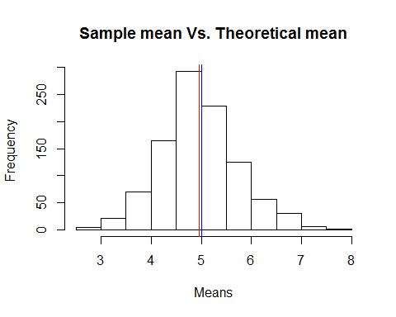

If zoomed in, it can be observed that the red line(indicating sample mean) is slightly to the left of blue line(indicating theoretical mean)

## 2. Sample variance Vs. Theoretical Variance

Store the sample variance of data in sample_variance

Store the theoretical variance in theoretical_variance

sample_variance = var(data)  
theoretical_variance = ((1/lambda)^2/n)

Print sample variance & theoretical variance

sample_variance

## [1] 0.5798728

theoretical_variance

## [1] 0.625

We can clearly see that theoretical variance is greater than sample variance.

## 3. Showing that the distribution is approximately normal

To confirm if the distribution is approximatley normal, plot Sample quantile Vs. Theoretical quantiles. The plot should lie on the 45 degree line of the QQ plot if its normal.

qqnorm(data, main="Normal Q-Q Plot")  
qqline(data, col="2")

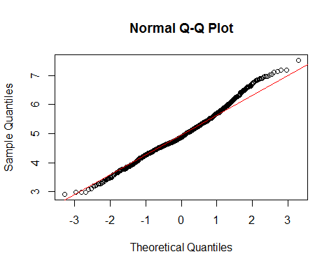

Since the line is approximately 45 degrees, we can say that our distributions is approimately normal.