Perform Clustering for the crime data and identify the number of clusters formed and draw inferences.
Data Description:
Murder -- Muder rates in different places of United States
Assualt- Assualt rate in different places of United States
UrbanPop - urban population in different places of United States
Rape - Rape rate in different places of United States
Normalisation:-
Normalise all values in the crime data set.

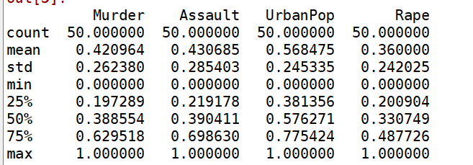

Linkage function:-
In this Crime data set ,apply linkage function.
Method:Euclidean(measures distance fromone point of one cluster to farthest point of another cluster)
Metric:performs hierarcial clustering.

Plot the linkage graph:-
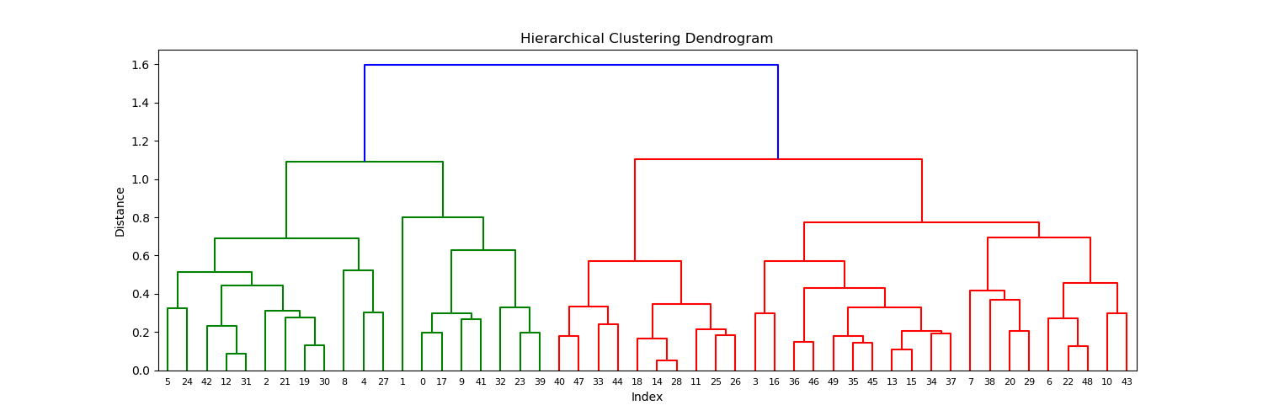
In this Crime data set ,there forming a 97 clusters....

Agglomerative clustering:-
In however in this crime datas of united states,we only identify a low rates of murder and low rate of rapes in overall population.
So i want only 2 clusters for analysing the datas in crime data set.
Output:-
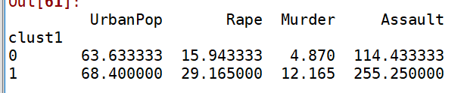

In were normal analysing,where murder is low rate compare to Rape and Assault rates.for the urban population is less in oneplace however the assualt,rape murder are less compared to high population areas.

