**Market Research**

Project Report

Analysis of Consumer Behaviour towards Adidas Footwear

***Submitted By***

***Vivek Prajapat***

Contents

Problem definition 2

Approach to the problem 3

Research Questions: 3

Research design 3

Survey Design 3

Pretesting 3

Sampling Techniques 4

Data analysis and Results 4

Data Collection and cleaning 4

One tail test in SPSS 4

Research Question 1: Is price an important factor while purchasing footwear? 4

Research Question 2: Is variety a major concern while buying footwear? 5

Research Question 3: Whether discount offers affect the sales and inclination of consumers towards purchasing. 7

Research Question 4: What features of the advertisement attracts consumers towards purchasing? 7

Research Question 5: Identifying the online and offline consumer base. 9

Research Question 6: What factors contribute to switching to another brand? 10

Additional Research 1: Advertisement Reach frequency 12

Additional Research 2: Untapped market of customized shoes 12

Limitations and caveats 12

Conclusions and recommendations 13

Team members and their contribution 13

Appendix: Survey Questionnaire 14

References 20

# Problem definition

This marketing research project is being proposed keeping in mind the Indian operations of Adidas Inc. Customer satisfaction is analysed to measure how products and services offered by the company meet or surpass customer expectation.

As a first step towards this problem we targeted the consumer base for the product range and have suggested appropriate marketing strategies that will help Adidas to achieve its target of becoming the top most brand in India.

|  |  |
| --- | --- |
| Management Decision Problem | Marketing Research Problem |
| How to prevent shifting of customers to another brand? | Identify the customer base which have shifted and factors contributing to it. |
| Should the advertising campaign be changed? | Analyse the effect of current promotion campaign. |
| How to approach and appease new customers? | Identify new customer base, their needs and preferences and determine the most effective means of advertising. |

# 

# Approach to the problem

Almost every age group and subgroups were targeted while conducting the survey in order to get a thorough insight of consumer behaviour towards Adidas footwear. The survey was floated to the people from different cities across India.

Although sales or market share can indicate how well a firm is performing currently, satisfaction is perhaps the best indicator of how likely it is that the firm’s customers will make further purchases in the future.

## Research Questions:

1. Is price an important factor while purchasing footwear?
2. Is variety a major concern while buying footwear?
3. Whether discount offers affect the sales and inclination of consumers towards purchasing.
4. What features of the advertisement attracts consumers towards purchasing?
5. Identifying the online and offline consumer base.
6. What factors contribute to switching to another brand?

## 

# Research design

After having completed our survey research and having gained a sense of real-world problem we decided to go ahead to understand the problem from a larger pool of probable consumers and gather quantifiable information for our data analysis.

## Survey Design

The survey was designed keeping in mind all the parameters required to accomplish the project task. We started our study with a few demographic questions which helped us to understand the needs and wants of different segments and later customise our service for different segments. Areas like quality, price, variety, advertisements and brand switching were focused.

## Pretesting

We did a participating pretest of our questionnaire with few of our batch mates where we asked them to explain the reaction to questions, wording and order. Based on the feedback we modified our questionnaire so that it is understandable before floating it to a broader audience.

## 

## Sampling Techniques

In order to target almost every age group and different regions of the country, we have incorporated the random sampling technique.

Since reaching out to older people was a tedious task, we randomly and manually helped them to get the questionnaire form filled.

# Data analysis and Results

## Data Collection and cleaning

The sample survey was conducted to determine consumer behaviour towards the online and offline market and data was thoroughly checked for any error.

We have collected 90 responses which are perfect sample size for the analysis. There were no missing values, so the question of removing any variable did not arise. However, some of the values were labelled to numeric form in order to carry out the analysis in SPSS.

Labelling was done as follows:

|  |  |
| --- | --- |
| Male | 1 |
| Female | 2 |
| Strongly disagree | 1 |
| Disagree | 2 |
| Neutral | 3 |
| Agree | 4 |
| Strongly agree | 5 |

## One tail test in SPSS

Since in SPSS, there is the only option for two-tail test but the power of one tail t-test in more than two-tail t-test. Therefore, to perform one tail test with 95% significance level, we have to cover the area from - ∞ to some value such that area between these two values comes out to be 95%. If we apply two tail test with 90% significance level, so area which left out of significance level is 10 % which is equally distributed to both side from mean by 5% .p- value is the probability of making type 1 error (when we reject the null hypothesis while it is true) — however, the area which is outside of significance level.

Therefore, if we apply two-tail test with 90% significance level and half the p-value, so we cover 5% with half p-value and 90% from two tail significance level. By doing this, we have cover 95% area and perform one-tail t-test in SPSS.

### 

### Research Question 1: Is price an important factor while purchasing footwear?

To analyse this RQ, we used results of following questions from our questionnaire:

5. a. Rate the critical factors while purchasing any footwear [price]

6. Select appropriate price range while buying footwear

#### One tail test on 5.a

|  |  |  |  |  |  |  |
| --- | --- | --- | --- | --- | --- | --- |
| One-Sample Test | | | | | | |
|  | | | | | | |
|  | Test Value = 3 | | | | | |
| t | df | Sig. (2-tailed) | Mean Difference | 90% Confidence Interval of the Difference | |
| Lower | Upper |
| 5. Rate the importance factors while purchasing any footwear. [Price] | 7.530 | 89 | .000 | .8000 | .623 | .977 |

##### Result from Question 5.a

Null Hypothesis – Price is not an important factor on purchasing footwear.

Alternate Hypothesis – Price is an important factor on purchasing footwear.

H0: µ ≤ 3

Ha: µ > 3

**Interpretation:** p value is <0.05 .so we reject our null hypothesis which means **Price is an important factor.**

### Research Question 2: Is variety a major concern while buying footwear?

To analyse this RQ, we used results of following questions from our questionnaire:

3. How many different types of shoes do you have?

4. b. I like to experiment with new styles

4. c. I like to buy trendy and stylish shoes

#### One tail test on 3.

|  |  |  |  |  |  |  |
| --- | --- | --- | --- | --- | --- | --- |
| One-Sample Test | | | | | | |
|  | Test Value = 3 | | | | | |
| t | df | Sig. (2-tailed) | Mean Difference | 90% Confidence Interval of the Difference | |
| Lower | Upper |
| 3. How many different types of shoes (Sports/Casual/Formal etc.) do you have? | 6.058 | 89 | .000 | 1.1000 | .798 | 1.402 |

##### Result from Question 3

Null Hypothesis – Variety was not an important factor on purchasing footwear.

Alternate Hypothesis – Variety was an important factor on purchasing footwear.

H0: µ ≤ 3

Ha: µ > 3

**Interpretation:** p value is <0.05 .so we reject our null hypothesis which means **variety is an important factor while purchasing.**

#### One tail t test 4.b

|  |  |  |  |  |  |  |
| --- | --- | --- | --- | --- | --- | --- |
| **One-Sample Test** | | | | | | |
|  | Test Value = 3 | | | | | |
| t | df | Sig. (2-tailed) | Mean Difference | 90% Confidence Interval of the Difference | |
| Lower | Upper |
| 4. How do the following statements describe your buying behavior? [I like to experiment with new styles] | 4.204 | 89 | .000 | .5444 | .329 | .760 |

##### Result from Question 4.b

Null Hypothesis – experiment with new styles is not an important factor on purchasing footwear.

Alternate Hypothesis – experiment with new styles is an important factor on purchasing footwear.

H0: µ ≤ 3

Ha: µ > 3

**Interpretation:** p value is <0.05 .so we reject our null hypothesis which means **experiment with new styles is an important factor while purchasing. Hence variety is important.**

#### One tail t test 4.c

|  |  |  |  |  |  |  |
| --- | --- | --- | --- | --- | --- | --- |
| One-Sample Test | | | | | | |
|  | Test Value = 3 | | | | | |
| t | df | Sig. (2-tailed) | Mean Difference | 90% Confidence Interval of the Difference | |
| Lower | Upper |
| 4. How do the following statements describe your buying behavior? [I like to buy trendy or stylish shoes] | 3.476 | 89 | .001 | .4889 | .255 | .723 |

##### Result from Question 4.c

Null Hypothesis – Latest fashion trend is not an important factor on purchasing footwear.

Alternate Hypothesis – Latest fashion trend is an important factor on purchasing footwear.

H0: µ ≤ 3

Ha: µ > 3

**Interpretation:** p value is <0.05 .so we reject our null hypothesis which means **Latest fashion trend is an important factor while purchasing.**

### Research Question 3: Whether discount offers affect the sales and inclination of consumers towards purchasing.

To analyse this RQ, we used results of following questions from our questionnaire:

10. After viewing discount offers, I generally go for shopping.

#### One tail t test 10

|  |  |  |  |  |  |  |
| --- | --- | --- | --- | --- | --- | --- |
| One-Sample Test | | | | | | |
|  | | | | | | |
|  | Test Value = 3 | | | | | |
| t | df | Sig. (2-tailed) | Mean Difference | 90% Confidence Interval of the Difference | |
| Lower | Upper |
| 10. After viewing discount offers, I generally go for shopping. | 9.755 | 8 | .000 | 1.0222 | .848 | 1.196 |

##### Result from Question 10

Null Hypothesis – discount is not an important factor on purchasing footwear.

Alternate Hypothesis – discount is an important factor on purchasing footwear.

H0: µ ≤ 3

Ha: µ > 3

**Interpretation:** p value is <0.05 .so we reject our null hypothesis which means **discount is an important factor while purchasing.**

### Research Question 4: What features of the advertisement attracts consumers towards purchasing?

To analyse this RQ, we used results of following questions from our questionnaire:

8. Rate the factors in the Advertisement.

9. After viewing this ad, I would consider purchasing the product.

#### One tail t test on 8

|  |  |  |  |  |  |  |
| --- | --- | --- | --- | --- | --- | --- |
| One-Sample Test | | | | | | |
|  | Test Value = 3 | | | | | |
| t | df | Sig. (2-tailed) | Mean Difference | 90% Confidence Interval of the Difference | |
| Lower | Upper |
| 8. Rate the factors in the Advertisement. [Youth oriented] | 3.974 | 89 | .000 | .5111 | .297 | .725 |
| 8. Rate the factors in the Advertisement. [Adidas slogan "Impossible is nothing"] | 1.115 | 89 | .268 | .1556 | -.076 | .387 |
| 8. Rate the factors in the Advertisement. [Tag line #fan the fire] | .520 | 89 | .604 | .0667 | -.146 | .280 |
| 8. Rate the factors in the Advertisement. [Motivational] | 4.721 | 89 | .000 | .5778 | .374 | .781 |

##### Result from Question 8.1

Null Hypothesis – Ad’s youth orientation is not an important factor on purchasing footwear.

Alternate Hypothesis – Ad’s youth orientation is an important factor on purchasing footwear.

H0: µ ≤ 3

Ha: µ > 3

**Interpretation:** p value is <0.05 .so we reject our null hypothesis which means **ad should be youth oriented**.

##### Result from Question 8.2

Null Hypothesis – Ad’s slogan is not an important factor on purchasing footwear.

Alternate Hypothesis – Ad’s slogan is an important factor on purchasing footwear.

H0: µ ≤ 3

Ha: µ > 3

**Interpretation:** p value is >0.05 .so we fail to reject our null hypothesis which means **ad’ slogan does not affect consumer while purchasing.**

##### Result from Question 8.3

Null Hypothesis – tag line of ad is not an important factor on purchasing footwear.

Alternate Hypothesis – tag line of ad is an important factor on purchasing footwear.

H0: µ ≤ 3

Ha: µ > 3

**Interpretation:** p value is >0.05 .so we fail to reject our null hypothesis which means **ad’s tagline does not affect consumer while purchasing**

##### Result from Question 8.4

Null Hypothesis –Motivational factor of Ad is not an important factor on purchasing footwear.

Alternate Hypothesis – Motivational factor of Ad is an important factor on purchasing footwear.

H0: µ ≤ 3

Ha: µ > 3

**Interpretation:** p value is <0.05 .so we reject our null hypothesis which means Motivational factor of Ad is an important factor while purchasing.

#### One tail t test on 9

|  |  |  |  |  |  |  |
| --- | --- | --- | --- | --- | --- | --- |
| One-Sample Test | | | | | | |
|  | Test Value = 3 | | | | | |
| t | df | Sig. (2-tailed) | Mean Difference | 90% Confidence Interval of the Difference | |
| Lower | Upper |
| 9. After viewing this ad,I would consider purchasing the product. | 5.456 | 89 | .000 | .7444 | .518 | .971 |

##### Result from Question 9

Null Hypothesis – Ad was not an important factor on purchasing footwear.

Alternate Hypothesis – Ad was an important factor on purchasing footwear.

H0: µ ≤ 3

Ha: µ > 3

**Interpretation:** Since p value <0.05, we reject our null hypothesis which means **ad is an important factor while purchasing.**

### Research Question 5: Identifying the online and offline consumer base.

To analyse this RQ, we used results of following questions from our questionnaire:

7. Usually, where do you shop for shoes?

11. Where do you see Adidas advertisement generally?

##### Result from Question 7

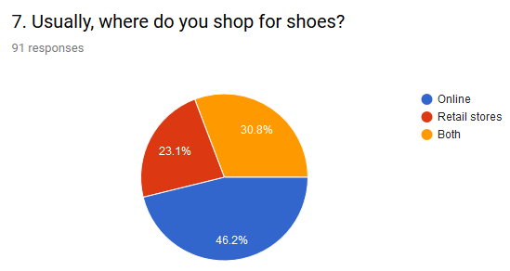

**Interpretation:** Online medium of shopping has most outreach among the recipients

##### Result from Question 11

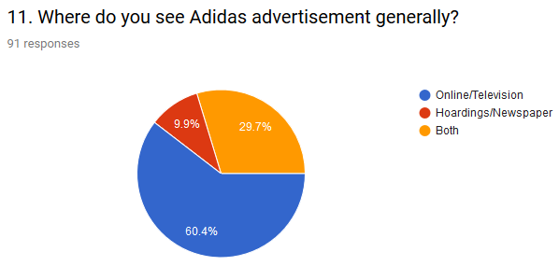

**Interpretation:** Online medium and television have most outreach among the recipients.

### Research Question 6: What factors contribute to switching to another brand?

To analyse this RQ, we used results of following questions from our questionnaire:

Q13. Consider a scenario where you are switching your currently preferred brand. What would be the following factor's (about your current brand) relevance for this switch (Unreasonable Price, Bad quality, Low Durability Outdated Looks) helps to tackle this RQ.

#### One tail t test on 13

|  |  |  |  |  |  |  |
| --- | --- | --- | --- | --- | --- | --- |
| One-Sample Test | | | | | | |
|  | Test Value = 3 | | | | | |
| t | df | Sig. (2-tailed) | Mean Difference | 90% Confidence Interval of the Difference | |
| Lower | Upper |
| 13. Consider a scenario where you are switching your currently preferred brand. What would be the following factor's (about your current brand) relevance for this switch. [Unreasonable Price] | 4.168 | 89 | 0 | 0.4667 | 0.281 | 0.653 |
| 13. Consider a scenario where you are switching your currently preferred brand. What would be the following factor's (about your current brand) relevance for this switch. [Bad quality] | 4.311 | 89 | 0 | 0.6333 | 0.389 | 0.878 |
| 13. Consider a scenario where you are switching your currently preferred brand. What would be the following factor's (about your current brand) relevance for this switch. [Low Durability] | 1.939 | 89 | 0.056 | 0.2556 | 0.037 | 0.475 |
| 13. Consider a scenario where you are switching your currently preferred brand. What would be the following factor's (about your current brand) relevance for this switch. [Outdated Looks] | -1.305 | 89 | 0.195 | -0.1889 | -0.429 | 0.052 |

##### Result from Question 13.a.

Null Hypothesis – Unreasonable Price is not an important factor for switching.

Alternate Hypothesis – Unreasonable Price is an important factor on switching footwear.

H0: µ ≤ 3

Ha: µ > 3

**Interpretation:** p value is <0.05 .so we reject our null hypothesis which means **unreasonable price is an important factor while switching brands.**

##### Result from Question 13.b

Null Hypothesis – Bad quality is not an important factor for switching.

Alternate Hypothesis – Bad quality is an important factor on switching footwear.

H0: µ ≤ 3

Ha: µ > 3

**Interpretation:** p value is <0.05 .so we reject our null hypothesis which means **bad quality is an important factor while switching brands**

##### Result from Question 13.c

Null Hypothesis – Low Durability is not an important factor for switching.

Alternate Hypothesis – Low Durability is an important factor on switching footwear.

H0: µ ≤ 3

Ha: µ > 3

**Interpretation:** p value is <0.05 .so we reject our null hypothesis which means **durability is an important factor while switching brands.**

##### Result from Question 13.d

Null Hypothesis – Outdated Looks is not an important factor for switching.

Alternate Hypothesis – Outdated Looks is an important factor on switching footwear.

H0: µ ≤ 3

Ha: µ > 3

**Interpretation:** p value is >0.05 .so we fail to reject our null hypothesis which means **outdated looks is not an important factor while switching brands**

### Additional Research 1: Advertisement Reach frequency

We obtained additional information from results of following questions from our questionnaire:

Q12. How frequently do you see Adidas advertisements?

##### Result from Question 12

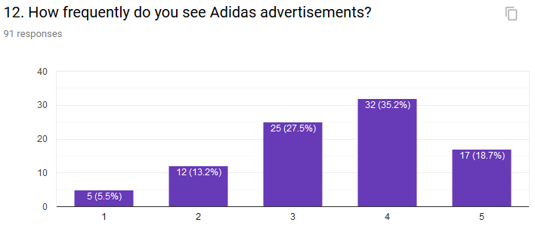

### Additional Research 2: Untapped market of customized shoes

We asked people whether they will prefer customization or not so from our analysis, it came out that people would prefer customization if the company offer at reasonable price.

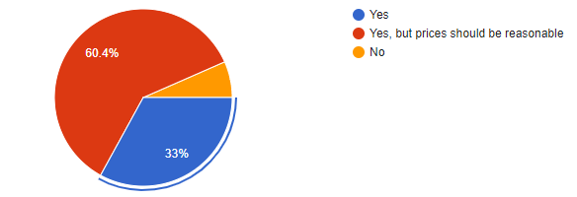

# Limitations and caveats

1. Many of the respondents were not willing to fill the questionnaire.
2. We find it difficult to cover up people of all age groups equally since not all elder people use smartphones.
3. Since the sample research is based on the respondents' response, the problems of personal inhibitions, indifference and unawareness of the nature and purpose of investigation renders survey information invalid or at least imprecise.
4. We have shown them only one particular genre (motivational) of ad.

# Conclusions and recommendations

We used multiple dimensions of market research to conduct various tests on our survey results, and we found about the acceptability of Adidas footwear, its viability and a better understanding of the complete product Adidas need to offer.

As per our survey group results, we conclude that price, latest fashion trend, variety, sale and discount offers are an essential factor while purchasing footwear for Indians.

As far as advertisement is concerned, Indians are attracted towards a youth-oriented and motivational advertisement. Moreover, the tagline and slogan should be contextually reflective of the two factors mentioned above.

Since the most effective medium of reaching out to the public is via television and online advertisements and a fair amount of people, buy shoes both online and from retail stores, a balance must be maintained between online and billboard advertisements outside the retail stores.

Unreasonable price, poor quality, durability, and old looks seem to be an essential factor in switching brands. To appease customers currently preferring other brands to switch to Adidas, the company need to focus on showcase these qualities about their products.

# Appendix:

# Survey Questionnaire - <https://docs.google.com/forms/d/1mm0rnn8ooh_ypq2k2h_5FJ77n4TATQ8n_-9txNRpflY/edit>

# 

# References

1. NPTEL lectures on marketing research by Prof. J K Nayak
2. "Nike - Channel Conflict." Graduate School of Business, Stanford University, February 2000
3. *Belch & Belch. "Advertising and Promotion." McGraw-Hill Irwin. New York. 2001. p.493
4. Brand Personality and Mobile Marketing:An Empirical Investigation by O. BOUHLEL, N. MZOUGHI, D. HADIJI, and I. BEN SLIMANE
5. http://www.gallup.com/178685/methodology-center.aspx
6. www.consumerbehavior.net