

**PORTFOLIO**

**COMPUTER SCIENCE AND ENGINEERING**

Submitted by:

Name: VIVEK KUAMR

Registration no. :12406652

Section: K24CT

**SUBMITTED TO : Dr . JOSHVA RAJG**

**DECLARATION**

**"Hello. I am Vivek Kumar; I am pursuing B.Tech. My portfolio indicates various projects, which can be considered as the backbones of my technical proficiency as well as my solving skill, Explore further about the interplay of technology and creativity with me".**

|  |  |
| --- | --- |
| Platforms for profile creation | Link to student profile |
| Linkedin | <https://www.linkedin.com/in/vivek-kumar-860941276/?trk=public-profile-join-page> |
| Github | <https://github.com/Vivek-coder-01> |
| Geek of Greek | <https://www.geeksforgeeks.org/user/vivekkr65aq/> |
| Medium | <https://medium.com/@vivekkr96311> |
| CV | <https://drive.google.com/file/d/1NpS3OHmmuemZGXj3U5qObEGWePfsB-GA/view?usp=drive_link> |

1. Linkedin

Profile:

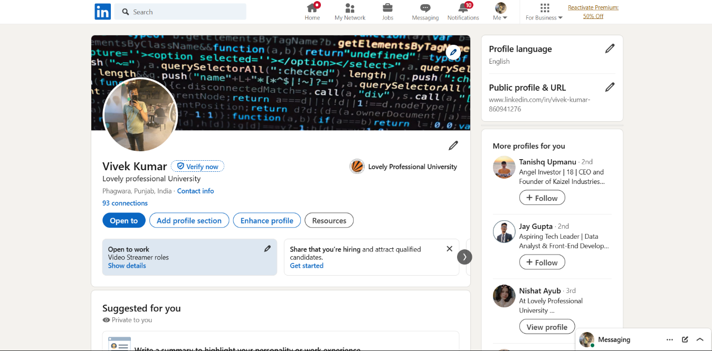

1. Github

Profile:

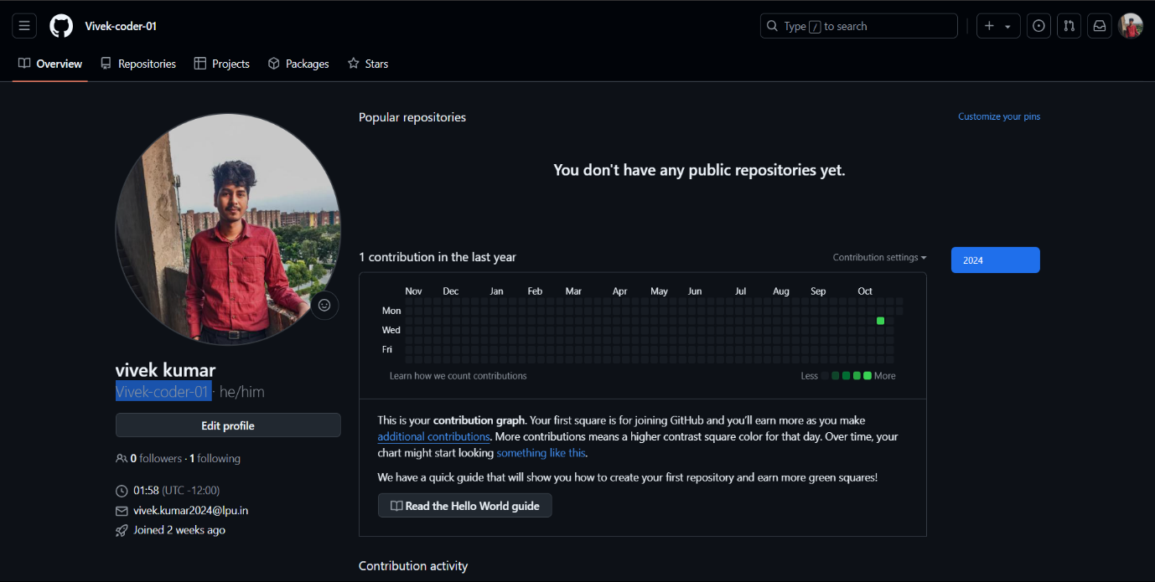

1. Geek of Greek

Profile:

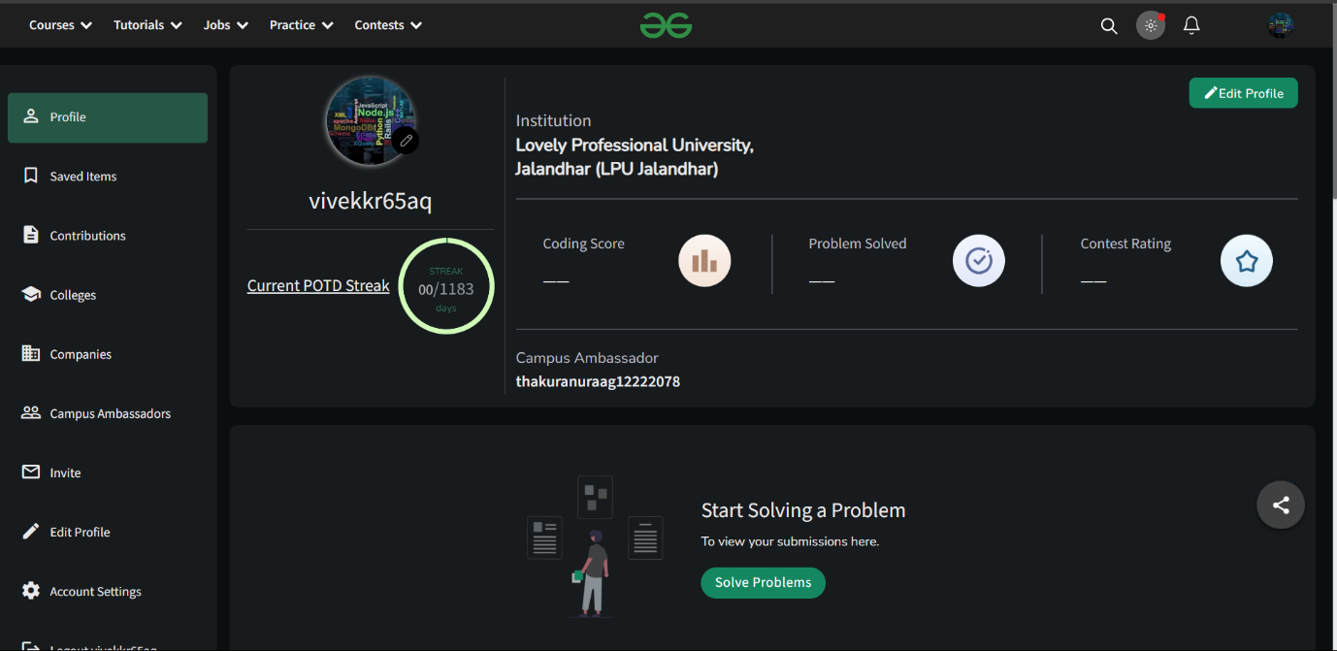

1. Medium

Profile:



1. CV

