A

Project Report

On

Bluetooth RC

Car With Remote Arduino

Submitted in partial fulfillment of the requirement for the V1 semester

**Bachelor of Computer Applications**

By

**Vivek Joshi, 2015402**



**DEPARTMENT OF COMPUTER SCIENCE & TECHNOLOGY**

**GRAPHIC ERA DEEMED UNIVERSITY**

**DEHRADUN**

**2021-2022**

**DECLARATION**

I, **Vivek Joshi** student of **B-tech, Semester 6,** Department of Computer Science and Technology, Graphic Era Deemed University, Dehradun, declare that the technical project work entitled “Bluetooth RC Car With Remote Arduino” has been carried out by me and submitted in partial fulfillment of the course requirements for the award of degree in B-tech of **Graphic Era Deemed University** during the academic year **2021-2022**. The matter embodied in this synopsis has not been submitted to any other university or institution for the award of any other degree or diploma.

**Date: 29/06/22**



**CERTIFICATE**

This is to certify that the project report entitled “Bluettoth RC Car with Remote Arduino” is a bonafide project work carried out by Vivek Joshi , roll n0- 2015402.. in partial fulfillment of award of degree of B-techof Graphic Era Deemed University, Dehradun during the academic year 2021-2022. It is certified that all corrections/suggestions indicated for internal assessment have been incorporated. The project has been approved as it satisfies the academic requirements associated with the degree mentioned.

**Dr. Devesh Pratap Singh,**

Head of Dept. of Computer Science

Here by I am submitting the project report on **“Bluetooth RC Car With Remote Arduino”** as per the scheme of Graphic Era Deemed University, Dehradun.

I would like to express our sincere gratitude to **Dr. Devesh Pratap Singh,** Head of Dept. of Computer Science, for providing a congenial environment to work in and carry out our project.

I consider it mine cardinal duty to express the deepest sense of gratitude to Mr. Piyush Agarwal Asst. Professor, Department of Computer Science and Application for the invaluable guidance extended at every stage and in every possible way.

I would like to also thank Skyfi labs for helping me in better understanding each component of topic in an interesting way and help me to learn Arduino IDE.

Finally I am very much thankful to all the faculty members of the Department of Computer Science and Technology, friends and our parents for their constant encouragement, support and help throughout the period of project conduction.

**Name : Vivek Joshi**

***University Roll No: 2015402***

In childhood many of us like to play with a remote control car but the major problem experience was from remote, but now no need of that box remote, as we can use our smart phone as an alternative of remote, no need to carry an extra remote with your car fully controlled via Bluetooth.

For Bluetooth control I have use a HC-05 Bluetooth module which is simple to use, and plug in with arduino uno circuit. A motor driver has been used which acts as an interface between the control circuit and motor, code has been written and uploaded using Arduino IDE.

A mobile app which is used in this project can be downloaded from Google play store.

**🡪In order to accomplish this project following tools were used:**

**🡪Arduino UNO board**

**🡪Bluetooth Module – HC-05**

**🡪Laptop And Arduino Board connector**

**🡪A 9v Battery**

**🡪Male To Female Pin Connector**

**🡪Female To Female Pin Connector**

**🡪Electrical wires**

**🡪L298N Motor Driver**

**→ Old car with motors**

**🡪 For coding purpose arduino ide was used and code was written in arduino sketch using C++ language.**

**🡪 A sketch is the name that Arduino uses for a program. It's the unit of code that is uploaded to and run on an Arduino board.**

**Microcontroller**

**HC-05 Bluetooth Module**

**Mobile Phone**

**Motor Driver**

**Front Motor**

**Back Motor**

**Building up a project on Bluetooth controlled car was a great piece of experience, it not only help me in gathering information about new technologies but also made me realize the use of programming in real life.**

**Discussing about how this learning process started and journey up to building up this project goes like this:**

**First of all we need Arduino UNO embedded board which has following components(These are already embedded):**

* **8-bit microcontroller with on chip flash memory for program storage. Arduino mostly uses AVR mega series microcontroller developed by Atmel, here I have used AT Mega 328 microcontroller.**
* **An oscillator - It work as a clock for microcontroller, here it is used of 18MHZ frequency.**
* **A USB plug in order to load our program and a power supply port.**
* **And further there are analog pins and digital pins (comprising PWM pins).**

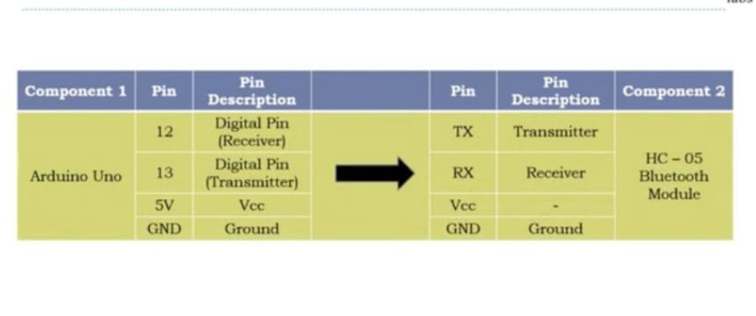**Second is to make connections of arduino board with other peripheral devices like HC-05Bluetooth module, L298N Motor . This is to be done as per connection schematic--🡪**

|  |  |  |  |
| --- | --- | --- | --- |
| Arduino UNO | PIN | → | Motor Driver |
| 7 | IN1 |
| 8 | IN2 |
| 9 | IN3 |
| 10 | IN4 |
|  |  |

|  |  |  |
| --- | --- | --- |
| MOTOR DRIVER | | Front Control/Back Control |
| IN | OUT |  |
| IN1 | OUT1 | **Front Control** |
| IN2 | OUT1 |
| IN3 | OUT2 | **Back Control** |
| IN4 | OUT2 |

**Now put the bandwidth(bits per second) in 9600 of arduino( Serial Monitor) , HC-05 bluetooth module so that all devices can communicate with each other.**

**Now upload the coding part that is sketch to arduino board using arduino IDE.**

**Now using Mobile phone open the app for controlling car, and connect phone Bluetooth with HC-05.**

**Now you can operate your car using your smartphone only.**

**The completion of the project went quiet well, I learned much new things while I was building up it, and I get up to know various platforms which help us to learn all this stuff. I was able to learn the practical use of IOT. The practical helped me to learn the debugging of code and development tools of Project. Arduino provides an open platform for developers to make up projects like this one.**

**Overall working on this project was great fun as I came up with great piece of knowledge and understanding of the topic.**

***Reference:***

Skifi Labs(online teaching platform)

Youtube

www.google.com