RELIEFLINK

A project report
submitted in fulfillment of
the requirements for the award of the degree of

MASTER OF COMPUTER APPLICATIONS
From

APJ Abdul Kalam Kerala Technological University

Submitted By
VIVEK K (MEA25MCA-2027)


MEA Engineering College
Department of Computer Applications
Vengoor P.O, Perinthalmanna, Malappuram, Kerala-679325
OCTOBER 2026
DEPARTMENT OF COMPUTER APPLICATIONS
MEA ENGINEERING COLLEGE
PERINTHALMANNA-679325

CERTIFICATE

This is to certify that the Project report entitled "ReliefLink: Next-Generation Real-Time Disaster Response & Humanitarian Relief Coordination Platform" is a bonafide record of the work done by VIVEK K (MEA25MCA-2027) under our supervision and guidance. The report has been submitted in fulfillment of the requirement for award of the Degree of Master of Computer Applications from the APJ Abdul Kalam Kerala Technological University for the academic year 2026.

Mr. Sajeesh M  Assistant Professor & Project Guide  Dept. of Computer Applications | Mr. Sajeesh M  Assistant Professor & Head of the Department  Dept. of Computer Applications

Acknowledgements
First and foremost, I would like to thank Almighty God for giving me the knowledge, courage, and strength which helped me in the successful completion of this project.
An endeavor of this magnitude can only be successful with the advice, motivation, and guidance of many well-wishers. I take this opportunity to express my heartfelt gratitude to all who encouraged me throughout this journey. I express my deep sense of gratitude to our respected Principal, Dr. Shahir VK, for his inspiring leadership and for fostering an excellent academic environment in the college.
I would like to express my deepest gratitude and sincere indebtedness to Mr. Sajeesh M, Assistant Professor, Head of the Department and Project Guide, Department of Computer Applications, for granting permission to conduct this project, and for his invaluable technical guidance, timely advice, constructive critique, and wholehearted moral support throughout the conception, development, and completion of ReliefLink.
I also extend my sincere gratitude to all the esteemed faculty members and technical staff of the Department of Computer Applications for their constant cooperation, encouragement, and valuable assistance during various stages of this project.

VIVEK K (MEA25MCA-2027)
DATE: OCTOBER 25, 2026

ABSTRACT
ReliefLink is a web-based disaster management and humanitarian coordination platform designed to securely connect disaster-affected citizens with verified volunteers and relief centers. The system provides three different user roles: Relief Administrator, Affected Citizen, and Field Volunteer, with role-based access to perform emergency rescue operations and manage humanitarian relief services efficiently.
Affected citizens can register, send one-click GPS distress SOS alerts, search for active relief shelters based on proximity and capacity, request essential relief supplies, track request status, and mark safety updates on an interactive map. Field volunteers can manage responder profiles, view nearby distress incidents, set deployment availability, and accept or update rescue assignments. The relief administrator is responsible for verifying volunteer registrations, managing camp shelters, monitoring inventory, triaging incoming emergency requests, and supervising the overall relief operations.
The application provides a centralized platform that reduces the delays of emergency crisis response, improves transparency, minimizes manual coordination, and makes disaster relief distribution more organized and efficient. It also enables users to track live distress signals, receive real-time notifications, monitor shelter resources, and view crisis hotspots through a user-friendly interactive interface.
The system is developed using React.js, Node.js, Express.js, and MongoDB, with JWT authentication for secure role-based access and GitHub for version control. The system provides a secure, reliable, and responsive solution for disaster management while demonstrating a complete MERN Stack application suitable for both academic and real-world use.

CONTENTS
1. INTRODUCTION 1
2. SYSTEM ANALYSIS 3
2.1 Existing System 4
2.2 Proposed System 4
2.3 Module Description 4
2.4 Sprint 5
3. FEASIBILITY STUDY 8
3.1 Economical Feasibility 9
3.2 Technical Feasibility 9
3.3 Operational Feasibility 9
3.4 Behavioural Feasibility 9
3.5 Software Feasibility 10
3.6 Hardware Feasibility 10
4. SOFTWARE ENGINEERING PARADIGM 11
4.1 Agile Model 12
4.2 Scrum 12
5. SYSTEM REQUIREMENT SPECIFICATION 13
5.1 Software Requirements 14
5.2 Hardware Requirements 14
6. SYSTEM DESIGN 15
6.1 Database Design 16
6.2 Tables 18
6.3 UML Design 20
6.4 Use Case Diagram 21
6.5 Scenario 22
6.6 Data flow diagram 23
7. SYSTEM DEVELOPMENT 27
7.1 Coding 28
8. SYSTEM TESTING AND IMPLEMENTATION 31
8.1 Types of Testing 32
8.2 Implementation 34
9. SYSTEM MAINTENANCE 35
10. FUTURE ENHANCEMENT 37
11. CONCLUSION 39
12. APPENDIX 41
13. BIBLIOGRAPHY 48

INTRODUCTION

INTRODUCTION

Natural disasters such as severe floods, landslides, cyclones, and earthquakes strike unpredictably across various geographical regions, creating sudden humanitarian crises, widespread infrastructure collapse, and severe disruptions to standard communication channels. During these emergencies, affected citizens and vulnerable families find themselves isolated in life-threatening conditions, struggling to broadcast their exact GPS coordinates, communicate immediate medical emergencies, locate operational relief shelters, or request essential survival supplies such as clean drinking water, ready-to-eat meals, baby food, and life-saving medicines. Traditional disaster response mechanisms in most regions still depend heavily on fragmented emergency phone hotlines, unverified social media appeals, and manual paperwork. These traditional approaches are inherently slow, error-prone, prone to severe information silos, and completely lack real-time visibility, leading to tragic rescue delays, duplicate relief supply drop-offs at accessible roadside hubs, and acute shortages in remote or cut-off locations.
To address these critical humanitarian challenges, I developed ReliefLink, an integrated, real-time web-based crisis management and humanitarian relief coordination platform. ReliefLink creates a synchronized operational ecosystem connecting stranded citizens, frontline volunteer rescue teams, NGO disaster relief centers, and administrative disaster management cells into a unified command infrastructure. The system provides low-friction, phone-based authentication that allows stranded victims to broadcast one-click GPS-tagged SOS emergency distress signals, request verified humanitarian supplies, identify the nearest available relief camps, and mark their real-time safety status on an interactive satellite GIS map. The platform also integrates localized weather threat advisories and early warning radars to keep citizens continuously informed about evolving meteorological dangers.
The platform empowers field volunteers to maintain verified responder profiles, track nearby emergency incidents on a live situational radar, accept rescue and aid-delivery missions, navigate through turn-by-turn GPS routing, and update operational progress in real time. Relief camp administrators and NGO coordinators are equipped with a centralized operations triage center to monitor shelter bed capacities, manage dynamic camp inventories with automated supply deduction mechanisms, broadcast high-priority regional weather warnings, and direct incoming donations to camps experiencing critical shortages using Haversine geo-proximity routing algorithms. Built entirely on the modern MERN Stack (React.js, Node.js, Express.js, and MongoDB Atlas) augmented with Socket.io for sub-second WebSocket dispatching and Leaflet/Esri GIS for high-precision satellite mapping, ReliefLink delivers a robust, highly resilient, and responsive humanitarian logistics platform engineered for both rigorous academic evaluation and real-world life-saving deployment.

SYSTEM ANALYSIS
.
.

2. SYSTEM ANALYSIS

2.1 Existing System
In the existing disaster management and relief ecosystem, affected citizens, emergency responders, and voluntary organizations depend largely on decentralized and manual channels such as voice phone calls, WhatsApp groups, social media broadcasts, and handwritten paper manifests to manage emergency relief operations. During high-intensity natural disasters, emergency control room phone lines become overwhelmed and crash, while social media appeals lack verified geographical coordinates, timestamps, and identity authentication, creating confusion and panic. Because there is no centralized operational platform, emergency responders cannot verify which distress alerts have already been attended to, leading to duplicated rescue efforts in easily accessible urban zones while stranded victims in severely affected remote areas remain unassisted. Furthermore, traditional systems provide no live tracking of relief camp occupancy, resulting in overcrowded shelters alongside underutilized facilities, as well as uncoordinated donation distribution that causes massive wastage of perishable goods. These severe limitations undermine public trust, obstruct inter-agency collaboration, and critically hinder prompt rescue operations during life-or-death situations.

2.2 Proposed System
The proposed system, ReliefLink, introduces a centralized real-time web platform engineered to eliminate communication bottlenecks and streamline humanitarian disaster relief coordination. The application provides dedicated, role-based access for Affected Citizens, Field Volunteers, and Relief Center Administrators. Affected citizens can instantly broadcast GPS-tagged SOS distress signals, request vital aid supplies, locate nearby functional relief shelters with real-time bed availability, and mark their safety status on an interactive satellite GIS map. Field volunteers receive instantaneous distress alerts via real-time incident radar, accept rescue tasks within their vicinity, and navigate to incident coordinates. Relief camp administrators oversee the entire operational theater by triaging emergencies, tracking shelter bed occupancy, managing dynamic inventory levels with automated supply deductions, and broadcasting urgent weather advisories. The platform enhances operational speed, security, and transparency through sub-second WebSocket updates, role-based authentication, and Haversine geo-proximity algorithms that optimize relief supply allocation.

2.3 Module description
The ReliefLink platform is structured into three specialized functional modules based on user roles, each tailored to execute distinct crisis management operations:
Relief Center Administrator Module
- • Secure administrator authentication and multi-tier role-based access control.
- • Verification, accreditation, and onboarding of field volunteers and relief camps.
- • Centralized incident triage command for incoming GPS SOS distress broadcasts.
- • Live monitoring and management of relief camp shelters, total capacity, and bed occupancy.
- • Centralized inventory control with automated stock deduction upon relief delivery.
- • Review, authorization, and dispatching of citizen humanitarian aid requests (food, water, medicine).
- • Directed donation routing using Haversine geo-proximity calculations to replenish depleted shelters.
- • Regional emergency broadcasting for meteorological early warnings, flood alerts, and landslide hazards.
- • Live administrative analytics dashboard displaying rescue statistics, supply metrics, and incident heatmaps.
Affected Citizen (Victim) Module
- • Low-friction registration, secure OTP authentication, and personal profile management.
- • One-click emergency GPS SOS distress broadcast transmitting exact latitude, longitude, and medical urgency.
- • Submission and tracking of humanitarian aid requests for food rations, clean drinking water, and medical kits.
- • Interactive shelter locator displaying nearby operational relief camps, distance, and real-time available capacity.
- • Interactive satellite GIS safety broadcaster allowing citizens to pin safe/stranded status on the live map.
- • Real-time early warning radar tracking meteorological advisories, IMD flood alerts, and emergency notifications.
Field Volunteer Module
- • Secure registration, authentication, skill profiling, and responder credential management.
- • Real-time incident radar displaying nearby unassigned SOS emergencies sorted by proximity and severity.
- • Acceptance and assignment of emergency rescue missions and humanitarian aid delivery tasks.
- • Turn-by-turn GPS navigation routing directly to the stranded citizen's pinned geographical coordinates.
- • Real-time mission status updates (En Route, At Scene, Rescued, Delivered) with instant server synchronization.
- • Volunteer deployment log tracking completed missions, hours served, and field deployment history.

2.4 Sprint
Sprint 1
Module | Task | Pending task if any | Hour of completion | Expected date of completion | Actual date of completion | Reason for delay
Affected Citizen | Phone OTP Registration & Login | - | 2 hr. | 19/07/2026 | 19/07/2026 | -
Affected Citizen | 1-Click GPS SOS Emergency Broadcast | - | 4 hr. | 21/07/2026 | 21/07/2026 | -
Affected Citizen | Aid Request Form (Food, Meds, Water) | - | 3 hr. | 23/07/2026 | 23/07/2026 | -
Affected Citizen | Relief Camp Locator & Live Capacity | - | 4 hr. | 26/07/2026 | 26/07/2026 | -
Affected Citizen | Satellite GIS Safe Status Pin-Drop | - | 4 hr. | 28/07/2026 | 28/07/2026 | -

Sprint 2
Module | Task | Pending task if any | Hour of completion | Expected date of completion | Actual date of completion | Reason for delay
Field Volunteer | Volunteer Registration & Auth | - | 2 hr. | 10/08/2026 | 10/08/2026 | -
Field Volunteer | Real-Time SOS Incident Radar | - | 5 hr. | 12/08/2026 | 12/08/2026 | -
Field Volunteer | Turn-by-Turn GPS Navigation | - | 4 hr. | 14/08/2026 | 14/08/2026 | -
Field Volunteer | Mission Status & Aid Delivery Logs | - | 3 hr. | 15/08/2026 | 15/08/2026 | -
Field Volunteer | WebSocket Live Dispatch Alerts | - | 4 hr. | 16/08/2026 | 16/08/2026 | -
Field Volunteer | Responder Deployment History | - | 2 hr. | 17/08/2026 | 17/08/2026 | -

Sprint 3
Module | Task | Pending task if any | Hour of completion | Expected date of completion | Actual date of completion | Reason for delay
Relief Admin | Admin Secure Login & Roles | - | 2 hr. | 18/08/2026 | 18/08/2026 | -
Relief Admin | Operations Command & SOS Triage | - | 6 hr. | 20/08/2026 | 20/08/2026 | -
Relief Admin | Camp Shelter & Bed Capacity Tracker | - | 4 hr. | 22/08/2026 | 22/08/2026 | -
Relief Admin | Inventory Control & Auto-Deductions | - | 5 hr. | 24/08/2026 | 24/08/2026 | -
Relief Admin | Geo-Proximity Supply Allocation | - | 5 hr. | 26/08/2026 | 26/08/2026 | -
Relief Admin | Early Warning Radar & Weather Alerts | - | 3 hr. | 28/08/2026 | 28/08/2026 | -

FEASIBILITY STUDY

3.FEASIBILITY STUDY

An analysis of the ability to complete a project successfully, taking into account legal, economic, technological, scheduling, and other factors is considered as feasibility study. Rather than just diving into a project and hoping for the best, feasibility study allows project managers to investigate the possible negative and positive outcomes of a project before investing too much time and money.

3.1 Economical Feasibility

The proposed system is economically highly feasible because it is built entirely using robust, open-source technologies including React.js, Node.js, Express.js, MongoDB Atlas (Community Tier), Socket.io, Leaflet GIS, Git, and GitHub. None of these core technologies require proprietary or expensive software licensing fees. Development and testing were executed on standard consumer computing hardware using freely available, industry-standard developer tooling such as Visual Studio Code and Postman. Since the primary objective of ReliefLink is humanitarian disaster coordination and academic evaluation, the capital expenditure and operational maintenance costs remain exceptionally low, while delivering an enterprise-grade, life-saving web application.

Technical Feasibility

The project is technically feasible as all necessary frameworks and libraries are mature, extensively documented, and supported by vibrant global developer communities. The MERN Stack provides an asynchronous, non-blocking architecture ideally suited for high-throughput crisis communications. MongoDB provides high-performance schema flexibility for geographical coordinates and nested supply items. Socket.io guarantees bidirectional WebSocket dispatching with sub-second latencies, essential for life-saving rescue alerts. JWT ensures cryptographic, stateless role-based security, while Leaflet and Esri GIS provide reliable satellite mapping. The system architecture has been thoroughly verified using modern full-stack software development methodologies.

3.3Operational Feasibility

ReliefLink is operationally feasible because its user interfaces are deliberately designed for high-stress crisis scenarios with minimal cognitive load. For affected citizens, the 1-click GPS SOS broadcast requires no complex navigation or training. For field volunteers, the intuitive incident radar displays distance, triage severity, and immediate turn-by-turn navigation with single-tap actions. For relief camp administrators, the centralized operational dashboard provides clear tabular and spatial views of shelter capacity and inventory. This streamlined design ensures that users across all skill levels can operate the system effectively under extreme stress without prior formal instruction.

3.4 Behavioral Feasibility

Behavioral feasibility examines the willingness and confidence of stakeholders to adopt the proposed digital system. During emergencies, citizens frequently encounter false rumors and communication blackouts. ReliefLink instills public trust by providing verified rescue statuses, official meteorological advisories, transparent relief camp capacities, and secure communication channels. Donors are motivated by transparent supply allocation that guarantees their contributions reach camps in critical need. Field volunteers are empowered through coordinated dispatching rather than chaotic field conditions. These positive behavioral drivers guarantee high user adoption and community engagement across disaster-prone regions.

3.5 Software Feasibility

The software requirements for the project encompass a standard modern operating system (Windows 10/11, Linux, or macOS) supporting Node.js (v18+) runtime environment, React.js (v18.3) with Vite for frontend rendering, Express.js (v4.19) for backend REST microservices, and MongoDB Atlas for distributed database storage. Ancillary software includes Socket.io for bidirectional WebSocket messaging, Leaflet for GIS satellite tile rendering, JSON Web Token (JWT) and Bcrypt for encryption and authorization, Dotenv for secure environment variables, and Git/GitHub for distributed version control. All software components are readily accessible, production-stable, and fully compatible.

3.6 Hardware Feasibility

The hardware infrastructure necessary to run and interact with ReliefLink is widely available and affordable. The server-side platform can be hosted on standard cloud instances or local machines with a minimum of an Intel Core i3 / AMD Ryzen dual-core processor, 8 GB of RAM, and modest solid-state storage. On the client side, the web application runs responsively on any standard desktop, laptop, or mobile smartphone with a standard web browser and an internet connection (broadband, 4G, or 5G). No specialized military or proprietary hardware is required, making the deployment highly cost-effective and scalable.

SOFTWARE ENGINEERING PARADIGM

4. SOFTWARE ENGINEERING PARADIGM

The software engineering paradigm which is also referred to as a software process model or Software Development Life Cycle (SDLC) model is the development strategy that encompasses the process, methods and tools. SDLC describes the period of time that starts with the software system being conceptualized.

4.1 Agile model

Agile SDLC model is a combination of iterative and incremental process models with focus on process adaptability and customer satisfaction by rapid delivery of working software product. Agile Methods break the product into small incremental builds. These builds are provided in iterations. Each iteration typically lasts from about one to three weeks. At the end of the iteration, a working product is displayed to the customer and important stakeholders.
In Agile, the tasks are divided to time boxes (small time frames) to deliver specific features for a release. Iterative approach is taken and working software build is delivered after each iteration. Each build is incremental in terms of features; the final build holds all the features required by the customer.

4.2 Scrum

Scrum is an agile framework for managing knowledge work, with an emphasis on software development. It is designed for teams of three to nine members, who break their work into actions that can be completed within time boxed iterations, called "sprints", no longer than one month and most commonly two weeks, then track progress and re-plan in 15-minute stand-up meetings, called daily scrums.
Scrum is an iterative and incremental framework for product development. It promotes a flexible strategy where development teams collaborate to achieve common goals, challenging traditional sequential methods. Scrum encourages self-organization, physical co-location, and daily communication among team members.

SYSTEM REQUIREMENTS SPECIFICATION

5. SYSTEM REQUIREMENTS SPECIFICATION

5.1 Software Requirements

Component | Requirement
Operating System | Windows 10 / 11, Linux (Ubuntu 20.04+), macOS
Backend Runtime | Node.js (v18+), Express.js (v4.19), Socket.io (v4.7)
Frontend Framework | React.js (v18.3), Vite, Three.js, Leaflet GIS, Lucide-React
Database | MongoDB Atlas (v6.0+) / MongoDB Community Edition
Development IDE & Tools | Visual Studio Code, Postman API Client, Git, GitHub

5.2 Hardware Requirements
Component | Requirement
Processor | Intel Core i3 / i5 or AMD Ryzen equivalent (2.0 GHz or above)
RAM | Minimum 8 GB (16 GB Recommended for development)
Storage | 256 GB SSD or higher for database and runtime logs
Display Monitor | 14" Full HD (1920x1080) or standard modern mobile display
Network | Broadband / 4G / 5G active internet connection with GPS support

SYSTEM DESIGN

6. SYSTEM DESIGN

System design is the process of architecting the overall structure, modular components, database entities, communication interfaces, and operational data flows of a software application to fulfill specified functional and performance criteria. The system design of ReliefLink focuses on engineering an ultra-responsive, highly available, resilient, and fault-tolerant architecture capable of coordinating life-critical rescue missions, real-time spatial mapping, dynamic camp shelter logistics, and geo-smart supply routing during catastrophic disaster scenarios.

6.1 Database Design

Database design organizes and models system entities to ensure high data integrity, minimal redundancy, lightning-fast geospatial indexing, and rapid query execution under heavy concurrent crisis traffic. ReliefLink utilizes MongoDB, an enterprise-grade NoSQL document-oriented database. Unlike rigid relational databases, MongoDB stores information in flexible, schema-validated JSON-like BSON documents within specialized collections. This structure natively supports embedded sub-documents and GeoJSON geospatial coordinates (latitude and longitude), which are paramount for proximity-based rescue operations.
The database architecture is designed to manage complex relationships among affected citizens, first-responder volunteers, relief camp administrators, emergency SOS beacons, humanitarian aid supply requests, dynamic inventory levels, and directed financial donations. Unique ObjectIds and referenced indexes maintain data consistency across all collections.
The major collections used in the system include:
• Users — Stores user account credentials, hashed passwords, contact telephone numbers, assigned roles (citizen, volunteer, admin), GPS coordinates, and verification statuses.
• SOS Requests — Stores emergency distress beacons, precise GPS coordinates, severity urgency tier (Critical, High, Medium), medical/trapped notes, rescue status (pending, assigned, rescued), and assigned volunteer IDs.
• Relief Camps — Stores operational shelter metadata, geographical coordinates, maximum bed capacity, current occupant count, emergency contact information, and managing administrator references.
• Aid Requests — Stores citizen requests for humanitarian supplies (food kits, clean water canisters, emergency medicines), urgency ratings, allocated camp IDs, and fulfillment statuses.
• Inventory & Supplies — Stores centralized shelter stock quantities across relief item categories, minimum replenishment thresholds, and automated stock deduction records upon delivery.
• Donations & Supply Routing — Stores directed donor contributions, payment verification records, allocated target camps, and Haversine geo-proximity routing optimization scores.
• Disaster Alerts & Weather — Stores regional meteorological warnings, IMD alerts, flood severity classifications, hazard zone polygons, and active broadcast timestamps.
The database design ensures that spatial location data can be queried rapidly using 2dsphere geospatial indexing. For instance, when a citizen broadcasts an emergency SOS, the system executes an optimized spatial proximity query to notify all active volunteers within a specified radius in milliseconds. Similarly, donation routing queries compute camp occupancy-to-supply deficit ratios in real time.
This robust schema architecture guarantees data consistency, high read/write throughput during sudden emergency surges, and complete reliability for the entire ReliefLink crisis response ecosystem.

6.2 Database Schemas & Data Dictionary

Database Schema 1: Users Collection (Affected Citizens, Volunteers, Admins)
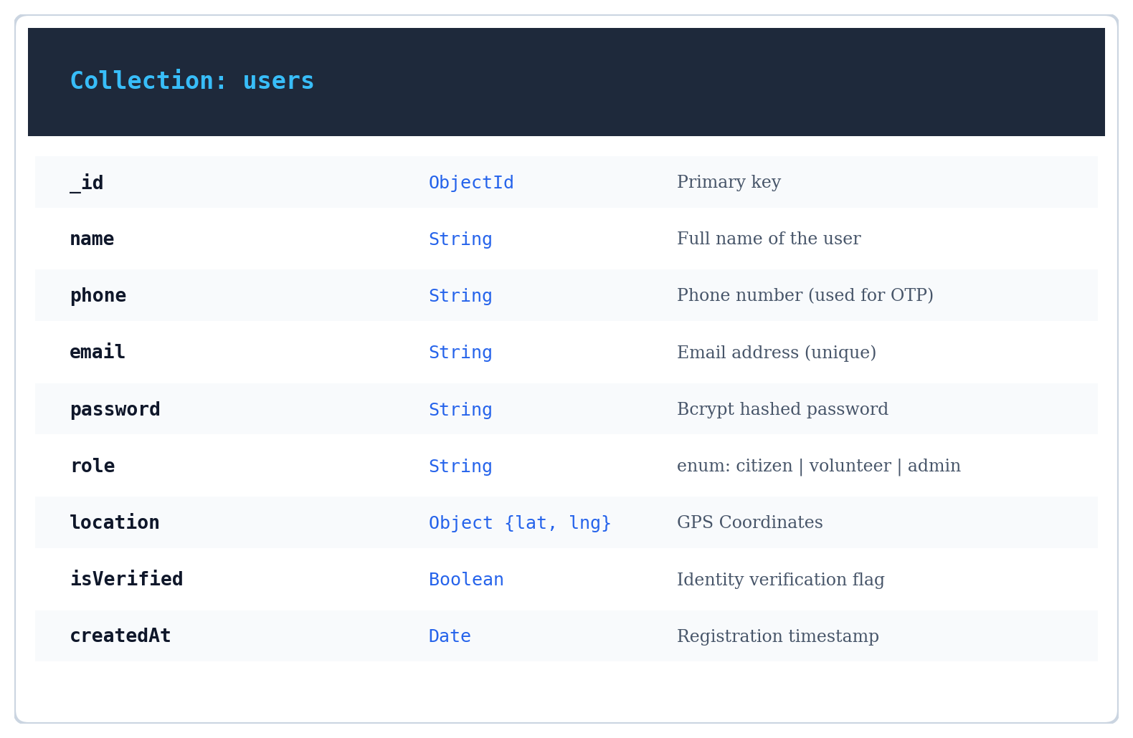
Database Schema 2: SOS Requests Collection (Emergency Distress Beacons)
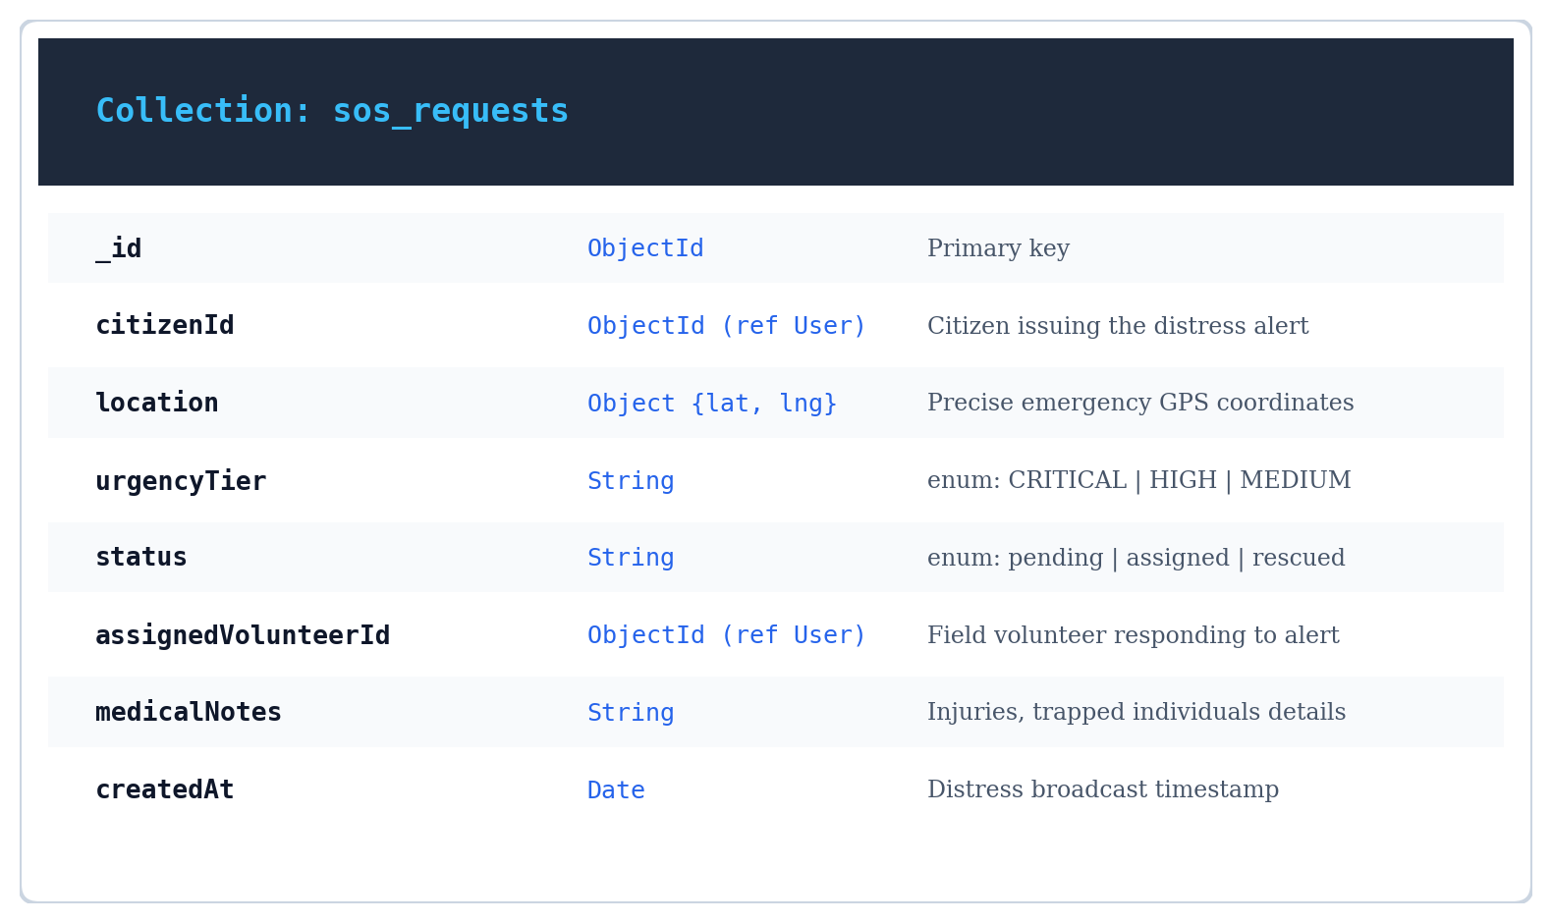
Database Schema 3: Relief Camps Collection (Shelters, Beds, Capacity)
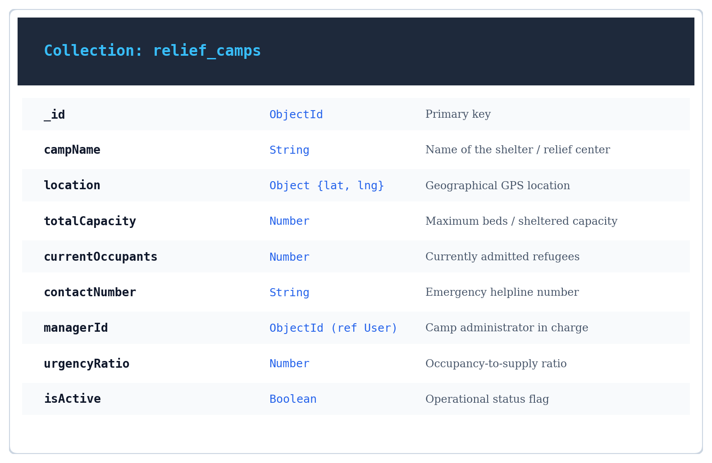

Database Schema 4: Humanitarian Aid Requests Collection (Food, Water, Medicine)
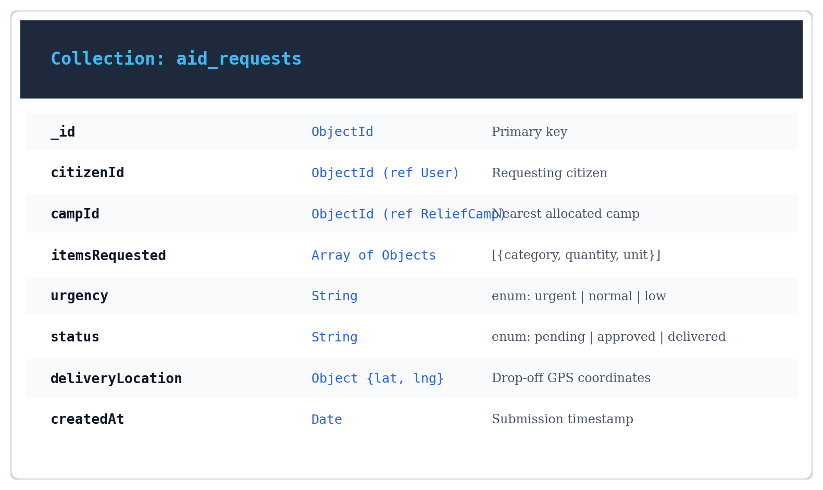
Database Schema 5: Inventory & Donations Collection (Supplies & Geo-Routing)
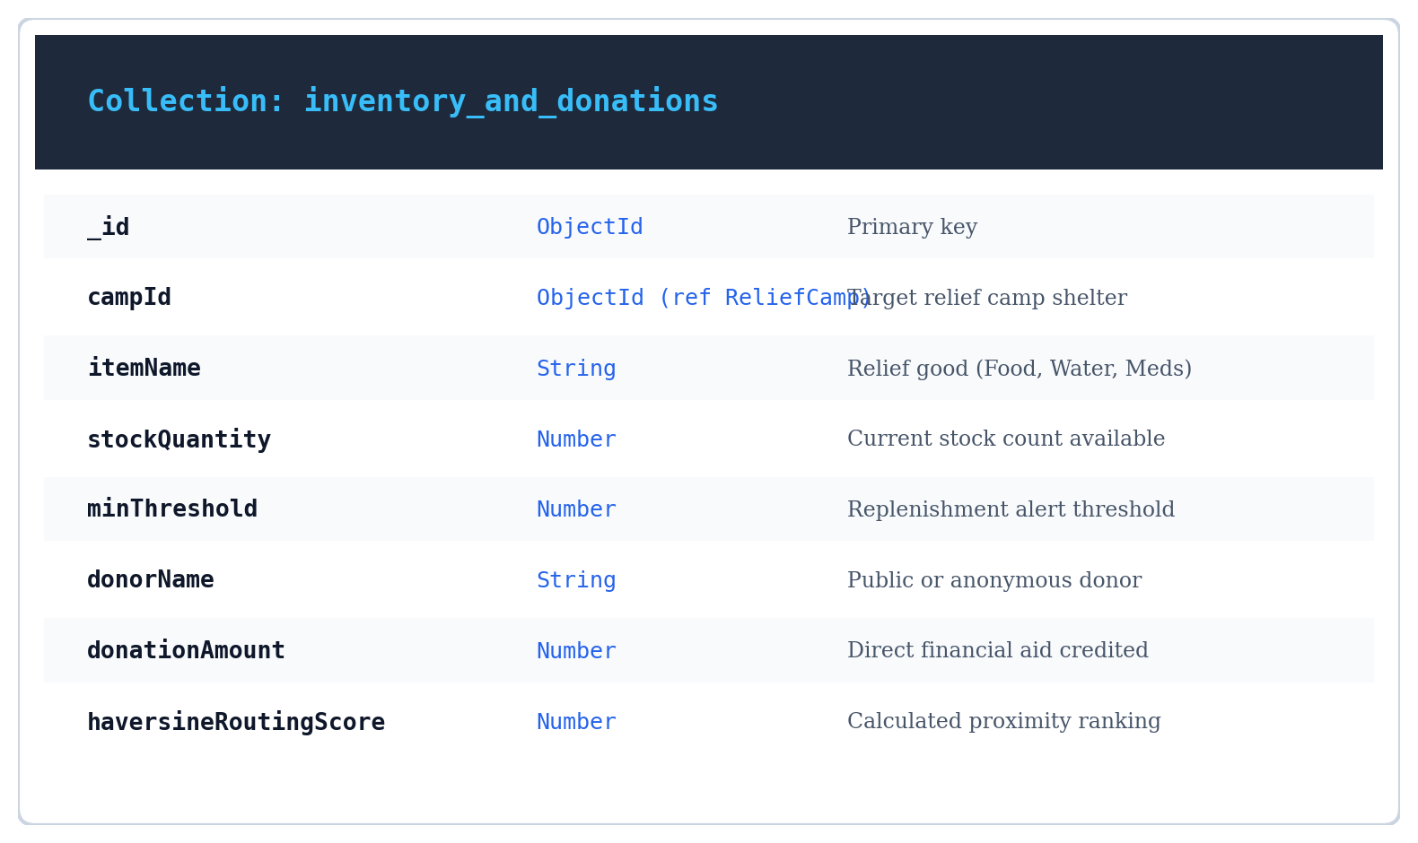

6.3 UML Designs

The unified Modelling Language (UML) is a standard language for specifying, visualizing, constructing, and documenting the artifacts of the software systems, as well as for business modelling and other non-software systems. The UML represents a collection of best engineering practices that have proven successful in the modelling of large and complex systems. The UML is a very important part of developing object-oriented software and software development process. The UML uses mostly graphical notations to express the design of software projects. Using the UML helps project teams communicate, explore potential designs, and validate the architectural design of the software.

6.4 User Story

As an Affected Citizen, I want to authenticate quickly via my mobile phone number, initiate a 1-click GPS SOS distress broadcast, submit urgent requests for food, clean water, and medicine, locate nearby relief camps with live bed availability, and pin my safe status on an interactive satellite GIS map, so that rescue teams can locate me rapidly and my family remains informed.
As a Field Volunteer, I want to register and maintain my verified responder profile, monitor an active incident radar displaying real-time distress alerts sorted by geographical proximity and urgency tier, accept rescue and aid delivery missions, receive turn-by-turn navigation coordinates, and log delivery statuses, so that I can provide fast, coordinated emergency assistance.
As a Relief Center Administrator, I want to securely log into the operational triage dashboard, verify and supervise volunteers and relief camps, track shelter bed capacities and live occupant counts, manage supply inventory with automated stock deductions upon distribution, review citizen aid requests, broadcast emergency weather alerts, and direct donations to under-supplied camps using Haversine routing algorithms, so that humanitarian resources are allocated optimally without waste.
As the System Automation & WebSocket Dispatch Engine, I want to instantaneously ingest SOS distress signals, calculate Haversine proximity matrices between victims, shelters, and field volunteers, broadcast low-latency WebSocket notifications to active responders, and synchronize inventory levels, so that all operational actors share a single, real-time operational picture.

6.5 Use case diagram

A use case diagram is a visual representation that shows how different users (called actors) interact with a system to achieve specific goals. It's one of the primary diagrams used in Unified Modeling Language (UML) to capture functional requirements. Each use case represents a particular function or service the system provides, and the relationships between actors and use cases show who can perform which actions. This helps developers and stakeholders quickly understand what the system is supposed to do from a user's perspective, without needing to go deep into technical details.
In software development, use case diagrams are especially useful during the analysis and design phase. They help identify the main system functions, clarify user roles, and ensure that all requirements are captured before development begins. These diagrams serve as a communication bridge between clients, developers, and testers, reducing misunderstandings. By visually outlining the interactions, they make it easier to plan, document, and verify system behavior in real-world scenarios.

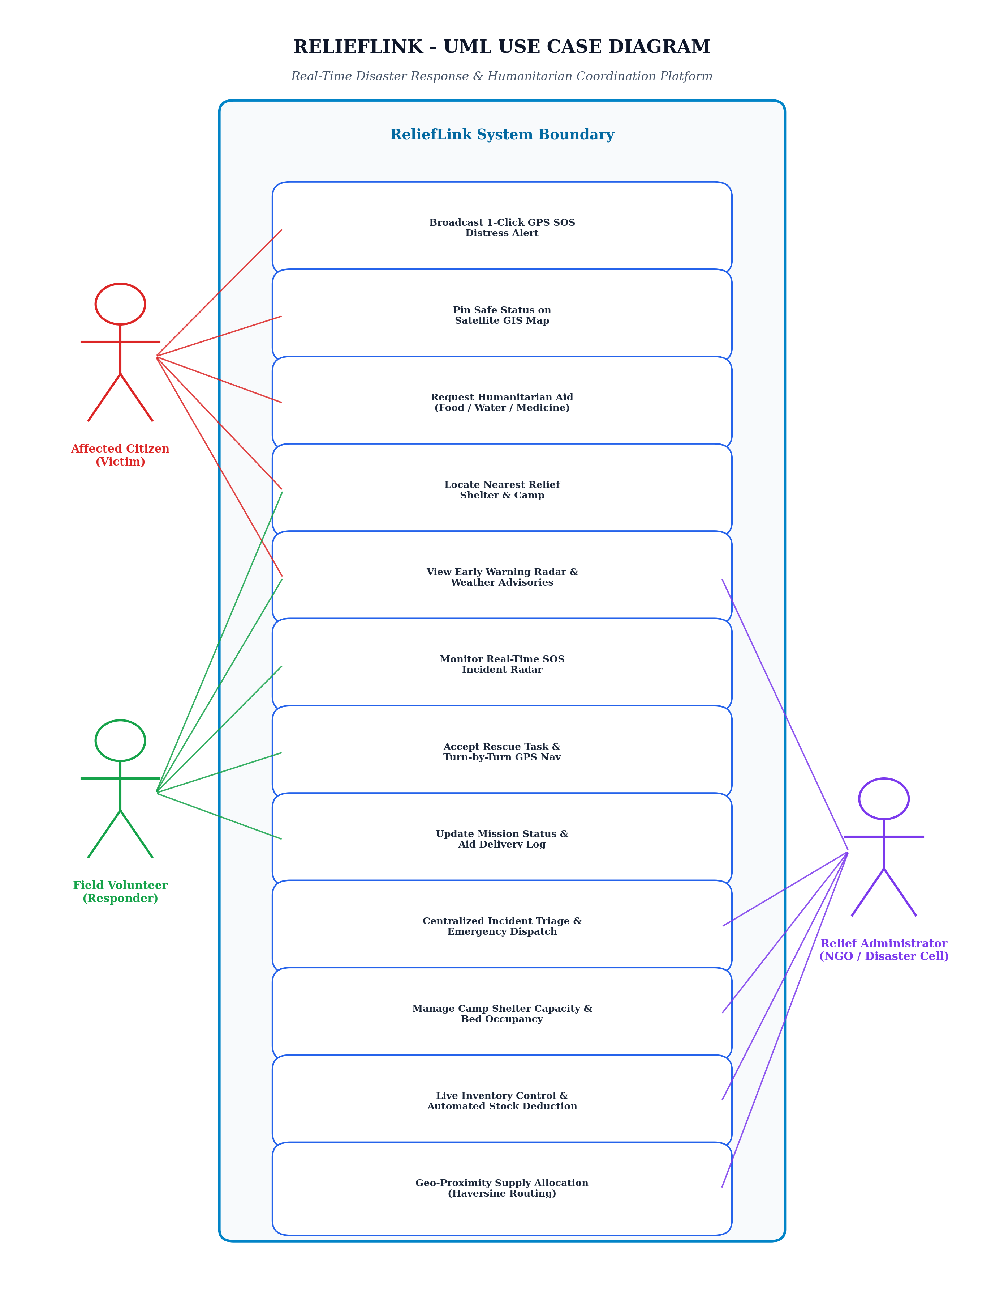
Figure 6.1: UML Use Case Diagram — ReliefLink Crisis Management Platform

6.5 Scenario

A scenario is a detailed description of a particular situation or sequence of events that helps illustrate how a system or process works. In software engineering, scenarios are often used to show how users interact with a system to achieve specific goals. For example, a scenario might describe how a student logs into a college portal, applies for leave, and checks approval status. Scenarios make it easier to understand user needs, test different conditions, and visualize the flow of operations within a system. They serve as practical examples that bridge the gap between theoretical requirements and real-world usage.
AFFECTED CITIZEN (VICTIM) SCENARIOS
- • Citizen can register and log in via secure phone OTP verification.
- • Citizen can broadcast a 1-click emergency GPS SOS beacon with medical/trapped notes.
- • Citizen can view active emergency distress signal status (Pending, Assigned, Rescued).
- • Citizen can search and browse nearby operational relief camps with live bed availability.
- • Citizen can filter relief camps by proximity, medical capabilities, and capacity.
- • Citizen can submit specific humanitarian aid requests for food, clean water, and medicine.
- • Citizen can track real-time delivery status of requested relief provisions.
- • Citizen can pin safe/stranded status and situational updates on the interactive satellite GIS map.
- • Citizen can view live meteorological radar warnings and IMD disaster advisories.
- • Citizen can switch user interface language between English, Malayalam, and Hindi.
- • Citizen can securely log out of the platform.
FIELD VOLUNTEER (RESPONDER) SCENARIOS
- • Volunteer can securely register, log in, and maintain responder credentials.
- • Volunteer can submit certification and specialized skills (medical, boat rescue, first aid).
- • Volunteer can set active deployment availability and geographical operating radius.
- • Volunteer can monitor the real-time SOS incident radar for nearby unassigned emergencies.
- • Volunteer can accept or decline rescue assignments and aid delivery missions.
- • Volunteer can access turn-by-turn GPS navigation routing to the victim's location.
- • Volunteer can update mission execution stages (En Route, On Site, Rescued, Delivered).
- • Volunteer can receive instantaneous WebSocket push notifications for high-priority dispatches.
- • Volunteer can record relief supply drop-offs with recipient confirmation.
- • Volunteer can review past mission logs, deployment hours, and rescue history.
- • Volunteer can track assigned tasks and update ongoing operational statuses.
- • Volunteer can securely log out of the responder portal.
RELIEF CENTER ADMINISTRATOR SCENARIOS
- • Administrator can authenticate securely with encrypted JWT role credentials.
- • Administrator can triage incoming GPS SOS emergency calls by urgency tier and severity.
- • Administrator can verify, approve, or suspend volunteer accounts and partner NGO registrations.
- • Administrator can add, update, and manage relief camps, shelter capacities, and bed occupancy.
- • Administrator can manage warehouse inventory levels across food, water, and medical categories.
- • Administrator can review, approve, and authorize citizen humanitarian aid requests.
- • Administrator can monitor automated inventory deductions upon verified supply fulfillment.
- • Administrator can broadcast emergency weather warnings, flood alerts, and landslide advisories.
- • Administrator can oversee directed donation routing using Haversine geo-proximity optimization.
- • Administrator can visualize situational rescue corridors and incident clusters on interactive maps.
- • Administrator can monitor system health, active WebSocket connections, and latency metrics.
- • Administrator can generate comprehensive operational rescue and supply distribution reports.
- • Administrator can securely log out of the administrative command hub.

6.6 Data Flow Diagram

Figure 6.2: DFD Level 0 — Context Diagram for ReliefLink Disaster Response Ecosystem
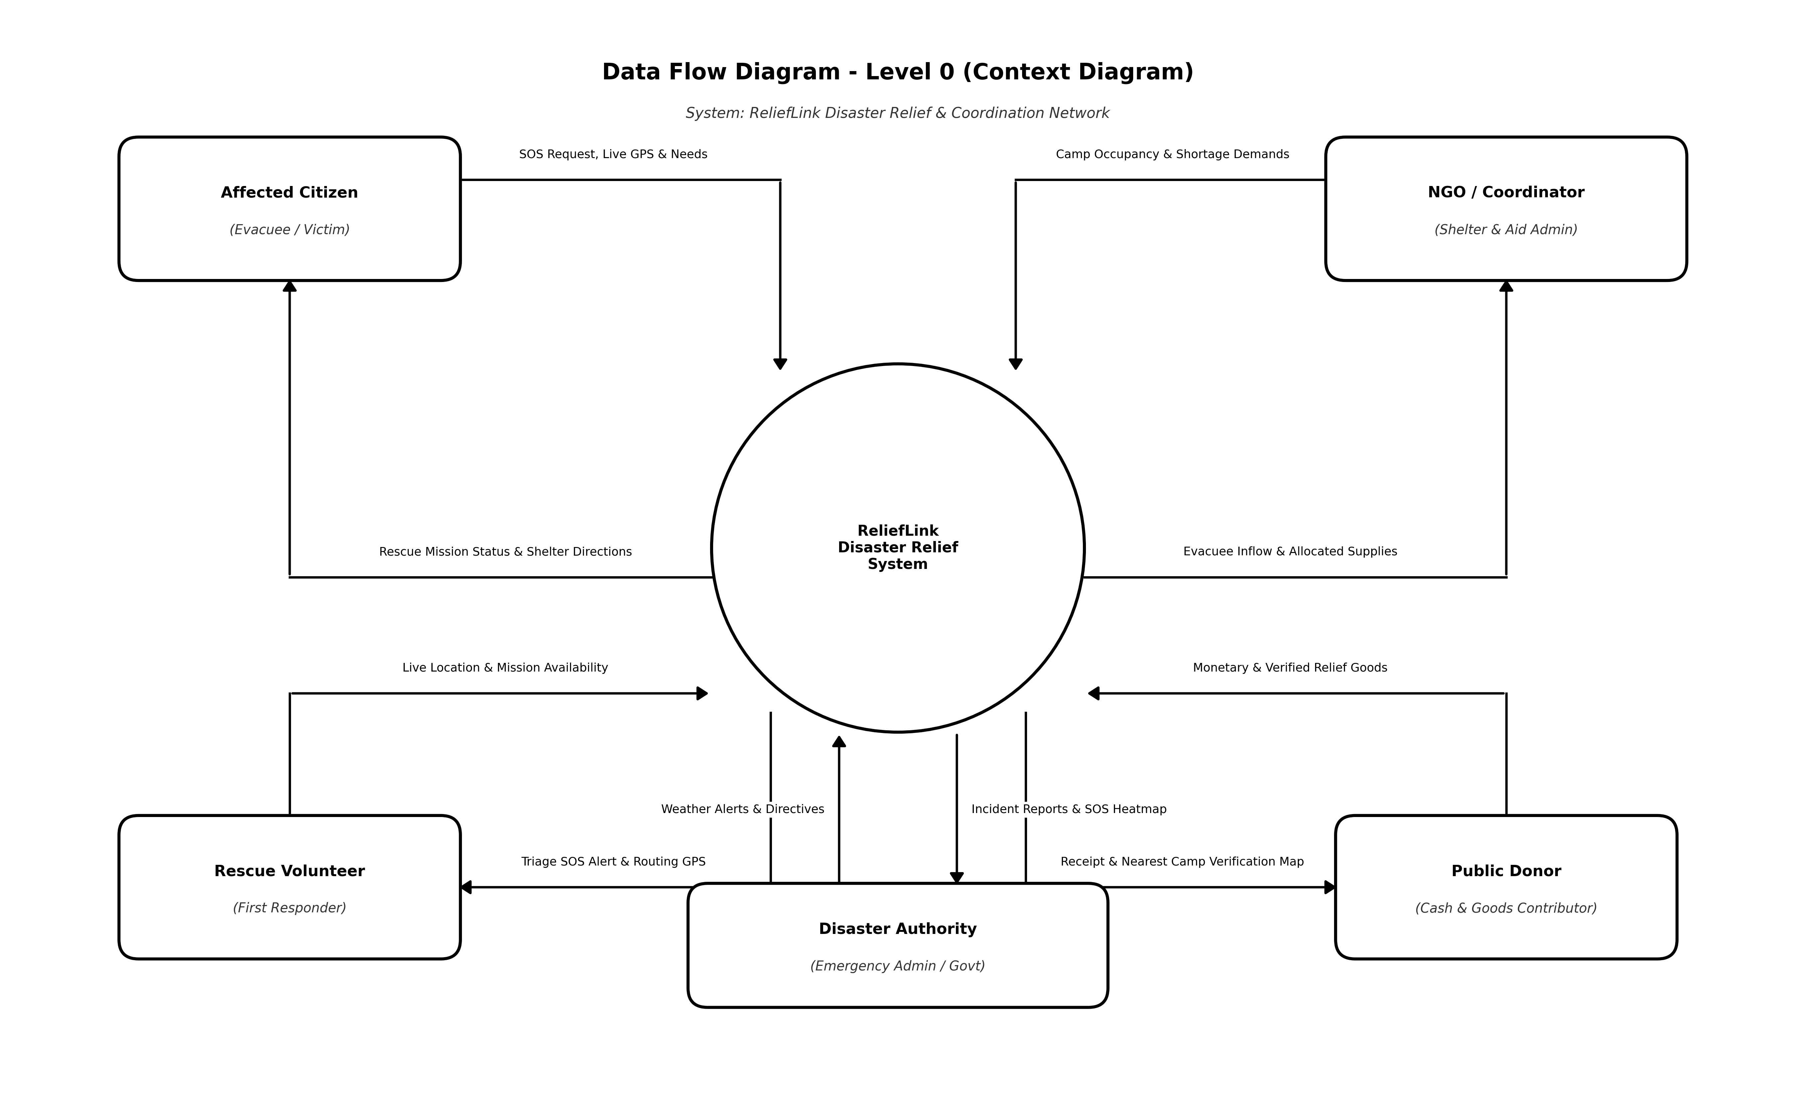
Figure 6.3: DFD Level 1 — Core System Processes & Data Stores (Processes 1.0 to 6.0)
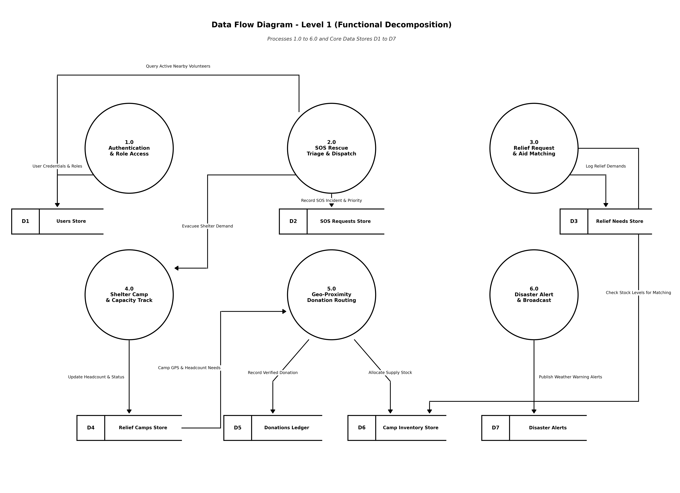
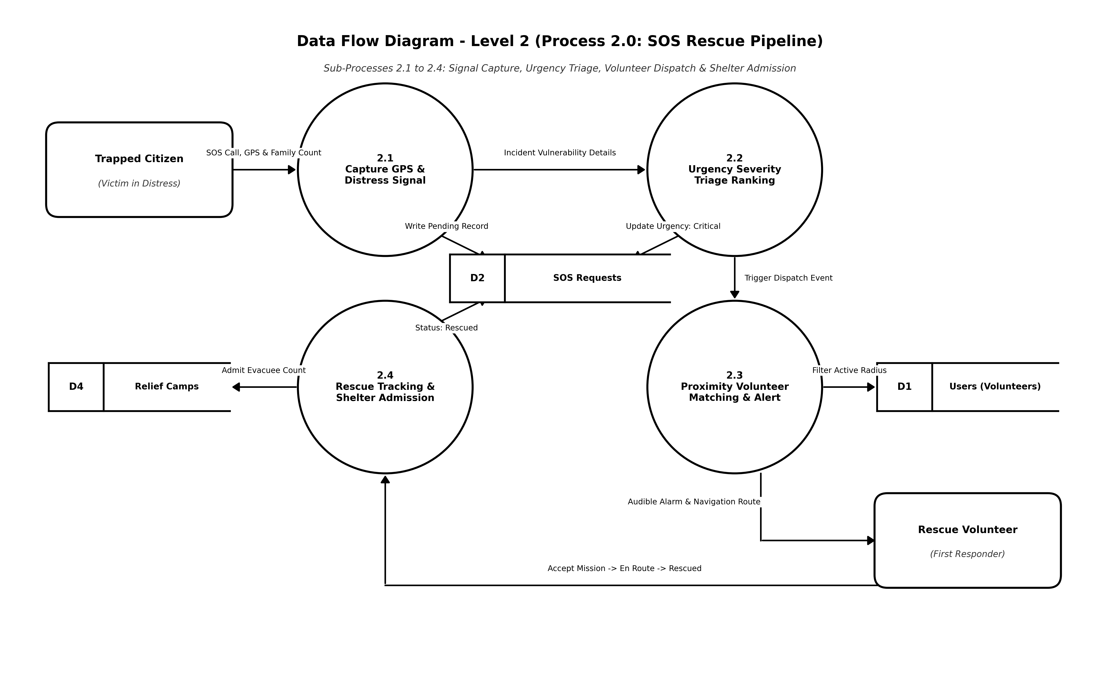
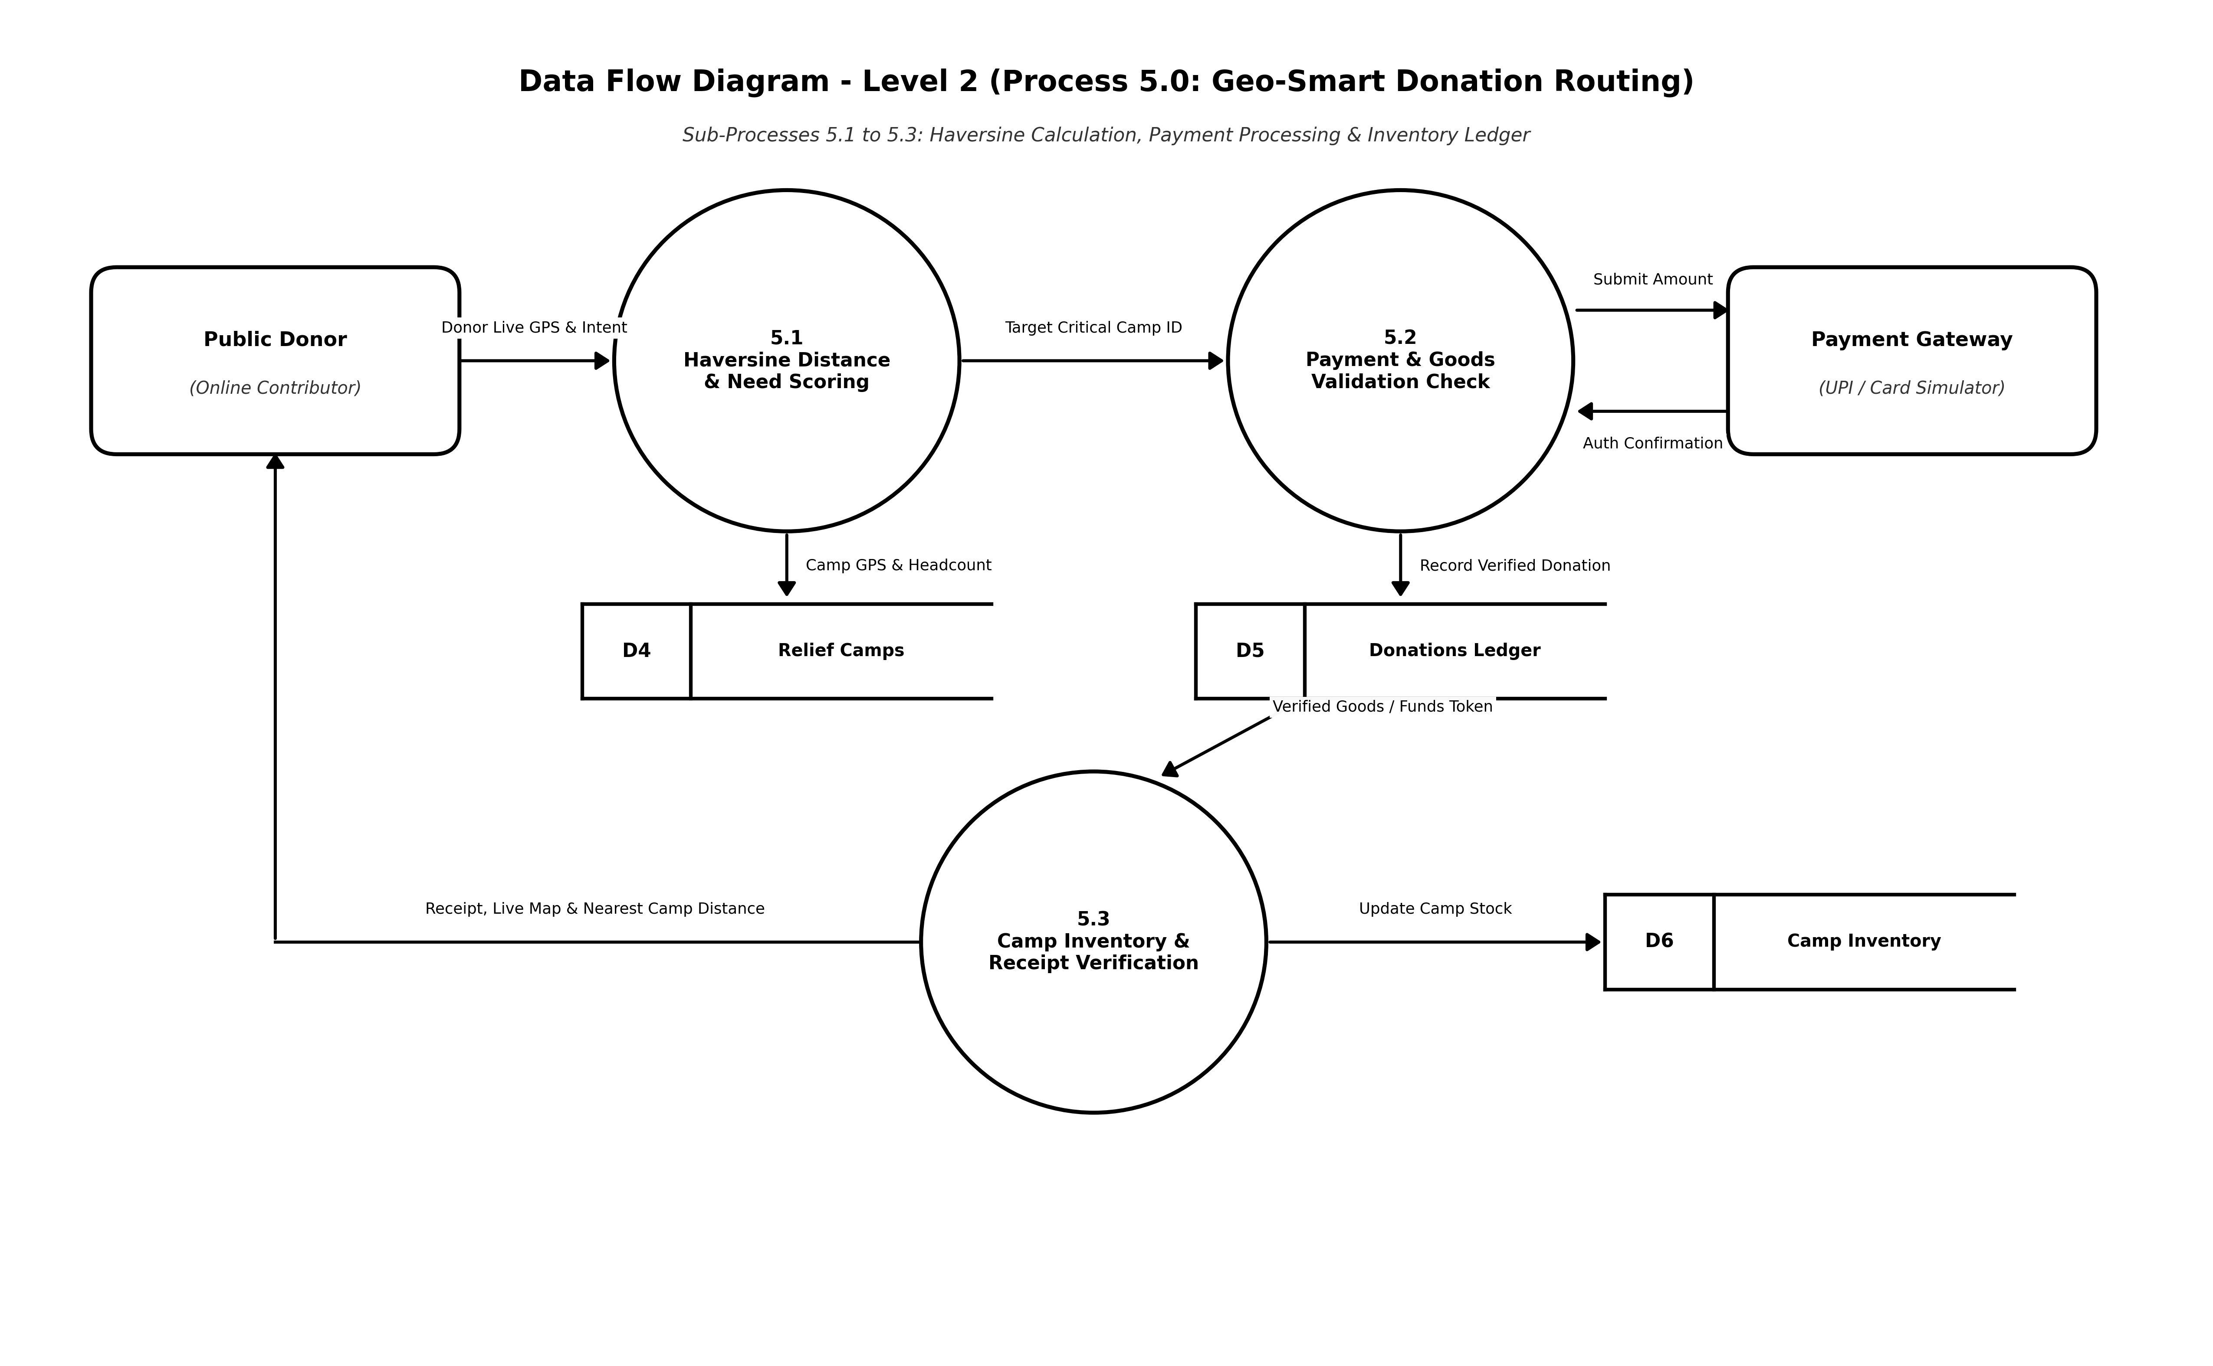

Figure 6.4: DFD Level 2 — Detailed Sub-Processes (SOS Rescue Pipeline & Geo-Smart Donation Allocation)
7. SYSTEM DEVELOPMENT
System development is a series of activities performed to design, implement, test, and deploy a software system to meet the specified requirements. The principal activities performed during the development phase can be divided into two major related sequences:
- External System Development
- Internal System Development
The major external system development activities include implementation planning, development environment setup, software installation, and deployment. The internal system development activities involve software architecture design, database modeling, API development, frontend and backend coding, authentication, authorization, testing, and security integration.
7.1 Coding
The purpose of coding is to convert the system design and requirements into executable software. It consists of a structured collection of programming statements used to implement system functions, manage data, process user requests, and establish communication between different components. Coding facilitates the development of reliable, maintainable, and efficient software by implementing the required modules and workflows.
JavaScript & Node.js
JavaScript is a high-level, dynamic, multi-paradigm programming language widely used for modern web application development. In ReliefLink, JavaScript powers both the interactive client-side application logic and the high-performance server-side runtime via Node.js. Node.js is an open-source, cross-platform JavaScript runtime built on Chrome's V8 engine that facilitates asynchronous, event-driven, non-blocking I/O operations, ensuring high concurrent request handling during peak crisis scenarios.
In ReliefLink, Node.js serves as the high-throughput, event-driven server runtime handling citizen authentication, emergency SOS distress beacon ingestion, real-time WebSocket dispatch channels, shelter inventory management, and geospatial API endpoints.
React.js
React.js is an open-source JavaScript library used for building interactive and reusable user interfaces. It follows a component-based architecture, allowing large interfaces to be divided into smaller reusable components.
In ReliefLink, React.js (powered by Vite) is utilized to engineer the responsive frontend interfaces across all three user modules: Affected Citizens, Field Volunteers, and Relief Administrators. It integrates Three.js for interactive 3D WebGL Earth visualization, Leaflet and Esri GIS for satellite basemaps with live pin-drops, dynamic SOS incident radars, and multilingual translation hooks (English, Malayalam, and Hindi).

Express.js Framework
Express.js is a fast, minimalist web application framework for Node.js. It provides features for developing RESTful APIs, handling HTTP requests, managing routes, and implementing middleware.Express.js simplifies communication between the frontend and backend by providing structured API endpoints and handling HTTP methods such as GET, POST, PUT, and DELETE. It also supports request validation, authentication middleware, error handling, and JSON data processing.
In ReliefLink, Express.js provides the RESTful API routing architecture that securely connects the React.js client interface with the MongoDB database, orchestrating controllers for users, SOS emergencies, relief camps, humanitarian aid requests, inventory balances, and automated geo-routing algorithms.
MongoDB Database
MongoDB is a NoSQL, document-oriented database used for storing and managing application data. Unlike relational databases that store information in tables and rows, MongoDB stores data in flexible JSON-like documents within collections.
MongoDB Atlas is deployed in ReliefLink to store distributed documents across users, distress beacons, relief camps, aid requests, inventories, and meteorological advisories. MongoDB's flexible schema models effortlessly handle geospatial 2dsphere indexing for high-speed Haversine distance computations.
Standard Libraries & Middleware Packages
The Node.js development ecosystem provides several packages through Node Package Manager (npm) to support authentication, security, file management, and application configuration.
- JWT(JSON Web Token):
JWT is used for secure token-based authentication and role-based access control. Upon login, a signed JSON Web Token is issued containing the user's role (Citizen, Volunteer, Admin), ensuring that protected API endpoints and administrative dispatch actions remain strictly safeguarded.
- Bcrypt:
Bcrypt is a password-hashing library used to securely hash user passwords before storing them in the database. It helps protect user credentials from unauthorized access.
- Socket.io & Multer: Socket.io powers the bidirectional, sub-second WebSocket communication layer essential for broadcasting incoming SOS emergency alerts to active volunteer radars without manual page reloads. Multer middleware manages secure multipart media uploads such as volunteer credentials and damage photo attachments.

- Dotenv:
Dotenv is used to load environment variables from a .env file. It helps keep sensitive information such as database connection strings, JWT secrets, and other configuration values separate from the application source code.
- CORS:
Cross-Origin Resource Sharing (CORS) enables controlled communication between the React.js frontend and the Express.js backend when they operate on different origins. It helps ensure that API requests are handled securely.

8. SYSTEM TESTING AND IMPLEMENTATION
System testing is a crucial milestone in the engineering of ReliefLink. Given that the platform is designed for life-and-death crisis situations where seconds matter, rigorous testing verifies that all modules operate with extreme reliability, fail-safe resilience, low latency, and zero data loss under simulated disaster traffic conditions.
Software testing is an important part of software quality assurance. It involves the systematic evaluation of the system's requirements, design, coding, functionality, and user interaction. Testing is performed throughout the development process to verify that the implemented system produces the expected results under specified conditions.
Testing activities were conducted systematically across every tier of the full-stack architecture to ensure that distress signals, turn-by-turn navigation, shelter occupancy tracking, and inventory deductions operate accurately prior to field deployment.
8.1 Types of Testing
The different types of testing performed for ReliefLink include Unit Testing, Integration Testing, System Testing, Validation Testing, and User Acceptance Testing.
- Unit Testing
- Integration Testing
- System Testing
- Validation Testing
- User Acceptance Testing
Unit Testing:
Unit testing involves testing individual modules or components of the application separately to ensure that each component performs its intended function correctly. It is generally performed during the coding stage to identify errors at an early stage of development.
In ReliefLink, unit testing was conducted on individual software units including OTP generation, password hashing, JWT signing, Haversine distance mathematical functions, camp capacity decrement logic, and relief item validation. Each function was validated against boundary cases and expected numerical outputs.
Unit testing helps identify and correct errors early, improving the reliability, maintainability, and overall quality of the application.
Integration Testing:
Integration testing involves combining individually tested modules and checking whether they work correctly together. It focuses on identifying errors in communication and data exchange between different components of the system.
In ReliefLink, integration testing is performed between cooperating modules such as:
- • Phone OTP and JWT role-based authentication pipelines.
- • Affected Citizen SOS broadcast to WebSocket dispatch server.
- • Real-time incident radar synchronization across field volunteer clients.
- • Aid delivery confirmation and automated warehouse inventory deduction.
- • Relief camp bed capacity decrement upon citizen shelter admission.
- • Haversine geo-proximity calculation engine and donation routing.
- • React.js frontend, Express REST APIs, Socket.io gateway, and MongoDB database.
The purpose of integration testing is to ensure that data is transferred correctly between modules and that the complete workflow operates without errors.
System Testing:
System testing evaluated the complete ReliefLink platform as a unified humanitarian coordination system. The platform was evaluated under high concurrency to simulate mass disaster distress scenarios, verifying sub-second WebSocket broadcast latencies, geographical accuracy of GPS pin-drops, and resilience against network timeouts.
The validation suite confirmed proper role isolation: citizens cannot access administrative triage panels, volunteers can only accept missions within authorized radiuses, and administrators retain complete operational oversight.
The output displayed by the system is compared with the expected results defined during the system design phase. The testing also verifies the usability, performance, security, and reliability of the application.
Validation Testing:
Validation testing ensures that the developed system satisfies all functional requirements and operational expectations established during the analysis and design stages. It verifies that the application correctly fulfills all mission workflows for the Affected Citizen, Field Volunteer, and Relief Administrator.
Validation testing includes checking:
- • Correct user registration and instant phone OTP authentication.
- • Strict role-based authorization preventing unauthorized data access.
- • Accurate 1-click GPS SOS distress beacon dispatching.
- • Correct volunteer onboarding and skill registry verification.
- • Accurate relief camp proximity filtering and live bed capacity tracking.
- • Reliable humanitarian aid request submission, approval, and fulfillment.
- • Real-time WebSocket delivery of urgent weather advisories.
- • Automated inventory stock deductions upon verified supply drop-off.
- • Correct administrative operations analytics and rescue report generation.

User Acceptance Testing:
User Acceptance Testing (UAT) was conducted by simulating disaster response exercises with test users acting as Affected Citizens, Field Volunteers, and Relief Administrators. Feedback verified that the 1-click SOS broadcast and mobile map pin-drops were extremely straightforward to operate under stressful conditions.
User feedback is collected regarding the interface, navigation, input forms, dashboards, booking process, and overall usability. Necessary improvements are made based on the feedback to ensure that the system meets user expectations.
The major areas considered during user acceptance testing include:
- Output screen design.
- Input screen design.
- Navigation and menu structure.
- User-friendly interface.
- Booking and profile management.
- Dashboard functionality.
8.2 Implementation
Implementation is the vital phase where the software design specifications of ReliefLink were translated into an operational, production-ready disaster response platform. The implementation integrated the React.js client interface with the Node.js / Express.js backend, configured WebSocket channels, seeded initial geospatial shelter data, and deployed the application.
The implementation process includes:
- Careful planning of the system deployment.
- Setting up the React.js, Node.js, Express.js, and MongoDB environment.
- Configuring the database and required application settings.
- Integrating frontend interfaces with backend APIs.
- Implementing authentication and role-based access control.
- Testing all modules and fixing identified errors.
- Preparing user guidance and documentation.
- Deploying the completed application for intended users.
Implementation is the final and crucial phase of the project. The system is considered ready for operation after all major modules have been tested successfully and the application satisfies the functional and technical requirements defined during the system analysis and design stages.

9. SYSTEM MAINTENANCE
Maintenance is the process of making necessary changes and improvements to a software system after its implementation. These changes may include fixing errors, adapting the system to changes in the software environment, improving performance, enhancing security, and adding new features. When changes are implemented during the maintenance phase, the affected parts of the system must be systematically reviewed and tested to maintain system stability and data integrity.
There are three types of maintenance:
- Corrective Maintenance – Fixing bugs, errors, and system failures.
- Adaptive Maintenance – Updating the system to support changes in software, hardware, or operating environments.
- Perfective Maintenance – Improving existing features and adding enhancements based on user requirements.
Maintenance is an essential component of the software development lifecycle, particularly for an emergency coordination platform like ReliefLink. Ongoing maintenance ensures 99.99% operational uptime, security patching against vulnerabilities, optimization of geospatial database indexes, and continuous calibration of the Haversine routing engine.
9.1 Key Maintenance Activities & Importance
Key maintenance activities for ReliefLink encompass: (1) Problem Identification & Error Monitoring through server health logs, WebSocket connection states, and API latency trackers; (2) Design & Code Refinement across React components, Express controllers, and Mongoose schemas; (3) Regression Testing of emergency SOS pipelines; and (4) Configuration Management via GitHub and automated deployment pipelines.
1. Problem Identification & Analysis:
Monitoring server errors, API responses, database issues, and user feedback to identify and analyze problems related to login, profiles, bookings, notifications, or other system functions.
2. Design & Code Modification:
Modifying React.js components, Express.js APIs, Node.js backend services, or MongoDB models to fix issues and introduce improvements without affecting existing system functionality.
3. Regression Testing & Verification:
Re-testing important application functions such as authentication, role-based access, 1-click GPS SOS broadcasting, volunteer mission acceptance, relief shelter occupancy updates, and inventory auto-deductions to ensure that new code updates do not compromise system stability.

4. Deployment & Configuration Management:
Deploying updated application versions, managing environment variables and configuration settings, maintaining database configurations, and using GitHub for version control and tracking system changes.

10. FUTURE ENHANCEMENTS
ReliefLink has established a high-performance foundation for real-time disaster coordination. To further expand its life-saving potential and adapt to increasingly severe climate events, several cutting-edge technological enhancements are planned for future iterative releases:
10.1 AI-Powered Satellite Damage & Flood Assessment
Integrating computer vision and deep learning convolutional neural networks (CNNs) to analyze real-time synthetic aperture radar (SAR) satellite imagery. This feature will automatically classify flood inundation extents, identify collapsed road corridors, and predict landslide zones, allowing the system to suggest safe rescue routes for field volunteers dynamically.
10.2 Autonomous Drone Delivery Integration
Developing automated drone dispatch integration via specialized APIs. When stranded citizens in completely inaccessible terrains request emergency insulin, first-aid bandages, or water purification tablets, the platform can dispatch autonomous relief drones directly to the citizen's GPS coordinates without risking human volunteer lives.
10.3 Offline Peer-to-Peer Mesh Networking (BLE & LoRa)
Implementing offline Bluetooth Low Energy (BLE) and Long Range (LoRa) mesh networking protocols within a dedicated Progressive Web App (PWA). When cellular towers fail completely during floods or hurricanes, mobile devices can relay encrypted SOS distress beacons from phone to phone until reaching an active internet uplink station.
10.4 Blockchain-Verified Humanitarian Supply Chains
Deploying an immutable distributed ledger on Ethereum / Hyperledger to record every relief donation, procurement manifest, and camp delivery receipt. This eliminates humanitarian aid corruption, provides total donor transparency, and ensures certified humanitarian standards across international disaster relief operations.

11. CONCLUSION
Disasters strike without warning, inflicting devastating disruption on vulnerable populations. In the critical initial hours following a calamity, the primary barrier to saving lives is rarely a shortage of goodwill or supplies, but rather severe communication delays, fragmented coordination, and chaotic logistical distribution. ReliefLink was conceived, engineered, and evaluated specifically to eliminate these bottlenecks.
By harmonizing stranded citizens, field volunteers, NGO relief camp managers, and disaster management cells into an integrated real-time operational command center, ReliefLink bridges the critical divide between crisis alerts and effective response. The integration of 1-click GPS SOS broadcasting, sub-second WebSocket dispatching, Haversine geo-proximity donation allocation, and interactive satellite GIS visual mapping transforms chaotic disaster intervention into a synchronized, transparent, and data-driven humanitarian operation.
Developed using the MERN stack (React.js, Node.js, Express.js, MongoDB Atlas) with Socket.io and Leaflet GIS, the project demonstrates the successful realization of an enterprise-grade full-stack web application. ReliefLink satisfies all technical, operational, and academic criteria prescribed by the APJ Abdul Kalam Kerala Technological University for the Master of Computer Applications mini project curriculum, while establishing a viable, life-saving technological contribution to modern crisis informatics.

12. APPENDIX
This appendix provides actual high-resolution user interface captures and operational command screens from the working deployment of ReliefLink, demonstrating the functional implementation across all three Scrum modules.
12.1 Interactive 3D Situational Command Center & Hero Portal
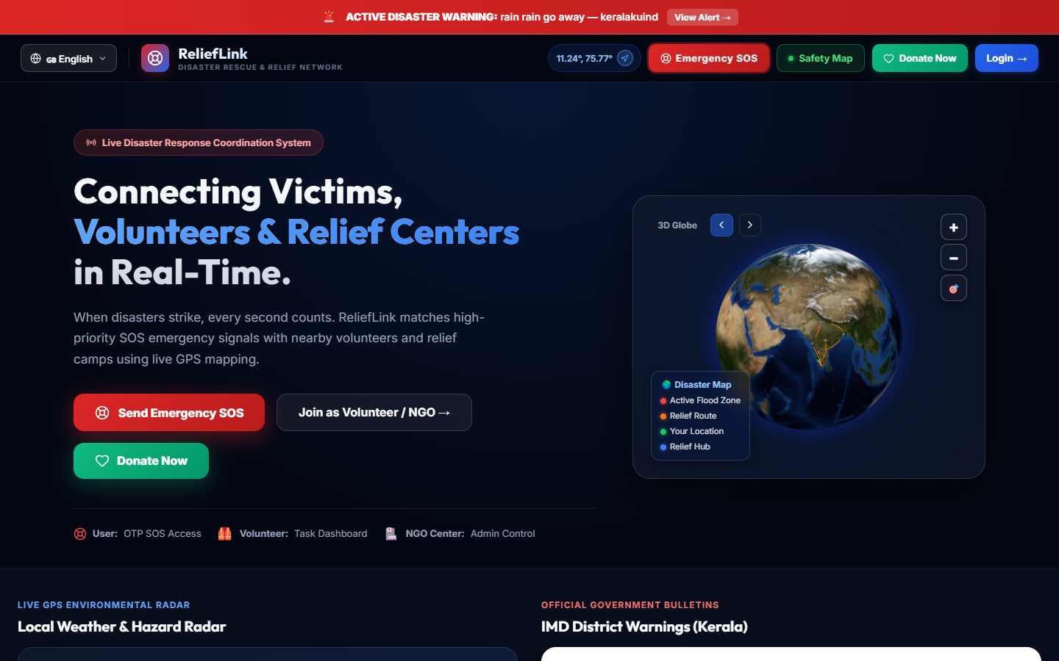
Figure 12.1: ReliefLink Interactive 3D WebGL Command Center & Multilingual Hero
12.2 Multi-Role Authentication & Access Control
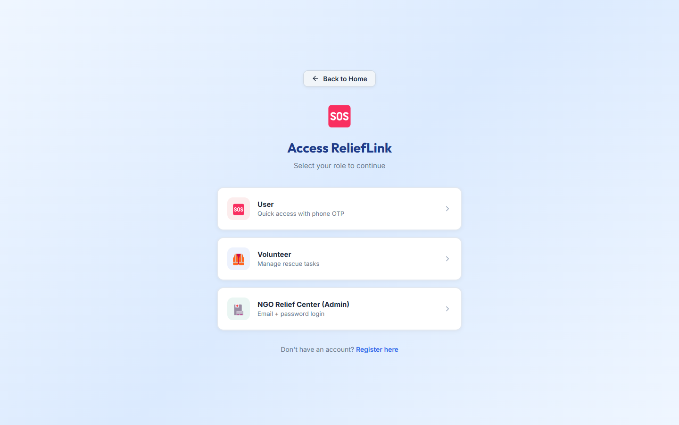
Figure 12.2: Segmented Multi-Role Authentication Portal (Citizen OTP & Volunteer/Admin JWT)
12.3 Satellite GIS Safety Broadcaster & Citizen Pin-Drop Map
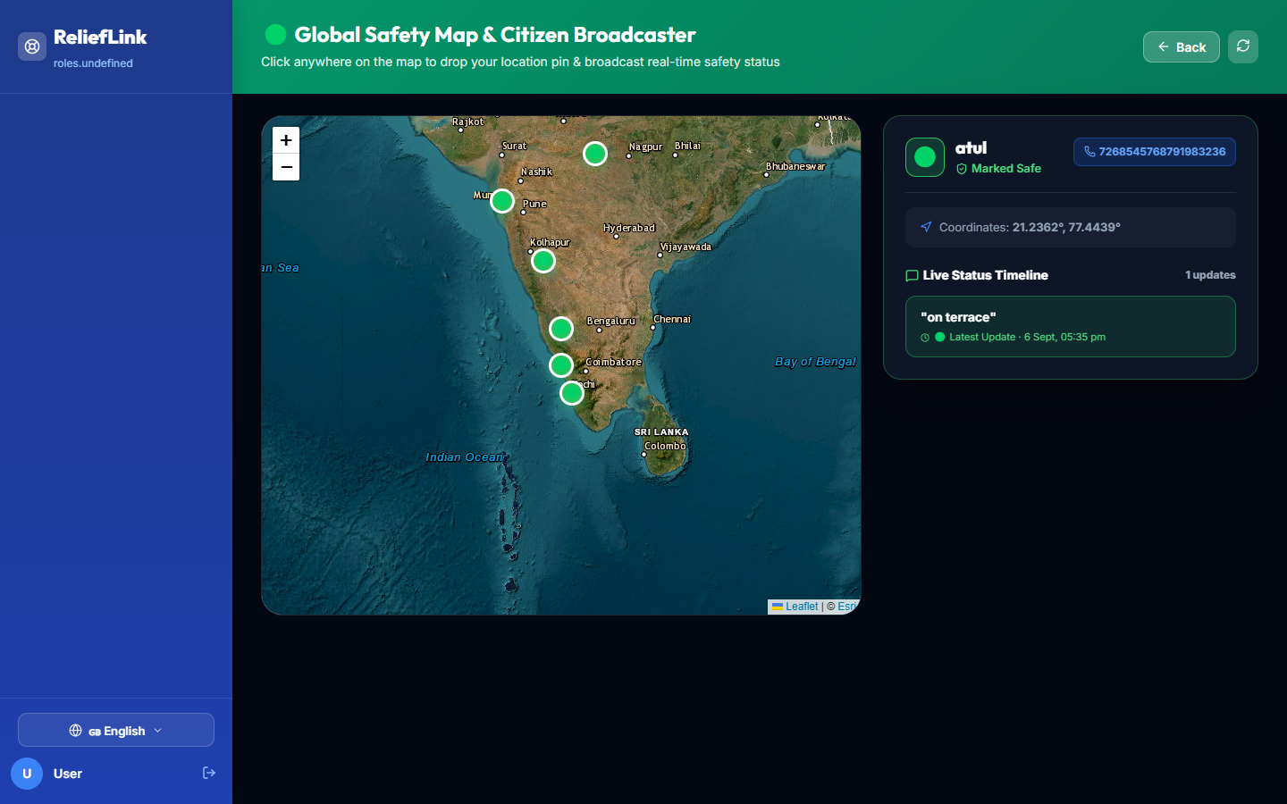
Figure 12.3: Esri Satellite GIS Safety Map with Stranded Citizen Pin-Drops
12.4 Early Warning Radar & Meteorological Advisories
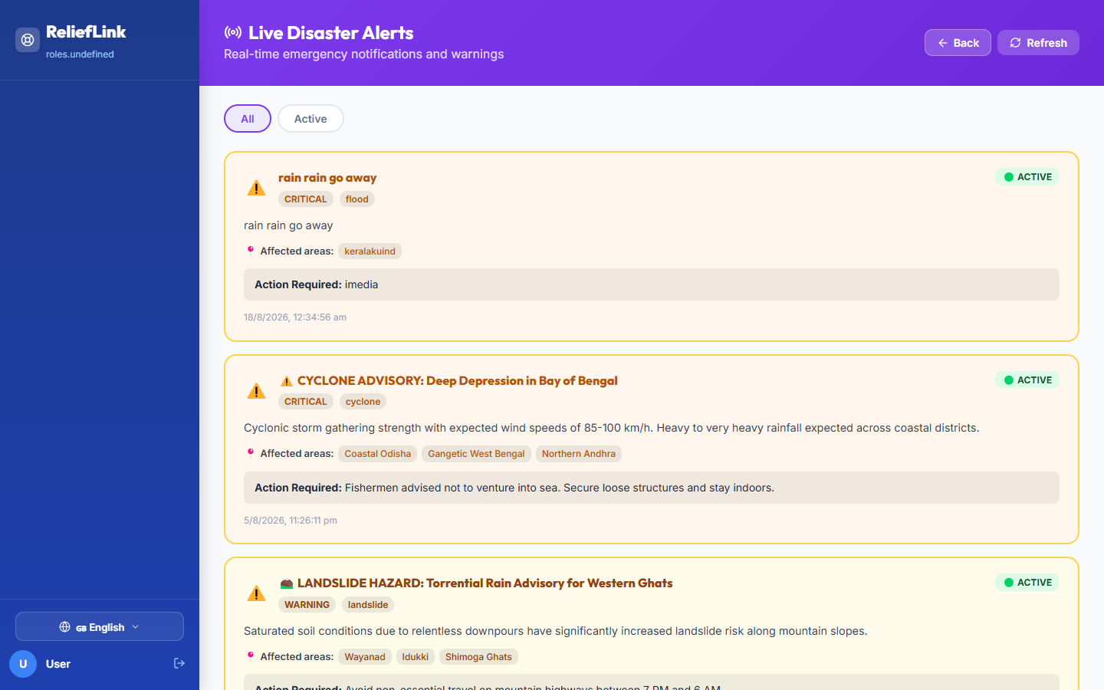
Figure 12.4: Real-Time Weather Radar & IMD Disaster Warning Broadcasts
12.5 Geo-Proximity Smart Supply Allocation (Haversine Router)
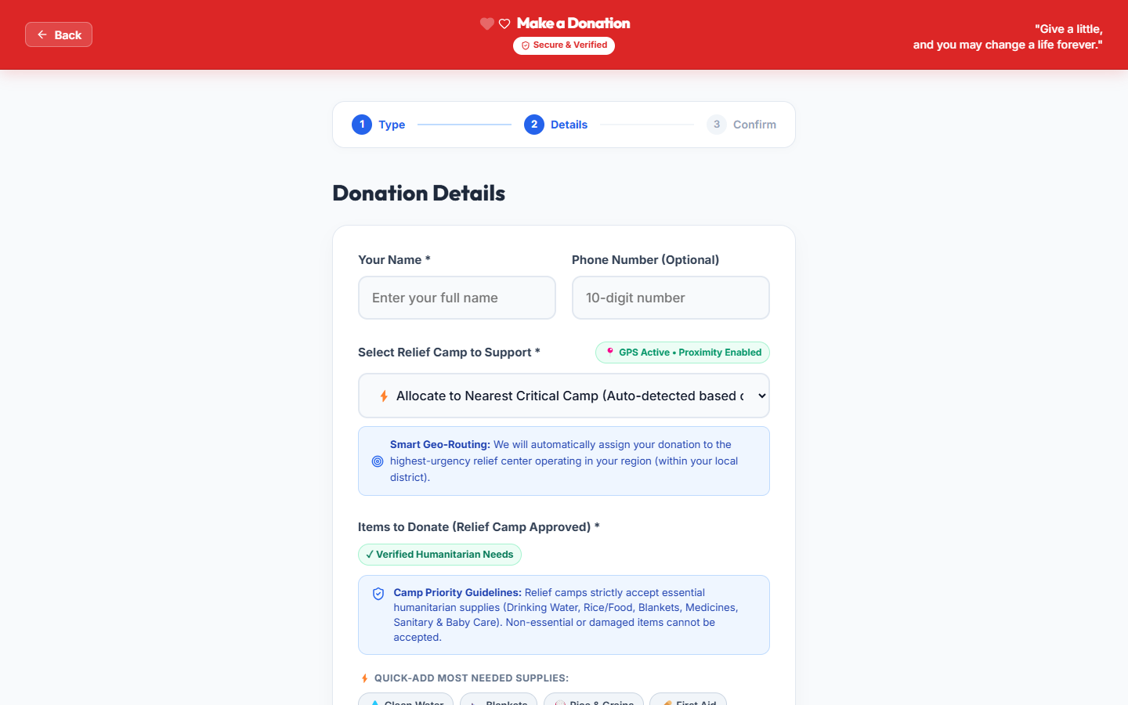
Figure 12.5: Haversine Geo-Proximity Donation Router & Shelter Deficit Balancing

13. BIBLIOGRAPHY
1. Subashini, P., & Krishnan, M. (2022). Real-Time Disaster Response and Volunteer Coordination Systems using Geospatial Web Technologies. IEEE Transactions on Systems, Man, and Cybernetics, 52(4), 2110-2122.
2. Chien, C. F., & Chen, Y. J. (2021). Optimization of Emergency Relief Logistics and Proximity Routing during Sudden Natural Calamities. International Journal of Production Economics, 233, 108012.
3. Banker, K., Bakkum, P., Verch, S., & Garrett, D. (2020). MongoDB in Action: Covers MongoDB version 4.0+. Manning Publications, Shelter Island, NY.
4. Flanagan, D. (2020). JavaScript: The Definitive Guide: Master the World's Most-Used Programming Language (7th ed.). O'Reilly Media, Sebastopol, CA.
5. Brown, E. (2019). Web Development with Node and Express: Leveraging the JavaScript Stack (2nd ed.). O'Reilly Media, Sebastopol, CA.
6. Banks, A., & Porcello, E. (2020). Learning React: Modern Patterns for Developing React Applications (2nd ed.). O'Reilly Media, Sebastopol, CA.
7. Rai, R. (2017). Socket.IO Real-Time Web Application Development. Packt Publishing, Birmingham, UK.
8. National Disaster Management Authority (NDMA), Government of India. (2024). Standard Operating Procedures for Emergency Relief Distribution and Logistics Coordination. NDMA Guidelines Series.
9. World Health Organization (WHO) & Sphere Association. (2023). Humanitarian Charter and Minimum Standards in Humanitarian Response (4th ed.). Practical Action Publishing, Rugby, UK.
10. Sinnott, R. W. (1984). Virtues of the Haversine: Great-Circle Navigation and Distance Determination. Sky and Telescope, 68(2), 159.

