RELIEFLINK

A project report
submitted in fulfillment of
the requirements for the award of the degree of

MASTER OF COMPUTER APPLICATIONS
From

APJ Abdul Kalam Kerala Technological University

Submitted By
VIVEK K(MEA25MCA-2027)


MEA Engineering College
Department of Computer Applications
Vengoor P.O, Perinthalmanna, Malappuram, Kerala-679325
OCTOBER 2026
DEPARTMENT OF COMPUTER APPLICATIONS
MEA ENGINEERING COLLEGE
PERINTHALMANNA-679325

CERTIFICATE

This is to certify that the Project report entitled "Petcare Connect" is a bonafide record of the work done by VIVEK K (MEA25MCA-2027) under our supervision and guidance. The report has been submitted in fulfillment of the requirement for award of the Degree of Master of Computer Applications from the APJ Abdul Kalam Kerala Technological University for the year 2026.

Mr. Sajeesh M  Assistant Professor  Project Guide  Dept. of Computer Applications | Mr. Sajeesh M  Assistant Professor  Head of the Department  Dept. of Computer Applications

Acknowledgements
First and foremost, We would like to thank the Almighty God for giving us the knowledge and strength which helped us in the successful completion of this project.
An endeavor over a long period may be successful only with advice and guidance of many well wishers. We take this opportunity to express our gratitude to all who encouraged us to complete this project. We would like to express our deep sense of gratitude to our respected Principal Dr. Shahir VK for his inspiration and for creating an atmosphere in the college to do the project.
We would like to thank Mr. Sajeesh M, Assistant Professor and Head of the Department, for providing permission and facilities to conduct the project in a systematic way. We are highly indebted to Mr. Adil Narakkoden, Assistant Professor in Department of Computer Applications for guiding us and giving timely advices, suggestions and wholehearted moral support in the successful completion of this project.
Our sincere thanks to Project Co-ordinator Mr. Adil Narakkoden, Assistant Professor in Department of Computer Applications for his wholehearted moral support in completion of this project.

NIRANJAN P (MEA25MCA-2020)
DATE: OCTOBER 25, 2026

ABSTRACT
PetCare Connect is a web-based platform designed to securely connect pet owners with verified pet caregivers. The system provides three different user roles: Administrator, Pet Owner, and Pet Caregiver, with role-based access to perform specific tasks and manage pet care services efficiently.
Pet owners can register and manage their pet profiles, search for verified caregivers based on location, services, and availability, send booking requests, track booking status, and provide ratings and reviews after completing a service. Pet caregivers can create and manage their profiles, provide information about their experience and services, set availability and pricing, and accept or reject booking requests. The administrator is responsible for verifying caregiver registrations, managing users, monitoring bookings, handling complaints and reviews, and supervising the overall operation of the platform.
The application provides a centralized platform that reduces the difficulties of finding reliable pet caregivers, improves transparency, minimizes manual communication, and makes pet care booking more organized and convenient. It also enables users to manage pet information, track bookings, receive notifications, and monitor service activities through a user-friendly interface.
The system is developed using React.js, Node.js, Express.js, and MongoDB, with JWT authentication for secure role-based access and GitHub for version control. The system provides a secure, reliable, and user-friendly solution for pet care management while demonstrating a complete MERN Stack application suitable for both academic and real-world use.

CONTENTS
1. INTRODUCTION 1
2. SYSTEM ANALYSIS 3
2.1 Existing System 4
2.2 Proposed System 4
2.3 Module Description 4
2.4 Sprint 5
3. FEASIBILITY STUDY 8
3.1 Economical Feasibility 9
3.2 Technical Feasibility 9
3.3 Operational Feasibility 9
3.4 Behavioural Feasibility 9
3.5 Software Feasibility 10
3.6 Hardware Feasibility 10
4. SOFTWARE ENGINEERING PARADIGM 11
4.1 Agile Model 12
4.2 Scrum 12
5. SYSTEM REQUIREMENT SPECIFICATION 13
5.1 Software Requirements 14
5.2 Hardware Requirements 14
6. SYSTEM DESIGN 15
6.1 Database Design 16
6.2 Tables 18
6.3 UML Design 20
6.4 Use Case Diagram 21
6.5 Scenario 22
6.6 Data flow diagram 23
7. SYSTEM DEVELOPMENT 27
7.1 Coding 28
8. SYSTEM TESTING AND IMPLEMENTATION 31
8.1 Types of Testing 32
8.2 Implementation 34
9. SYSTEM MAINTENANCE 35
10. FUTURE ENHANCEMENT 37
11. CONCLUSION 39
12. APPENDIX 41
13. BIBLIOGRAPHY 48

INTRODUCTION

INTRODUCTION

Pets are an important part of many families, and providing proper care, safety, and attention to them is a major responsibility for pet owners. However, due to busy work schedules, travel, emergencies, or other personal commitments, pet owners may find it difficult to provide continuous care for their pets. In such situations, they often depend on friends, relatives, neighbours, or informal sources such as social media to find suitable caregivers. These traditional methods are often unreliable, time-consuming, and lack proper verification, making it difficult to ensure the safety and well-being of pets.
To address these issues, I developed PetCare Connect, a secure web-based platform designed to simplify and organize the complete pet care booking process. The system provides a centralized environment where pet owners can register, create and manage pet profiles, search for verified caregivers based on location, services, and availability, and submit booking requests conveniently through the application. The platform also allows owners to track booking status, receive notifications, view booking history, and provide ratings and reviews after service completion.
The platform enables pet caregivers to create and manage their profiles, provide information about their experience and services, set availability and pricing, and accept or reject booking requests efficiently. Administrators are responsible for verifying caregiver registrations, managing users, monitoring bookings, handling complaints and reviews, and supervising overall system activities. By integrating these operations into a single platform, PetCare Connect improves transparency, reduces manual communication, minimizes the difficulty of finding reliable caregivers, and provides an efficient and user-friendly solution for pet care management. Built using the MERN Stack, the system provides a secure, reliable, and organized platform suitable for both academic and real-world applications.

SYSTEM ANALYSIS
.
.

2. SYSTEM ANALYSIS

2.1 Existing System
In the existing system, pet owners generally depend on personal contacts such as friends, relatives, neighbors, or social media platforms to find someone who can take care of their pets during their absence. This process is completely manual and does not provide any guarantee regarding the caregiver's reliability or experience. Since there is no centralized platform, users often spend considerable time searching for suitable caregivers and communicating individually with different people. Additionally, there is no proper booking system, real-time status tracking, or review mechanism to help users make informed decisions. These limitations reduce trust, transparency, and overall efficiency in pet care management.

2.2 Proposed System
The proposed system, PetCare Connect, introduces a centralized online platform that simplifies the process of finding trusted pet caregivers. The application enables pet owners to search for verified caregivers based on availability and location, send booking requests, and receive notifications throughout the booking process. Caregivers can manage their profiles, update their availability, and respond to booking requests, while administrators oversee the entire platform by verifying caregiver registrations, managing user accounts, and monitoring bookings. The system improves transparency, security, and convenience through role-based authentication, real-time updates, and a review system that helps maintain service quality.

2.3 Module description
The system is divided into 3 modules based on user roles, each with specific functionalities:
Admin
- Secure administrator login and role-based access.
- Verify and approve caregiver registrations.
- Manage pet owner and caregiver accounts.
- Manage pet and caregiver profiles.
- Monitor and manage all booking requests and statuses.
- View and manage ratings, reviews, and user complaints.
- Remove fake or inappropriate accounts.
- Manage platform settings and system operations.
- Monitor the admin dashboard and generate user and booking reports.
Pet Owner
- Secure registration, login, and profile management.
- Add, edit, and delete pet profiles.
- Search and filter verified caregivers based on availability.
- Send booking requests and track booking status.
- Receive booking notifications and view booking history.
- Submit ratings and reviews after service completion.
Pet Caregiver
- Secure registration, login, and caregiver profile management.
- Submit caregiver profile for verification.
- Set availability, working schedule, services, and pricing.
- Accept or reject booking requests and update booking progress.
- Mark services as completed and receive booking notifications.
- View ratings and reviews.

2.4 Sprint
Sprint 1
Module | Task | Pending task if any | Hour of completion | Expected date of completion | Actual date of completion | Reason for delay
Pet Owner | Owner registration | - | 1 hr. | 19/07/2026 | 19/07/2026 | -
Pet Owner | Login & Logout | - | 1 hr. | 19/07/2026 | 19/07/2026 | -
Pet Owner | Dashboard | - | 1 hr. | 19/07/2026 | 19/07/2026 | -
Pet Owner | Profile management | - | 3 hr. | 22/07/2026 | 22/07/2026 | -
Pet Owner | Pet management | - | 4 hr. | 26/07/2026 | 26/07/2026 | -

Sprint 2
Module | Task | Pending task if any | Hour of completion | Expected date of completion | Actual date of completion | Reason for delay
Pet  Caregiver | Registration | - | 1 hr. | 14/08/2026 | 14/08/2026 | -
Pet  Caregiver | Login & Logout | - | 1 hr. | 14/08/2026 | 14/08/2026 | -
Pet  Caregiver | Dashboard | - | 1 hr. | 14/08/2026 | 14/08/2026 | -
Pet  Caregiver | Profile management | - | 6 hr. | 15/08/2026 | 15/08/2026 | -
Pet  Caregiver | Services, Pricing & Availability | - | 3 hr. | 15/08/2026 | 15/08/2026 | -
Pet  Caregiver | Verification status | - | 2 hr. | 16/08/2026 | 16/08/2026 | -

Sprint 3
Module | Task | Pending task if any | Hour of completion | Expected date of completion | Actual date of completion | Reason for delay
Admin | Login & Logout | - | 1 hr. | 16/08/2026 | 16/08/2026 | -
Admin | Dashboard | - | 2 hr. | 16/08/2026 | 16/08/2026 | -
Admin | User management | - | 4 hr. | 16/08/2026 | 16/08/2026 | -
Admin | Caregiver verification | - | 3 hr. | 16/08/2026 | 16/08/2026 | -
Admin | Pet & Booking management | - | 4 hr. | 17/08/2026 | 17/08/2026 | -
Admin | Reviews | - | 1 hr. | 18/08/2026 | 18/08/2026 | -

FEASIBILITY STUDY

3.FEASIBILITY STUDY

An analysis of the ability to complete a project successfully, taking into account legal, economic, technological, scheduling, and other factors is considered as feasibility study. Rather than just diving into a project and hoping for the best, feasibility study allows project managers to investigate the possible negative and positive outcomes of a project before investing too much time and money.

3.1 Economical Feasibility

The proposed system is economically feasible because it is developed using open-source technologies such as React.js, Node.js, Express.js, MongoDB Community Edition, Git, and GitHub, which do not require expensive software licenses. Development can be carried out using standard personal computers and freely available development tools like Visual Studio Code and Postman. Since the project is intended for academic purposes, the implementation and maintenance costs remain low while still delivering a complete and functional web application

Technical Feasibility

The project is technically feasible because all the required technologies are widely available, well-documented, and commonly used in modern web development. The MERN Stack provides efficient communication between the frontend and backend while MongoDB offers flexible data storage. JWT authentication ensures secure user access, and GitHub supports collaborative development and version control. The development team can successfully implement the system using existing software tools and technical knowledge.

3.3Operational Feasibility

The system is operationally feasible because it is designed with a simple and intuitive user interface that can be easily understood by administrators, pet owners, and caregivers. The registration, booking, and profile management processes are straightforward, reducing the need for extensive user training. Real-time notifications and booking updates improve communication between users, making the overall system convenient and practical for everyday use.

3.4 Behavioral Feasibility

Behavioral feasibility focuses on user acceptance of the proposed system. PetCare Connect encourages users to adopt a digital platform by providing verified caregivers, secure authentication, transparent booking management, and a rating system that builds trust among users. These features improve user confidence and promote a positive experience, increasing the likelihood that pet owners and caregivers will willingly use the application. This paragraph expands on the trust and transparency goals described in the project abstract.

3.5 Software Feasibility

The software requirements for the project include a modern operating system such as Windows, Linux, or macOS, along with React.js for frontend development, Node.js and Express.js for backend services, and MongoDB for database management. The project also utilizes JWT for authentication, bcrypt for password security, Multer for file uploads, Git and GitHub for version control, and Visual Studio Code with Postman for development and API testing. These software tools are readily available and fully support the implementation of the proposed system.

3.6 Hardware Feasibility

The hardware requirements for developing and running the application are modest and easily available. A computer with at least an Intel Core i3 processor, 4 GB of RAM (8 GB recommended), sufficient storage space, and a stable internet connection is adequate for development and testing. Since the project is web-based and built using lightweight development tools, no specialized hardware is required, making it practical and cost-effective for academic development.

SOFTWARE ENGINEERING PARADIGM

4. SOFTWARE ENGINEERING PARADIGM

The software engineering paradigm which is also referred to as a software process model or Software Development Life Cycle (SDLC) model is the development strategy that encompasses the process, methods and tools. SDLC describes the period of time that starts with the software system being conceptualized.

4.1 Agile model

Agile SDLC model is a combination of iterative and incremental process models with focus on process adaptability and customer satisfaction by rapid delivery of working software product. Agile Methods break the product into small incremental builds. These builds are provided in iterations. Each iteration typically lasts from about one to three weeks. At the end of the iteration, a working product is displayed to the customer and important stakeholders.
In Agile, the tasks are divided to time boxes (small time frames) to deliver specific features for a release. Iterative approach is taken and working software build is delivered after each iteration. Each build is incremental in terms of features; the final build holds all the features required by the customer.

4.2 Scrum

Scrum is an agile framework for managing knowledge work, with an emphasis on software development. It is designed for teams of three to nine members, who break their work into actions that can be completed within time boxed iterations, called "sprints", no longer than one month and most commonly two weeks, then track progress and re-plan in 15-minute stand-up meetings, called daily scrums.
Scrum is an iterative and incremental framework for product development. It promotes a flexible strategy where development teams collaborate to achieve common goals, challenging traditional sequential methods. Scrum encourages self-organization, physical co-location, and daily communication among team members.

SYSTEM REQUIREMENTS SPECIFICATION

5. SYSTEM REQUIREMENTS SPECIFICATION

5.1 Software Requirements

Component | Requirement
Operating system | Windows 8 or above
Backend | Node.js
Frontend | Html, CSS, Javascript, Bootstrap
Database | MongoDB
IDE | VS code

5.2 Hardware Requirements
Component | Requirement
Processor | Intel core i3 or above
RAM | Minimum 8GB (recommended 16GB)
Monitor | 14" LCD or Above
Key Board | 108 Keys
Mouse | Any type of mouse

SYSTEM DESIGN

6. SYSTEM DESIGN

System design is the process of defining the architecture, components, modules, database structure, interfaces, and overall workflow of a software system. It provides a detailed plan for implementing the proposed system and ensures that all functional and technical requirements are properly organized. The system design of PetCare Connect – Pet Caregiver Management System focuses on providing a secure, scalable, user-friendly, and efficient platform for managing pet owners, pets, caregivers, bookings, reviews, notifications, and related activities.

6.1 Database Design

Database design is the process of organizing and structuring data so that it can be stored, accessed, updated, and managed efficiently. PetCare Connect uses MongoDB, a NoSQL document-oriented database, for storing and managing system data. Unlike traditional relational databases that organize information into tables and rows, MongoDB stores data in collections and documents using a flexible JSON-like structure.
The database is designed to store information related to pet owners, caregivers, pets, bookings, reviews, notifications, complaints, and other system activities. Each major entity is represented as a separate collection, and relationships between entities are maintained using unique identifiers and references.
The major collections used in the system include:
Users – Stores user account information, login credentials, roles, and basic profile details for pet owners, caregivers, and administrators.
Pets – Stores pet information such as pet name, breed, age, gender, vaccination status, medical notes, and pet image.
Caregiver Profiles – Stores caregiver details such as experience, bio, location, services offered, pricing, availability, profile image, and verification status.
Bookings – Stores booking information such as pet owner, caregiver, pet details, booking date, service details, booking status, and timestamps.
Reviews – Stores ratings and reviews submitted by pet owners for caregivers after completion of services.
Notifications – Stores booking updates, verification notifications, and other important system messages.
Complaints – Stores complaints submitted by users, including complaint details, status, and resolution information.
The database design ensures that information is organized logically and can be retrieved efficiently. Unique identifiers are used to connect related documents. For example, a pet can reference the owner who registered it, while a booking can reference the pet owner, caregiver, and pet involved in the service.
This database structure supports efficient management of pet care activities and provides a reliable foundation for the overall PetCare Connect system.

6.2 Database Schemas & Data Dictionary

User/Pet owner
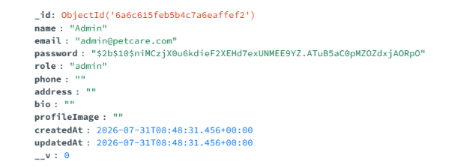
Pet
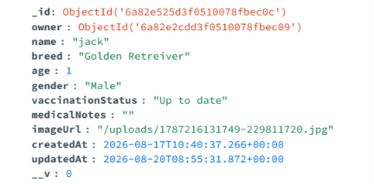
Caregiver
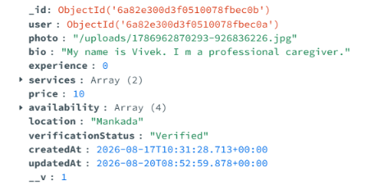

Notification
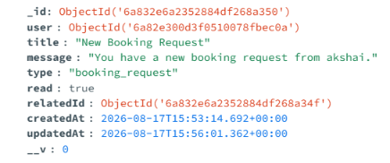
Review
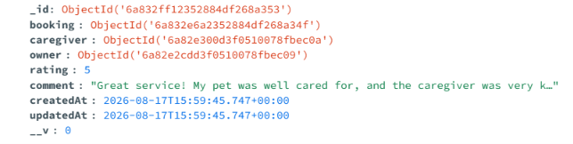

6.3 UML Designs

The unified Modelling Language (UML) is a standard language for specifying, visualizing, constructing, and documenting the artifacts of the software systems, as well as for business modelling and other non-software systems. The UML represents a collection of best engineering practices that have proven successful in the modelling of large and complex systems. The UML is a very important part of developing object-oriented software and software development process. The UML uses mostly graphical notations to express the design of software projects. Using the UML helps project teams communicate, explore potential designs, and validate the architectural design of the software.

6.4 User Story

As a pet owner, I want to register and create my profile, add and manage my pet details, search for verified pet caregivers based on location, services, and availability, and send booking requests for my pets so that I can find reliable caregivers and arrange pet care conveniently. I want to receive booking notifications, track the status of my requests, view my booking history, and submit ratings and reviews after service completion so that I can monitor my pet care activities and share my experience.
As a pet caregiver, I want to register and create my caregiver profile with my experience, services, pricing, location, and availability, and submit my profile for administrator verification so that pet owners can identify trusted caregivers. I want to accept or reject booking requests, manage my availability, update booking progress, mark services as completed, receive notifications, and view ratings and reviews so that I can manage my pet care services efficiently.
As a system administrator, I want to verify and approve caregiver registrations, manage pet owner and caregiver accounts, monitor pet and caregiver profiles, oversee booking requests, and handle complaints, ratings, and reviews so that the platform remains secure, reliable, and well-managed. I also want to remove inappropriate accounts, manage platform settings, monitor system activities, and generate booking and user activity reports for effective administration.
As the system automation engine, I want to automatically update booking statuses, send notifications for booking activities, maintain booking history, and synchronize pet, caregiver, user, and booking information so that all users receive accurate and up-to-date information throughout the pet care service process.

6.5 Use case diagram

A use case diagram is a visual representation that shows how different users (called actors) interact with a system to achieve specific goals. It's one of the primary diagrams used in Unified Modeling Language (UML) to capture functional requirements. Each use case represents a particular function or service the system provides, and the relationships between actors and use cases show who can perform which actions. This helps developers and stakeholders quickly understand what the system is supposed to do from a user's perspective, without needing to go deep into technical details.
In software development, use case diagrams are especially useful during the analysis and design phase. They help identify the main system functions, clarify user roles, and ensure that all requirements are captured before development begins. These diagrams serve as a communication bridge between clients, developers, and testers, reducing misunderstandings. By visually outlining the interactions, they make it easier to plan, document, and verify system behavior in real-world scenarios.

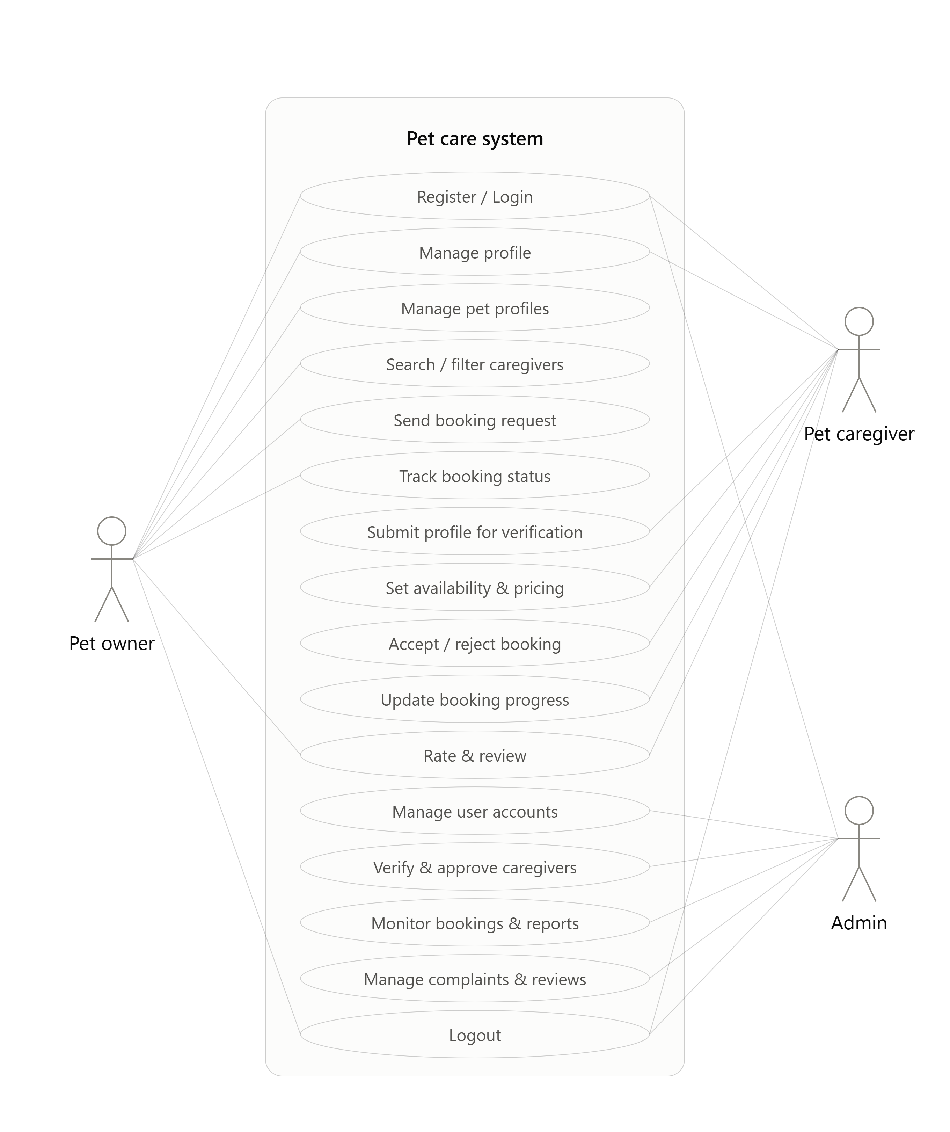
Use Case Diagram – Petcare Connect System

6.5 Scenario

A scenario is a detailed description of a particular situation or sequence of events that helps illustrate how a system or process works. In software engineering, scenarios are often used to show how users interact with a system to achieve specific goals. For example, a scenario might describe how a student logs into a college portal, applies for leave, and checks approval status. Scenarios make it easier to understand user needs, test different conditions, and visualize the flow of operations within a system. They serve as practical examples that bridge the gap between theoretical requirements and real-world usage.
PET OWNER
- Pet Owner can Register and Login.
- Pet Owner can View and Edit Profile Information.
- Pet Owner can Add, Edit, and Delete Pet Profiles.
- Pet Owner can Search and Browse Verified Caregivers.
- Pet Owner can Filter Caregivers by Location, Services, and Availability.
- Pet Owner can Send Booking Requests to Caregivers.
- Pet Owner can Track Booking Status and Service Progress.
- Pet Owner can Receive Booking Notifications.
- Pet Owner can View Booking History and Completed Services.
- Pet Owner can Submit Ratings and Reviews for Caregivers.
- Pet Owner can Logout.
PET CAREGIVER
- Pet Caregiver can Register and Login.
- Pet Caregiver can Create and Edit Caregiver Profile.
- Pet Caregiver can Submit Profile for Administrator Verification.
- Pet Caregiver can Manage Services and Pricing.
- Pet Caregiver can Set and Update Availability and Working Schedule.
- Pet Caregiver can View and Manage Booking Requests.
- Pet Caregiver can Accept or Reject Booking Requests.
- Pet Caregiver can Update Booking Status and Service Progress.
- Pet Caregiver can Mark Services as Completed.
- Pet Caregiver can Receive Booking Notifications.
- Pet Caregiver can View Ratings and Reviews.
- Pet Caregiver can Logout.
ADMIN
- Administrator can Securely Login.
- Administrator can View and Manage User Accounts.
- Administrator can Verify and Approve Caregiver Registrations.
- Administrator can View and Manage Pet and Caregiver Profiles.
- Administrator can Monitor and Manage All Booking Requests.
- Administrator can View Booking Status and Service Activities.
- Administrator can View Ratings and Reviews.
- Administrator can Handle User Complaints.
- Administrator can Remove Fake or Inappropriate Accounts.
- Administrator can Manage Platform Settings.
- Administrator can View Dashboard Statistics.
- Administrator can Generate User and Booking Reports.
- Administrator can Logout.

6.6 Data Flow Diagram

Level 0
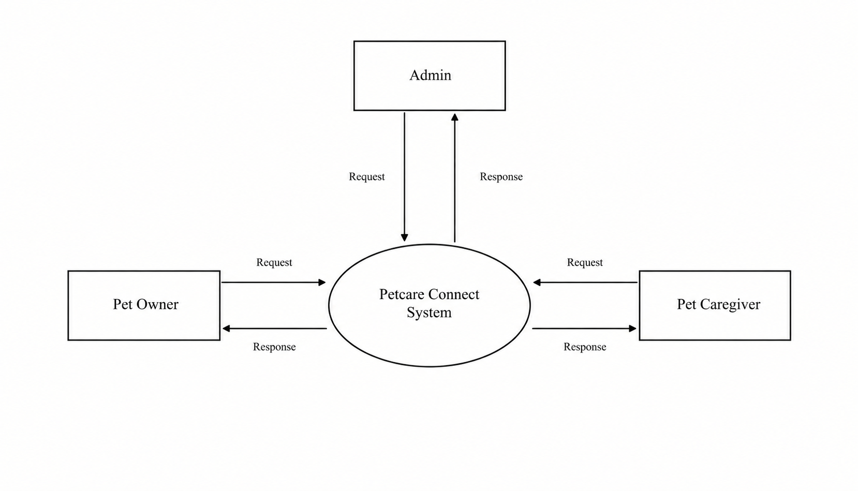
Level 1 (Admin, Pet owner, Pet caregiver)
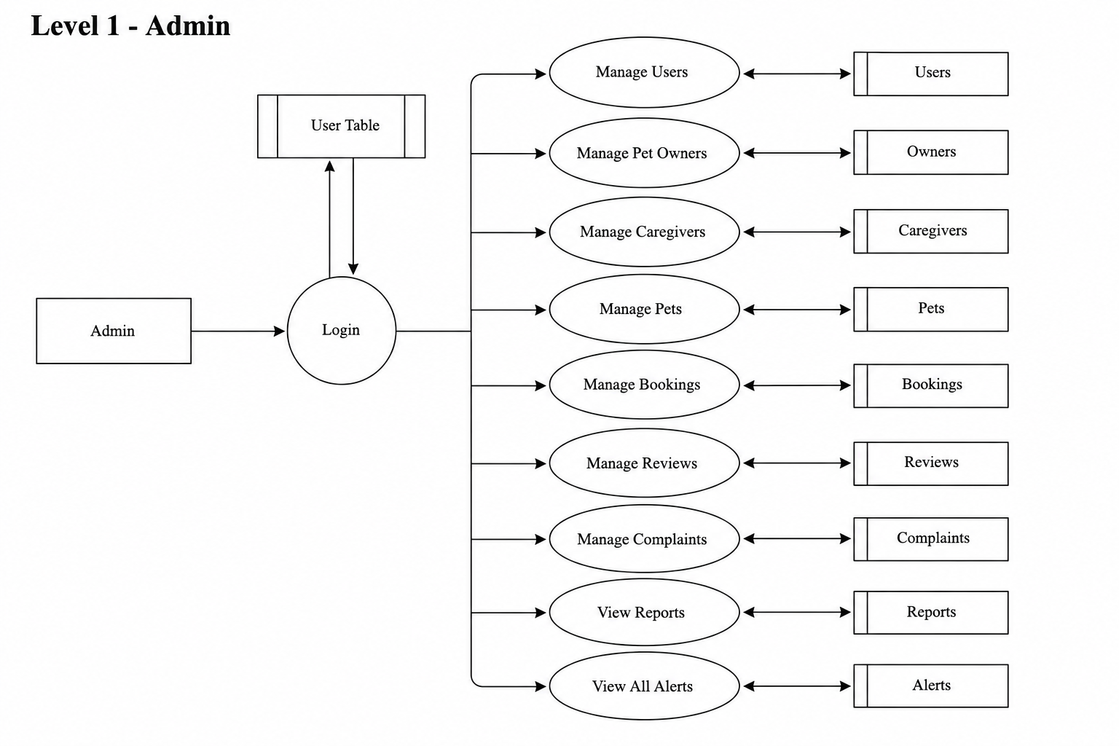
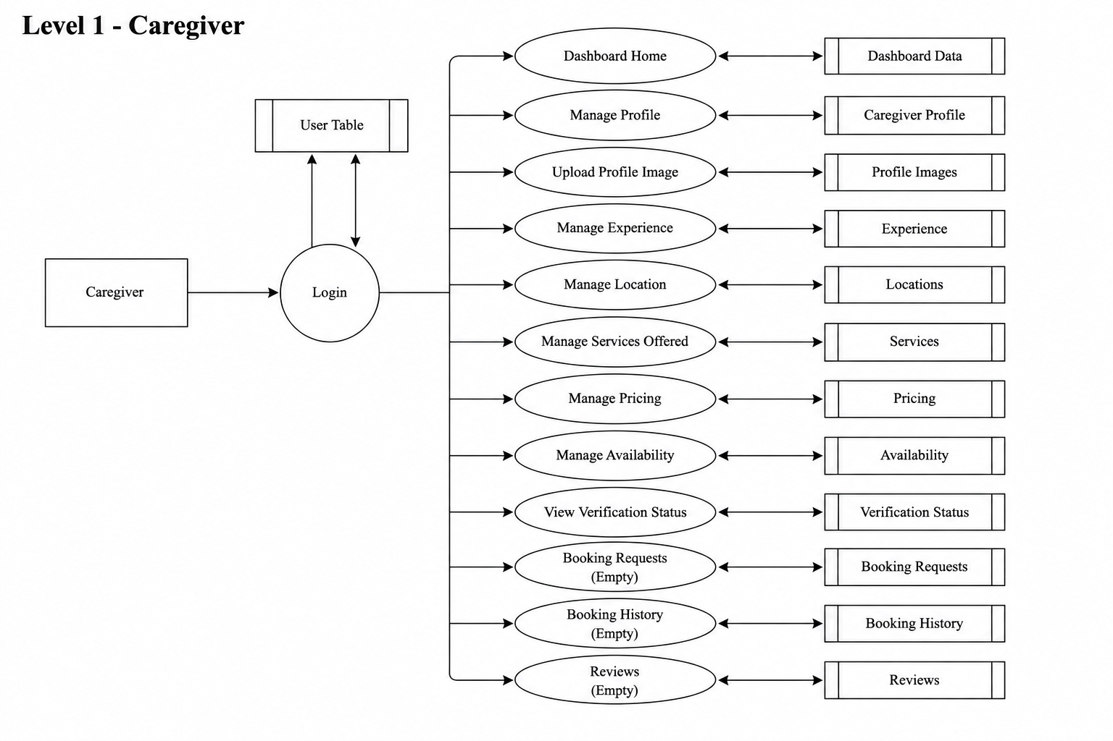
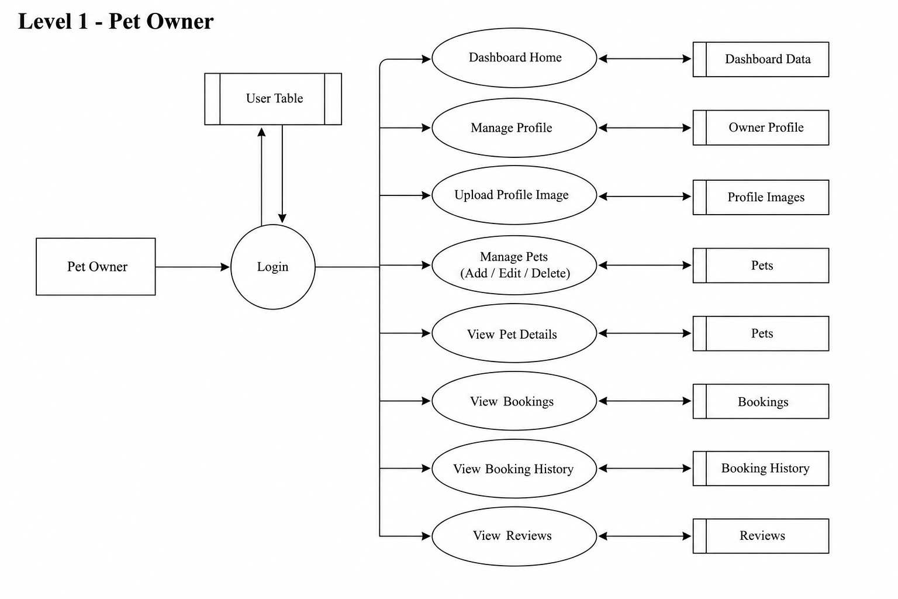

Level 2 (Admin)
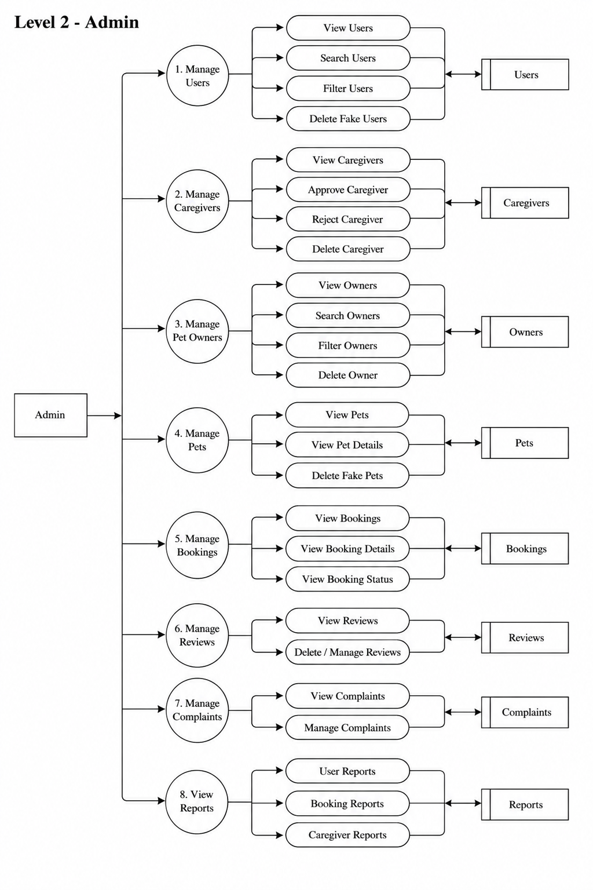
7. SYSTEM DEVELOPMENT
System development is a series of activities performed to design, implement, test, and deploy a software system to meet the specified requirements. The principal activities performed during the development phase can be divided into two major related sequences:
- External System Development
- Internal System Development
The major external system development activities include implementation planning, development environment setup, software installation, and deployment. The internal system development activities involve software architecture design, database modeling, API development, frontend and backend coding, authentication, authorization, testing, and security integration.
7.1 Coding
The purpose of coding is to convert the system design and requirements into executable software. It consists of a structured collection of programming statements used to implement system functions, manage data, process user requests, and establish communication between different components. Coding facilitates the development of reliable, maintainable, and efficient software by implementing the required modules and workflows.
JavaScript & Node.js
JavaScript is a high-level, dynamic, multi-paradigm programming language widely used for web application development. It is used in PetCare Connect for implementing interactive frontend features and server-side application logic.Node.js is an open-source, cross-platform JavaScript runtime environment built on Google Chrome's V8 JavaScript engine. It allows JavaScript code to run on the server side and supports fast, scalable, asynchronous, and event-driven applications. Node.js uses a non-blocking I/O model, making it suitable for handling multiple client requests efficiently.
In PetCare Connect, Node.js serves as the core server-side runtime for handling user authentication, pet management, caregiver management, booking operations, notifications, and other backend business logic.
React.js
React.js is an open-source JavaScript library used for building interactive and reusable user interfaces. It follows a component-based architecture, allowing large interfaces to be divided into smaller reusable components.
In PetCare Connect, React.js is used to develop the frontend interfaces for Pet Owners, Pet Caregivers, and Administrators. It provides components for dashboards, forms, pet profiles, caregiver profiles, booking management, notifications, and other user interactions.

Express.js Framework
Express.js is a fast, minimalist web application framework for Node.js. It provides features for developing RESTful APIs, handling HTTP requests, managing routes, and implementing middleware.Express.js simplifies communication between the frontend and backend by providing structured API endpoints and handling HTTP methods such as GET, POST, PUT, and DELETE. It also supports request validation, authentication middleware, error handling, and JSON data processing.
In PetCare Connect, Express.js acts as the primary backend framework connecting the React.js frontend with the MongoDB database and managing APIs for users, pets, caregivers, bookings, reviews, and complaints.
MongoDB Database
MongoDB is a NoSQL, document-oriented database used for storing and managing application data. Unlike relational databases that store information in tables and rows, MongoDB stores data in flexible JSON-like documents within collections.
MongoDB is used in PetCare Connect to store information related to users, pets, caregiver profiles, bookings, reviews, notifications, and complaints. Its flexible document structure makes it suitable for managing the different types of information required by the application. The database supports CRUD operations such as Create, Read, Update, and Delete, allowing users and administrators to efficiently manage system information.
Standard Libraries & Middleware Packages
The Node.js development ecosystem provides several packages through Node Package Manager (npm) to support authentication, security, file management, and application configuration.
- JWT(JSON Web Token):
JWT is used for secure token-based authentication and role-based access control. After successful login, a token is generated and used to authenticate requests and control access to features based on the user's role, such as Pet Owner, Pet Caregiver, or Administrator.
- Bcrypt:
Bcrypt is a password-hashing library used to securely hash user passwords before storing them in the database. It helps protect user credentials from unauthorized access.
- Multer:
Multer is middleware used for handling file uploads. In PetCare Connect, it can be used for uploading pet images, caregiver profile images, and other required images or documents.

- Dotenv:
Dotenv is used to load environment variables from a .env file. It helps keep sensitive information such as database connection strings, JWT secrets, and other configuration values separate from the application source code.
- CORS:
Cross-Origin Resource Sharing (CORS) enables controlled communication between the React.js frontend and the Express.js backend when they operate on different origins. It helps ensure that API requests are handled securely.

8. SYSTEM TESTING AND IMPLEMENTATION
Testing is an essential stage in the development of PetCare Connect. It ensures that all modules and components of the system function correctly and work together as expected. Testing helps identify errors, verify system functionality, and ensure that the application operates accurately and efficiently before it is deployed for actual use.
Software testing is an important part of software quality assurance. It involves the systematic evaluation of the system's requirements, design, coding, functionality, and user interaction. Testing is performed throughout the development process to verify that the implemented system produces the expected results under specified conditions.
Testing involves planned activities conducted systematically to ensure that PetCare Connect operates reliably, securely, and efficiently before live operation.
8.1 Types of Testing
The different types of testing performed for PetCare Connect include:
- Unit Testing
- Integration Testing
- System Testing
- Validation Testing
- User Acceptance Testing
Unit Testing:
Unit testing involves testing individual modules or components of the application separately to ensure that each component performs its intended function correctly. It is generally performed during the coding stage to identify errors at an early stage of development.
In PetCare Connect, individual modules such as user registration, login, pet management, caregiver profile management, booking management, and review submission are tested separately. The input and output of each function are checked against the expected results.
Unit testing helps identify and correct errors early, improving the reliability, maintainability, and overall quality of the application.
Integration Testing:
Integration testing involves combining individually tested modules and checking whether they work correctly together. It focuses on identifying errors in communication and data exchange between different components of the system.
In PetCare Connect, integration testing is performed between modules such as:
- Registration and authentication
- Pet Owner and pet management
- Pet Owner and caregiver search
- Caregiver and booking management
- Booking and notification systems
- Booking and ratings/reviews
- Frontend, backend, and MongoDB database
The purpose of integration testing is to ensure that data is transferred correctly between modules and that the complete workflow operates without errors.
System Testing:
System testing evaluates the complete PetCare Connect application as a single integrated system. It verifies whether all functional and non-functional requirements are satisfied.
The system is tested for important operations such as user registration, authentication, pet management, caregiver verification, caregiver search, booking requests, booking status updates, notifications, reviews, complaints, and administrator functions.
The output displayed by the system is compared with the expected results defined during the system design phase. The testing also verifies the usability, performance, security, and reliability of the application.
Validation Testing:
Validation testing ensures that the developed system meets the requirements and expectations defined during the analysis and design stages. It verifies whether the system performs the functions required by the Pet Owner, Pet Caregiver, and Administrator.
Validation testing includes checking:
- Correct user registration and login.
- Proper role-based access.
- Accurate pet profile management.
- Correct caregiver verification.
- Proper caregiver search and filtering.
- Successful booking request and status updates.
- Correct notification delivery.
- Proper ratings and review submission.
- Accurate administrator monitoring and reporting.

User Acceptance Testing:
User Acceptance Testing (UAT) is performed to determine whether the system is suitable for its intended users. The application is tested from the perspective of Pet Owners, Pet Caregivers, and Administrators.
User feedback is collected regarding the interface, navigation, input forms, dashboards, booking process, and overall usability. Necessary improvements are made based on the feedback to ensure that the system meets user expectations.
The major areas considered during user acceptance testing include:
- Output screen design.
- Input screen design.
- Navigation and menu structure.
- User-friendly interface.
- Booking and profile management.
- Dashboard functionality.
8.2 Implementation
Implementation is the stage where the designed PetCare Connect system is converted into a fully functional web application. It involves setting up the development environment, configuring the database, integrating the frontend and backend, testing the application, and preparing the system for actual use.
The implementation process includes:
- Careful planning of the system deployment.
- Setting up the React.js, Node.js, Express.js, and MongoDB environment.
- Configuring the database and required application settings.
- Integrating frontend interfaces with backend APIs.
- Implementing authentication and role-based access control.
- Testing all modules and fixing identified errors.
- Preparing user guidance and documentation.
- Deploying the completed application for intended users.
Implementation is the final and crucial phase of the project. The system is considered ready for operation after all major modules have been tested successfully and the application satisfies the functional and technical requirements defined during the system analysis and design stages.

9. SYSTEM MAINTENANCE
Maintenance is the process of making necessary changes and improvements to a software system after its implementation. These changes may include fixing errors, adapting the system to changes in the software environment, improving performance, enhancing security, and adding new features. When changes are implemented during the maintenance phase, the affected parts of the system must be systematically reviewed and tested to maintain system stability and data integrity.
There are three types of maintenance:
- Corrective Maintenance – Fixing bugs, errors, and system failures.
- Adaptive Maintenance – Updating the system to support changes in software, hardware, or operating environments.
- Perfective Maintenance – Improving existing features and adding enhancements based on user requirements.
Maintenance is an important part of the software development lifecycle because it is not possible to identify every possible issue during initial development and testing. Continuous maintenance is required to keep the PetCare Connect platform secure, reliable, efficient, and compatible with changing technologies and user requirements. Maintenance may include improving the booking process, enhancing security, optimizing database operations, and introducing new pet-care features.
9.1 Key Maintenance Activities & Importance
Software maintenance is particularly important for a multi-user web-based platform such as PetCare Connect. Continuous monitoring and improvements help maintain system reliability, security, and usability. The key maintenance activities include:
1. Problem Identification & Analysis:
Monitoring server errors, API responses, database issues, and user feedback to identify and analyze problems related to login, profiles, bookings, notifications, or other system functions.
2. Design & Code Modification:
Modifying React.js components, Express.js APIs, Node.js backend services, or MongoDB models to fix issues and introduce improvements without affecting existing system functionality.
3. Regression Testing & Verification:
Re-testing important application functions such as authentication, role-based access, pet management, caregiver verification, booking requests, booking status updates, and reviews to ensure that new changes do not create unexpected problems.

4. Deployment & Configuration Management:
Deploying updated application versions, managing environment variables and configuration settings, maintaining database configurations, and using GitHub for version control and tracking system changes.

