1. Write a program that computes the perimeter and the area of a rectangle. Define

your own values for the length and width. (Assuming that L and W are the length

and width of the rectangle, Perimeter = 2*(L+W) and Area = L*W. Display the

output on the screen using dbms_output.put_line.

GRGF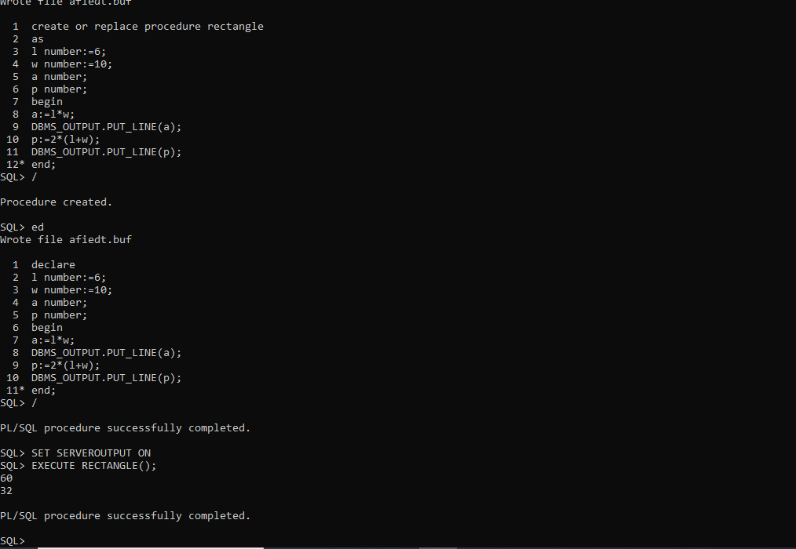

2. Write a program that declares an integer variable called num, assigns a value to it,

and computes and inserts into the tempp table the value of the variable itself, its

square, and its cube.

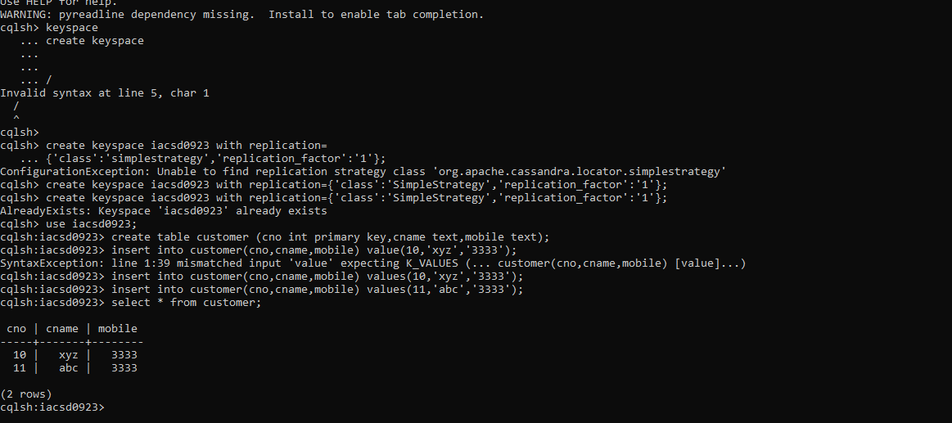

3. Convert a temperature in Fahrenheit (F) to its equivalent in Celsius (C) and vice

versa. The required formulae are:-

C= (F-32)*5/9

F= 9/5*C + 32

Display the output on the screen using dbms_output.put_line. Data has to be

input by the user.

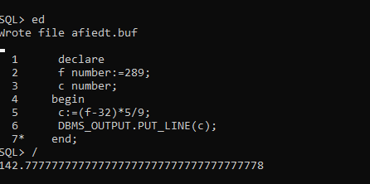

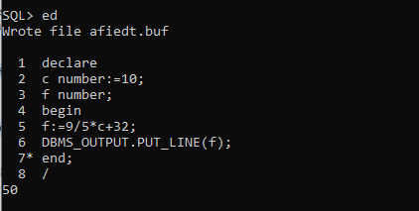

5. Write a program that enables a user to input an integer. The program should then

state whether the integer is evenly divisible by 5. (Use decode instead of IF

statement where required). Display the output on the screen using

dbms_output.put_line. Data has to be input by the user.

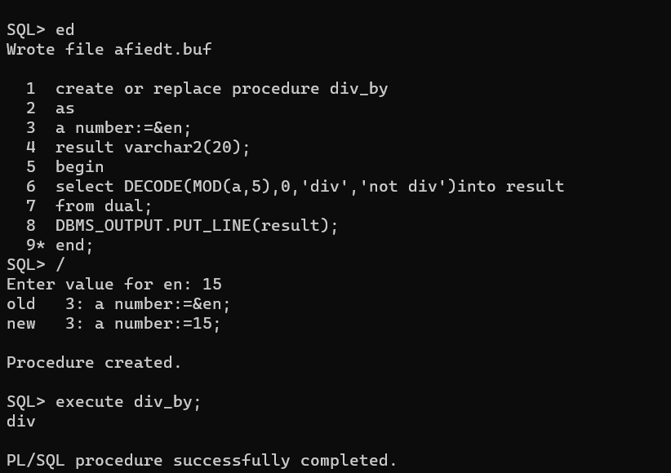

6. Your block should read in two real numbers and tell whether the product of the

two numbers is equal to or greater than 100. Display the output on the screen

using dbms_output.put_line. (Use decode instead of IF statement where

required). Data has to be input by the user.

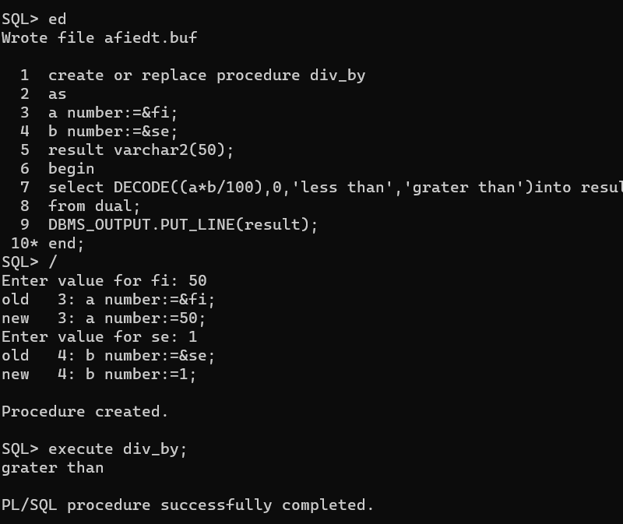

6. Convert a number of inches into yards, feet, and inches. For example, 124 inches

equals 3 yards, 1 foot, and 4 inches. Display the output on the screen using

dbms_output.put_line. Data has to be input by the user.

