1. Write trigger on employee table for insert, update and delete, make

appropriate entries in following table.

Create table emp_check(

Empid number;

Ename varchar2(20),

Oldsal number(9,2),

Newsal number(9,2),

Uname varchar2(20),

Chk_date date

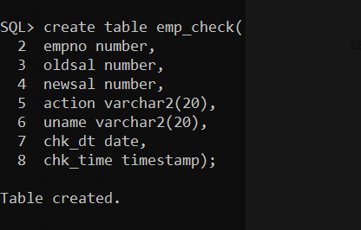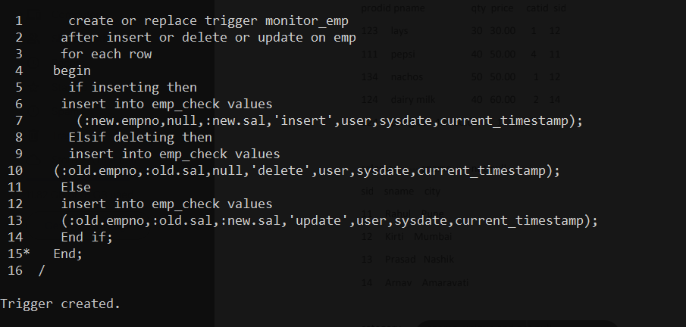

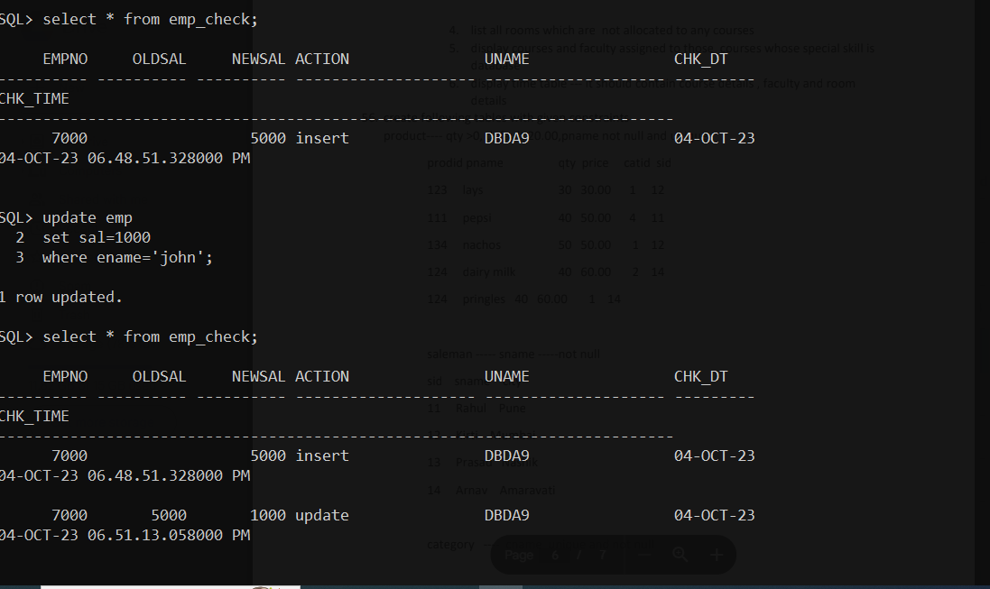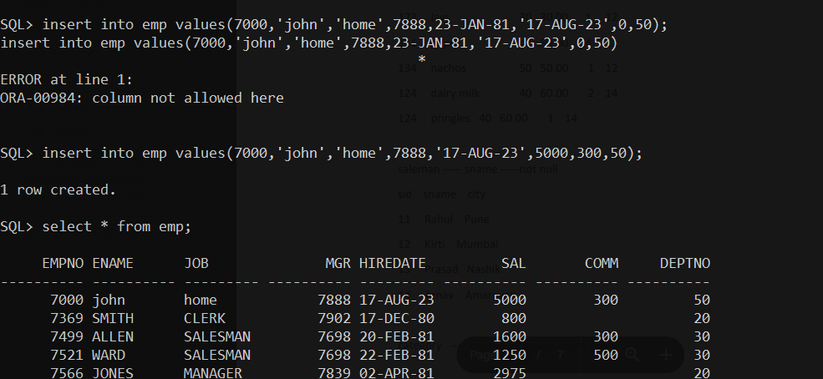

1. Print the following patterns using loop :

a.*

* *

* * *

* * * *

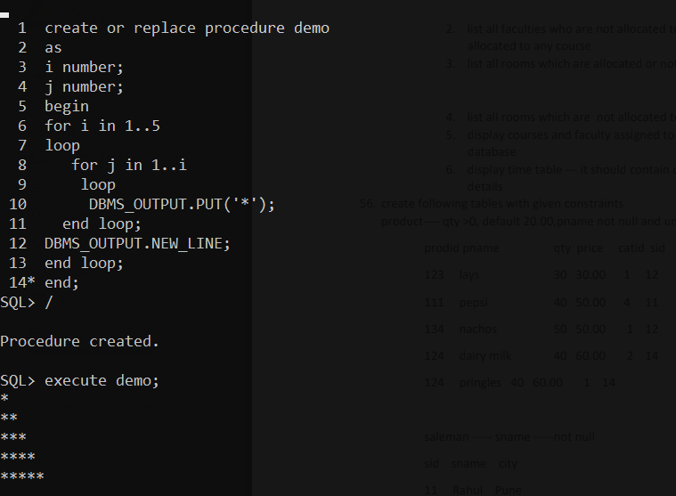

b.

*

***

*****

***

*

c.

1010101

10101

101

1

d.

1

1 2

1 2 3

1 2 3 4

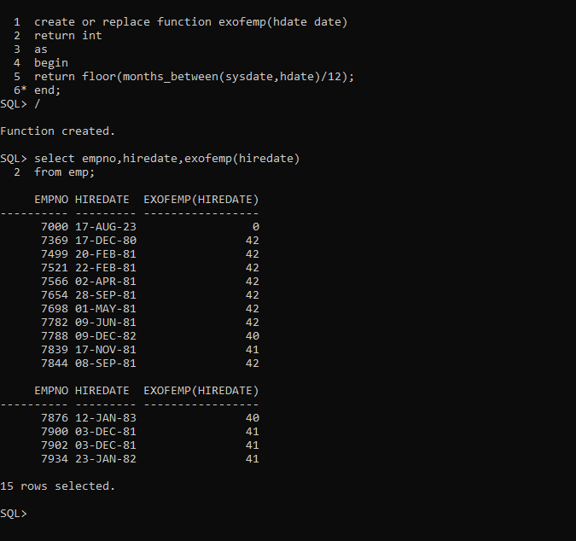

b. Ti calculate net sal by using formula.

Netsal=sal+da+hra-pf+comm

Da-→ 10% sal hra→ 15% sal pf --→ 8 % of sal

1. Write a procedure for the following.

a. To accept employee number , delete the record of the given

employee.

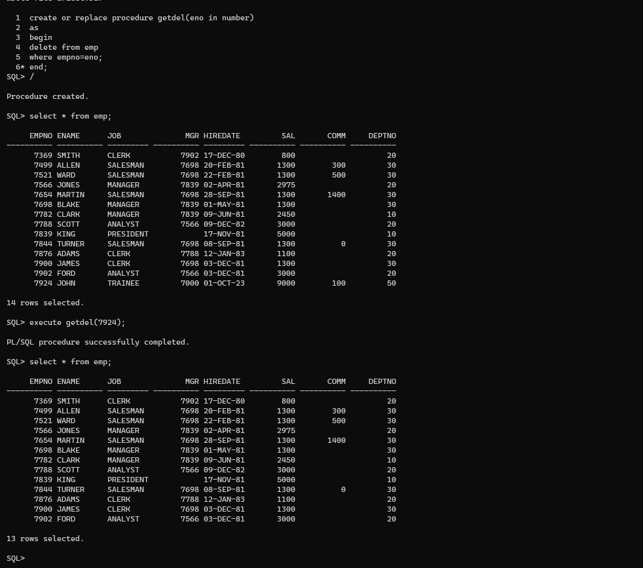

b. To accept grade,losal and hisal and insert a record into

salgrad table

