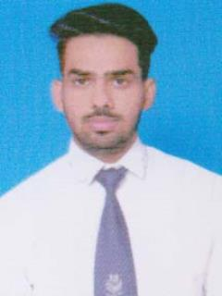 **VIVEK KUMAR**

Nai Basti ● Mursan, 204213.

● vivek.kumar_bca19@gla.ac.in ● +91 8954600038

# EDUCATION

**Bachelor of Computer Applications, GLA University, Mathura**May 2022

**Intermediate, RBS Sr. Sec. School Mursan, Hathras** May 2018

**High School, RBS Sr. Sec. School Mursan, Hathras** May 2016

# INTERNSHIP EXPERIENCE

* Certification in Java from udemy
* Certification in HTLM, CSS, PHP from Coursera
* Certification in Python, SQL Bootcamp, c and c++ from Udemy

# PROJECTS

* **KG-KIDS MANAGEMENT SYSTEM**
* **This is a Web Application through which Preschoolers can get the educational content through the animated videos.**

# SKILLS

**Technical**

* I have good commands in C, C++ and Python
* I am learning java right now

**Professional**

* Good listener
* Self Motivated
* Ability to identify and solve problems

# Extra/Co-Curricular Activities

* Participated in Hacking Workshop
* Attended workshop on Machine Learning
* Attended seminar on Digital Marketing

**Declaration** I hereby declare that all the above mentioned information is true and correct to the best of my knowledge.