CHANGE USERNAME ON LINUX

Create a temporary admin user if you don’t have one:
> sudo adduser tempadmin
> sudo usermod -aG sudo tempadmin
Log out of your current account and log in as tempadmin.
- Now run the username change commands:
> sudo usermod -l newname oldname
> sudo usermod -d /home/newname -m newname
> sudo groupmod -n newname oldname
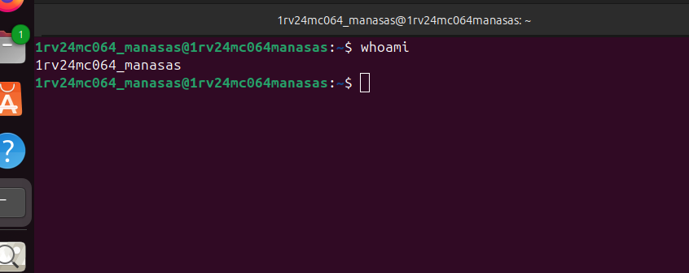
INSTALL DOCKER USING APT REPO

# Add Docker's official GPG key:
sudo apt-get update
sudo apt-get install ca-certificates curl
sudo install -m 0755 -d /etc/apt/keyrings
sudo curl -fsSL https://download.docker.com/linux/ubuntu/gpg -o /etc/apt/keyrings/docker.asc
sudo chmod a+r /etc/apt/keyrings/docker.asc

# Add the repository to Apt sources:
echo \
"deb [arch=$(dpkg --print-architecture) signed-by=/etc/apt/keyrings/docker.asc] https://download.docker.com/linux/ubuntu \
$(. /etc/os-release && echo "${UBUNTU_CODENAME:-$VERSION_CODENAME}") stable" | \
sudo tee /etc/apt/sources.list.d/docker.list > /dev/null
sudo apt-get update

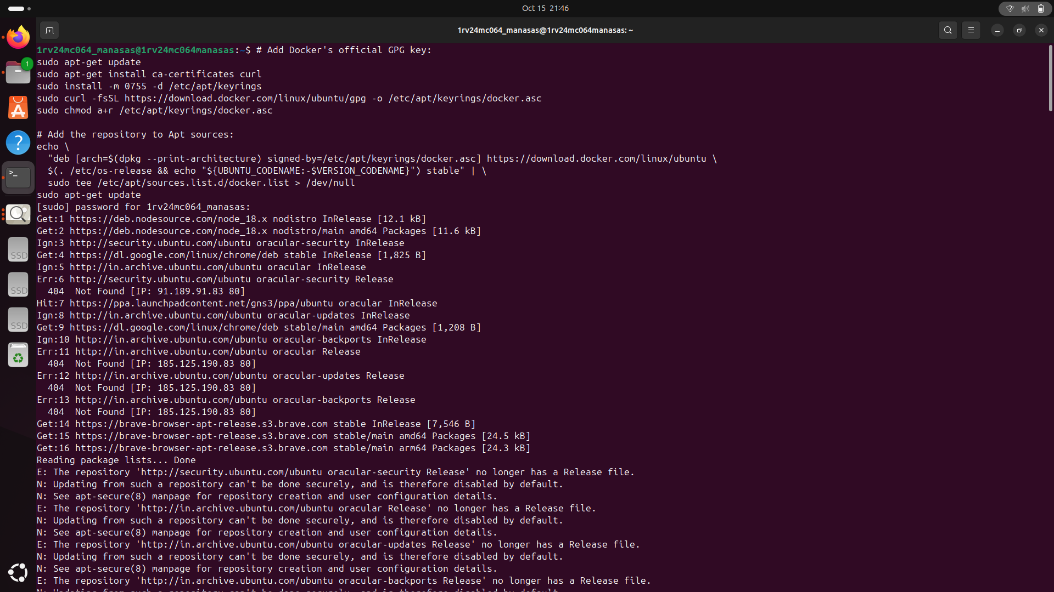
TO CHECK STATUS
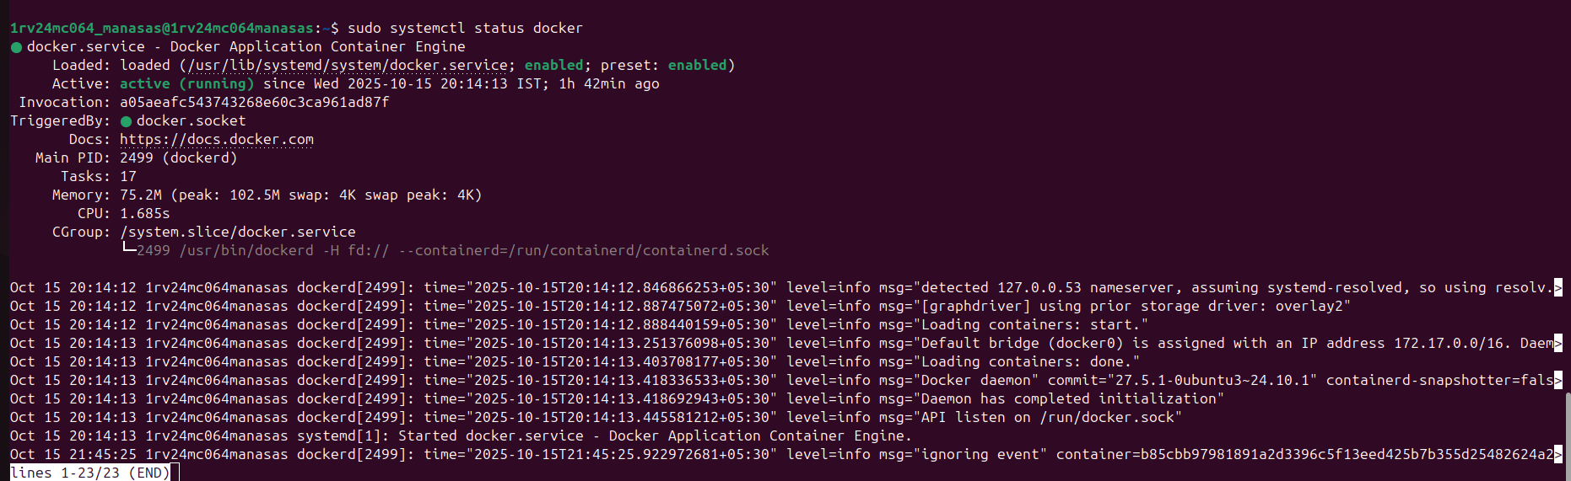
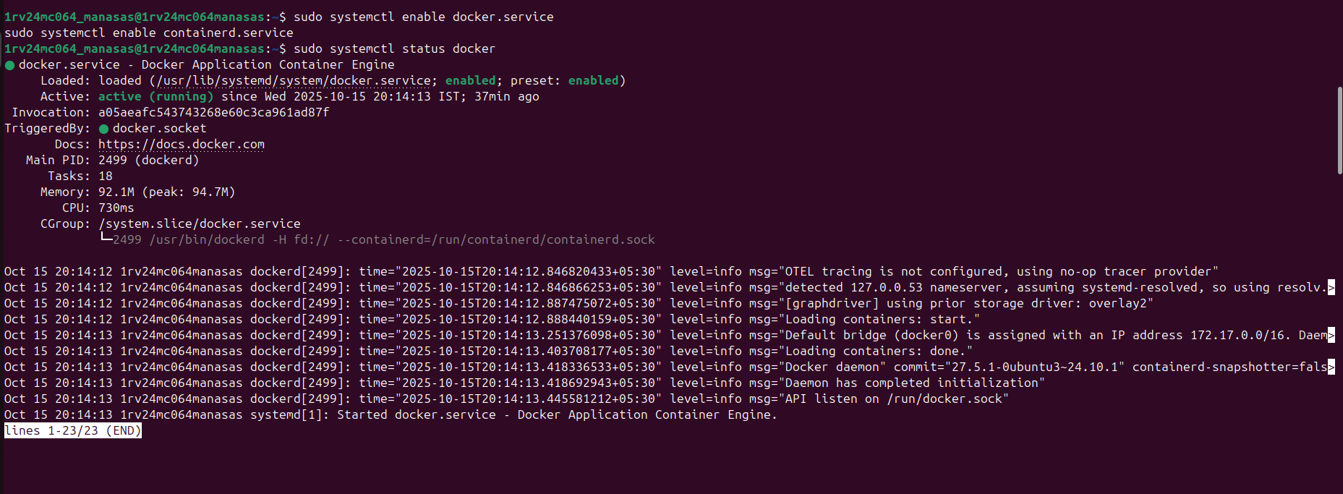
ENABLE DOCKER
RUN SAMPLE CONTAINER
