**VERISK ISO PROJECT**

Objective: Identify the Fraudulent name, Location, Category

**User input:**

The script allows 3 different types of input option.

**Case 1:** When the user wants to run a specific article from the excel sheet.

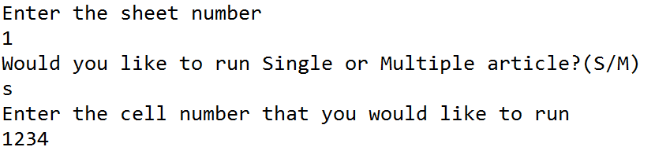

Sheet number: 1 represents the First sheet in the excel spreadsheet.

Cell number denotes the cell number from the excel sheet which needs to be analysed.

Hint: Usually the first cell from the excel sheet is used for indicating the title of the specific column.

**Case 2:** When the user wants to run all the articles from a sheet in excel.

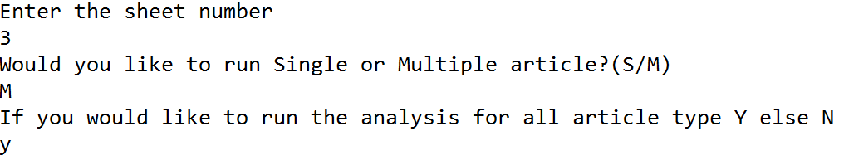

**Case 3:** When the user wants to run a specific group of articles from a sheet in excel.

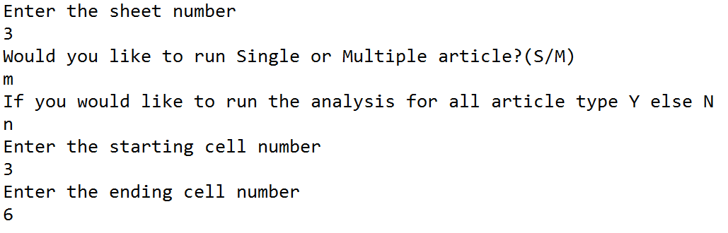

Output:

The script generates 3 types of output for the user.

Output in IDE: Case number is displayed at the top of the screen then it displays the government title with the official name, followed by the fraudulent name. The State , the City and the Category is mentioned at the bottom

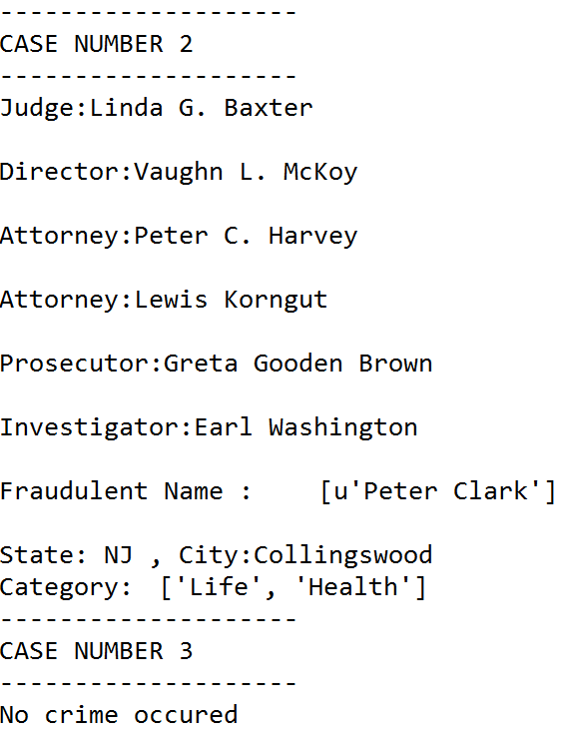

Output In Excel sheet: Excel is made according to the specifications mentioned in the requirement.

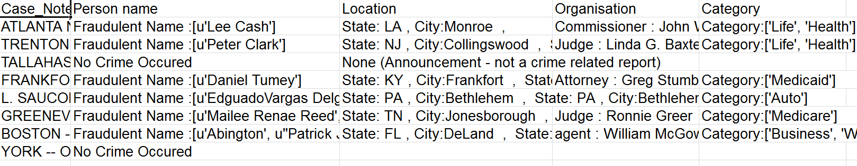

Output in text: Text output provides a high level summary of the fraudulent name, state, city and the type of scheme.

