Task 3: Backup Configuration for Web Servers

Step 1: Create Backup Directory
First, ensure the /backups/ directory exists:
sudo mkdir -p /backups
sudo chmod 700 /backups

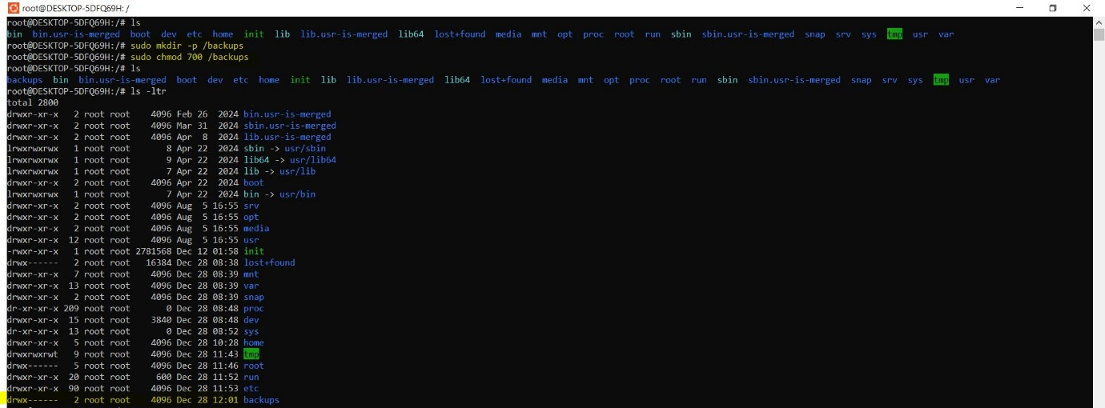

Step 2: Backup Scripts

2.1 Apache Backup Script (Sarah)
Create a script /usr/local/bin/backup_apache.sh:
sudo nano /usr/local/bin/backup_apache.sh

Insert the following:
#!/bin/bash

# Variables
DATE=$(date +%F)
BACKUP_DIR="/backups"
SERVER_NAME="apache"
SRC_CONF="/etc/httpd/"
SRC_HTML="/var/www/html/"
BACKUP_FILE="${BACKUP_DIR}/${SERVER_NAME}_backup_${DATE}.tar.gz"
LOG_FILE="${BACKUP_DIR}/${SERVER_NAME}_backup_${DATE}.log"

# Create backup
tar -czf "$BACKUP_FILE" "$SRC_CONF" "$SRC_HTML"

# Verify backup integrity
echo "Verifying backup: $BACKUP_FILE" > "$LOG_FILE"
tar -tzf "$BACKUP_FILE" >> "$LOG_FILE" 2>&1

# Confirmation
echo "Backup completed for Apache. Backup file: $BACKUP_FILE"
echo "Verification log: $LOG_FILE"

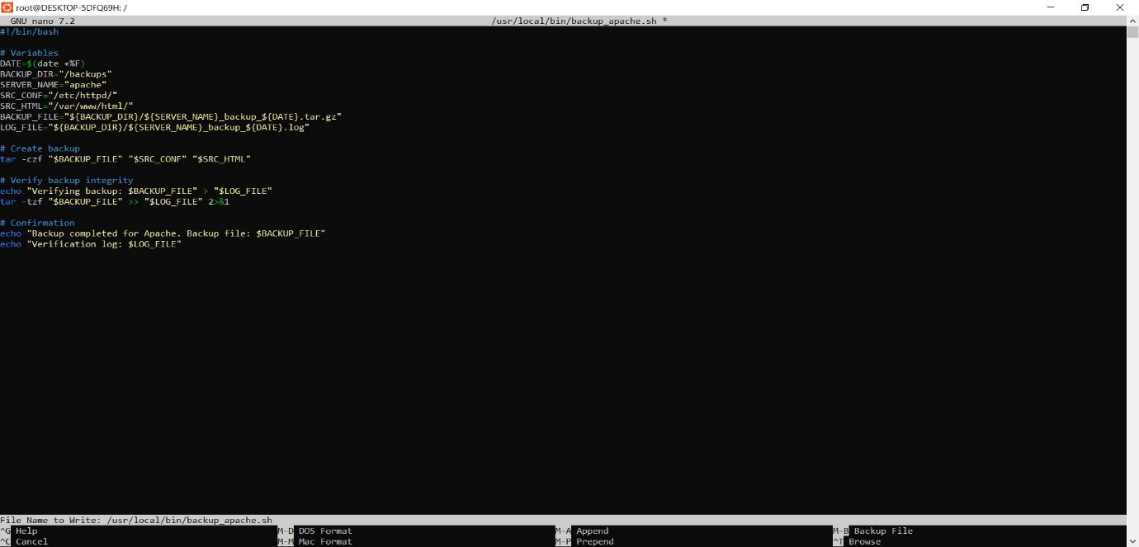

Make the script executable:
sudo chmod +x /usr/local/bin/backup_apache.sh

2.2 Nginx Backup Script (Mike)
Create a script /usr/local/bin/backup_nginx.sh:
sudo nano /usr/local/bin/backup_nginx.sh

Insert the following:
#!/bin/bash

# Variables
DATE=$(date +%F)
BACKUP_DIR="/backups"
SERVER_NAME="nginx"
SRC_CONF="/etc/nginx/"
SRC_HTML="/usr/share/nginx/html/"
BACKUP_FILE="${BACKUP_DIR}/${SERVER_NAME}_backup_${DATE}.tar.gz"
LOG_FILE="${BACKUP_DIR}/${SERVER_NAME}_backup_${DATE}.log"

# Create backup
tar -czf "$BACKUP_FILE" "$SRC_CONF" "$SRC_HTML"

# Verify backup integrity
echo "Verifying backup: $BACKUP_FILE" > "$LOG_FILE"
tar -tzf "$BACKUP_FILE" >> "$LOG_FILE" 2>&1
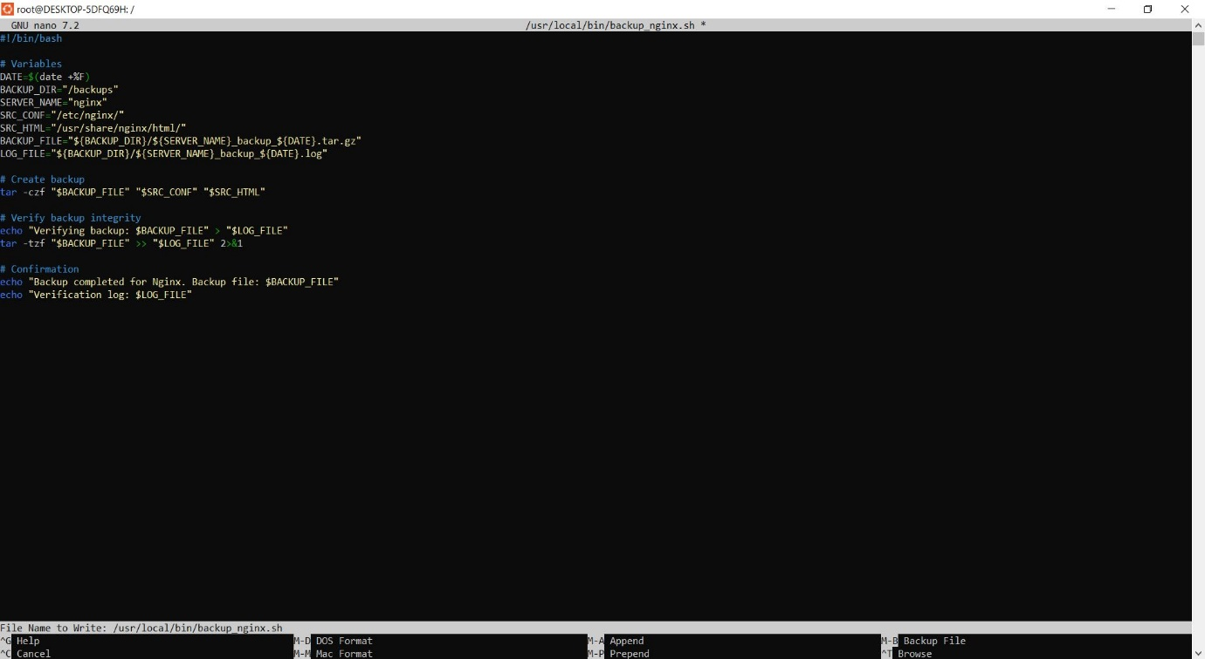
# Confirmation
echo "Backup completed for Nginx. Backup file: $BACKUP_FILE"
echo "Verification log: $LOG_FILE"

Make the script executable:
sudo chmod +x /usr/local/bin/backup_nginx.sh

Step 3: Schedule Cron Jobs

3.1 Apache Cron Job
Edit the root crontab (or Sarah’s user crontab if allowed):
sudo crontab –e

Add this line to run every Tuesday at 12:00 AM:
0 0 * * 2 /usr/local/bin/backup_apache.sh

3.2 Nginx Cron Job
Edit the root crontab (or Mike’s user crontab if allowed):
sudo crontab -e
Add this line:
0 0 * * 2 /usr/local/bin/backup_nginx.sh
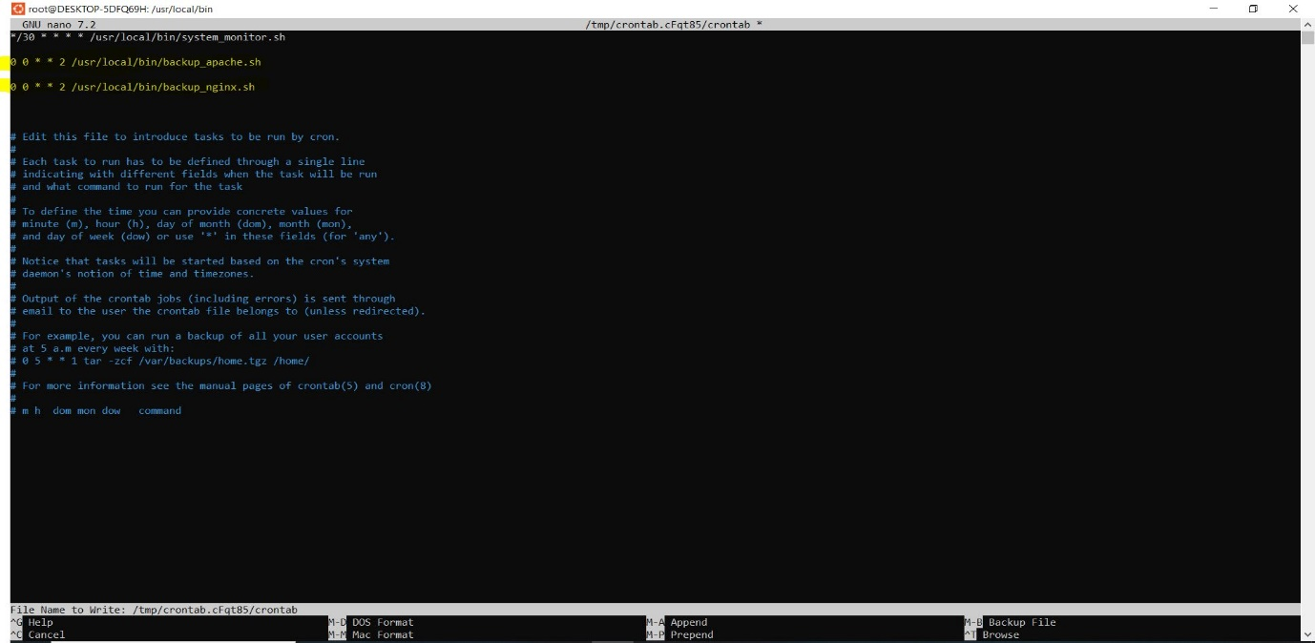

Demo Cron Script for 5 minutes of interval
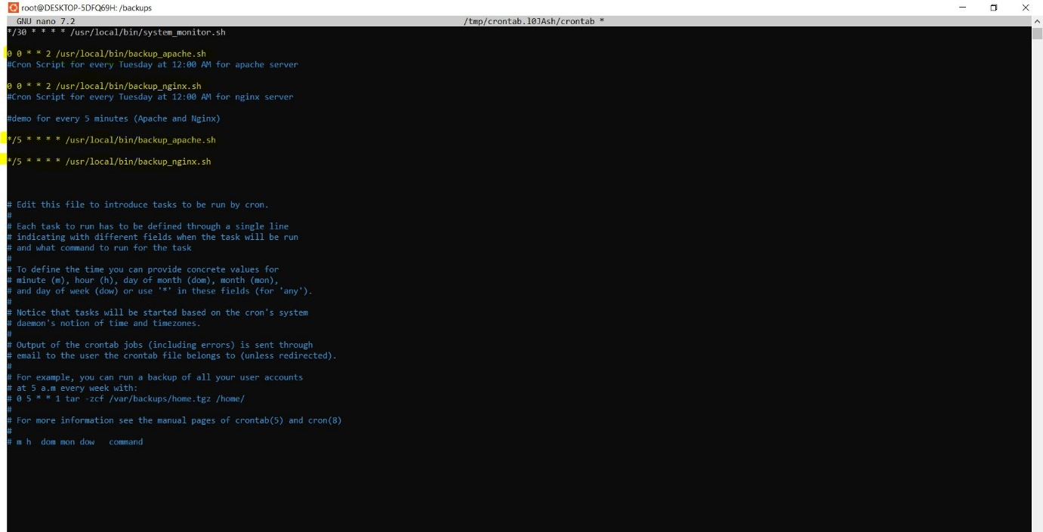

Step 4: Package Update and Upgradation
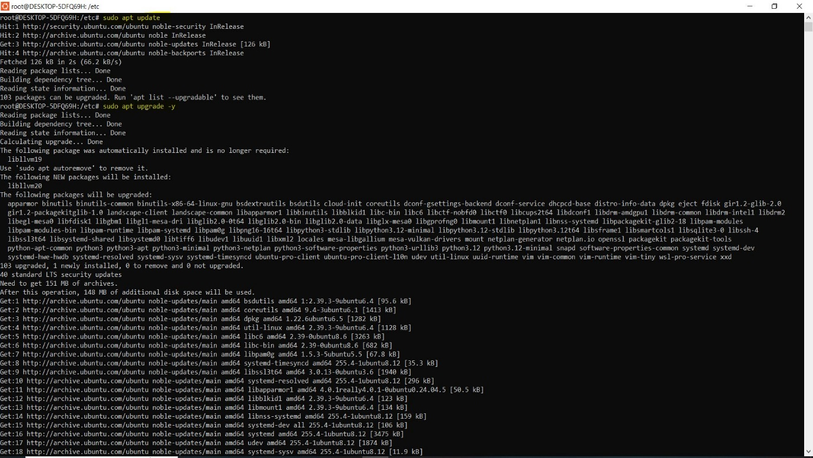

Step 5: Apache2 and Nginx (Installation, Status and Port Details)

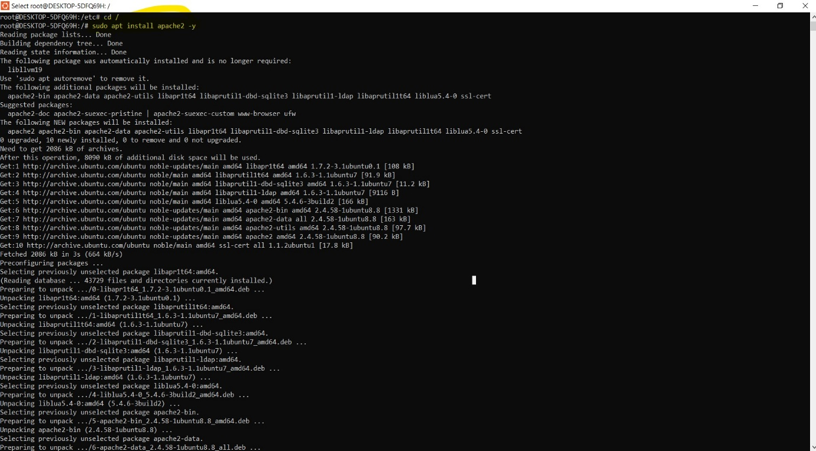
Apache2 Installation:

Nginx Installation:
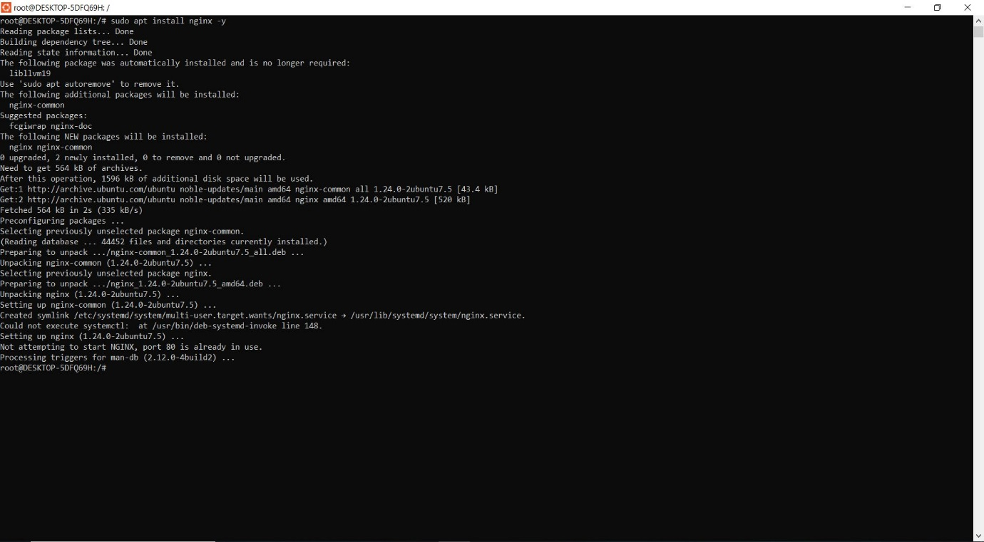

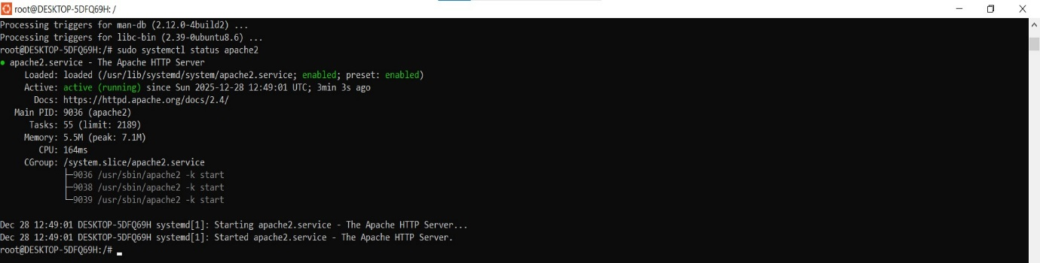
Apache2 and Nginx Status:

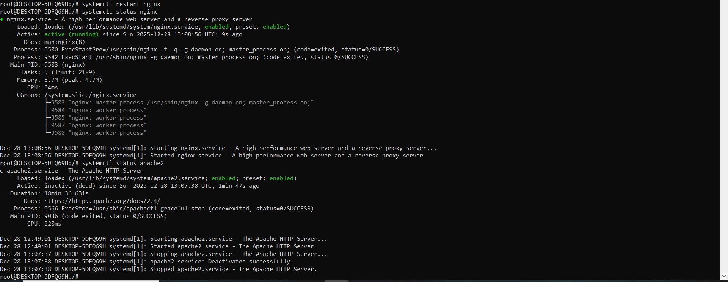

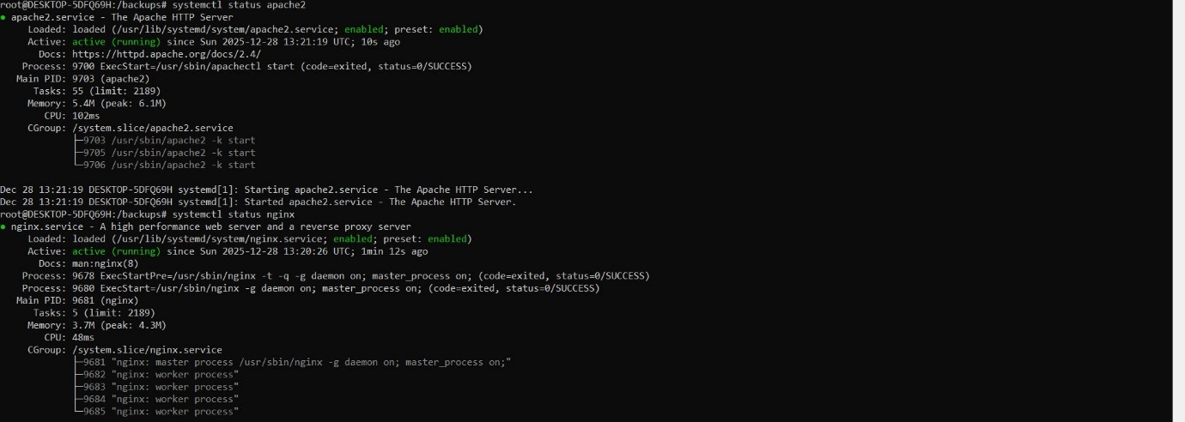

:

Apache2 and Nginx Port Details:

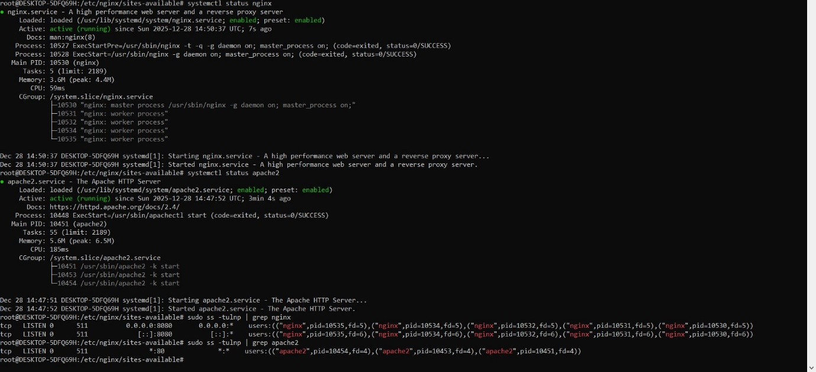

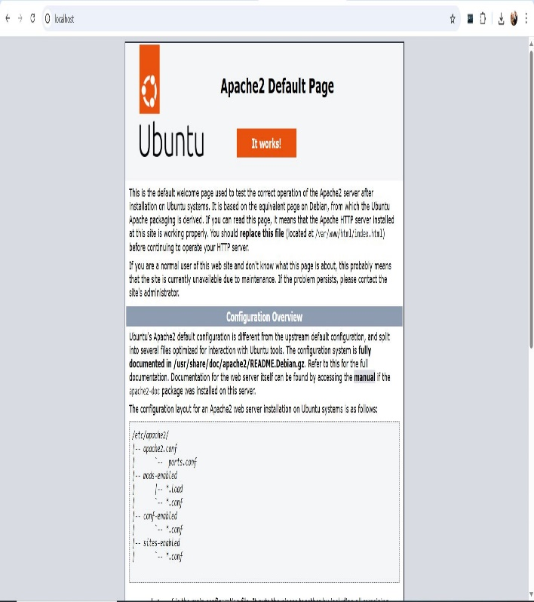
Apache2 and Nginx Successfully Running Browser Check
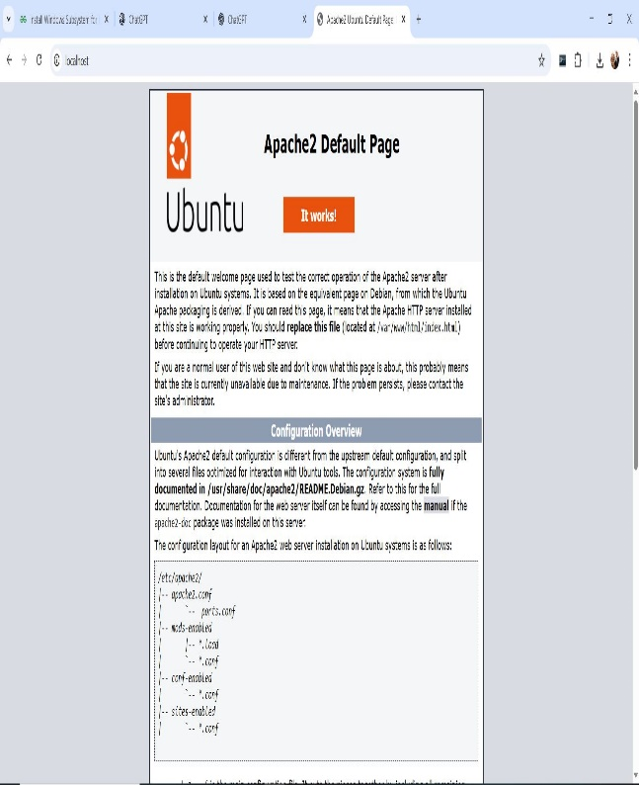

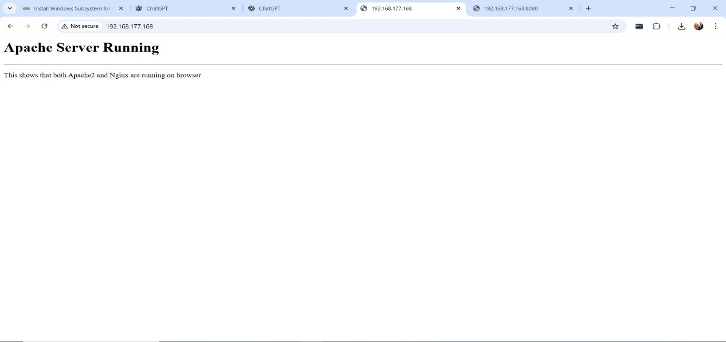
Apache2 and Nginx Respective Html Browser Page

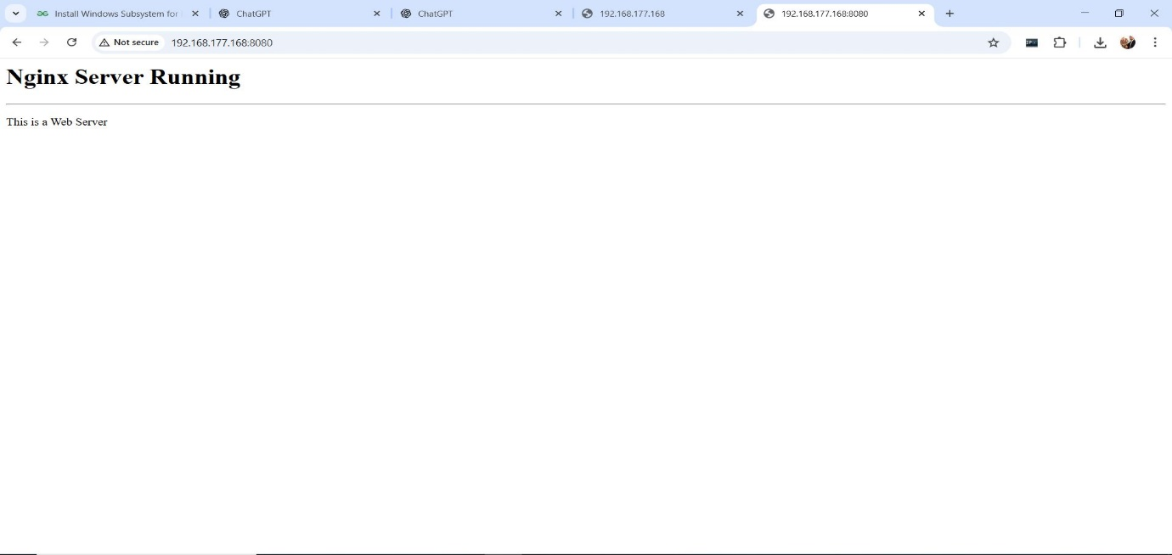

Step 6: Verify Backups
After the cron job runs (or manually run the scripts), you should see:
ls -lh /backups/
Check the verification log:
cat /backups/apache_backup_2025-12-28.log
Similarly for Nginx:
cat /backups/nginx_backup_2025-12-28.log

