Task 2: User Management and Access Control

1. Create User Accounts (Sarah and Mike)
sudo useradd -m -s /bin/bash sarah
sudo useradd -m -s /bin/bash mike
- -m → creates the home directory (/home/sarah, /home/mike)
- -s /bin/bash → sets Bash as the default shell

2. Set Secure Passwords
sudo passwd sarah
sudo passwd mike
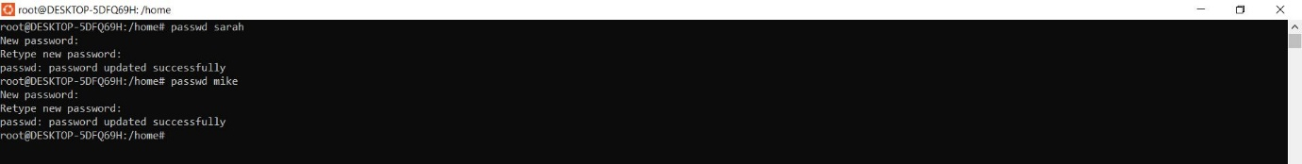
You will be prompted to enter secure passwords for each user.

3. Create Dedicated Workspace Directories
sudo mkdir -p /home/sarah/workspace
sudo mkdir -p /home/mike/workspace
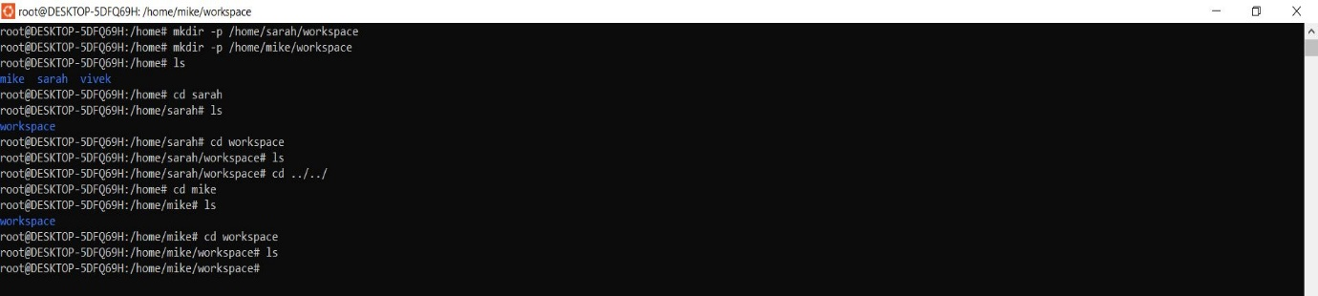

4. Assign Ownership to Each User
sudo chown -R sarah:sarah /home/sarah/workspace
sudo chown -R mike:mike /home/mike/workspace

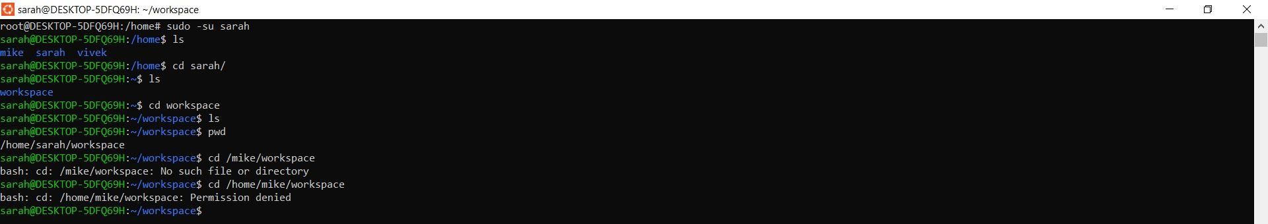

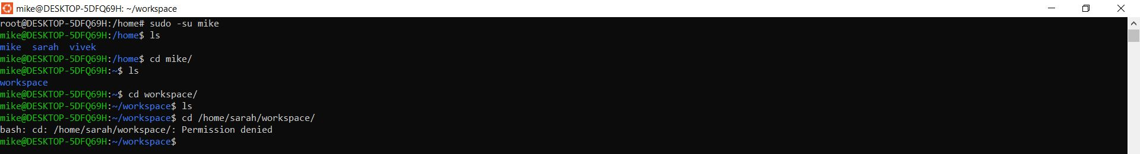

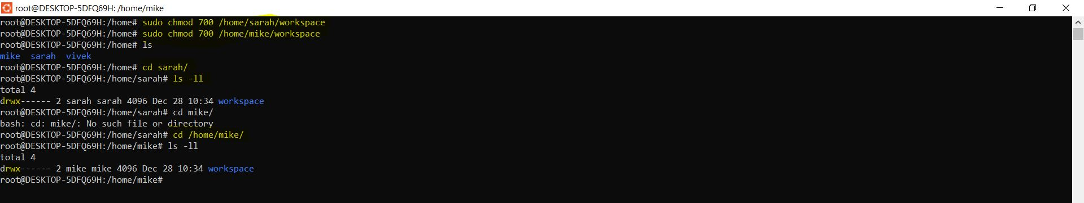

5. Restrict Directory Permissions (User-Only Access)
sudo chmod 700 /home/sarah/workspace
sudo chmod 700 /home/mike/workspace
- 700 →
  - Owner: read, write, execute
  - Group & others: no access
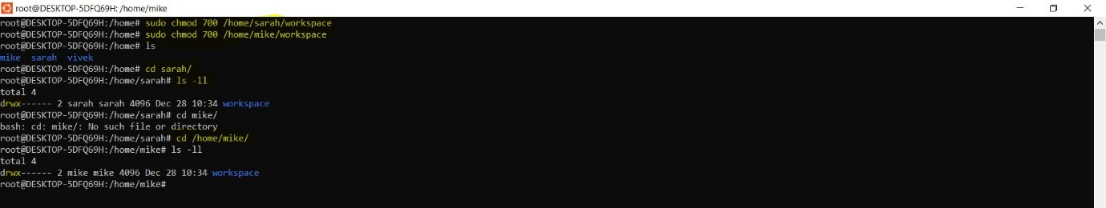
This ensures only the respective user can access their workspace.

6. Enforce Password Expiration (30 Days)
sudo chage -M 30 sarah
sudo chage -M 30 mike
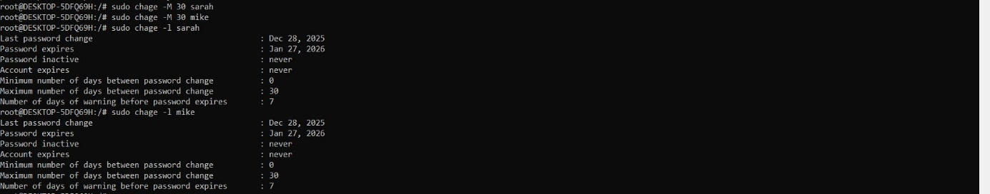

Optional (recommended) minimum days between password changes:

sudo chage -m 1 sarah
sudo chage -m 1 mike

7. Enforce Password Complexity (System-Wide)
Edit the password quality configuration file:
sudo nano /etc/security/pwquality.conf

Add or modify the following lines:
minlen = 12
dcredit = -1
ucredit = -1
lcredit = -1
ocredit = -1
This enforces:
- Minimum length: 12 characters
- At least:
  - 1 digit
  - 1 uppercase letter
  - 1 lowercase letter
  - 1 special character
Save and exit.

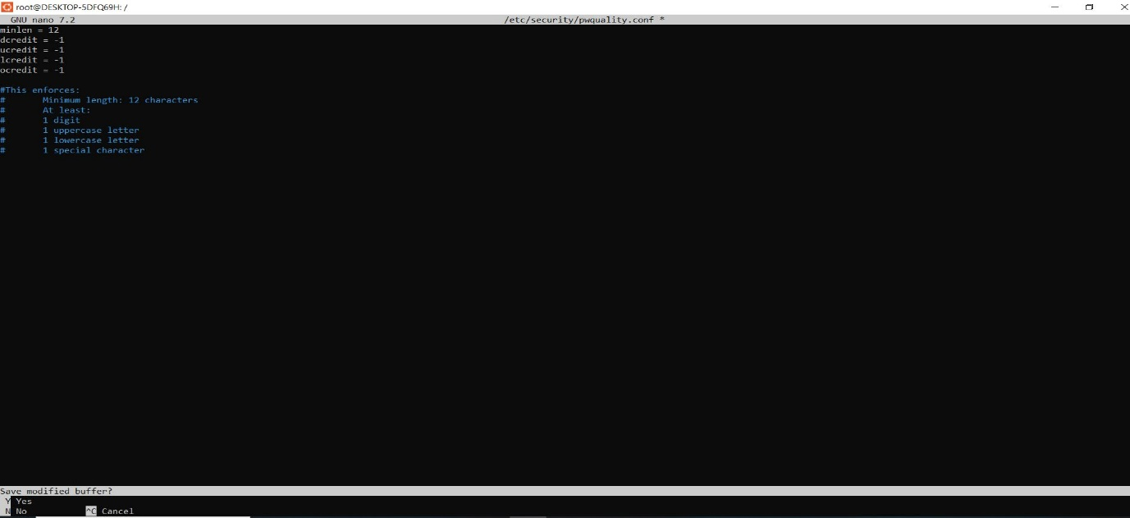

8. Verify Password Aging Policy (Optional)
sudo chage -l sarah
sudo chage -l mike
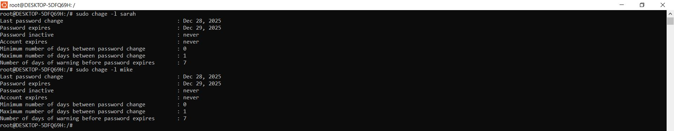

✅ Summary of What This Achieves
- ✔ Created secure user accounts for Sarah and Mike
- ✔ Isolated workspaces for confidentiality
- ✔ Strict directory permissions (user-only access)
- ✔ Password expiration every 30 days
- ✔ Enforced password complexity rules

