Task 1: System Monitoring Setup

Objective
Configure a system monitoring setup to ensure the development environment’s health, performance, and capacity planning by monitoring CPU, memory, processes, and disk usage with proper logging and documentation.

Scenario
- The development server reports intermittent performance issues.
- New developers require visibility into system resource usage.
- System metrics must be consistently tracked for capacity planning and troubleshooting.

Tools Used
- htop – Interactive process viewer
- nmon (optional) – Performance monitoring tool
- df – Disk space usage
- du – Directory-wise disk usage
- cron – Scheduling automated logging
- Linux shell scripting

1. Install and Configure Monitoring Tools

1.1 Install htop
sudo apt update
sudo apt install htop –y

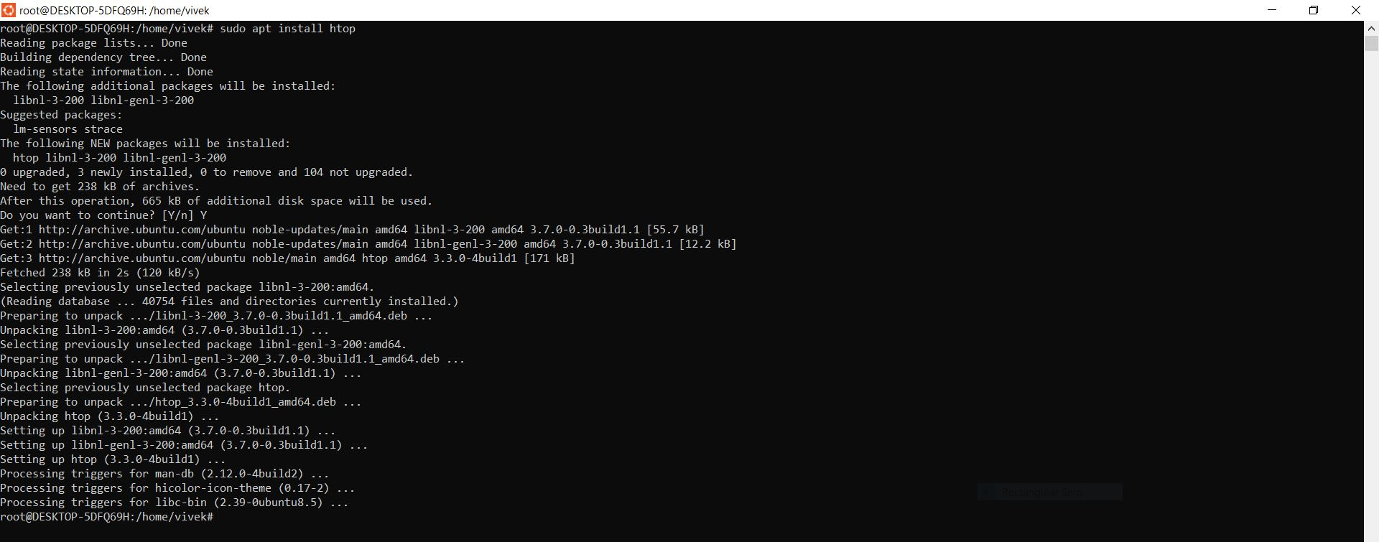

1.2 Launch htop
Htop

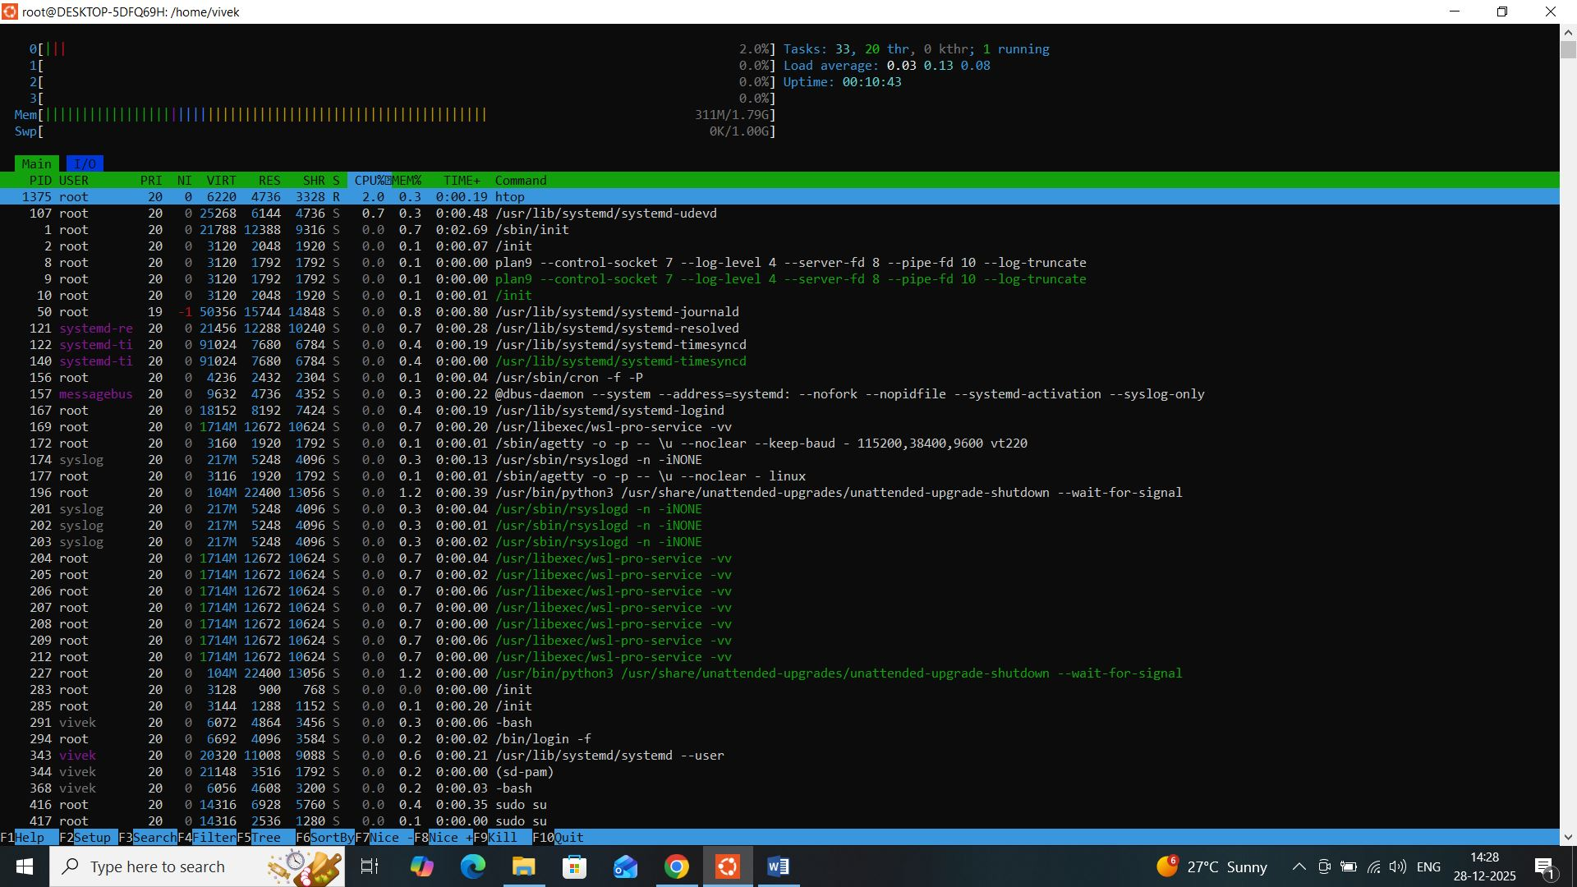

htop Monitoring Capabilities
- CPU usage (per core)
- Memory and swap usage
- Running processes
- Process owner, PID, CPU%, MEM%

Basic htop Controls
- F6 → Sort processes (CPU / Memory)
- F9 → Kill process
- F10 → Exit

Optional: Install nmon
sudo apt install nmon -y
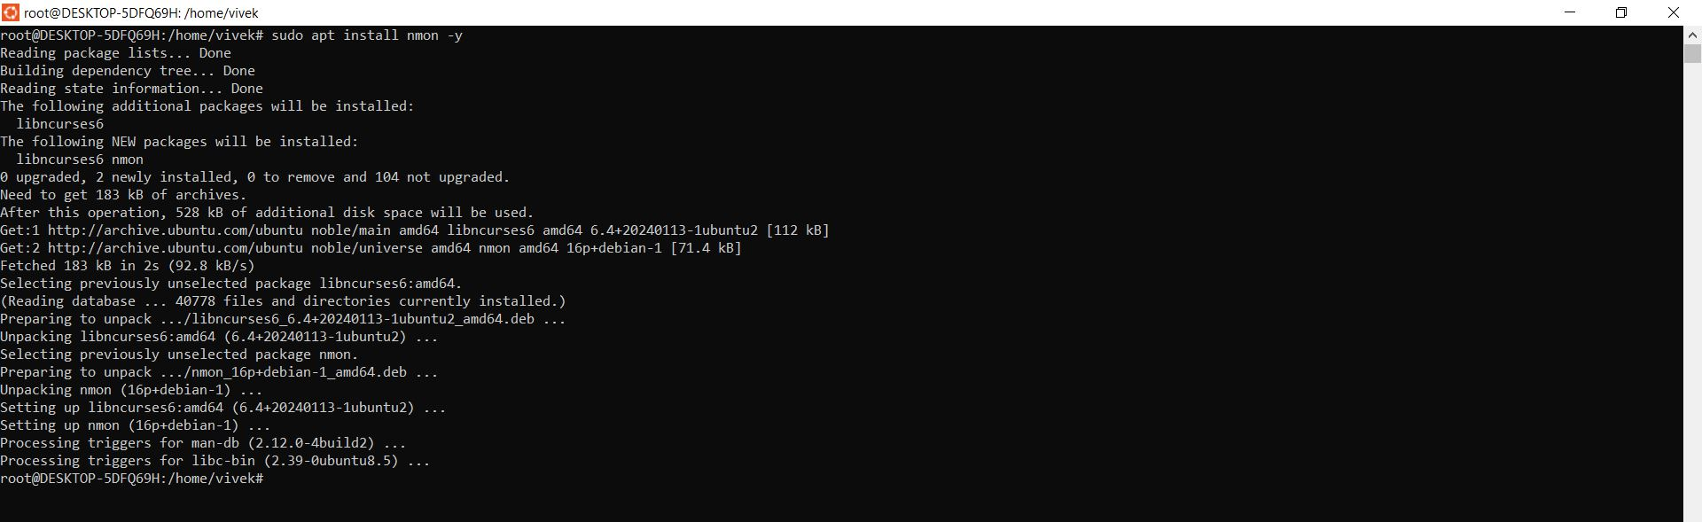

Launch:
nmon
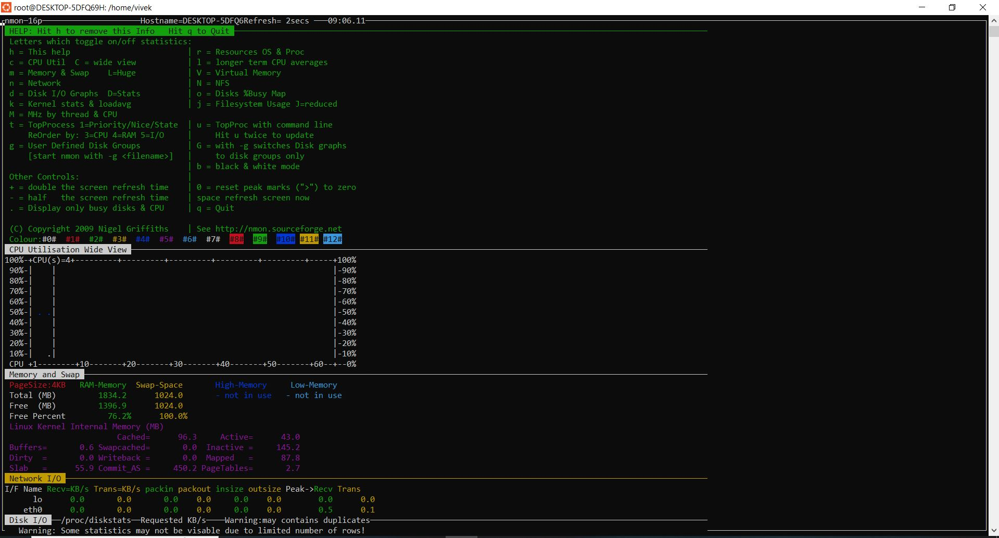

Key shortcuts:
- c → CPU
- m → Memory
- d → Disk
- p → Processes

2. Disk Usage Monitoring

2.1 Check Overall Disk Usage (df)
df -h
Sample Output:
Filesystem Size Used Avail Use% Mounted on
/dev/sda1 80G 45G 32G 59% /

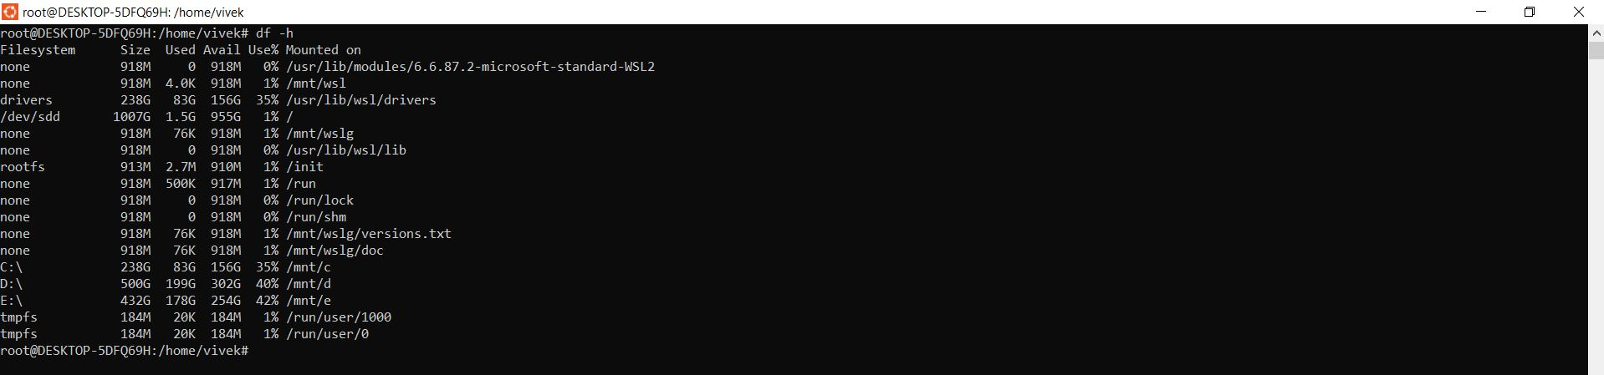

2.2 Directory-wise Disk Usage (du)
du -sh /var/*
To find top disk-consuming directories:
du -ah / | sort -rh | head -10
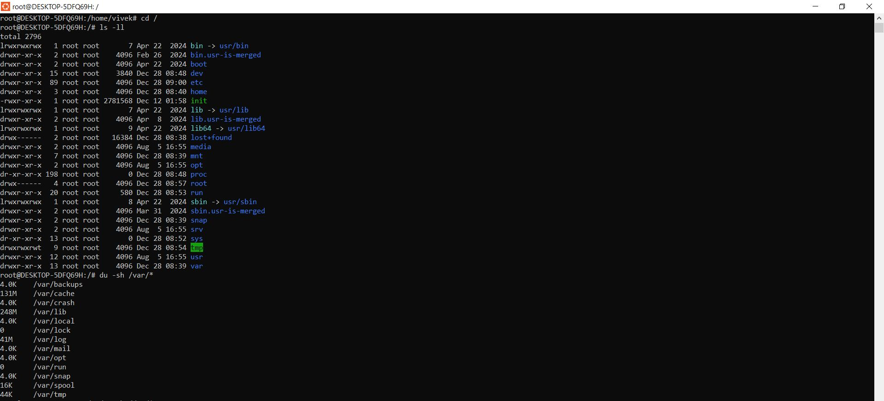

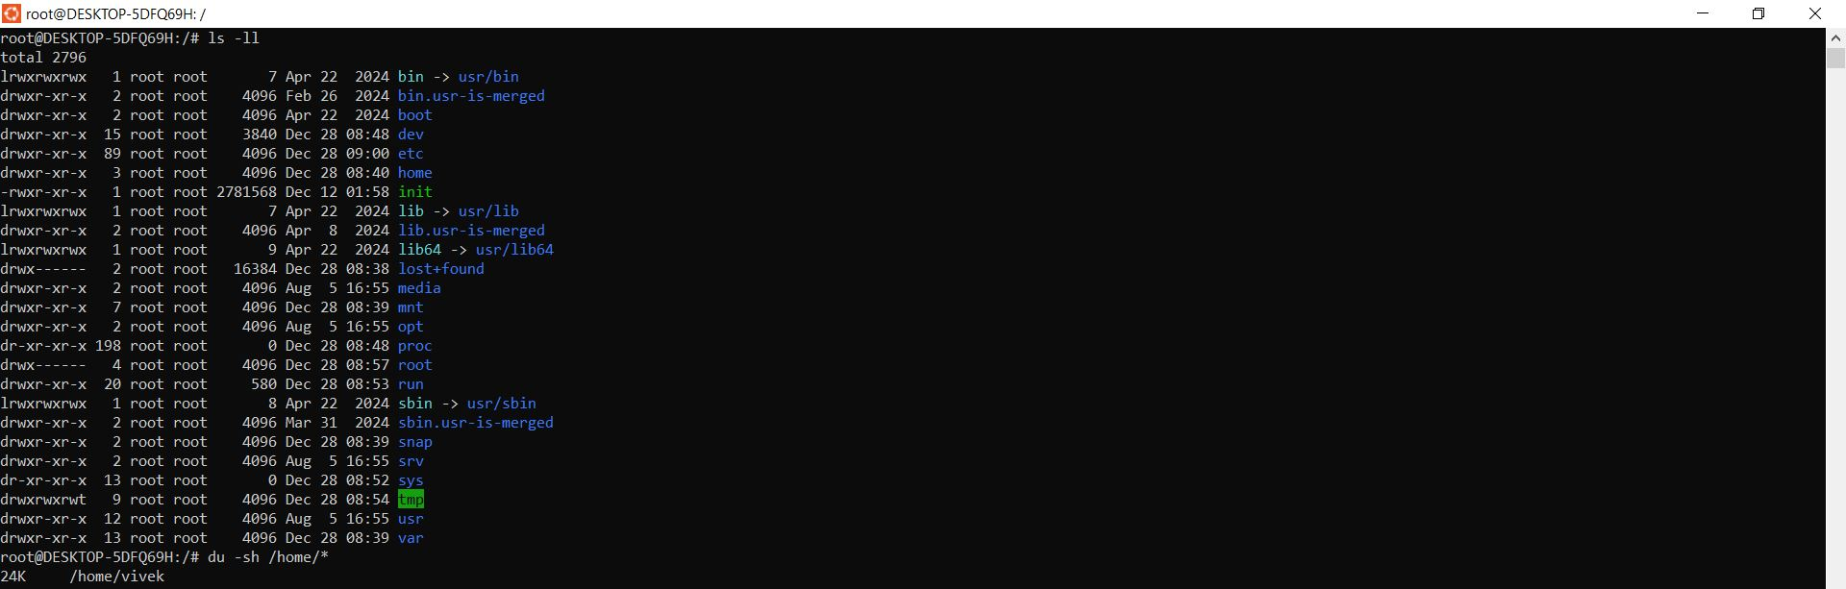

3. Process Monitoring (Identify Resource-Intensive Processes)

Top CPU-consuming processes
ps -eo pid,ppid,cmd,%cpu,%mem --sort=-%cpu | head

Top Memory-consuming processes
ps -eo pid,ppid,cmd,%mem,%cpu --sort=-%mem | head

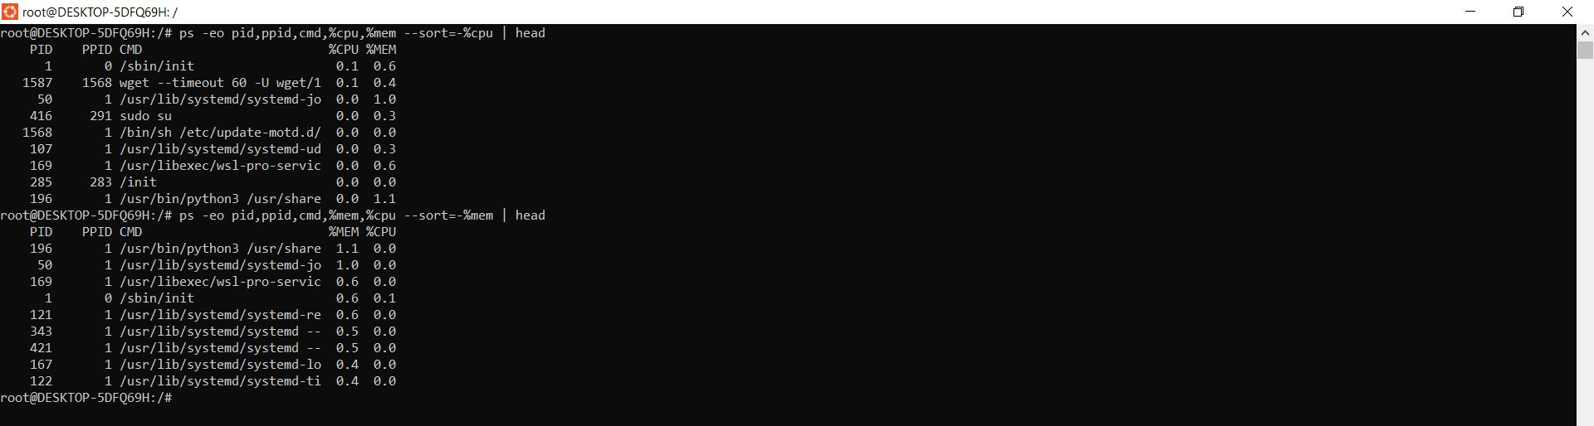

4. Logging and Reporting Setup

4.1 Create Log Directory
sudo mkdir -p /var/log/system-monitoring
sudo chmod 755 /var/log/system-monitoring

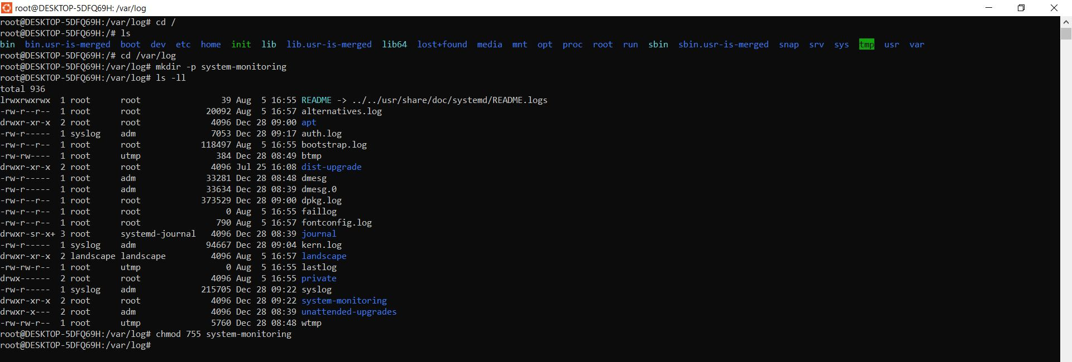

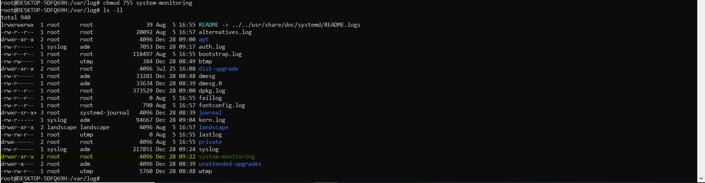

4.2 Create Monitoring Script
sudo nano /usr/local/bin/system_monitor.sh

Script Content
#!/bin/bash

LOG_DIR="/var/log/system-monitoring"
DATE=$(date '+%Y-%m-%d %H:%M:%S')

echo "===== System Monitoring Report: $DATE =====" >> $LOG_DIR/system_report.log

echo "--- CPU & Memory Usage ---" >> $LOG_DIR/system_report.log
top -b -n1 | head -15 >> $LOG_DIR/system_report.log

echo "--- Disk Usage (df) ---" >> $LOG_DIR/system_report.log
df -h >> $LOG_DIR/system_report.log

echo "--- Top Disk Usage Directories ---" >> $LOG_DIR/system_report.log
du -sh /var/* 2>/dev/null >> $LOG_DIR/system_report.log

echo "--- Top CPU Processes ---" >> $LOG_DIR/system_report.log
ps -eo pid,cmd,%cpu --sort=-%cpu | head >> $LOG_DIR/system_report.log

echo "--- Top Memory Processes ---" >> $LOG_DIR/system_report.log
ps -eo pid,cmd,%mem --sort=-%mem | head >> $LOG_DIR/system_report.log

echo "==========================================" >> $LOG_DIR/system_report.log
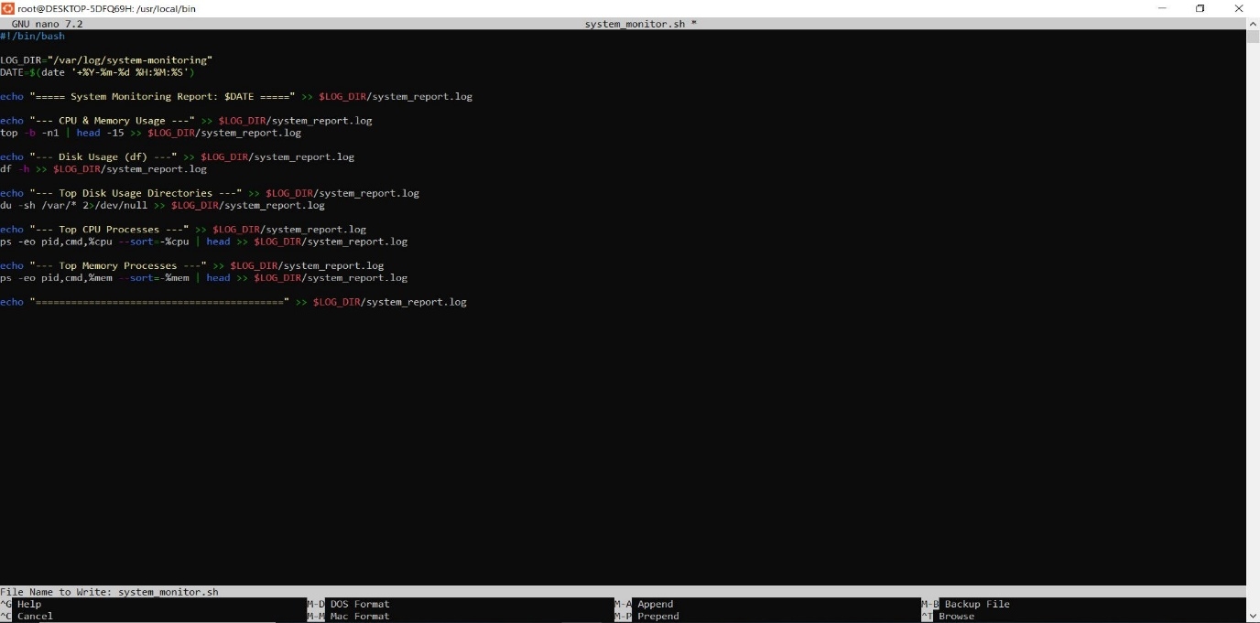

4.3 Make Script Executable
sudo chmod +x /usr/local/bin/system_monitor.sh
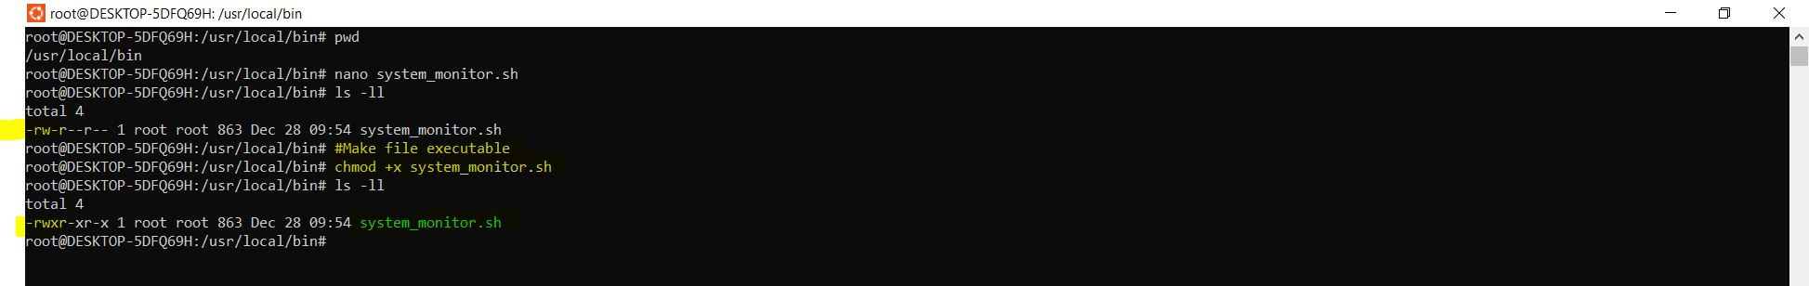

4.4 Schedule Automatic Logging (Cron Job)
Run every 30 minutes:
crontab -e
Add:
*/30 * * * * /usr/local/bin/system_monitor.sh
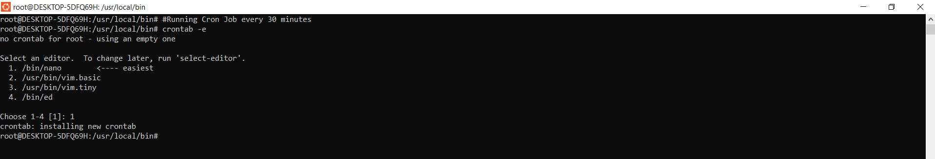

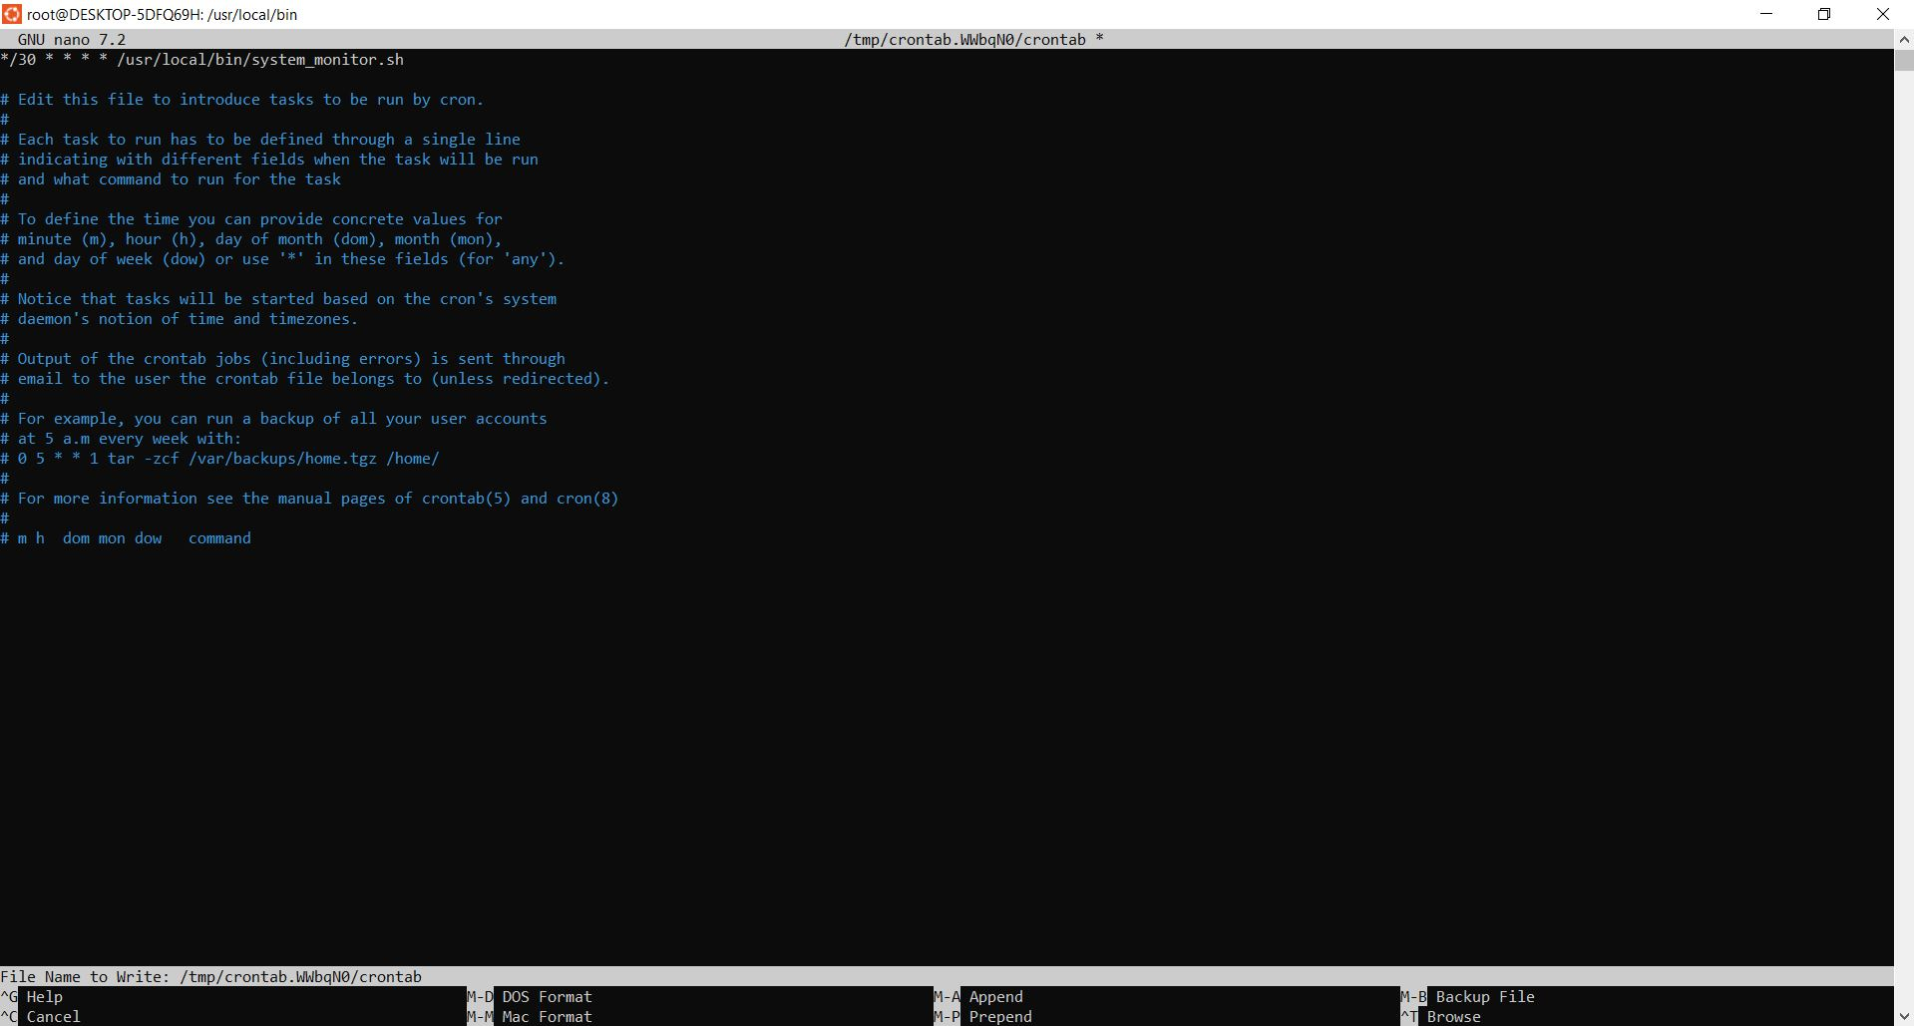

5. Verification

Manual Run
sudo /usr/local/bin/system_monitor.sh

Check Logs
cat /var/log/system-monitoring/system_report.log

6. Outcome
- CPU, memory, disk, and process usage are continuously monitored.
- Resource-intensive processes are easily identified.
- Logs provide historical data for performance analysis and capacity planning.
- Developers gain visibility into system health.

7. Conclusion
This monitoring setup ensures:
- Improved system stability
- Faster troubleshooting
- Better resource planning
- Clear documentation and audit-ready logs

