1. Develop a web server with following functionalities:

- Serve static resources.

- Handle GET request.

- Handle POST request.

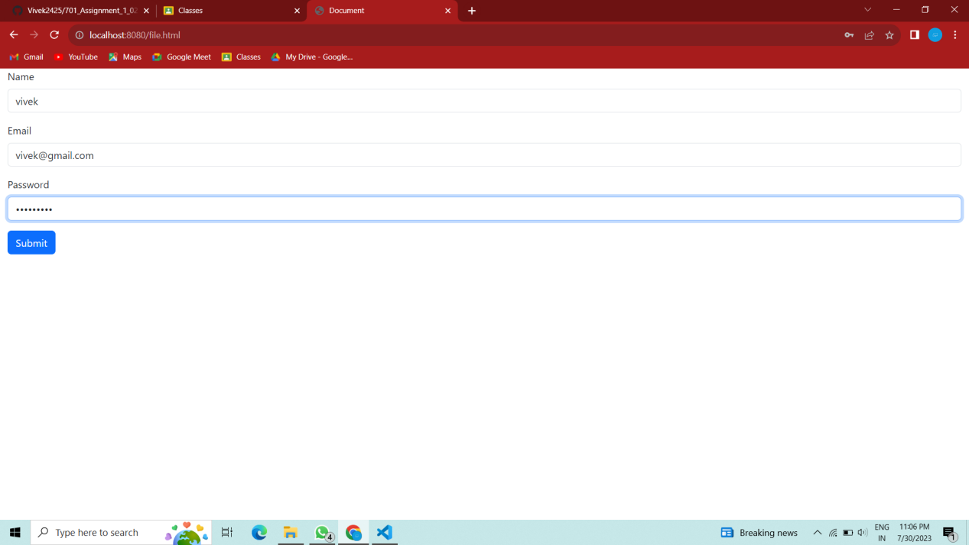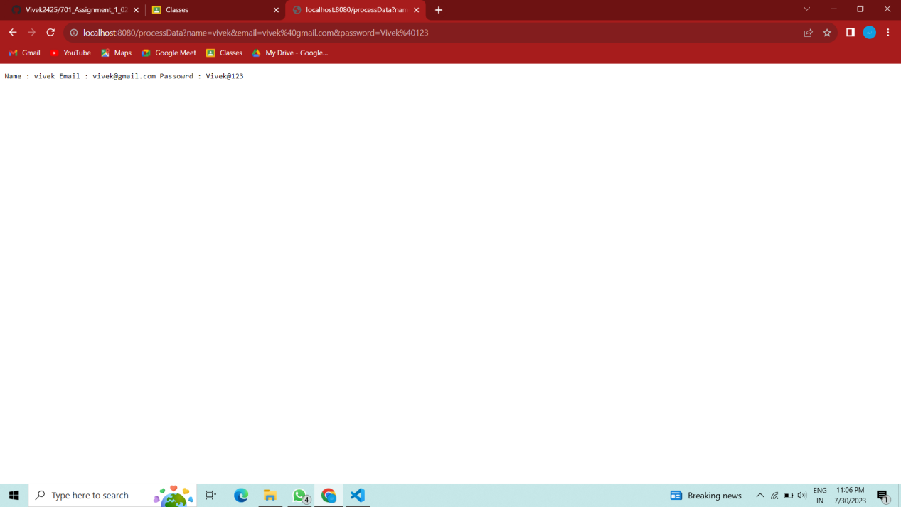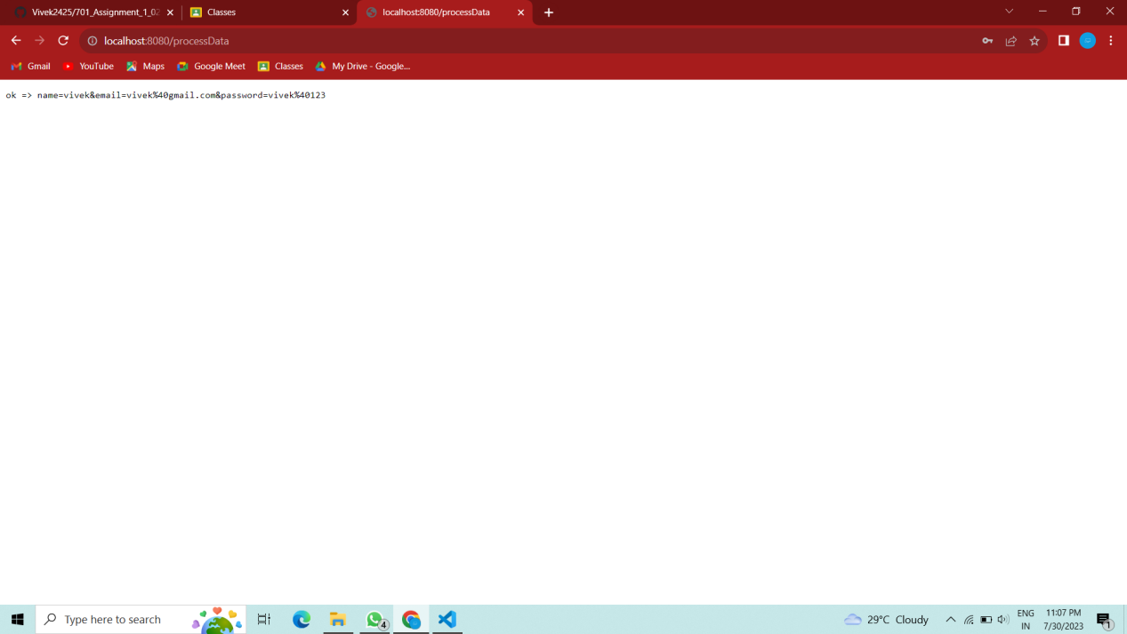

2. Develop nodejs application with following requirements:

- Develop a route "/gethello" with GET method. It displays "Hello NodeJS!!" as response.

- Make an HTML page and display.

- Call "/gethello" route from HTML page using AJAX call. (Any frontend AJAX call API can be

used.)

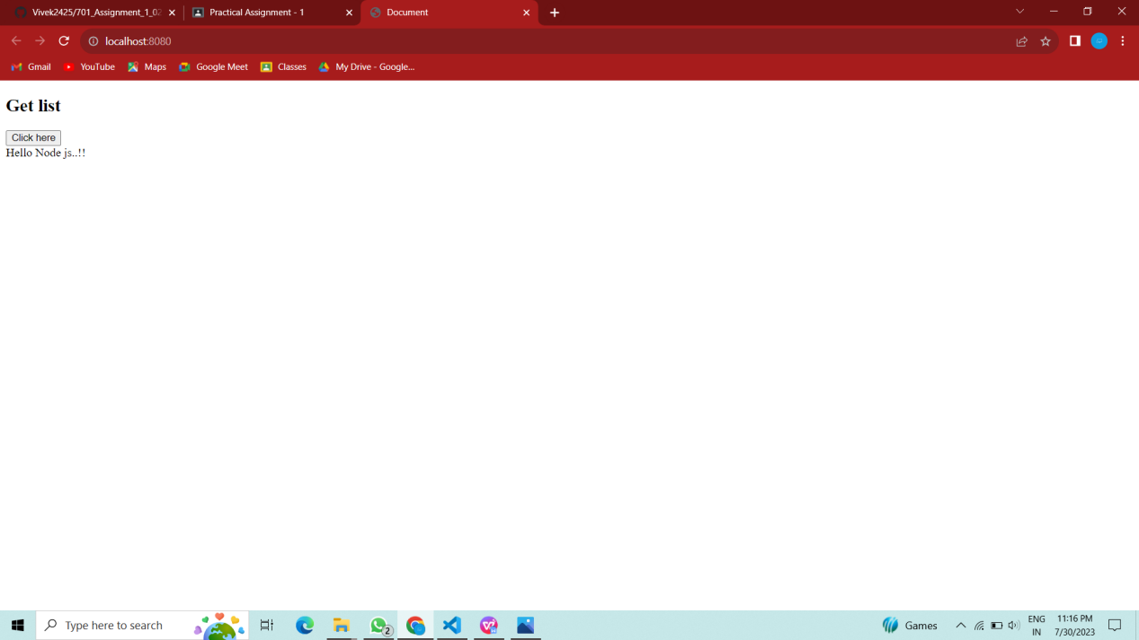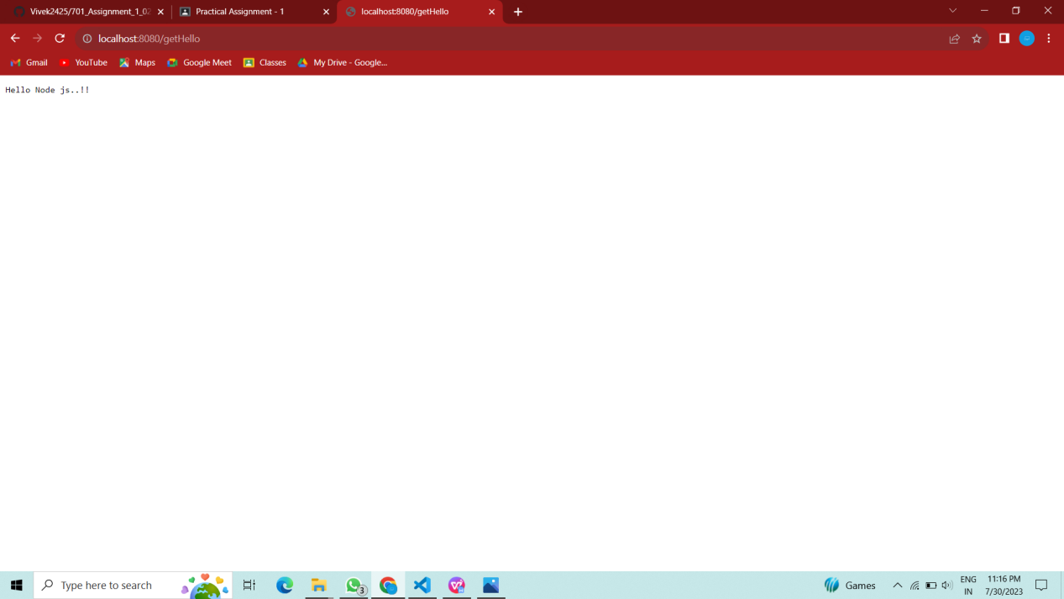

1. Develop a module for domain specific chatbot and use it in a command line application.

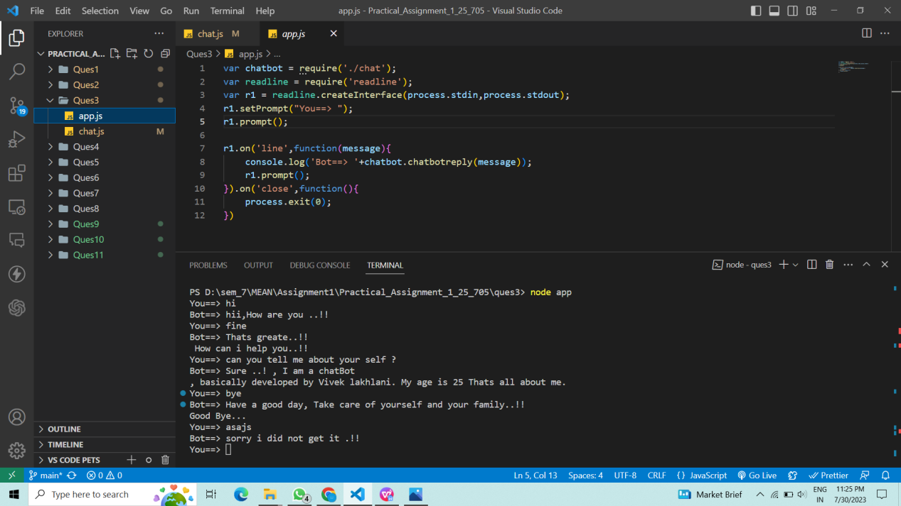

1. Use above chatbot module in web based chatting of websocket.

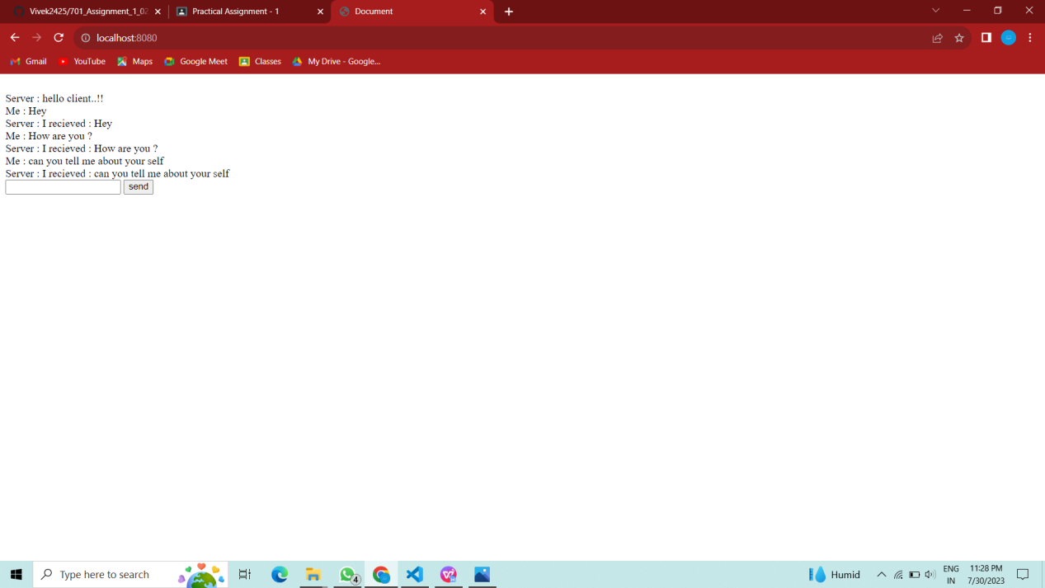

1. Write a program to create a compressed zip file for a folder.

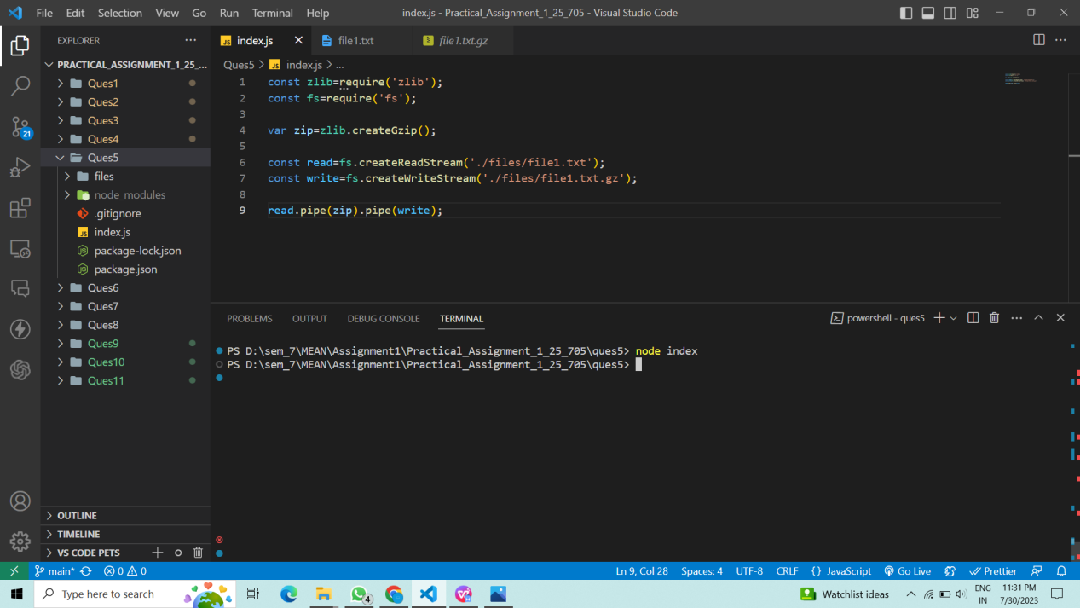

1. Write a program to extract a zip file.

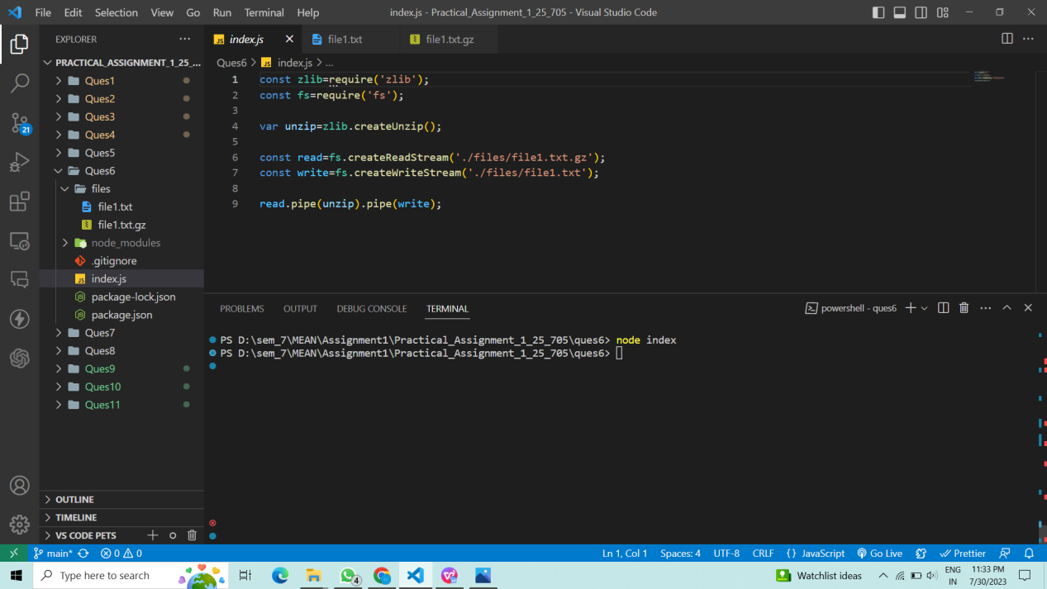

1. Write a program to promisify fs.unlink function and call it.

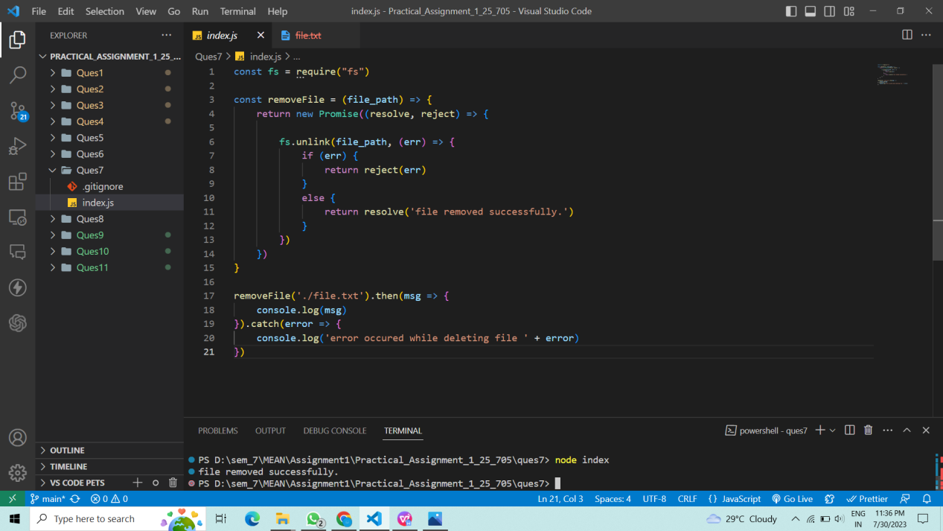

1. Fetch data of google page using note-fetch using async-await model.

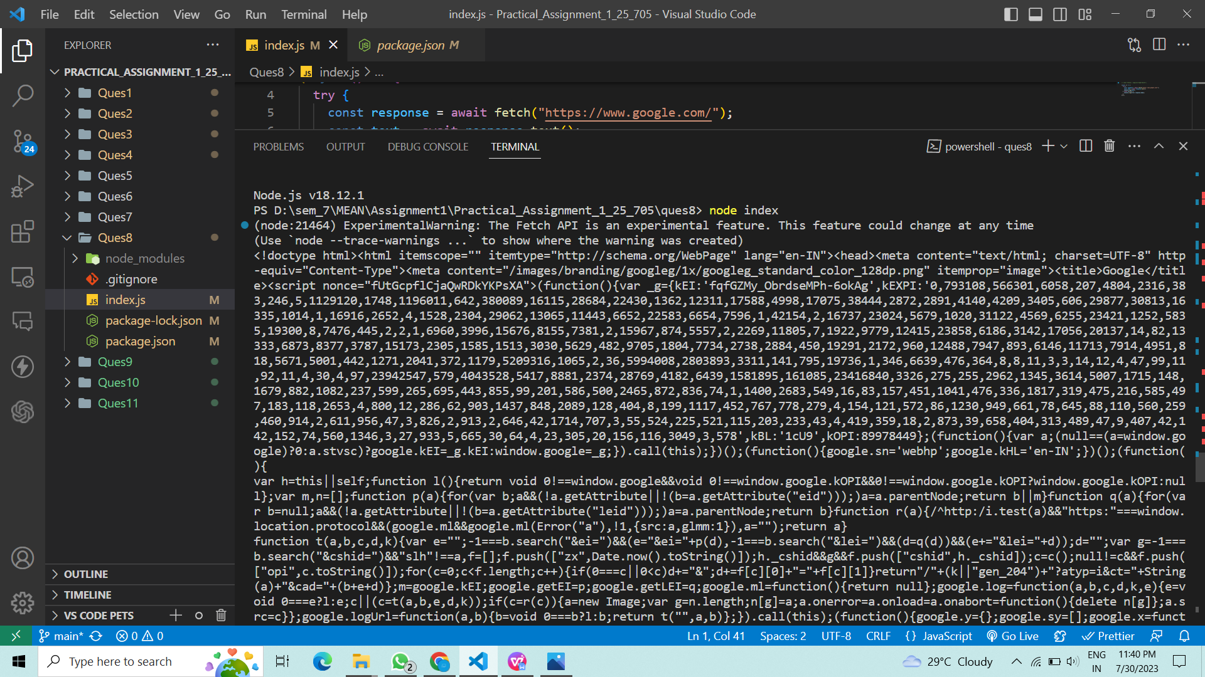

9. Write a program that connect Mysql database, Insert a record in employee table and

display all records in employee table using promise based approach.

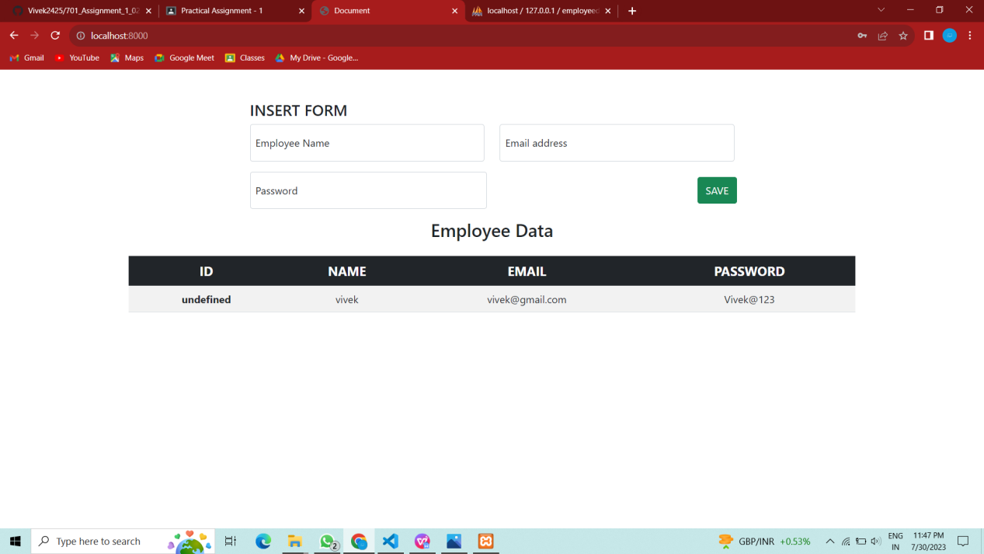

10. Set a server script, a test script and 3 user defined scripts in package.json file in your nodejs

application.