Experiment 05: Study Power BI and its functionalities.

1. What is Power BI?
Power BI is a business analytics platform developed by Microsoft that helps users transform raw data into actionable insights. It provides a collection of tools and services that allow users to connect, visualize, analyze, and share data across an organization.
It is designed for different types of users:
- Business users → Explore reports and dashboards
- Report creators → Build and publish reports using Power BI Desktop
- Decision makers → Analyze insights for strategic decisions
- Administrators → Manage and configure Power BI environment
- Developers → Extend and embed Power BI features into applications
Power BI is also a core component of Microsoft Fabric, which is an all-in-one analytics platform. While Power BI focuses on reporting and visualization, Fabric provides additional capabilities like data engineering, data science, and real-time analytics.

2. Power BI and Microsoft Fabric
Microsoft Fabric integrates Power BI with other data services into a unified platform.

Key Points:
- No migration is required for existing Power BI users
- Existing accounts (Power BI or Microsoft 365) can be used
- Power BI interface remains familiar
- Fabric enhances capabilities without replacing Power BI

Shared Features with Fabric:
- OneLake integration (unified data storage)
- Direct Lake mode (query without data duplication)
- Dataflows and notebooks
- Data Activator (real-time alerts)
- Security and governance
- Copilot (AI-powered assistance)

Unique Power BI Features:
- Power BI Desktop (report creation)
- Power BI Service (sharing and collaboration)
- Dashboards and reports
- Q&A (natural language queries)
- Visual marketplace
- KPI tracking (Power BI Goals)

3. Step-by-Step Working of Power BI
Power BI follows a structured workflow:
- Get Started
  - Sign up and install Power BI Desktop or use browser-based service
- Connect and Prepare Data
  - Connect to Excel, SQL, cloud platforms, APIs
  - Clean and transform data
- Model Data
  - Create relationships between tables
  - Add calculations using DAX
- Build Reports and Dashboards
  - Use drag-and-drop visuals
  - Create interactive charts
- Analyze Data
  - Apply filters, sorting, drill-down
  - Use AI insights and analytics
- Share and Collaborate
  - Publish reports to Power BI Service
  - Share with teams
- Administer and Secure
  - Apply security roles
  - Monitor usage and access

4. Power BI Desktop vs Power BI Service
Need | Tool | Purpose
Create reports | Power BI Desktop | Advanced data modeling and report design
Share reports | Power BI Service | Collaboration and cloud sharing
View reports | Power BI Mobile | Access on smartphones and tablets

Power BI Desktop Features:
- Connect to 100+ data sources
- Use Power Query for data transformation
- Create models with DAX
- Use built-in and custom visuals
- Advanced tools like performance analyzer

Power BI Service Features:
- Team workspaces for collaboration
- Dashboard sharing and app creation
- Dataflows for reusable data
- Real-time dashboards
- Scheduled refresh and alerts
- Security (RLS, audit logs, sensitivity labels)

5. Core Functionalities of Power BI

5.1 Data Connectivity
Power BI supports a wide range of data sources:
- Files (Excel, CSV)
- Databases (SQL Server)
- Cloud services
- APIs and web data
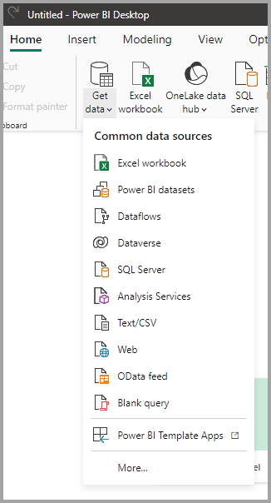
Picture: representing different data sources in power BI

5.2 Data Transformation (Power Query)
- Clean and shape raw data
- Handle missing values and duplicates
- Convert data types
- Merge and split columns

5.3 Data Modeling
- Create relationships between tables
- Use DAX for calculations
- Build structured data models

5.4 Data Visualization
- Charts (bar, line, pie, area)
- Maps and KPIs
- Interactive dashboards
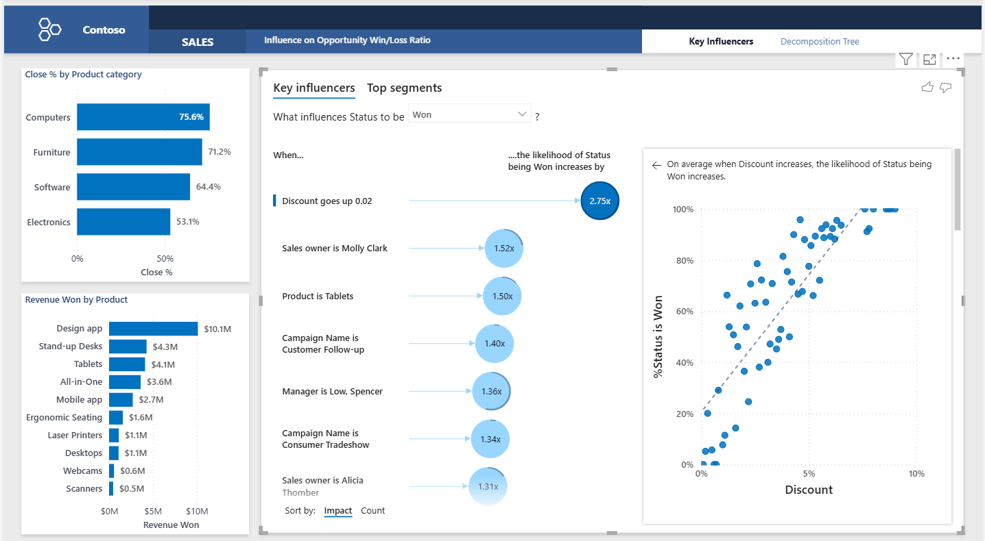
Picture : Sample dashboard with multiple visuals

5.5 Dashboard Creation
- Combine visuals into a single view
- Monitor KPIs in real time

5.6 DAX (Data Analysis Expressions)
Used for calculations and analytics:
Total Sales = SUM(Sales[Amount])
Average Sales = AVERAGE(Sales[Amount])

5.7 Real-Time Analytics
- Supports streaming data
- Useful in IoT, finance, and monitoring systems

5.8 Collaboration and Sharing
- Publish reports online
- Share dashboards securely
- Embed in apps/websites

5.9 AI Features
- Natural Language Query (Q&A)
- Forecasting
- Key Influencers

5.10 Security
- Row-Level Security (RLS)
- Data encryption
- Access control

6. Specialized Features of Power BI

6.1 Paginated Reports
- Pixel-perfect reports for printing (invoices, statements)
- Created using Power BI Report Builder

6.2 On-Premises Reporting
- Use Power BI Report Server
- Store reports locally instead of cloud

6.3 Mobile Access
- View dashboards on smartphones
- Optimized mobile experience

7. Advantages of Power BI
- Easy to learn and use
- Strong Microsoft integration
- Real-time analytics
- Cloud and on-premises support
- Advanced AI capabilities

8. Limitations of Power BI
- Performance issues with large datasets
- Requires internet for cloud features
- Advanced features need technical knowledge

9. Applications of Power BI
- Business intelligence and reporting
- Financial analysis
- Marketing analytics
- Healthcare data analysis
- Educational insights

10. Conclusion
Power BI is a comprehensive and powerful analytics tool that transforms raw data into meaningful insights. It integrates seamlessly with Microsoft Fabric, offering advanced capabilities like AI, real-time analytics, and secure data sharing. With tools like Power BI Desktop and Power BI Service, users can efficiently create, analyze, and distribute reports.
Its flexibility, ease of use, and strong visualization features make it an essential tool in modern data analysis and decision-making processes.

