UNITEC INSTITUTE OF TECHNOLOGY
Master of Applied Technologies

Designing a Data-Driven Congestion Pricing System for

Auckland Using AI
Author:
Vivek Tollawala - 1597483
Supervisor:
Dr. Prakash Karn
A thesis submitted in partial fulfillment of
the requirements for the degree of
Master of Applied Technologies
in the
School of Computing, Electrical & Applied Technology
Abstract
This thesis develops a prototype dynamic congestion pricing system for Auckland using a combination of traffic simulation, forecasting models, and pricing logic. Auckland’s road congestion creates delays, uncertain travel times, higher fuel use, emissions, and productivity losses. The main purpose of this study is to test whether a data-driven workflow can forecast short-term corridor conditions and use those forecasts to support adaptive toll pricing.
The project uses SUMO to generate simulated traffic data for an Auckland road-network scenario. The raw edge-level outputs are cleaned and aggregated into 10-minute observations of an aggregated edge-based corridor travel-time indicator. Three forecasting models are then compared: ARIMA, XGBoost, and Long Short-Term Memory (LSTM). Their predictions are used to calculate a congestion index by comparing the forecast indicator with a simulated free-flow baseline of the aggregated indicator. This index is then translated into a prototype dynamic toll value.
The study also includes a simple demand response model to estimate how drivers may react to tolls, and a congestion feedback step to estimate the possible travel-time improvement after demand is reduced. The final prototype is extended with an MQTT-based IoT demonstration and a Gradio dashboard so that the workflow can be shown as a complete system rather than only as a set of separate scripts.
The results show that ARIMA and LSTM produced similar error values on this small, smoothed simulation dataset, while the pricing and feedback modules demonstrated a prototype communication workflow for linking forecasts, toll logic, and a simulated congestion indicator. The work should be understood as a proof-of-concept rather than a ready policy solution or a strong model ranking, but it provides a practical foundation for future research using real Auckland traffic data, stronger behavioural models, and more detailed equity analysis.

Table of Contents
Designing a Data-Driven Congestion Pricing System for 1
Auckland Using AI 1
CHAPTER 1 6
INTRODUCTION 6
1.1 Background 6
1.2 Research Objectives 7
1.2.1 Main Aim 7
1.2.2 Specific Objectives 7
1.3 Questions & Challenges 8
1.4 Scope of Study 8
1.5 Significance of the Study 8
1.6 Thesis Structure 9
CHAPTER 2 10
LITERATURE REVIEW 10
2.1 Introduction 10
2.2 Congestion Pricing Approaches 10
2.3 Traffic Forecasting Techniques 11
2.4 Data Aggregation and Corridor-Level Analysis 11
2.5 Intelligent Transport Systems and IoT Integration 11
2.6 Demand Response and Behavioural Modelling 12
2.7 Research Gap 12
2.8 Summary 12
CHAPTER 3 13
DATASET AND ANALYSIS 13
3.1 Introduction 13
3.2 Data Source and Simulation Setup 13
3.3 Data Collection 13
3.4 Data Processing Pipeline 14
3.4.1 Raw Dataset 14
3.4.2 Data Cleaning 14
3.4.3 Temporal Aggregation 14
3.4.4 Corridor-Level Dataset 14
3.4.5 Labelled Dataset 14
3.4.6 Dataset Splitting 14
3.5 Evaluation Metrics 15
3.5.1 Mean Absolute Error (MAE) 15
3.5.2 Root Mean Square Error (RMSE) 15
3.6 Forecasting Setup 15
3.7 Summary 16
CHAPTER 4 16
PROPOSED METHODOLOGY AND SYSTEM IMPLEMENTATION 16
4.1 Introduction 16
4.2 Overall System Architecture 16
4.3 Traffic Simulation and Data Preparation 16
4.4 Traffic Forecasting Models 16
4.4.1 ARIMA Model 16
4.4.2 XGBoost Model 17
4.4.3 LSTM Model 17
4.5 Model Evaluation and Results 17
4.6 Dynamic Congestion Pricing Model 17
4.6.1 Congestion Index 17
4.6.2 Simulated Free-Flow Baseline of the Aggregated Indicator 18
4.6.3 Pricing Function 18
4.6.4 Pricing Results 18
4.7 Demand Response Modelling 18
4.8 Congestion Feedback Analysis 19
4.9 IoT Integration Using MQTT 19
4.10 System Demonstration Using Gradio 19
4.11 Summary 19
CHAPTER 5 20
CONCLUSION AND FUTURE WORK 20
5.1 Introduction 20
5.2 Summary of Findings 20
5.3 Research Contributions 21
5.4 Limitations of the Study 22
5.5 Future Work 22
5.6 Results 22
5.7 Final Conclusion 23

CHAPTER 1

INTRODUCTION

1.1 Background
Traffic congestion is a practical and daily problem for many growing cities, and Auckland is no exception. Population growth, urbanisation, and higher vehicle use have placed more pressure on the existing road network. When demand is higher than the available road capacity, people experience longer travel times, less reliable journeys, more fuel use, and higher emissions. Congestion also affects freight movement and economic productivity because delays on the road can carry through into business operations and service delivery.
Traditional congestion-management approaches, such as road expansion, fixed tolling, and signal changes, can help in some cases. However, they are often limited because they do not respond directly to the changing traffic conditions that happen throughout the day. A fixed toll may be too high when traffic is light and too low when congestion is severe. For this reason, dynamic congestion pricing is becoming a useful area of transport research. The idea is to change the price according to the level of congestion, so the road-use signal better reflects the actual network condition.
Machine learning and traffic simulation make this problem more interesting because they allow a system to look ahead rather than only react to what has already happened. SUMO can be used to create a controlled traffic simulation, while forecasting models can estimate short-term travel-time conditions. In addition, IoT technologies and lightweight protocols such as MQTT show how traffic information could be streamed between sensors, models, and decision-support tools in a real-time system.
The gap addressed in this thesis is the lack of a single, connected prototype that brings these parts together for an Auckland-focused context. This research therefore develops an end-to-end workflow that links simulation, data processing, forecasting, dynamic pricing, demand response, congestion feedback, and system demonstration.

1.2 Research Objectives

1.2.1 Main Aim
The main aim of this research is to design, implement, and evaluate a data-driven dynamic congestion pricing prototype for Auckland. The work combines traffic simulation, forecasting models, pricing logic, and a basic real-time architecture. The goal is not to create a final tolling policy, but to test whether a practical technical workflow can support adaptive and predictive congestion management in a New Zealand transport context.

1.2.2 Specific Objectives
To achieve the main aim, the following specific objectives are defined:
1. Model Development and Evaluation
- To develop and compare multiple traffic forecasting models, including ARIMA, XGBoost, and LSTM, using simulation-based traffic data.
- To evaluate model performance using metrics such as Mean Absolute Error (MAE) and Root Mean Square Error (RMSE).
- To identify the most suitable model for short-term traffic prediction in congestion pricing applications.
2. Data Processing and System Pipeline Design
- To generate traffic data using SUMO simulation for a 48-hour period.
- To extract edge-level traffic statistics at 60-second intervals.
- To aggregate data into 10-minute aggregated edge-based corridor travel-time indicator suitable for forecasting.
- To structure datasets into raw, cleaned, labelled, training, validation, and testing datasets.
3. Dynamic Pricing Model Development
- To develop a congestion index based on the predicted aggregated indicator relative to the simulated free-flow baseline of the aggregated indicator.
- To estimate the simulated free-flow baseline of the aggregated indicator using the 5th percentile of observed values.
- To design a pricing function that dynamically adjusts tolls based on congestion levels.
- To incorporate policy constraints such as toll caps for realism and fairness.
4. Demand Response and Feedback Analysis
- To model driver response to pricing using elasticity assumptions.
- To evaluate how dynamic pricing influences travel demand.
- To analyse the impact of reduced demand on congestion levels.
- To quantify changes in the simulated congestion indicator and prototype system efficiency.
5. System Integration and Real-Time Extension
- To design an IoT-based communication framework using MQTT for real-time data streaming.
- To simulate a publish–subscribe architecture for traffic data exchange.
- To develop a prototype user interface using Gradio for system demonstration.
- To evaluate the feasibility of extending the system architecture into a prototype communication workflow for future real-world validation.

1.3 Questions & Challenges
This study is guided by the following research questions:
- How accurately can machine learning models predict short-term traffic conditions using simulation-based data?
- How can dynamic congestion pricing be designed to respond effectively to real-time traffic conditions?
- What is the impact of pricing on travel demand and congestion levels?
- How can simulation, forecasting, pricing, and IoT integration be combined into a unified intelligent transport system?
- To what extent can the proposed framework be extended to real-world implementation?

1.4 Scope of Study
This research focuses on a simulation-based congestion pricing framework for Auckland. SUMO-generated traffic data is used instead of live sensor data so the workflow can be tested in a controlled and reproducible way. The forecasting models are applied to aggregated aggregated edge-based corridor travel-time indicator, and the pricing model is evaluated under simulated conditions.
The project also includes an MQTT-based real-time extension, but this is only a prototype demonstration. A full live deployment with real sensors, transport authority systems, and production databases is outside the scope of this thesis. The behavioural component is also simplified by using a constant elasticity assumption, so it should be treated as an initial estimate rather than a complete model of driver behaviour.

1.5 Significance of the Study
This research contributes to intelligent transportation systems by showing how simulation, forecasting, dynamic pricing, behavioural response, and system integration can be connected in one workflow. Many transport studies focus on one part of the problem, such as prediction accuracy or pricing theory. This thesis instead demonstrates the full pipeline from traffic-data generation to pricing output and dashboard display.
The findings are relevant for Auckland because they show how a data-driven system could support future congestion-management work. The prototype is not a policy recommendation on its own, but it gives urban planners, transport authorities, and researchers a starting point for testing smarter and more adaptive traffic-management tools.

1.6 Thesis Structure
This thesis is organised as follows:
- Chapter 1 introduces the research background, objectives, research questions, and scope.
- Chapter 2 presents a comprehensive literature review on congestion pricing, traffic forecasting, and intelligent transport systems.
- Chapter 3 describes the dataset, data processing techniques, and evaluation metrics used in the study.
- Chapter 4 presents the proposed methodology, including simulation, forecasting models, pricing algorithm, and system integration.
- Chapter 5 discusses the results, conclusions, limitations, and future research directions.

CHAPTER 2

LITERATURE REVIEW

2.1 Introduction
Urban congestion is a common problem in many cities, but the causes and solutions are not the same everywhere. Some congestion is linked to population growth and land-use patterns, while some is caused by limited capacity, peak-hour demand, incidents, and the lack of good alternatives for certain trips. Because of this, modern congestion management has moved beyond only building more road capacity. Researchers and transport agencies are now also looking at pricing, forecasting, simulation, and intelligent transport systems.
This chapter reviews the main areas connected to this thesis: congestion pricing, traffic forecasting, data aggregation, IoT-based transport systems, and demand response. The purpose is to show how the current project fits into existing work and why an integrated Auckland prototype is useful.

2.2 Congestion Pricing Approaches
Congestion pricing is a demand-management approach that uses a charge to influence travel behaviour. Instead of treating road space as unlimited, pricing recognises that using a road during congested periods creates delay for other users. Singapore’s electronic road pricing system is one of the most discussed examples because it uses charging as part of a broader traffic-management strategy.
London and Stockholm also show that congestion charging can reduce traffic volumes and support wider transport goals. However, these examples also show that pricing is not just a technical tool. It needs public acceptance, clear policy objectives, and careful design. A system that is seen as unfair or unclear may face resistance, even if it has technical benefits.
More recent research has moved toward dynamic pricing, where the charge changes according to traffic indicators such as speed, density, or travel time. This is closer to the approach used in this thesis. A dynamic system can respond to changing conditions, but many pricing models still focus mainly on the toll rule itself and do not always connect that rule to short-term traffic forecasting.

2.3 Traffic Forecasting Techniques
Accurate traffic prediction is important because a pricing system should ideally respond before congestion becomes severe. ARIMA is a traditional time-series model and is often used as a baseline because it is simple, interpretable, and efficient. It can work well when the data has strong temporal patterns, although it may not capture complex non-linear relationships.
Machine-learning models such as XGBoost are useful when the dataset has features that describe recent traffic conditions, time-of-day patterns, or other explanatory variables. XGBoost can model non-linear relationships and feature interactions, but it depends on good feature engineering.
Deep-learning approaches such as LSTM are designed for sequential data. They can learn temporal dependencies over multiple time steps and have been widely used in traffic prediction studies. However, LSTM models are usually more data-hungry and computationally demanding. For a small or smooth dataset, the extra complexity may not always produce a better forecast.
For this reason, this thesis compares ARIMA, XGBoost, and LSTM rather than assuming the most advanced model will automatically perform best. The comparison is important because the corridor-level dataset used in this project is aggregated and relatively small.

2.4 Data Aggregation and Corridor-Level Analysis
Traffic data is often collected at a high frequency, which can make it noisy and difficult to model directly. Aggregating the data into intervals such as 5, 10, or 15 minutes is a common way to make the series more stable and easier to interpret. In this thesis, 10-minute aggregation is used because it provides enough detail for short-term forecasting while reducing some of the noise found in one-minute edge outputs.
Corridor-level analysis also helps simplify the problem. Instead of modelling each road segment separately, several active edges are combined into one corridor travel-time series. This gives a broader view of traffic movement and makes the pricing model easier to test. The trade- off is that aggregation can hide local detail. This means advanced models may have less complex variation to learn from.

2.5 Intelligent Transport Systems and IoT Integration
Intelligent transport systems combine sensing, communication, analytics, and decision support. In a real traffic-pricing environment, data would need to move from sensors or traffic APIs into models and then into a dashboard or control system. This makes communication architecture an important part of the design.
MQTT is useful in this context because it is a lightweight publish-subscribe protocol. It allows one component to publish messages while another component subscribes to them. In this thesis, MQTT is used as a demonstration of how traffic data could be streamed through a simple IoT layer. The implementation is not a production system, but it shows how the project could move beyond static files in future work.

2.6 Demand Response and Behavioural Modelling
Congestion pricing only works if travellers respond in some way to the price signal. Some may change departure time, shift route, use public transport, combine trips, or decide not to travel. The size of this response depends on income, trip purpose, urgency, available alternatives, and the design of the pricing scheme.
This thesis uses an elasticity-based model because it is simple and suitable for a prototype. The model assumes a relationship between price change and travel demand. This does not capture the full complexity of driver behaviour, but it provides a practical way to include a first estimate of behavioural response in the pricing workflow.

2.7 Research Gap
Based on the reviewed literature, several key gaps have been identified:
- Many congestion pricing systems rely on static or rule-based pricing rather than predictive models.
- Existing traffic forecasting studies often focus on model accuracy without integrating results into decision-making systems.
- Limited research combines simulation, machine learning, dynamic pricing, and behavioural modelling into a single framework.
- Real-time system integration using IoT technologies is often discussed conceptually but not implemented in a complete pipeline.
- Few studies focus on the specific context of Auckland, considering local traffic conditions and policy constraints.

2.8 Summary
This chapter reviewed the main literature areas that support the project: congestion pricing, forecasting, data aggregation, intelligent transport systems, and behavioural modelling. The review shows that each area has been studied separately in detail, but there is still value in connecting them into one working pipeline.
This thesis responds to that gap by building a dynamic congestion pricing prototype that links simulation, machine learning, pricing, demand response, and a basic real-time system design.

CHAPTER 3

DATASET AND ANALYSIS

3.1 Introduction
This chapter explains the dataset, the processing pipeline, and the evaluation method used in the study. The aim is to make the workflow clear enough to reproduce, starting from raw SUMO simulation output and ending with the dataset used for forecasting and pricing.

3.2 Data Source and Simulation Setup
Because real-time corridor-level Auckland traffic data was not fully available for this project, a simulation-based approach was used. Traffic data was generated in SUMO, which provides a controlled environment for modelling traffic movement and testing the rest of the system.
An Auckland road-network scenario was created using OpenStreetMap data and imported into SUMO. The simulated traffic demand was designed to represent typical urban conditions, including both peak and off-peak periods. The simulation was run for 48 hours, which provided enough data to observe time-based traffic patterns.
SUMO Simulation Visual
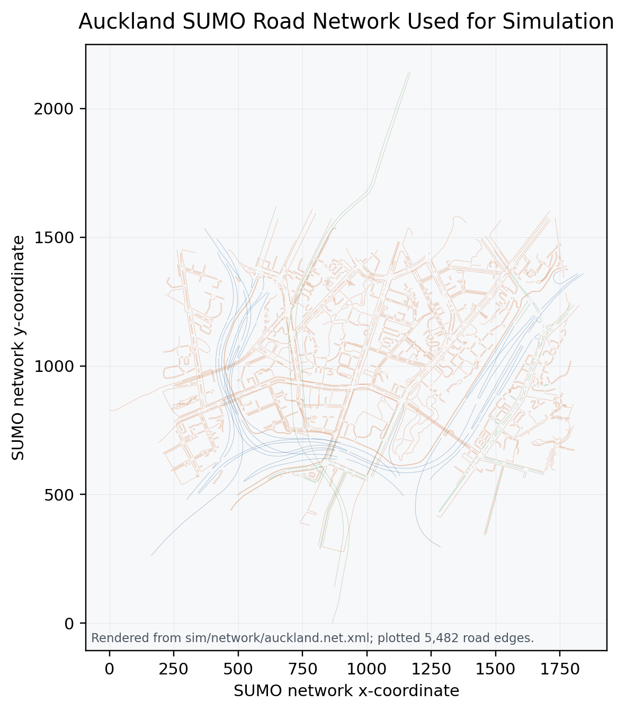
SUMO network view for the Auckland simulation scenario
SUMO network view for the Auckland simulation scenario.
The network visual confirms the road graph used to generate the simulated edge-level traffic observations. It is included to make the simulation setup easier to inspect alongside the configuration and data-collection description.

3.3 Data Collection
During the simulation, traffic statistics were collected at edge level using SUMO’s edge-output configuration. The following parameters were recorded:
- Edge ID
- Time interval (seconds)
- Mean speed
- Travel time
Data was collected every 60 seconds, producing high-resolution traffic observations. The raw output was first stored in XML format (edge_data.xml) and then converted into CSV format for analysis.
The raw dataset contained approximately 1.5 million observations, which gave detailed traffic information across the simulation period.

3.4 Data Processing Pipeline
Figure 3.2 - Dataset Transformation Workflow
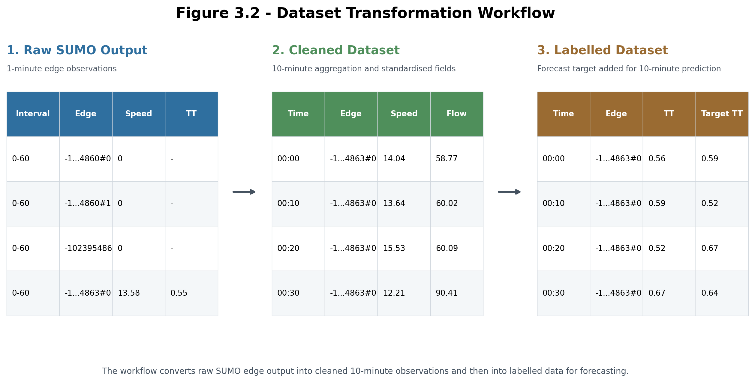
Figure 3.2 - Dataset Transformation Workflow
Figure 3.2 - Dataset Transformation Workflow.
This figure shows how the data used in the project changes across the preprocessing pipeline. Raw SUMO edge observations are first cleaned and aggregated into 10-minute records, and the processed records are then labelled with the next-step travel-time target used for forecasting.
To make the raw simulation data suitable for forecasting and pricing, a multi-stage processing pipeline was implemented.

3.4.1 Raw Dataset
The raw dataset contains edge-level traffic observations at 60-second intervals. This level of detail is useful, but it is also noisy and too granular for the corridor-level pricing model.

3.4.2 Data Cleaning
The raw data was cleaned by removing invalid or missing values and standardising the format of the observations. Timestamps were also converted into a consistent datetime format.

3.4.3 Temporal Aggregation
The cleaned data was aggregated into 10-minute intervals. For each interval, the mean active edge-level travel-time value was calculated. This produced a smoother edge-based traffic-state indicator for forecasting.

3.4.4 Corridor-Level Dataset
Instead of analysing every individual edge, selected active edges were combined to create a aggregated edge-based corridor travel-time measure. This captures broader traffic behaviour while keeping the model manageable.
The final corridor dataset contains 287 observations, with each observation representing one 10-minute interval.
This sample size is a direct result of using a 48-hour SUMO simulation and then aggregating the cleaned edge-level outputs into a single corridor-level sequence. The aggregation step is useful because it creates an interpretable input for pricing decisions, but it also reduces the number of observations available for model training and testing. Therefore, the dataset should be understood as suitable for a prototype evaluation rather than a full-scale validation of operational traffic forecasting performance.

3.4.5 Labelled Dataset
To support forecasting, the dataset was converted into a supervised learning format by creating a target variable:
- $y_{t+10}$: travel time 10 minutes ahead
This allows the models to predict the next travel-time value from historical corridor data.

3.4.6 Dataset Splitting
The final dataset was split into training and testing sets using a chronological approach:
- Training set: 80% (229 observations)
- Testing set: 20% (58 observations)
This approach avoids using future data during training and protects the time-series structure of the experiment.
The resulting split produced 229 training observations and 58 testing observations. This is enough to demonstrate the end-to-end workflow, but it is small for comparing statistical, machine learning, and deep learning models. In particular, the LSTM result should be interpreted with caution because deep learning models normally require larger and more varied datasets to generalise reliably. The model comparison in this thesis is therefore treated as prototype evidence, not as a final claim about which forecasting model would perform best in a real Auckland deployment.

3.5 Evaluation Metrics
Two standard metrics were used to evaluate the forecasting models:

3.5.1 Mean Absolute Error (MAE)
$$MAE=\frac{1}{n}∑∣y_{\text{actual}}−y_{\text{predicted}}∣$$
MAE measures the average size of the prediction errors.

3.5.2 Root Mean Square Error (RMSE)
$$RMSE=\sqrt{\frac{1}{n}∑(y_{\text{actual}}−y_{\text{predicted}})^{2}}$$
RMSE gives more weight to larger errors and helps show whether a model has occasional large mistakes.

3.6 Forecasting Setup
The forecasting task in this study is defined as:
- Forecast horizon: 10 minutes ahead
- Input: historical aggregated edge-based corridor travel-time indicator
- Output: predicted aggregated indicator at $t+10$
Three models were implemented and evaluated:
- ARIMA (statistical model)
- XGBoost (machine learning model)
- LSTM (deep learning model)
All models were trained using the training dataset and evaluated on the testing dataset.

3.7 Summary
This chapter described the dataset generation, processing pipeline, and evaluation methodology used in this study. Starting from high-resolution simulation data, the pipeline transforms raw traffic observations into a structured time-series dataset suitable for forecasting and congestion analysis.
The next chapter presents the proposed methodology, including the forecasting models, dynamic pricing algorithm, demand response modelling, and system integration.

CHAPTER 4

PROPOSED METHODOLOGY AND SYSTEM IMPLEMENTATION

4.1 Introduction
This chapter explains the methodology used to build the dynamic congestion pricing prototype. The framework connects traffic simulation, data processing, forecasting, pricing, demand response, congestion feedback, and system demonstration. The main purpose is to show how raw traffic observations can be converted into practical pricing decisions through a complete workflow.

4.2 Overall System Architecture
Figure 4.1 - Full System Architecture
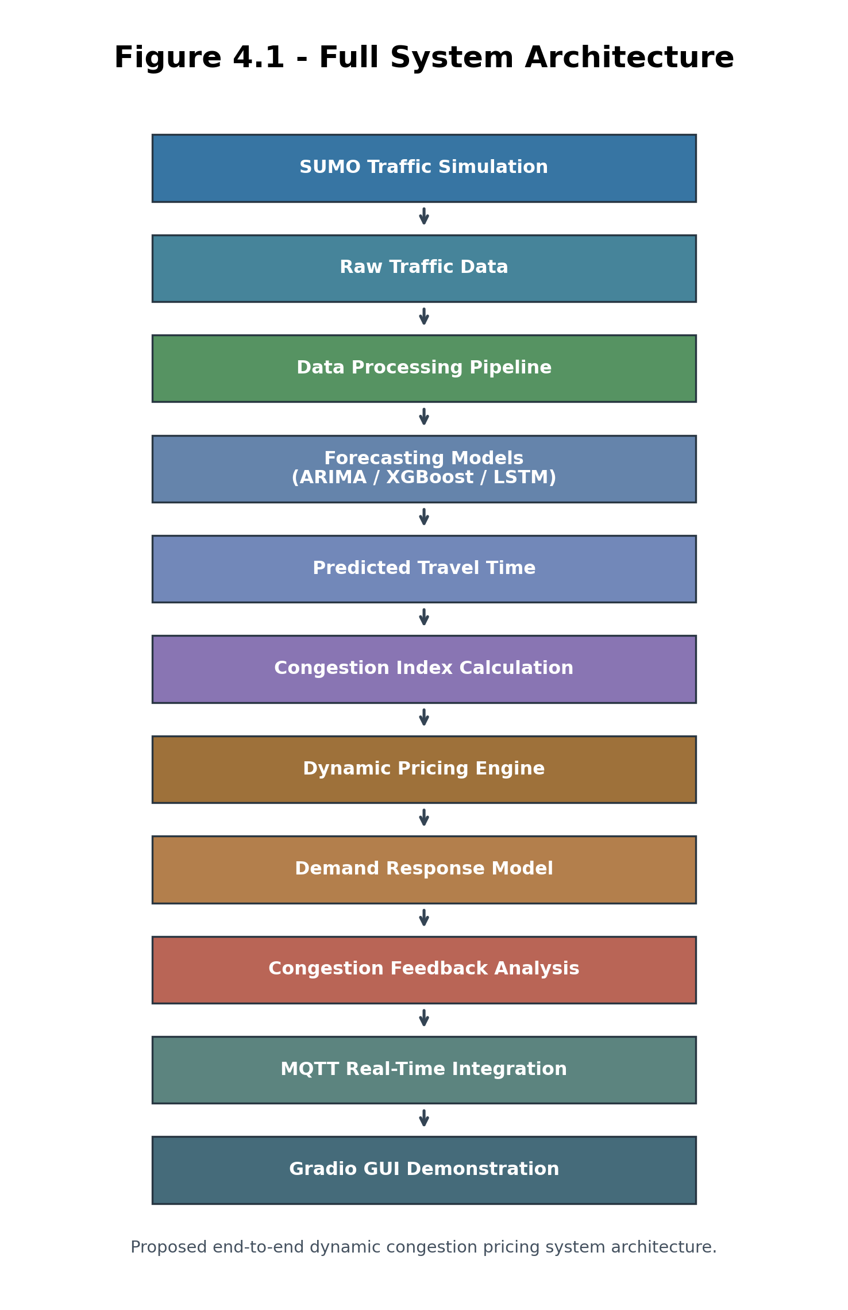
Figure 4.1: Proposed end-to-end dynamic congestion pricing system architecture
Figure 4.1: Proposed end-to-end dynamic congestion pricing system architecture.
The architecture presents the complete flow from simulation-based traffic-data generation to forecasting, pricing, behavioural response, feedback analysis, real-time MQTT integration, and the final Gradio demonstration interface.
The proposed system follows a structured pipeline:
SUMO Simulation -> Data Extraction -> Data Processing -> Forecasting Models ->
Dynamic Pricing -> Demand Response -> Congestion Feedback -> IoT Integration
This architecture gives the project a clear flow from data generation to decision support. Each stage produces an output that becomes the input for the next stage.

4.3 Traffic Simulation and Data Preparation
Traffic data is generated in SUMO using a 48-hour Auckland traffic scenario. Edge-level statistics are collected every 60 seconds and then converted into CSV format. After cleaning, the data is aggregated into a 10-minute edge-based corridor traffic-state indicator, resulting in a structured dataset of 287 observations.

4.4 Traffic Forecasting Models
Three models were implemented and compared for short-term travel-time forecasting.

4.4.1 ARIMA Model
ARIMA (AutoRegressive Integrated Moving Average) is used as the statistical time-series baseline. It captures temporal dependence using autoregression, differencing, and moving-average components.
- Model configuration: ARIMA(1,1,1)
- Strength: effective for linear temporal patterns
- Limitation: limited capability for non-linear dynamics

4.4.2 XGBoost Model
XGBoost is a gradient-boosting method that builds an ensemble of decision trees. In this project, it is used with lagged travel-time and time-based features.
- Strength: handles non-linear relationships and feature interactions
- Limitation: requires feature engineering and tuning

4.4.3 LSTM Model
LSTM (Long Short-Term Memory) is a deep-learning model designed for sequential data. It is included to test whether a sequence model can capture useful travel-time patterns beyond the simpler approaches.
- Strength: captures long-term dependencies in time series
- Limitation: computationally intensive

4.5 Model Evaluation and Results
Figure 4.2 - Forecasting Results Comparison
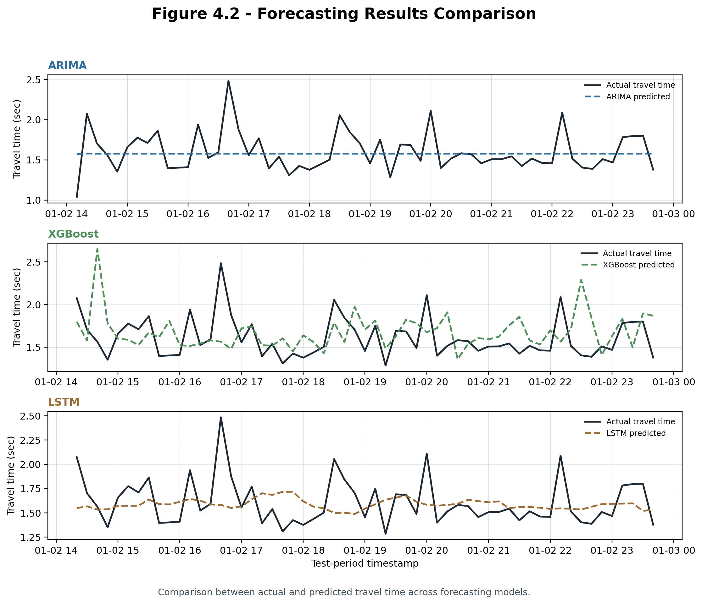
Figure 4.2: Comparison between actual and predicted aggregated indicator across forecasting models
Figure 4.2: Comparison between actual and predicted aggregated indicator across forecasting models.
Table 4.1: Model comparison results
Model | Forecast horizon | MAE (sec) | RMSE (sec)
Persistence baseline | 10-min | 0.25 | 0.34
ARIMA | 10-min | 0.19 | 0.25
XGBoost | 10-min | 0.25 | 0.33
LSTM | 10-min | 0.19 | 0.25
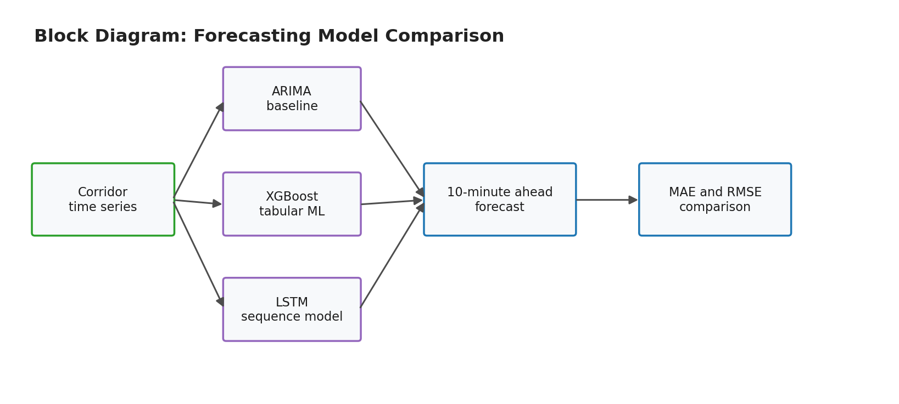
Block diagram comparing the forecasting models used in the study
Block diagram comparing the forecasting models used in the study.
The models were evaluated using MAE and RMSE. A simple persistence baseline was also calculated by using the previous corridor travel-time value as the next 10-minute prediction. This baseline is included to show whether the implemented models improve on a minimal time-series forecasting rule.
Analysis
- The very low error values should be interpreted in relation to the highly aggregated corridor-level dataset. The 10-minute aggregation smooths the original SUMO edge-level outputs, so the final prediction task has less short-term variation than raw traffic data.
- Figure 4.2 provides the actual-versus-predicted comparison used to visually inspect the forecasting behaviour.
- The chronological train-test split helps reduce data leakage risk because the first 80% of observations were used for training and the final 20% were reserved for testing. Random splitting was not used.
- ARIMA and LSTM improved on the persistence baseline, but the margin should be treated as prototype-level evidence because the test set contains only 58 observations.
- ARIMA and LSTM achieved almost the same performance.
- XGBoost produced slightly higher error.
- The similarity between ARIMA and LSTM is likely related to corridor-level aggregation, which smooths the series and reduces the complexity of the prediction task.

4.6 Dynamic Congestion Pricing Model

4.6.1 Congestion Index
Congestion is measured using:
$$CI=\frac{TT_{\text{pred}}}{TT_{\text{free}}}$$
Where:
- $TT_{\text{pred}}$= predicted aggregated indicator
- $TT_{\text{free}}$= simulated free-flow baseline of the aggregated indicator

4.6.2 Simulated Free-Flow Baseline of the Aggregated Indicator
The simulated free-flow baseline of the aggregated indicator is estimated using the 5th percentile:
The travel-time variable used in this study is not intended to represent the complete end-to-end journey time across an Auckland corridor. It is derived from SUMO edge-output data and calculated as an aggregated mean of active edge-level travel-time observations within each 10-minute interval. Because the SUMO network is composed of many short road segments, the resulting simulated free-flow value is small, approximately 1.31 seconds. Therefore, this value should be interpreted as an edge-based corridor traffic-state indicator rather than a full route travel duration. The purpose of this metric is to capture relative changes in traffic conditions over time. The congestion index, forecasting models, and pricing logic are therefore based on changes relative to this simulated free-flow baseline, not on absolute real-world travel-time values. This means the study demonstrates a prototype data-driven workflow for dynamic pricing, but it does not claim to estimate actual Auckland corridor journey times or operational toll levels. In a real deployment, this metric would need to be replaced or calibrated using observed route-level travel times from GPS, Bluetooth, loop detector, ANPR, or Auckland Transport data. The present study should therefore be understood as a proof-of-concept system using simulation-derived traffic-state indicators.
$$TT_{\text{free}}≈1.31\text{ seconds}$$
This gives a practical estimate of uncongested corridor conditions.

4.6.3 Pricing Function
Toll pricing is defined according to congestion levels:
- No toll when congestion is low
- Increasing toll with higher congestion
- Maximum toll cap applied for policy realism

4.6.4 Pricing Results
Figure 4.3 - Dynamic Pricing Output
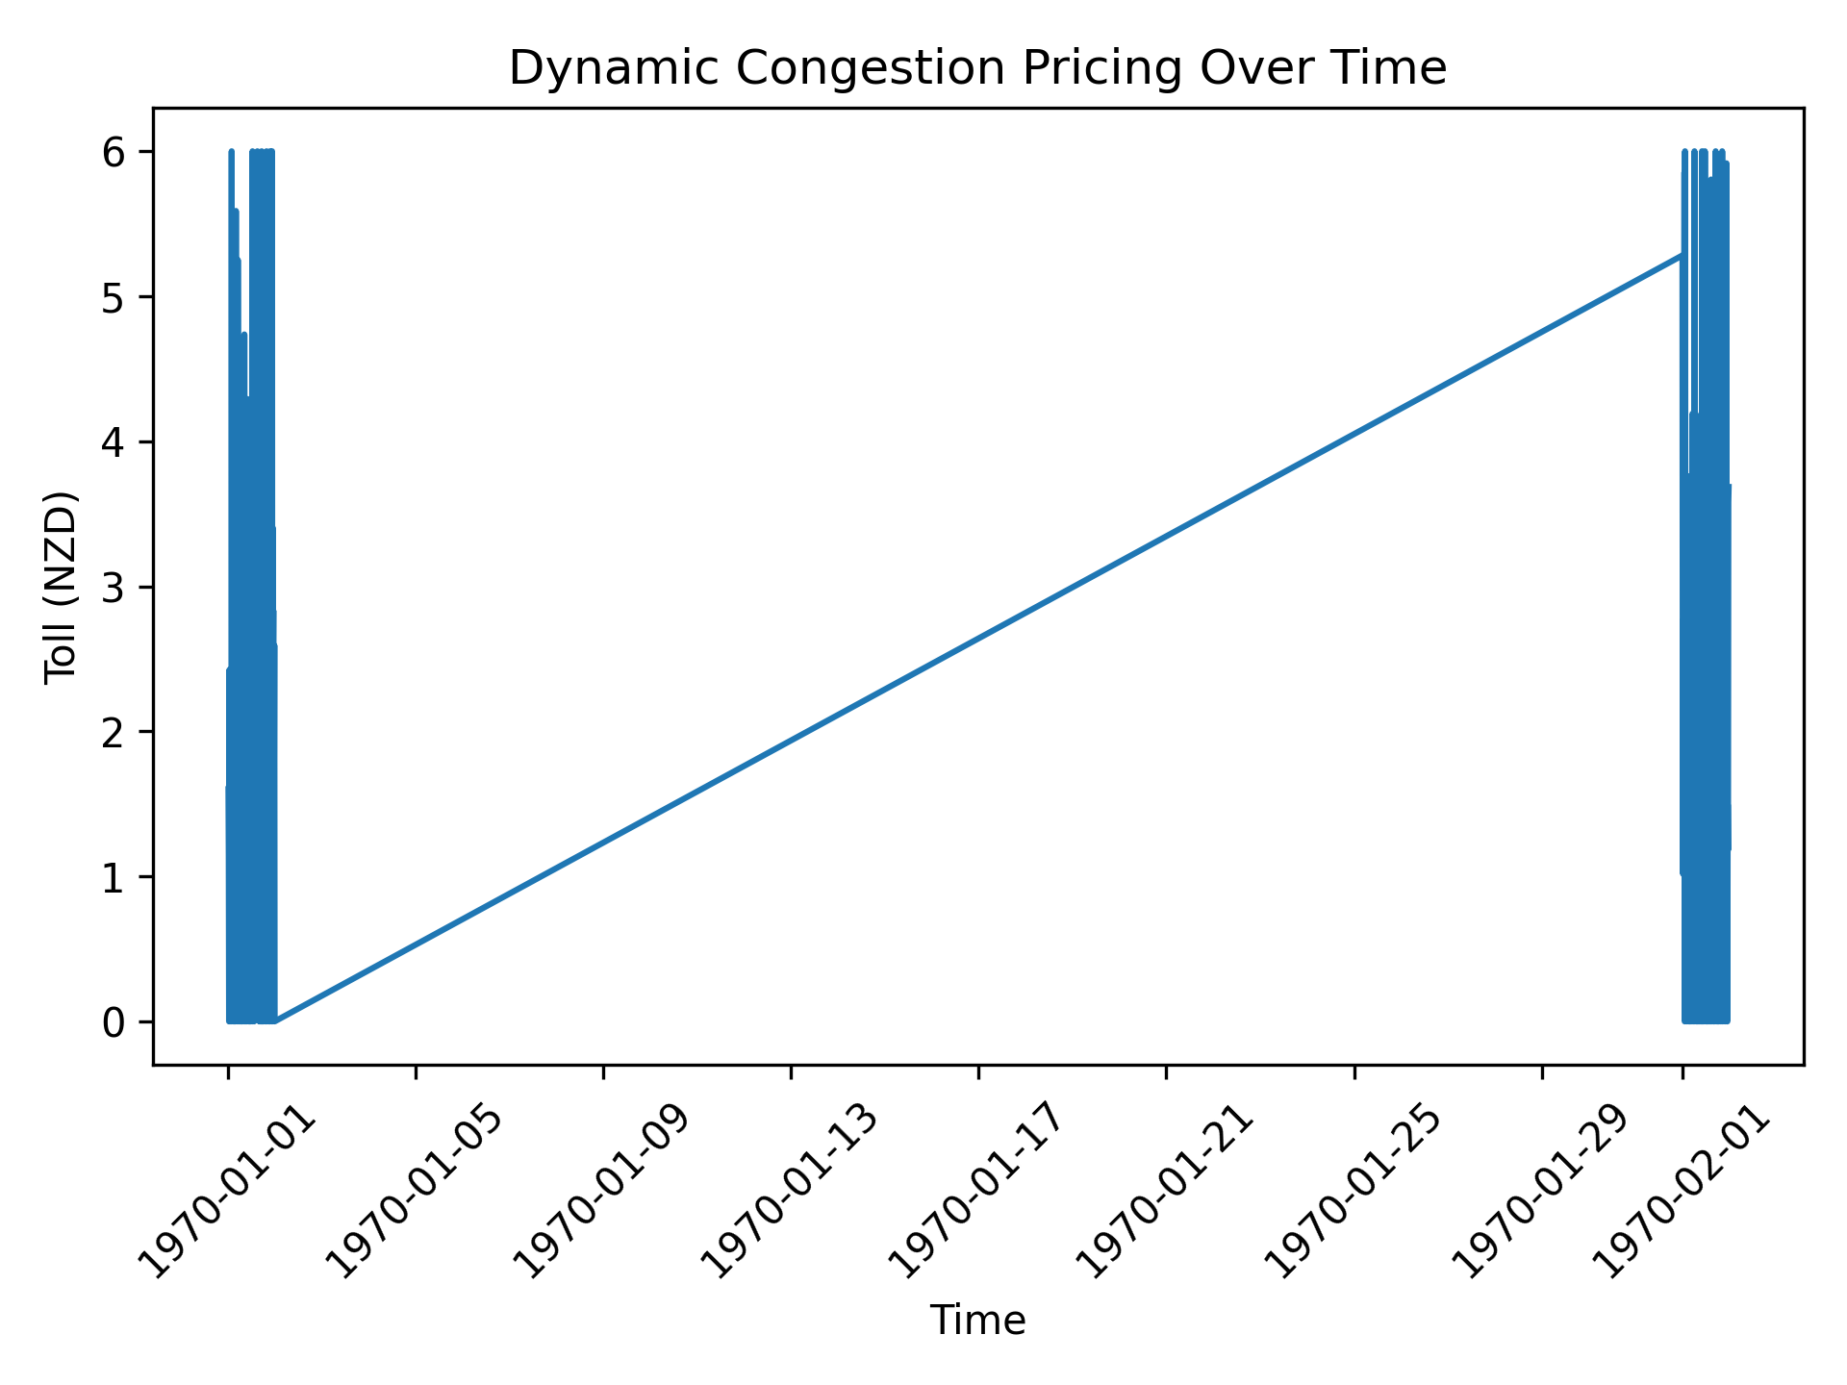
Figure 4.3: Dynamic toll variation in response to predicted congestion
Figure 4.3: Dynamic toll variation in response to predicted congestion.
Table 4.2: Pricing output summary
Measure | Value
Total 10-minute intervals | 286
Tolled intervals | 199 (69.6%)
Average toll when applied | NZD 2.66
Revenue proxy | NZD 529.47
Average demand reduction | 3.70%
Maximum demand reduction | 12.00%
Average reduction in the simulated congestion indicator | 2.96%
Maximum reduction in the simulated congestion indicator | 9.60%
Sample Dynamic Toll Schedule
Time | Predicted TT (sec) | CI | Toll (NZD)
00:10 | 1.52 | 1.16 | 1.60
00:20 | 1.46 | 1.11 | 1.14
00:30 | 1.27 | 0.96 | 0.00
00:40 | 1.63 | 1.24 | 2.42
00:50 | 1.52 | 1.16 | 1.58
01:00 | 1.43 | 1.09 | 0.00
01:10 | 1.45 | 1.11 | 1.07
01:20 | 1.57 | 1.20 | 1.98
- Total intervals: 286
- Tolled intervals: 199 (69.6%)
- Average toll: NZD 2.66
- Total revenue proxy: NZD 529.47
These results show that the pricing rule responds to changing congestion levels rather than applying a single fixed charge.

4.7 Demand Response Modelling
Figure 4.4 - Demand Response
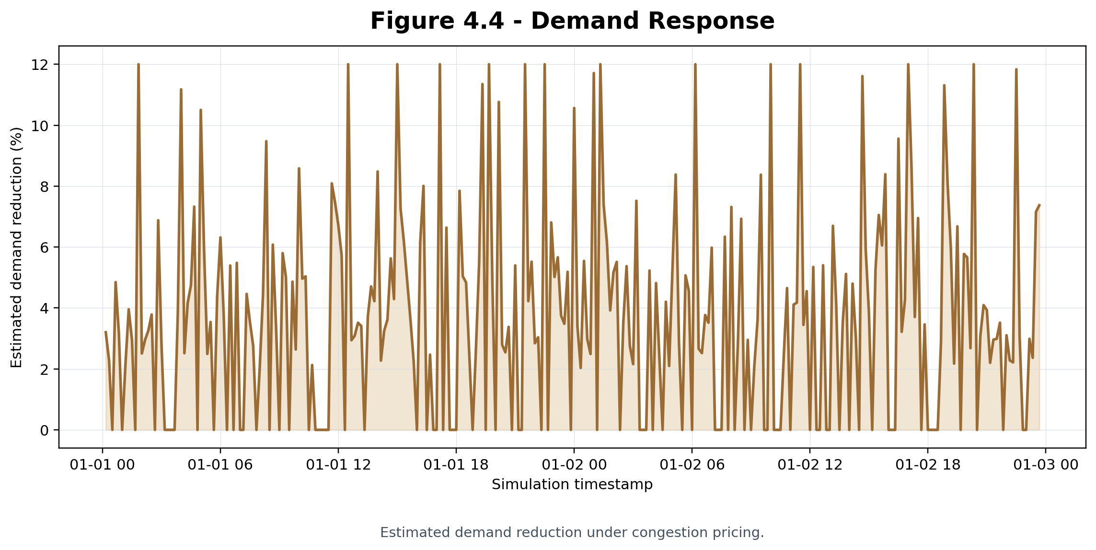
Figure 4.4: Estimated demand reduction under congestion pricing
Figure 4.4: Estimated demand reduction under congestion pricing.
To estimate behavioural impact, demand response is modelled using a price elasticity assumption:
$$\text{Elasticity}=−0.10$$
Results
- Average demand reduction: 3.70%
- Maximum demand reduction: 12.00%
This indicates that the pricing signal can influence estimated travel demand under the selected assumptions.

4.8 Congestion Feedback Analysis
Table 4.3: Demand response summary
Time | Toll (NZD) | Demand reduction | Remaining demand factor
00:10 | 1.60 | 3.20% | 0.968
00:20 | 1.14 | 2.28% | 0.977
00:30 | 0.00 | 0.00% | 1.000
00:40 | 2.42 | 4.85% | 0.952
00:50 | 1.58 | 3.16% | 0.968
01:00 | 0.00 | 0.00% | 1.000
01:10 | 1.07 | 2.15% | 0.979
01:20 | 1.98 | 3.96% | 0.960
Figure 4.5 - Congestion Feedback Analysis
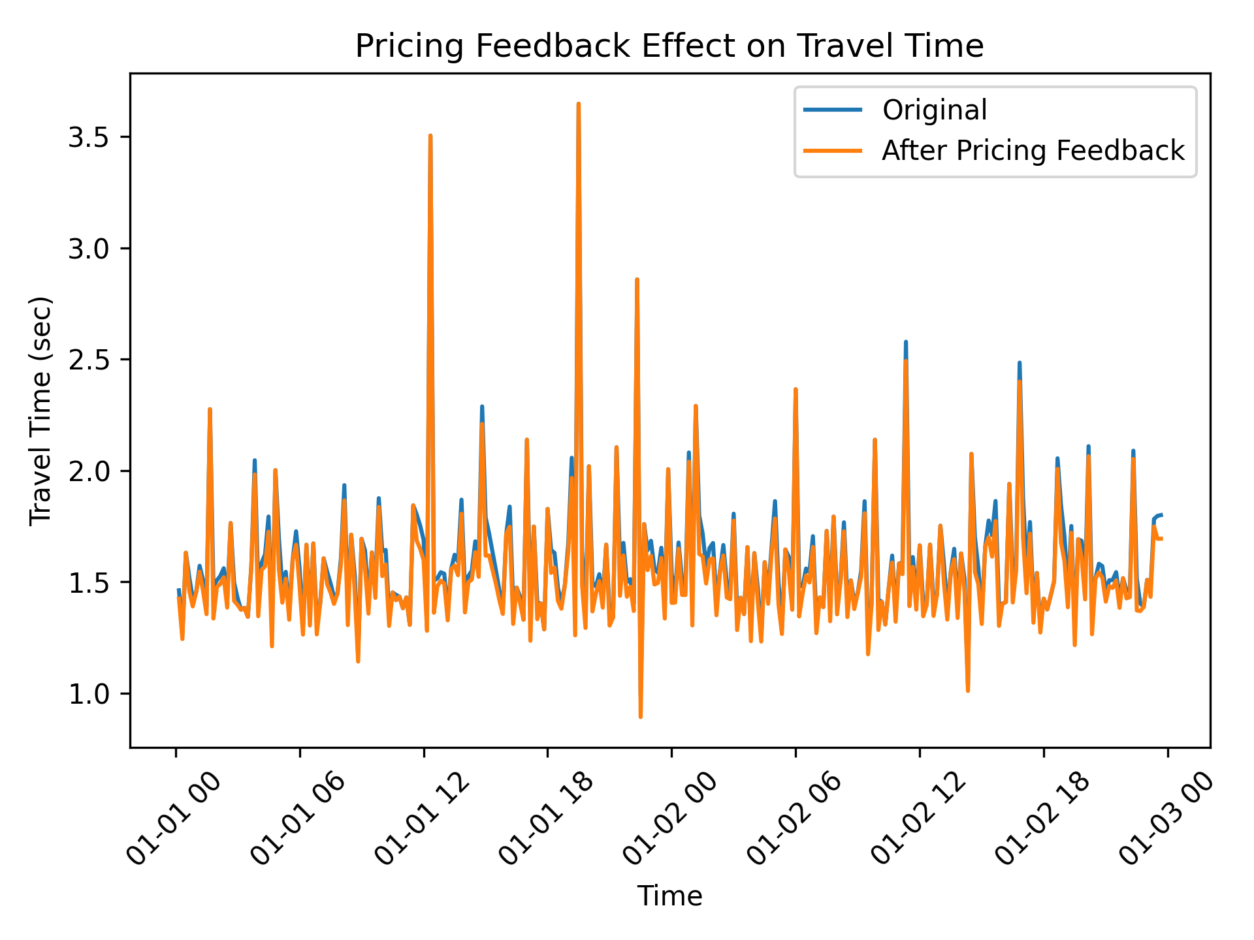
Figure 4.5: Reduction in the simulated congestion indicator after pricing-induced demand adjustment
Figure 4.5: Reduction in the simulated congestion indicator after pricing-induced demand adjustment.
Table 4.4: Demand response and congestion feedback sample
Time | Baseline TT (sec) | Adjusted TT (sec) | Demand reduction
00:10 | 1.46 | 1.42 | 3.20%
00:20 | 1.27 | 1.24 | 2.28%
00:30 | 1.63 | 1.63 | 0.00%
00:40 | 1.52 | 1.46 | 4.85%
00:50 | 1.43 | 1.39 | 3.16%
01:00 | 1.45 | 1.45 | 0.00%
01:10 | 1.57 | 1.55 | 2.15%
01:20 | 1.51 | 1.46 | 3.96%
Reduced demand is then translated into improved travel-time conditions.
Results
- Average reduction in the simulated congestion indicator: 2.96%
- Maximum reduction: 9.60%
This shows the feedback effect between pricing, demand reduction, and travel-time improvement.

4.9 IoT Integration Using MQTT
Figure 4.6 - MQTT Architecture
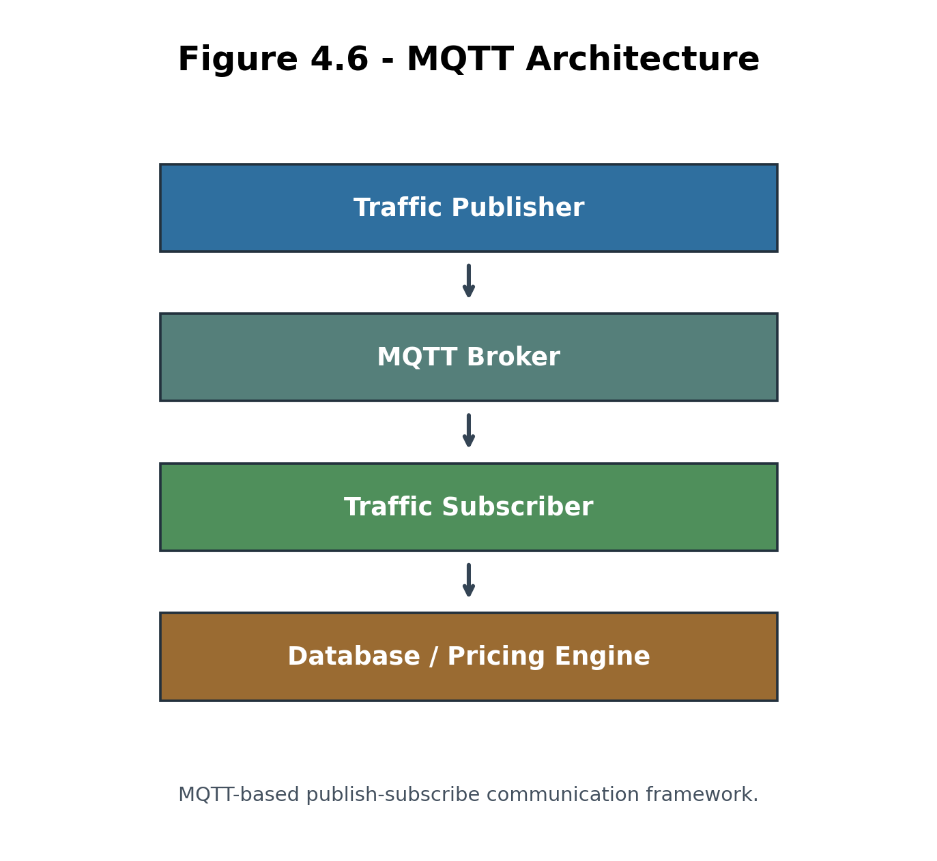
Figure 4.6: MQTT-based publish-subscribe communication framework
Figure 4.6: MQTT-based publish-subscribe communication framework.
To demonstrate real-time system capability, an IoT-based communication layer is built using MQTT.
Implementation:
- Publisher simulates traffic data
- Subscriber receives data in real-time
- Topic-based communication implemented
This architecture demonstrates a prototype communication workflow that could be extended and validated in future work.

4.10 System Demonstration Using Gradio
Figure 4.7 - Gradio GUI Screenshot
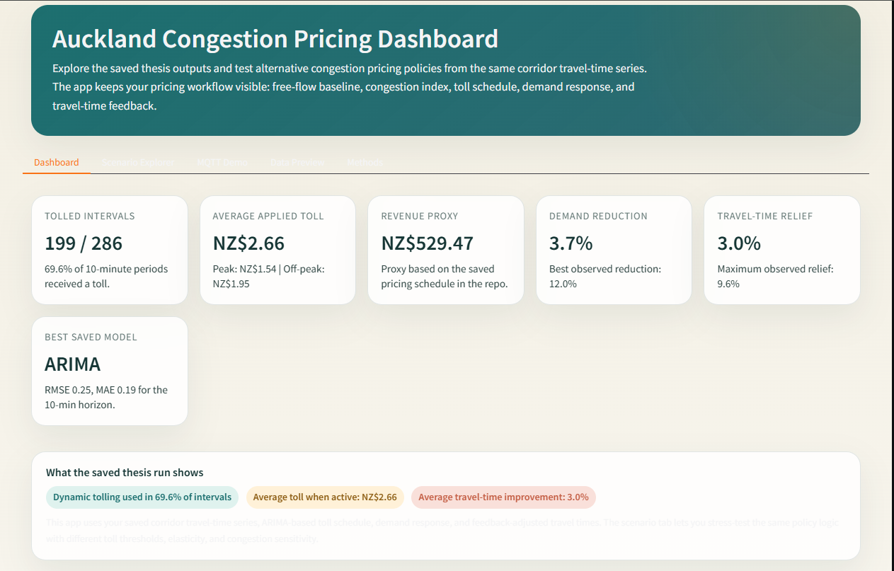
Figure 4.7: Gradio-based graphical interface for congestion pricing demonstration
Figure 4.7: Gradio-based graphical interface for congestion pricing demonstration.
Additional Gradio Screenshots
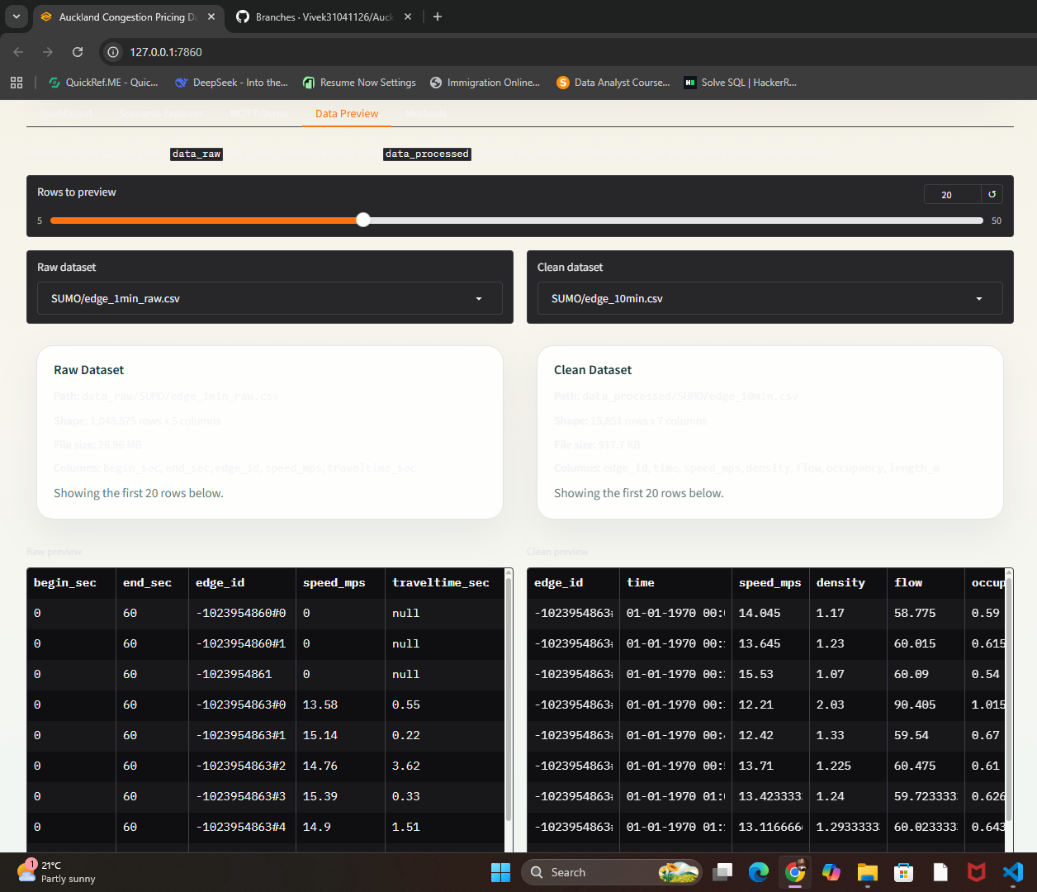
Gradio data-preview screen showing project datasets
Gradio data-preview screen showing project datasets.
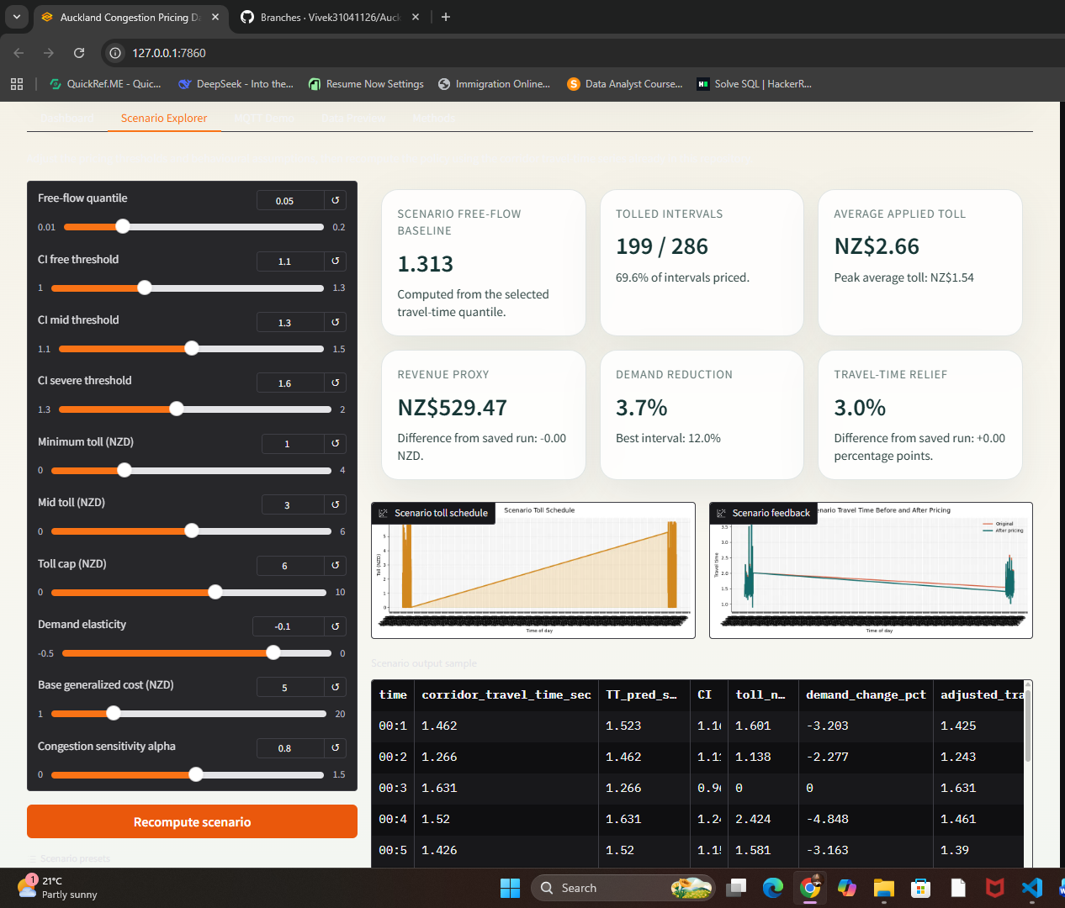
Gradio scenario explorer used to compare pricing outcomes
Gradio scenario explorer used to compare pricing outcomes.
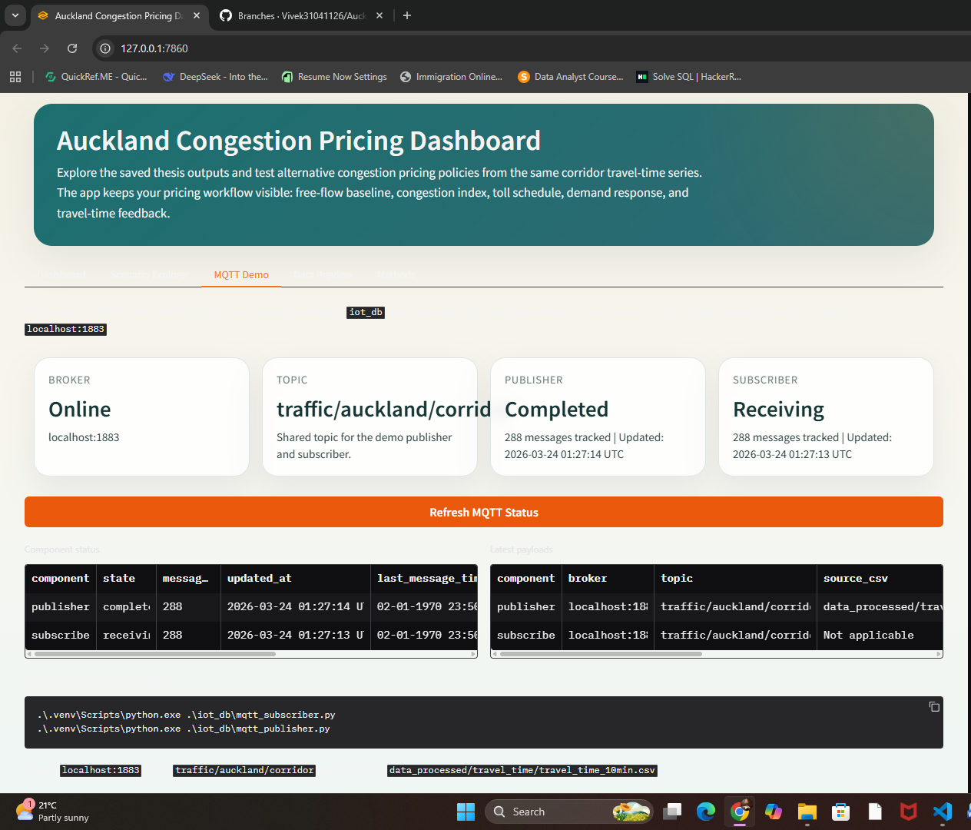
MQTT demonstration screen integrated into the Gradio prototype
MQTT demonstration screen integrated into the Gradio prototype.
A graphical interface was developed using Gradio to demonstrate the system.
Features:
- Dataset preview
- Congestion calculation
- Dynamic pricing output
This interface provides a simple way to inspect the system behaviour and present the results.

4.11 Summary
This chapter presented the full methodology, including traffic simulation, forecasting models, dynamic pricing, demand response, congestion feedback, and system integration.
The results show that the prototype can forecast an aggregated edge-based corridor travel-time indicator, adjust tolls dynamically, and estimate possible changes in the simulated congestion indicator under the selected simulation and behavioural assumptions.

CHAPTER 5

CONCLUSION AND FUTURE WORK

5.1 Introduction
This chapter summarises the main findings of the research, explains the contributions of the prototype, discusses the limitations, and outlines future work. The study aimed to develop a data-driven dynamic congestion pricing framework for Auckland by connecting simulation, forecasting, pricing, behavioural response, and system-level design.

5.2 Summary of Findings
This research developed and evaluated an end-to-end congestion pricing prototype. The major findings are summarised below:
1. Traffic Simulation and Data Processing
- A 48-hour traffic simulation was conducted using SUMO.
- Edge-level data was collected at 60-second intervals.
- The data was aggregated into 10-minute aggregated edge-based corridor travel-time indicator.
- The final dataset contained 287 observations.
2. Forecasting Model Performance
- Three forecasting models were implemented: ARIMA, XGBoost, and LSTM.
- ARIMA and LSTM achieved similar performance:
  - MAE approximately 0.19 sec
  - RMSE approximately 0.25 sec
- XGBoost produced slightly higher error.
- Corridor-level aggregation simplified the prediction problem, which helped the simpler ARIMA model perform competitively.
3. Dynamic Pricing Effectiveness
- A congestion index was used to quantify traffic conditions.
- The simulated free-flow baseline of the aggregated indicator was estimated using the 5th percentile.
- Pricing responded dynamically to congestion levels.
- 69.6% of intervals were tolled
- Average toll: NZD 2.66
- Revenue proxy: NZD 529.47
4. Demand Response Impact
- Elasticity-based modelling was used to estimate behavioural response to pricing.
- Average demand reduction: 3.70%
- Maximum reduction: 12.00%
5. Congestion Reduction
- Pricing was associated with estimated simulated improvements in traffic conditions.
- Average reduction in the simulated congestion indicator: 2.96%
- Maximum reduction: 9.60%
6. System Integration
- An MQTT-based communication layer was implemented for real-time data simulation.
- A Gradio-based interface was developed for system demonstration.
- The system shows potential for future real-time development.

5.3 Research Contributions
Research Contribution Block Diagram
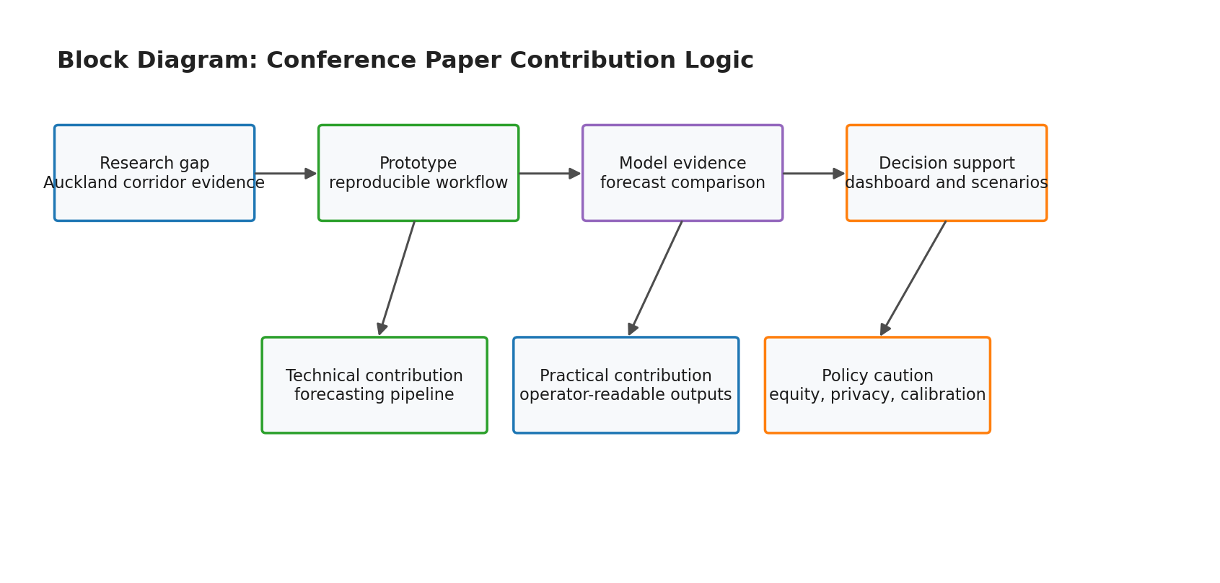
Block diagram summarising the contribution logic of the research
Block diagram summarising the contribution logic of the research.
This study makes several practical contributions to intelligent transportation systems:
- Development of a complete end-to-end congestion pricing framework integrating simulation, forecasting, pricing, and behavioural modelling
- Demonstration of data-driven dynamic pricing based on predicted traffic conditions
- Evidence that simple models such as ARIMA can perform competitively under aggregated traffic conditions
- Integration of IoT communication (MQTT) for real-time system design
- Development of a prototype GUI using Gradio for demonstration and validation
Together, these contributions provide a practical foundation for future smart-transport research in the Auckland context.

5.4 Limitations of the Study
Although the prototype was implemented, several limitations remain:
- The system relies on simulation data rather than real-world traffic data.
- Behavioural modelling uses a fixed elasticity assumption, which cannot capture all driver behaviour.
- The study focuses on a single corridor-level representation, limiting network-wide analysis.
- Real-time implementation is simulated rather than deployed in a live environment.
- External factors such as weather, incidents, and public transport interactions are not included.

5.5 Future Work
Several directions for future research are suggested:
1. Real-World Data Integration
- Replace simulation data with real-time traffic data from sensors and APIs
2. Advanced Behavioural Modelling
- Use data-driven or agent-based models to better capture driver decision-making
3. Network-Level Expansion
- Extend the model to multiple corridors or entire city networks
4. Prototype Communication Workflow
- Fully implement MQTT-based architecture with live data ingestion and database integration
5. Policy and Equity Considerations
- Evaluate fairness impacts of congestion pricing across different user groups

5.6 Results
The performance of the proposed forecasting models was evaluated using the aggregated edge-based corridor travel-time indicator at a 10-minute temporal resolution over a continuous 48-hour simulation period. Three models were assessed: a classical ARIMA baseline, a machine learning model (XGBoost), and a deep learning model (LSTM). Model accuracy was measured using Mean Absolute Error (MAE) and Root Mean Squared Error (RMSE), but the 229-training and 58-testing split means the comparison should be interpreted as prototype evidence rather than a strong model benchmark.
The ARIMA(1,1,1) model achieved an MAE of 0.19 seconds and an RMSE of 0.25 seconds for 10-minute-ahead prediction of the aggregated indicator. This performance provides a useful statistical baseline and indicates a high degree of temporal regularity in the simulated indicator series. The XGBoost model, trained using lagged indicator features and time-of-day variables, produced a slightly higher MAE of 0.25 seconds and an RMSE of 0.33 seconds. Despite its ability to capture non-linear relationships, XGBoost did not outperform the ARIMA model in this prototype setting, suggesting limited non-linear structure in the aggregated simulation signal.
The LSTM model achieved an MAE of 0.19 seconds and an RMSE of 0.25 seconds, matching the performance of the ARIMA baseline on this dataset. This result should be interpreted cautiously because the input signal is highly smoothed and the test set contains only 58 observations. It suggests that additional model complexity did not produce visible gains in this prototype, but it does not establish that LSTM and ARIMA would perform equivalently on larger, route-level, or real-world Auckland datasets.
Dynamic congestion pricing was then applied using the predicted aggregated edge-based corridor travel-time indicator to compute a congestion index relative to the simulated free-flow baseline of the aggregated indicator. A baseline of approximately 1.31 seconds was estimated using the 5th percentile of the simulated edge-based indicator values. This value is not an Auckland route journey time; it is a simulation-derived traffic-state baseline produced from short SUMO edge segments. Based on this baseline, a piecewise tolling scheme was implemented, activating only when the indicator exceeded defined congestion thresholds. The pricing mechanism resulted in tolls being applied in 69.6% of the evaluated time intervals, with an average toll of NZD 2.66 when active and a total revenue proxy of NZD 529.47 over the evaluation period.
Analysis of temporal pricing patterns revealed that average off-peak tolls slightly exceeded peak-period tolls. This outcome reflects the presence of residual and non-recurrent congestion outside traditional peak hours, highlighting the advantage of continuous dynamic pricing over static peak/off-peak schemes. The pricing schedule exhibited smooth temporal variation and remained bounded within the predefined cap, supporting policy realism and acceptability.
To assess behavioural impacts, a short-run price elasticity of demand of -0.10 was applied to estimate traffic demand response. The pricing scheme produced an average demand reduction of 3.70%, with a maximum reduction of 12.00% during highly congested intervals. Although modest in magnitude, these reductions align with empirical findings that congestion pricing primarily redistributes demand rather than suppressing travel altogether.
Finally, a congestion-demand feedback mechanism was incorporated to estimate possible prototype-level impacts. Accounting for reduced demand resulted in an average reduction in the simulated congestion indicator of 2.96%, with maximum reductions reaching 9.60%. These results suggest that relatively small behavioural changes may reduce the simulated indicator under the model assumptions, but they should not be interpreted as verified Auckland travel-time savings or operational policy effects without calibration against observed route-level travel-time and behavioural data.

5.7 Final Conclusion
This research demonstrates prototype-level technical feasibility for a dynamic congestion pricing workflow in a simulated Auckland corridor. The proposed framework is not a final operational solution, but it shows how the main technical components can work together.
By integrating simulation, machine learning, pricing logic, demand response, IoT communication, and a dashboard interface, this study provides a practical prototype for intelligent traffic-management research. The findings indicate the potential value of data-driven systems, while also showing the need for real-world data, stronger behavioural modelling, equity analysis, and careful policy evaluation before any implementation claim can be made.
Bibliography
# Auckland / New Zealand Context
- Sankaran, J. K., Gore, A., & Coldwell, B. (2005). The impact of road traffic congestion on supply chains: insights from Auckland, New Zealand. Good for Auckland problem context. https://doi.org/10.1080/13675560500166780
- McArthur, J. (2018). The Production and Politics of Urban Knowledge: Contesting Transport in Auckland, New Zealand. Urban Policy and Research, 37(1), 45–61. https://www.tandfonline.com/doi/full/10.1080/08111146.2018.1476229
# Congestion Pricing, Equity, and Dynamic Tolling
- Santos, G. (2005). Urban Congestion Charging: A Comparison between London and Singapore. Good for international congestion-pricing background.** https://doi.org/10.1080/01441640500064439**
- Leape, J. (2006). The London Congestion Charge. Very useful for literature review and policy discussion.** https://doi.org/10.1257/jep.20.4.157**
- Santos, G. (2008). London Congestion Charging. Brookings-Wharton Papers on Urban Affairs, 2008(1), 177– 234. https://doi.org/10.1353/urb.2008.a249794
- Eliasson, J., Hultkrantz, L., Nerhagen, L., & Rosqvist, L. S. (2009). The Stockholm congestion-charging trial 2006: Overview of effects. Strong evidence paper for impacts of congestion charging.** https://doi.org/10.1016/j.tra.2008.09.007**
- Eliasson, J. (2009). A cost–benefit analysis of the Stockholm congestion charging system. Transportation Research Part A: Policy and Practice, 43(4), 468–480. https://doi.org/10.1016/j.tra.2008.11.014
- Borjesson, M., Eliasson, J., Hugosson, M. B., & Brundell-Freij, K. (2012). The Stockholm congestion charges—5 years on. Effects, acceptability and lessons learnt. Transport Policy, 20, 1–12. https://www.sciencedirect.com/science/article/abs/pii/S0967070X11001284?via%3Dihub
- Hosford, K., Firth, C., Brauer, M., & Winters, M. (2021). The effects of road pricing on transportation and health equity: a scoping review. Best fit for your equity section.** https://doi.org/10.1080/01441647.2021.1898488**
- Lombardi, C., Picado-Santos, L., & Annaswamy, A. M. (2021). Model-Based Dynamic Toll Pricing: An Overview. Good review paper for your pricing-method section.** https://doi.org/10.3390/app11114778**
- Thao Phan, Annaswamy, A. M., Yanakiev, D., & Eric Tseng. (2016). A model-based dynamic toll pricing strategy for controlling highway traffic. 2016 American Control Conference (ACC), 6245–6252. https://ieeexplore-ieee-org.libproxy.unitec.ac.nz/document/7526651
- Zhang, Y., Atasoy, B., Akkinepally, A., & Ben-Akiva, M. (2019). Dynamic Toll Pricing using Dynamic Traffic Assignment System with Online Calibration. Transportation Research Record: Journal of the Transportation Research Board, 2673(10), 532–546. https://journals.sagepub.com/doi/10.1177/0361198119850135
- Sato, K., Seo, T., & Fuse, T. (2021). A reinforcement learning-based dynamic congestion pricing method for the morning commute problems. Transportation Research Procedia, 52, 347– 355. https://www.sciencedirect.com/science/article/pii/S2352146521000739?via%3Dihub
- Lu, J., Hong, C., & Wang, R. (2024). MAGT-toll: A multi-agent reinforcement learning approach to dynamic traffic congestion pricing. PLOS ONE, 19(11), e0313828. https://journals.plos.org/plosone/article?id=10.1371/journal.pone.0313828
- Genser, A., & Kouvelas, A. (2022). Dynamic optimal congestion pricing in multi-region urban networks by application of a Multi-Layer-Neural network. Transportation Research Part C: Emerging Technologies, 134, 103485. https://doi.org/10.1016/j.trc.2021.103485
- YANG, H., ZHANG, X., & HUANG, H. (2002). Determination of Optimal Toll Levels and Toll Locations of Alternative Congestion Pricing Schemes. Transportation and Traffic Theory in the 21st Century, 519–540. https://doi.org/10.1016/b978-008043926-6/50028-2
- Yang, L., Saigal, R., & Zhou, H. (2012). Distance-Based Dynamic Pricing Strategy for Managed Toll Lanes. Transportation Research Record: Journal of the Transportation Research Board, 2283(1), 90–99. https://doi.org/10.3141/2283-10
- Goodwin, P. (1993). Urban traffic congestion in Europe: Road pricing and public transport finance. Transport Policy, 1(1), 74–75. https://www.sciencedirect.com/science/article/abs/pii/0967070X9390010K?via%3Dihub
- Glaister, S., & Graham, D. J. (2006). Proper Pricing for Transport Infrastructure and the Case of Urban Road Congestion. Urban Studies, 43(8), 1395–1418. https://doi.org/10.1080/00420980600776475
- Li, S., & Robuste, F. (2021). From urban congestion pricing to tradable mobility credits: A review. Transportation Research Procedia, 58, 670–677. https://doi.org/10.1016/j.trpro.2021.11.088
- Liu, Z., Shiwakoti, N., & Bie, Y. (2018). MEASURING THE PUBLIC ACCEPTANCE OF URBAN CONGESTION-PRICING: A SURVEY IN MELBOURNE (AUSTRALIA). Transport, 33(4), 902–912. https://doi.org/10.3846/16484142.2016.1155170
- Walters, A. A. (1961). The Theory and Measurement of Private and Social Cost of Highway Congestion. Econometrica, 29(4), 676. https://doi.org/10.2307/1911814
- Arnott, R., de Palma, A., & Lindsey, R. (1990). Economics of a bottleneck. Journal of Urban Economics, 27(1), 111–130. https://doi.org/10.1016/0094-1190(90)90028-l
- Evans, A. W. (1992). Road Congestion Pricing: When Is It A Good Policy- Journal of Transport Economics and Policy, 26(3), 213–243. https://doi.org/10.3828/jtep.1992.26.3.213
- Harsman, B., & Quigley, J. M. (2010). Political and public acceptability of congestion pricing: Ideology and self-interest. Journal of Policy Analysis and Management, 29(4), 854–874. https://doi.org/10.1002/pam.20529
- Giuliano, G. (1992). An assessment of the political acceptability of congestion pricing. Transportation, 19(4), 335–358. https://doi.org/10.1007/bf01098638
- Grisolia, J. M., Lopez, F., & Ortuzar, J. de D. (2015). Increasing the acceptability of a congestion charging scheme. Transport Policy, 39, 37–47. https://doi.org/10.1016/j.tranpol.2015.01.003
- Milenkovic, M., Glavic, D., & Maricic, M. (2019). Determining factors affecting congestion pricing acceptability. Transport Policy, 82, 58–74. https://doi.org/10.1016/j.tranpol.2019.08.004
- Eliasson, J. (2016). Is congestion pricing fair- Consumer and citizen perspectives on equity effects. Transport Policy, 52, 1–15. https://doi.org/10.1016/j.tranpol.2016.06.009
- Armelius, H., & Hultkrantz, L. (2006). The politico-economic link between public transport and road pricing: An ex-ante study of the Stockholm road-pricing trial. Transport Policy, 13(2), 162–172. https://doi.org/10.1016/j.tranpol.2005.11.011
- Albert, G., & Mahalel, D. (2006). Congestion tolls and parking fees: A comparison of the potential effect on travel behavior. Transport Policy, 13(6), 496–502. https://doi.org/10.1016/j.tranpol.2006.05.007
- Eliasson, J., & Mattsson, L.-G. (2006). Equity effects of congestion pricing. Transportation Research Part A: Policy and Practice, 40(7), 602–620. https://doi.org/10.1016/j.tra.2005.11.002
- Safirova, E., Gillingham, K., Harrington, W., Nelson, P., & Lipman, A. (2005). Choosing Congestion Pricing Policy. Transportation Research Record: Journal of the Transportation Research Board, 1932(1), 169–177. https://doi.org/10.1177/0361198105193200120
- Zhang, G., Wang, Y., Wei, H., & Yi, P. (2008). A Feedback-Based Dynamic Tolling Algorithm for High-Occupancy Toll Lane Operations. Transportation Research Record: Journal of the Transportation Research Board, 2065(1), 54–63. https://doi.org/10.3141/2065-08
- Fu, L., & Kulkarni, R. (2013). Model-Based Dynamic Pricing Algorithm for Managed Lanes. Transportation Research Record: Journal of the Transportation Research Board, 2333(1), 74–79. https://doi.org/10.3141/2333-09
- Cho, H. W., & Laval, J. A. (2016). Microsimulation-Based Real-Time Congestion Pricing Strategy for Managed Lane. Transportation Research Record: Journal of the Transportation Research Board, 2554(1), 19–26. https://doi.org/10.3141/2554-03
- Pessaro, B., & Buddenbrock, P. (2015). Managed Lane Toll Prices. Transportation Research Record: Journal of the Transportation Research Board, 2484(1), 159–164. https://doi.org/10.3141/2484-17
- Mitrovic, D., Stevanovic, A., & Glavic, D. (2020). Evaluation of Alternative Methods for Dynamic I-95 Express Lane Pricing. Transportation Research Record: Journal of the Transportation Research Board, 2674(10), 846–860. https://doi.org/10.1177/0361198120934791
- Jin, W.-L., Wang, X., & Lou, Y. (2020). Stable dynamic pricing scheme independent of lane-choice models for high-occupancy-toll lanes. Transportation Research Part B: Methodological, 140, 64–78. https://doi.org/10.1016/j.trb.2020.07.008
## Traffic Forecasting, Travel Time, and AI/ML
- Kumar, S. V., & Vanajakshi, L. (2015). Short-term traffic flow prediction using seasonal ARIMA model with limited input data. European Transport Research Review, 7(3). https://doi.org/10.1007/s12544-015-0170-8
- Guoqiang Yu, & Changshui Zhang. (n.d.). Switching ARIMA model based forecasting for traffic flow. 2004 IEEE International Conference on Acoustics, Speech, and Signal Processing, 2, ii-429–432. https://doi.org/10.1109/icassp.2004.1326286
- hong-qiong, H., & tian-hao, T. (2007). Short-term Traffic Flow Forecasting Based on ARIMA-ANN. 2007 IEEE International Conference on Control and Automation, 2370–2373. https://doi.org/10.1109/icca.2007.4376785
- Smith, B. L., Williams, B. M., & Keith Oswald, R. (2002). Comparison of parametric and nonparametric models for traffic flow forecasting. Transportation Research Part C: Emerging Technologies, 10(4), 303–321. https://doi.org/10.1016/s0968-090x(02)00009-8
- Min, W., & Wynter, L. (2011). Real-time road traffic prediction with spatio-temporal correlations. Transportation Research Part C: Emerging Technologies, 19(4), 606–616. https://doi.org/10.1016/j.trc.2010.10.002
- Vlahogianni, E. I., Karlaftis, M. G., & Golias, J. C. (2005). Optimized and meta-optimized neural networks for short-term traffic flow prediction: A genetic approach. Transportation Research Part C: Emerging Technologies, 13(3), 211–234.https://doi.org/10.1016/j.trc.2005.04.007
- Vlahogianni, E. I., Karlaftis, M. G., & Golias, J. C. (2014). Short-term traffic forecasting: Where we are and where we’re going. Transportation Research Part C: Emerging Technologies, 43, 3–19. https://doi.org/10.1016/j.trc.2014.01.005
- Lv, Y., Duan, Y., Kang, W., Li, Z., & Wang, F.-Y. (2014). Traffic Flow Prediction With Big Data: A Deep Learning Approach. IEEE Transactions on Intelligent Transportation Systems, 1–9. https://doi.org/10.1109/tits.2014.2345663
- Polson, N. G., & Sokolov, V. O. (2017). Deep learning for short-term traffic flow prediction. Transportation Research Part C: Emerging Technologies, 79, 1–17. https://doi.org/10.1016/j.trc.2017.02.024
- Ma, X., Tao, Z., Wang, Y., Yu, H., & Wang, Y. (2015). Long short-term memory neural network for traffic speed prediction using remote microwave sensor data. Transportation Research Part C: Emerging Technologies, 54, 187–197. https://doi.org/10.1016/j.trc.2015.03.014
- Wang, Z., Fu, K., & Ye, J. (2018). Learning to Estimate the Travel Time. Proceedings of the 24th ACM SIGKDD International Conference on Knowledge Discovery & Data Mining, 858–866. https://doi.org/10.1145/3219819.3219900
- Cui, Z., Ke, R., Pu, Z., & Wang, Y. (2020). Stacked bidirectional and unidirectional LSTM recurrent neural network for forecasting network-wide traffic state with missing values. Transportation Research Part C: Emerging Technologies, 118, 102674. https://doi.org/10.1016/j.trc.2020.102674
- Li, J., Guo, F., Sivakumar, A., Dong, Y., & Krishnan, R. (2021). Transferability improvement in short-term traffic prediction using stacked LSTM network. Transportation Research Part C: Emerging Technologies, 124, 102977. https://doi.org/10.1016/j.trc.2021.102977
- Wang, J., Chen, R., & He, Z. (2019). Traffic speed prediction for urban transportation network: A path based deep learning approach. Transportation Research Part C: Emerging Technologies, 100, 372–385. https://doi.org/10.1016/j.trc.2019.02.002
- Yang, J.-M., Peng, Z.-R., & Lin, L. (2021). Real-time spatiotemporal prediction and imputation of traffic status based on LSTM and Graph Laplacian regularized matrix factorization. Transportation Research Part C: Emerging Technologies, 129, 103228. https://doi.org/10.1016/j.trc.2021.103228
- Yu, B., Yin, H., & Zhu, Z. (2018). Spatio-Temporal Graph Convolutional Networks: A Deep Learning Framework for Traffic Forecasting. Proceedings of the Twenty-Seventh International Joint Conference on Artificial Intelligence, 3634–3640. https://doi.org/10.24963/ijcai.2018/505
- Guo, S., Lin, Y., Feng, N., Song, C., & Wan, H. (2019). Attention Based Spatial-Temporal Graph Convolutional Networks for Traffic Flow Forecasting. Proceedings of the AAAI Conference on Artificial Intelligence, 33(01), 922–929. https://doi.org/10.1609/aaai.v33i01.3301922
- Wu, Z., Pan, S., Long, G., Jiang, J., & Zhang, C. (2019). Graph WaveNet for Deep Spatial-Temporal Graph Modeling. Proceedings of the Twenty-Eighth International Joint Conference on Artificial Intelligence, 1907–1913. https://doi.org/10.24963/ijcai.2019/264
- Zheng, C., Fan, X., Wang, C., & Qi, J. (2020). GMAN: A Graph Multi-Attention Network for Traffic Prediction. Proceedings of the AAAI Conference on Artificial Intelligence, 34(01), 1234–1241. https://doi.org/10.1609/aaai.v34i01.5477
- Jiang, W., & Luo, J. (2022). Graph neural network for traffic forecasting: A survey. Expert Systems with Applications, 207, 117921. https://doi.org/10.1016/j.eswa.2022.117921
- Chen, Z., & Fan, W. (2021). A Freeway Travel Time Prediction Method Based on an XGBoost Model. Sustainability, 13(15), 8577. https://doi.org/10.3390/su13158577
- Zhang, Y., & Haghani, A. (2015). A gradient boosting method to improve travel time prediction. Transportation Research Part C: Emerging Technologies, 58, 308–324. https://doi.org/10.1016/j.trc.2015.02.019
- Zheng, F., & Van Zuylen, H. (2013). Urban link travel time estimation based on sparse probe vehicle data. Transportation Research Part C: Emerging Technologies, 31, 145–157. https://doi.org/10.1016/j.trc.2012.04.007
- Zhang, X., & Rice, J. A. (2003). Short-term travel time prediction. Transportation Research Part C: Emerging Technologies, 11(3–4), 187–210. https://doi.org/10.1016/s0968-090x(03)00026-3
- Fei, X., Lu, C.-C., & Liu, K. (2011). A bayesian dynamic linear model approach for real-time short-term freeway travel time prediction. Transportation Research Part C: Emerging Technologies, 19(6), 1306–1318. https://doi.org/10.1016/j.trc.2010.10.005
- van Lint, J. W. (2006). Reliable Real-Time Framework for Short-Term Freeway Travel Time Prediction. Journal of Transportation Engineering, 132(12), 921–932. https://doi.org/10.1061/(asce)0733-947x(2006)132:12(921)
- Zou, Y., Zhu, X., Zhang, Y., & Zeng, X. (2014). A space–time diurnal method for short-term freeway travel time prediction. Transportation Research Part C: Emerging Technologies, 43, 33–49. https://doi.org/10.1016/j.trc.2013.10.007
- Elhenawy, M., Chen, H., & Rakha, H. A. (2014). Dynamic travel time prediction using data clustering and genetic programming. Transportation Research Part C: Emerging Technologies, 42, 82–98. https://doi.org/10.1016/j.trc.2014.02.016
- Qiao, W., Haghani, A., & Hamedi, M. (2012). Short-Term Travel Time Prediction considering the Effects of Weather. Transportation Research Record: Journal of the Transportation Research Board, 2308(1), 61–72. https://doi.org/10.3141/2308-07
- Ryu, U., Wang, J., Kim, T., Kwak, S., & U, J. (2018). Construction of traffic state vector using mutual information for short-term traffic flow prediction. Transportation Research Part C: Emerging Technologies, 96, 55–71. https://doi.org/10.1016/j.trc.2018.09.015
- Stathopoulos, A., & Karlaftis, M. G. (2003). A multivariate state space approach for urban traffic flow modeling and prediction. Transportation Research Part C: Emerging Technologies, 11(2), 121–135. https://doi.org/10.1016/s0968-090x(03)00004-4
- Williams, B. M. (2001). Multivariate Vehicular Traffic Flow Prediction: Evaluation of ARIMAX Modeling. Transportation Research Record: Journal of the Transportation Research Board, 1776(1), 194–200. https://doi.org/10.3141/1776-25
- Yin, H., Wong, S. C., Xu, J., & Wong, C. K. (2002). Urban traffic flow prediction using a fuzzy-neural approach. Transportation Research Part C: Emerging Technologies, 10(2), 85–98.https://doi.org/10.1016/s0968-090x(01)00004-3
## SUMO, ITS, IoT, and Communication Standards
- Lopez, P. A., Wiessner, E., Behrisch, M., Bieker-Walz, L., Erdmann, J., Flotterod, Y.-P., Hilbrich, R., Lucken, L., Rummel, J., & Wagner, P. (2018). Microscopic Traffic Simulation using SUMO. 2018 21st International Conference on Intelligent Transportation Systems (ITSC), 2575–2582. https://doi.org/10.1109/itsc.2018.8569938
- Krajzewicz, D. (2010). Traffic Simulation with SUMO – Simulation of Urban Mobility. Fundamentals of Traffic Simulation, 269–293. https://doi.org/10.1007/978-1-4419-6142-6_7
- Krajzewicz, D. (2014). SUMO in Scientific Literature, 2002–2012. Simulation of Urban Mobility, 160–174. https://doi.org/10.1007/978-3-662-45079-6_12
- Papathanasopoulou, V., Markou, I., & Antoniou, C. (2016). Online calibration for microscopic traffic simulation and dynamic multi-step prediction of traffic speed. Transportation Research Part C: Emerging Technologies, 68, 144–159. https://doi.org/10.1016/j.trc.2016.04.006
- Clemente, M. L. (2022). Building a real-world traffic micro-simulation scenario from scratch with SUMO. SUMO Conference Proceedings, 3, 215–230. https://doi.org/10.52825/scp.v3i.109
- Stang, C., & Bogenberger, K. (2024). Calibration of Microscopic Traffic Simulation in an Urban Environment Using GPS-Data. SUMO Conference Proceedings, 5, 71–78. https://doi.org/10.52825/scp.v5i.1099
- Rieck, D., Schunemann, B., & Radusch, I. (2015). Advanced Traffic Light Information in OpenStreetMap for Traffic Simulations. Modeling Mobility with Open Data, 25–34. https://doi.org/10.1007/978-3-319-15024-6_2
- Bieker, L., Krajzewicz, D., Morra, A., Michelacci, C., & Cartolano, F. (2015). Traffic Simulation for All: A Real World Traffic Scenario from the City of Bologna. Modeling Mobility with Open Data, 47–60. https://doi.org/10.1007/978-3-319-15024-6_4
- Gubbi, J., Buyya, R., Marusic, S., & Palaniswami, M. (2013). Internet of Things (IoT): A vision, architectural elements, and future directions. Future Generation Computer Systems, 29(7), 1645–1660. https://doi.org/10.1016/j.future.2013.01.010
- Atzori, L., Iera, A., & Morabito, G. (2010). The Internet of Things: A survey. Computer Networks, 54(15), 2787–2805. https://doi.org/10.1016/j.comnet.2010.05.010
- Zanella, A., Bui, N., Castellani, A., Vangelista, L., & Zorzi, M. (2014). Internet of Things for Smart Cities. IEEE Internet of Things Journal, 1(1), 22–32. https://doi.org/10.1109/jiot.2014.2306328
- Gong, T., Zhu, L., Yu, F. R., & Tang, T. (2023). Edge Intelligence in Intelligent Transportation Systems: A Survey. IEEE Transactions on Intelligent Transportation Systems, 24(9), 8919–8944. https://doi.org/10.1109/tits.2023.3275741
- Karagiannis, G., Altintas, O., Ekici, E., Heijenk, G., Jarupan, B., Lin, K., & Weil, T. (2011). Vehicular Networking: A Survey and Tutorial on Requirements, Architectures, Challenges, Standards and Solutions. IEEE Communications Surveys & Tutorials, 13(4), 584–616. https://doi.org/10.1109/surv.2011.061411.00019
- Gerla, M., Lee, E.-K., Pau, G., & Lee, U. (2014). Internet of vehicles: From intelligent grid to autonomous cars and vehicular clouds. 2014 IEEE World Forum on Internet of Things (WF-IoT), 241–246. https://doi.org/10.1109/wf-iot.2014.6803166
## Official Auckland / Standards / Policy Sources
- Ministry of Transport. (n.d.). The Congestion Question: Main Findings. https://www.transport.govt.nz/assets/Uploads/Report/TheCongestionQuestionMainFindings.pdf
- Ministry of Transport. (n.d.). The Congestion Question: Technical Report. https://www.transport.govt.nz/assets/Uploads/Report/TheCongestionQuestionTechnicalReport.pdf
- Auckland Transport. (2025). Developer Portal: Realtime API. https://dev-portal.at.govt.nz/realtime-api
- Auckland Transport. (2025). Open GIS Data Portal. https://data-atgis.opendata.arcgis.com/
- Miska, M. (2017). Data Standards for the New Zealand Transport Network (NZ Transport Agency Research Report 627). https://www.nzta.govt.nz/resources/research/reports/627/
- New Zealand Government. (2020). Privacy Act 2020. https://www.legislation.govt.nz/act/public/2020/0031/latest/LMS23223.html
- OASIS. (2014). MQTT Version 3.1.1. https://docs.oasis-open.org/mqtt/mqtt/v3.1.1/os/mqtt-v3.1.1-os.html
- OASIS. (2019). MQTT Version 5.0. https://docs.oasis-open.org/mqtt/mqtt/v5.0/os/mqtt-v5.0-os.html
- Shelby, Z., Hartke, K., & Bormann, C. (2014). The Constrained Application Protocol (CoAP) (RFC 7252). https://www.rfc-editor.org/rfc/rfc7252.html
- OASIS. (2012). Advanced Message Queuing Protocol (AMQP) Version 1.0. https://docs.oasis-open.org/amqp/core/v1.0/os/amqp-core-overview-v1.0-os.html
- Kumar, S. V., & Vanajakshi, L. (2015). Short-term traffic flow prediction using seasonal ARIMA model with limited input data. Strong ARIMA traffic reference.** https://doi.org/10.1007/s12544-015-0170-8**
- Chen, T., & Guestrin, C. (2016). XGBoost: A Scalable Tree Boosting System. Use this for the XGBoost method itself.** https://doi.org/10.1145/2939672.2939785**
- Chen, Z., & Fan, W. (2021). A Freeway Travel Time Prediction Method Based on an XGBoost Model. Very close to your travel-time forecasting task.** https://doi.org/10.3390/su13158577**
- Hochreiter, S., & Schmidhuber, J. (1997). Long Short-Term Memory. Use this for the LSTM method itself.** https://doi.org/10.1162/neco.1997.9.8.1735**
- Ma, X., Tao, Z., Wang, Y., Yu, H., & Wang, Y. (2015). Long short-term memory neural network for traffic speed prediction using remote microwave sensor data. Good traffic-specific LSTM paper.** https://doi.org/10.1016/j.trc.2015.03.014**
- Lopez, P. A., Behrisch, M., Bieker-Walz, L., et al. (2018). Microscopic Traffic Simulation using SUMO. This is the right SUMO citation for your methodology.** https://doi.org/10.1109/ITSC.2018.8569938**

