SCHOOL OF COMPUTING, UNITEC
Master of Applied Technologies
Thesis Proposal
Title: Designing a Data-Driven Congestion Pricing System for
Auckland Using AI
Student Name: Vivek Tollawala - 1597483
Supervisor: Dr. Prakash Karn
Date: [10/11/2025]

Abstract
The congestion in Auckland remains a problem of travel delay, pollution and economic efficiency even after decades of traditional management tools like fixed tolls and signal timing. Although cities such as Singapore, London, and Stockholm have implemented dynamic congestion pricing, New Zealand still lacks an evidence-based, data-driven framework that has been tailored to local circumstances. This study suggests that an Auckland city congestion forecasting and dynamic toll simulation system, based on the use of AI, should be designed and tested. This includes emulating Internet-of-Things (IoT) sensors and utilizing a self-hosted database to process real-time data. By applying Auckland Transport Open Data APIs and SUMO simulations, three different forecasting models will be developed: ARIMA, XGBoost, and LSTM. These models will be trained and compared to determine the most relevant and computationally efficient predictor of short-term traffic flow. A dynamic toll algorithm will vary charges in real-time based on forecasting congestion rates will be evaluated by simulating income-group scenarios. It is anticipated that a local, low-cost prototype, which is technically feasible, predictively accurate, and informed by equity considerations, will be developed, providing empirical data and policy advice for the future of congestion pricing in New Zealand.

Table of Contents
1. Introduction 4
1.1 Background and Motivation 4
1.2 Objectives 6
1.2.1 Main Aim 6
1.2.2 Specific Objectives 6
1.3 Research Questions and Challenges 7
1.4 Proposal Structure 7
2. Literature Review 8
2.1 Traditional Traffic Management Approaches 8
2.2 AI Models for Traffic Prediction 9
2.2.1 XGBoost for Structured Traffic Data 9
2.2.2 LSTM for Temporal Dependencies 9
2.2.3 Strengths and Limitations 10
2.2.4 Research Implications 10
2.3 IoT and Communication Protocols 10
2.3.1 Lightweight IoT Protocols 10
2.3.2 Challenges and Limitations 11
2.3.3 Implications for Congestion Pricing 11
2.5 Global Experiences with Congestion Pricing 11
2.5.1 Singapore 11
2.5.2 London 12
2.5.3 Stockholm 12
2.5.4 Lessons for Auckland 12
2.6 Research Gap 12
3. Research Design and Methodology 13
3.1 Overall Research Framework 14
3.2 Data Acquisition and Preparation 14
3.2.1 Auckland Transport Open Data API 14
3.2.2 SUMO (Simulation of Urban Mobility) 14
3.3 AI Model Development and Evaluation 15
3.4 IoT Prototype and Backend Database Integration 16
3.4.1 Hardware/Software Stack 16
3.4.2 Experiment Parameters 16
3.5 Dynamic Pricing Algorithm 17
3.5.1 Dynamic Toll and Traffic Management Framework 17
3.5.2 Dynamic Toll Simulation 20
3.6 Evaluation Metrics 20
3.7 Expected Contributions 20
3.7 Timeline 20
4. Conclusion 22

List Of Figures
Figure 1: Synthetic congestion heatmap of selected Auckland corridors (SH1, SH16, CBD arterials, Airport). Congestion peaks occur during morning and evening rush hours……………………………………………………………………………………………………………………..19
Figure 2: Workflow for Selecting the Best AI Forecasting Model…………………………….20
Figure 3: End-to-End Workflow of the Proposed Dynamic Tolling System for Predicting Future Travel Times and Sending Notifications to Users……………………… 21
Figure 4: IoT Simulation Workflow for Vehicle Detection and Billing Notification…..21
Figure 5: Hierarchy of Forecasting Models (ARIMA, XGBoost, LSTM)……………………..22

List Of Tables
Table 1: Comparative AI Models………………………………………………………………………………12
Table 2: Global Congestion Pricing Lessons……………………………………………………………..17

Chapter 1

1. Introduction

1.1 Background and Motivation
Traffic jamming in the Auckland area has turned out to be one of the most acute urban issues that are estimated to cost hundreds of millions annually in terms of lost productivity, lost fuel, freight delays, and environmental pollution[1]. Besides being an economic factor, congestion is also a social and environmental problem, which leads to increased greenhouse gas emissions, air pollution, and poor life quality of commuters [2]. As Auckland is projected to have more than two million people by 2033, the pressure on the current infrastructure will certainly increase unless new ways are implemented.
Conventional management techniques like fixed road signals, immobile road prices and incremental road extensions are constrained in terms of performance [3] These methods do not reflect the dynamics and non-linearity of traffic flows with congestion spiking as a result of small incidents or changes in the weather. In addition, expansion works on roads usually cause more demand which causes temporary alleviation but long-term reoccurrence of the congestion [4]
In acknowledgement of these issues, the New Zealand Government and Auckland Council have initiated the Congestion Question (TCQ) project to consider the issue of congestion pricing as one of the possible solutions [3]. The foreign experience teaches much:
- Singapore’s Electronic-road pricing (ERP) in Singapore dynamically varies charges in real time according to demand and attains huge congestion reductions [5], [6]
- London’s Congestion Charge decreased the traffic in the central city by almost 30 percent but experienced opposition due to the concept of fairness and equity in the community. [7], [8]
- Stockholm introduced congestion pricing, following a pilot initiative that showed both a reduction in traffic and achievable air quality, resulting in long-term acceptance of the initiative by people[9], [10]
These examples show that congestion pricing is not always useless, but its success is determined by the effective technical application, the equity of the design and popular confidence. In the case of Auckland, a technology-based, data-driven approach is needed.
Key requirements for a successful system include:
- Proper time-scale traffic predictions by AI models that can account both time- and spatial-related changes in traffic movement[11], [12]
- Real-time monitoring of road conditions by having roadside sensors and linked devices to collect data which can be scaled using IoT [13], [14].
- Development of cost-efficient backend database frameworks capable of real-time data ingestion, processing, and decision-making at scale within an edge or on-premise environment [15], [16].
- Connection to the public transport networks to influence mode-shift and offer low-cost options to those hit by the tolling.
- Support Advanced communication technology, 5G, to support the transmission of low-latency data to make real-time decisions.[17], [18]
Auckland is the perfect test location to the next-generation AI-enabled congestion pricing model due to this combination of technological readiness, international precedents, and local policy interest.

1.2 Objectives

1.2.1 Main Aim
The overall objective of the study is to design, implement, and test a localized and data-driven dynamic congestion pricing model to Auckland, involving Artificial Intelligence (AI)-based traffic prediction, Internet of Things (IoT)-simulated sensor data, and real-time data processing and decision support database systems[1], [3], [5]. The given framework aims to address the shortcomings of conventional fixed-pricing approaches and make adaptive, predictive, and equitable decisions on tolling in order to reflect the current traffic situation and keep the data privacy and equity standards of New Zealand[6], [19], [20].

1.2.2 Specific Objectives
To achieve the main aim, the study pursues the following specific objectives

- Model Development and Evaluation
- To build and compare several AI-based traffic forecasting models ARIMA, XGBoost, and LSTM with Open Data API and SUMO simulation datasets of Auckland Transport[3], [21].
- To assess the model performance with respect to predictive accuracy (RMSE, MAE), computational efficiency (training and inference time), and scalability of prediction of short-term traffic forecasting [21], [22].
- To determine the most appropriate model that will balance between accuracy and the possibility of the model being practical in the congestion pricing system [1], [5]

- System Design and Implementation
- To create and prototype an IoT-based smart transport data network with MQTT to communicate with lightweight and PostgreSQL / InfluxDB to store data.[3], [5]
- To estimate system level performance measures such as latency, throughput and rate of data-ingestion under simulated traffic loads. To prove that there exists a cost-effective and locally-hosted alternative to commercial cloud platforms.[1], [5]
- Dynamic Toll Algorithm Development
- To create a real time congestion responsive algorithm of adjusting the toll that will dynamically couple predicted congestion states with changing toll rates [7], [9].
- To test the performance of the algorithms under various traveling conditions (peak, off-peak, and night-time) with regards to responsiveness, stability, and optimization of traffic-flow [9], [10].
- Validation and Analysis
- To perform technical validation that measures the accuracy of the forecasting, the reliability of the database and responsiveness of the system in controlled simulation conditions[21], [22], [23].
- To conduct policy-riented assessment as to how the proposed framework would facilitate the application of fairness, equity, and the data-privacy principles in the context of transport in New Zealand[6].
- Expected Deliverables
The project will produce:
  - A working prototype system comprising of AI prediction, IoT data ingestion, backend database management, and real-time toll simulation [21], [22]
  - A benchmark report of the quantitative model results on model accuracy, latency, and throughput [21], [22]
  - A policy and design principle addressing the way Auckland Transport and other agencies in NZ can put data-driven congestion pricing into practice.

1.3 Research Questions and Challenges
This study will address:
- What is the most accurate, efficient and scalable short-term prediction of traffic congestion in the urban road network in Auckland using an Artificial Intelligence (AI) forecasting model, (ARIMA, XGBoost or LSTM)?
- What is the difference in model performance between the various data
sources (Auckland Transport API and SUMO simulation) and traffic conditions
(peak, off-peak, night-time)?

- Which mix of IoT communication protocols (e.g., MQTT) and backend database
structures (PostgreSQL / InfluxDB) is the fastest, most throughput and reliable,
when it comes to performing real-time traffic and tolling data ingestion in an
edge or on-premises?
- What is the mathematical model of a congestion-responsive price algorithm
that can come up with dynamically adjusted toll rates on-demand based on the
projected congestion levels, without compromising system stability and equity
under various commuting conditions?

1.4 Proposal Structure
The proposal will be structured in the following way: Chapter 2 will review the literature on AI forecasting, IoT/DB in relation to traffic systems, and congestion pricing in the world. Chapter 3 covers the proposed research design, data sets, methods of evaluation and architecture. At the end a timeline of work is given.

2. Literature Review

2.1 Traditional Traffic Management Approaches
Classical time-series models like the Auto-Regressive Integrated Moving Average (ARIMA) formed the foundation of the traditional urban traffic control systems that were mainly based on fixed signal timing, in addition to the static toll rates. This model, according to R. Liu et al. [24] was very effective in the previous years because of its simplicity, but is no longer adequate to control the modern non-linear, dynamic, and complex urban mobility systems. Statistical scheduling and pre-programmed signal cycles, which are used in the majority of cities, do not react to sudden and unpredictable changes in traffic flow due to an accident, unfavorable weather conditions, or other special events. It is observed that due to the fixed rates of toll charges, the traffic may be reduced during low demands, but in peak situations, the signals cannot effectively manage the demands, and in the case of the fixed cycle the signals do not change with the real time changes in the flow, hence resulting in poor usage of the resources and congestion, as stated by R. Liu et al.[24].

On the same note, the older models of traffic flow prediction have tended to use ARIMA as suggested by S. V. Kumar et al [21]. This model is found to provide reasonable short-term predictions when the short-term predicted conditions are steady, where traffic patterns are controlled by linear trends, but fails to represent the non-linear temporal and spatial interaction of metropolitan networks. ARIMA is therefore likely to give low accuracy when there is a peak or when there are some abnormal conditions like holidays or accidents. Researchers such as S. V. Kumar et al [21] have noted that ARIMA does a sufficient job with low-variability data, but does not reflect the highly dynamic and volatility nature of a real-world traffic system.

The major drawback of these classical models is that they do not incorporate contextual and multimodal data sources like weather, road incidence and interaction with public transport all which play a leading role in the congestion patterns. Moreover, they are not scalable in the era of big data, where millions of data points on the sensors of IoT platforms, cars with GPS systems installed, and mobile apps can be used to offer more information about the current traffic situation, as mentioned by P. A. Lopez et al [13], [14]. Therefore, traditional non-adaptive models cannot be used to accommodate decision-making based on data and low-latency needed by the dynamic congestion pricing system. Under these shortcomings, the literature is lessening its opposition to the use of machine learning (ML) and deep learning (DL) approaches that have the ability to better model complex, non-linear, spatiotemporal dependencies as suggested by S. V. Kumar et al [21]
The smart solutions particularly when combined with IoT-based sensors and backend database architecture provide the ability to have adaptive and data-driven traffic management systems, which dynamically react to real-time conditions. This conceptual basis of this thesis is the paradigm shift of the fixed, rule-based system to smart and information-driven systems, which will be developed to improve the congestion pricing and the traffic management of Auckland through the implementation of the AI, IoT and the use of the backend database technology.

2.2 AI Models for Traffic Prediction
The recent development of Artificial Intelligence (AI) and Machine Learning (ML) has deployed some potent short-term traffic-forecasting models that can outperform more conservative statistical methods by a significant margin [24]. In contrast to ARIMA and other timeseries models, AI techniques can learn not only non-linear trends, but also intricate interactions in traffic data sets at a scale. Specifically, this has been shown to be better forecasted by gradient-boosted decision trees like XGBoost and deep learning models like Long Short-Term Memory (LSTM) network, which have shown to be more accurate at predicting congestion due to the ability to capture both temporal interactions and spatial relationships [12], [23].

2.2.1 XGBoost for Structured Traffic Data
XGBoost is now one of the most popular machine learning algorithms in structured prediction problems, such as traffic prediction. It works on the principles of developing a set of decision trees that are trained one after another with each new tree correcting the mistakes of the one before it. XGBoost has been appreciated due to its effectiveness, scalability, and resistance to overfitting especially when working with large data sets characterized by heterogeneity of features like the amount of traffic, speed, occupancy and weather[11]. Research has indicated that XGBoost tends to be a better predictor of the short-term traffic flow, compared to traditional regression and shallow neural networks. Yet, the fact that it is based on the tabular representation makes it less useful in capturing temporal sequences or spatial relationships between road segments than deep learning methods [25].

2.2.2 LSTM for Temporal Dependencies
LSTM networks represent a type of Recurrent Neural Networks (RNNs) that are designed to be used in long-range dependency sequential data modeling. In traffic prediction, LSTMs work especially well, as traffic patterns are usually a temporal dependency, e.g., traffic congestion at the morning peak is strongly related to the situation in the last 15 to 30 minutes [26]. LSTMs have gating mechanisms; therefore, they are more effective than the normal RNNs by retaining important historical information and forgetting noise. Various experiments have verified that LSTM-based models are more successful in forecasting the average speed and volume of the traffic on highways and arteries than ARIMA and other statistical techniques [22]. Their weakness, however, is that they are relatively costly to train, and the sensitivity to hyperparameter decisions is likely to have an impact on scalability in real-time applications.

2.2.3 Strengths and Limitations
All in all, AI models have unequivocal benefits over customary approaches in precision, flexibility, and capability to consider a wide range of contextual aspects like weather, special events, and incident reports [26]. However, they are also problematic: XGBoost performs worse on sequence modelling, whereas deep learning method like LSTM is resource-consuming and might demand specialised hardware to execute in-time. Additionally, the models may not be very interpretable, which questions transparency and explainability of policies [16], [27].
Model | Strengths | Weaknesses | Use in Traffic Forecasting
ARIMA | Simple, interpretable, good for stable data | Struggles with non-linear, volatile traffic | Baseline benchmark
XGBoost | Handles tabular data, efficient, robust | Limited sequence modeling | Works well with weather + incidents
LSTM | Captures long-term temporal patterns | High training cost, hyperparameter sensitive | Best for rush-hour peaks

2.2.4 Research Implications
In the case of Auckland where the dynamics of congestion are conditioned by the peculiarities of geography, the accessibility of various forms of transport, and the variety of socio-economic layers, it is necessary to compare the models. This thesis will compare the XGBoost and LSTM to traditional models to define which offers the best balance between predictive accuracy, computational efficiency, and practicality in the real world to support dynamic congestion pricing.[11], [24], [28]
Table 1: Comparison of AI Models for Dynamic Traffic Forecasting.

2.3 IoT and Communication Protocols
Internet of Things (IoT) is now the key part of any contemporary intelligent transportation system, which allows for the gathering and relaying of realtime traffic data continuously. IoT devices, including roadside sensors, connected 3cars, and mobile apps are the keys in the context of congestion pricing since they are used to monitor traffic flows and feed dynamic pricing algorithms. Communication protocols and the network infrastructure behind them are very critical in the effectiveness of such systems[14], [15].

2.3.1 Lightweight IoT Protocols
Message queuing Telemetry Transport (MQTT) has become one of the most popular IoT communication standards as it is lightweight and low overhead as well as suitable in constrained devices [29]. MQTT allows publish-subscribe type messaging between sensors and database servers with low latency and reliable delivery in bandwidth limited conditions. IoT ecosystems also rely on other protocols like Constrained Application Protocol (CoAP) and Advanced Message Queuing Protocol (AMQP) though MQTT has been especially popular in the transport applications because of its scaling and ability to handle dynamic loads.

2.3.2 Challenges and Limitations
In spite of these developments, there are still a number of constraints. Numerous transport studies have depended on simulations, instead of actual IoT deployments, thus benchmarking protocols in live environments has been little studied[13], [14]. System reliability can be influenced by factors like network overload, sensor placement, loses of packets and cybersecurity issues. Besides, the heterogeneous device and protocol interoperability is also a challenge. MQTT itself is a lightweight protocol and can be efficient, although it lacks built-in strong security features and must be combined with other frameworks, like TLS/SSL in order to perform encryption and authentication.

2.3.3 Implications for Congestion Pricing
To be effective, the congestion pricing systems in Auckland require the IoT networks to provide:
- High frequency, low latency collection of data in several traffic zones.
- Bouncing capacity in the face of lost packets and broken communications.
- Safe management of sensitive commuter data based on privacy restriction policies.
- Scalability to meet any future increase on connected vehicles and sensor deployments.
According to the literature, though IoT and 5G technologies have a great potential, the benchmarking of these technologies in transport-specific applications has only a few empirical studies [13], [16]. This leaves a pathway that this present study can review the performance of MQTT, and related IoT protocols in simulated congestion pricing systems which are implemented on database servers.

2.5 Global Experiences with Congestion Pricing
Congestion pricing has been applied in a number of large cities in the world over the last twenty years, and it offers quality evidence on its effectiveness and constraints. Such experiences in the world provide valuable lessons to Auckland where congestion pricing has been debated as part of the Congestion Question (TCQ) project but not introduced yet [2], [3].

2.5.1 Singapore
Singapore was the first country to introduce electronic congestion pricing with their Electronic Road Pricing (ERP) system that uses dynamically set tolls depending on traffic congestion. ERP was first introduced in 1998, and generally recognised as one of the most technologically advanced schemes, utilising gantries with sensors and in-vehicle units to automatically deduct charges. The system has been effective in decreasing the traffic volumes in the major arterials by over 20 percent during periods of peak times and also in influencing a modal shift towards use of public transport. Yet, according to critics, high-income drivers are less price-sensitive to tolls, which is of concern regarding equity[7], [8].

2.5.2 London
In 2003, London launched its own Congestion Charge that focused on the entry of vehicles to the central part of the city during working days. The scheme firstly decreased the traffic by up to 30 percent and increased the use of cycling and public transport. The revenues generated were re-invested by upgrading the transportation process in order to increase the acceptance in due course. However, there are obstacles: it is expensive to enforce, there is also criticism of the system that it disproportionately impacts the small business and those who are less able to afford alternatives due to their low income. The experience of London has shown that it is necessary to consider social equity with effectiveness [30], [31], [32].

2.5.3 Stockholm
After a seven months trial in 2006, Stockholm adopted a congestion tax. In contrast to London, the system was installed temporarily and tested by quantitative data on traffic and the survey of opinions of the population. The findings indicated that traffic volumes were cut by 22 percent, emissions were cut, and the quality of air in cities improved. Although the response was negative at first, opinions changed after the citizens realized the benefits of the scheme and a referendum contributed to the adoption of the scheme permanently. The case of Stockholm shows the importance of piloting and involving people to establish trust and acceptance [9], [10].

2.5.4 Lessons for Auckland
The suitability of backend database systems for supporting New Zealand’s transport ecosystem remains relatively unexplored. While modern databases such as PostgreSQL (with TimescaleDB), InfluxDB, or MongoDB are capable of handling low-latency, high-frequency IoT data and scalable AI-driven analytics, their performance in local contexts—particularly their compliance with the NZ Privacy Act 2020, cost-efficiency under continuous traffic workloads, and integration with Auckland Transport’s digital infrastructure—has not been systematically evaluated. This thesis therefore aims to address this gap by designing and benchmarking a backend database-driven framework for real-time congestion pricing in Auckland[24].

2.6 Research Gap
Auckland has been facing chronic and expensive traffic jams especially during rush hours which has resulted in loss of economy, delays among commuters as well as negative environmental impacts. Even though the world has such examples as Singapore, London, and Stockholm, which have successfully deployed a congestion-pricing location-based framework to address traffic demand, the city of Auckland is still deficient of a localized, data-driven, and adaptive framework to meet the requirements of its geographic, socio-economic, and regulatory setting [6], [7], [8], [30], [31]. The literature available on intelligent transport systems and traffic forecasting relies mostly on international datasets or simulation-based environments, which cannot represent the multimodal form of Auckland, suburban road capacity, and weather variability by the sea. The latest AIs like XGBoost, LSTM, or CNN-LSTM have proven a high predictive accuracy in other jurisdictions, but there is no empirical benchmarking on the happy set of open datasets of Auckland Transport to test the accuracy of their short-term predictions and their computational efficiency [29], [33].

On the same note, although the literature acknowledges that IoT communication protocols like MQTT, CoAP, and AMQP can be used to transport real-time in monitoring transport, most of the studies are theoretical or simulation-based studies that have not been evaluated practically with regards to latency, throughput, and packet reliability during different traffic configurations [14], [15]. Conversely, PostgreSQL + TimescaleDB or InfluxDB, which are more cost efficient and privacy compliant backend database-driven architectures with the ability to scale to high-frequency IoT data streams, have not been systematically evaluated in the context of the transport ecosystem of New Zealand [13], [14], [24]. As a result, a research gap exists that should be filled with urgency: there is no unified, empirically tested, and Auckland-specific dynamic congestion-pricing system that could be used to integrate AI-based forecasting, IoT-driven data acquisition, and backend database technology, to facilitate real-time, dynamic, and effective traffic management. The main aim of this thesis is to fill this gap by designing, implementing, and testing a localized dynamic congestion-pricing prototype that is both technically sound and economically feasible in addition to being in line with the policies and privacy standards of New Zealand.

In conclusion, the issue of congestion pricing remains unresolved in Auckland since the huge volume of international evidence lacks the locally-tested, evidence-based solutions, which also include AI predictive modeling, IoT data collection, Backend Database, and policy safeguards. The thesis tries to fill that gap by constructing a prototype congestion pricing scheme in Auckland, which is technically correct and socially equitable

3. Research Design and Methodology
This chapter defines the methodological framework of designing and testing an AI-based dynamic congestion pricing system that is specific to Auckland. The research is based on the design-science and experimental methodology, combining machine-learning forecasting, IoT-facilitated data simulation, benchmarking (backend database) and dynamic toll specification. The methodology is broken down into the 6 interlinked phases as presented in Figure 3.

3.1 Overall Research Framework
The study assumes a quantitative and design-science method, which concentrates on the evaluation of empirical models and prototype testing.:
- The open-source and simulated data acquisition.
- Traffic forecasting feature engineering and pre-processing.
- AI models comparative training and validation.
- IoT data production and central database incorporation.
- Computation of dynamic toll and scenario simulation.
This method of approach is staged such that all research objectives are associated to an experimentally measurable part.

3.2 Data Acquisition and Preparation
This study will utilise both real-world and simulated datasets to ensure robustness and generalisability in the evaluation process. Real-world data will be sourced from Auckland Transport’s Open Data Portal, which provides live feeds on traffic flow, congestion levels, travel times, and sensor readings across key arterial routes. These datasets will be complemented by simulated traffic scenarios generated using appropriate modelling tools (e.g., SUMO or Python-based traffic simulation) to replicate diverse traffic conditions such as peak-hour congestion, road incidents, and weather disruptions. Prior to analysis, all datasets will undergo data cleaning, transformation, and normalization to handle missing values, remove inconsistencies, and standardize temporal formats. Additionally, feature engineering will be applied to derive key input variables such as average vehicle speed, occupancy rate, and time-of-day indicators. The integration of both real and simulated data will allow for comprehensive model benchmarking, enabling the assessment of algorithm performance under both controlled and dynamic real-world conditions.

3.2.1 Auckland Transport Open Data API
This accesses real-time and past data regarding the traffic and bus run times, road accidents, and time spent in transportation. With this dataset, it is certain that the forecasting models are based on the realities of the traffic specifics of Auckland, such as morning and evening rush hour congestion, seasonal changes, and interferences introduced by the incident or weather conditions [3], [34].

3.2.2 SUMO (Simulation of Urban Mobility)
Real-world data is always needed, but in many cases either incomplete or not under controlled experimental conditions. Thus, to create 3D but realistic traffic situations, SUMO simulations will be used. It will allow testing of extreme conditions (e.g., a sudden jump in demand, accidents or infrastructure disruptions) that might not be well-represented in the open data of Auckland.[13], [14]
The study will be able to test AI models and congestion pricing programs in both normal and stress-test conditions by using a combination of real and simulated data.
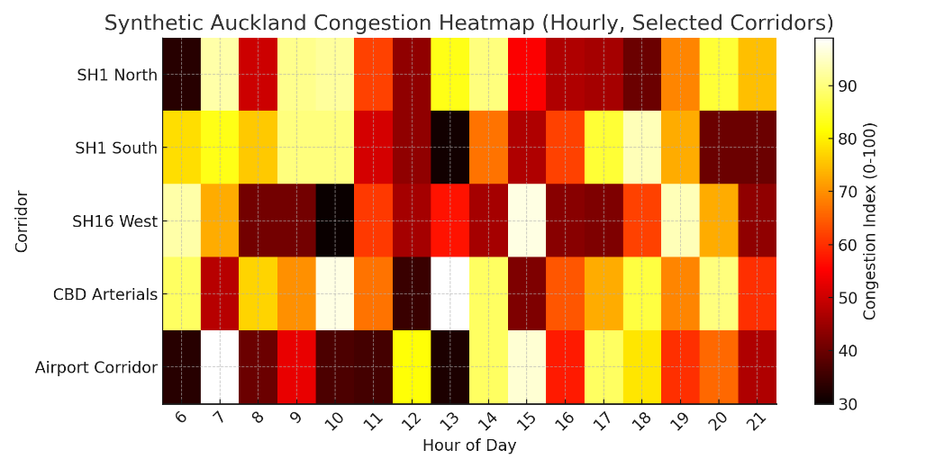
Figure 1: Synthetic congestion heatmap of selected Auckland corridors (SH1, SH16, CBD arterials, Airport). Congestion peaks occur during morning and evening rush hours [13].

3.3 AI Model Development and Evaluation
Several forecasting models will be designed and compared:
- ARIMA: A classical statistical time-series model that is utilized as a benchmark of the forecasting research. ARIMA extracts linear time dependence between historical traffic and it is effective in relatively steady settings with steady traffic patterns. Its greatest asset is in its interpretability and implementation portability, but it is not extensive in terms of non-linear and stochastic variations of complex urban networks like in the case of Auckland. Even with these shortcomings, ARIMA can serve as a good baseline to gauge the improvement that machine learning and deep learning models can bring[21].
- XGBoost: This is a supervised learning ensemble algorithm that builds decision trees sequentially in order to maximize predictive accuracy. XGBoost is very effective with tabular traffic information which is structured and incorporates a variety of contextual details to include in its calculation like speed, weather, occupancy and time of day. It holds strong resistance to overfitting, is scalable, as well as explainable using feature-importance metrics. Though XGBoost has been shown to be effective in non-linear relationships between variables, it does not support the ability to model time series on a variable that is the flow of time. Thus, it can be considered a hybrid of traditional and deep learning, providing good support in the medium-term forecasting with its strong back-up[11].
- LSTM: A variant of Recurrent Neural Network (RNN) that aims at memorizing temporal dependence over a long period in a sequence of data. The LSTMs store up to date information in gated memory cells, and are particularly useful in predicting time-dependent traffic, i.e. predicting morning or evening peak traffic congestion. They are very good at modeling dynamic changes under the influences of recent past historical trends, weather and incident data. Nevertheless, LSTMs are too slow in terms of resources and datasets, and hyperparameter optimization is critical to their performance. Nonetheless, they always achieve superior performance in relation to conventional models regarding the capacity to capture real-time changes, as well as abrupt congestion peaks of complex networks such as that of Auckland[25].
Table 1: Comparative AI Models.
Model | Description | Purpose
ARIMA | Classical statistical forecasting capturing linear temporal trends. | Baseline comparison.
XGBoost | Ensemble of gradient-boosted decision trees for structured tabular data. | Captures non-linear relationships and feature importance.
LSTM | Deep recurrent neural network maintaining memory of prior time steps. | Models sequential and temporal dependencies.

These models will not only be compared based on their ability to predict but also on their ability to be computationally efficient and also viable in real time application.

3.4 IoT Prototype and Backend Database Integration
As a way of simulating real-time sensor environments without reliance on commercial clouds,
an IoT testbed will be created.

3.4.1 Hardware/Software Stack
- ESP32 / Raspberry Pi microcontrollers acting as virtual roadside sensors.
- MQTT Broker (Mosquitto) pub-sub messages of low-latency.
- Backend Database: PostgreSQL (with TimescaleDB extension)
or InfluxDB for time-series ingestion.

3.4.2 Experiment Parameters
- The frequency of data generation 1 Hz (one message per second).
- The time per test: 30 minutes scenario-based test.
- Measured metrics:
  - Latency (ms) = Mean time to write message to DB.
  - Throughput (msg/s) = the number of successful messages/duration.
  - Reliability (%) = 100 × (successful / sent messages).

3.5 Dynamic Pricing Algorithm
The congestion pricing algorithm used in this research will be dynamic, varying the toll levels in real time based on the forecasted congestion and traffic scenarios. Two complementary plans are suggested to take place:
- Rule-based: The charges will be different as per set traffic density limits and per time-related groups. Toll rates are automatically raised to control demand when the predicted traffic volumes reach some predetermined level, and the prices lower to encourage road traffic when the traffic levels are low.
- AI-based Adaptive Strategy: Machine learning forecasts (e.g., XGBoost and LSTM predictions) keep predicting the short time congestion pattern, so that the system can adapt the tolls on a dynamic and fair manner according to the current road situation.

3.5.1 Dynamic Toll and Traffic Management Framework
The given framework demonstrates the entire end-to-end procedure of the suggested data-driven congestion pricing scheme of the Auckland transport network Figure 3. The system starts with real-time data collection on Auckland Transport APIs and roadside IoT sensors on vehicles, where they capture the vehicle number, vehicle license plate, travel speed, and the road condition [5], [18] The gathered information is sent safely to a back-end database (e.g. postgreSQL + timescaleDB or influxDB) where it is stored, cleaned, and pre-processed to be used in the further analysis.

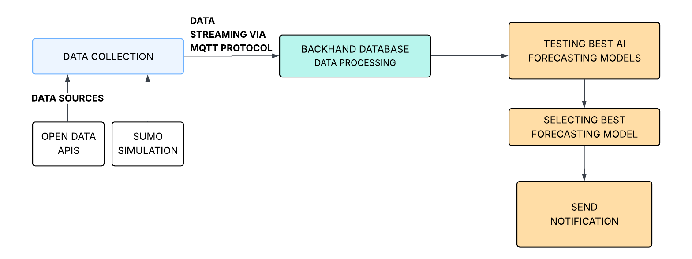
Figure 2: Workflow for Selecting the Best AI Forecasting Model.

A forecasting module is then predicted through an AI system that applies several models, such as ARIMA, XGBoost, and LSTM, to predict the near-future state of congestion in the Auckland traffic dynamism by determining which model will give the most precise and economically sound performance Figure 2. The system then uses the model of dynamic toll pricing, where the toll rates vary based on the expected traffic density and the time of user alerts.

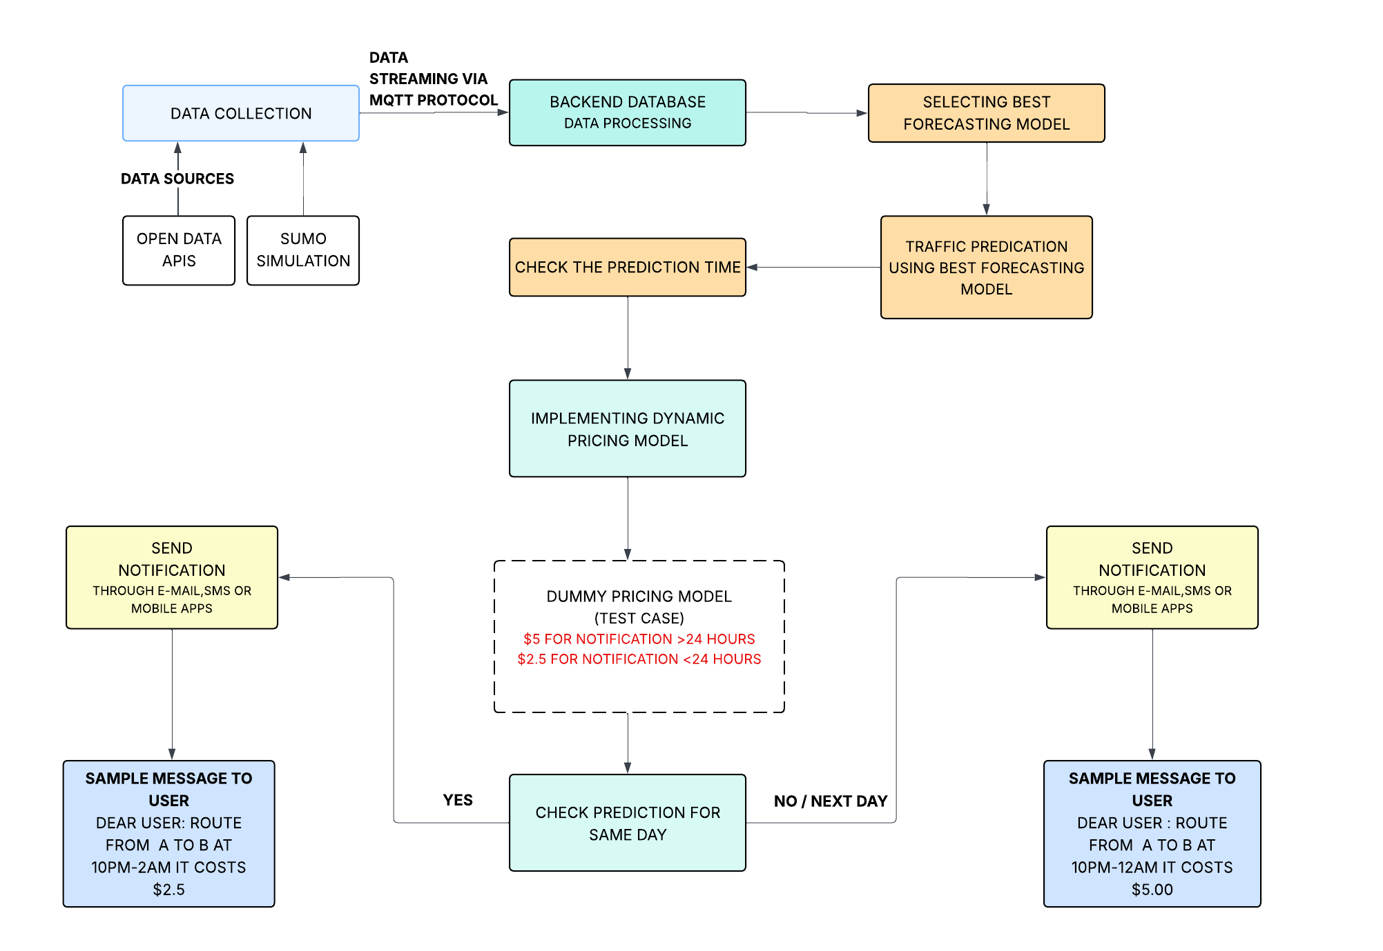
Figure 3: End-to-End Workflow of the Proposed Dynamic Tolling System for Predicting Future Travel Times and Sending Notifications to Users.
As an example, drivers are given automated warnings regarding the expected toll rates depending on the expected congestion:
- Advance Notification (more than 24 hours): It charges a congestion fee of 5 dollars to the people who are given notice on the congestion the previous day.
- Notice Reduction (Less than 24 hours): There is a charge of less than 24 hours that is considered urgent or same day except special off-peak cases like late-night traffic between 10 pm and 12 pm.
This is done by balancing the entry and exit time of the vehicles to the estimated congestion windows of the vehicles maintained in the backend database. Upon receiving the forecast of a high level of congestion, automatic billing and notification messages are created and sent to the drivers via the user interface or via the related mobile applications [13], [14].

Figure 3 illustrates the End-to-End Workflow of the Proposed Dynamic Tolling System for predicting future travel times and sending user notifications. It presents the complete
process—from real-time data sensing and processing to user alert generation. In
contrast, Figure 4 illustrates titled IoT Simulation Workflow of Vehicle Detection, and thenotification depicts the interaction between IoT sensors and the database, highlighting how vehicle detection data triggers billing and notification processes.

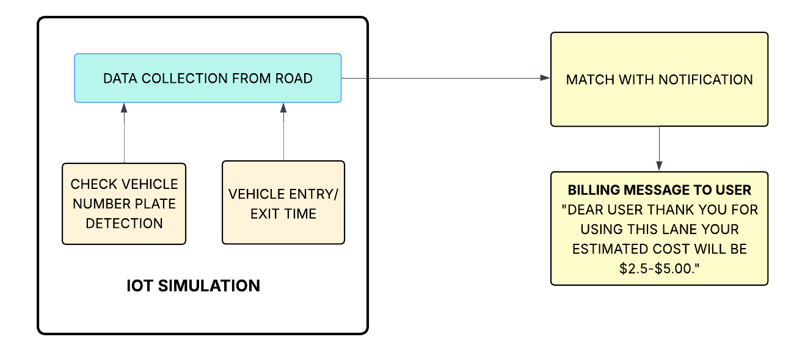Figure 4: IoT Simulation Workflow for Vehicle Detection and Billing Notification.
Moreover, Figure 5: illustrates the Hierarchy of Forecasting Models (ARIMA, XGBoost, LSTM) is a model-selection process in the framework. Such a hierarchy allows providing the systematic comparison between classical statistical approaches (ARIMA), the ensemble-based machine learning (XGBoost), and the deep learners (LSTM) to determine the best forecasting model in congestion prediction in Auckland.

To conclude, this composite plan proves that the alignment of IoT technologies, backend database manager, and AI predictive algorithms can provide a technically well-built, dynamic, and user-friendly congestion pricing framework. The framework does not only increase efficiency in traffic but also ensure fair and open tolling that is ideal to the standards of transport and privacy in New Zealand.
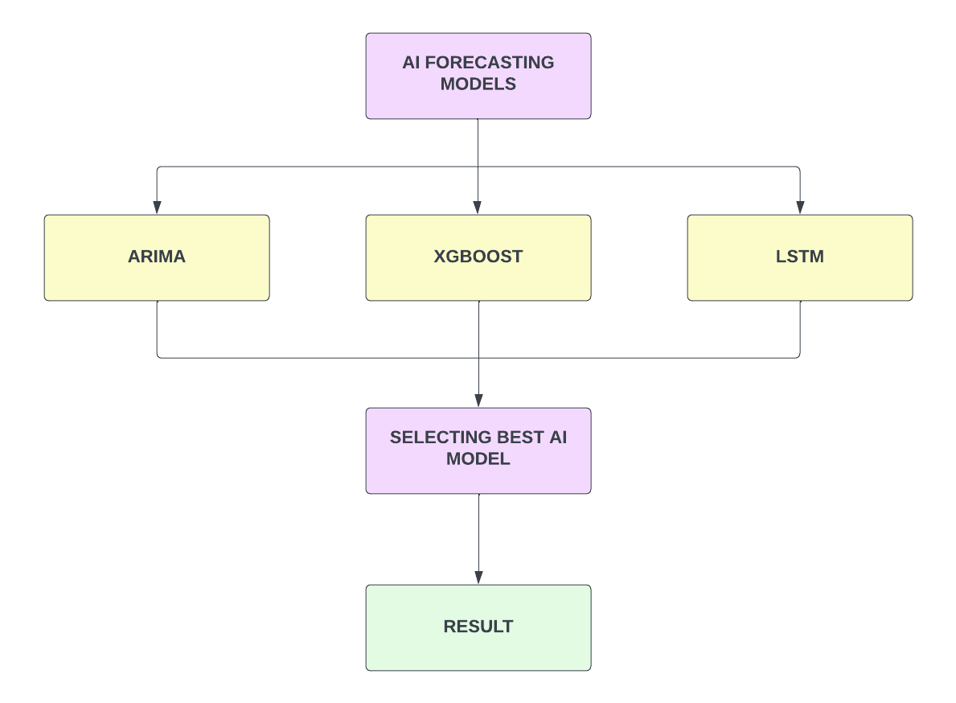

Figure 5: Hierarchy of Forecasting Models (ARIMA, XGBoost, LSTM)

3.5.2 Dynamic Toll Simulation
One can use the following mechanism of congestion-pricing: Cpred - Tnew:

$$T_{new}=T_{base}+α(C_{pred}-C_{threshold})$$
where
- $T_{base}$= nominal toll rate,
- $C_{threshold}$= permissible congestion level,
- $α$= experimentally determined coefficient of adjustment.
Workflow:
- After selecting an AI model, make 1-interval predictions of congestion.
- Obtain new toll rate by the following equation.
- Push rate messages and communications to virtual drivers.
- Record log transactions to be analyzed.

There will be several what-if scenarios (e.g., morning peak, off-peak, incident) that will be started to compare the results of the static and dynamic pricing in terms of the travel time decrease and toll stability.

3.6 Evaluation Metrics
The evaluation will use a dual framework:
- Technical Metrics: Accuracy of forecasting models (RMSE, MAE), system latency (end-to-end sensor to toll update delay), and throughput at peak-load[12].
This is a holistic assessment whereby the system will not only be technically feasible, but also acceptable to the society.

3.7 Expected Contributions
The research aims to deliver contributions on both technical and policy fronts:
- Technical: Design and implementation of a system prototype which will integrate AI forecasting, IoT data-gathering, database processing, and dynamic congestion-pricing algorithms. Comparison of the AWS and Azure performance to transport workloads will also be made [15].
- Academic: Development of the existing body of literature through provision of a distinct interdisciplinary case study that cuts across AI, IoT, Backend Database, and transport policy in a New Zealand context[10]

3.7 Timeline
- July – October 2025: Proposal Writing, Literature Review, and Dataset Preparation.
- October–December 2025: AI model development.
- December 2025 – January 2026: IoT prototype For Traffic Congestion.
- February – March 2026: Integration and testing of the dynamic pricing algorithm.
- April – May 2026: Policy analysis (privacy compliance).
- May – June 2026: Draft writing.
- June – July 2026: Revisions and Final thesis submission.
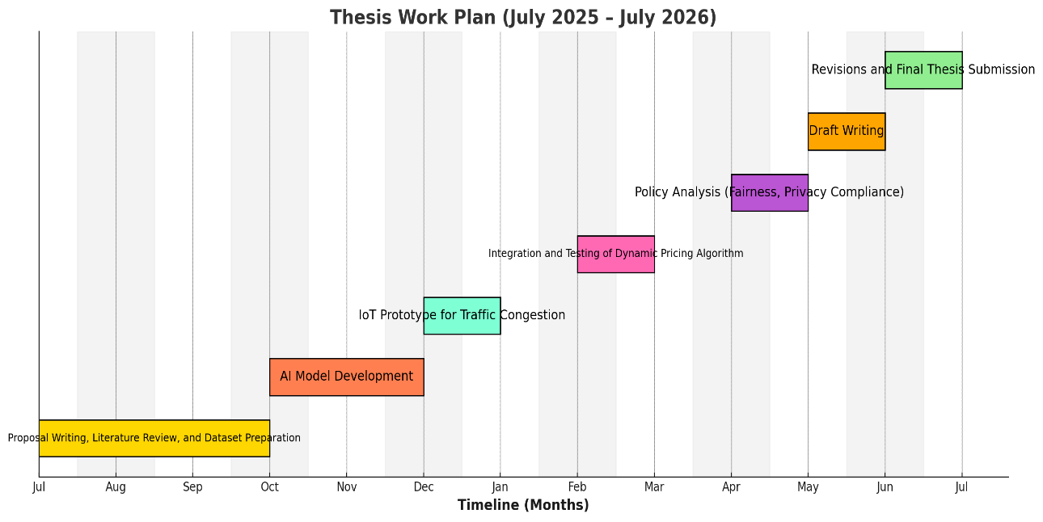

Chapter 4

4. Conclusion
The proposed research will seek to design, apply and critically assess a data-intensive congestion pricing scheme to the urban transport system of Auckland. The designed framework will combine artificial intelligence (AI)-based traffic forecasting engines, IoT-powered real-time sensor measurements and connected vehicles, and scalable Databse-based solutions to process them to allow dynamic and adaptive tolling measures In contrast to the traditional non-adaptable pricing solutions, this will dynamically examine live traffic patterns, anticipate congestion ahead of time, and modify toll rates on the fly, to maximize traffic flow and minimize urban bottlenecks [7], [10].
Besides the technical architecture, the research will also heavily focus on the equity and data privacy considerations[6]. The lack of objectivity will be resolved by assessing the effects of the system on various socio-economic categories to make sure that congestion fees will not be oppressive to vulnerable commuters, and privacy will be incorporated to align with the New Zealand Privacy Act 2020 and global best practices in the processing of sensitive mobility information.
It is believed that the results of this study will not just provide a technically viable and operationally viable prototype but also a socially acceptable policy framework that would provide balance between efficiency, sustainability and equity in the management of urban transport. In so doing, it will also help to serve the wider aims of New Zealand, which include minimizing congestion expenditures, minimizing emissions, and facilitating the exploration of smart cities seeking next-generation congestion pricing systems, as well as offer information to global cities[35], [36].

Bibliography

- J. K. Sankaran, A. Gore, and B. Coldwell, “The impact of road traffic congestion on supply chains: insights from Auckland, New Zealand,” International Journal of Logistics Research and Applications, vol. 9, no. 2, pp. 159–180, 2006, Available:https://www.tandfonline.com/doi/abs/10.1080/13675560500166780
- J. McArthur, “The production and politics of urban knowledge: Contesting transport in Auckland, New Zealand,” Urban Policy and Research, vol. 36, no. 1, pp. 45–61, Jun. 2018, Available: https://www.tandfonline.com/doi/abs/10.1080/08111146.2018.1476229
- Auckland Transport, “Developer Portal: Realtime API,” Auckland Transport, 2025. Available: https://dev-portal.at.govt.nz/realtime-api
- M. Miska, Data Standards for the New Zealand Transport Network (NZ Transport Agency Research Report 627). Wellington, New Zealand: NZ Transport Agency, 2017. Available: https://eprints.qut.edu.au/112940/
- E. Agge, Lakaki, Using Machine Learning on Open Traffic Data: The Case of the Finnish Open Government Data Portal, M.S. thesis, 2025. Available: https://dspace.lib.uom.gr/handle/2159/32580
- New Zealand Government, “Privacy Act 2020,” New Zealand Legislation,
2020. Available: https://www.legislation.govt.nz/act/public/2020/0031/latest/LMS23223.html
- G. Santos, “Urban congestion charging: A comparison between London and Singapore,” Transport Reviews, vol. 25, no. 5, pp. 511–534, 2005, Available: https://www.tandfonline.com/doi/abs/10.1080/01441640500064439
- S. H. Lam and T. D. Toan, “Land Transport Policy and Public Transport in Singapore,” Transportation, vol. 33, no. 2, pp. 171–188, Mar. 2006, Available: https://link.springer.com/article/10.1007/s11116-005-3049-z
- G. Santos, K. Button, and R. G. Noll, “London Congestion Charging,” Brookings-Wharton Papers on Urban Affairs, pp. 177–234, 2008. [Online]. Available: https://www.jstor.org/stable/25609551
- J. Leape, “The London Congestion Charge,” Journal of Economic Perspectives, vol. 20, no. 4, pp. 157–176, Fall 2006. Available: https://www.aeaweb.org/articles?id=10.1257/jep.20.4.157
- A.Broaddus, M. Browne, and J. Allen, “Sustainable Freight: Impacts of the London Congestion Charge and Low Emissions Zones,” Transportation Research Record, vol. 2478, no. 1, pp. 1–11, 2015. Available: https://journals.sagepub.com/doi/abs/10.3141/2478-01
- J. Eliasson, L. Hultkrantz, L. Nerhagen, and L. S. Rosqvist, “The Stockholm congestion–charging trial 2006: Overview of effects,” Transportation Research Part A: Policy and Practice, vol. 43, no. 3, pp. 240–250, Mar. 2009, Available: https://www.sciencedirect.com/science/article/pii/S0965856408001572?casa_token=zg_2-ikOdeAAAAAA:K9sIi9YdY7D3hCVomoCLciYTB78M8IzkQFvuylEHsHeP4YS9aGa8FpD3dd_Qan6t8QbiWR9MIdg
- M. Börjesson, J. Eliasson, M. B. Hugosson, and K. Brundell-Freij, “The Stockholm congestion charges—5 years on: Effects, acceptability and lessons learnt,” Transport Policy, vol. 20, pp. 1–12, Mar. 2012. Available: https://www.sciencedirect.com/science/article/abs/pii/S0967070X11001284
- Metropolitan Transportation Authority, “Central Business District Tolling Program (Congestion Relief Zone),” MTA, 2025. Available: https://www.mta.info/project/CBDTP
- Metropolitan Transportation Authority, “CBD Tolling Program: Tolling and Phase-in Schedule,” MTA, 2025. Available: https://congestionreliefzone.mta.info/tolling
- T. Chen and C. Guestrin, “XGBoost: A Scalable Tree Boosting System,” Proc. ACM SIGKDD, pp. 785–794, 2016. Available: https://dl-acm-org.libproxy.unitec.ac.nz/doi/10.1145/2939672.2939785
- S. Hochreiter and J. Schmidhuber, “Long Short-Term Memory,” Neural Computation, vol. 9, no. 8, pp. 1735–1780, 1997. Available: https://direct.mit.edu/neco/article-abstract/9/8/1735/6109/Long-Short-Term-Memory?redirectedFrom=fulltext
- N. G. Polson and V. Sokolov, “Deep learning for short-term traffic flow prediction,” Transportation Research Part C, vol. 79, pp. 1–17, 2017. Available: https://www.sciencedirect.com/science/article/abs/pii/S0968090X17300633?via%3Dihub
- S. V. Kumar and L. Vanajakshi, “Short-term traffic flow prediction using Seasonal ARIMA with limited data,” European Transport Research Review, vol. 7, no. 3, p. 21, 2015. Available: https://link.springer.com/article/10.1007/s12544-015-0170-8
- S. Narmadha and R. Saravanan, “Spatio-temporal vehicle traffic flow prediction using hybrid CNN-LSTM,” Journal of Building Engineering, vol. 70, 106458, 2023. Available: https://www.sciencedirect.com/science/article/abs/pii/S235271022300637X?via%3Dihub
- B. Yao, A. Ma, R. Feng, X. Shen, M. Zhang, and Y. Yao, “A Deep Learning Framework About Traffic Flow Forecasting for Urban Traffic Emission Monitoring System,” 2022. Available: https://www.frontiersin.org/journals/public-health/articles/10.3389/fpubh.2021.804298/full
- W. Jiang and J. Luo, “Graph Neural Network for Traffic Forecasting: A Survey,” arXiv e-prints, 2021. Available: https://arxiv.org/abs/2101.11174
- R. Liu, W. Zhang, and X. Gao, “A Review of Traffic Flow Prediction Methods in ITS,” Applied Sciences, vol. 15, no. 7, 3866, 2025. Available: https://www.mdpi.com/2076-3417/15/7/3866
- P. A. Lopez, M. Behrisch, L. Bieker-Walz, et al., “Microscopic Traffic Simulation using SUMO,” Proc. IEEE ITSC, pp. 2575–2582, 2018. Available: https://ieeexplore-ieee-org.libproxy.unitec.ac.nz/document/8569938
- Eclipse Foundation, “Eclipse SUMO — Simulation of Urban MObility,” Eclipse.dev, 2025. Available: https://eclipse.dev/sumo/
- OASIS, “MQTT Version 3.1.1 Plus Errata 01,” OASIS Standard, 2014. Available: https://dcomp.ufscar.br/verdi/topicos2017/mqtt-v3.1.1-errata01-os-complete.pdf
- Z. Shelby, K. Hartke, and C. Bormann, “The Constrained Application Protocol (CoAP),” IETF RFC 7252, 2014. Available: https://www.rfc-editor.org/info/rfc7252
- OASIS, “Advanced Message Queuing Protocol (AMQP) Version 1.0,” OASIS Standard, 2012. Available: https://docs.oasis-open.org/amqp/core/v1.0/os/amqp-core-overview-v1.0-os.html
- Enrico Russo; Gabriele Costa; Alessandro Armando: “Scenario Design and Validation for Next Generation Cyber Ranges” 2018. Available: https://ieeexplore-ieee-org.libproxy.unitec.ac.nz/abstract/document/8548324
- T. Gong, Q. Wang, X. Ma, et al., “Edge Intelligence in Intelligent Transportation Systems: A Survey,” IEEE T-ITS, vol. 24, no. 11, pp. 10875– 10894, 2023. Available: https://ieeexplore-ieee-org.libproxy.unitec.ac.nz/document/10133894
- K. Hosford, M. Palm, M. Winters, and K. Teschke, “The effects of road pricing on transportation and health equity: A systematic review,” PLOS ONE, vol. 16, no. 10, e0245410, 2021. Available: https://www.tandfonline.com/doi/abs/10.1080/01441647.2021.1898488
- Craik, Lauren, “Congestion Pricing: Moving from Equity Analysis to Transportation Justice” DSpace@MIT, 2022. Available: https://dspace.mit.edu/handle/1721.1/144684
- Shaheen, Susan, Stocker, Adam, Meza, Ruth. “Social Equity Impacts of Congestion Management Strategies,” escholarship, 2019. Available: https://escholarship.org/uc/item/9z9618mn
- K. Sato and F. Kurauchi, “A reinforcement learning–based dynamic congestion pricing method for the morning commute problems,” Sustainable Cities and Society, vol. 69, 102840, 2021. Available: https://www.sciencedirect.com/science/article/pii/S2352146521000739
- J. Lu, H. Jin, Z. Li, and B. Ran, “MAGT-toll: A multi-agent reinforcement learning approach to dynamic traffic congestion pricing,” PLOS ONE, vol. 19, no. 8, e0313828, 2024. Available: https://journals.plos.org/plosone/article?id=10.1371/journal.pone.0313828
- J. Zhang, Q. Li, and X. Chen, “A CNN–LSTM–GRU Hybrid Model for Spatiotemporal Highway Traffic Flow Prediction,” Systems, vol. 13, no. 9, 765, 2025. Available: https://www.mdpi.com/2079-8954/13/9/765
- Auckland Transport, “Open GIS Data Portal,” AT GIS Open Data, 2025. Available: https://data-atgis.opendata.arcgis.com/
- Transport for London, “Congestion Charge proposals (Consultation summary),” TfL Have Your Say, 2025. Available: https://haveyoursay.tfl.gov.uk/congestion-charge-proposals
- X. Tian, J. Ding, H. Liu, X. Xing, and J. Liu, “Short-term traffic flow prediction based on ICEEMDAN–MPE–PSO–DELM–ARIMA,” Scientific Reports, vol. 15, 26296, 2025. Available: https://www.nature.com/articles/s41598-025-11919-6

