Steps to be done post DB refresh from other environment:

- Configure BCC site agents by entering correct environment urls of the agents

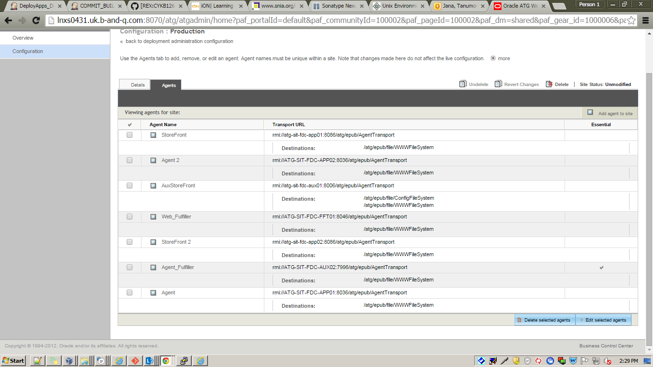
Change the agents of production and staging with correct URL. Then please do “make changes live” .

- Create a project, update the site urls with correct one and deploy the project.

Create a project from Site Administration Manage Site Assets .
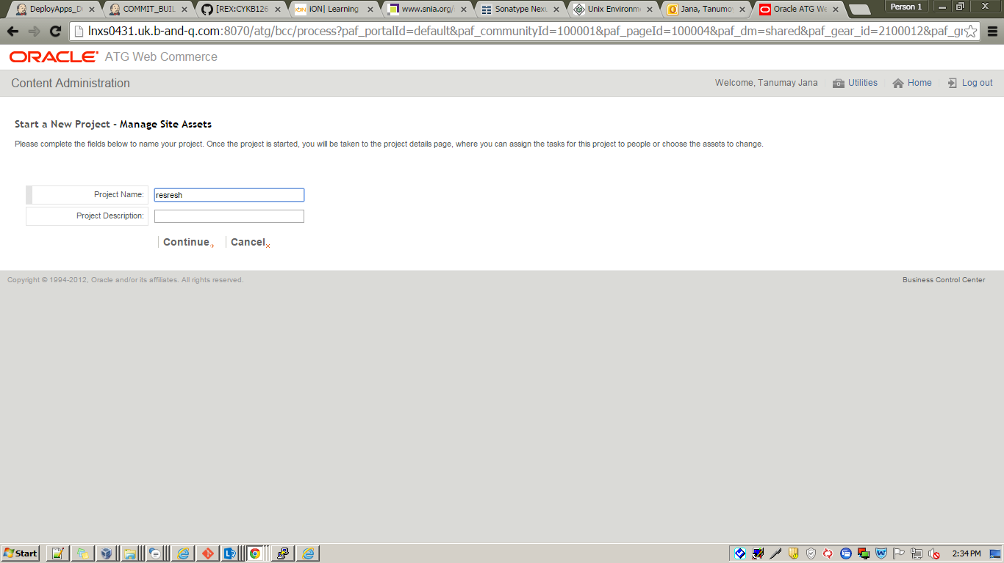

Please do correction with proper url in Site tab for (DIY, DIY ROI,TP,TP ROI)

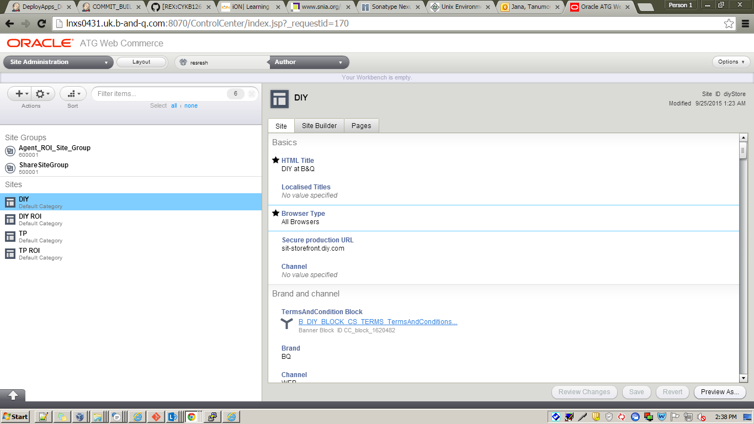

Important note: After making the above changes save it. Then approve the project for staging deployment and accept the deployment .Then approve the project for production deployment and accept it .If you do not accept the same the next project will not be lived.

- Configure search to point to the correct url for both Catalog Content Set and Non Product Content in content tab. (Only required if prod schema is also refreshed).

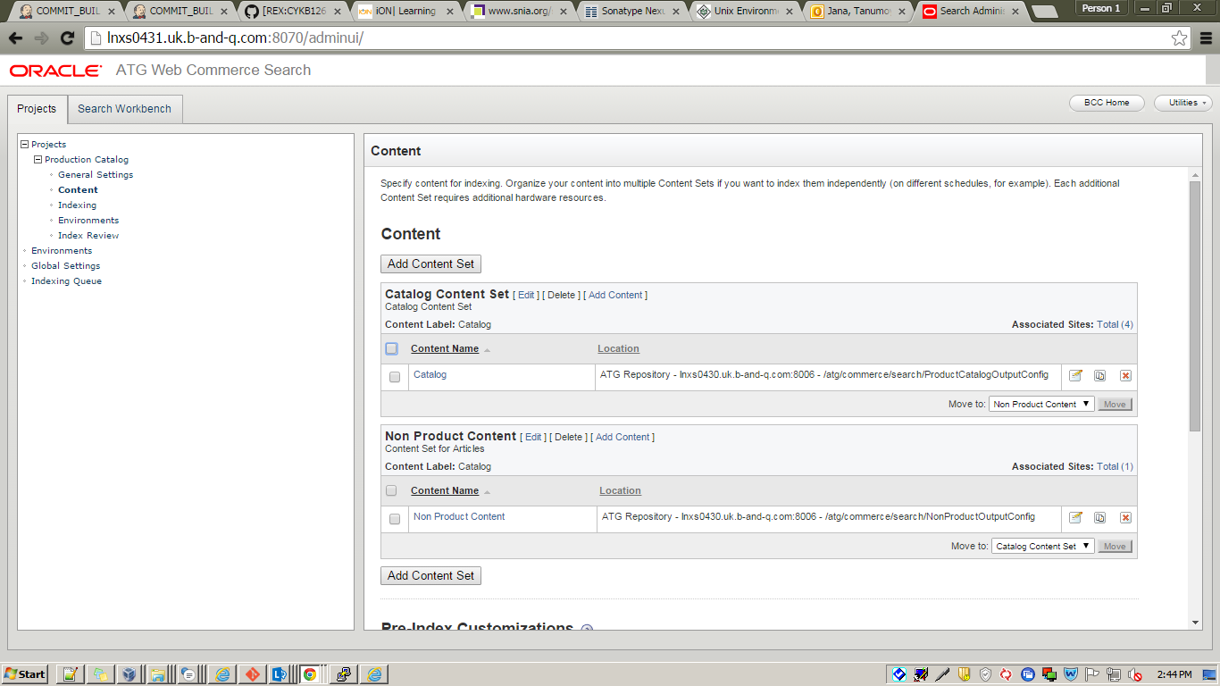

Configure search to point to the correct url in Environments tab for both Search Project: Production Catalog (commerce and indexing environment ) .Only required if prod schema is also refreshed).

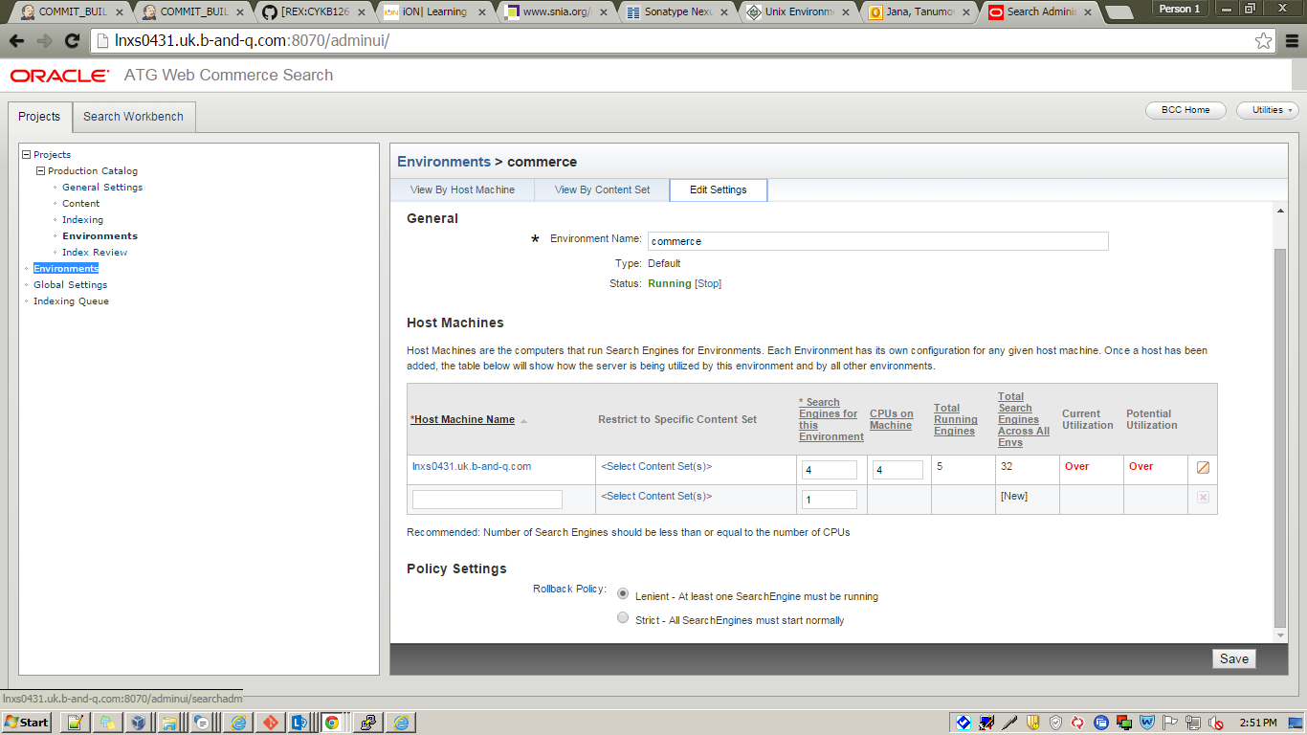
Please note that:
Do the same in staging as production.

- Trigger full indexing.

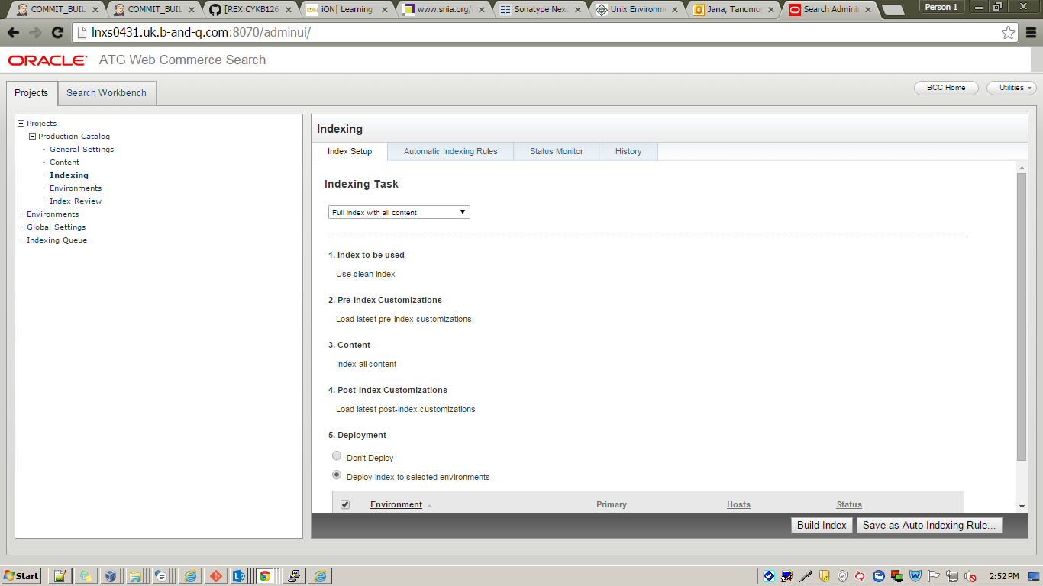
- Update das_id_generator table in prod schema to change the prefix to the current environment.(Only required if prod schema is also refreshed).
Do not change the prefix name where the env name is not mentioned.

- Update das_id_generator.sap_order, das_id_generator.return_order and das_id_generator.sap_quote with the latest respective order ids (normal order, quote order and return/exchange order) from SAP. (Only required if prod schema is also refreshed).

The 6th point is not our task.

