BCC Configuration For Facets



Author: Ankur Agarwal
Version: 0.1
Status: INTERNAL REVIEW DRAFT

Revision History
Version Number | Who | Revision Date | Summary of Changes | Changes marked
0.1 | Ankur Agarwal | 11/08/13 | Initial document creation
Reviewers
This document has been distributed to:
Name | Title
Ramuparaksh.C

Distribution
This document has been distributed to:
Name | Title

References
No. | Title | Document Name | Date

Table of Contents

1. Introduction 4
2. Purpose of document 4
3. BCC Configuration Workflow 4

Introduction

Darwin is a business and IT transformation programme and the first and most significant building block to deliver the B&Q’s multi-channel offering. The Darwin programme will deliver a web, call centre and in-store solution to support the B&Q’s multi-channel offering for both Retail and Trade (via TradePoint) customers.
The IT solution element of Darwin will:
Enable the B&Q business proposition;
Provide an IT solution foundation that has the potential to accelerate the delivery of multi-channel solutions in other OpCo’s across the Kingfisher Group;
Address end of life and support issues with existing systems.
There were three major customer releases planned
CR1 – enabling the Tradepoint website (trade customers)
CR2 – DIY.com site (Mobile devices included)
CR3 – Call center and in-store solution for handling returns, exchanges and refunds

Purpose of document
This document is to describe the BCC configuration for creating of Facets in BCC for products.

BCC Configuration Workflow

Please follow the below steps, along with the relevant screen shots for creating the New Search Project.

Step 1:

Go to BCC>Merchandising>Manage Commerce Assets.
Create a new project.

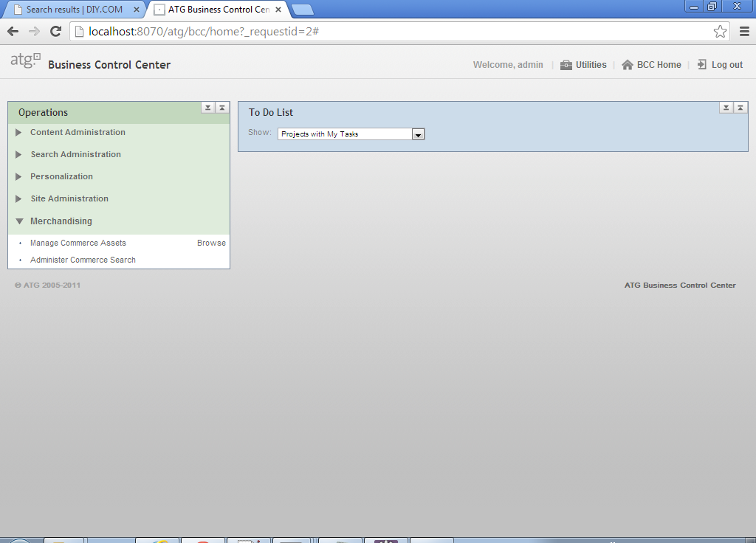
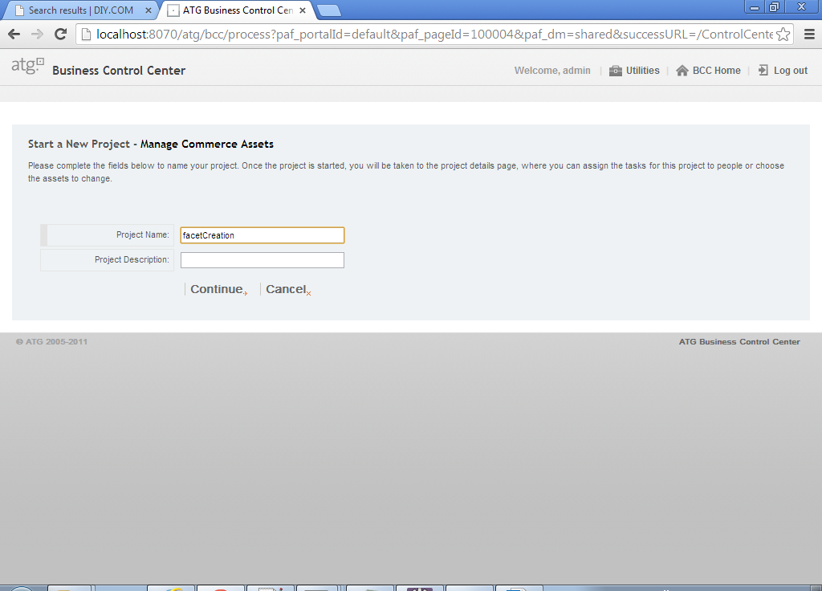

Step 2:

Click on "Merchandising" menu on the Left Hand Side. The below screen appears.
Click on "Search Merchandising" option.

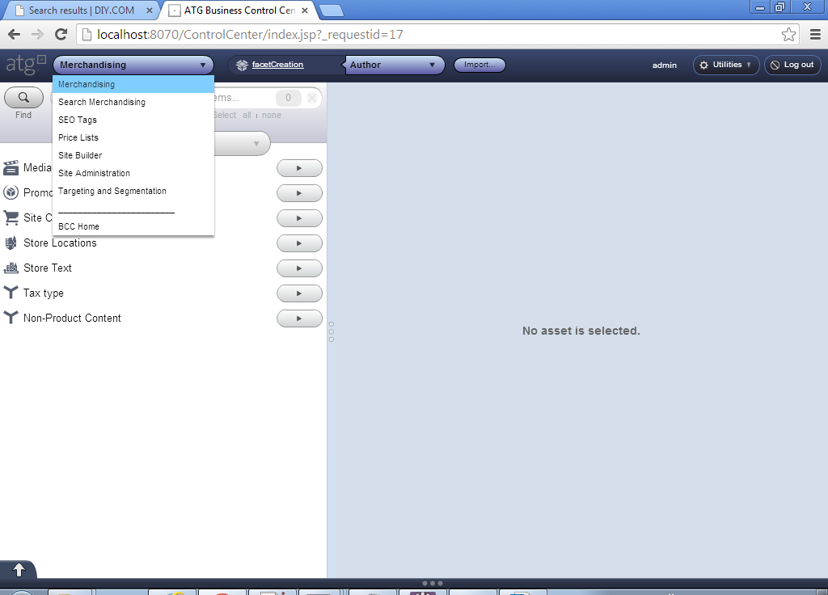
Step 3:

On the Search Merchandising, screen select the option.”Facets” from the drop down as shown below.

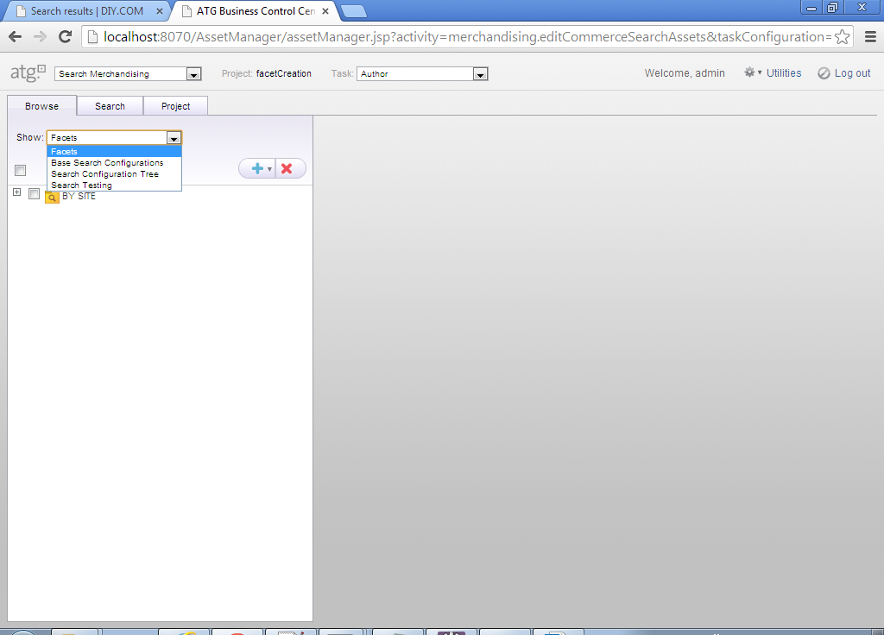

Step 4:

The below screen will appear, select any category from the available list, on which the facet needs to be created.
The right side of the page will have all the options to create a facet.

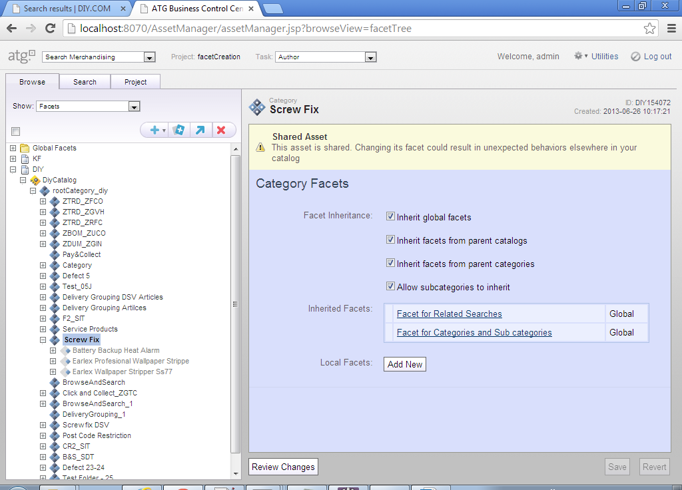
Step 5:

Click on, “Add New” button to add a new facet. The below screen appears.
Select a faceting property from the drop down, on which the facet needs to be created.
Also provide the name of the facet in the Text Box.
All other configuration that needs to be done can be done on this page.

Click on “Create and Close” and proceed to project deployment, otherwise click on “Create”, if you want to make another facet.

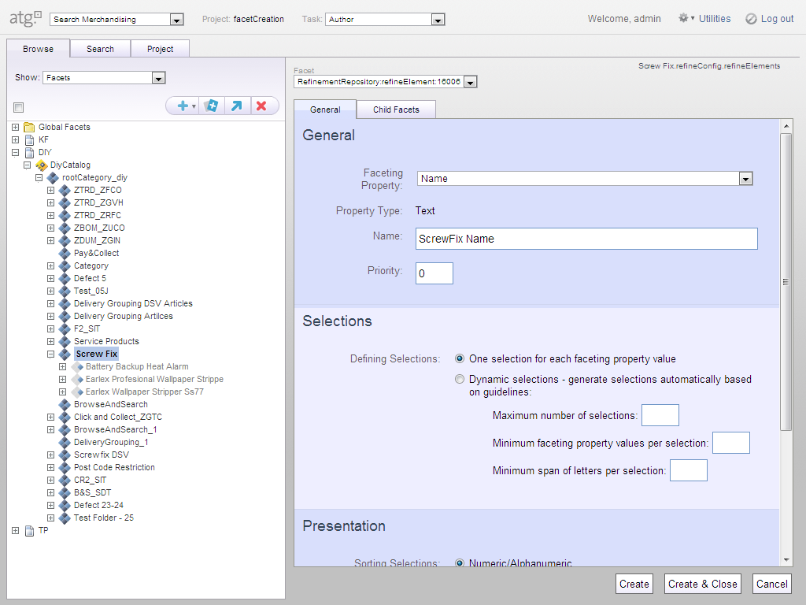

Creation of Global Facets :
The below steps show how to create a global facet.
Click on “Global Facets” as shown on the above screen, the below screen appears,
Select a faceting property, for eg. Parent Categories → Id shows the categories on the search terms.
Proceed as the steps above for creating more facets.
