STEP -1 :

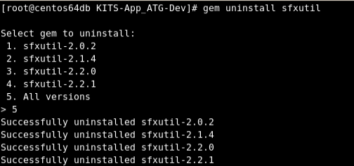
STEP-2 :

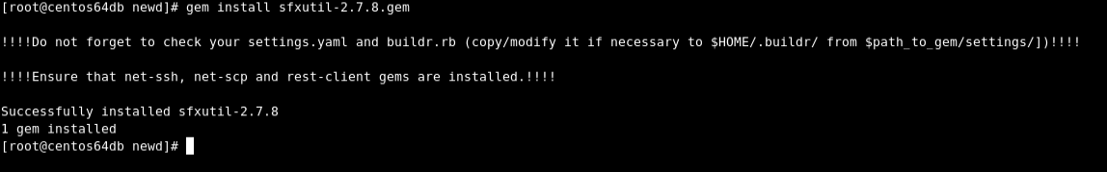
STEP-3 :

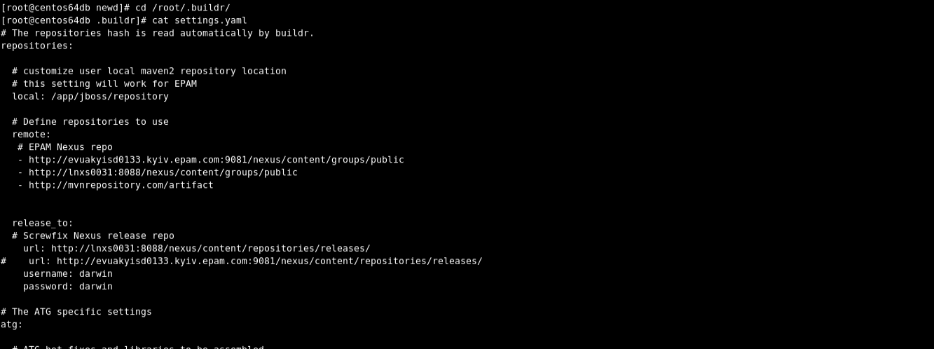

STEP -4

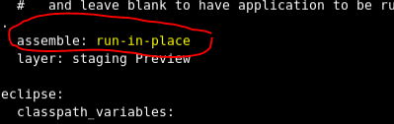

NOTE : REMEMBER TO GIVE A WHITE SPACE BEFORE WRITING "run-in-place".

STEP -5

Go back to the workspace where the codebase(DEV_MASTER_RESTRUCTURE) is cloned .

Run the below mentioned commands.

buildr –f buildfile_dev.rb clean build –e Common
buildr –f buildfile_dev.rb clean build test=no –e Web
buildr –f buildfile_dev.rb clean build –e Publishing
buildr –f buildfile_dev.rb clean build -e Fulfillment
buildr –f buildfile_dev.rb clean build -e Staging
buildr –f buildfile_dev.rb clean build -e lock

buildr –f buildfile_dev.rb eclipse –e all

Perform the makeLinks.sh
N.B: Use the updated makeLinks.sh which is in \\10.22.2.176\req_4_new_code

