STEP -1 :

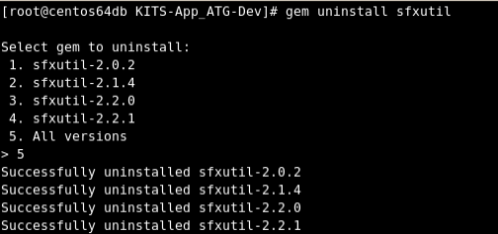
STEP-2 :

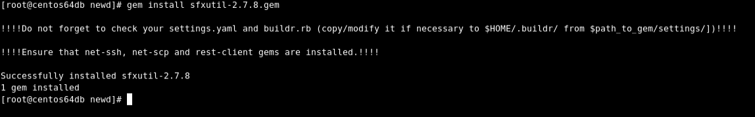
STEP-3 :

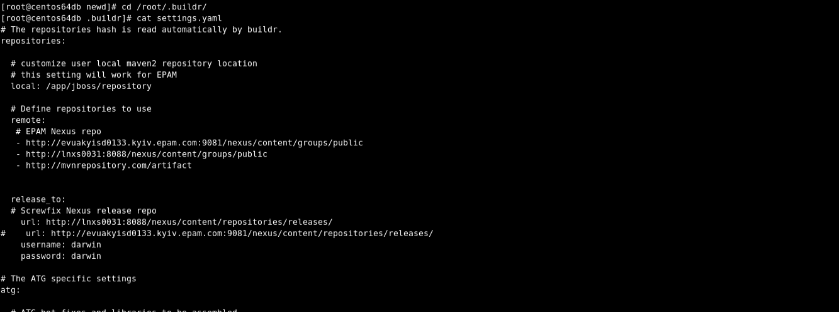

STEP -4

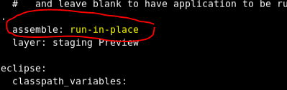

NOTE : REMEMBER TO GIVE A WHITE SPACE BEFORE WRITING "run-in-place".

STEP -5

Go back to the workspace where the codebase(DEV_MASTER_RESTRUCTURE) is cloned .

Run the below mentioned commands.

buildr -f buildfile_dev.rb clean build -e Common
buildr -f buildfile_dev.rb clean build -e Web
buildr -f buildfile_dev.rb clean build -e Publishing
buildr -f buildfile_dev.rb clean build -e Fulfillment
buildr -f buildfile_dev.rb clean build -e Staging
buildr -f buildfile_dev.rb clean build -e lock

buildr -f buildfile_dev.rb eclipse -e all

