Install the virtual box 4.1.8:

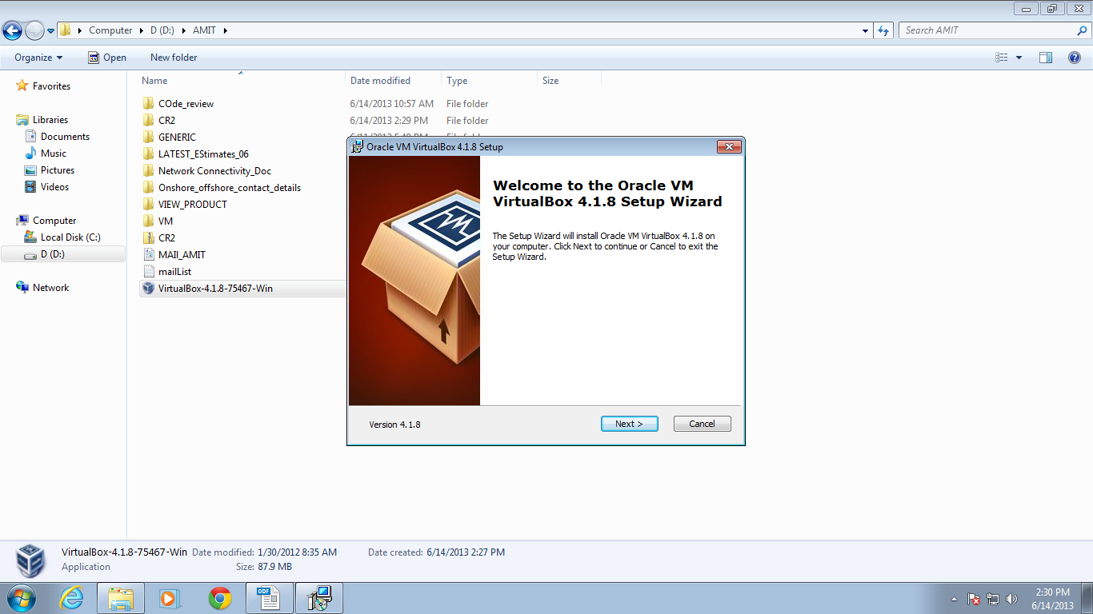

Follow the steps and finish.

Add the below entries in HOST file.

127.0.0.1 localhost
192.168.56.10 vm.local
192.168.56.10 kf.vm.local
192.168.56.10 tp.vm.local
192.168.56.10 vm.diy
192.168.56.10 centos64db

Then You have to shut down the machine and then start the bio setup screen by pressing F1 immediately after the starting of machine.

In Bio set up , Go to
Advanced----> CPU setup(Enter)------> keep the below 2 things enabled:

Intel Virtualisation Technology-enabled
VT-d -enabled
Then press F10(save & Exit).

Then go to Oracle VM VirtualBox : Go to machine------>add

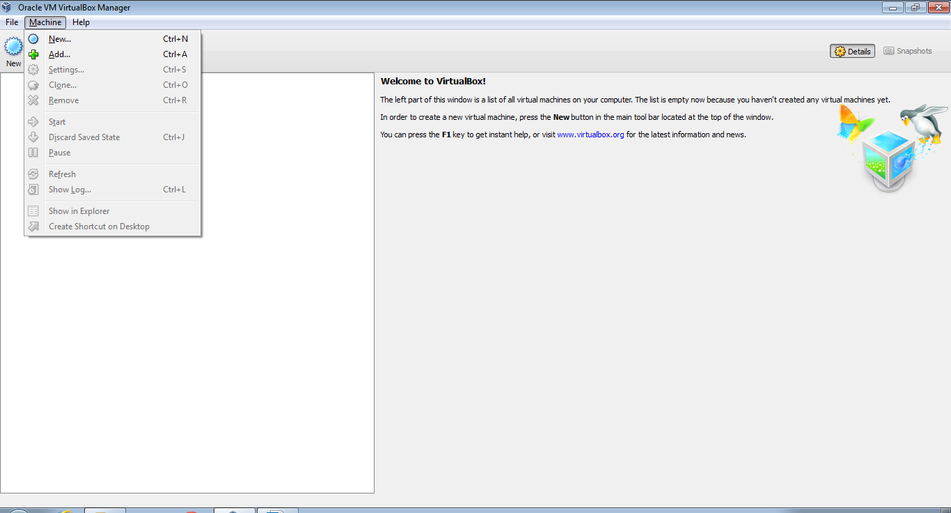

Then go to Oracle VM VirtualBox ---->>Go to machine------>add----->Browse to find VM path downloaded in your machine (EpamVMATG101)

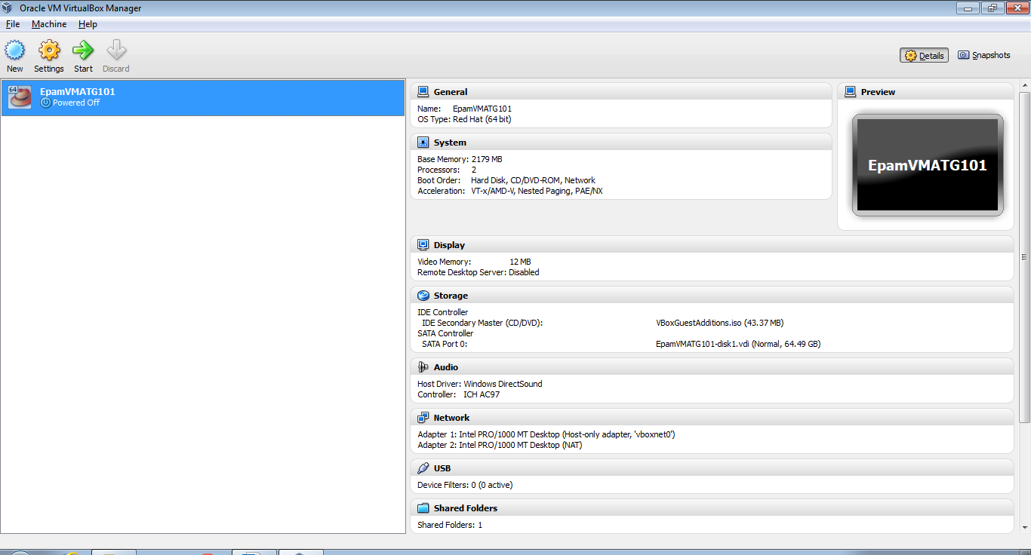

Click on Settings button. Make sure below settings:

System -> Processor -> 2

System -> Base memory -> 5200 MB

Display -> Video -> 64

Start Virtual machine you just added by clicking “Start” button.

After some time(around 10 min), it will ask for Centos64db login and password.

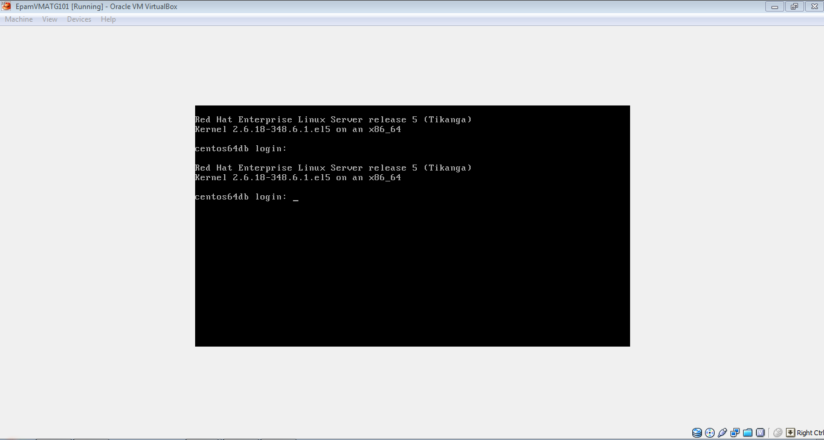

Login: root
pwd: oracle

root@centos64db]# ------>startx

Below is the final screen of VM.

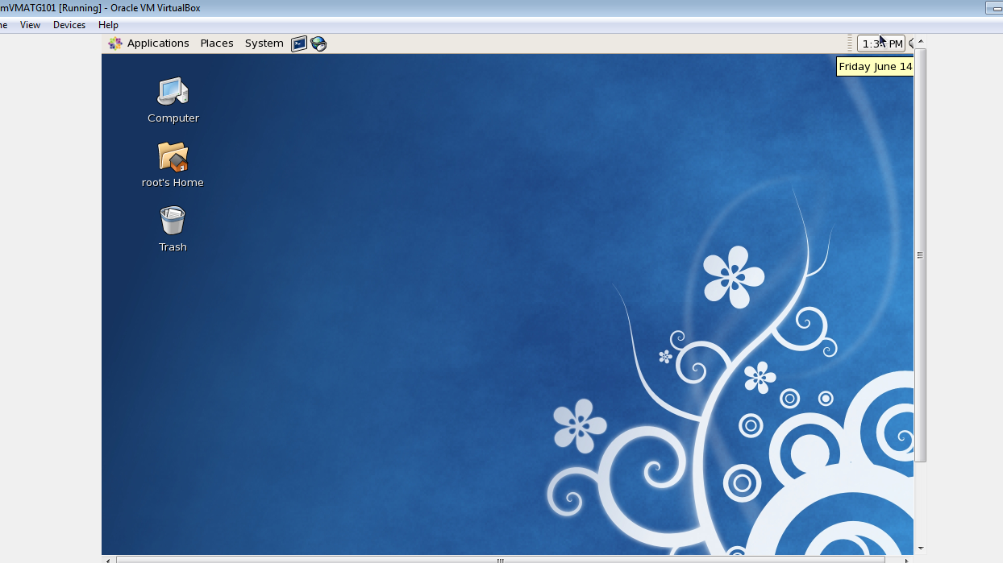

You should have oracle, mqm installed and started on the vm;

Please check if corresponding processes are running with commands:

ps aux | grep java
ps aux | grep mqm
ps aux | grep oracle

Find ip address of your vm machine with command:

The CentOS VM assumes a static IP of 192.168.56.10
- The /etc/hosts file has been set to point vm.local to 192.168.56.10
- Configure virtual hosts (both in the Guest & Host)
192.168.56.10 vm.local
192.168.56.10 kf.vm.local
192.168.56.10 tp.vm.local
192.168.56.10 vm.diy

