E-Commerce Sales & Customer Analytics
An End-to-End Data Analytics Case Study — Python · PostgreSQL · SQL · Power BI
Vivek
July 2026
Project Type: End-to-End Data Analytics Project
Tools Used: Python · PostgreSQL · Power BI · Excel · SQL · Pandas · NumPy · Matplotlib
Repository: github.com/Vivek7ok/E-commarce_data_analysis_

Table of Contents
Section | Page
1. Executive Summary | 2
2. Project Overview | 3
3. Dataset Overview | 4
4. Data Cleaning | 6
5. Database Design | 7
6. SQL Analysis | 9
7. Dashboard Development | 12
8. Business Insights | 16
9. Business Recommendations | 18
10. Challenges Faced | 18
11. Skills Demonstrated | 19
12. Project Workflow | 20
13. Conclusion | 21
14. Appendix | 21

1. Executive Summary
Business Problem. E-commerce marketplaces generate transactional data across customers, orders, payments, products, sellers, and reviews — but this data is only valuable if it can be turned into a single, trustworthy view of performance. Without that view, it is difficult to know which regions, categories, and sellers actually drive revenue, or where delivery and satisfaction problems are concentrated.
Goal. Build a complete analytics pipeline — from raw, imperfect data to an interactive decision-making tool — that answers concrete business questions about revenue, customers, products, sellers, delivery, and satisfaction.
Solution. A three-stage pipeline was implemented: Python/Pandas for data cleaning and exploratory analysis, PostgreSQL for structured, query-driven business analysis across eight SQL scripts, and Power BI for a six-page interactive dashboard modeled on the cleaned relational data.
Outcome. The analysis quantified the business at R$16.0 million in total revenue across 99,441 orders and 96,096 unique customers, served by 3,095 active sellers, with a 97% delivered order rate and a 4.09/5 average review score. It also surfaced actionable gaps — a ~3% repeat purchase rate, delivery times in northern states more than double the national average, and seller concentration of ~60% in São Paulo state — which are translated into the recommendations in Section 9.
Note on scope: All figures in this report are drawn directly from the repository’s data, SQL scripts, README, and Power BI screenshots. Where the underlying CSV files were available, headline figures were independently recalculated in Python and matched the project’s own findings (see Section 3 and Section 8).

2. Project Overview

Background
The project analyzes a Brazilian e-commerce marketplace dataset (customer orders, payments, products, sellers, and reviews) to understand what drives revenue and where operational friction exists. The dataset spans transactions across 2016–2018.

Objectives
As stated in the repository’s business problem definition, the project set out to: - Measure overall business performance (revenue, orders, AOV, customer base) - Identify the states, cities, and customers that drive the most revenue - Determine which product categories sell the most and generate the most revenue - Evaluate seller performance and geographic concentration - Analyze delivery times and their impact on cancellations and reviews - Understand how payment method relates to revenue share and customer satisfaction

Scope
The scope covers the full analytics lifecycle: raw data ingestion, cleaning and feature preparation, relational database design, SQL-based business-question analysis, and dashboard delivery. It does not include predictive modeling, customer segmentation via clustering, or a production deployment layer — the repository is structured as an analytical case study rather than a live application.

Technologies Used
Layer | Technology
Data cleaning & EDA | Python, Pandas, NumPy, Matplotlib, Seaborn
Database | PostgreSQL
Data loading | SQLAlchemy + psycopg2
Business analysis | SQL (CTEs, joins, window functions)
Visualization | Power BI
Version control | Git / GitHub

Expected Business Value
A stakeholder using this analysis can identify where revenue concentration creates risk (e.g., seller and customer geography), where operational investment would have the highest payoff (e.g., northern-state logistics), and which levers do not move customer satisfaction (e.g., price), redirecting attention to the levers that do (e.g., delivery reliability).

3. Dataset Overview

Source
The dataset consists of 8 relational CSV files stored in /Data/, mirroring a real e-commerce marketplace’s operational tables (customers, orders, order items, payments, products, reviews, sellers, and a product-category name translation table). A compressed copy is also included as Data_zip.zip.

Table Sizes and Key Columns
Table | Rows (excl. header) | Key Columns
customers.csv | 99,441 | customer_id, customer_unique_id, customer_zip_code_prefix, customer_city, customer_state
orders.csv | 99,441 | order_id, customer_id, order_status, order_purchase_timestamp, order_approved_at, order_delivered_carrier_date, order_delivered_customer_date, order_estimated_delivery_date
order_items.csv | 112,650 | order_id, order_item_id, product_id, seller_id, shipping_limit_date, price, freight_value
payments.csv | 103,886 | order_id, payment_sequential, payment_type, payment_installments, payment_value
products.csv | 32,951 | product_id, product_category_name, product_name_lenght, product_description_lenght, product_photos_qty, product_weight_g, product_length_cm, product_height_cm, product_width_cm
reviews.csv | 104,719 | review_id, order_id, review_score, review_comment_title, review_comment_message, review_creation_date, review_answer_timestamp
sellers.csv | 3,095 | seller_id, seller_zip_code_prefix, seller_city, seller_state
category_name.csv | 71 | product_category_name, product_category_name_english
(Row counts independently verified against the raw files in this analysis; they match the totals reported in the repository README.)

Data Size
Combined, the raw CSVs total approximately 62 MB, with orders.csv (17 MB), order_items.csv (15 MB), and reviews.csv (15 MB) as the largest tables.

Data Relationships
The tables form a standard order-centric relational model: - One customer → many orders - One order → many order items (one row per product line) and many payments (one row per installment) - One order item → one product and one seller - One order → one or more reviews - Products link to category_name for English category translations
The full relationship map is detailed in Section 5 (Database Design).

4. Data Cleaning
Cleaning was performed in Python/Pandas (Python/Cleaing.py) prior to loading data into PostgreSQL and Power BI. The table below summarizes what was done, table by table.
Table | Issue | Treatment
orders | Missing order_approved_at, order_delivered_carrier_date, order_delivered_customer_date | Forward-filled (.ffill()) to carry the last valid timestamp forward
orders | Date columns stored as text | Converted all four timestamp columns to proper datetime types via pd.to_datetime(..., errors='coerce')
reviews | Missing review_comment_title / review_comment_message | Filled with placeholder labels "No Title" / "No Message"
products | Missing product_category_name | Filled with the label "Missing"
products | Remaining nulls across numeric fields | Filled with 0 via .fillna(0)
products | Numeric fields stored as floats (due to prior NaNs) | Cast to integer: product_description_lenght, product_photos_qty, product_weight_g, product_length_cm, product_height_cm, product_width_cm
Representative snippet (orders cleaning):
# Fill missing delivery dates
orders['order_approved_at'] = orders['order_approved_at'].ffill()
orders['order_delivered_carrier_date'] = orders['order_delivered_carrier_date'].ffill()
orders['order_delivered_customer_date'] = orders['order_delivered_customer_date'].ffill()
# Convert order date columns to datetime
orders['order_purchase_timestamp'] = pd.to_datetime(orders['order_purchase_timestamp'], errors='coerce')
orders['order_delivered_customer_date'] = pd.to_datetime(orders['order_delivered_customer_date'], errors='coerce')
Representative snippet (products cleaning):
products['product_category_name'] = products['product_category_name'].fillna('Missing')
products = products.fillna(0)
numeric_product_columns = [
'product_description_lenght', 'product_photos_qty', 'product_weight_g',
'product_length_cm', 'product_height_cm', 'product_width_cm'
]
for column in numeric_product_columns:
products[column] = products[column].astype(int)

Data Validation
After cleaning, row counts, data types, and null counts were re-checked in Python/EDA.py using df.info(), df.describe(), and df.isnull().sum() prior to merging all eight tables into a single analytical DataFrame for exploratory analysis.

Feature Engineering & Transformation
The main derived features used across the SQL and dashboard layers are delivery time (order_delivered_customer_date − order_purchase_timestamp), monthly order/revenue periods (via DATE_TRUNC('month', ...)), and English category names (via the category_name translation join) — all computed downstream in SQL rather than pre-baked into the CSVs, keeping the cleaned data close to its raw form.
ℹ️ Note: The cleaning script (Cleaing.py) does not perform duplicate-row removal explicitly; no duplicate-handling step was found in the repository. This is noted for completeness rather than assumed.

5. Database Design

Overview
The cleaned CSVs are loaded into a PostgreSQL database using Python/Insert.py, which reads each cleaned file with Pandas and writes it to a table of the same name via SQLAlchemy’s to_sql(), one table per CSV (customers, orders, payments, products, reviews, sellers, order_items, category_name_translation).
engine = create_engine("postgresql+psycopg2://<user>:<password>@localhost:5432/<database>")
for file in files:
df = pd.read_csv(path)
table_name = file.replace(".csv", "")
df.to_sql(table_name, engine, if_exists="replace", index=False)
(Connection credentials in the original script are hardcoded inline; see Section 10 for a note on this.)

Entity-Relationship Diagram
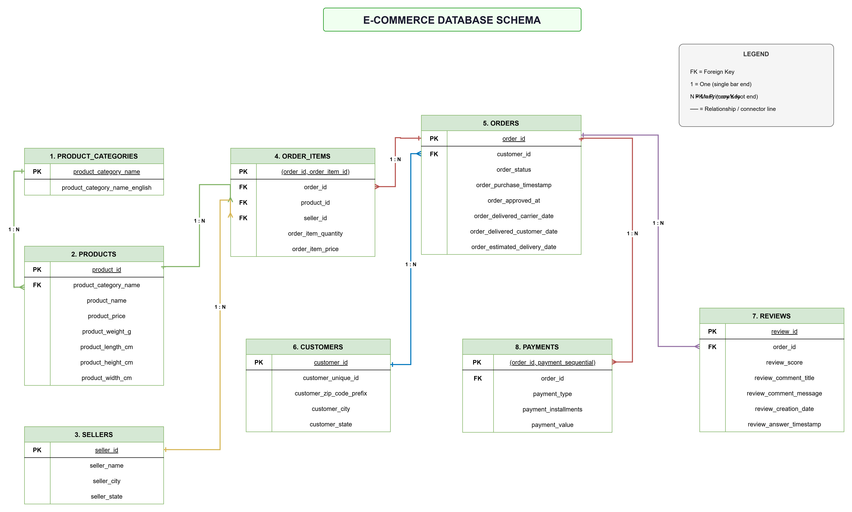 Figure 1. Entity-relationship diagram of the eight-table schema, showing primary keys, foreign keys, and cardinalities (source: ER Digram/Database_Schema.png).

Tables, Keys, and Relationships
Table | Primary Key | Foreign Keys | Relationship
customers | customer_id | — | 1 customer → N orders
orders | order_id | customer_id → customers | 1 order → N order items, N payments, N reviews
order_items | (order_id, order_item_id) | order_id → orders, product_id → products, seller_id → sellers | N items per order
products | product_id | product_category_name → category_name | 1 product → N order items
sellers | seller_id | — | 1 seller → N order items
payments | (order_id, payment_sequential) | order_id → orders | N payment installments per order
reviews | review_id | order_id → orders | 1+ reviews per order
category_name | product_category_name | — | Lookup / translation table
This schema explains an important modeling detail visible throughout the SQL and dashboard layers: because both order_items and payments use composite keys (an order can have multiple items and multiple payment installments), any join across orders → order_items → payments without careful aggregation can multiply rows and inflate sums — a nuance addressed directly in Section 10.
The Power BI data model (built on top of this same schema) is shown below:
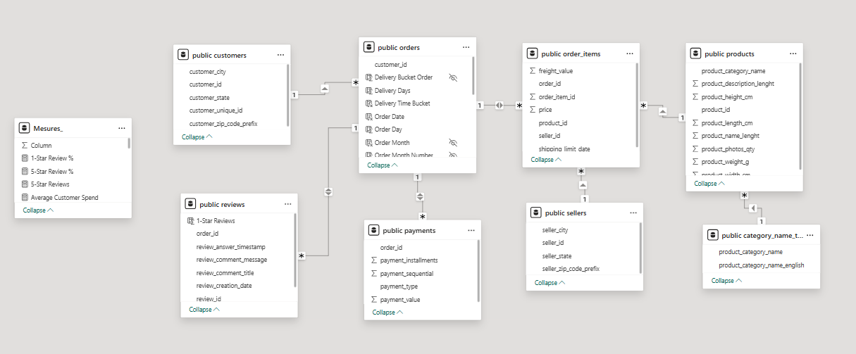 Figure 2. Power BI relationship view, replicating the PostgreSQL schema with a supporting Measures_ table for DAX calculations (source: Power bi/Schema.png).

6. SQL Analysis
Business-question analysis was implemented across 8 SQL scripts in /Sql/, executed against the PostgreSQL database in numeric order. Each script targets one analytical theme. Representative queries are shown below; the full set (34 queries total) is available in the repository.

6.1 KPI Analysis (01_KPI_Analysis.sql)
Objective: Establish top-line business metrics — revenue, orders, customers, sellers, AOV, and monthly trend.
SELECT
DATE_TRUNC('month', o.order_delivered_customer_date::timestamp) AS month,
ROUND(SUM(p.payment_value)::numeric, 1) AS total_revenue,
ROUND(SUM(SUM(p.payment_value)) OVER (
ORDER BY DATE_TRUNC('month', o.order_delivered_customer_date::timestamp)
)::numeric, 1) AS running_total
FROM orders o
JOIN payments p ON o.order_id = p.order_id
WHERE o.order_status = 'delivered'
GROUP BY DATE_TRUNC('month', o.order_delivered_customer_date::timestamp)
ORDER BY month;
Business meaning: Tracks monthly revenue alongside a cumulative running total, letting stakeholders see both the trend and the year-to-date trajectory in one view — the basis for the dashboard’s revenue-by-quarter chart.

6.2 Customer Analysis (02_Customer_Analysis.sql)
Objective: Identify top-spending customers, spending averages, and repeat-purchase behavior.
WITH cte AS (
SELECT c.customer_unique_id, SUM(p.payment_value) AS total_spending
FROM customers c
JOIN orders o ON o.customer_id = c.customer_id
JOIN payments p ON p.order_id = o.order_id
GROUP BY c.customer_unique_id
)
SELECT ROUND(AVG(total_spending)::numeric, 2) AS avg_spending_per_customer
FROM cte;
Business meaning: Uses customer_unique_id (rather than customer_id, which can vary per order) to correctly compute spend and repeat-purchase counts per real-world customer — a deliberate and correct modeling choice given this dataset’s structure.

6.3 Product Analysis (03_Product_Analysis.sql)
Objective: Rank product categories by revenue, volume, price, and review performance.
SELECT p.product_category_name AS category, SUM(p2.payment_value) AS total_revenue
FROM products p
JOIN order_items oi ON p.product_id = oi.product_id
JOIN payments p2 ON p2.order_id = oi.order_id
GROUP BY product_category_name
ORDER BY total_revenue DESC
LIMIT 5;
Business meaning: Surfaces the top revenue-generating categories, feeding directly into the Products dashboard page and the category-level insights in Section 8.

6.4 Seller Analysis (04_Seller_Analysis.sql)
Objective: Rank sellers by revenue, volume sold, and average review score; profile seller geography.
SELECT seller_state, COUNT(seller_id) AS number_of_sellers
FROM sellers
GROUP BY seller_state
ORDER BY number_of_sellers DESC
LIMIT 5;
Business meaning: Quantifies how concentrated the seller base is geographically — a key input to the seller-diversification recommendation in Section 9.

6.5 Order Analysis (05_Order_Analysis.sql)
Objective: Break down order status, delivery time, and cancellation patterns.
SELECT customer_state,
AVG(order_delivered_customer_date::timestamp - order_purchase_timestamp::timestamp) AS delivery_time
FROM orders o
JOIN customers c ON c.customer_id = o.customer_id
WHERE order_status = 'delivered'
GROUP BY customer_state
ORDER BY delivery_time DESC
LIMIT 1;
Business meaning: Identifies the single slowest-delivery state as a starting point for logistics investigation; the dashboard extends this to a full state ranking.

6.6 Payment Analysis (06_Payment_Analysis.sql)
Objective: Quantify revenue share and satisfaction by payment method.
SELECT payment_type, SUM(payment_value) * 100.0 / (SELECT SUM(payment_value) FROM payments) AS percentage
FROM payments
WHERE payment_type <> 'not_defined'
GROUP BY payment_type;
Business meaning: Directly produces the revenue-share-by-payment-type figures used on the Executive and Sales dashboard pages.

6.7 Review Analysis (07_Review_Analysis.sql)
Objective: Assess review-score distribution and its relationship to price and order status.
SELECT product_id,
ROUND(AVG(price)::numeric, 1) AS avg_price,
ROUND(AVG(review_score), 1) AS avg_review
FROM order_items oi
JOIN reviews r ON r.order_id = oi.order_id
GROUP BY product_id
ORDER BY avg_price DESC
LIMIT 10;
Business meaning: Used to test whether higher-priced products earn better reviews — the basis for the near-zero price/review correlation discussed in Section 8.

6.8 Advanced Window Functions (08_Advanced_Window_Functions.sql)
Objective: Identify peak months and top-value orders using ranking logic.
SELECT DATE_TRUNC('month', o.order_delivered_customer_date::timestamp) AS month,
ROUND(SUM(p.payment_value)::numeric, 1) AS total_revenue
FROM orders o
JOIN payments p ON o.order_id = p.order_id
WHERE o.order_status = 'delivered'
GROUP BY DATE_TRUNC('month', o.order_delivered_customer_date::timestamp)
ORDER BY total_revenue DESC
LIMIT 1;
Business meaning: Pinpoints the single highest-revenue month, which — cross-referenced with the cancellation analysis — reveals that peak demand and peak cancellations coincided (Section 8).

7. Dashboard Development
The Power BI file (Power bi/E-commarce Analysis.pbix) contains six report pages, each targeting a different stakeholder question. Navigation is handled via a consistent left-side page menu, and every page shares a light green/blue color theme with the “Olist” brand mark in the top-left corner.

7.1 Executive Summary
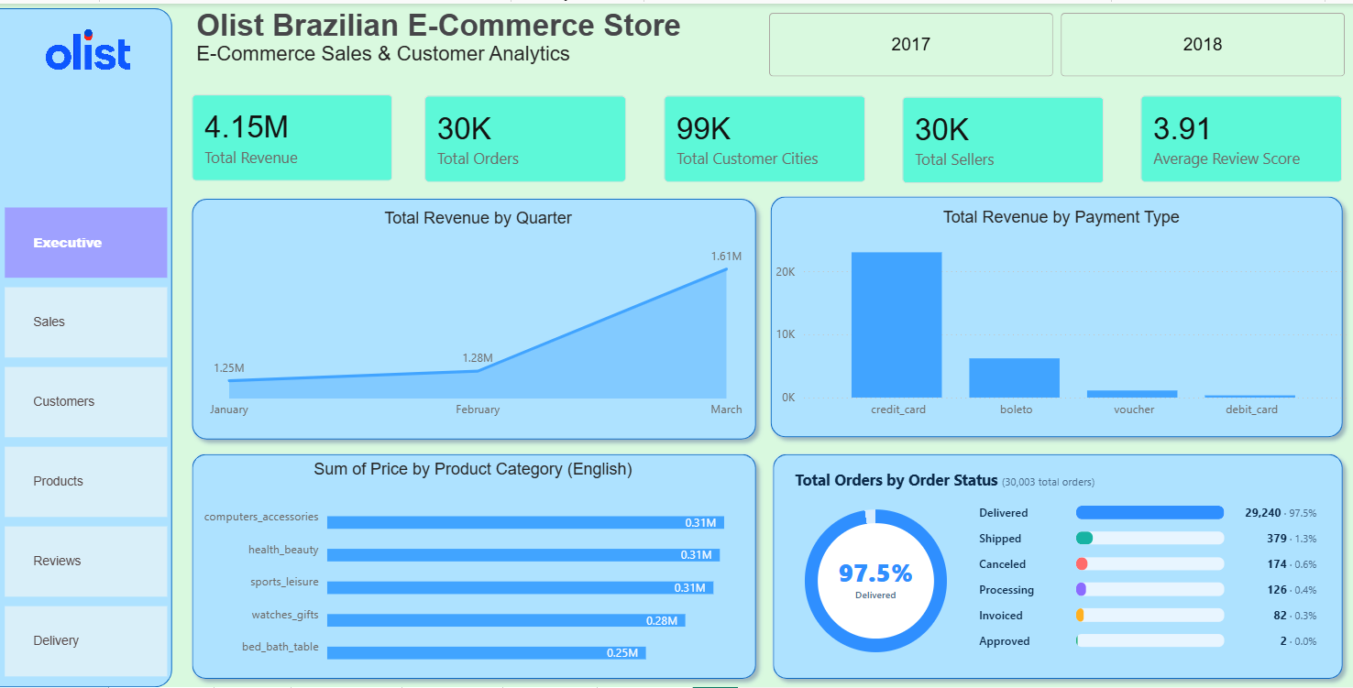 Figure 3. Executive summary page — total revenue, orders, customer cities, sellers, and average review score as headline cards, with revenue-by-quarter, revenue-by-payment-type, top categories, and an order-status donut chart below.
- KPIs: Total Revenue, Total Orders, Total Customer Cities, Total Sellers, Average Review Score
- Charts: Revenue by Quarter (line), Revenue by Payment Type (bar), Sum of Price by Product Category (bar), Total Orders by Order Status (donut with legend)
- Filters: Year slicer (2017 / 2018 buttons visible in this view)

7.2 Sales Analysis
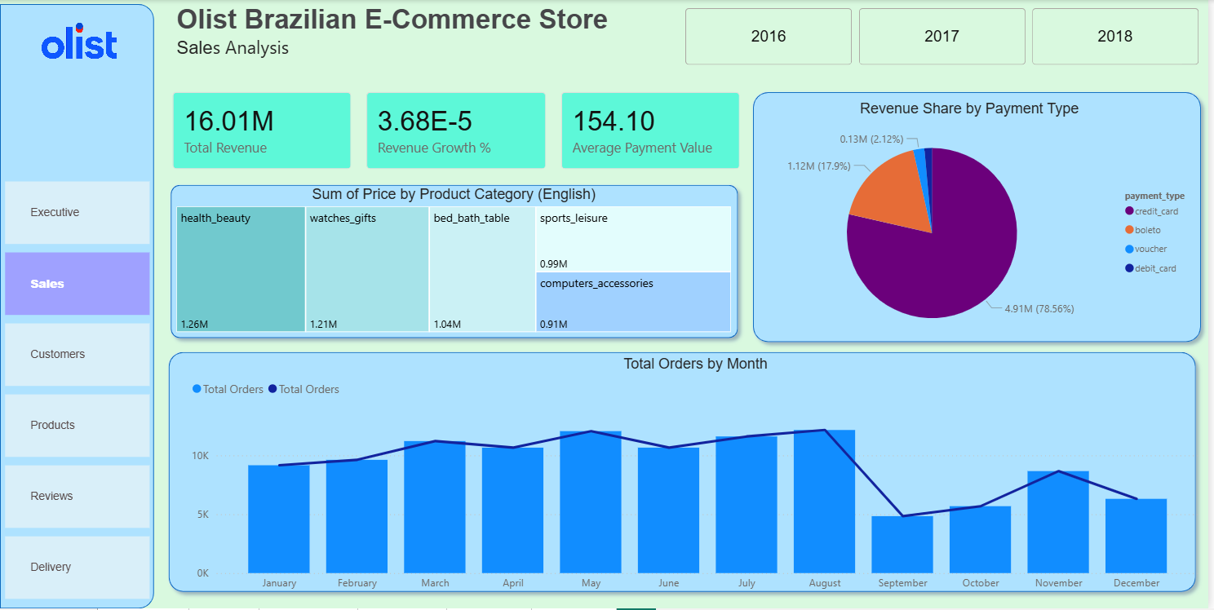 Figure 4. Sales page — full-period total revenue, revenue growth rate, and average payment value, with category revenue treemap, payment-type pie chart, and a monthly order-volume combo chart.
- KPIs: Total Revenue, Revenue Growth %, Average Payment Value
- Charts: Sum of Price by Product Category (treemap), Revenue Share by Payment Type (pie), Total Orders by Month (bar + line combo)
- Filters: Year slicer (2016 / 2017 / 2018)

7.3 Customer Analysis
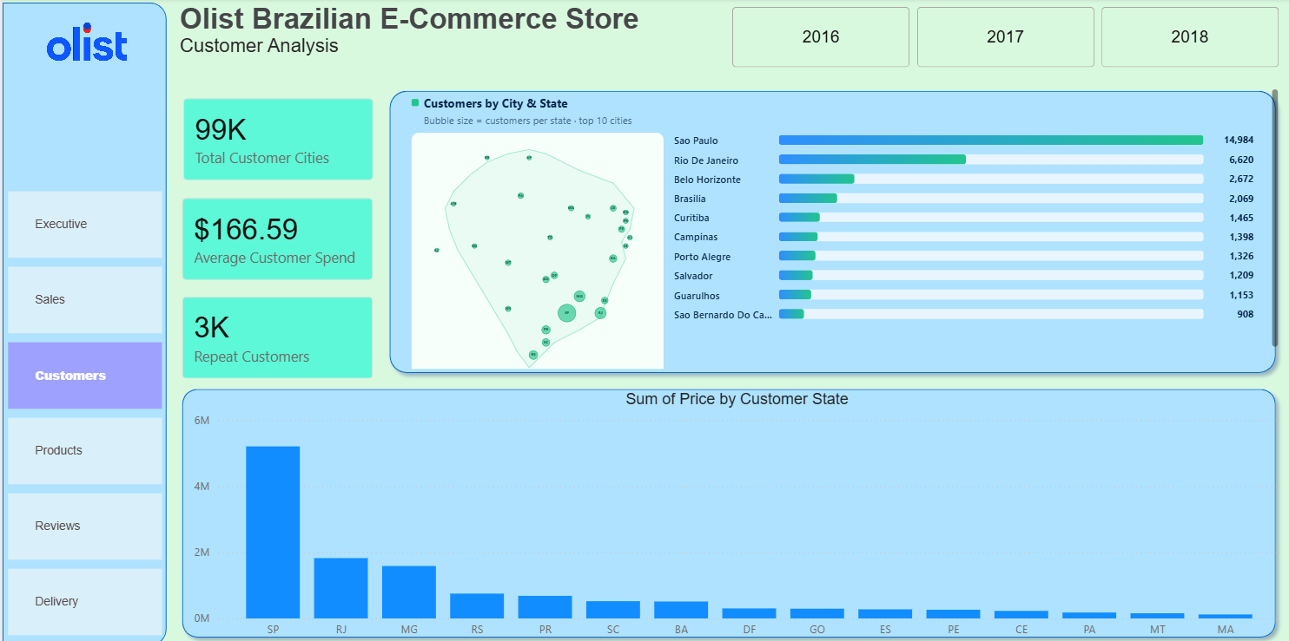 Figure 5. Customer page — city/state geographic bubble map, top-10 city ranking, and revenue by state.
- KPIs: Total Customer Cities, Average Customer Spend, Repeat Customers
- Charts: Customers by City & State (bubble map + ranked list), Sum of Price by Customer State (bar)
- Filters: Year slicer (2016 / 2017 / 2018)

7.4 Product & Seller Analysis
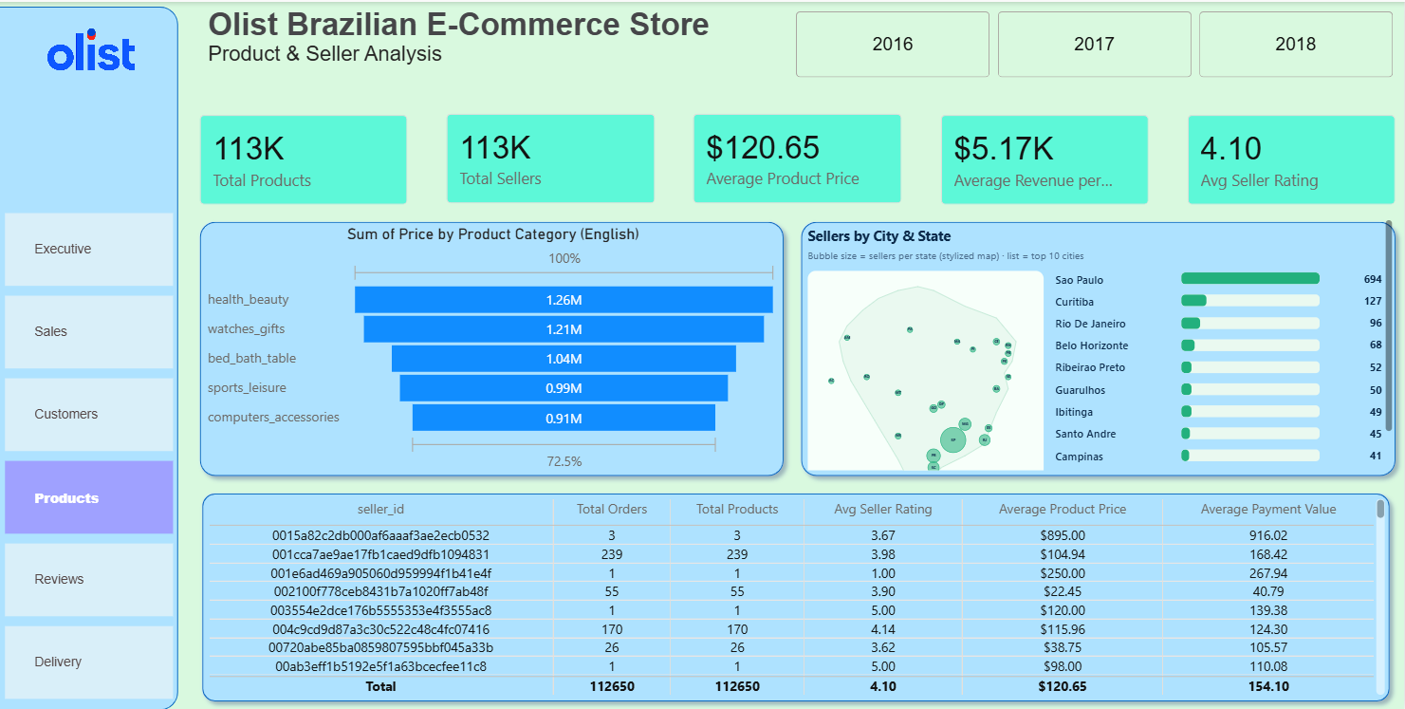 Figure 6. Product & seller page — category revenue funnel, seller geography, and a detailed per-seller performance table.
- KPIs: Total Products, Total Sellers, Average Product Price, Average Revenue per Seller, Average Seller Rating
- Charts: Sum of Price by Product Category (funnel with cumulative %), Sellers by City & State (bubble map + ranked list), a sortable seller-level table (Total Orders, Total Products, Avg Seller Rating, Average Product Price, Average Payment Value)
- Filters: Year slicer (2016 / 2017 / 2018)

7.5 Delivery Performance
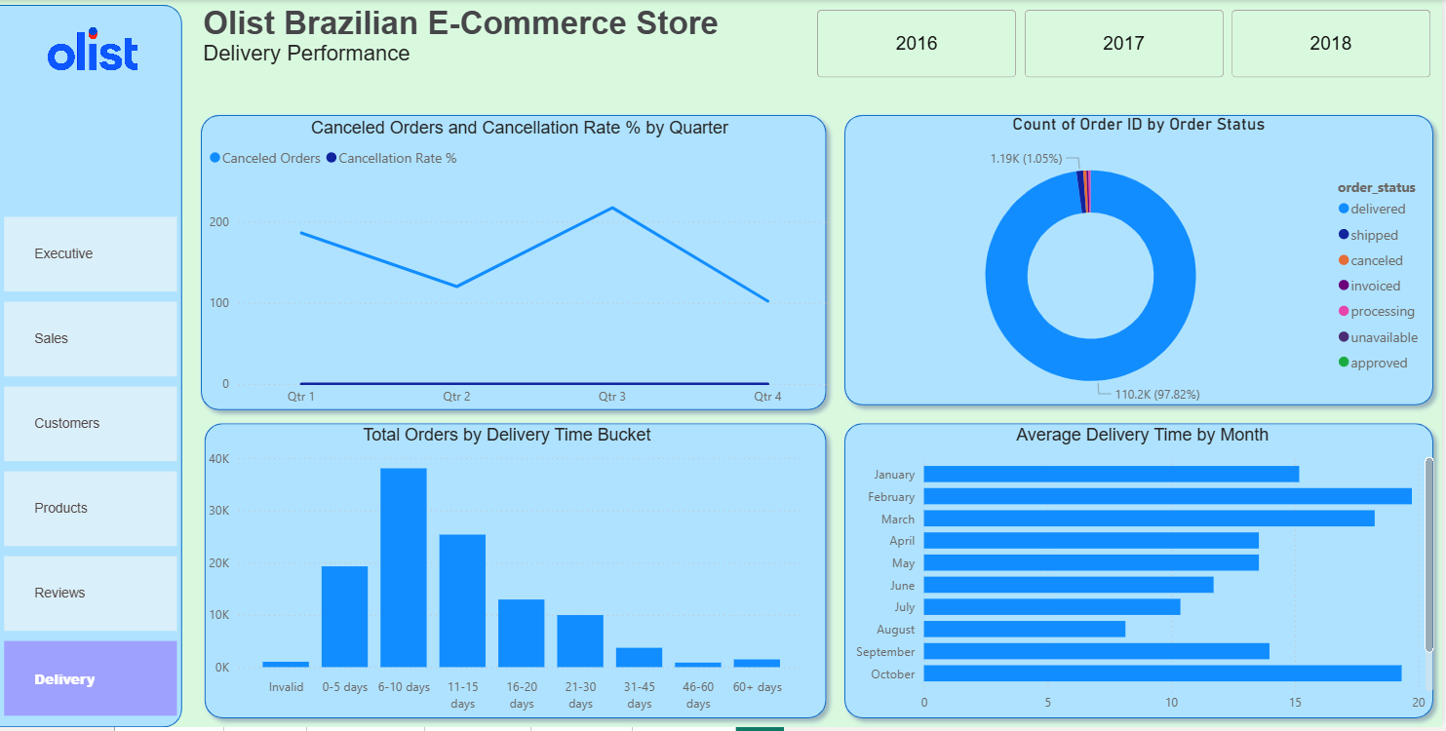 Figure 7. Delivery page — cancellation trend, order-status breakdown, delivery-time distribution, and average delivery time by month.
- Charts: Canceled Orders & Cancellation Rate % by Quarter (line), Count of Order ID by Order Status (donut), Total Orders by Delivery Time Bucket (histogram: Invalid, 0–5, 6–10, 11–15, 16–20, 21–30, 31–45, 46–60, 60+ days), Average Delivery Time by Month (horizontal bar)
- Filters: Year slicer (2016 / 2017 / 2018)

7.6 Customer Satisfaction (Reviews)
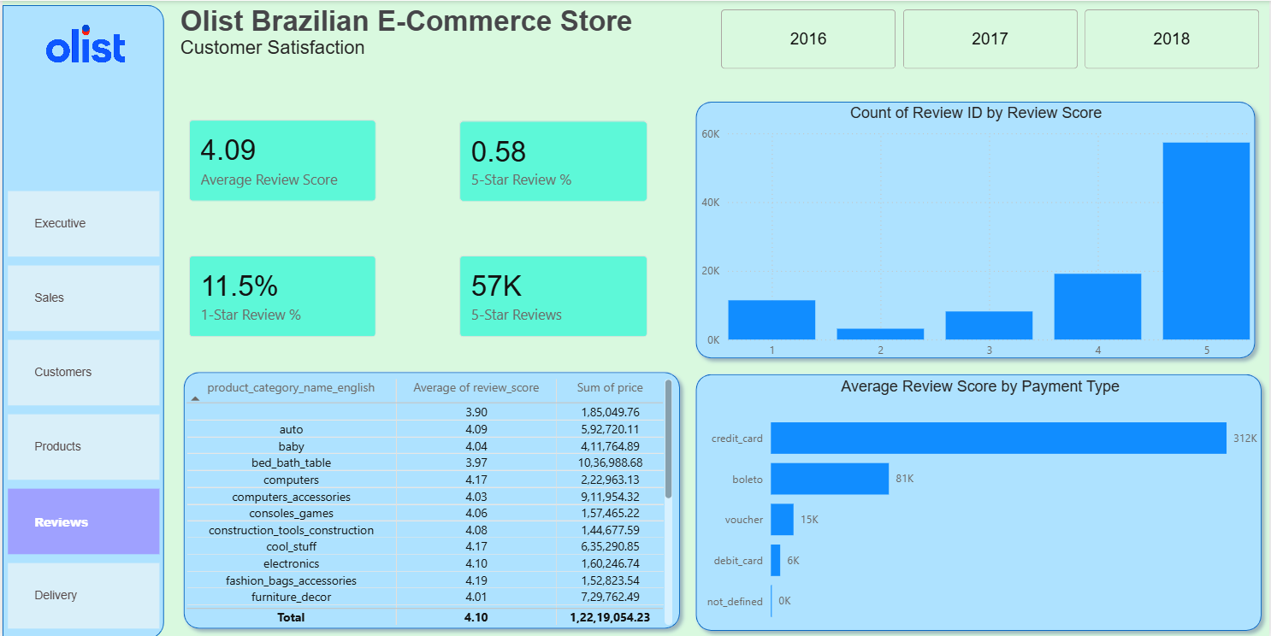 Figure 8. Reviews page — score distribution, satisfaction by payment type, and a per-category review/revenue breakdown table.
- KPIs: Average Review Score, 5-Star Review %, 1-Star Review %, Count of 5-Star Reviews
- Charts: Count of Review ID by Review Score (bar), Average Review Score by Payment Type (bar), a category-level table (Average of review_score, Sum of price) with totals row
- Filters: Year slicer (2016 / 2017 / 2018)

DAX Measures
The Power BI model includes a dedicated Measures_ table (visible in Figure 2) holding calculated measures such as 1-Star Review %, 5-Star Review %, 5-Star Reviews, and Average Customer Spend — keeping DAX logic centralized rather than scattered across individual visual fields.
ℹ️ Note on figures across pages: Headline numbers differ slightly page-to-page (e.g., Executive shows 4.15M in revenue while Sales shows 16.01M) because each page’s year slicer can be set to a different selection; the report does not include a page showing all three years simultaneously selected on every card. The SQL- and README-reported totals (R$16.0M, 99,441 orders) reflect the full, unfiltered dataset and are treated as the canonical figures throughout this report.

8. Business Insights
Each insight below is grounded in the SQL analysis and/or dashboard screenshots, and — where the raw CSVs were available — was independently recalculated during this review.

Overall Performance
💡 Total revenue is R$16,008,872 across 99,441 orders (AOV R$154.10), with 96,478 orders (97.0%) reaching delivered status and only 625 (0.6%) canceled.

Customer Behavior
- São Paulo (SP) leads customer count with 41,746 customers — more than 3× the next state, Rio de Janeiro (12,852).
- São Paulo city alone generates ~R$2.20M in revenue, nearly double Rio de Janeiro (~R$1.16M), the #2 city.
- Average spend per customer is R$166.59, but only 2,997 customers (≈3.1%) placed more than one order — repeat purchases are rare.
- Paraíba (PB) has the highest average order value at R$248.33, well above the national average of R$154.10, despite not being a top-volume state.

Product Performance
- Top revenue categories: bed_bath_table (R$1.71M), health_beauty (R$1.66M), computers_accessories (R$1.59M), furniture_decor (R$1.43M), watches_gifts (R$1.43M).
- The same categories also lead in items sold, indicating revenue in this marketplace is volume-driven rather than premium-pricing-driven.
- 32,951 unique products were sold; the single highest-priced item sold for R$6,735.

Seller Analysis
- The seller base is heavily concentrated: 1,849 of 3,095 sellers (~60%) are based in São Paulo state, followed by Paraná (349) and Minas Gerais (244).
- Seller performance is highly uneven — the top seller alone generated roughly R$230K–R$245K in revenue depending on the aggregation method used (see the join caveat in Section 10), far above the typical seller.

Delivery Analysis
- Average delivery time is 12.1 days from purchase to customer delivery (README states 12 days 13 hours — consistent).
- Northern states have by far the slowest delivery: Roraima (~29 days), Amapá (~27 days), Amazonas (~26 days) — more than double the national average.
- Cancellations spike in specific months: August 2018 (84 cancellations) and February 2018 (73 cancellations) were the worst.
- August 2018 was also the highest-revenue month, suggesting demand spikes can coincide with fulfillment strain.

Customer Satisfaction
- The overall average review score is 4.09 / 5 — customers are largely satisfied.
- Review scores are similar across payment types (roughly 4.0–4.17), except unrecorded (not_defined) payments, which correlate with a much lower average review (~1.67).
- Price and review score show essentially no linear relationship (correlation ≈ -0.004) — charging more does not predict a better or worse review.

Revenue Opportunities
- Credit card dominates payment behavior, driving 78.3% of revenue, followed by boleto (17.9%), voucher (2.4%), and debit card (1.4%).
- Because repeat purchases are rare (~3%) but average order value is healthy, the clearest revenue lever is retention, not acquisition-only growth.

9. Business Recommendations
The following recommendations follow directly from the insights above and are drawn from the project’s own stated conclusions:
- Invest in customer retention — loyalty programs and targeted re-engagement — since only ~3% of customers currently place more than one order.
- Prioritize logistics improvements in the North region (Roraima, Amapá, Amazonas), where delivery times are more than double the national average.
- Investigate the August and February cancellation spikes to identify seasonal or operational causes (e.g., fulfillment capacity during demand surges) before they recur.
- Continue featuring top-performing categories (bed/bath, health & beauty, computer accessories) in promotions, since they drive both volume and revenue.
- Reduce reliance on São Paulo-based sellers by recruiting and supporting sellers in other states, diversifying fulfillment capacity and reducing single-region risk.
- Focus service-quality efforts on delivery speed and order accuracy rather than pricing to improve satisfaction, since price shows no measurable relationship with review score.

10. Challenges Faced
The challenges below are inferred directly from evidence in the codebase — missing-value patterns, data types, and script structure — rather than assumed.
Data Quality Issues - Several orders timestamp fields (order_approved_at, order_delivered_carrier_date, order_delivered_customer_date) contained missing values, requiring a forward-fill strategy rather than simple deletion, since dropping rows would have removed valid order and revenue records. - reviews had missing comment titles and messages, and products had missing category names — both needed explicit placeholder handling ("No Title", "No Message", "Missing") rather than being left as nulls, which would have broken downstream GROUP BY operations in SQL and Power BI.
Cleaning Challenges - Several numeric products columns (weight, dimensions, description length, photo count) were stored as floats due to embedded NaNs; they required a fillna(0) step before they could be safely cast to integers. - Category names required a separate translation table (category_name) to be joined in, since the raw product_category_name values are in Portuguese and not directly usable for an English-language business report.
SQL / Modeling Challenges - Both order_items and payments use composite primary keys (multiple rows per order), which means naive joins from orders through both tables simultaneously can multiply and inflate revenue sums. This is a genuine modeling risk in a schema of this shape, and is worth flagging explicitly: for example, the seller-revenue query in 04_Seller_Analysis.sql joins order_items to payments on order_id without deduplicating installment rows, which can overstate revenue for sellers whose orders were paid in multiple installments. An independent recalculation using order_items.price alone (avoiding the payments join) produced a somewhat lower top-seller figure (~R$229K) than the README’s reported R$244,627.60 — a reasonable illustration of how the choice of join and aggregation grain can shift a headline number in this schema.
Dashboard Design Decisions - Because Power BI’s cards and slicers are affected by the active year selection, different report pages can show different headline totals for the same underlying metric (see the note at the end of Section 7) — a common trade-off between page-level focus and dashboard-wide consistency.
Engineering / Portability - The data-loading script (Insert.py) uses hardcoded local file paths (Windows-style, e.g. d:\Data_set\...) and an inline database connection string with embedded credentials. This works for a single-machine analysis but is not portable or secure; parameterizing paths and credentials (e.g., via environment variables or a .env file) would be a natural next step if this pipeline were productionized.

11. Skills Demonstrated
Category | Skills
Data Preparation | Data Cleaning, Missing-Value Handling, Data Type Correction, Feature Engineering
Analysis | Exploratory Data Analysis (EDA), Correlation Analysis, Business Analysis, Problem Solving
Database | SQL, PostgreSQL, Relational Schema Design, CTEs, Joins, Window Functions
Programming | Python, Pandas, NumPy, Matplotlib, Seaborn, SQLAlchemy
Visualization & BI | Power BI, Dashboard Design, DAX Measures, Data Visualization
Communication | Reporting, Business Recommendations, Technical Documentation

12. Project Workflow
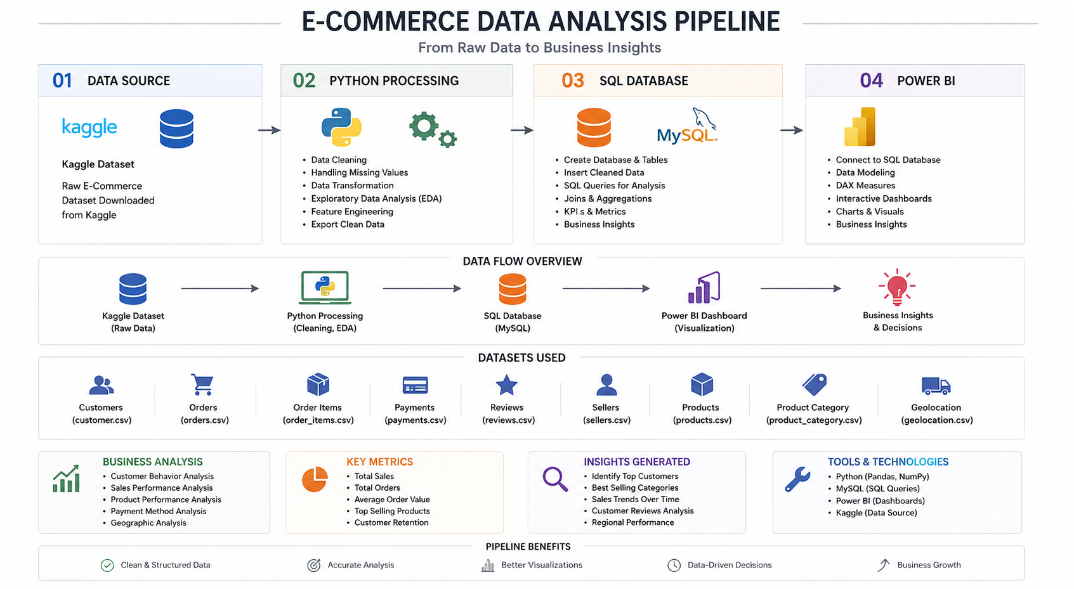 Figure 9. End-to-end pipeline diagram from the repository, illustrating the four-stage flow from raw data to business decisions.
Raw Data (Kaggle CSV export)
↓
Python Cleaning & EDA (Pandas — missing values, type fixes, feature prep)
↓
PostgreSQL Database (SQLAlchemy load → 8 relational tables)
↓
SQL Analysis (8 scripts — KPIs, customers, products, sellers, orders, payments, reviews, window functions)
↓
Power BI Dashboard (6 interactive pages, DAX measures)
↓
Business Insights (Section 8)
↓
Recommendations (Section 9)
ℹ️ Two small discrepancies worth noting for transparency: 1. The workflow graphic’s database icon and label reference MySQL, but the project’s actual database — per the README and Insert.py — is PostgreSQL. The SQL scripts also use PostgreSQL-specific syntax (DATE_TRUNC, ::numeric casts), confirming PostgreSQL as the implementation. 2. The workflow graphic lists geolocation.csv among the source datasets, but this file was not found in the repository’s /Data/ folder; only the eight files listed in Section 3 are present. It may have been part of the original Kaggle source but was not used in the final analysis.

13. Conclusion
This project delivers a complete, evidence-based analytics pipeline for an e-commerce marketplace — from raw, imperfect transactional data through to an interactive Power BI dashboard and a clear set of business recommendations. It demonstrates the full analyst toolkit: Python for cleaning and exploration, SQL for structured business-question answering, and Power BI for stakeholder-facing visualization, tied together by a coherent relational data model.
Key learnings surfaced through this review include the importance of choosing the correct customer key (customer_unique_id vs. customer_id) when measuring repeat purchases, the risk of row multiplication when joining tables with composite keys (order_items, payments), and the value of cross-checking dashboard headline numbers against their underlying filter context.
Business impact: the analysis identifies a marketplace with healthy average order value and high satisfaction, but with concentrated geographic risk (customers, sellers) and a retention gap (~3% repeat rate) — giving management two clear, data-backed priorities: diversify seller geography and invest in customer retention, ahead of new-customer acquisition.

14. Appendix

A. Tool Versions
No requirements.txt, environment file, or dependency lock file was found in the repository, so exact library versions could not be confirmed. The only version signal available is the Jupyter notebook’s kernel metadata (Python/EDA.ipynb), which recorded a Python 3 kernel.

B. Repository Folder Structure
E-commarce_data_analysis_/
├── README.md
├── Data_zip.zip
├── Data/
│ ├── customers.csv ├── payments.csv
│ ├── orders.csv ├── products.csv
│ ├── order_items.csv ├── reviews.csv
│ ├── sellers.csv └── category_name.csv
├── Python/
│ ├── Cleaing.py ├── EDA.py
│ ├── Insert.py └── EDA.ipynb
├── Sql/
│ ├── 01_KPI_Analysis.sql ├── 05_Order_Analysis.sql
│ ├── 02_Customer_Analysis.sql ├── 06_Payment_Analysis.sql
│ ├── 03_Product_Analysis.sql ├── 07_Review_Analysis.sql
│ └── 04_Seller_Analysis.sql └── 08_Advanced_Window_Functions.sql
├── ER Digram/
│ ├── Database_Schema.png
│ ├── Database_Schema.svg
│ └── Database_Schema.drawio.xml
├── Power bi/
│ ├── E-commarce Analysis.pbix
│ ├── Executive.png ├── Products.png
│ ├── Sales.png ├── Delivery.png
│ ├── Customers.png ├── Reviews.png
│ ├── Schema.png └── Logo.png
└── Work Flow.png

C. References
- Project repository: github.com/Vivek7ok/E-commarce_data_analysis_
- Author: Vivek — Data Analyst — GitHub

D. Design Specification (as applied in this document)
This Word version applies the brand theme matched to the Power BI dashboard’s blue-and-white identity:
Element | Specification
Primary color | Blue #2563EB (headings, section dividers, cover title, table headers)
Background | White #FFFFFF
Secondary color | Light gray #F1F5F9 (callout boxes, code blocks, banded table rows)
Body font | Calibri, 10.5pt
Heading font | Calibri, bold, Blue #2563EB
Tables | White background, blue header row with white text, thin gray gridlines
Callout boxes (💡 / ℹ️) | Light gray fill, blue left accent border
Code blocks | Light gray fill (#F1F5F9), blue left accent border, monospace text
Cover page | Centered title/subtitle, blue accent, project metadata block
Margins | 1 inch (2.5 cm) all sides, consistent throughout
Footer | Page number and report title on every content page

This report was compiled from the project repository’s README, Python scripts, SQL scripts, ER diagram, and Power BI dashboard exports. All figures were cross-verified against the raw dataset where available; assumptions were avoided in favor of stating explicitly where information was not present in the repository.

