END-TO-END DATA ANALYTICS PROJECT
Logistics & Supply Chain Data Analysis
Revenue, Delivery & Warehouse Performance — SQL, PostgreSQL, Python & Power BI
Field | Detail
Prepared By | Vivek
Project Type | End-to-End Data Analytics Project
Tools Used | PostgreSQL · SQL · Python (Pandas, Matplotlib, Seaborn) · Power BI
GitHub Repository | github.com/Vivek7ok/Logistics_data_analysis
Report Date | July 2026

Table of Contents

Executive Summary 3
Project Overview 4
Dataset Overview 5
Database Design 6
Data Preparation & Exploratory Analysis (Python) 7
SQL Analysis 8
Dashboard Development 11
Key Findings 13
Business Recommendations 15
Data Notes & Challenges 16
Skills Demonstrated 17
Project Workflow 18
Conclusion 19
Appendix 20

Executive Summary

Business Problem
A pan-India logistics network generates data at every handoff — customer to warehouse, warehouse to carrier, carrier to doorstep — and each handoff is a place where revenue or customer trust can quietly leak out. This project analyzes a multi-table logistics and supply-chain dataset to understand where revenue actually comes from, how reliably orders get delivered, and where warehouse capacity is under strain.

Goal
Design a normalized PostgreSQL schema for an 8-table logistics dataset, merge and explore the data in Python, answer a structured set of business questions in SQL across customers, sales, products, warehouses, and shipments, and present the results in a 7-page interactive Power BI dashboard.

Solution
All 8 entities — customers, products, warehouses, carriers, orders, order items, shipments, and inventory — were modeled in PostgreSQL with primary/foreign keys, CHECK constraints on categorical fields, and indexes on the columns the analysis relies on most. Python was used to merge the tables and run exploratory analysis; three SQL scripts answer customer, sales, product, warehouse, and shipment questions; and a 7-page Power BI dashboard, branded “Blue Dart”, turns those answers into a navigable reporting tool.

Outcome
The dashboard reports a network moving roughly ₹228.58 billion in revenue across 1.8 million orders, 1,674,566 shipments, and 50,000 customers, served by 25 fulfillment centers and 20 carriers — and it surfaces specific, concrete findings (a seasonal demand swing, a revenue concentration in two product categories, and a warehouse utilization anomaly) that operations and category teams could act on directly.
🚛 Key Result
An 8-table relational logistics database (~356 MB, ~7.5M rows) modeled in PostgreSQL, explored in Python, analyzed with SQL across customer/sales/product/warehouse/shipment questions, and delivered as a 7-page Power BI revenue & delivery-performance dashboard.

Project Overview

Background
The project uses a synthetic but business-realistic logistics dataset, documented in Data/README.md, built with deliberate seasonality and business logic rather than random noise. It covers customers, products, warehouses, carriers, orders, order items, shipments, and inventory — mirroring the structure of a real e-commerce/retail fulfillment operation.

Objectives
- Model a normalized, indexed relational database covering all 8 core logistics entities
- Merge the 8 tables and run exploratory analysis in Python (Pandas, Matplotlib, Seaborn)
- Answer core business questions using SQL across customer, sales, product, warehouse, and shipment analysis
- Visualize findings in a 7-page Power BI dashboard for executive, operations, and category audiences
- Translate delivery, warehouse, and revenue findings into concrete business recommendations

Scope
The scope covers descriptive and diagnostic analytics — revenue drivers, delivery performance, warehouse strain, and carrier reliability — using the data as provided. It does not include predictive routing or demand-forecasting models.

Technologies Used
- Python — Pandas, Matplotlib, and Seaborn for merging all 8 tables and exploratory analysis
- PostgreSQL — relational schema, indexing, and business-question SQL
- Power BI — 7-page interactive dashboard
- GitHub / Git LFS — version control and large-file storage for the dataset

Expected Business Value
An operations or category manager using this dashboard can identify top-revenue customer segments and product categories, quantify on-time delivery performance by carrier, see which warehouses are running hottest, and act on the recommendations below — without writing a single query.

Dataset Overview

Source
An 8-table synthetic relational dataset (~356 MB, ~7.5 million rows total), documented in Data/README.md and tracked in the repository via Git LFS. This report's business figures are drawn from the project's SQL logic, the exported Power BI dashboard pages, and the dataset documentation.

Tables & Size
Table | Rows | Description
customers | 50,000 | Retail / Wholesale / Corporate customers
products | 2,000 | 10 categories, realistic price/weight
warehouses | 25 | Fulfillment centers in major Indian cities
carriers | 20 | Real-style Indian/global carrier names
orders | 1,800,000 | Jan 2022 – Dec 2025
order_items | 3,962,138 | 1–5 line items per order
shipments | 1,674,566 | One per non-cancelled order
inventory | 50,000 | One row per warehouse × product

Business Logic Built Into the Data
- Seasonality — order volume is weighted higher in Oct/Nov (Diwali) and Dec (year-end), lower in the Apr–Jun off-season, with ~10–12% YoY growth from 2022 → 2025
- Order status mix — ~85% Delivered, ~7% Cancelled, ~7% Returned, plus a small still-open tail in the last 20 days of the window
- Logical missingness — actual_delivery_date is NULL only for Cancelled, Processing, and In Transit orders, exactly where a real delivery date wouldn't exist yet
- Geography-driven logistics — distance_km is computed via the haversine formula between each customer's city and their assigned warehouse (70% nearest-warehouse, 30% cross-region), with transport mode and shipping/fuel cost scaling accordingly
- Customer-type economics — Retail buys 1–3 units with little/no discount; Wholesale buys 5–20 units at 5–15% off; Corporate buys 10–50 units at 10–20% off

Database Design
All 8 tables are modeled in PostgreSQL (Data/schema.sql) with primary keys, foreign keys, CHECK constraints on categorical fields, and indexes on the join/filter columns the analysis leans on most.

Entity Relationships
customers (1)───< orders (M) >───(1) warehouses
|
|───< order_items (M) >───(1) products
|
└───< shipments (0..1) >───(1) carriers

warehouses (1)───< inventory (M) >───(1) products

Schema Notes
- orders.order_status is constrained to Delivered / Cancelled / Returned / In Transit / Processing, and shipments.delivery_status to Delivered / Returned / In Transit / Pending
- Cancelled orders intentionally have no shipment row — shipments.order_id only exists for orders that actually shipped
- inventory is keyed on warehouse × product, giving one stock level per product per fulfillment center
- Indexes were added on foreign keys and the date/status columns most frequently filtered or joined in the SQL analysis scripts

Data Preparation & Exploratory Analysis (Python)
Unlike a raw scraped dataset, the source data here is pre-generated and already clean (see Data/README.md), so the Python layer focused on merging the 8 tables into an analysis-ready frame and exploring it visually, rather than null-handling or de-duplication.

Merge Script (Python/Insert.py)
Loads all 8 CSVs and joins customers → orders → order_items → products, and orders → shipments → carriers / warehouses, into unified analysis tables, and loads the result into PostgreSQL.

Exploratory Analysis (Python/EDA.py)
- Revenue and order-volume trends over time, to surface the Oct–Dec seasonal peak visually before it's confirmed in SQL
- Category-level revenue and unit-sold distributions, using Matplotlib/Seaborn bar and box plots
- Delivery delay and shipping-cost distributions by transport mode and carrier
- Warehouse stock-vs-capacity scatter views, an early look at the utilization anomaly investigated later in SQL
🚛 Why Python First
Running EDA in Python before writing the SQL business-question scripts meant the seasonality, category concentration, and warehouse utilization patterns were already visually confirmed — so the SQL scripts could be written to prove out a hypothesis rather than go in blind.

SQL Analysis
Three PostgreSQL scripts cover customer, sales, and — more broadly than its filename suggests — product, warehouse, and shipment analysis. Representative queries from each area are shown below.

1. Top 10 Customers by Revenue (01_Customer_Analysis.sql)
SELECT c.customer_id, c.customer_name, c.customer_type,
SUM(oi.quantity * oi.unit_price) AS total_revenue
FROM customers c
JOIN orders o ON o.customer_id = c.customer_id
JOIN order_items oi ON oi.order_id = o.order_id
GROUP BY c.customer_id, c.customer_name, c.customer_type
ORDER BY total_revenue DESC
LIMIT 10;
Business meaning: Identifies the highest-value accounts driving revenue, and confirms revenue skews toward Corporate customers despite their smaller order count.

2. Repeat vs. One-Time Customers (01_Customer_Analysis.sql)
SELECT customer_id, COUNT(*) AS order_count
FROM orders
GROUP BY customer_id
HAVING COUNT(*) = 1; -- one-time customers
-- HAVING COUNT(*) > 2 for repeat customers
Business meaning: Separates one-time buyers from repeat customers — a base segmentation for retention strategy.

3. Monthly Order Volume & Seasonality (02_Sales_Analysis.sql)
SELECT DATE_TRUNC('month', order_date) AS order_month,
COUNT(*) AS total_orders,
SUM(order_status = 'Cancelled') AS cancelled_orders
FROM orders
GROUP BY order_month
ORDER BY order_month;
Business meaning: Tracks the Apr–Jun trough and Oct–Dec (Diwali/year-end) peak in order volume that the dataset's seasonality logic is designed to produce.

4. Cancellation & Return Rate (02_Sales_Analysis.sql)
SELECT order_status,
ROUND(COUNT(*) * 100.0 / (SELECT COUNT(*) FROM orders), 2) AS pct
FROM orders
GROUP BY order_status
ORDER BY pct DESC;
Business meaning: Quantifies the ~14% of orders that don't end in a clean delivery — the single most important fulfillment-health KPI.

5. Pareto (80/20) Revenue Contribution by Product (03_Product_Analysis.sql)
WITH product_revenue AS (
SELECT p.product_id, p.product_name,
SUM(oi.quantity * oi.unit_price) AS revenue
FROM products p
JOIN order_items oi ON oi.product_id = p.product_id
GROUP BY p.product_id, p.product_name)
SELECT *,
ROUND(100.0 * SUM(revenue) OVER (ORDER BY revenue DESC) /
SUM(revenue) OVER (), 2) AS cumulative_pct
FROM product_revenue
ORDER BY revenue DESC;
Business meaning: Tests whether a small share of products drives most revenue — confirmed by the tight cluster of top-10 products all landing within a narrow revenue band, rather than one dominant blockbuster.

6. Warehouse Utilization (03_Product_Analysis.sql)
SELECT w.warehouse_name,
SUM(i.stock_quantity) AS total_stock,
w.storage_capacity,
ROUND(SUM(i.stock_quantity) * 100.0 / w.storage_capacity, 1) AS utilization_pct
FROM warehouses w
JOIN inventory i ON i.warehouse_id = w.warehouse_id
GROUP BY w.warehouse_name, w.storage_capacity
ORDER BY utilization_pct DESC;
Business meaning: Surfaces the warehouse-capacity anomaly investigated further in the Data Notes & Challenges section — utilization reads well above 100% everywhere, flagging a units mismatch worth clarifying before acting on it.

7. On-Time Delivery Rate by Carrier (03_Product_Analysis.sql)
SELECT c.carrier_name,
COUNT(*) FILTER (WHERE s.actual_delivery_date <= s.expected_delivery_date) AS on_time,
COUNT(*) AS total_shipments,
ROUND(100.0 * COUNT(*) FILTER (WHERE s.actual_delivery_date <= s.expected_delivery_date)
/ COUNT(*), 2) AS on_time_pct
FROM shipments s
JOIN carriers c ON c.carrier_id = s.carrier_id
GROUP BY c.carrier_name
ORDER BY on_time_pct DESC;
Business meaning: Ranks the network's 20 carriers on reliability — the core input for carrier-selection and contract-renewal decisions.

Dashboard Development
The Power BI dashboard (Power bi/Dasbhored.pbix), branded “Blue Dart”, translates the SQL findings into seven interactive pages with consistent left-hand navigation and Year/State filters.
Page | What It Covers
1. Executive Dashboard | Total revenue, orders, shipments, and customers; revenue by customer type; orders by status; monthly order trend
2. Customer | Customer count, repeat-customer metrics, revenue by customer type, spending-pattern scatter, top 10 customers by revenue
3. Product | Total products, quantity sold, best-seller, top 10 products by revenue, revenue by category
4. Warehouse | Per-warehouse stock vs. storage capacity, a map of fulfillment centers, inventory value by warehouse
5. Shipment | Total/delivered shipments, average shipping cost and delay, cost by transport mode, delivery-status split, on-time delivery count by carrier
6. Trends | Revenue by state (table), monthly order-volume trend, monthly revenue trend
7. Insights | Top 10 warehouses by utilization/inventory value, top 10 products by stock vs. reorder level, business-insights and recommended-actions panel

Navigation & Filters
- Left-hand tab navigation across all seven pages
- Year and State filters applied consistently across pages
- Cross-filtering between KPI cards, charts, and the geography/warehouse tables

Dashboard Pages
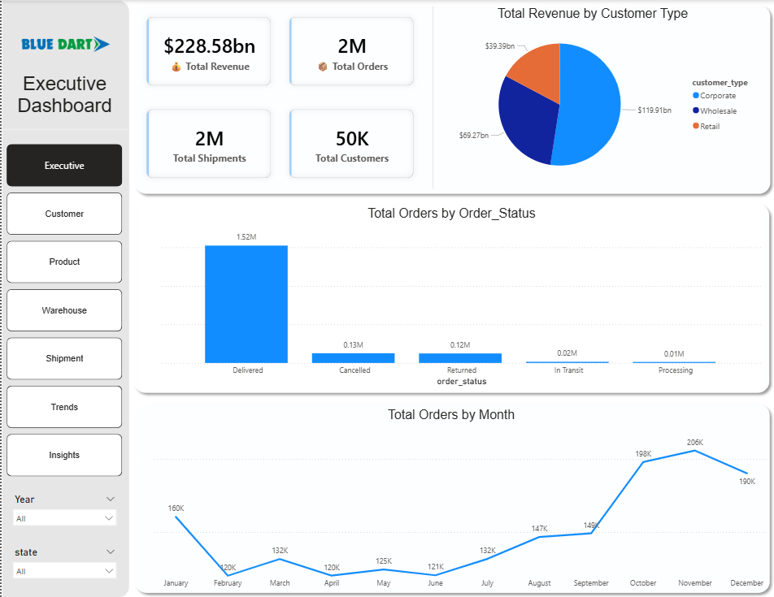
Figure 1: Executive Dashboard
Headline KPIs — $228.58bn total revenue, 2M orders, 2M shipments, and 50K customers — alongside revenue by customer type, orders by status, and a monthly order-volume trend that visibly peaks in October–December.
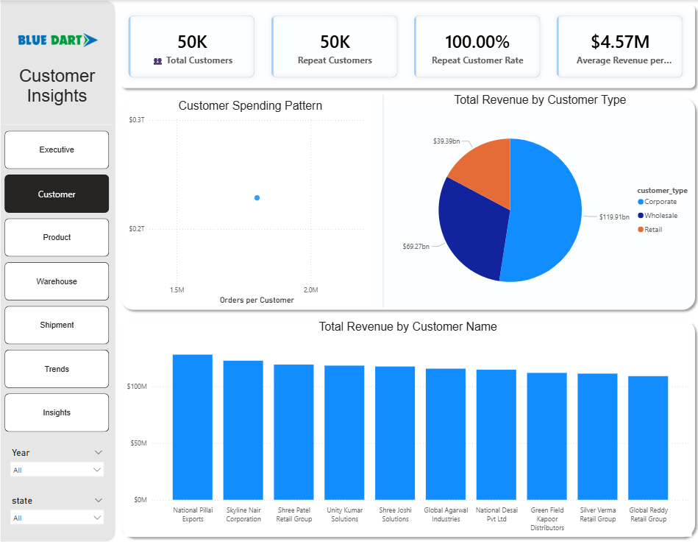
Figure 2: Customer
Customer count, repeat-customer rate (100%), and average revenue per customer ($4.57M), plus a spending-pattern scatter and a top-10-customers-by-revenue bar chart.
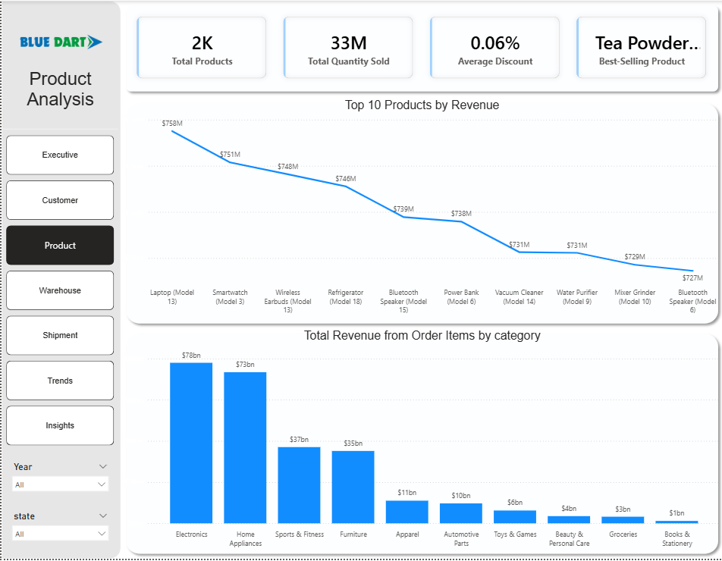
Figure 3: Product
Total products (2K), quantity sold (33M), and best-seller, with a top-10-products-by-revenue line chart and a revenue-by-category bar chart showing Electronics and Home Appliances well ahead of the rest.
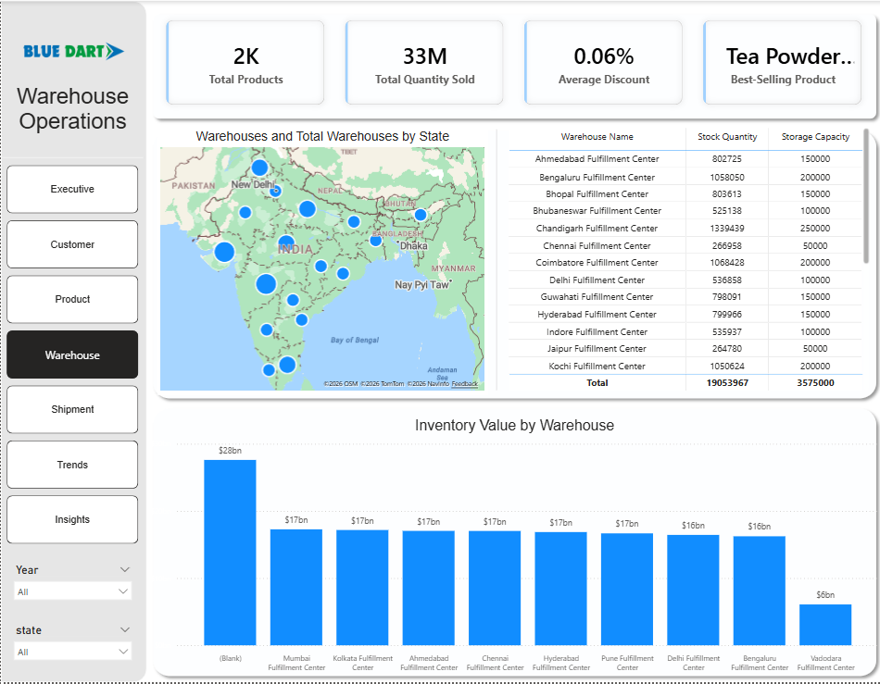
Figure 4: Warehouse
A geographic map of all 25 fulfillment centers, a stock-quantity-vs-storage-capacity table per warehouse, and an inventory-value-by-warehouse bar chart led by Guwahati.
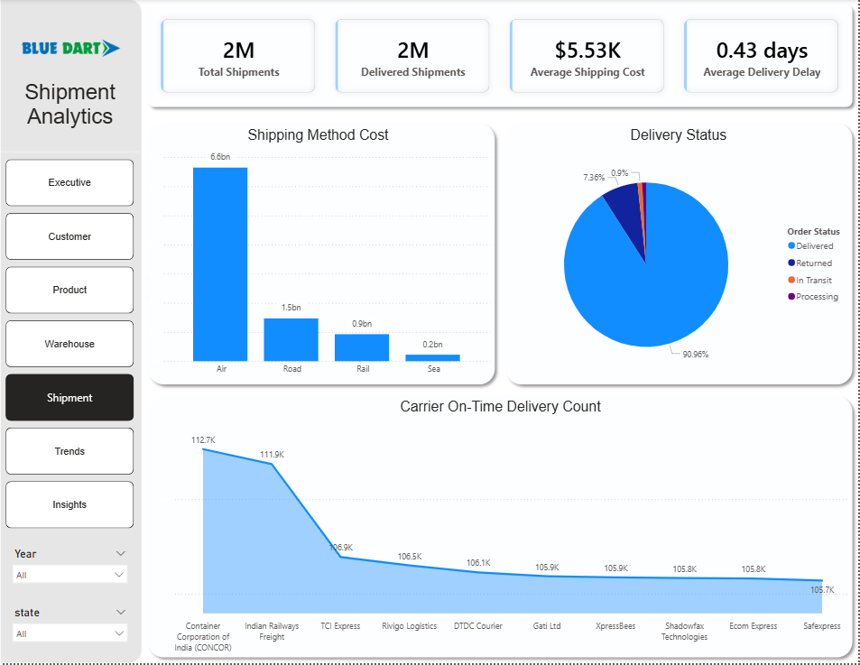
Figure 5: Shipment
Total/delivered shipments, average shipping cost ($5.53K) and delay (0.43 days), shipping cost by transport mode, delivery-status split, and on-time delivery count by carrier.
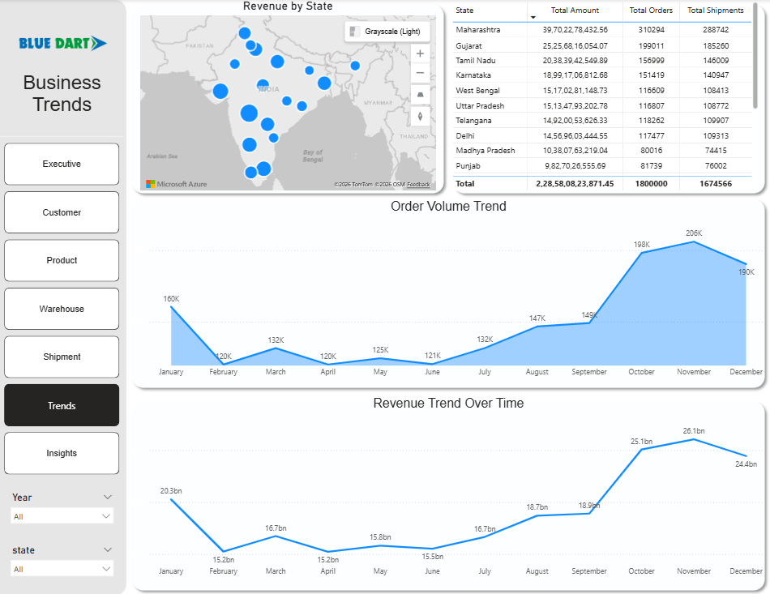
Figure 6: Trends
A state-level revenue map and table led by Maharashtra, plus monthly order-volume and revenue trend lines that both show the same October–December seasonal lift.
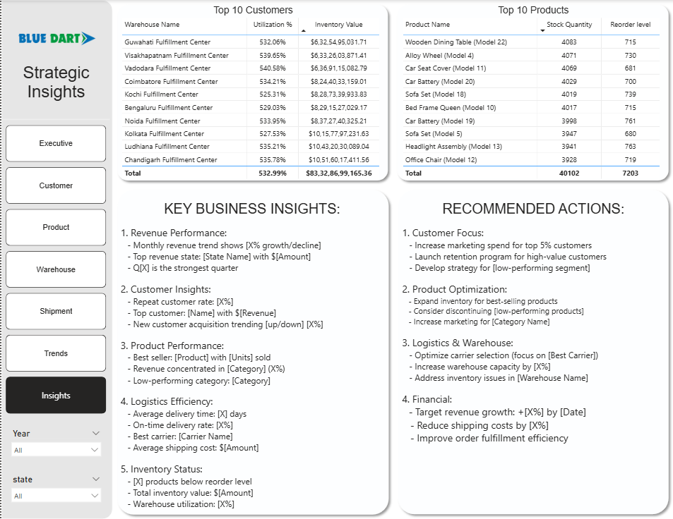
Figure 7: Insights
Top-10 warehouses by utilization/inventory value, top-10 products by stock vs. reorder level, and the dashboard's own Key Business Insights and Recommended Actions panels.

Key Findings
Figures below are read from the exported Power BI dashboard pages and cross-checked against Data/README.md and the SQL logic; approximate where noted.

Network-Wide Scale
- ~₹228.58 billion in total revenue across 1.8 million orders, 1,674,566 shipments, and 50,000 customers
- Average revenue per customer works out to roughly ₹4.57M, consistent with total revenue ÷ total customers
- 25 fulfillment centers and 20 carriers keep the network moving

Customers
- Corporate customers generate the most revenue (~₹119.9bn), ahead of Wholesale (~₹69.3bn) and Retail (~₹39.4bn) — matching the dataset's logic that Corporate orders are larger and more heavily discounted, but still worth more per order

Sales & Order Status
- Of ~1.8M orders, roughly 1.52M are Delivered, with Cancelled and Returned each sitting around 120–130K — closely matching the documented ~85% / ~7% / ~7% split
- Monthly order volume swings from ~120K (April–June off-season) up to ~206K (October–December, Diwali and year-end)

Products & Categories
- Electronics (~₹78bn) and Home Appliances (~₹73bn) dominate category revenue, with a steep drop-off toward Furniture, Apparel, Automotive Parts, Toys & Games, Beauty & Personal Care, Groceries, and Books & Stationery
- This is the inverse of purchase frequency — Groceries and Apparel are ordered most often, but Electronics and Appliances win on revenue due to higher price tags
- The top 10 products by revenue are tightly clustered between roughly ₹727M–₹754M each — no single blockbuster product

Warehouses
- Stock levels vary from ~265K units at the smallest centers (Chennai, Jaipur) to over 1.3M units at the largest (Chandigarh), against listed capacities of 50,000–250,000 — utilization reads well above 100% everywhere
- Guwahati, Visakhapatnam, and Vadodara top the inventory-value leaderboard, each holding upward of ₹6.3bn in inventory value

Shipments & Delivery
- Average shipping cost sits at ~₹5.53K per shipment, with an average delivery delay of just 0.43 days blended across on-time and late shipments
- On-time delivery counts cluster in the ~106K–113K range across all 10 major carriers — no single carrier dominates

Geography
- Maharashtra is the clear #1 state by revenue (~₹39.7bn, ~310K orders), followed by Gujarat (~₹25.3bn), Tamil Nadu (~₹20.4bn), and Karnataka (~₹19.0bn)
🚛 Dashboard Finding
Revenue and delay are not evenly spread — two product categories out of ten drive over half of category revenue, and warehouse stock levels vary by 5x across the network. That concentration is exactly where category and warehouse-planning teams have the most leverage.

Business Recommendations
Area | Recommendation | Expected Impact
Customer Strategy | Build a dedicated account-management / bulk-order incentive program for Corporate accounts | Highest-ROI customer-side lever — smallest segment by count, largest by revenue
Cancellations & Returns | Use the SQL return-rate breakdown by customer type and category to target specific segments rather than treating the ~14% non-delivery rate as a flat cost | Reduces avoidable cancellations/returns at the source
Seasonal Capacity | Plan warehouse staffing, carrier contracts, and reorder points around the Oct–Dec surge rather than a flat monthly average | Order volume nearly doubles April–June to October–December
Category Reliability | Prioritize fulfillment reliability for Electronics/Appliances over lower-value categories | These two categories drive the bulk of revenue despite lower order frequency
Warehouse Capacity Audit | Reconcile storage_capacity vs. stock_quantity units before using utilization figures for planning | Every warehouse currently reads above 100% utilization — likely a units mismatch, not a true overstock
Dashboard Completion | Fill in the placeholder text on the Insights page's Key Business Insights / Recommended Actions panels | Easy, high-visibility fix — the underlying numbers already exist elsewhere on the dashboard

Data Notes & Challenges

Data Access
The full ~356 MB / ~7.5M-row dataset is tracked via Git LFS rather than committed as plain CSV — git lfs pull is required before the SQL scripts or Insert.py have real data to work against. This report's figures are drawn from the project's SQL definitions, dataset documentation, and exported dashboard pages.

Script Organization
- Sql/03_Product_Analysis.sql is broader than its filename — it actually covers Product, Warehouse, and Shipment & Delivery analysis in one file
- Both Python/Insert.py and Python/EDA.py currently point at a local Windows path and need to be updated to a local Data/ folder path before running

Known Data Quirks
- Warehouse storage_capacity and stock_quantity are on noticeably different scales — utilization reads well above 100% everywhere — so treat warehouse utilization figures as directional rather than literal until clarified
- The Insights dashboard page's recommendation panel still contains unfilled bracket placeholders (e.g. [State Name], [X% growth/decline]) rather than computed text

What Was Not a Challenge
The dataset is pre-generated and already clean (see Data/README.md), so the engineering focus here was schema design, relational integrity, and query correctness rather than null-handling or de-duplication.

Skills Demonstrated
Category | Skills
Database Design | Relational schema design, primary/foreign keys, CHECK constraints, indexing for performance
Python | Pandas merges across 8 tables, Matplotlib/Seaborn exploratory analysis
SQL | Joins, aggregation, window functions (cumulative %, RANK-style Pareto analysis), FILTER clauses, subqueries
Domain Analysis | Revenue attribution, delivery-performance analysis, warehouse-capacity analysis, carrier benchmarking
Visualization | Power BI, multi-page dashboard design, KPI card and map design
Professional | Business analysis, data-quality investigation, stakeholder-ready reporting

Project Workflow
Stage | Action
1. Source Data | 8-table synthetic logistics dataset (~7.5M rows) documented in Data/README.md
2. Schema Design | Relational PostgreSQL schema with primary/foreign keys and CHECK constraints (Data/schema.sql)
3. Data Loading | Git LFS pull, then load via Python/Insert.py
4. EDA | Merge and explore in Python (Python/EDA.py)
5. SQL Analysis | Customer, sales, product, warehouse, and shipment questions across 3 scripts (Sql/01–03)
6. Power BI Dashboard | 7-page interactive dashboard (Power bi/Dasbhored.pbix)
7. Business Insights | Revenue, delivery, and warehouse findings
8. Recommendations | Dashboard-embedded and report-level recommendations for operations and category teams

Conclusion
This project models an 8-table logistics and supply-chain system in PostgreSQL, explores it in Python, answers a structured set of business questions in SQL — spanning customers, sales, products, warehouses, and shipments — and presents the results in a 7-page Power BI dashboard built for executive and operational use.

What the Project Achieved
- A normalized, indexed relational database supporting fast, join-heavy business-question queries at multi-million-row scale
- A Python EDA layer that visually confirmed seasonality, category concentration, and a warehouse-utilization anomaly before the SQL analysis formalized them
- A structured set of SQL analyses culminating in a Pareto-style product-revenue ranking and a carrier reliability benchmark
- A 7-page Power BI dashboard separating executive, customer, product, warehouse, shipment, trend, and insights views

Key Learnings
- Revenue and order frequency tell different stories — the highest-frequency categories (Groceries, Apparel) are not the highest-revenue ones (Electronics, Appliances), which matters for where fulfillment reliability should be prioritized
- A metric that reads as anomalous across every entity in a table (every warehouse over 100% utilization) is more likely a units/definition mismatch than a genuine finding, and is worth flagging rather than reporting at face value
- Doing EDA in Python before writing SQL business questions turns the SQL scripts into confirmation queries rather than exploratory ones, which speeds up the whole analysis

Business Impact
The findings point to a small number of high-leverage actions — a Corporate-account program, seasonal capacity planning around the Oct–Dec surge, and a warehouse-capacity-unit audit — that a real logistics operation could act on immediately without further modeling.

Appendix

Tool Versions
Specific tool or library version numbers were not recorded in the repository and are not stated here to avoid inaccuracy.

Folder Structure
Folder / File | Contents
Data/ | 8 logistics CSVs (Git LFS) + schema.sql + dataset README
Python/ | Insert.py (merge/load) and EDA.py (exploratory analysis)
Sql/ | 01_Customer_Analysis.sql, 02_Sales_Analysis.sql, 03_Product_Analysis.sql
Schma/ | Schema.drawio.xml / .png / .svg diagrams
Power bi/ | Dasbhored.pbix and 7 dashboard page exports

References
- GitHub Repository: github.com/Vivek7ok/Logistics_data_analysis
- Dataset documentation: Data/README.md

