Student Mental Health & Burnout
Exploratory Data Analysis Report
─────────────────────────────────
Dataset: student_mental_health_burnout.csv
Total Records: 150,000 | Features: 20 | No Missing Values
Prepared: March 2026

1. Executive Summary
This report presents a comprehensive Exploratory Data Analysis (EDA) of the Student Mental Health & Burnout dataset, comprising 150,000 student records across 20 features. The dataset captures academic, behavioral, and psychological dimensions of student life with zero missing values, making it ideal for analysis.

Key highlights from the analysis:
- The dataset contains 150,000 clean records with 20 features spanning academic performance, mental health scores, and lifestyle indicators.
- Gender distribution is perfectly balanced — approximately 33.3% each for Male, Female, and Other.
- The majority of students (40.2%) fall in the Average financial stress category, while Good and Bad are nearly equal at ~30% each.
- Depression scores peak in the 3rd academic year (5.518) and drop in the 4th year (5.476), suggesting mid-program academic pressure is highest.
- Burnout and stress levels are uniformly distributed across Low, Medium, and High categories (~33% each).

2. Dataset Overview
The dataset contains rich information on student mental health and burnout factors. Below is a summary of key dataset characteristics:

Metric | Value | Notes
Total Records | 150,000 | After deduplication
Total Features | 20 columns | No missing values
Age Range | 17 – 25 years | Mean age: 21
CGPA Range | 4.0 – 10.0 | Mean CGPA: 7.0
Academic Years | 1st – 4th | Balanced distribution
Gender Groups | Male, Female, Other | ~33% each

2.1 Feature Description
The 20 features in the dataset cover the following categories:
- Identity: student_id, age, gender, course, year
- Academics: daily_study_hours, attendance_percentage, cgpa, academic_pressure_score
- Mental Health: stress_level, anxiety_score, depression_score, burnout_level
- Lifestyle: daily_sleep_hours, screen_time_hours, physical_activity_hours, sleep_quality
- Environment: financial_stress_score, social_support_score, internet_quality

3. Descriptive Statistics
The table below summarizes the central tendency and spread of key numeric variables across all 150,000 records:

Feature | Mean | Std | Min | 25% | 75% | Max
Age | 21.00 | 2.58 | 17 | 19 | 23 | 25
Daily Study Hours | 5.51 | 2.60 | 1.0 | 3.3 | 7.7 | 10.0
CGPA | 7.00 | 1.73 | 4.0 | 5.5 | 8.5 | 10.0
Anxiety Score | 5.49 | 2.87 | 1 | 3 | 8 | 10
Depression Score | 5.50 | 2.87 | 1 | 3 | 8 | 10

Observations: The mean CGPA of 7.00 with a standard deviation of 1.73 indicates a moderately distributed academic performance. Anxiety and depression scores have a mean near 5.5 (out of 10), suggesting moderate mental health challenges across the student population. Daily study hours average 5.51, with some students studying up to 10 hours per day.

4. Financial Stress Analysis

4.1 Financial State Distribution
Students were classified into three financial states based on their financial_stress_score: Good (≤3), Average (3–7), and Bad (≥7). The distribution is shown below:

Financial State | Count | Percentage
Average (score 3–7) | 60,309 | 40.2%
Good (score ≤ 3) | 44,932 | 29.9%
Bad (score ≥ 7) | 44,759 | 29.8%

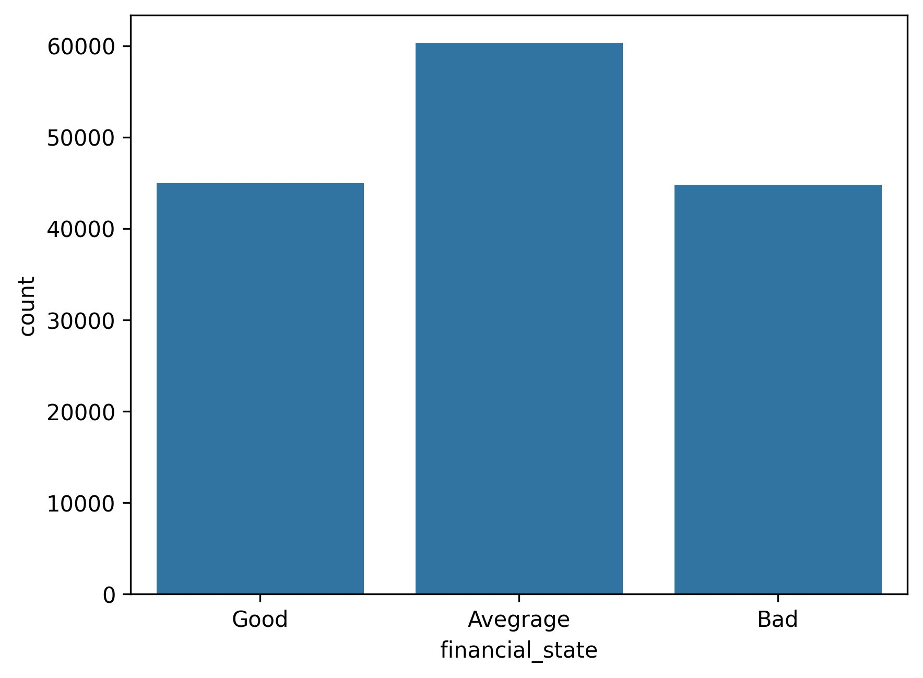
Figure 1: Financial State Distribution — Count of Students by Financial Category
Insight: The majority of students (40.2%) are in the Average financial state. The near-equal split between Good (29.9%) and Bad (29.8%) suggests financial stress is a widespread and diverse issue among the student population.

5. Gender & Study Hours Analysis

5.1 Gender Distribution
The dataset has a near-perfect balance across three gender categories, as shown below:

Gender | Count | Avg Study Hours
Female | 49,988 (33.3%) | 5.50 hrs
Male | 49,964 (33.3%) | 5.51 hrs
Other | 50,048 (33.3%) | 5.52 hrs

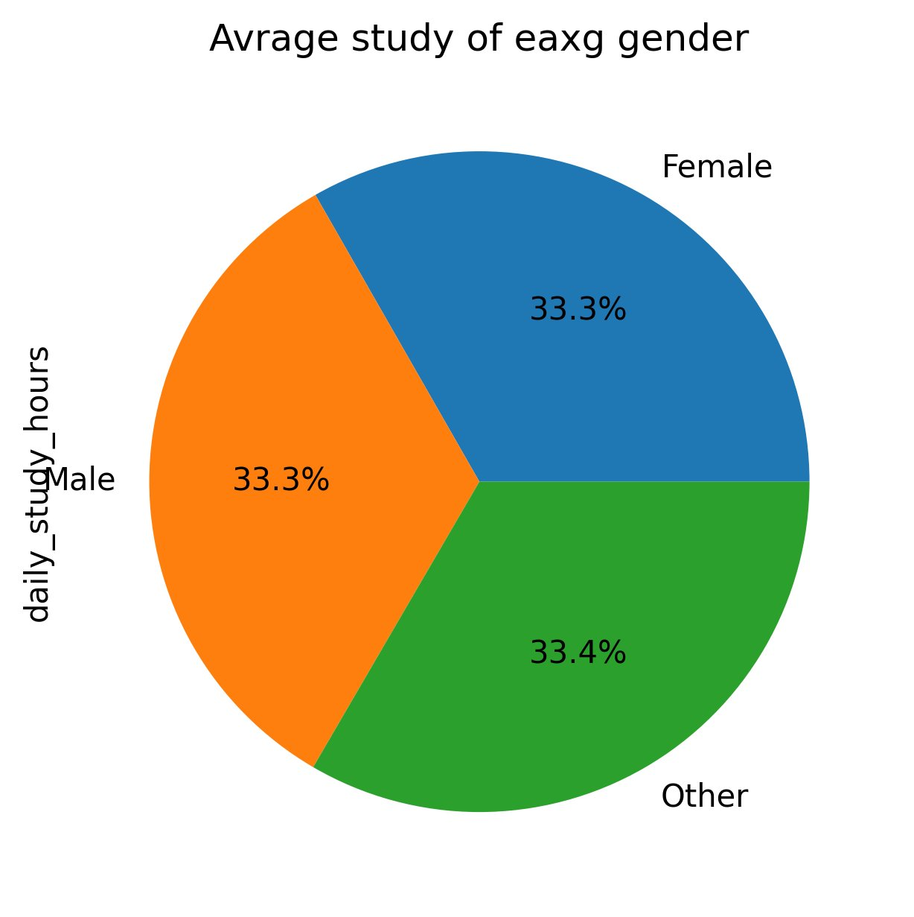
Figure 2: Average Daily Study Hours by Gender (Pie Chart)
Insight: All three gender groups show virtually identical average daily study hours (5.50–5.52 hrs), indicating no significant gender-based difference in study behavior. The even split (33.3% each) also makes the dataset well-suited for unbiased gender-based comparisons.

6. Depression Score by Academic Year
Understanding how depression evolves across academic years is crucial for designing targeted mental health interventions. The line chart below tracks the mean depression score from 1st to 4th year:

Academic Year | Avg Depression Score
1st Year | 5.490
2nd Year | 5.505
3rd Year | 5.518 ← Peak
4th Year | 5.476

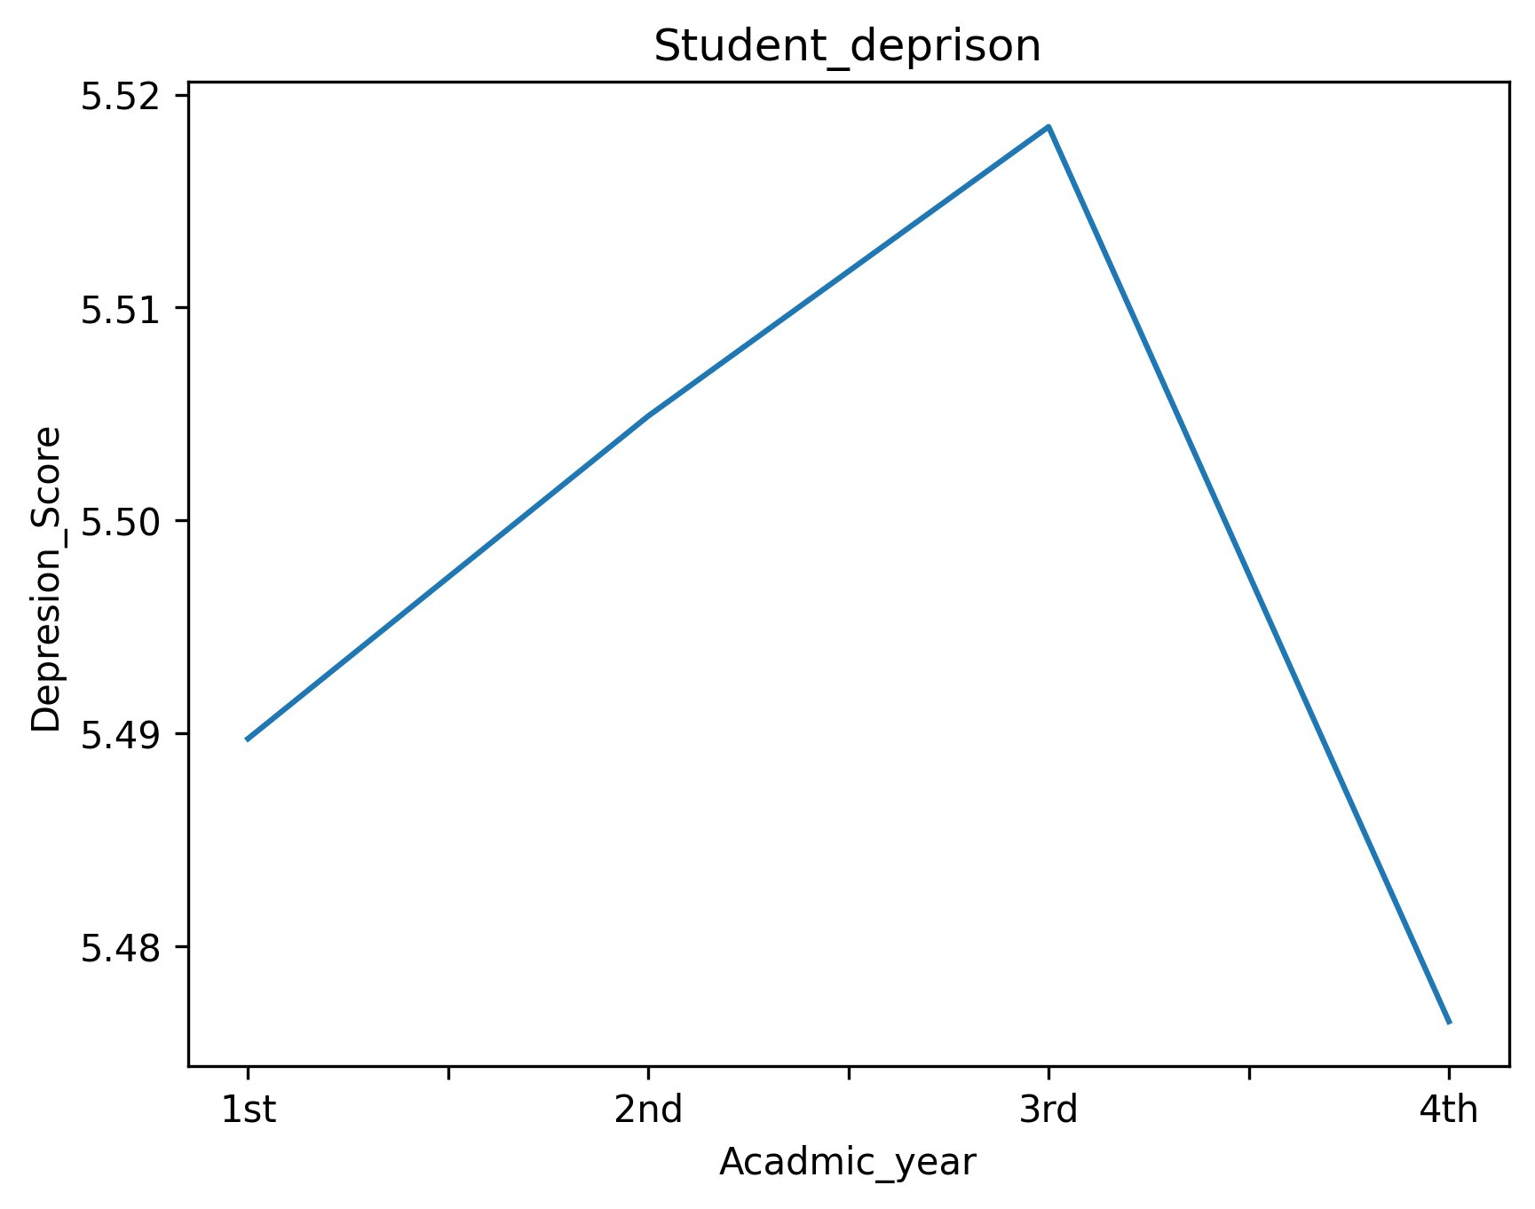
Figure 3: Average Depression Score by Academic Year (Line Chart)
Insight: Depression scores follow a rise-and-fall pattern, peaking at 3rd year (5.518) and declining in 4th year (5.476). This is consistent with real-world observations where 3rd-year students face increased academic pressure, project work, and career concerns. The recovery in 4th year may reflect adaptation or narrowing focus on graduation.

7. Physical Activity by Academic Year
The chart below illustrates the average physical activity hours across academic years. A pie chart representation highlights the relative proportions of physical engagement per year:

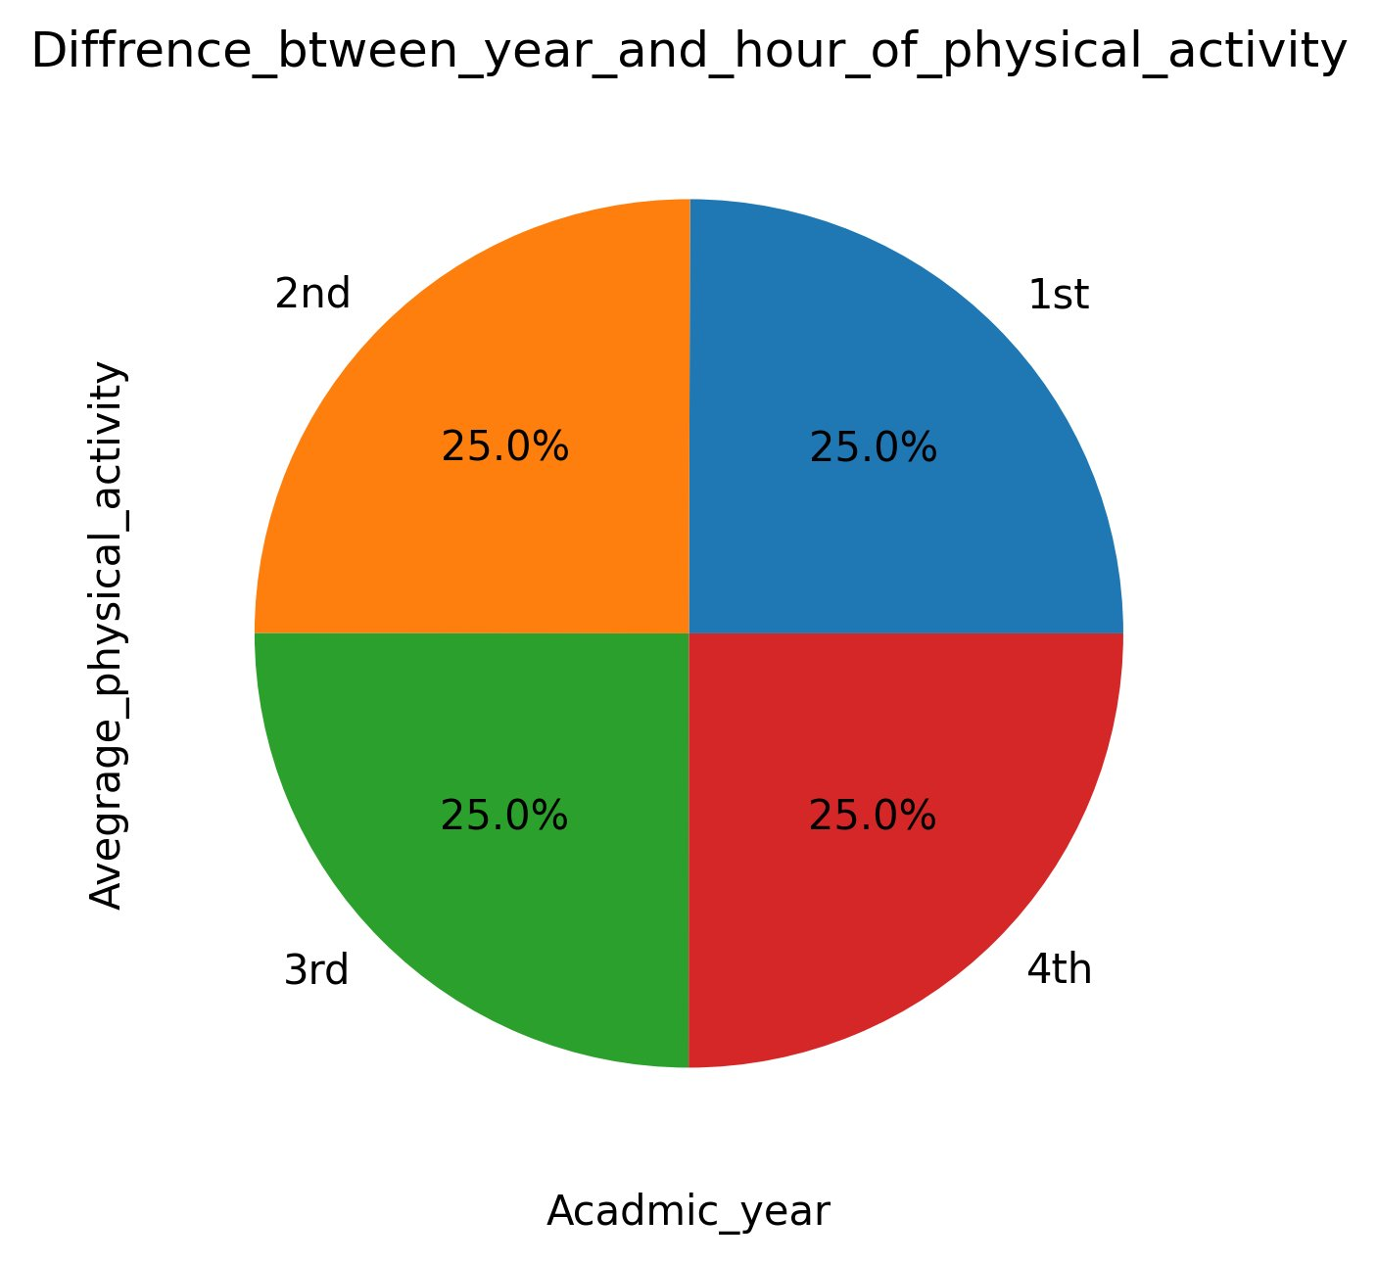
Figure 4: Average Physical Activity Hours by Academic Year (Pie Chart)
Insight: Physical activity hours are virtually identical across all four academic years (~1.0 hr/day each), resulting in an equal 25% share per year in the pie chart. This uniformity indicates that academic year does not significantly influence the amount of physical activity students engage in.

8. Burnout & Stress Level Distribution

8.1 Burnout Levels
The burnout levels across the student population are distributed as follows:

Burnout Level | Count | Percentage
Low | 50,265 | 33.5%
Medium | 49,969 | 33.3%
High | 49,766 | 33.2%

Insight: Burnout levels are uniformly spread across Low, Medium, and High categories with roughly 33% each. This suggests that burnout is not concentrated in any specific group — it is a widespread phenomenon affecting all segments of the student population.

8.2 Stress Levels
Similarly, stress levels (High: 50,295 | Medium: 50,090 | Low: 49,615) are also nearly uniformly distributed, indicating that stress, like burnout, is a universal concern across this student dataset.

9. Academic Performance — Top CGPA Students
The following students achieved the highest CGPA scores in the dataset:

Rank | Student ID | CGPA
1st | 100039 | 10.0
2nd | 234931 | 10.0
3rd | 215471 | 10.0

The average CGPA across all 150,000 students is 7.00, with a standard deviation of 1.73. The distribution is fairly symmetric, suggesting a bell-shaped performance distribution. Three students achieved a perfect score of 10.0.

10. Key Findings & Recommendations

10.1 Key Findings
- Financial stress is moderate for most students (40%), but nearly 30% face severe financial difficulties — requiring targeted support programs.
- Depression peaks in 3rd year — institutions should deploy counseling resources and workload management strategies specifically for 3rd-year students.
- Physical activity is uniformly low (~1 hr/day regardless of year) — campus wellness programs should encourage more active lifestyles.
- Burnout and stress are uniformly spread across all groups — systemic, institution-wide mental health solutions are more appropriate than targeted ones.
- Gender does not significantly influence study hours or performance, indicating equitable academic engagement.

10.2 Recommendations
- Introduce peer-support financial counseling programs, particularly for students in the 'Bad' financial state category.
- Scale up mental health and counseling resources during 3rd-year, when depression scores peak.
- Launch institution-wide wellness campaigns promoting physical activity, as current levels (~1 hr/day) are below recommended thresholds.
- Develop early warning systems using existing features (anxiety score, depression score, academic pressure) to flag at-risk students before burnout escalates.

11. Conclusion
This exploratory data analysis of the Student Mental Health & Burnout dataset reveals a student population under significant but uniformly distributed psychological stress. With 150,000 complete, clean records across 20 well-structured features, the dataset provides a robust foundation for both descriptive insights and predictive modeling.

The analysis shows that financial stress, depression (particularly in the 3rd year), and burnout are widespread concerns. At the same time, the near-equal gender distribution and uniform burnout spread make this dataset highly representative and unbiased. Future work should focus on building predictive models to identify at-risk students early and designing interventions backed by this data.

