SUPERSTORE SALES
DATA ANALYSIS REPORT
Fiscal Years 2014 – 2017

Prepared by: Vivek Mali
Tools Used: Python (Pandas, Matplotlib, Seaborn), MySQL, Power BI
Data Source: Kagle(Superstore.csv) | 9,994 Records

1. Executive Summary
This report presents a comprehensive data analysis of the Superstore retail dataset spanning four fiscal years (2014-2017). The analysis covers 9,994 transaction records across 793 unique customers, examining sales performance, profitability, discount strategies, shipping patterns, and customer behavior. Data was stored in a MySQL database, analyzed using Python (Pandas, Matplotlib, Seaborn), and visualized in Power BI.

Key Performance Indicators

Total Sales | Total Profit | Profit Margin | Total Orders | Customers | Date Range
$2,297,201 | $286,397 | 12.5% | 5,009 | 793 | 2014-2017

The business achieved $2.3M in total sales with a 12.5% overall profit margin. Revenue grew consistently from $484K in 2014 to $733K in 2017, representing a 51% increase over the period. However, profitability analysis reveals critical issues with discount pricing and specific product categories that require strategic attention.

2. Regional & Category Sales Performance

2.1 Sales by Region
The West and East regions dominate total revenue, collectively accounting for over 61% of all sales. The Central region, despite its geographic size, delivers the lowest profit margin at 7.9%, suggesting operational inefficiencies or pricing issues in that market.

Region | Sales ($) | Profit ($) | Margin %
West | $725,458 | $108,418 | 14.9%
East | $678,781 | $91,523 | 13.5%
Central | $501,240 | $39,706 | 7.9%
South | $391,722 | $46,749 | 11.9%

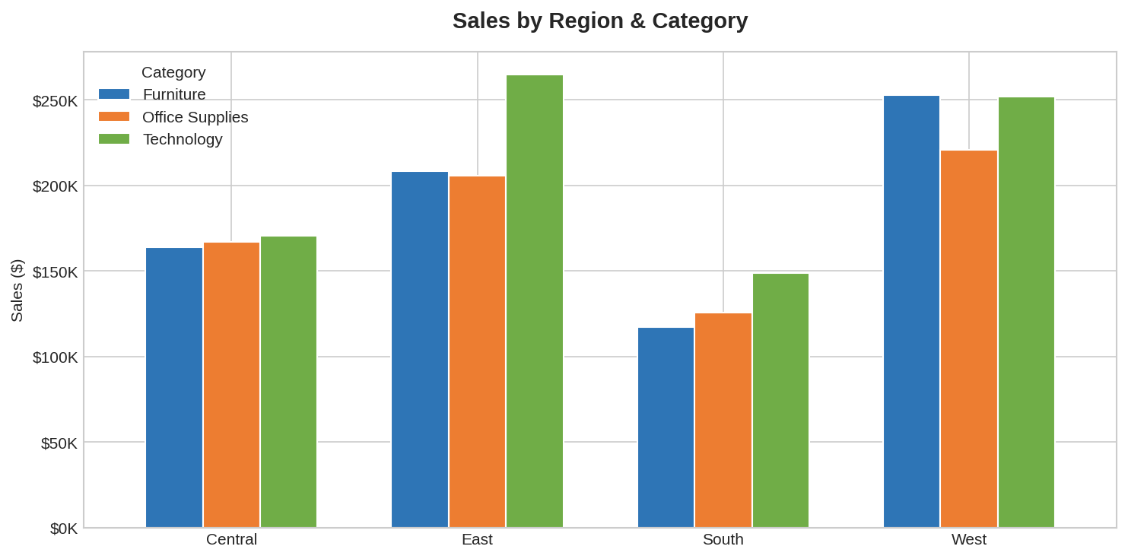
Across all regions, Technology and Office Supplies consistently outperform Furniture in terms of profitability. The West region leads in both absolute sales and profit margin, making it the most valuable market for the business.

2.2 Category Performance
Technology generates the highest sales volume and the best profit margin (17.4%), making it the star performer. Office Supplies follows closely with a 17.0% margin. Furniture, despite ranking second in total sales, delivers a meager 2.5% profit margin — a significant red flag.

Category | Sales ($) | Profit ($) | Margin %
Technology | $836,154 | $145,455 | 17.4%
Office Supplies | $719,047 | $122,491 | 17.0%
Furniture | $742,000 | $18,451 | 2.5%

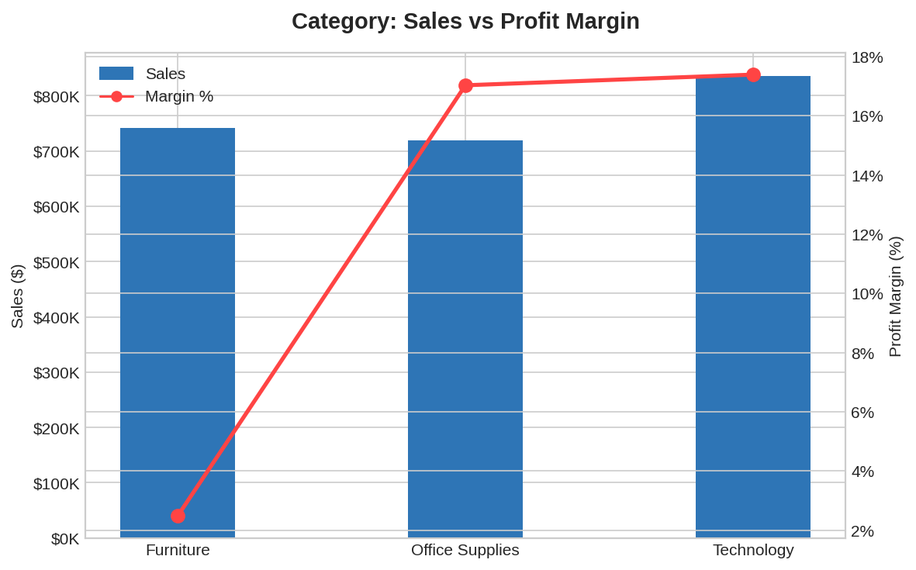

3. Annual Growth Trend
The business demonstrates consistent year-over-year growth across all four years. Both sales and profit have trended upward, with 2017 recording the strongest performance at $733K in sales and $93K in profit. This represents a compound annual growth rate (CAGR) of approximately 14.8% for sales.

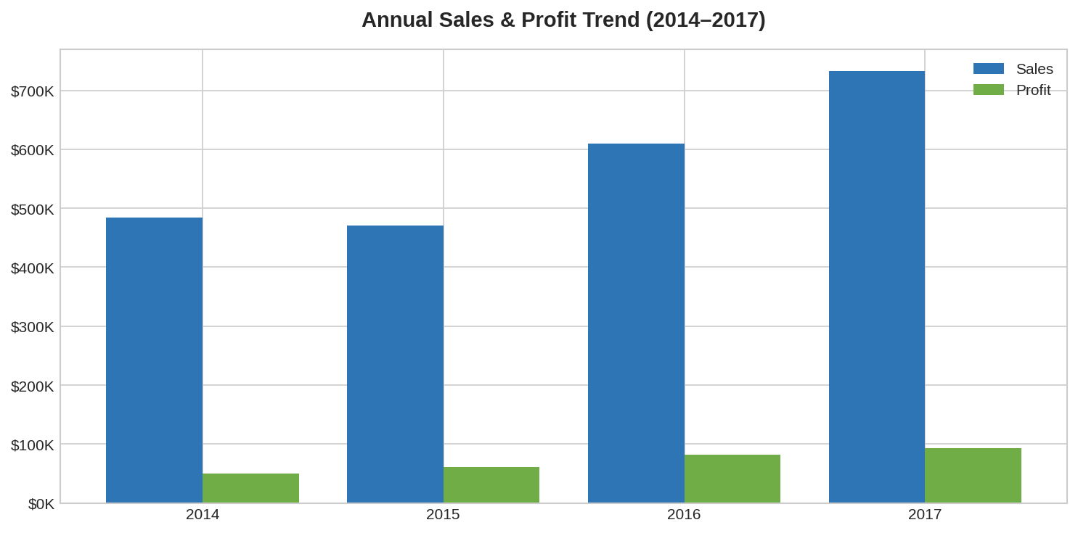
Notable observations from the annual trend analysis include:
- 2015 saw a slight sales dip from 2014 ($470K vs $484K) but profit improved, indicating better cost control.
- 2016 marked a significant acceleration with a $139K jump in sales over 2015.
- 2017 was the strongest year, with sales growing 20.4% over 2016.
- Profit margins remained relatively stable (10-12.7%) across all years, suggesting consistent operational performance.

4. Discount Impact Analysis
Discount strategy has a profound and measurable impact on profitability. The analysis reveals a clear inverse relationship between discount levels and profit — a critical insight that should drive pricing policy decisions.

Discount Level | Avg Profit ($) | Total Profit ($) | Impact
No Discount | $66.90 | $320,988 | Strongly Positive
Low (0-10%) | $96.10 | $9,029 | Positive
Medium (11-20%) | $24.70 | $91,756 | Marginal
High (>20%) | -$97.20 | -$135,376 | Strongly Negative

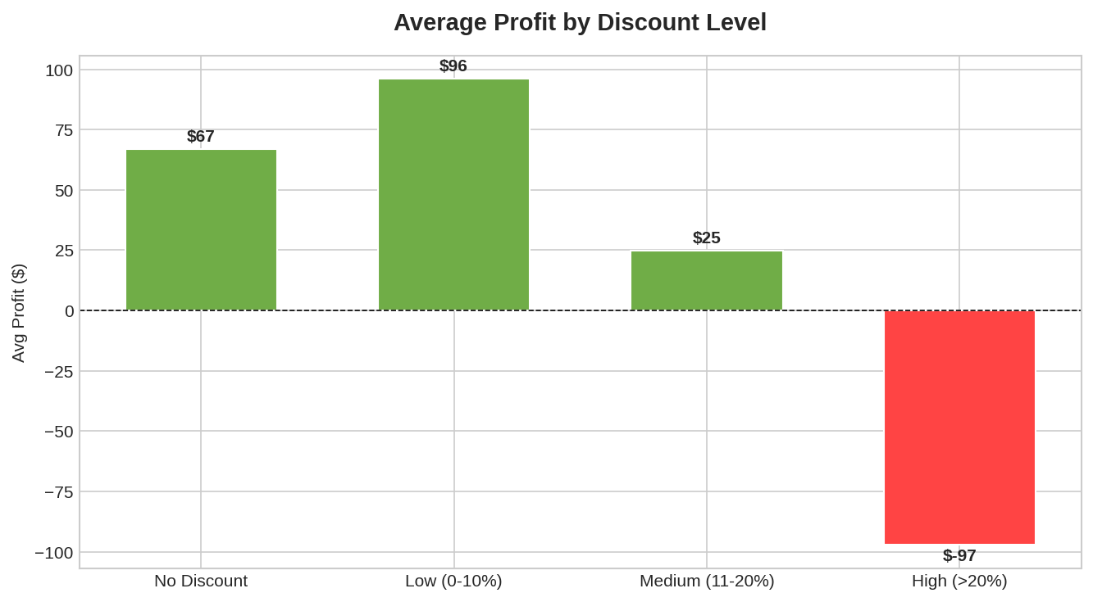
The data presents a stark warning: orders with discounts above 20% generate an average loss of $97.20 per transaction, totaling -$135,376 in aggregate losses. This is the single largest profit drain in the business. Key recommendations:
- Immediately review and restrict high-discount approvals (>20%). These orders are actively destroying value.
- The sweet spot is no-discount or low-discount (0-10%) pricing, which generates the best per-order profitability.
- Medium discounts (11-20%) remain marginally profitable and can be used strategically for customer retention.

5. Sub-Category & Shipping Analysis

5.1 Profitability by Sub-Category
Not all sub-categories contribute equally to the bottom line. Three sub-categories generate negative total profit and represent opportunities for immediate strategic intervention.

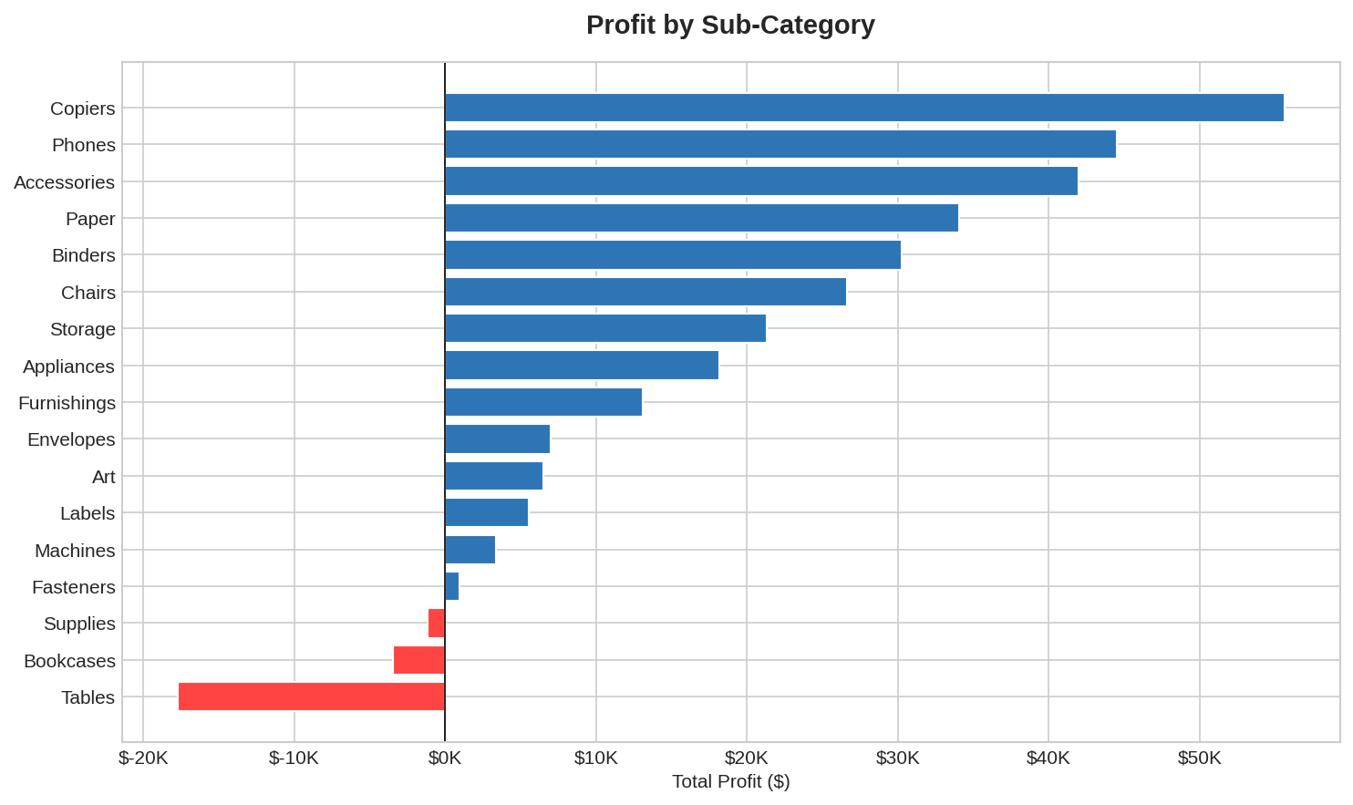
- Tables: -$17,726 total loss — the worst performing sub-category. High sales volume masks severe margin erosion likely caused by heavy discounting and high logistics costs.
- Bookcases: -$3,473 total loss — another Furniture sub-category with structural profitability issues.
- Supplies: -$1,189 total loss — a smaller but notable concern within Office Supplies.
- Copiers, Phones, and Accessories are the top profitable sub-categories and should receive continued investment.

5.2 Shipping Mode Distribution
Standard Class shipping dominates at 59.1% of total sales value, reflecting customer preference for cost-effective delivery. Same Day shipping represents only 5.6% of sales, suggesting limited demand for premium delivery options.

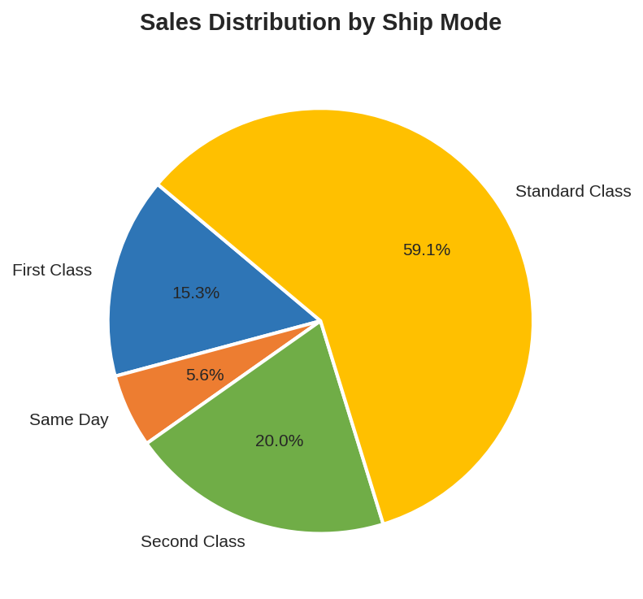

6. Customer Value Analysis
The top 10 customers by revenue account for a significant portion of business. However, revenue alone is a misleading metric — profitability per customer reveals very different priorities for account management.

Customer Name | Revenue ($) | Profit ($) | Orders
Sean Miller | $25,043 | -$1,981 | 5
Tamara Chand | $19,052 | $8,981 | 5
Raymond Buch | $15,117 | $6,976 | 6
Tom Ashbrook | $14,596 | $4,704 | 4
Adrian Barton | $14,474 | $5,445 | 10
Ken Lonsdale | $14,175 | $807 | 12
Sanjit Chand | $14,142 | $5,757 | 9
Hunter Lopez | $12,873 | $5,622 | 6
Sanjit Engle | $12,209 | $2,651 | 11
Christopher Conant | $12,129 | $2,177 | 5

- Sean Miller is the top revenue customer ($25,043) but generates a net loss of -$1,981. This warrants a review of his discount history and order composition.
- Tamara Chand is the most valuable customer in profit terms ($8,981 profit on $19,052 sales = 47.1% margin).
- Ken Lonsdale has 12 orders (the most frequent buyer in the top 10) but generates only $807 in profit — low loyalty ROI.
- Adrian Barton represents the best balance of frequency (10 orders), revenue ($14,474), and solid profit ($5,445).

7. SQL Query Analysis Insights
The following insights were derived from structured SQL queries executed against the MySQL sales database. These queries formed the backbone of the analytical investigation and complement the Python EDA.

Query Focus | Key Finding
Top Revenue Segment | West + Technology delivered the highest revenue combination
Discount Impact | High discounts (>20%) result in avg -$97 loss per order; no-discount orders generate $67 avg profit
Monthly Trends | Q4 consistently peaks; Nov-Dec are highest sales months each year
Loss-Making Categories | Furniture (especially Tables: -$17,726) has negative profit despite high sales volume
Top Customer Value | Sean Miller tops revenue at $25K but generates negative profit (-$1,981) - a key profitability risk

The SQL analysis confirms patterns observed in the EDA and highlights actionable business intelligence. The combination of regional grouping, time-series analysis, and customer segmentation queries provides a multi-dimensional view of performance.

8. Strategic Recommendations

8.1 Immediate Actions
- Discount Policy Reform: Cap maximum discounts at 20% across all categories. Introduce approval workflows for any discount above 15% to prevent margin destruction.
- Furniture Category Review: Conduct a detailed cost analysis for Tables and Bookcases. Consider price adjustments, supplier renegotiation, or discontinuation of low-margin SKUs.
- High-Revenue / Low-Profit Customer Audit: Review Sean Miller's account and similar profiles. Apply targeted pricing corrections while maintaining the relationship.

8.2 Growth Opportunities
- West Region Expansion: The West leads in both sales and margin — allocate additional marketing and inventory resources to this region.
- Technology Category Investment: With 17.4% margins and strong growth, Technology should be the primary focus for product line expansion and marketing spend.
- Q4 Seasonal Strategy: Historical data shows consistent Q4 peaks. Implement dedicated seasonal promotions and inventory planning to capitalize on this trend.
- Corporate Segment Development: The Corporate segment (30.7% of sales, 13.0% margin) shows solid fundamentals and could benefit from dedicated account management.

8.3 Analytical Next Steps
- Implement real-time dashboards in Power BI with automated MySQL data refresh to monitor KPIs weekly.
- Build a customer churn prediction model to identify at-risk high-value customers.
- Develop a dynamic pricing model that adjusts discount thresholds based on product margin and regional demand.

— End of Report —

