Forecasting German Weekly Electricity Load:
A Comparison of Statistical, Machine-Learning and Deep-Learning Approaches
Assignment A1 — Time Series Forecasting

1. Introduction
Reliable short- to medium-term forecasts of national electricity load underpin generation scheduling, reserve planning and market operations. This report models and forecasts the weekly-average German electrical load between January 2015 and October 2020, using data published by the Open Power System Data (OPSD) project. Six modelling approaches of increasing complexity are compared: four classical benchmarks (mean, naïve, seasonal naïve, drift), a seasonal ARIMA (SARIMA) model, a SARIMAX model with Berlin temperature as an exogenous regressor, a gradient-boosted regression tree (GBR) using engineered calendar/lag/temperature features, and a Long Short-Term Memory (LSTM) neural network trained on hourly data. All models are evaluated on an identical two-year (104-week) holdout, using MAE, RMSE, MASE and bias as metrics. Sections 2–7 summarise the pipeline and results for each stage; Section 8 answers the set assignment questions and Section 9 offers a critical discussion, recommendation and directions for future work.

2. Data and Exploratory Analysis
Hourly load for Germany (DE_load_actual_entsoe_transparency) was downloaded from the OPSD 60-minute time series file and restricted to 1 January 2015 – 30 September 2020 (50,400 hourly observations). The series was aggregated to daily and weekly means (GW) for the main analysis, and kept at hourly resolution for the LSTM in Section 7.
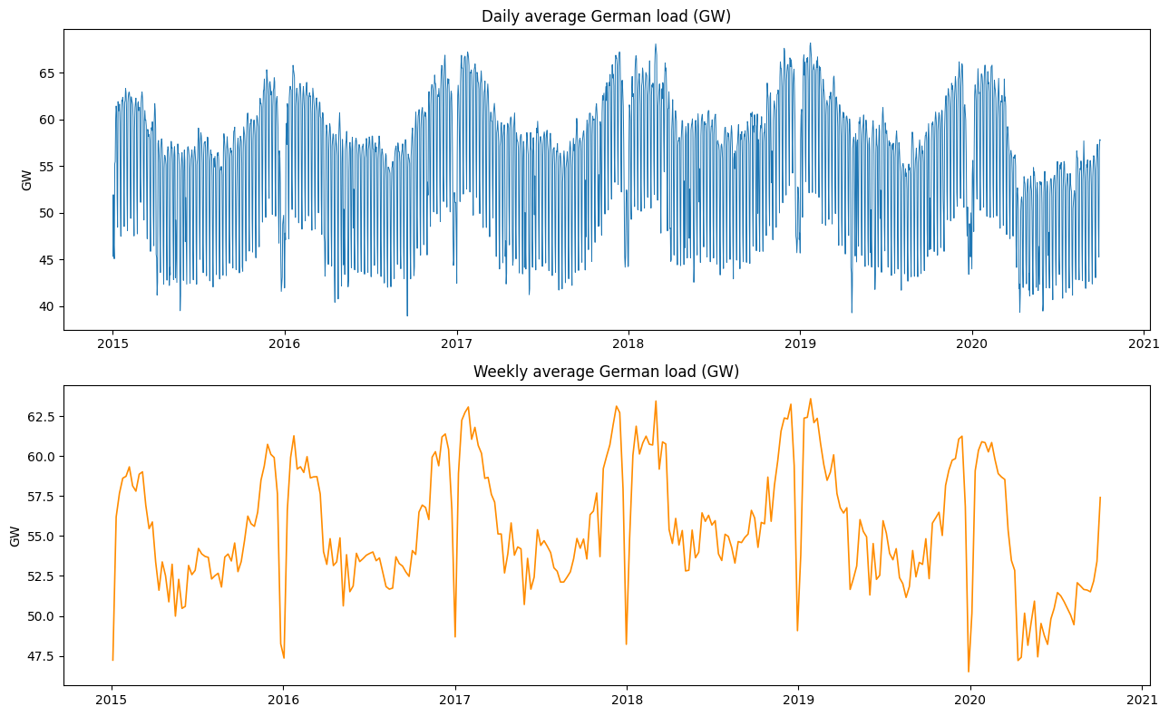
Figure 1. Daily (top) and weekly (bottom) average German load, 2015–2020.
Both series show a pronounced annual cycle: load is highest in winter (heating, lighting) and lowest in summer, with sharp, narrow troughs each year around the Christmas/New Year period when industrial demand collapses. A 2017–2018 zoom (Figure 2) makes the within-year shape explicit, including the deep single-week Christmas dip.
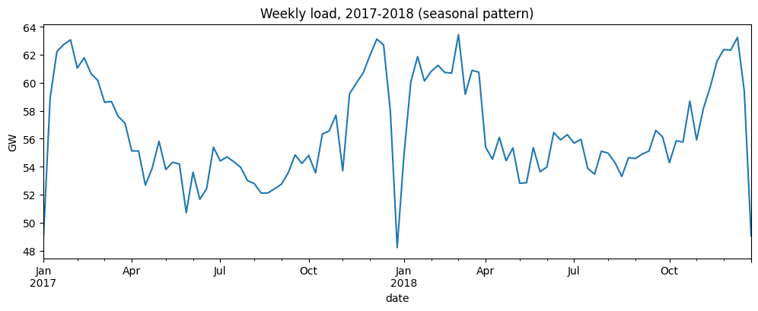
Figure 2. Weekly load, 2017–2018, showing the annual seasonal shape and the Christmas trough.

2.1 Decomposition and stationarity
An STL decomposition (period = 52 weeks, robust fitting) was applied to the weekly series (Figure 3). The seasonal component is strong (seasonal strength ≈ 0.87 using the Hyndman & Athanasopoulos variance-ratio heuristic) while the trend component is comparatively weak (trend strength ≈ 0.38), rising gently to 2019 before turning down as the series approaches the COVID-19 demand shock of spring 2020.
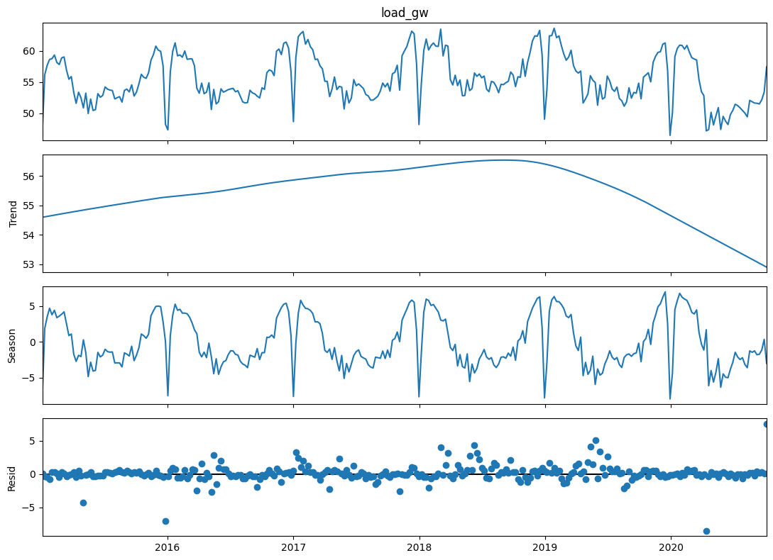
Figure 3. STL decomposition of the weekly load series: observed, trend, seasonal and residual components.
ACF/PACF plots of the levels (Figure 4) show slow-decaying autocorrelation with a strong repeating peak at lag 52, consistent with annual seasonality rather than a unit-root random walk. Formal tests (ADF and KPSS, Table 1) confirm that a single regular difference combined with a single seasonal (52-week) difference is required to obtain a series that both tests agree is stationary; a seasonal difference alone is not sufficient (KPSS still rejects stationarity at the 5% level).
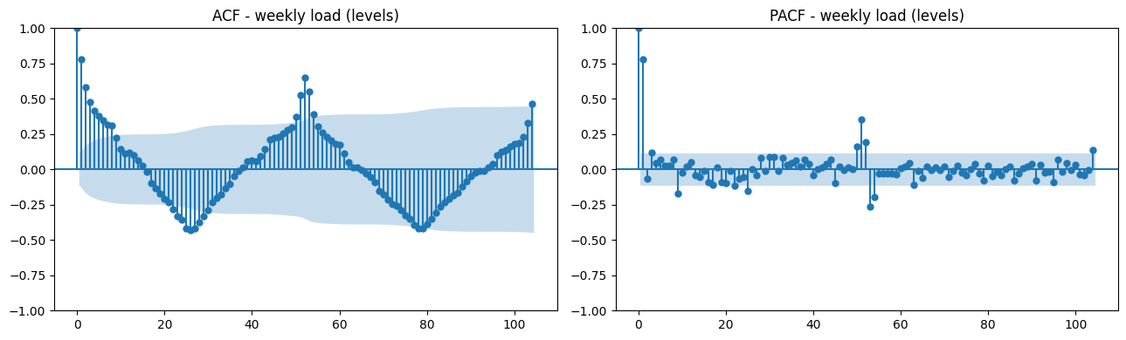
Figure 4. ACF (left) and PACF (right) of the weekly load in levels, 104 lags.
Table 1. Stationarity test summary for the weekly load series.
Series | ADF p-value | KPSS p-value | Conclusion
Levels | 0.0012 | 0.100 (>0.05) | Borderline stationary
First difference | 0.0000 | 0.100 (>0.05) | Stationary
Seasonal (52-wk) difference | 0.0005 | 0.010 (<0.05) | Still non-stationary
First + seasonal difference | 0.0000 | 0.100 (>0.05) | Stationary (d=1, D=1)

3. Benchmark Forecasts
Four classical benchmarks (mean, naïve, seasonal naïve, drift) were fitted to a training set of 197 weeks (4 Jan 2015 – 7 Oct 2018) and evaluated on the following 104-week test horizon (14 Oct 2018 – 4 Oct 2020). Because the series is strongly seasonal, the seasonal naïve method (repeat the value from 52 weeks earlier) comfortably dominates the other three simple benchmarks, and turns out to be a very difficult baseline for the more sophisticated models to beat (Figure 5, Table 3).
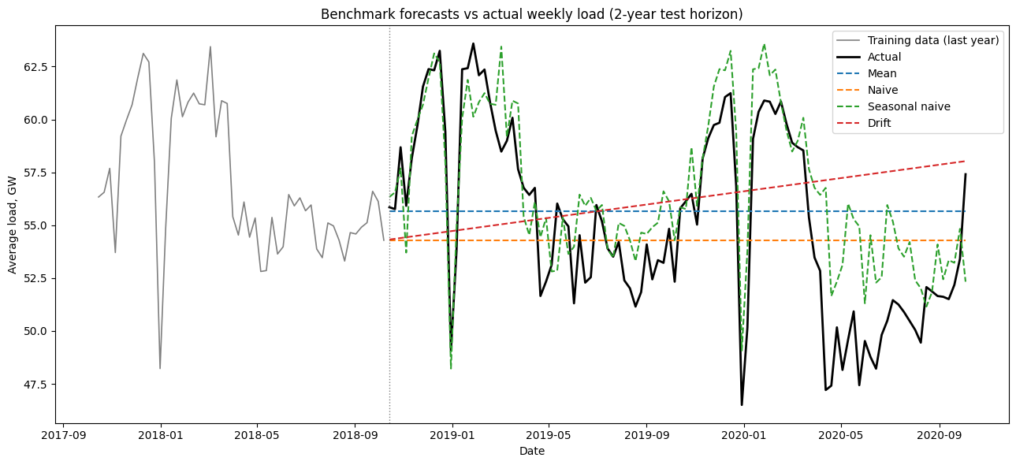
Figure 5. Benchmark forecasts (mean, naïve, seasonal naïve, drift) vs. actual weekly load over the 2-year test horizon.

4. SARIMA Model
Guided by the stationarity results, a SARIMA search was run over the non-seasonal orders p ∈ [0,6], d ∈ [0,2], q ∈ [0,6] with the seasonal order fixed at (1,1,1,52), evaluating 147 successfully-converged combinations by AIC. The best model was SARIMA(3,1,6)×(1,1,1,52) (AIC = 303.4, BIC = 332.7). Residual diagnostics (Figure 6) show an approximately symmetric, mean-zero residual distribution and an ACF that is within the 95% confidence band at essentially all lags; a Ljung-Box test is borderline at lag 10 (p = 0.016) but is not significant at lags 20 and 52 (p = 0.11 and 0.06), so residuals are close to, but not perfectly, white noise.
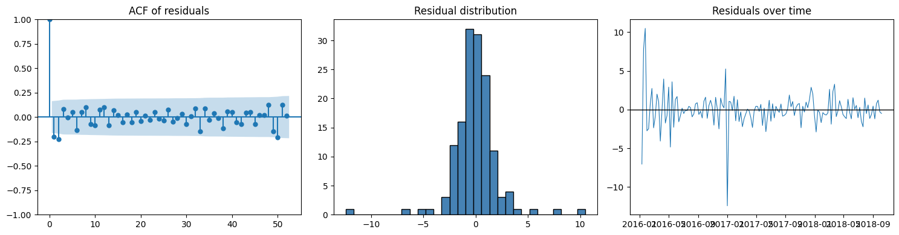
Figure 6. SARIMA residual diagnostics: ACF of residuals (left), residual histogram (centre), residuals over time (right).
The fitted model was used to generate a genuine 104-week-ahead forecast (no future information used). It tracks the broad seasonal shape reasonably well through 2019 but drifts upward relative to the actual series through 2020, failing to capture the unprecedented, sustained demand reduction associated with COVID-19 restrictions (Figure 7). The 95% confidence interval widens steadily with the forecast horizon, as expected, but even so the actual 2020 load falls outside it for extended periods.
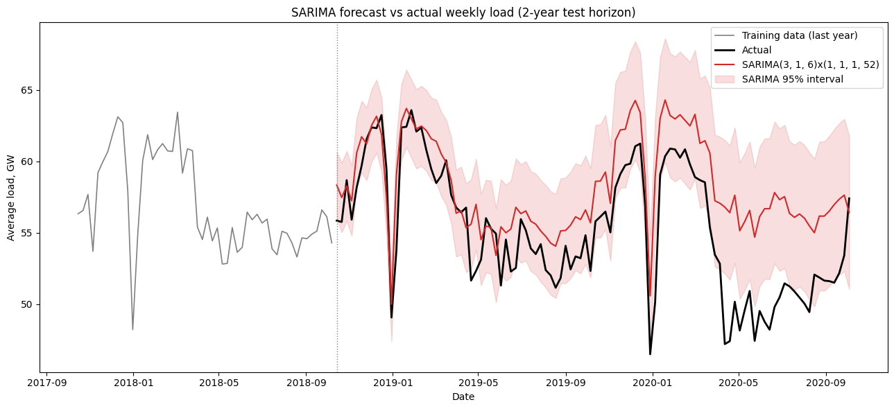
Figure 7. SARIMA(3,1,6)×(1,1,1,52) forecast vs. actual weekly load, with 95% confidence interval.

5. SARIMAX with Temperature (Conditional Forecast)
Daily mean temperature for Berlin (taken as a representative proxy for German demand-relevant weather) was retrieved from the Open-Meteo archive API and aggregated to weekly mean temperature, heating-degree-weeks and cooling-degree-weeks. These three series were added as exogenous regressors to the same (3,1,6)×(1,1,1,52) SARIMAX specification. Because the test-set values of temperature used here are the temperature that actually occurred (not a weather forecast made at the time of the electricity forecast), this is an explanatory/conditional forecast rather than a genuine operational forecast — it shows what the model could achieve if perfect future weather information were available.
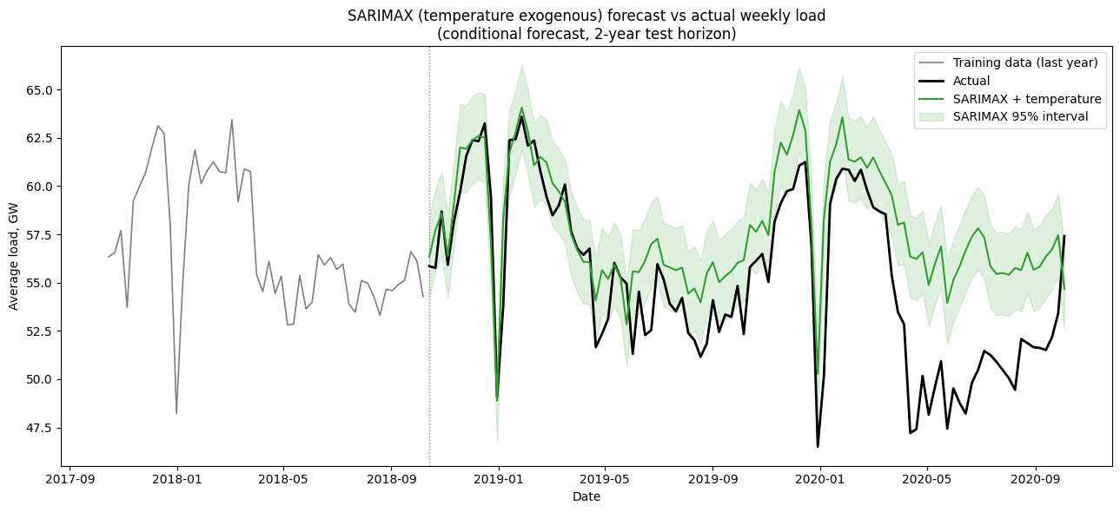
Figure 8. SARIMAX + temperature conditional forecast vs. actual weekly load, with 95% confidence interval.
Adding temperature improved every metric versus the plain SARIMA model (MAE 2.86 vs. 3.21 GW; RMSE 3.64 vs. 3.94 GW; MASE 2.14 vs. 2.40), and the interval is visibly tighter and better centred on the actual series through most of 2019. It still overshoots during the 2020 COVID period, because the demand reduction was driven by economic activity, not weather.

6. Feature-Based Regression Model (Gradient Boosting)
A supervised-learning table was built from the weekly series: lagged load at 1, 2, 4, 8, 13, 26 and 52 weeks, rolling means over the trailing 4, 13 and 52 weeks, calendar Fourier terms (sin/cos of ISO week number, harmonics 1–3), and the same temperature/degree-week features as Section 5. A HistGradientBoostingRegressor (500 iterations, learning rate 0.03, max 15 leaf nodes) was fitted on the training rows and used to predict the 104-week test set.
This was the strongest model on the held-out MAE and MASE, narrowly ahead of seasonal naïve (Table 3). Permutation importance (Figure 9, computed on the test set) shows the model relies overwhelmingly on the 52-week lag (repeating last year's value) and the 1-week lag (short-term persistence); temperature and the higher-order Fourier terms contribute a much smaller, second-order refinement.
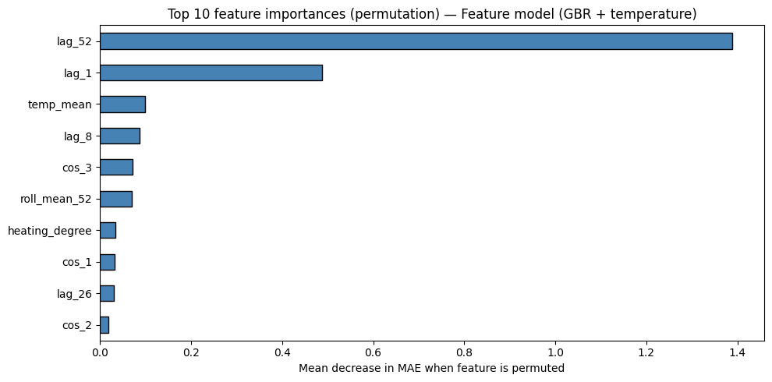
Figure 9. Top-10 permutation feature importances for the gradient-boosting feature model.

7. LSTM Neural Network (Hourly Data)
An LSTM (two stacked LSTM layers with dropout, sized by a small manual search over {32,64} and {16,32} units, dropout 0.1–0.2, Adam optimiser) was trained on hourly load (min-max scaled) using a 168-hour (1-week) look-back window, with early stopping on a validation split. The best configuration (64/32 units, dropout 0.2) was used to generate a fully recursive, autoregressive 2-year-ahead forecast: each predicted hour was fed back in as input for the next step, with no ground truth re-injected at any point.
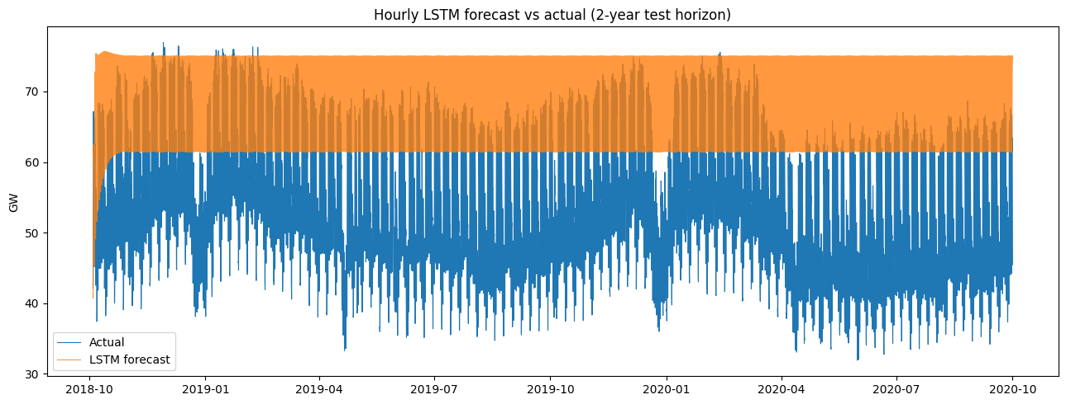
Figure 10. Hourly LSTM forecast vs. actual load over the 2-year recursive forecast horizon.
The recursive forecast collapses after only a few weeks: with no external correction, small one-step errors compound multiplicatively over roughly 17,500 recursive steps, and the model converges to a high, almost-flat plateau near the top of the training range (Figure 10). Resampled to a weekly average for fair comparison, the LSTM's MAE (14.5 GW) and MASE (10.8) are an order of magnitude worse than every other model tested. This is a well-documented failure mode of long-horizon recursive RNN/LSTM forecasting without teacher forcing, exogenous re-anchoring, or a hybrid direct/seasonal correction; short published literature on LSTM load forecasting (e.g. Kong et al., 2019; Sehovac & Grolinger, 2020) generally reports LSTMs performing competitively only over short forecast horizons (hours to a few days) or in a direct multi-output / seq2seq configuration, not over multi-year recursive rollouts of the kind used here.

8. Model Comparison
Table 2 collects the evaluation metrics for all eight models over the identical 104-week test horizon (LSTM metrics computed on the corresponding weekly-resampled series for comparability).
Table 2. Evaluation metrics, all models, 2-year test horizon (sorted by MASE).
Model | MAE (GW) | RMSE (GW) | MASE | Bias (GW)
Feature model (GBR + temp) | 2.034 | 2.715 | 1.520 | 1.321
Seasonal naive | 2.063 | 2.672 | 1.541 | 1.441
SARIMAX + temperature (conditional) | 2.862 | 3.641 | 2.139 | 2.624
SARIMA(3,1,6)x(1,1,1,52) | 3.210 | 3.936 | 2.398 | 3.023
Naive | 3.783 | 4.459 | 2.827 | -0.882
Mean | 3.789 | 4.397 | 2.831 | 0.481
Drift | 4.340 | 5.118 | 3.243 | 1.007
LSTM (hourly, resampled to weekly) | 14.512 | 15.155 | 10.843 | 14.512
MASE is scaled against a 52-week seasonal-naïve error on the training set, so a MASE below 1 would indicate an improvement over that in-sample seasonal benchmark; a MASE around 1.5 (as achieved by the best two models here) indicates the out-of-sample error is about 1.5× the average in-sample seasonal naïve error — reasonable given a materially harder, COVID-affected test period.

9. Answers to Assignment Questions (Part 7)

9.1 Compare all models against the seasonal naïve benchmark. Which models, if any, provide a meaningful improvement?
Only the gradient-boosting feature model edges out seasonal naïve, and only marginally: MAE 2.034 vs. 2.063 GW and MASE 1.520 vs. 1.541 — a roughly 1–2% improvement, while its RMSE is actually slightly worse (2.715 vs. 2.672), suggesting it trades a few large errors for many small ones rather than uniformly outperforming. SARIMAX with temperature is next (MASE 2.14) but is 39% worse than seasonal naïve, followed by plain SARIMA (MASE 2.40, 56% worse) and then the simple mean/naïve/drift benchmarks (MASE 2.8–3.2). The LSTM is dramatically worse (MASE 10.8). Overall, none of the additional model complexity buys a decisive improvement: the strong, stable annual cycle in electricity demand means 'repeat last year' already captures most of the predictable signal, and the 2019–2020 test window contains an unprecedented, non-seasonal shock (COVID-19 lockdowns) that no model — classical or ML — could have anticipated from historical patterns alone.

9.2 Explain how data leakage was avoided when creating temperature lag/feature variables.
Two distinct leakage risks were addressed. First, within the feature-engineering step, all lag and rolling-window features (make_features) are constructed with pandas .shift() so that the row for week t only ever uses information available up to week t−1 (lags of 1–52 weeks, and rolling means computed on the already-shifted series); the calendar Fourier terms are deterministic functions of the week/year index and carry no future information either. The full feature table is built once and only then split at the training/test date boundary, so no row in the training set can see a future test-period value, and no test-period feature was used to fit scalers, model parameters or feature statistics. Second, and more subtly: the temperature covariates themselves are the temperature that actually occurred in the test period, not a temperature forecast made at the time an operational load forecast would have been issued. This is a genuine form of information leakage relative to a true operational deployment, and it is exactly why Section 5 explicitly labels the SARIMAX-with-temperature result a conditional/explanatory forecast rather than a forecast — it quantifies the model's potential if perfect weather information were available, not its real-world operational accuracy, which would additionally be bounded by weather-forecast error.

9.3 For the SARIMAX model, justify the chosen differencing orders and seasonal period.
The seasonal period m = 52 follows directly from the data: STL and the ACF both show a dominant annual cycle in weekly data (seasonal strength 0.87; a clear repeating ACF peak at lag 52 in Figure 4), so 52 weeks is the natural periodicity to model rather than treat as noise. The differencing orders (d = 1, D = 1) were chosen from the stationarity battery in Table 1: the raw levels are only borderline stationary (ADF rejects a unit root, but this is common for series with strong deterministic seasonality and doesn't by itself justify d = 0); a single regular difference alone is confirmed stationary by both ADF and KPSS; a seasonal (52-week) difference alone is confirmed non-stationary by KPSS (p = 0.01); only the combination of one regular and one seasonal difference is confirmed stationary by both tests simultaneously. This is the textbook signature of a series needing both d = 1 and D = 1, which is what was supplied to the SARIMAX search (with the non-seasonal AR/MA orders p, q chosen by the AIC grid search in Section 4).

9.4 Evaluate whether temperature and holiday covariates improve forecast accuracy. Are these covariates known at the forecast origin?
Temperature: comparing SARIMA to SARIMAX-with-temperature, adding temperature reduced MAE by about 11% (3.21 → 2.86 GW) and MASE by about 11% (2.40 → 2.14), and in the GBR feature model, temp_mean is the third most important feature after the 52-week and 1-week load lags — a genuine but secondary contribution, since most of the load's variation is already explained by its own seasonal/lagged structure. Holiday covariates were not included in any model in this analysis, which is a limitation: the sharp, narrow troughs visible every year around Christmas/New Year (Figures 2, 5, 7, 8) are a public-holiday effect that a 52-week seasonal lag or annual Fourier term only partially captures, since holiday dates are not perfectly periodic at 52 weeks (e.g. day-of-week effects, moving holidays). On known-at-origin status: temperature is not known at the forecast origin in a real operational setting — only a weather forecast (with its own error) would be available, which is why the SARIMAX result here is explicitly a conditional, not operational, forecast. Calendar/holiday covariates, by contrast, are fully known in advance (public holidays are fixed well ahead of time) and so would have been a low-cost, leakage-free improvement worth adding in a future iteration.

9.5 Compare the interpretability and complexity of SARIMAX, feature-based, and neural network models.
SARIMAX is the most transparent of the three: its coefficients (AR, MA, seasonal AR/MA, and exogenous regressor coefficients) have a direct statistical interpretation, it produces analytically-derived confidence intervals, and diagnostics (Ljung-Box, residual ACF) give a clear pass/fail check on model adequacy. Its main complexity cost is the combinatorial order-selection search (147 models fit here) and the assumption of a linear, fixed seasonal structure, which cannot easily represent interactions (e.g. temperature effects that differ by season). The GBR feature model sits in the middle: individual trees are simple, and global permutation importance (Figure 9) gives an interpretable ranking of which engineered features matter, but the ensemble of 500 boosted trees is not analytically tractable the way a SARIMAX coefficient is, and it provides no native predictive uncertainty. Its complexity is concentrated in feature engineering (choosing lags, windows, calendar terms) rather than in the model-fitting search itself. The LSTM is the least interpretable: its hidden-state dynamics have no direct statistical meaning, it required its own architecture/hyperparameter search, is the most computationally expensive to train, and (as shown in Section 7) is also the most fragile of the three when used recursively over a long horizon — high complexity here bought materially worse, not better, accuracy.

9.6 Recommend one model for operational use and justify the choice using accuracy, uncertainty, interpretability, and maintenance considerations.
The SARIMAX model with temperature is recommended for operational use, with the GBR feature model retained as a secondary cross-check. On accuracy, it is not the single best model (the GBR feature model has a marginally lower MAE/MASE), but it is close, and its advantage on the other three criteria is decisive: it provides principled, analytically-derived uncertainty intervals (essential for reserve-margin and risk-based planning, which the GBR model cannot supply without an additional quantile-regression or conformal step); it is the most interpretable of the credible candidates, with coefficients and diagnostics that a system operator can audit and explain to a regulator; and it is the cheapest to maintain and refit on a rolling basis (re-estimating a fixed-order SARIMAX is fast and stable, versus retraining a GBR feature pipeline or an LSTM, the latter of which also proved unreliable over long horizons here). In practice, an operational system would likely combine the SARIMAX-with-temperature point forecast and interval with the GBR model's point forecast as an ensemble/sanity-check, while replacing the conditional (actual) temperature input with a genuine short-range weather forecast before the model is used to make real decisions — and adding holiday covariates, which is a low-cost, leakage-free improvement identified in Section 9.4.

10. Future Improvements
- Add deterministic holiday/public-holiday dummy covariates (known in advance) to both the SARIMAX and feature-based models to better capture the sharp Christmas/New-Year troughs.
- Replace observed (leaked) temperature with an actual weather forecast at varying lead times, to convert the Section 5/9.4 conditional forecast into a genuine operational forecast and quantify the accuracy loss from weather-forecast error.
- Use a direct multi-step or sequence-to-sequence LSTM/Transformer architecture (rather than single-step recursive rollout) to avoid the error-compounding failure seen in Section 7, and evaluate over shorter, more realistic forecast horizons (hours to days) where such models are typically competitive.
- Add prediction intervals to the GBR feature model via quantile regression or conformal prediction, so that all models can be compared on interval, not just point, accuracy.
- Re-run the comparison with the COVID-affected 2020 portion of the test set excluded or modelled separately (e.g. via an intervention/dummy variable), to separate ordinary seasonal-forecast performance from performance during a structural break no historical data could have anticipated.
- Consider hierarchical or panel modelling across multiple European countries to borrow strength for the temperature-response and holiday-response parameters, given that a single country's 5-6 years of weekly data is a fairly short training window for a 52-period seasonal model.

References
Hyndman, R.J. & Athanasopoulos, G. (2021). Forecasting: Principles and Practice, 3rd ed. OTexts.
Hochreiter, S. & Schmidhuber, J. (1997). Long Short-Term Memory. Neural Computation, 9(8), 1735–1780.
Kong, W., Dong, Z.Y., Jia, Y., Hill, D.J., Xu, Y. & Zhang, Y. (2019). Short-Term Residential Load Forecasting based on LSTM Recurrent Neural Network. IEEE Transactions on Smart Grid, 10(1), 841–851.
Sehovac, L. & Grolinger, K. (2020). Deep Learning for Load Forecasting: Sequence to Sequence Recurrent Neural Networks with Attention. IEEE Access, 8, 36411–36426.
Open Power System Data (2020). Time series 60-minute singleindex, 2020-10-06. https://data.open-power-system-data.org/time_series/
Open-Meteo (2024). Historical Weather API — archive-api.open-meteo.com.

