**INTELLIGENT TRANPORTATION OPTIMIZATION PLATFORM**

Vivek Agrawal

18th November, 2023

GitHub Link: <https://github.com/VivekAgrawl/intelligent-transportation-optimization-platform.git>

Web Application Link: <https://transintel.streamlit.app/>

*Abstract*

Our project introduces an innovative Intelligent Maintenance Prediction Service designed to revolutionize the transportation and logistics sector. The prototype focuses on predicting vehicle maintenance needs using advanced machine learning technologies. Assessment of the predictive model, based on a synthetic dataset, reveals promising results with robust performance metrics, such as AUC scores and classification reports. The integration of this model into a user-friendly web application ensures practical implementation.

Strategically positioning the service within the fleet management market, our business model outlines a clear value proposition and revenue streams. Financial modelling, employing a flexible linear growth model, offers insights into potential profits, contingent on assumed pricing and client growth.

In conclusion, our Intelligent Maintenance Prediction Service emerges as a transformative solution poised to address operational inefficiencies in transportation. The project's adaptability to real-world data and commitment to sustainability positions it as an impactful innovation, capable of reshaping practices within the fleet management landscape, fostering efficiency, and contributing to a more sustainable transportation ecosystem.

**1.0 Prototype Selection**

**1.1 Introduction**

One of the identified challenges in the transportation and logistics industry is the issue of unplanned maintenance, causing disruptions, increased costs, and customer dissatisfaction. To address this specific problem, the team has proposed a prototype focused on "Maintenance Prediction." This prototype aims to leverage advanced technologies, including machine learning and artificial intelligence, to predict potential vehicle maintenance needs proactively.

**1.2 Feasibility**

The Maintenance Prediction prototype demonstrates high feasibility within the short-term horizon of 2-3 years. The implementation of machine learning algorithms to analyze historical maintenance data and real-time vehicle performance metrics allows for the development of an accurate prediction model. The required technology infrastructure is readily available and can be integrated into existing fleet management systems, ensuring a relatively quick deployment timeline.

**1.3 Viability**

The prototype's long-term viability is evident in its adaptability to the evolving landscape of the transportation and logistics sector. As machine learning models continuously improve with additional data, the Maintenance Prediction system can evolve to address new challenges and incorporate emerging technologies. The ongoing refinement of predictive algorithms ensures that the prototype remains effective and relevant for the next 20-30 years, contributing to sustained operational efficiency.

**1.4 Monetization**

The Maintenance Prediction prototype offers a clear path for monetization through direct means. By providing transportation companies with a tool to predict maintenance needs, the prototype contributes to cost savings through reduced unplanned downtime, lower maintenance expenses, and improved operational efficiency. The monetization strategy involves offering the predictive maintenance service as a subscription-based model or through a per-use licensing structure. This direct revenue generation model ensures the prototype's financial viability and aligns with the project's goals.

In summary, the Maintenance Prediction prototype stands out as a feasible, viable, and monetizable solution to the challenge of unplanned maintenance in the transportation and logistics industry. Its short-term feasibility, long-term adaptability, and clear monetization potential make it a strong contender for further development within the scope of this project.

**2.0 Prototype Development**

**2.1 Dataset and Features**

Our prototype development begins with a synthetic dataset encompassing crucial features related to vehicle performance and environmental conditions. The features include:

* Vehicle Speed Sensor
* Vibration
* Engine Load
* Engine Coolant Temperature
* Intake Manifold Pressure
* Engine RPM
* Speed OBD
* Intake Air Temperature
* Mass Air Flow Rate
* Throttle Position Manifold
* Voltage Control Module
* Ambient Air Temperature
* Accelerator Pedal Position (D)
* Engine Oil Temperature
* Litres per 100 km Instant
* CO2 in g per km Instant
* Maintenance Flag

Visual representations, such as histograms and box plots, have been employed to provide a detailed overview of the dataset's distribution and the relationship between each feature and the 'Maintenance Flag.'

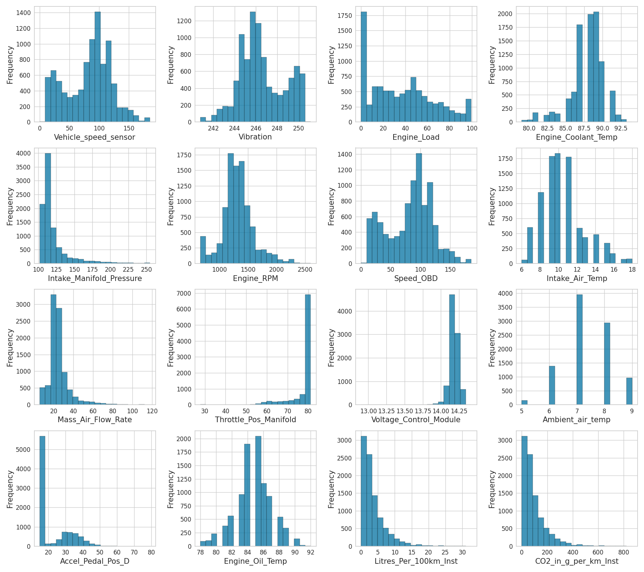

**Figure 2.1: Dataset Distribution - Histograms**

This figure illustrates the distribution of each feature in the dataset through histograms. It offers insights into the range and frequency of values, providing a foundational understanding of the dataset's characteristics.

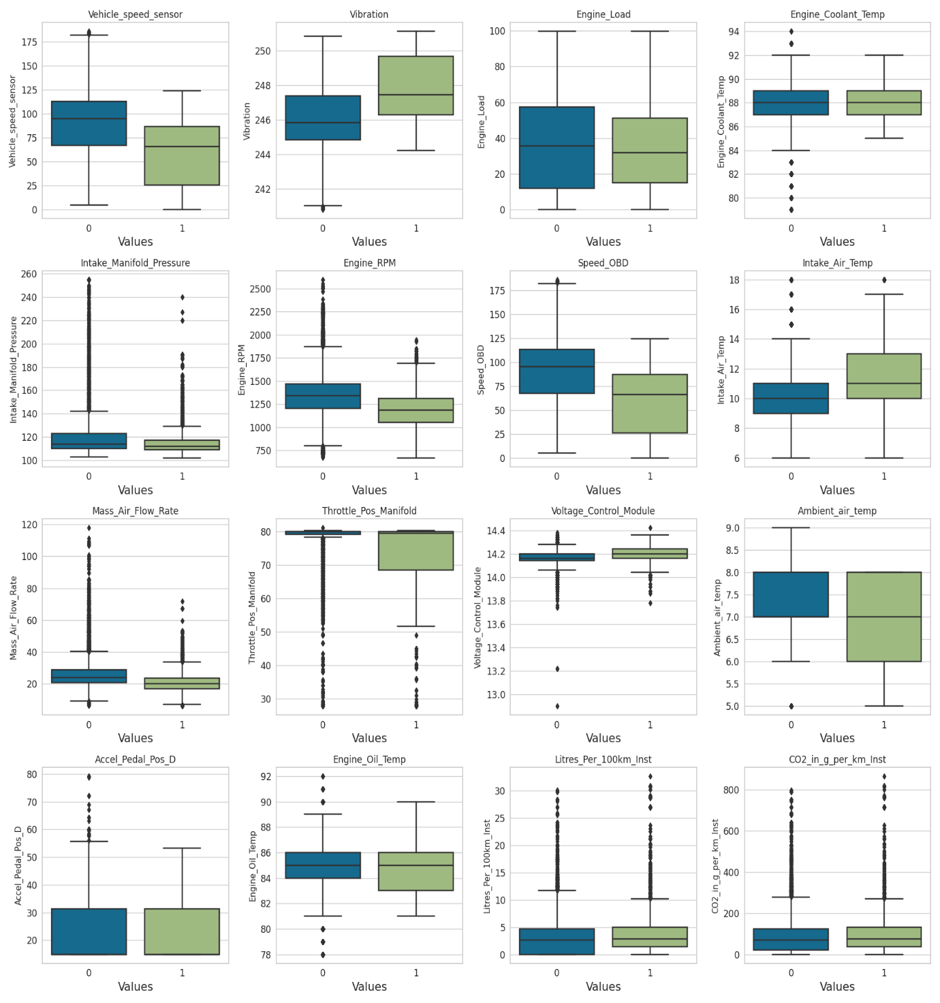

**Figure 2.2: Feature Distribution Across Maintenance Flag**

In this figure, box plots showcase how each feature varies across different values of the 'Maintenance Flag.' These visualizations help identify patterns and potential correlations between specific features and maintenance requirements.

**2.2 Model Selection and Training**

The classification task involved evaluating multiple models, with the Extra Trees Classifier emerging as the optimal choice. The model demonstrated exceptional performance, achieving an AUC score of 0.9451.

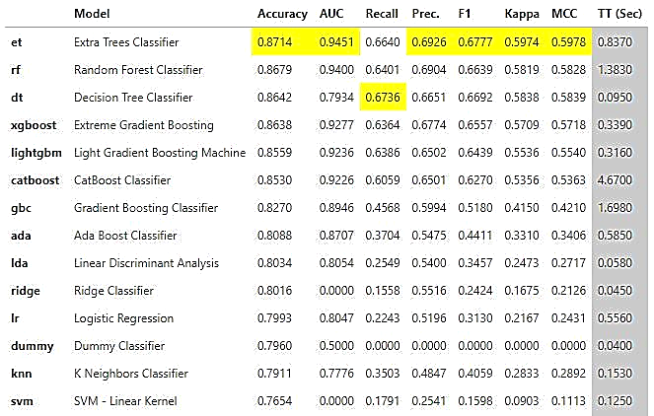

**Figure 2.3: Model Comparison - AUC Scores**

This figure compares the performance of different models in terms of AUC scores. It clearly highlights the superiority of the Extra Trees Classifier in accurately predicting maintenance needs.

**2.3 Evaluation Metrics and Analysis**

A detailed classification report has been generated, providing precision, recall, and F1 score for each class. Additionally, error analysis has been conducted to pinpoint areas for potential model refinement.

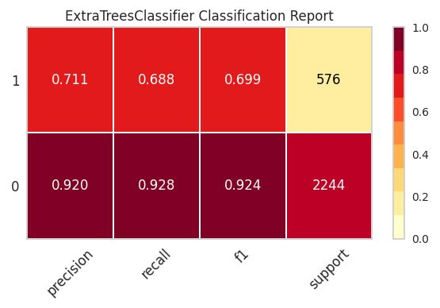

**Figure 2.4: Classification Report**

This figure breaks down the model's performance metrics, offering a nuanced understanding of precision, recall, and F1 score for each class. It serves as a comprehensive overview of the classifier's accuracy.

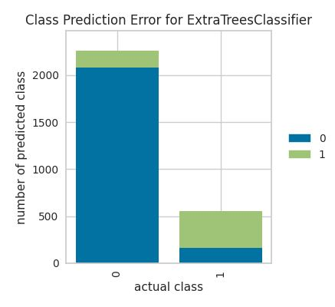

**Figure 2.5: Error Analysis - Confusion Matrix**

The confusion matrix visualizes the model's errors, detailing instances of false positives and false negatives. This figure aids in identifying specific areas for improvement in the predictive model.

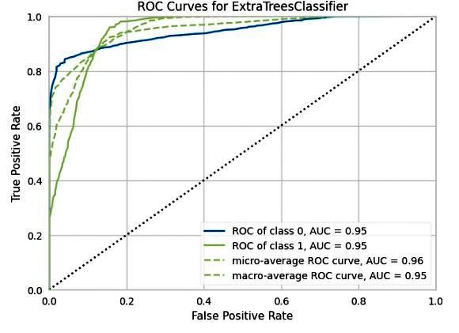

**Figure 2.6: ROC Curve**

The ROC curve illustrates the trade-off between sensitivity and specificity, showcasing the Extra Trees Classifier's robust performance in distinguishing between maintenance and non-maintenance instances.

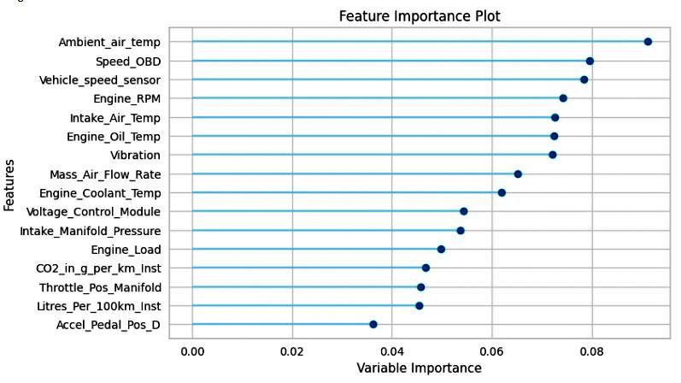

**Figure 2.7: Feature Importance Plot**

This figure highlights the significance of each input variable in predicting 'Maintenance Flag.' It provides valuable insights into which features play a crucial role in the model's decision-making process.

The complete web application shown in Figure 2.8, designed to deploy and interact with the developed model, was created using Streamlit and successfully deployed on Streamlit Cloud.

The codes used for the prototype development are available on GitHub for transparency and replicability in future analyses and improvements. The link to the GitHub repository is provided at the beginning of this report.

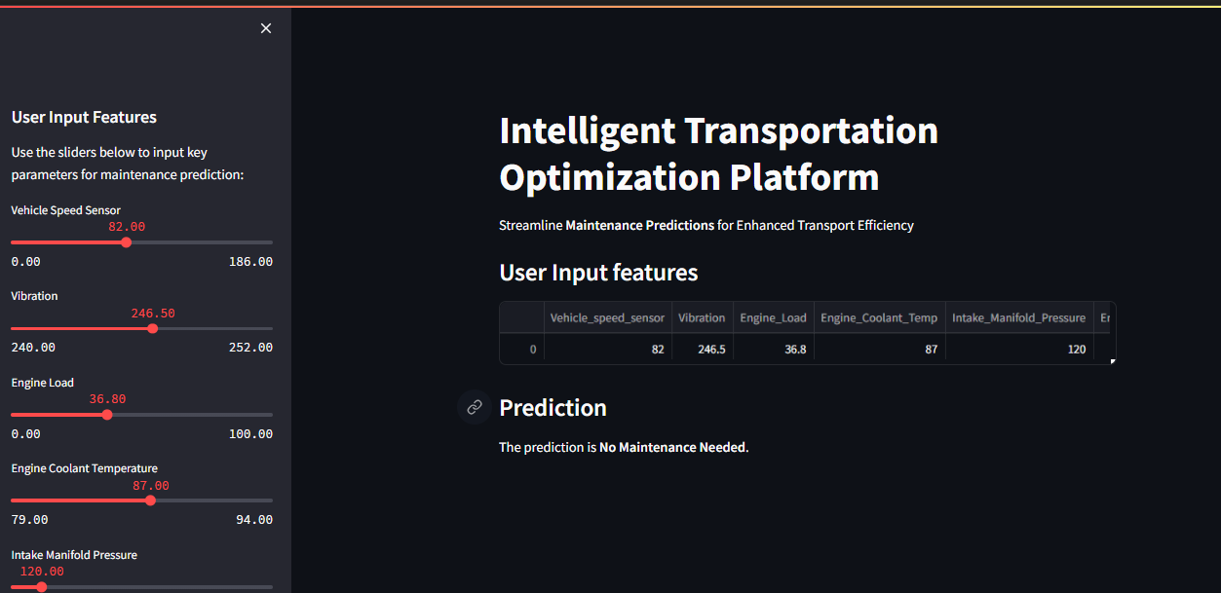

**Figure 2.8** [**Web Application**](https://transintel.streamlit.app/)

**3.0 Business Modelling**

In this section, our focus shifts from the technical aspects of the prototype to the strategic and operational considerations necessary for the successful deployment and integration of our AI-based Maintenance Prediction Service within the transportation and logistics industry.

**3.1 Value Proposition**

The first critical element of our business model revolves around defining the value proposition of our AI Product/Service. Specifically, we outline how our Maintenance Prediction Service addresses the industry challenges, such as minimizing unplanned maintenance, reducing operational downtime, and ultimately leading to significant cost savings for transportation companies.

**3.2 Customer Segmentation**

Understanding our target audience is pivotal. We identify and segment potential customers within the transportation and logistics sector who stand to benefit the most from our Maintenance Prediction Service. This segmentation could include fleet management companies, logistics providers, and other stakeholders invested in optimizing their vehicle maintenance processes.

**3.3 Revenue Streams**

Clarifying how our AI Product/Service generates revenue is crucial for the viability of the project. This involves detailing the pricing strategy, whether it be a subscription-based model, pay-per-use, or a tiered pricing structure. Additionally, exploring potential partnerships or collaborations that contribute to revenue generation enhances the overall sustainability of the business model.

**3.4 Distribution Channels**

Effectively reaching our target customers involves defining the distribution channels through which our AI Product/Service will be delivered. This could include direct sales, partnerships with existing industry platforms, or even integration into widely used fleet management systems.

**3.5 Cost Structure**

In parallel with revenue streams, we outline the anticipated costs associated with developing, deploying, and maintaining the AI Product/Service. This involves considering technology infrastructure costs, ongoing model updates, marketing expenditures, and any other operational expenses.

**3.6 Key Partnerships and Collaborations**

Identifying and establishing key partnerships and collaborations is vital for the success of our business model. This could involve collaborations with technology providers, industry associations, or even governmental bodies that support advancements in the transportation and logistics sector.

**3.7 Risk Analysis**

Assessing potential risks, both internal and external, is an essential part of our business model. This includes evaluating regulatory challenges, technological risks, and market acceptance. Strategies for mitigating these risks are outlined to ensure a proactive approach to potential obstacles.

By thoroughly addressing these components in the Business Modelling section, we lay the foundation for a comprehensive and well-rounded strategy for the successful implementation and sustainability of our AI Maintenance Prediction Service in the transportation and logistics industry.

**4.0 Financial Modelling**

When it comes to planning the finances for introducing the Maintenance Prediction Service, we're taking a practical approach, especially since we don't have specific data about the market. We're using a simple method called a linear growth model to estimate how much profit we might make.

Imagine we're stepping into the world of managing vehicle fleets in India. We use a basic equation to calculate the profit: we take the pricing of our service, multiply it by the number of sales, and then subtract the costs of production, maintenance, and other stuff.

For example, let's say we're charging ₹10,000 for our service. In the first year, we think we can get 50 clients, and we expect that number to go up by 20 clients each year. This helps us figure out how much money we might make each year after considering all the costs.

These calculations give us a simple picture of what our finances could look like based on our assumptions. It's like a starting point. As we get more real information about the market, we can adjust these numbers to make our financial plan more accurate. This method allows us to be flexible and adapt our plans as we learn more about the fleet management market in India.

**5.0 Conclusion**

In addressing transportation challenges, our Intelligent Maintenance Prediction Service excels. Predicting vehicle maintenance using advanced tech ensures smooth operations. The user-friendly app, powered by a robust model, makes maintenance forecasting accessible. Positioned strategically in the fleet market, our service, though based on assumptions, flexibly adapts to real-world data. This innovative solution promises to reshape the transportation sector, enhancing efficiency and sustainability.