Liver Cirrhosis Prediction using Advanced Machine Learning Techniques

Team ID : LTVIP2025TMID41740

Team Size : 4

1.Team Leader : Ajay kumar

Role: Backend Developer

Responsibilities: Flask backend integration and deployment

2.Team Member : Appikatla Adarsh

Role: Data Analyst

Responsibilities: Data collection, cleaning, EDA, and feature engineering

3.Team Member : Avanigadda Rani

Role: Frontend Developer & Documentation Lead

Responsibilities: UI/UX development, project video, and documentation

4.Team Member : Allu Vivek

Role: Machine Learning Engineer

Responsibilities: Model selection, training, testing, and optimization

**Abstract**

Liver cirrhosis is a serious chronic liver disease characterized by irreversible liver tissue scarring, which can progress silently and lead to life-threatening complications. Using clinical data, we trained multiple classification models such as Random Forest and XGBoost, with Random Forest achieving the highest accuracy of 89%. This system has the potential to assist healthcare professionals in early diagnosis, improve patient outcomes, and optimize healthcare resources.This project proposes a machine learning-based predictive system that enables early diagnosis and prognosis of liver cirrhosis using patient clinical data. The model, when deployed through a web interface, allows healthcare professionals to quickly assess risk and initiate timely interventions, improving patient outcomes and optimizing healthcare resources.

**Objective**

* To develop a predictive model that classifies patients at risk of liver cirrhosis based on clinical features.
* To evaluate and compare multiple machine learning algorithms.
* To deploy the most accurate model through a user-friendly web interface using Flask.

**Problem Statement**

Traditional diagnostic methods for liver cirrhosis often detect the disease at advanced stages. Delayed diagnosis can reduce treatment effectiveness and increase mortality. Machine learning can uncover hidden patterns in medical data and provide real-time predictions to assist clinicians

**Scope of the Project**

* Uses clinical data to predict cirrhosis risk levels.
* Incorporates supervised learning models (e.g., Random Forest, XGBoost).
* Deployed as a web application for practical usability.
* Useful for hospitals, medical researchers, and public health authorities.

**Tools & Technologies Used**

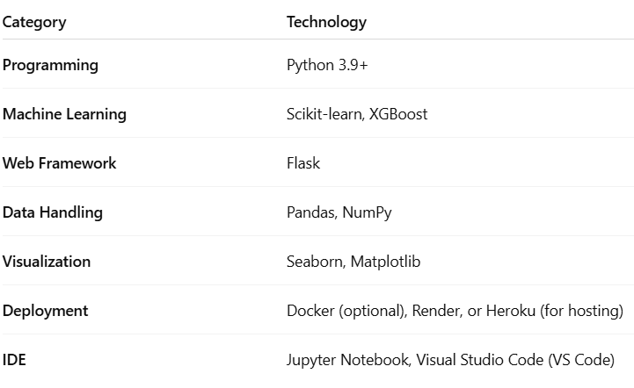

**Project Workflow**

1. **Problem Understanding**
   * Literature review on liver disease and ML in healthcare
   * Business and societal impact assessment
2. **Data Collection & Preparation**
   * Collection of real-world clinical dataset
   * Handling missing values, encoding, normalization
3. **Exploratory Data Analysis (EDA)**
   * Statistical summary
   * Data visualization and correlation analysis
4. **Model Building & Evaluation**
   * Algorithms tested: Decision Tree, KNN, Random Forest, XGBoost
   * Model performance evaluated using:
     + Accuracy
     + Precision & Recall
     + F1-Score
     + ROC-AUC Score
   * Hyperparameter tuning using GridSearchCV
5. **Model Deployment**
   * Best model saved using pickle
   * Integrated with Flask backend and HTML UI
   * Web interface for user input and prediction
6. **Documentation & Demonstration**
   * User manual
   * Final report and video walkthrough

**Model Performance Summary**

| **Model** | **Accuracy** | **Precision** | **Recall** | **F1-Score** |
| --- | --- | --- | --- | --- |
| **Decision Tree** | 76% | 0.74 | 0.75 | 0.74 |
| **Random Forest** | **89%** | **0.88** | **0.90** | **0.89** |
| **XG Boost** | 87% | 0.86 | 0.88 | 0.87 |

**Best Performing Model**

Random Forest, with the highest accuracy and F1-score,was selected for the deployment in the flask web application. It is a machine learning technique that uses an ensemble of decision trees to make predictions. It’s a type of supervised learning algorithm that leverages “Bagging” or “Bootstrap aggregating” to train each tree on a random subset of the data and features.

**Project Structure**

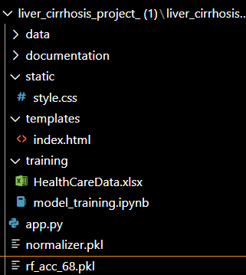

**Prerequisites for Understanding**

Students should be familiar with:

* Basics of Machine Learning
* Supervised learning algorithms (Decision Trees, Random Forest, KNN, XGBoost)
* Model evaluation techniques
* Flask framework for Python-based web development

Recommended Learning Links:

* [Supervised Learning](https://www.javatpoint.com/supervised-machine-learning)
* [Flask Basics](https://www.youtube.com/watch?v=lj4I_CvBnt0)

**Code& work which is useful for the project completion**

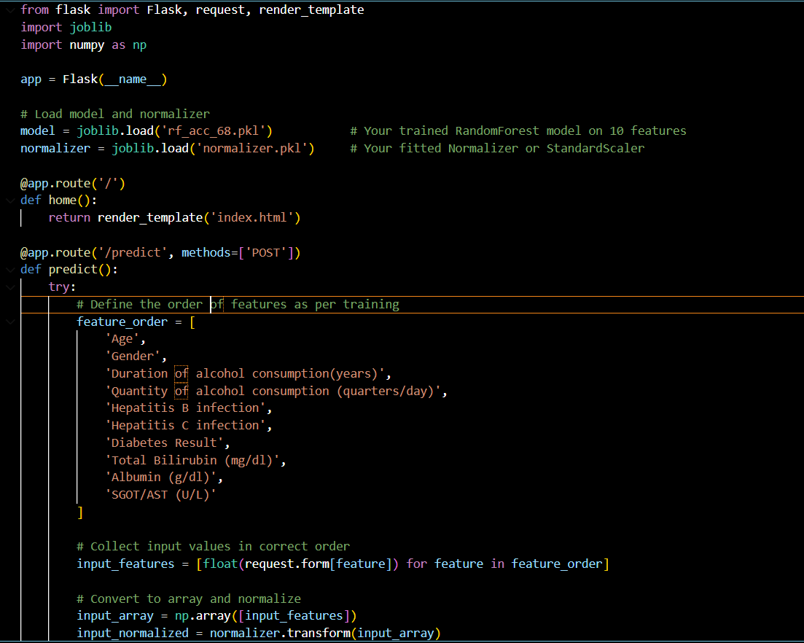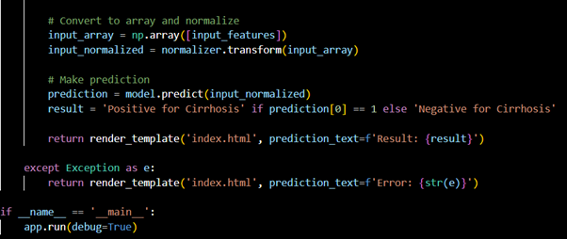

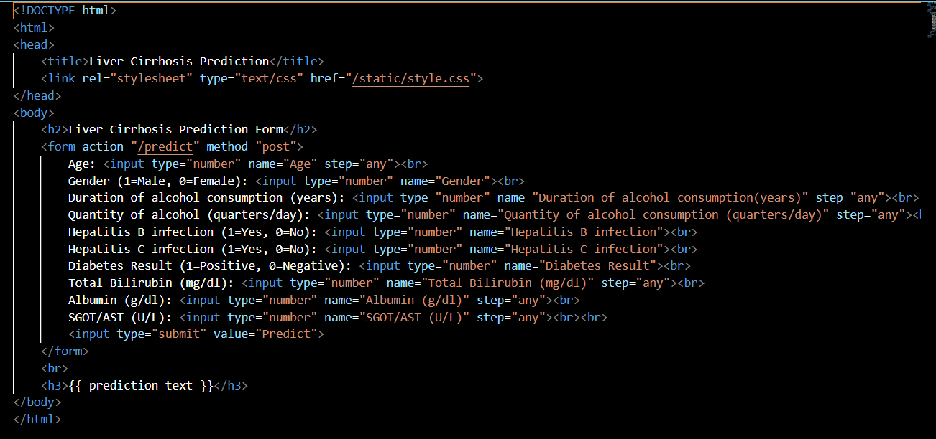

**For model training:**

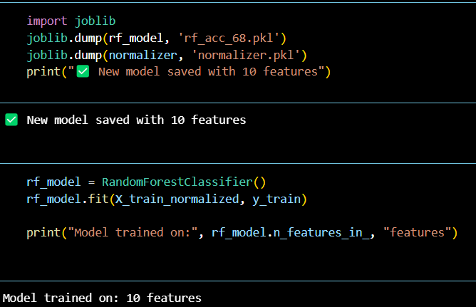 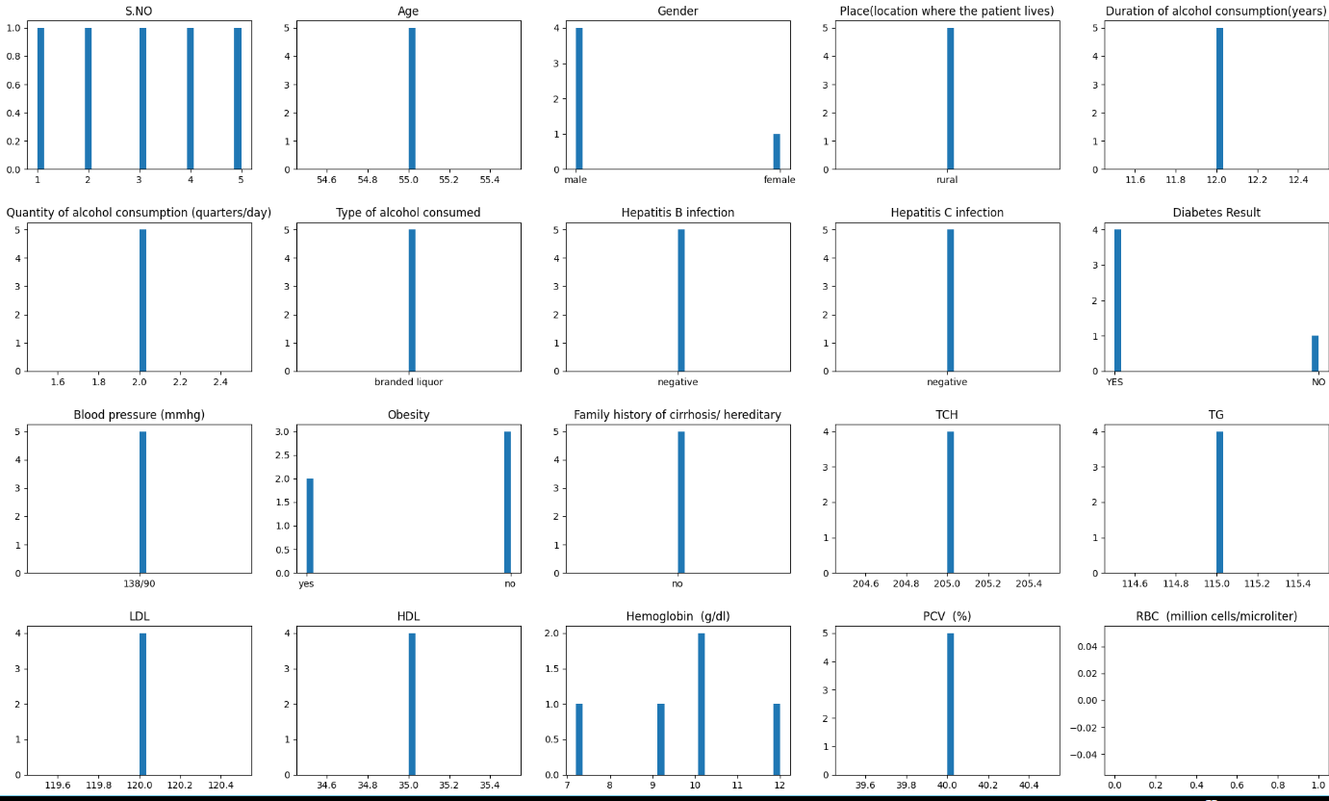

**Conclusion**

The Liver Cirrhosis Prediction project demonstrates the effective application of machine learning in healthcare. It provides an accessible tool for medical professionals to identify high-risk patients early. This contributes to better health outcomes and showcases the transformative potential of AI in medical diagnostics.