1. Problem statement

**Cricket score card** - A database system to keep track of cricket tournament statistics.

1. Objectives

* Maintain record of team score
* Maintain record of individual player performance
* Maintain record of matches in tournaments( win/loss )
* Maintain ranking of teams in tournament
* Creation, Maintenance, modifying of details about the teams and players

1. Functional requirements

* The system is able to keep track of all matches records.
* The performances of players in the team are updated in accordance to matches.
* The system is able to find out winner team and loser team and also records individual performance of players.

1. ER diagram

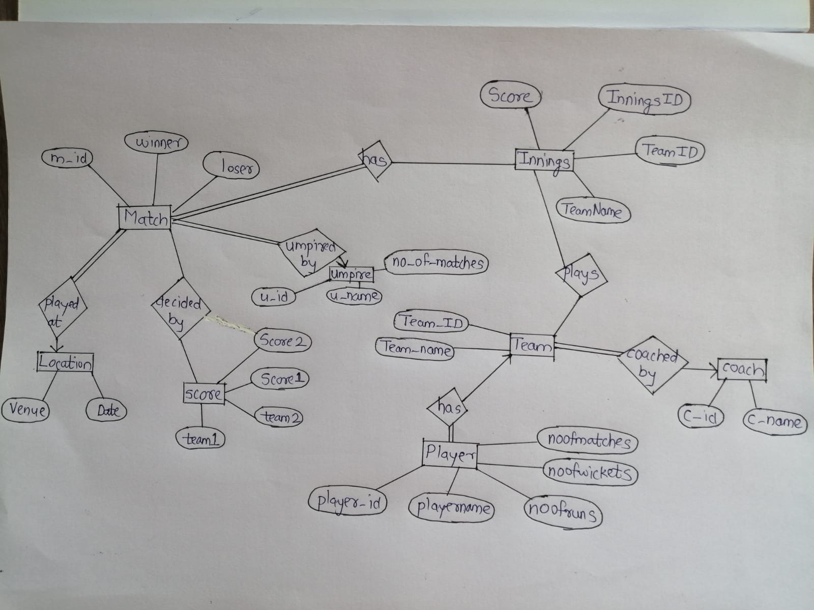

1. Relational schemas obtained from ER.

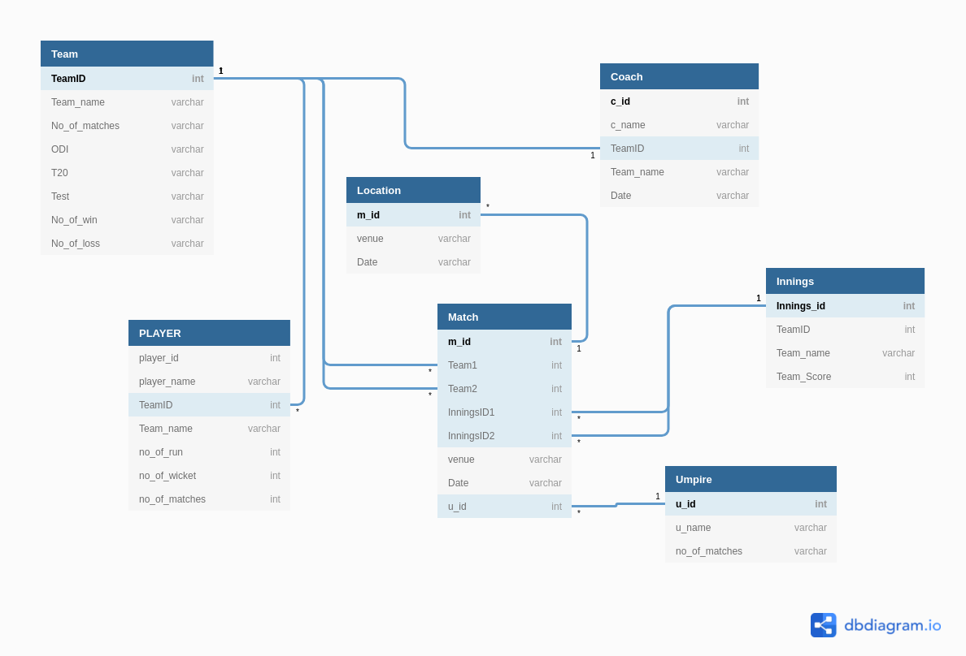

6. Set of Functional dependencies that must hold on each table.

* Team(Team_name) → Team(TeamID, NoOfWin, NoOfLoss, ODI, T20, Test)
* PLAYER(TeamID, jersey_no) → player(Player_name, Batting, Bowling, No_of_matches)
* RESULT(team1, team2, date, venue) → RESULT(m_id, score1, score2, winner, u_id)
* Team(TeamID) → Team(Team_name, NoOfWin, NoOfLoss, ODI, T20, Test)
* coach(c_id) → coach(c_id, c_name, TeamID)
* player(PlayerID, TeamID) → player(Player_name, Batting, Bowling, No_of_matches, jersey_no)
* RESULT(m_id) → RESULT(team1, score1, team2, score2, winner, u_id)
* UMPIRE(u_id) → UMPIRE(u_name, no_of_matches)

1. Each table has to be normalized up to 3NF.

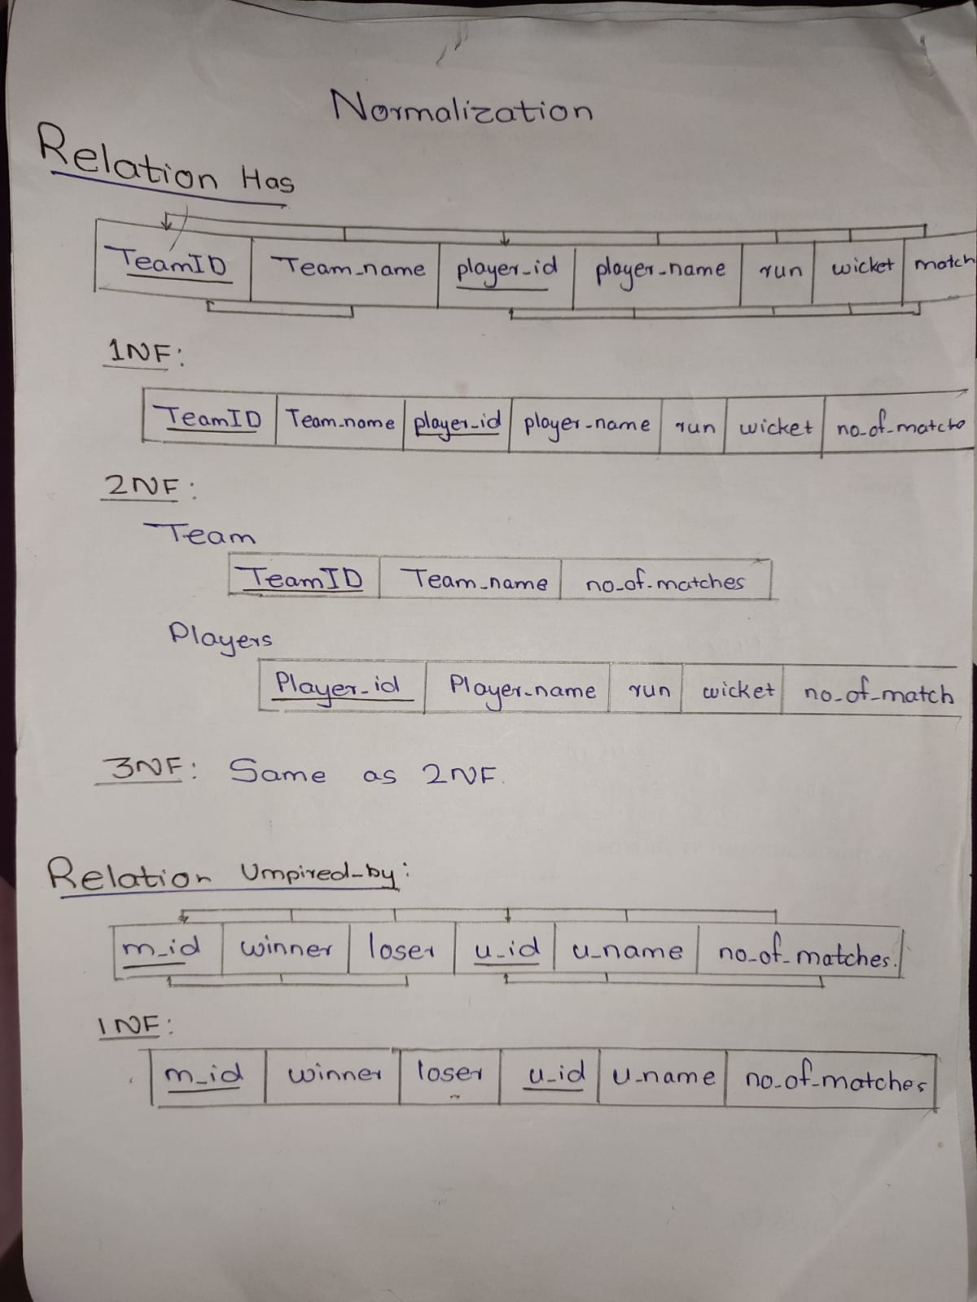

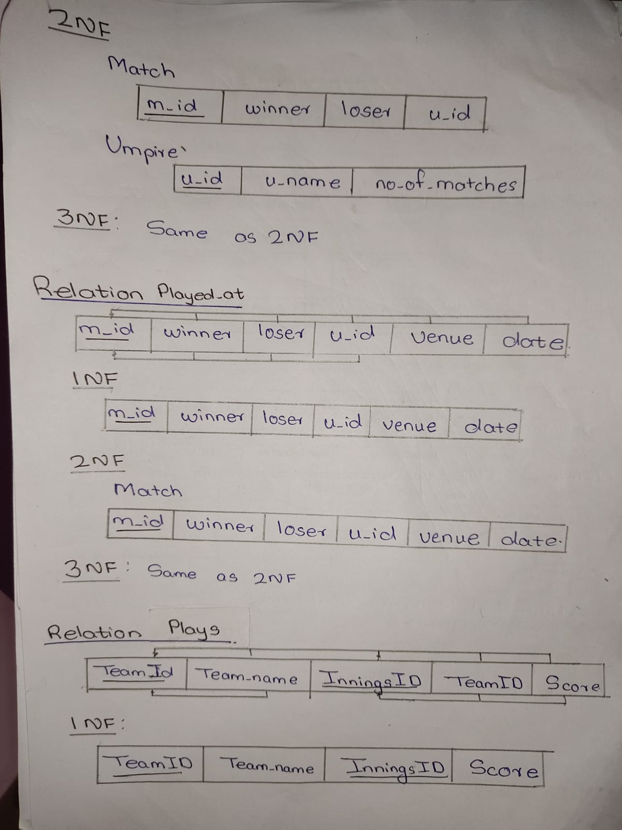

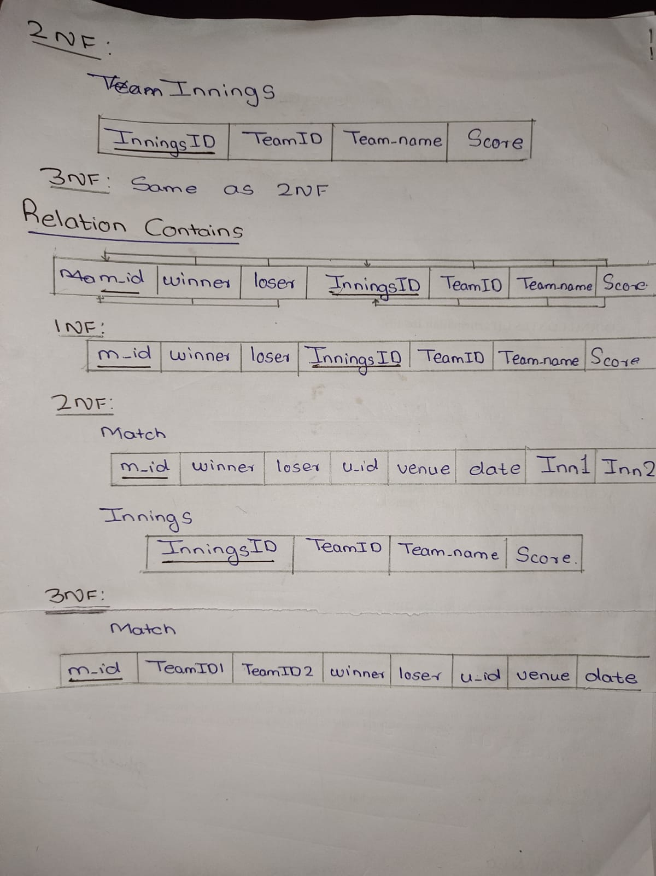

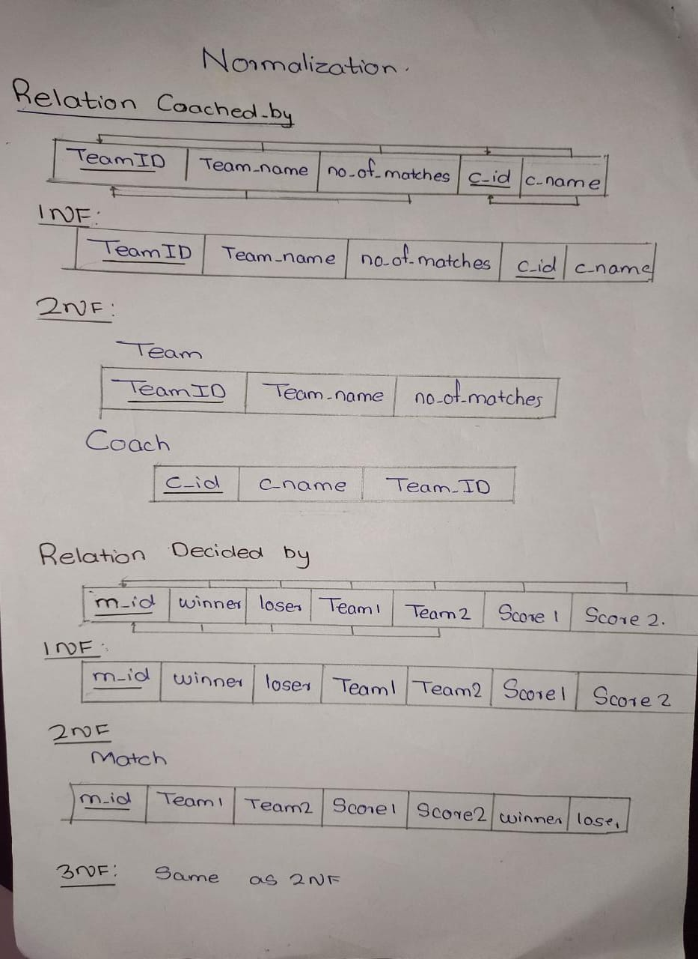

**Normalized Tables (up to 3NF)**

TEAM

|  |  |  |  |  |  |  |  |
| --- | --- | --- | --- | --- | --- | --- | --- |
| TeamID | Team_name | No_Of_Win | No_Of_loss | No_of_matches | ODI | T20 | TEST |

PLAYER

|  |  |  |  |  |  |  |
| --- | --- | --- | --- | --- | --- | --- |
| player_id | TeamID | player_name | No_of_matches | No_of_runs | No_of_wickets | jersey_no |

MATCH

|  |  |  |  |  |  |  |  |  |
| --- | --- | --- | --- | --- | --- | --- | --- | --- |
| m_id | TeamID1 | Score1 | TeamID2 | Score2 | u_id | winner | Venue | Date |

Coach

|  |  |  |
| --- | --- | --- |
| c_id | c_name | TeamID |

UMPIRE

|  |  |  |
| --- | --- | --- |
| u_id | u_name | no_of_matches |

The schema is normalized up-to 3-NF.

**NORMALISED SCHEMA:**

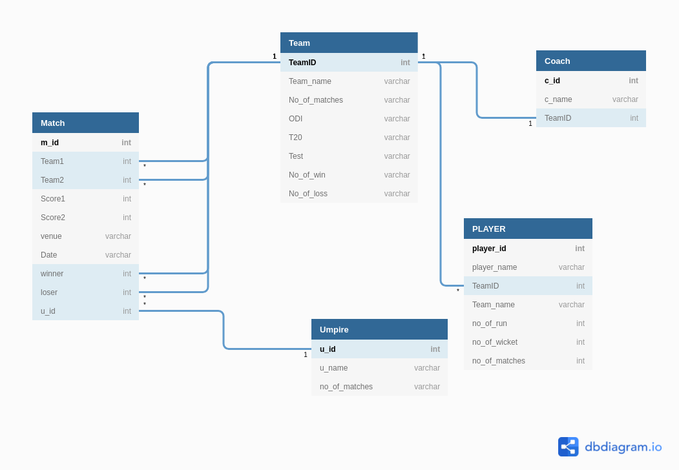

**Github link -**

**https://github.com/VivekBhand/Cricket-Score-Card.git**