Name: - Vivek Chahar

Email :- vivekchahar1960@gmail.com

Mobile-No. :- 8700348696

**Assessment – 1**

**Ques 1>**  Write a function that prints the numbers from 1 to 100. But for multiples of three, print "Fizz" instead of the number, and for the multiples of five, print "Buzz". For numbers that are multiples of both three and five, print "FizzBuzz".

**Code:-**

function fizzBuzz() {

for (let i = 1; i <= 100; i++) {

if (i % 3 === 0) {

console.log("Fizz")

}

else if (i % 5 === 0) {

console.log("Buzz")

}

else if( i%3===0 && i%5===0){

console.log("FizzBuzz");

}

else{

console.log(i)

}

}

}

fizzBuzz();

**Output:-**

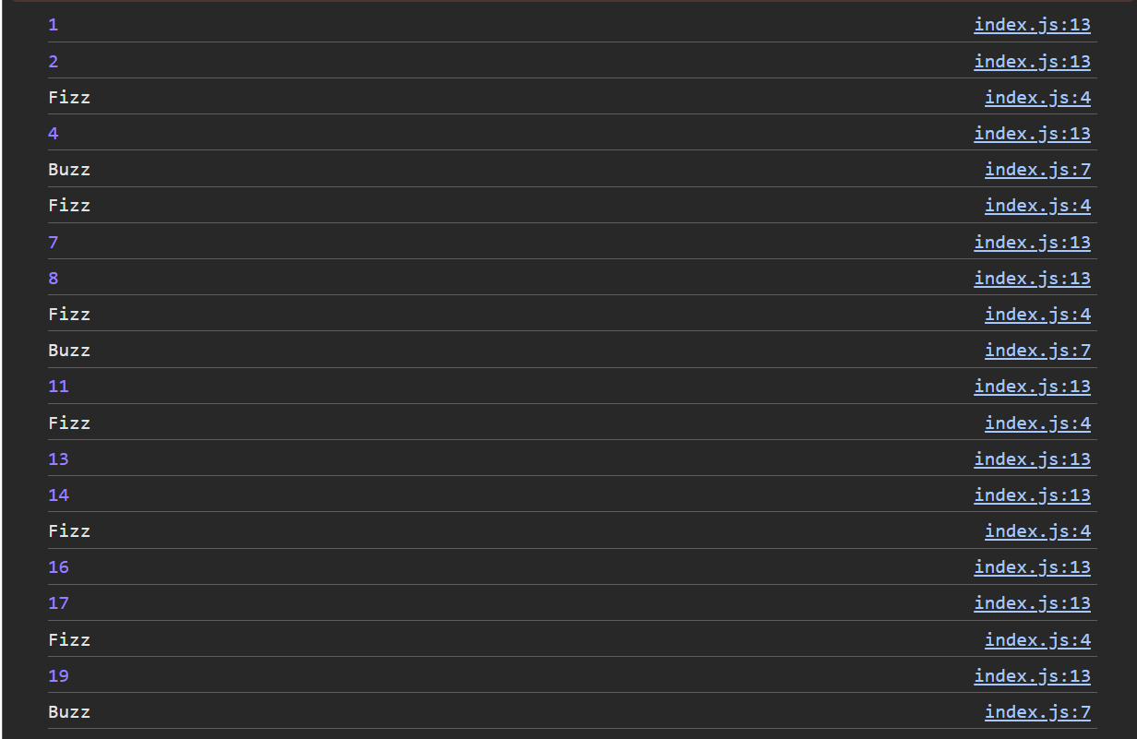

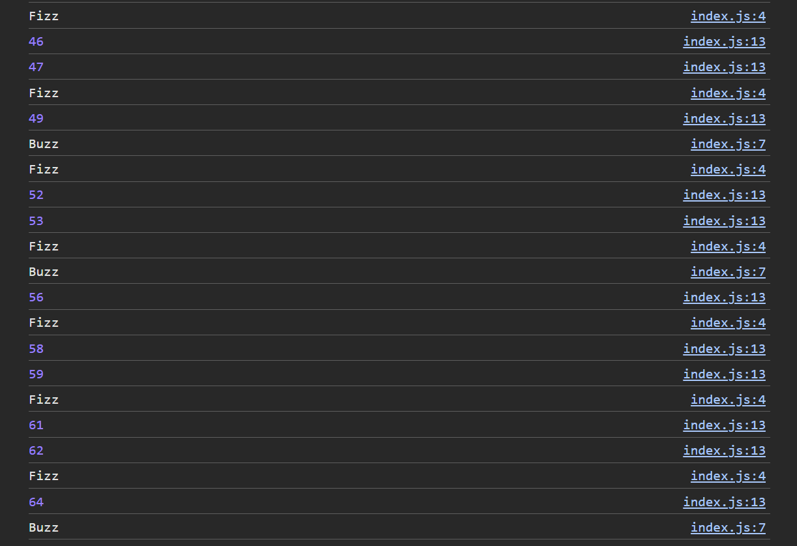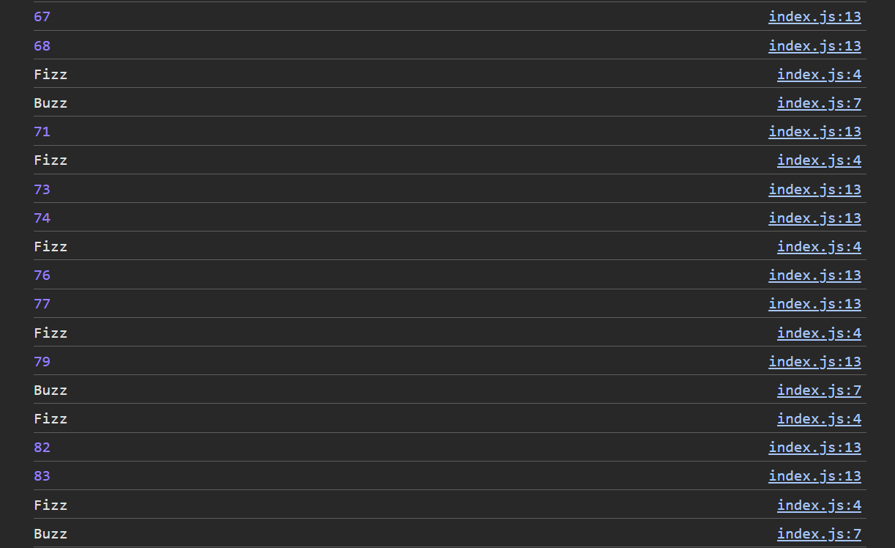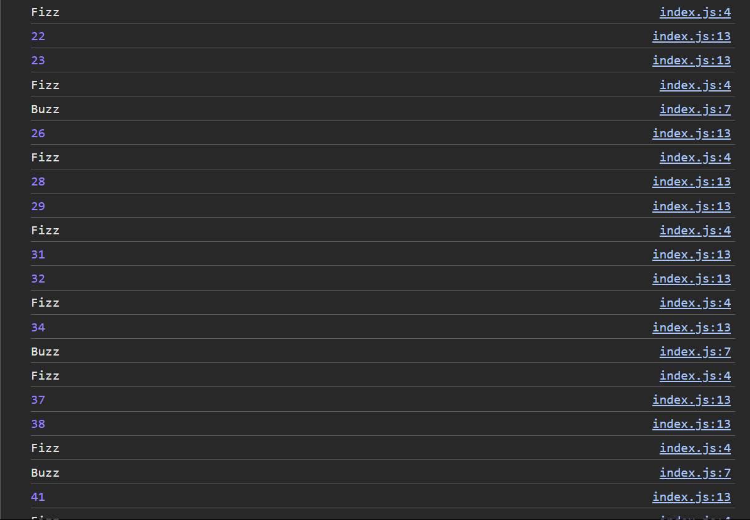

**Ques 2:-** Write a function that takes a string input representing a simple arithmetic expression (only addition and subtraction) and returns the result.

**Code:-**

function evaluateExpression(expression) {

expression = expression.replace(/\s+/g, '');

let total = 0;

let currentNumber = '';

let operator = '+';

for (let i = 0; i < expression.length; i++) {

const char = expression[i];

if (char >= '0' && char <= '9') {

currentNumber += char;

}

if (char === '+' || char === '-' || i === expression.length - 1) {

if (operator === '+') {

total += parseInt(currentNumber);

} else if (operator === '-') {

total -= parseInt(currentNumber);

}

operator = char;

currentNumber = '';

}

}

return total;

}

const expression = "4-9+18";

console.log(evaluateExpression(expression));

**Output :-**

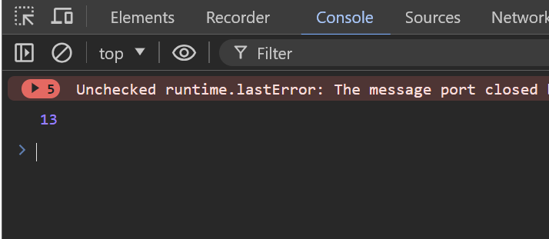

**Ques 3:-** Write a function that takes a nested array and returns a flattened array.

**Code : -**

function flattenArray(nestedArray) {

const flattenedArray = [];

function flatten(element) {

if (Array.isArray(element)) {

for (let item of element) {

flatten(item);

}

} else {

flattenedArray.push(element);

}

}

flatten(nestedArray);

return flattenedArray;

}

// Example usage

const nestedArray = [1, [2, [3], 5], 8, [9]];

console.log(flattenArray(nestedArray));

**Output:-**



**Ques 4:-** Write a function that checks if two given strings are anagrams of each other.

**Code:-**

function areAnagrams(str1, str2) {

const formatString = str => str.replace(/[^a-z]/gi, '').toLowerCase();

// Format the strings

const formattedStr1 = formatString(str1);

const formattedStr2 = formatString(str2);

if (formattedStr1.length !== formattedStr2.length) {

return false;

}

const sortedStr1 = formattedStr1.split('').sort().join('');

const sortedStr2 = formattedStr2.split('').sort().join('');

return sortedStr1 === sortedStr2;

}

console.log(areAnagrams("vivek", "kevvi"));

**Output :-**



**Ques 5:-** Write a function that takes an array and returns a new array with duplicates removed.

**Code :-**

function removeDuplicates(array) {

return [...new Set(array)];

}

const arrayWithDuplicates = [1,1,1,1,3,3,3,2,2,2,4,4,4,5];

const uniqueArray = removeDuplicates(arrayWithDuplicates);

console.log(uniqueArray);

**Output:-**



**Ques 6: -** Write a function that takes a string and capitalizes the first letter of each word in the string.

**Code :-**

function capitalizeFirstLetters(string) {

return string.split(' ')

.map(word => word.charAt(0).toUpperCase() + word.slice(1).toLowerCase())

.join(' ');

}

const inputString = "hello Vivek ! this is a assesment";

const capitalizedString = capitalizeFirstLetters(inputString);

console.log(capitalizedString);

**Output :-**



**Ques 7:-** Write a function that generates the first n numbers of the Fibonacci sequence.

**Code:-**

function generateFibonacci(n) {

if (n <= 0) return [];

if (n === 1) return [0];

if (n === 2) return [0, 1];

const fibonacciSequence = [0, 1];

for (let i = 2; i < n; i++) {

const nextNumber = fibonacciSequence[i - 1] + fibonacciSequence[i - 2];

fibonacciSequence.push(nextNumber);

}

return fibonacciSequence;

}

const n = 6;

const fibonacciNumbers = generateFibonacci(n);

console.log(fibonacciNumbers);

**Output:-**



**Ques 8 :-**  Implement a simple HashMap class with put, get, and remove methods.

**Code:-**

class HashMap {

constructor() {

this.map = {};

}

put(key, value) {

this.map[key] = value;

}

get(key) {

return this.map.hasOwnProperty(key) ? this.map[key] : null;

}

remove(key) {

if (this.map.hasOwnProperty(key)) {

delete this.map[key];

}

}

}

const hashMap = new HashMap();

hashMap.put("name", "Vivek Chahar");

hashMap.put("age", 21);

console.log(hashMap.get("name"));

console.log(hashMap.get("age"));

**Output :-**

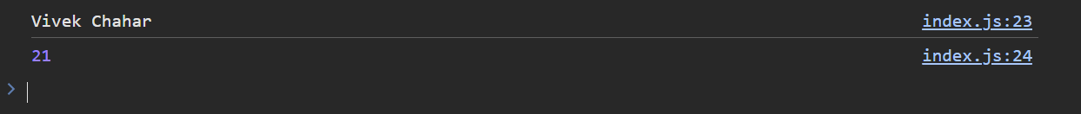

**Ques 9:-**  Write a function that filters out even numbers from an array.

**Code:-**

function filterEvenNumbers(array) {

return array.filter(number => number % 2 !== 0);

}

const numbers = [1, 4,8,4,5,7,1];

const oddNumbers = filterEvenNumbers(numbers);

console.log(oddNumbers);

**Output:-**



**Ques 10:-** Write a function that converts a given string to title case (capitalizing the first letter of each word).

**Code:-**

function toTitleCase(string) {

return string.split(' ')

.map(word => word.charAt(0).toUpperCase() + word.slice(1).toLowerCase())

.join(' ');

}

const inputString = "hii my name is vivek chahar";

const titleCasedString = toTitleCase(inputString);

console.log(titleCasedString);

**Output :-**

