Name: s.vivek ganesh varma

Regno:192011456

1. Exp.7.. Create a Virtual Machine with 1 CPU, 2GB RAM and 15GB storage disk using a Type 2 Virtualization Software.

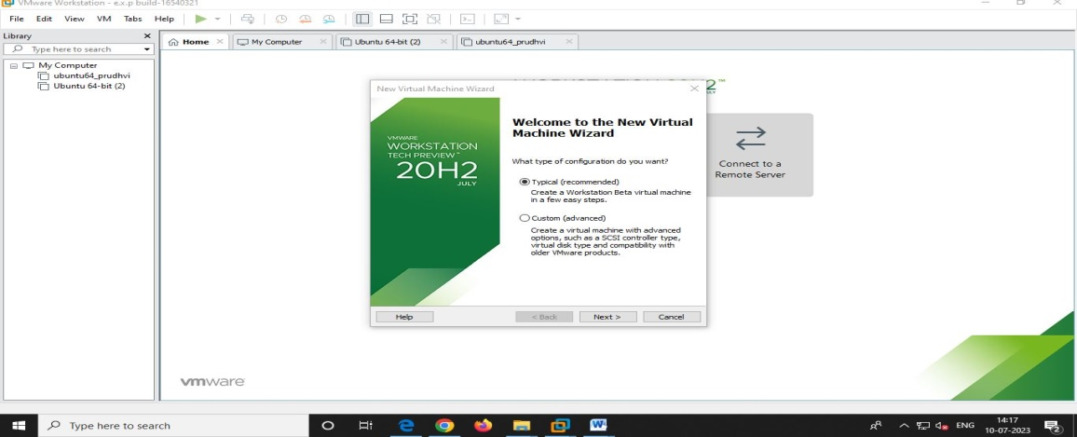

step2

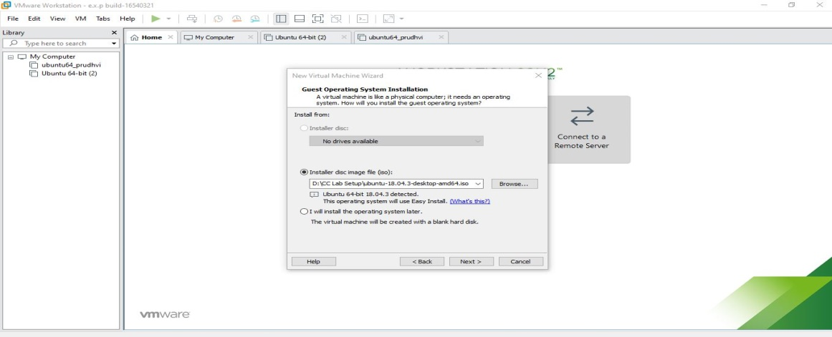

Step3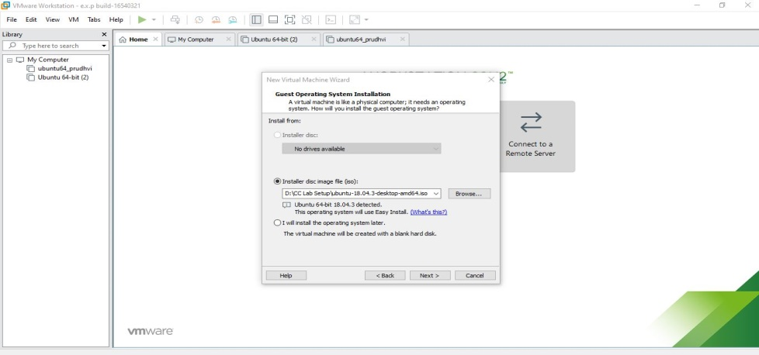

Step4 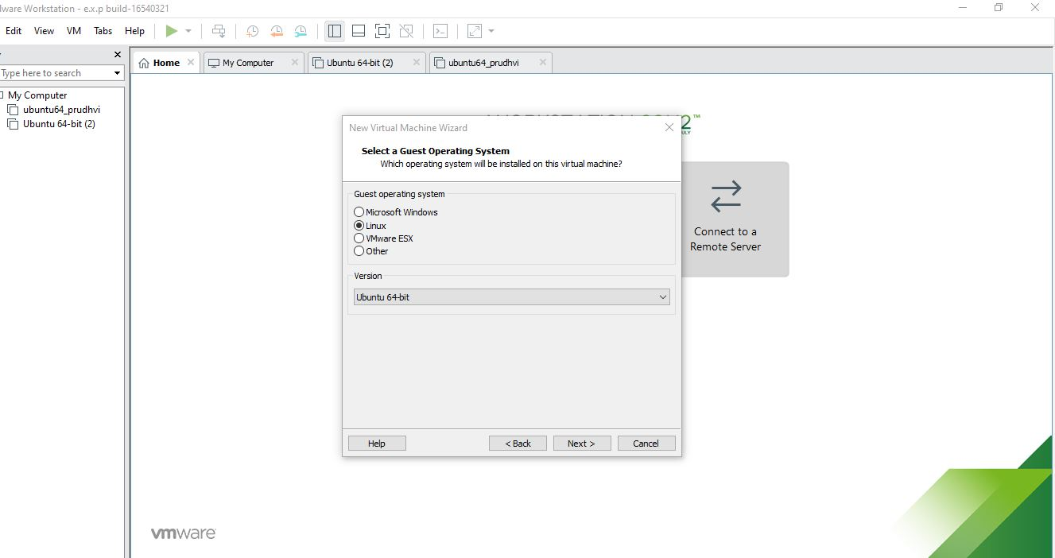

Step5

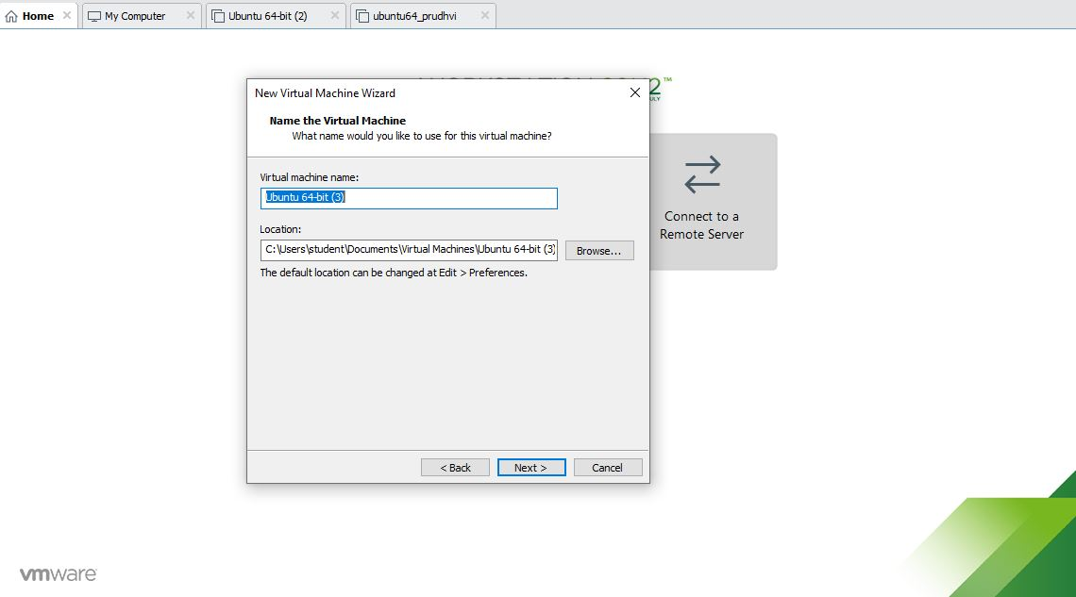

Step6