Question : 1
List 3 examples of 'population' and 'sample' in the context of apps you use daily (like Instagram followers, Zomato restaurants, or Flipkart products). For each, clearly define what would be considered the population and what would be a sample :

App / Context | Population | Sample
Instagram Followers | All followers of an Instagram account | 100 randomly selected followers
Zomato Restaurants | All restaurants listed on Zomato in a city | 50 randomly selected restaurants
Flipkart Products | All products available on Flipkart | 200 randomly selected products

Example: If there are 10000 Instagram followers, all 10000 are the population, while 100 selected followers are the sample.

Question : 2
Write a Python script that simulates random sampling: given a list of 1000 fake user IDs (e.g., user1 to user1000), select 50 random users to simulate a survey sample. Print the selected user IDs.<br><br><em><strong>Hint:</strong> Use the random.sample() function from Python's random module.</em>

import random
users=[f "user{i}" for i in range(1,1001)]
sample_users=random.sample(users,50)
print("Selected 50 users:")
for user in sample_users:
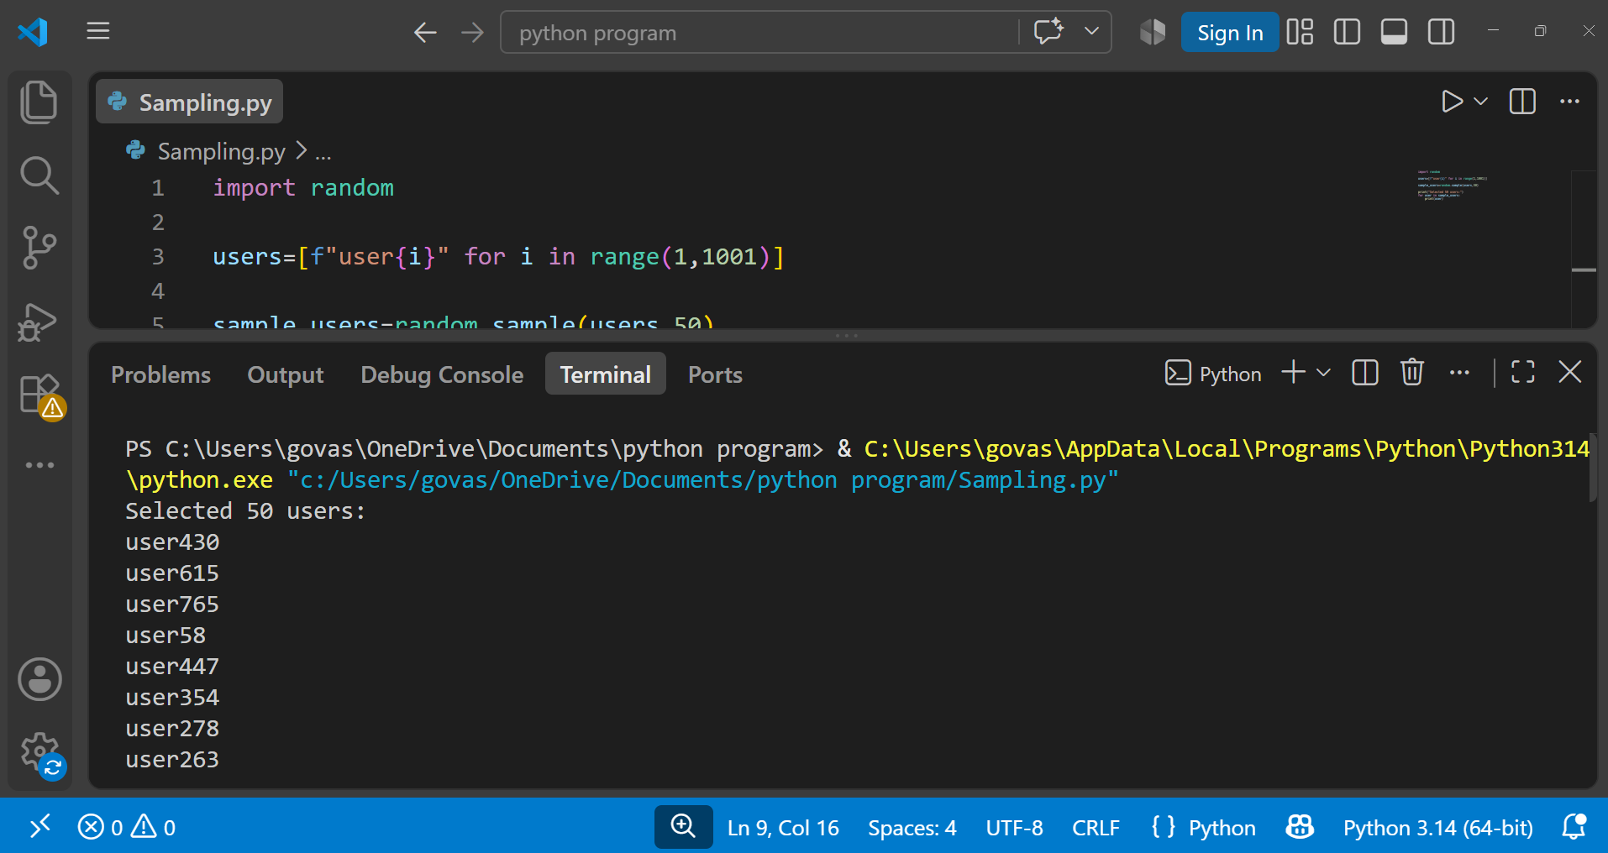
print(user)

Question : 3

Imagine you are analyzing food delivery times on Swiggy. Explain in 2-3 sentences why you would use sampling instead of collecting data from every single order ever made :

We use sampling because Swiggy has millions of orders, so collecting data from every order would take too much time and effort.
A sample of orders can provide useful information about overall delivery times quickly and efficiently.

Question : 4
Given this scenario: A survey about music preferences is only sent to users who recently streamed Bollywood songs on Spotify. Identify and explain the type of bias this introduces in the sample :
This introduces Selection Bias also called Sampling Bias.

The survey is sent only to users who recently streamed Bollywood songs, so users who listen to other types of music are not properly represented. Therefore, the results may incorrectly suggest that most Spotify users prefer Bollywood music.

Question : 5
Choose any two types of sampling (for example: random sampling, stratified sampling, systematic sampling, cluster sampling). For each, describe how you would use it to select a sample of users from BookMyShow to study movie booking habits :

Two Types of Sampling for BookMyShow :

- Random Sampling : Select users randomly from all BookMyShow users who have booked movies. For example, if there are 100,000 users, randomly select 1,000 users and study their movie-booking habits.

- Stratified Samplin : Divide BookMyShow users into groups such as age groups (18–25, 26–35, 36–50, etc.). Then randomly select users from each group so that every age group is represented in the sample.
--------------------------------------------------------------------------------------------------------------------------------------
- Cluster Sampling : Cluster sampling means dividing the population into groups (clusters) and randomly selecting some complete groups for the study.
Divide users based on their city, such as Ahmedabad, Mumbai, Delhi, and Bangalore. Randomly select a few cities and study the movie-booking habits of all selected users from those cities.

- Systematic sampling : means selecting every nth user from a list after choosing a random starting point.

If there are 10,000 users and we need a sample of 1,000 users, we can select every 10th user from the list after choosing a random starting point.

