Question : 1
Create two Python lists: one representing the number of hours you spend on Instagram each day for a week, and another for the number of posts you make each day. Plot these as a scatter plot using matplotlib and visually describe whether the relationship looks like a positive, negative, or zero correlation :

import matplotlib.pyplot as plt
instagram_hours=[1,2,3,4,5,3,6]
posts=[1,2,3,4,5,3,6]
plt.scatter(instagram_hours,posts)
plt.xlabel("Hours Spent on Instagram")
plt.ylabel("Number of Posts")
plt.title("Instagram Hours vs Number of Posts")
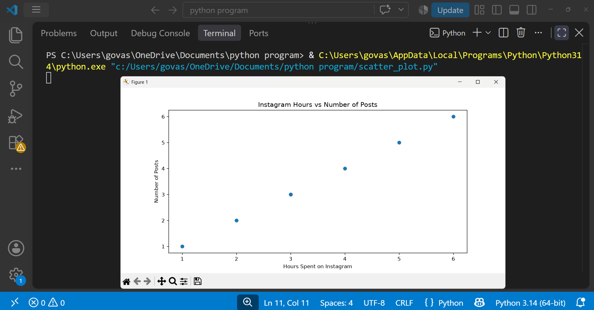
plt.show()
Observation : The scatter plot shows a positive correlation because, generally, as the number of hours spent on Instagram increases, the number of posts also increases.

Question : 2
Given the following data for 6 friends: their monthly Zomato order count and their monthly Swiggy order count, calculate the correlation coefficient between the two lists using numpy's corrcoef(). Print the result and explain if the correlation is positive, negative, or zero :

import numpy as np
zomato_orders=[10,15,20,25,30,35]
swiggy_orders=[8,14,18,24,29,33]

correlation=np.corrcoef(zomato_orders,swiggy_orders)
print("Correlation Matrix:")
print(correlation)
print(f"\nCorrelation coefficient:{correlation[0, 1]}")

Expected result :
The correlation coefficient will be very close to +1 ( 0.998325496345654 ).


Explanation :
The relationship is strongly positive. Friends who order more frequently from Zomato also tend to order more frequently from Swiggy.

Question : 3
Think of two variables from your daily life (for example, number of YouTube videos watched per day and daily study hours). Write a short paragraph describing whether you expect a positive, negative, or zero correlation between them, and why :

I expect a negative correlation between the number of YouTube videos I watch per day and the number of hours I study.

Generally, if I spend more time watching YouTube videos I may have less time available for studying. Therefore as the number of YouTube videos watched increases, my daily study hours may decrease.

However, this is only an expected relationship and does not necessarily mean that watching YouTube directly causes lower study hours.

Question : 4
Use ChatGPT to generate a small dataset (10 pairs of numbers) that shows a strong negative correlation between time spent on Spotify and marks scored in a test. Paste the dataset and plot it as a scatter plot using matplotlib.<br><br><em><strong>Hint:</strong> Ask ChatGPT to "generate 10 pairs of numbers with a strong negative correlation" and specify your variables.</em>

Here is a dataset with a strong negative correlation :
Spotify Hours | Test Marks
1 | 95
2 | 91
3 | 88
4 | 84
5 | 80
6 | 76
7 | 71
8 | 67
9 | 63
10 | 58

import matplotlib.pyplot as plt
spotify_hours=[1,2,3,4,5,6,7,8,9,10]
test_marks=[95,91,88,84,80,76,71,67,63,58]

plt.scatter(spotify_hours,test_marks)
plt.xlabel("Time Spent on Spotify (Hours)")
plt.ylabel("Test Marks")
plt.title("Spotify Time vs Test Marks")
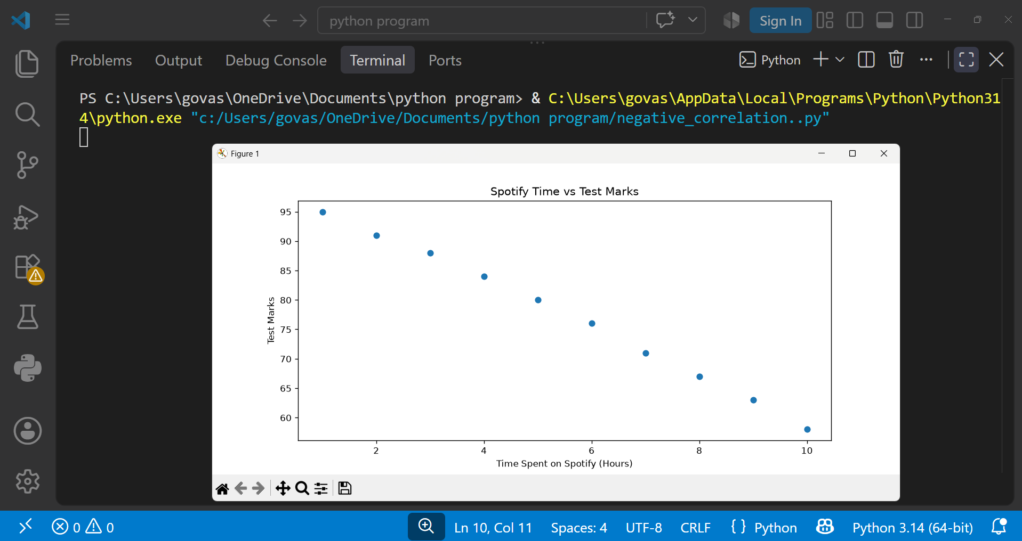
plt.show()

Observation :
The scatter plot shows a strong negative correlation. As time spent on Spotify increases, test marks generally decrease.

