Question : 1
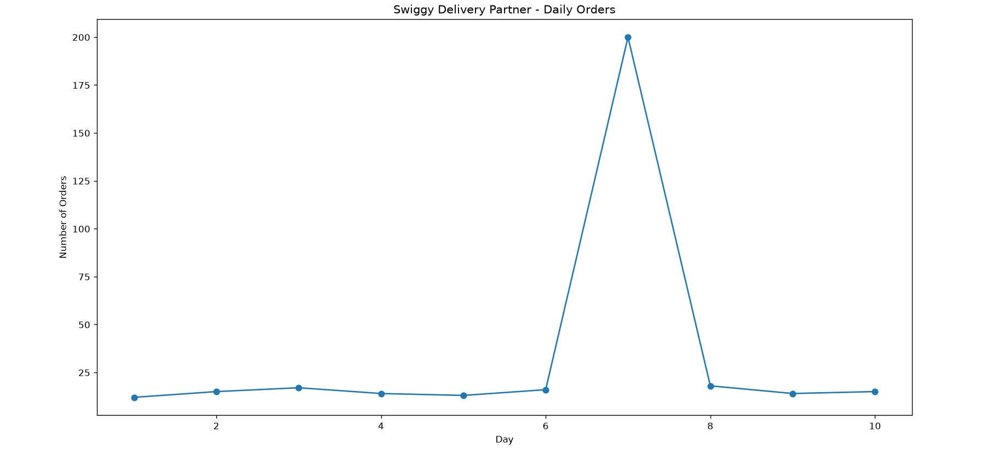
Given the daily order counts for a Swiggy delivery partner over 10 days: [12, 15, 17, 14, 13, 16, 200, 18, 14, 15], plot a simple graph (hand-drawn or using any tool) and describe whether the data is left skewed, right skewed, or symmetrical. Explain your reasoning based on the shape :
Observation :
Most days have orders between 12 and 18, but on one day the orders suddenly increase to 200. Therefore, the data is Right Skewed (Positively Skewed).
Reason :
“ The extreme value 200 creates a long tail on the right side of the distribution Hence, the data is right skewed. ”

Question : 2
Take the following list of Instagram influencer follower counts (in thousands): [5, 7, 8, 8, 9, 10, 12, 15, 95]. Calculate the mean and median, then state which is higher and what that tells you about the skewness of the data.<br><br><em><strong>Hint:</strong> If the mean is pulled away from the median, the data is skewed in that direction.</em>

Given follower counts (in thousands): [5, 7, 8, 8, 9, 10, 12, 15, 95]

Mean :
Mean = Sum of values ÷ Number of values
5 + 7 + 8 + 8 + 9 + 10 + 12 + 15 + 95 = 169
Mean = 169 ÷ 9 = 18.78 thousand

Median :
Data is already sorted : 5, 7, 8, 8, 9, 10, 12, 15, 95
There are 9 values, so the middle value is the 5th value.
Median = 9 thousand

The mean is higher than the median.

Conclusion : The value 95 thousand is an extreme high value that pulls the mean upward. Therefore, the data is Right Skewed (Positively Skewed).
“ Mean > Median → Right Skewed ”

Question : 3
Find a real-world example of right-skewed data from any app you use (like Zomato order amounts, Paytm wallet balances, or YouTube video views). Briefly describe the dataset and explain why you think it is right skewed :

Example: YouTube Video Views
Suppose the views of 10 videos on a YouTube channel are(in thousand views):
[1, 2, 3, 4, 5, 6, 8, 10, 15, 1000]

Most videos receive relatively low views, while one video becomes viral and gets 1000 thousand views.

This creates a long tail toward the right side.

Therefore, YouTube video-view data is often right skewed, because a small number of viral videos can have extremely high views compared with the majority of videos.

Question : 4
Given this dataset of Flipkart product ratings: [3, 3, 4, 4, 4, 5, 5, 5, 5, 5], draw a rough graph and state if the distribution is symmetrical, left skewed, or right skewed. Justify your answer in one line :

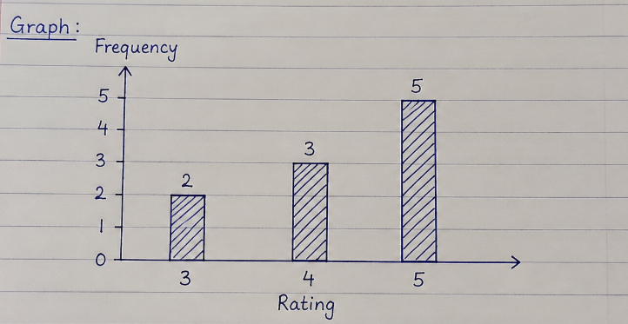
Flipkart Product Ratings : [3, 3, 4, 4, 4, 5, 5, 5, 5, 5]
Rating | Frequency
3 | 2
4 | 3
5 | 5

Conclusion : Left Skewed (Negative Skewness)

Reason : Most of the rating are on the Higher side (4 and 5) with a tail towards the Lower value (3).

