QUESTION : 1
Create a table named MusicPlaylist with columns: id, song_name, artist, genre, and duration. Insert at least 5 records representing songs from your favorite Spotify playlist, then write a SELECT statement to retrieve all columns for all songs.

CREATE TABLE MusicPlaylist(
id INT,
song_name VARCHAR(100),
artist VARCHAR(100),
genre VARCHAR(50),
duration TIME,
PRIMARY KEY(id)
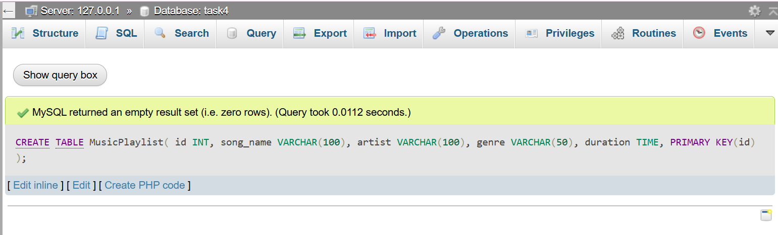
);
- INSERT INTO MusicPlaylist (id, song_name, artist, genre, duration)
VALUES
(1, 'Blinding lights', 'The weeknd', 'Pop', '00:03:20'),
(2, 'Believer', 'Imagine dragons', 'Rock', '00:03:24'),
(3, 'Shape of you', 'Ed sheeran', 'Pop', '00:03:53'),
(4, 'Levitating', 'Dua lipa', 'Pop', '00:03:23'),
(5, 'Perfect', 'Ed sheeran', 'Romantic', '00:04:23');
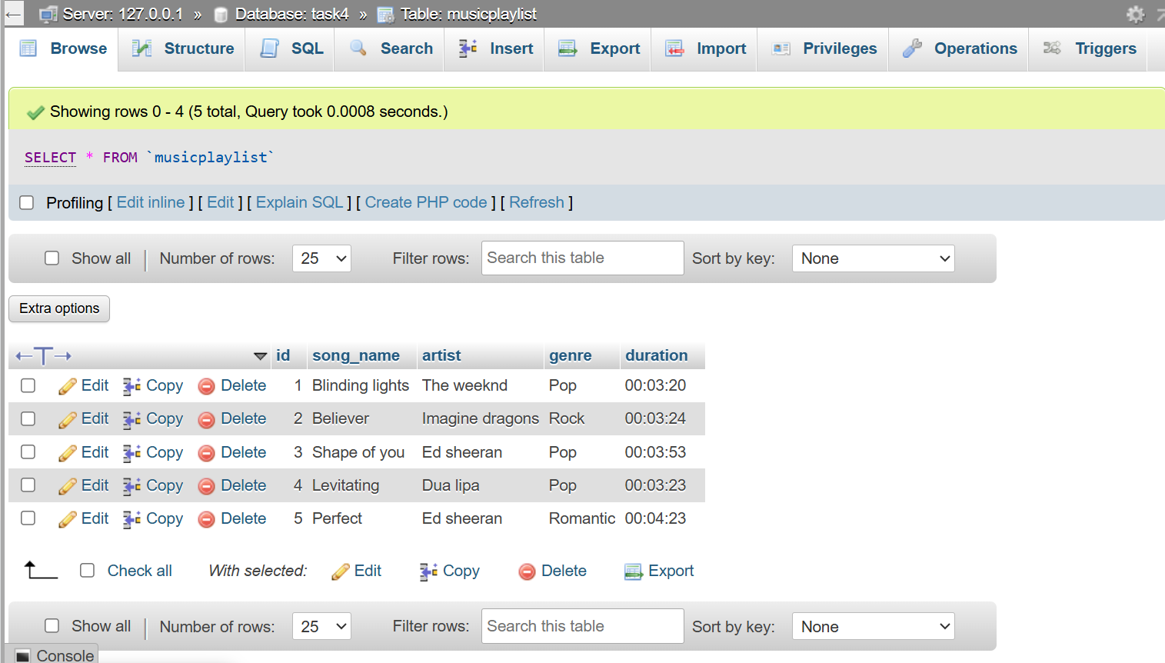
- SELECT * FROM MusicPlaylist;

QUESTION : 2
Write a SQL query to display only the song_name and artist columns from the MusicPlaylist table, showing just the first 3 records using the LIMIT keyword.
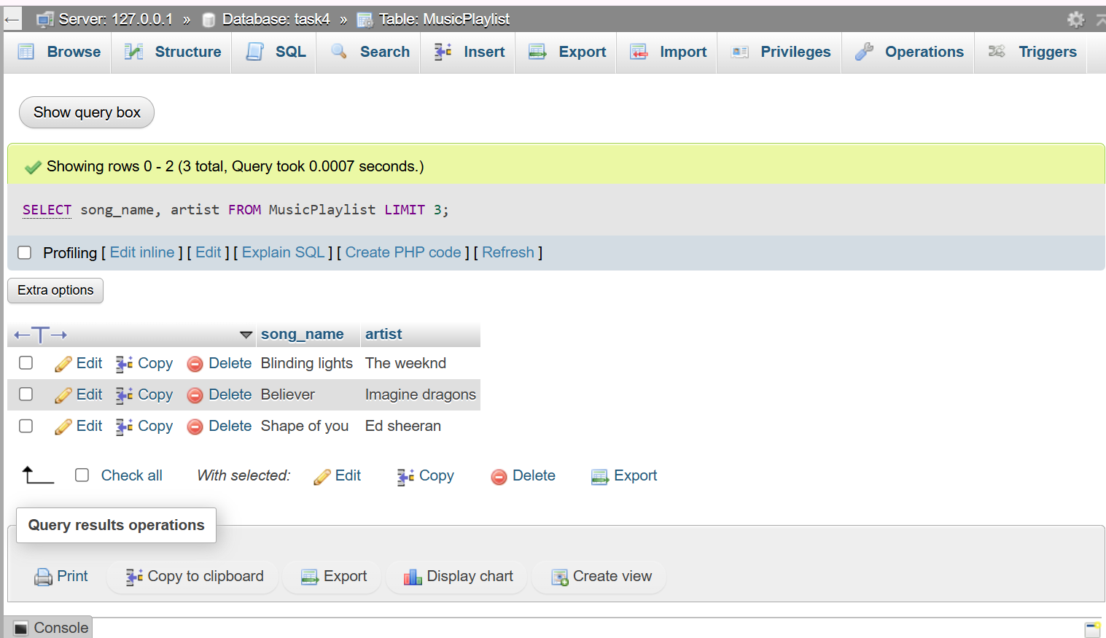
- SELECT song_name, artist FROM MusicPlaylist LIMIT 3;
QUESTION : 3
Suppose you have a table named FoodOrders with columns: id, restaurant, food_item, and order_date. Write a SQL query to list all unique restaurant names where you have placed orders, using the DISTINCT keyword.

- CREATE TABLE FoodOrders(
id INT,
restaurant VARCHAR(100),
food_item VARCHAR(100),
order_date DATE,
PRIMARY KEY(id)
);

VALUES :
- INSERT INTO FoodOrders (id, restaurant, food_item, order_date)
VALUES
(1,'Dominos','Margherita pizza','2026-07-01'),
(2,'McDonalds','Burger','2026-07-02'),
(3,'KFC','Chicken bucket','2026-07-03'),
(4,'Subway','Veg sandwich','2026-07-04'),
(5,'Dominos','Garlic bread','2026-07-05'),
(6,'McDonalds','French fries','2026-07-06'),
(7,'Pizza hut','Veg supreme pizza','2026-07-07'),
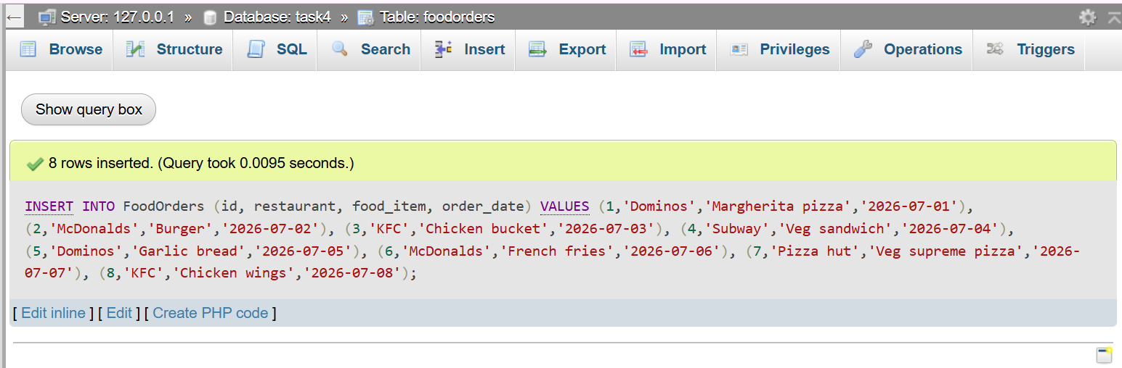
(8,'KFC','Chicken wings','2026-07-08');
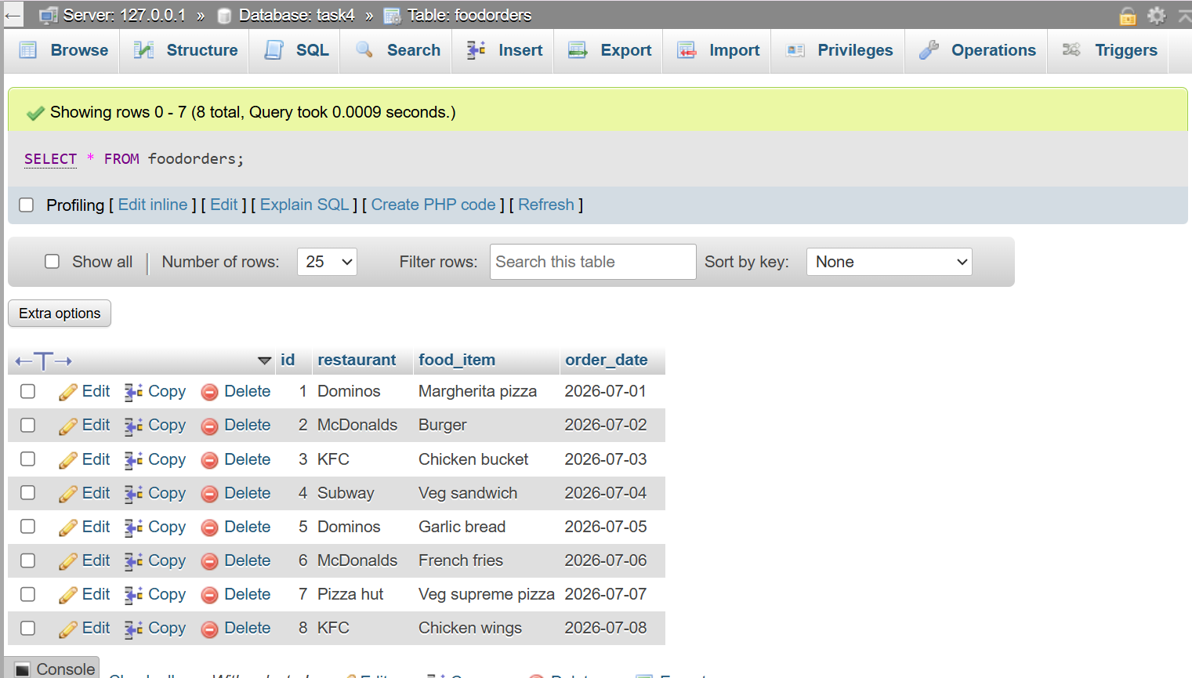
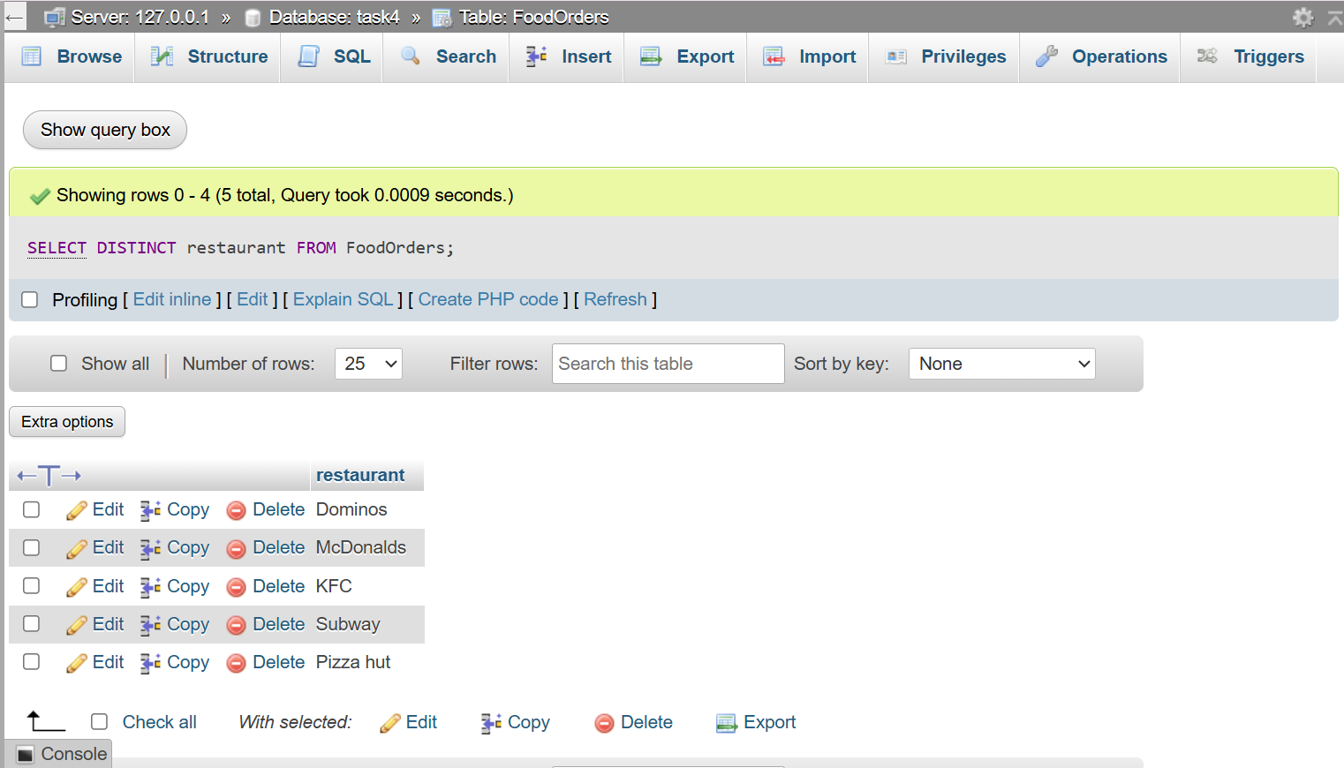
- SELECT DISTINCT restaurant FROM FoodOrders;

QUESTION : 4
Write a SQL query on the FoodOrders table to select food_item as 'Dish' and order_date as 'Date Ordered', displaying only these two columns with the column aliases in the output.

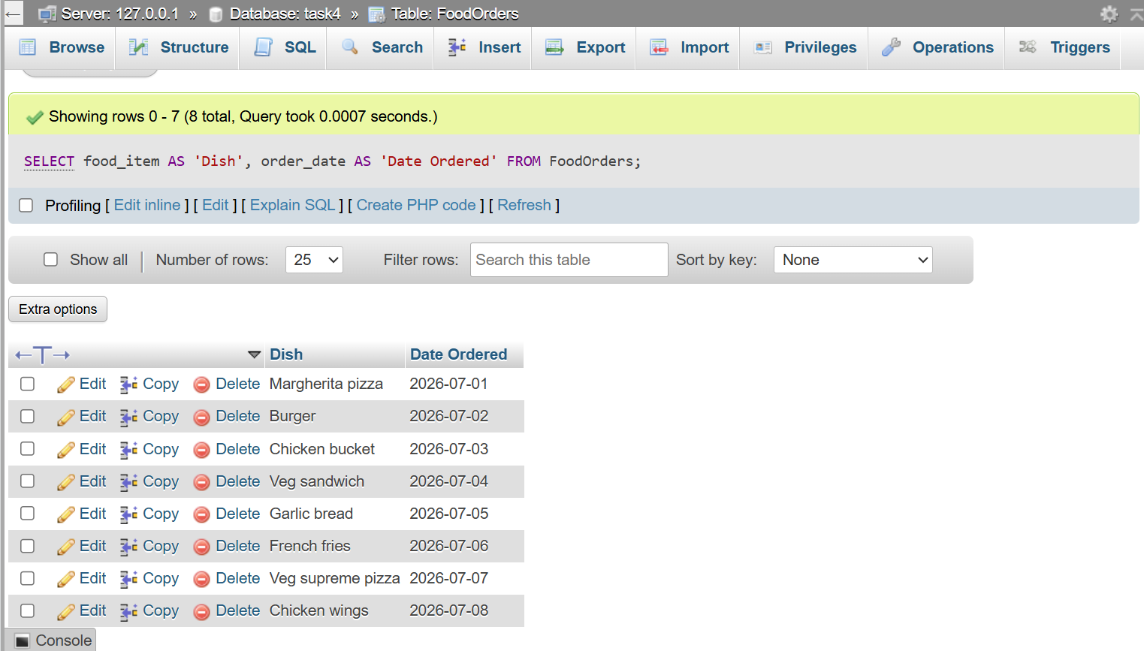
- SELECT food_item AS 'Dish', order_date AS 'Date Ordered' FROM FoodOrders;

QUESTION : 5
You tried running this query: SELECT DISTINCT food_item, restaurant FROM FoodOrders LIMIT 2, but it returns an error or doesn't work as expected. Identify and fix the mistake in the query.<br><br><em><strong>Hint:</strong> Check the correct placement and usage of the LIMIT keyword in SQL syntax.</em>
Error Query :
- SELECT DISTINCT food_item, restaurant FROM FoodOrders LIMIT;
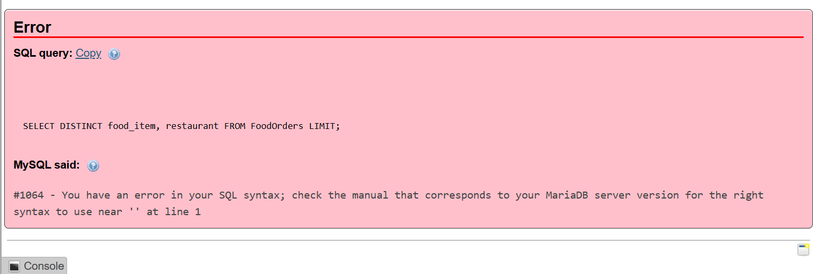
Correct Query :
- SELECT DISTINCT food_item,restaurant FROM FoodOrders LIMIT 2;
