QUESTION : 1
Install MySQL or PostgreSQL on your system and create a new database named 'music_streaming_app' using the command line or GUI tool of your choice :

CREATE DATABASE music_streaming_app;
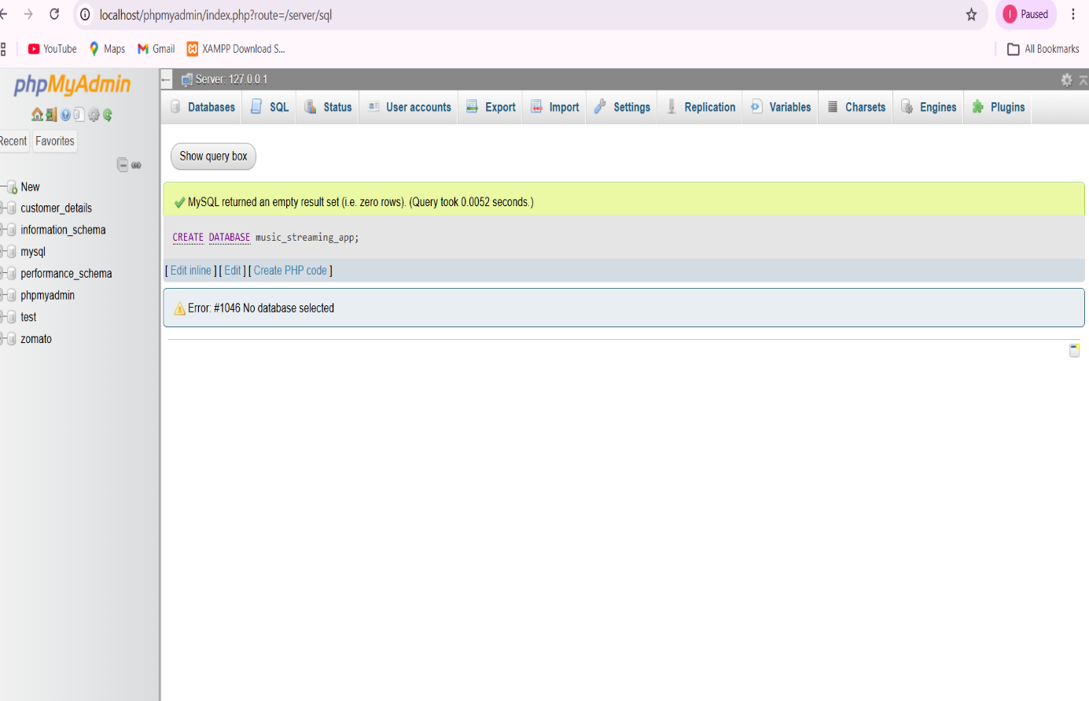

QUESTION: 2
Inside the 'music_streaming_app' database, create a table called 'playlists' with columns: playlist_id (integer, primary key), name (varchar), and created_by (varchar):

CREATE TABLE playlists
(
playlist_id int PRIMARY KEY,
name varchar(100),
created_by varchar(100)
);
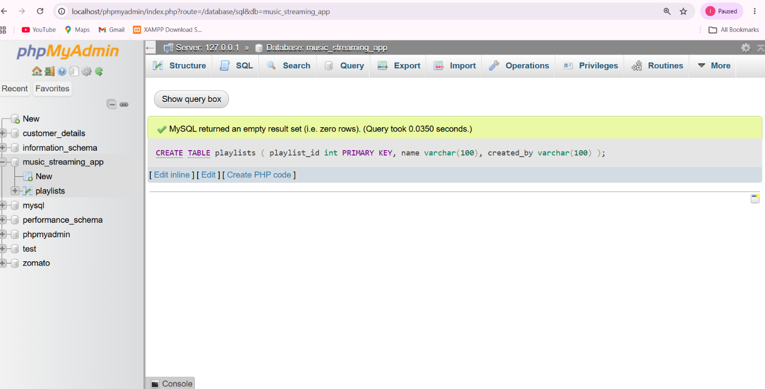

QUESTION: 3

Insert three sample rows into the 'playlists' table representing playlists like 'Bollywood Hits', 'Chill Vibes', and 'Workout Mix', each created by a different user:

INSERT INTO playlists (playlist_id,name,created_by) VALUES (1,"Bollywood Hits","Amit");

INSERT INTO playlists (playlist_id,name,created_by) VALUES (2,"Chill Vibes","Vivek");

INSERT INTO playlists (playlist_id,name,created_by) VALUES (3,"Workout Mix","Rahul");

SELECT * FROM playlists;
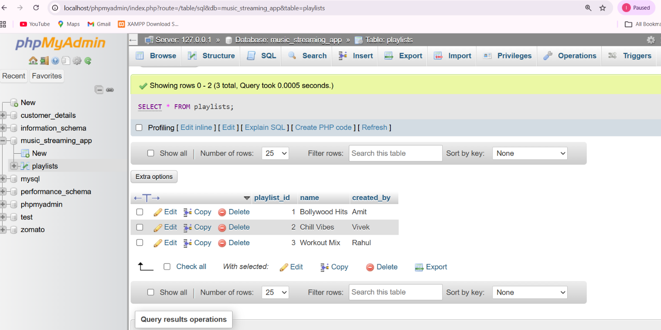
QUESTION: 4

Write an SQL SELECT query to display all playlists created by the user 'Amit' from the 'playlists' table.<br><br><em><strong>Hint:</strong> Use the WHERE clause to filter by the 'created_by' column</em>:

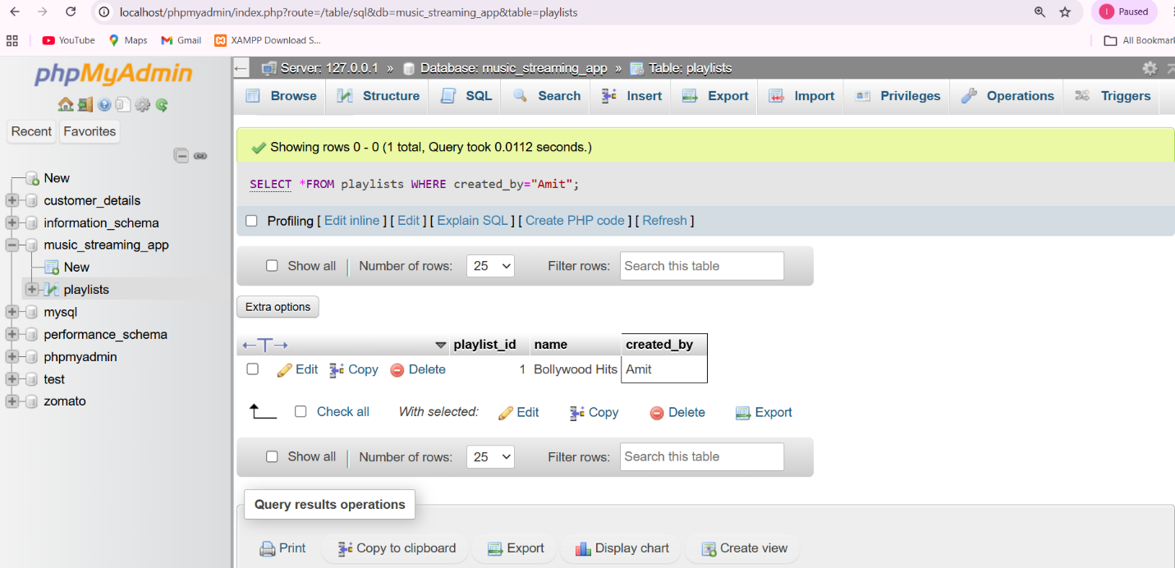
- SELECT *FROM playlists WHERE created_by="Amit";

QUESTION: 5

Open ChatGPT or Copilot and ask it to explain the difference between a table, a row, and a column in SQL using an example from a food delivery app like Zomato. Paste the explanation you receive into your assignment:

*Table:
A table is a collection of related data organized in rows and columns. For example, in a Zomato database, there may be an Orders table that stores information about food orders.

*Column:
A column represents a specific attribute of the data. In the Orders table, columns could be Order_ID, Customer_Name, Restaurant_Name, and Order_Amount.
*Row:
A row represents a single record in the table.

FOR EXAMPLE:
Order_ID | Customer_Name | Restaurant_Name | Order_Amount
101 | Rahul | Pizza Hut | 450

This entire entry is one row because it contains all information for a single order.

