QUESTION : 1
Create a table called Playlist with columns: id (INT, primary key), song_name (VARCHAR), artist (VARCHAR), and duration (INT, seconds). Insert a single row for your current favorite song :
- CREATE TABLE Playlist(
id INT,
song_name VARCHAR(150),
artist VARCHAR(150),
duration INT,
PRIMARY KEY(id)
);
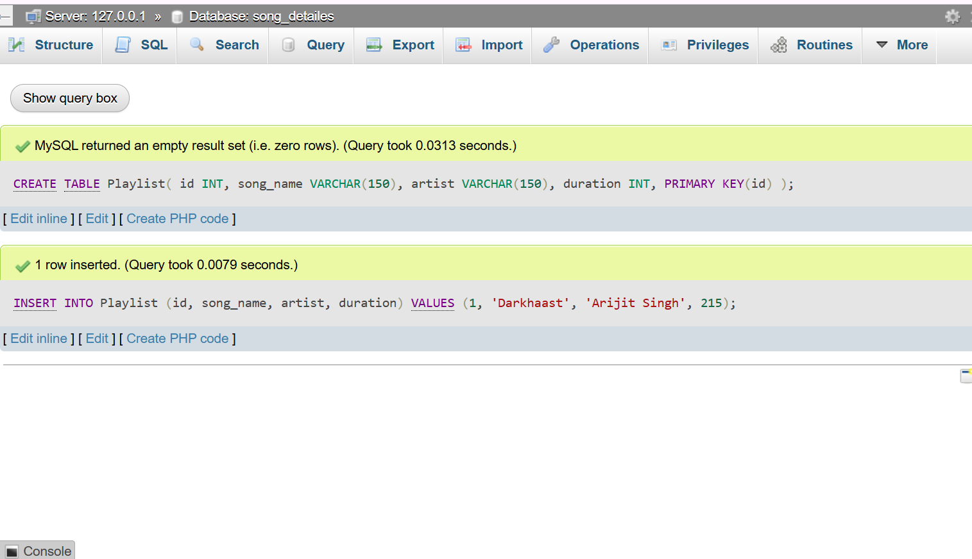
- INSERT INTO Playlist (id, song_name, artist, duration)
VALUES (1, 'Darkhaast', 'Arijit Singh', 215);

QUESTION : 2
Insert 3 new rows into the Playlist table for songs you recently listened to on Spotify, including their song_name, artist, and duration :

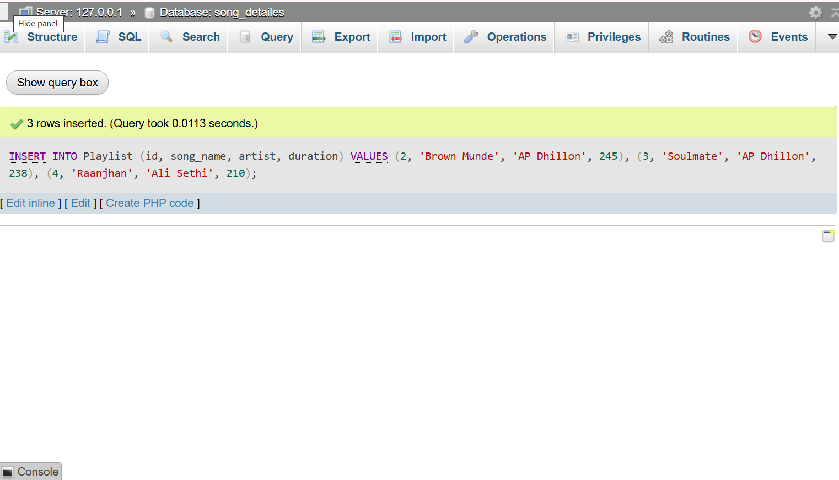
- INSERT INTO Playlist (id, song_name, artist, duration)
VALUES (2, 'Brown Munde', 'AP Dhillon', 245),
(3, 'Soulmate', 'AP Dhillon', 238),
(4, 'Raanjhan', 'Ali Sethi', 210);
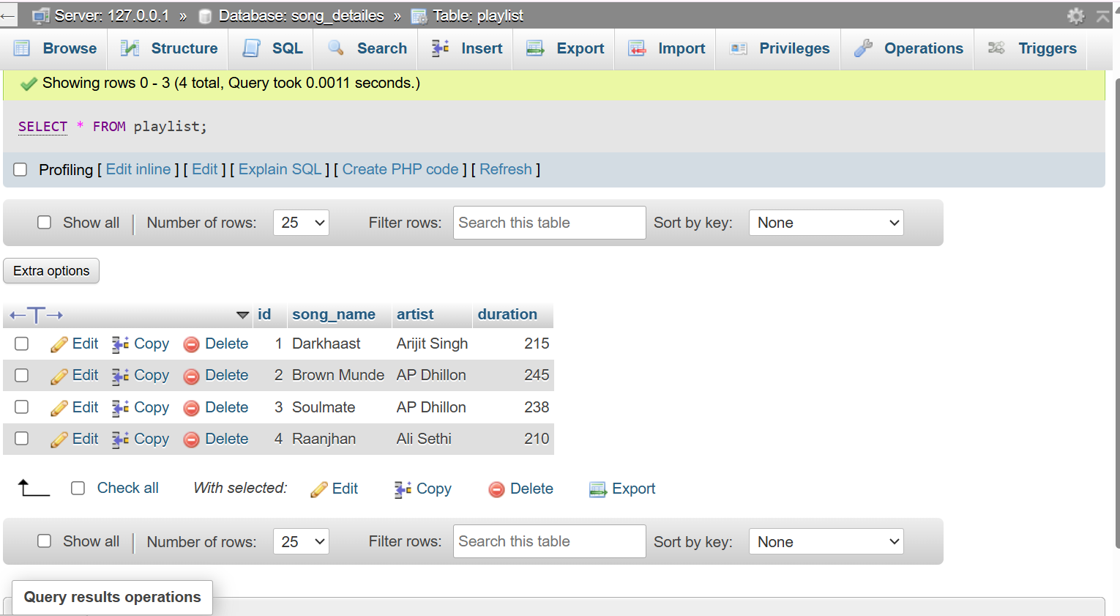
- SELECT * FROM playlist ;
QUESTION : 3

Update the artist name for one of your Playlist entries to fix a type (for example, change 'Arijit Singh' to 'Ariiijit Singh') using the UPDATE statement with a WHERE clause :

- UPDATE Playlist SET artist = 'Ariiijit Singh' WHERE artist = 'Arijit Singh' ;
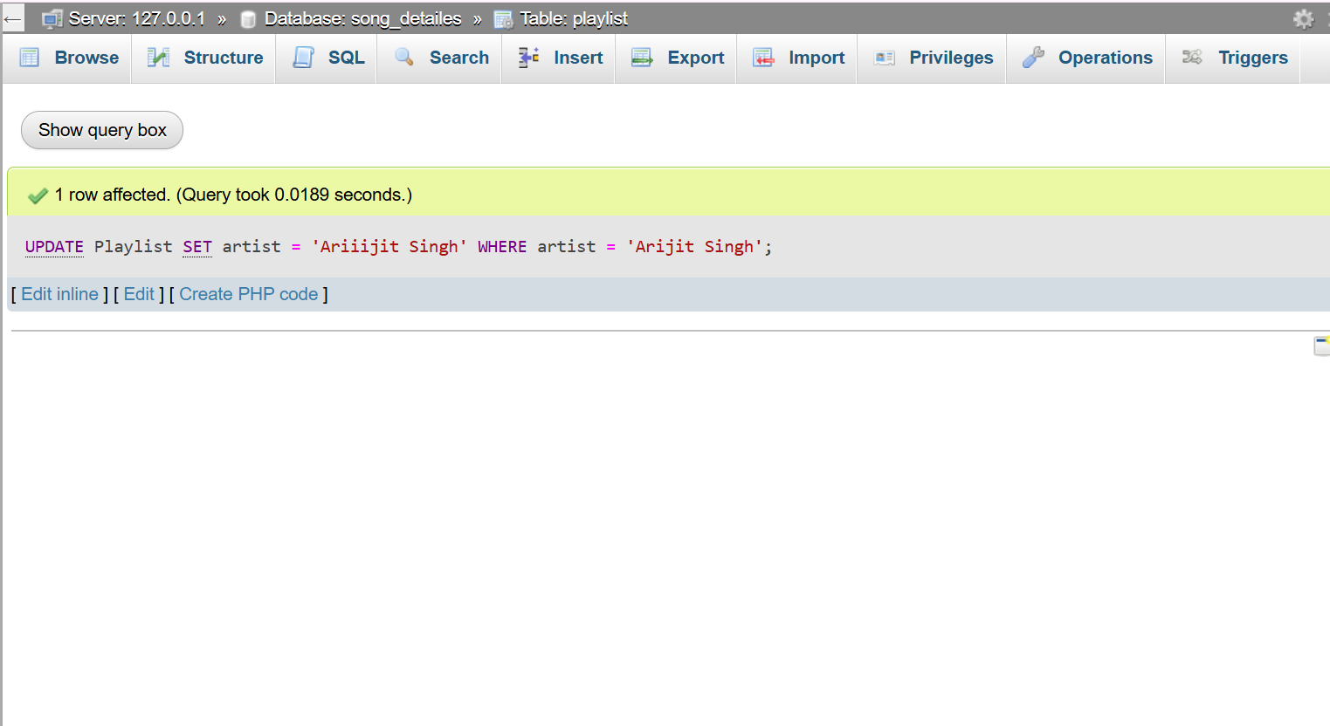

QUESTION : 4
Delete a song from the Playlist table where the duration is less than 120 seconds using the DELETE statement and a WHERE clause.<br><br><em><strong>Hint:</strong> Make sure your WHERE clause is specific so you don’t accidentally delete all rows.</em> :

- DELETE FROM Playlist WHERE duration < 120 ;
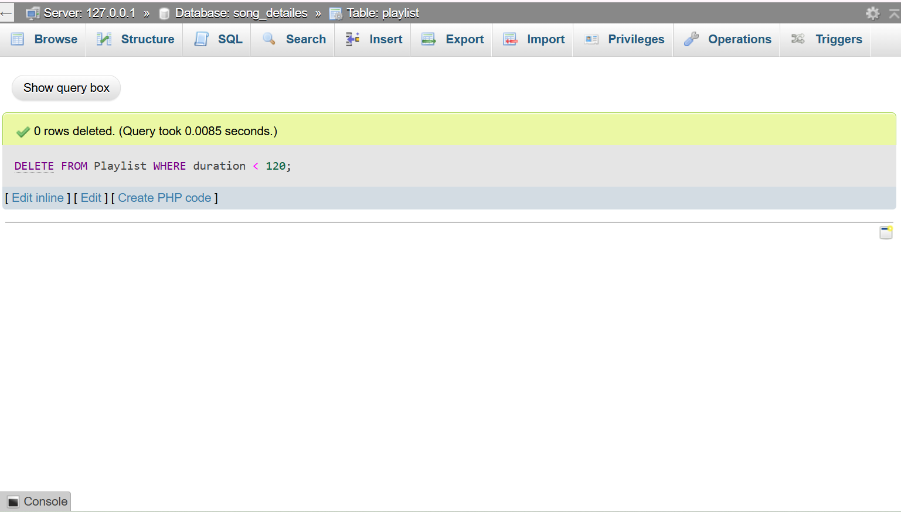

QUESTION : 5
Write an SQL statement that would update the song_name for all songs by 'AP Dhillon' in your Playlist to add '(Remix)' at the end of the name, but only if the duration is more than 180 seconds.<br><br><em><strong>Constraint:</strong> Combine UPDATE with WHERE to target only the correct rows</em> :
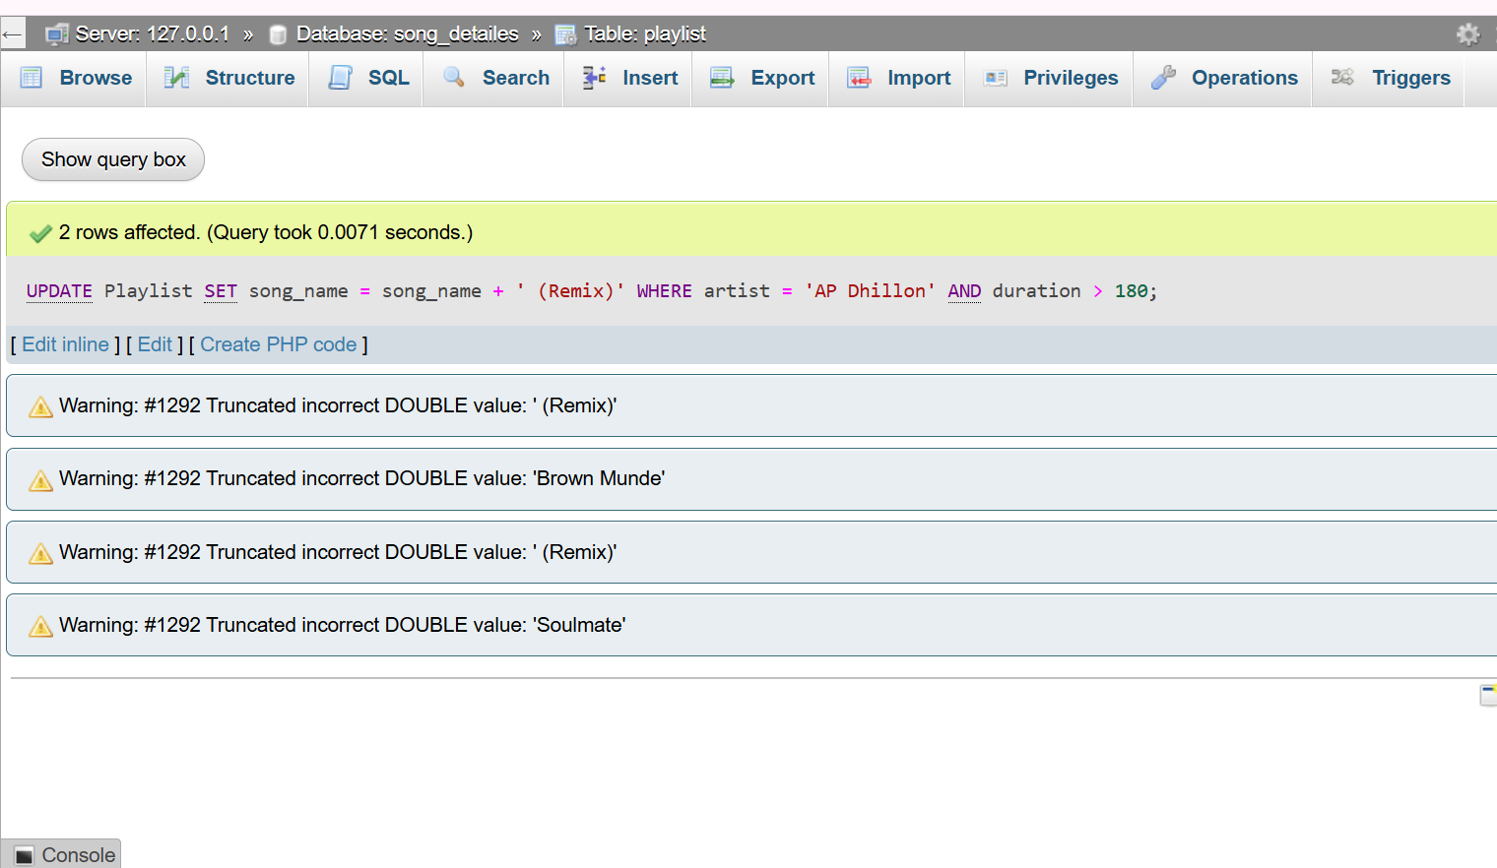
- UPDATE Playlist SET song_name = song_name + ' (Remix)' WHERE artist = 'AP Dhillon' AND duration > 180 ;

