## Shri G.S. Institute Of technology & science, Indore



Dept. Of Electronics & Telecommunication Engineering

Session: Jan- Jun 2019

## Assignment Submission of

MATLAB PROGRAMMINGS

## Submitted By-

Vivek Kumar Gupta (BE, E&Tc, IIIYr.)

Enrollment No- 0801EC161093

## Submitted To-

Mr. Aditya Nalwaya(Ass. Prof. CSE)

Mrs. Vaishali Naik(Ass. Prof. CSE)

Q.1

%Create a 10x10 random matrix with the command A=rand(10). Now do the following operations.

% a) Multiply all elements by 100 and then round off all elements of the matrix to integers with the command A=fix(A).

% b) Replace all elements of A<10 with Zeros.

% c) Replace all elements of A>90 with infinity (inf).

% d) Extract all 30 <= aij <= 50 in a vector b, that is find all elements between 30 and 50 and put them in a vector b.

%

A=rand(10);

%%

%(a)

A=A*100;

A=fix(A);

%%

%(b)

A(A<10)=0;

%%

%(c)

A(A>90)=inf;

%%

%(d)

b=A(A>=30 & A<=50)

>> Q1

b = 48 42 39 31 43 38 48 44 49 34 50 34 47 35 38 46 33

Q2. Find out the values of current il. 12 13 for the following given ckt using the

% MATLAB R1=5 ohm, R2=100 ohm, R3=200 ohm,R4=150 ohm,R=250 ohm; V1= 5V and V2= 10V.

% [V]= [R][I]

% [i]= inv([R])[V]

% -V1= (R1+R4)I1 + (-R4)I2 + (0)I3

% 0= (-R4)I1 + (R2+R4+R5)I2 + (-R5)I3

% -V2= (0)I1 + (-R5)I2 + (R3+R5)I3

R1=5;

R2=100;

R3=200;

R4=150;

R5=250;

V1=5;

V2=10;

V=[-V1;0;-V2];

R=[R1+R4 -R4 0;

-R4 R2+R4+R5 -R5;

0 -R5 R3+R5];

I=inv(R)*V;

I

>>I = -0.0788 -0.0481 -0.0490

Q3. Write a program which does the following operation on given signal:

% a) Addition, Multiplication and Convolution of two signal

% b) Folding, Shifting and Scaling operation on a given signal

%%

%Let two DIGITAL signals are X, Y

N=0:9;

X=N;

H=fliplr(N);%H=9:-1:0

%%

%(a)Addition, Multiplication and Convolution

Added=X+H;

Product=X.*H;

Convolution=conv(X,H);

%stem(0:19,Convolution)

%%

%(b) Folding, Shifting and Scaling operation on a given signal

%Folding using inbuilt function

Folded1=fliplr(X);

%Using for loop

Folded2=[];

for ij=length(X):-1:1

Folded2=[Folded2 X(ij)];

end

Folded2;

%Shifing by 3 in right(Delay)

N2=N+3;

Shfited1(N2)=X;

%Scaling by factor c=2

Scaled=X(1:2:9);

3. Write a program which does the following operation on given signal:

% a) Addition, Multiplication and Convolution of two signal

% b) Folding, Shifting and Scaling operation on a given signal

%%

%Let two DIGITAL signals are X, Y

N=0:9;

X=N;

H=fliplr(N);%H=9:-1:0

subplot(421); stem(N,X,'r'); title('Signals X');

subplot(422); stem(N,H,'g'); title('Signals Y');

%%

%(a)Addition, Multiplication and Convolution

Added=X+H;

Product=X.*H;

Convolution=conv(X,H);

subplot(423); stem(N,Added,'b'); title('Added signals');

subplot(424); stem(N,Product,'m'); title('Product signals');

subplot(425); stem(-9:9,Convolution,'r'); title('Convolution signals');

%stem(0:19,Convolution)

%%

%(b) Folding, Shifting and Scaling operation on a given signal

%Folding using inbuilt function

Folded1=fliplr(X);

%Using for loop

Folded2=[];

for ij=length(X):-1:1

Folded2=[Folded2 X(ij)];

end

subplot(426); stem(0:9,Folded2,'r'); title('Folded signals');

%Shifing by 3 in right(Delay)

N2=N+3;

Shfited1(N2)=X;

subplot(427); stem(0:11,Shfited1,'r'); title('Shifted signals');

%Scaling by factor c=2

Scaled=X(1:2:9);

subplot(428); stem(0:4,Scaled,'r'); title('Scaled signals');

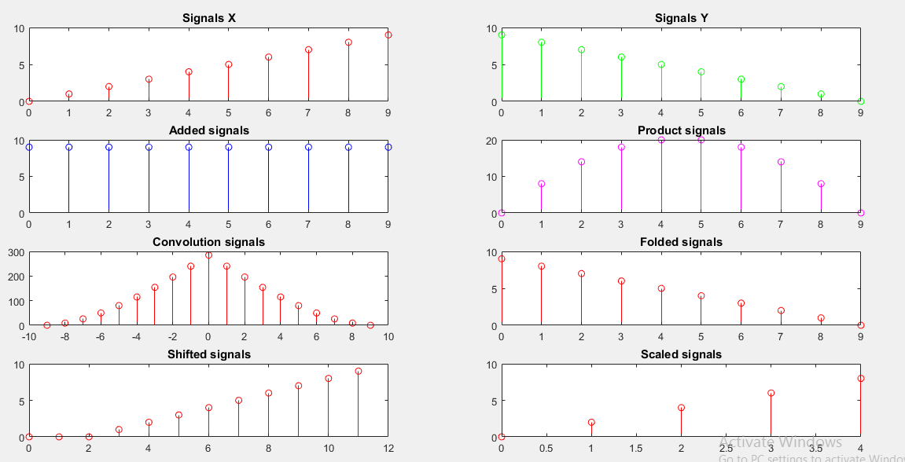

Q4. Program to draw fourier transform of trinangular function.

T=4; %a= -2 to b= +2

V0=5; %V=+-(10) Asussumed

w= 2*pi/T;

%%

%Function declareation

fun1= @(t)( (-4*V0/T).*(t + T/2) );

fun2= @(t)( (4*V0/T).*t );

fun3= @(t)( (-4*V0/T).*(t - T/2) );

func= @(t)( fun1(t)+fun2(t)+fun3(t) );

%%

%a0, an & bn finding

a10=@(n)(2/T)*integral( fun1, -T/2, -T/4 );

a20=@(n)(2/T)*integral( fun2, -T/4, T/4 );

a30=@(n)(2/T)*integral( fun3, T/4, T/2 );

a0 =@(n)( a10(n)+a20(n)+a30(n) );

a1n=@(n)(2/T)*integral( @(t)fun1(t).*cos(n*w*t), -T/2, -T/4 );

a2n=@(n)(2/T)*integral( @(t)fun2(t).*cos(n*w*t), -T/4, T/4 );

a3n=@(n)(2/T)*integral( @(t)fun3(t).*cos(n*w*t), T/4, T/2 );

an =@(n)( a10(n)+a20(n)+a30(n) );

b1n=@(n)(2/T)*integral( @(t)fun1(t).*sin(n*w*t), -T/2, -T/4 );

b2n=@(n)(2/T)*integral( @(t)fun2(t).*sin(n*w*t), -T/4, T/4 );

b3n=@(n)(2/T)*integral( @(t)fun3(t).*sin(n*w*t), T/4, T/2 );

bn =@(n)( b1n(n)+b2n(n)+b3n(n) );

%%

t=-4:0.01:4;

t1=-3:0.01:-1;

t2=-1:0.01: 1;

t3= 1:0.01: 3;

%%

for j=1:2:50

%hold on

plot(t1,fun1(t1),'k')

plot(t2,fun2(t2),'k')

plot(t3,fun3(t3),'k')

FS=0;

for k=1:j

FS=FS + an(k).*cos(k*w*t)+bn(k).*sin(k*w*t);

end

FS=FS+a0(0);

plot(t,t==0,'g',t==0,t,'g', t1,fun1(t1),'b', t2,fun2(t2),'b', t3, fun3(t3),'b',t,FS,'r' )

pause(1)

end

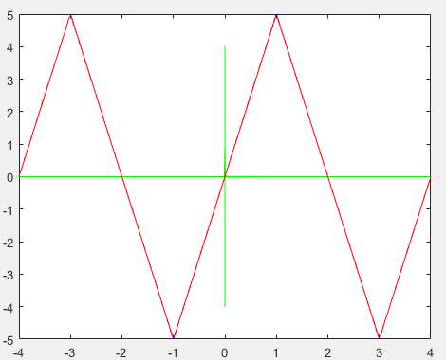

Q5. Amplitude Modulation

Ac=2; fc=300;

%mu=input('Enter Value of mu: ');

%Am= mu*Ac;

fm=25;

mt= @(t)sin(2*pi*fm*t);

ct= @(t)sin(2*pi*fc*t);

yt= @(t,mu)Ac*(1 + mu*mt(t)).*ct(t);

t=0:0.0001:0.1;

subplot(5,1,1)

plot( t,mt(t),'g' );

title('Message Signal: m(t)');

xlabel('time'); ylabel('Amplitude');

subplot(5,1,2)

plot( t,2*ct(t),'b' );

title('Career Signal: c(t)');

xlabel('time'); ylabel('Amplitude');

subplot(5,1,3)

plot( t,yt(t,0.5),'r' );

title('Amplitude Modulated Signal: y(t): mu=0.5');

xlabel('time'); ylabel('Amplitude');

subplot(5,1,4)

plot( t,yt(t,1),'r' );

title('Amplitude Modulated Signal: y(t): mu=1');

xlabel('time'); ylabel('Amplitude');

subplot(5,1,5)

plot( t,yt(t,1.5),'r' );

title('Amplitude Modulated Signal: y(t): mu=1.5');

xlabel('time'); ylabel('Amplitude');

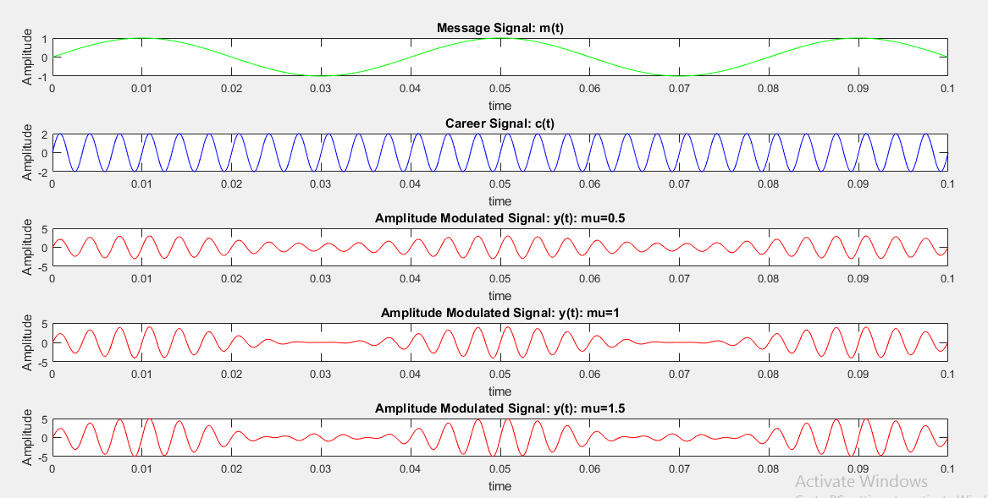

Q6. Program to implement ASK, PSK And QAM

b=randi(0:1,1,10);

subplot(3,2,1);

n=length(b);

t=0:0.01:n;

x=1:(n+1)*100;

for i=1:n

for j=i:.1:i+1

a(x(i*100:(i+1)*100))=b(i);

end

end

a=a(100:end);

plot(t,a,'r')

title("Random Generated Bit Pattern"); xlabel("n");ylabel("Bit value");

%%

s=a.*sin(2*pi*5*t);

subplot(3,2,2)

plot(t,s,'g')

title("ASK Plot"); xlabel("t");ylabel("Amplitude");

%%

%PSK

for i=1:n

if b(i)==0

p(i)=-1;

else

p(i)=1;

end

for j=i:.1:i+1

ps(x(i*100:(i+1)*100))=p(i);

end

end

ps=ps(100:end);

s=ps.*sin(2*pi*5*t);

subplot(3,2,3)

plot(t,s,'b')

title("PSK Plot"); xlabel("t");ylabel("Amplitude");

%%

%FSK

for i=1:n

if b(i)==0

p(i)=-1;

else

p(i)=1;

end

for j=i:.1:i+1

f(x(i*100:(i+1)*100))=p(i);

end

end

f=f(100:end);

s=sin(2*pi*7.5*t+(2*pi*2.5*t).*f);

subplot(3,2,4)

plot(t,s,'m')

title("FSK Plot"); xlabel("t");ylabel("Amplitude");

%%

M = 16;

k = log2(M);

n2 = 50000;

nps = 1; % number per sample

rng default

data = randi([0,1],n2,1);

subplot(3,2,5);

stem(data([1:40]));

title('Random binary bits');

xlabel('Bit index');

ylabel('bits value');

four_bit_data = reshape(data , length(data)/k ,k); % creates 4 bit data for QAM

datanew = bi2de(four_bit_data); % converts 4 bit binary data to decimal value

subplot(3,2,6);

stem(datanew([1:40]));

title('random value');

xlabel('index value');

ylabel('Integer value');

modulated_data = qammod(datanew , M ,'bin');

Eb = 10;

snr = Eb + 10*log10((k)/(nps));

recieved_signal = awgn(modulated_data , snr , 'measured');

newplot = scatterplot(recieved_signal,1,0,'b.');

hold on;

scatterplot(modulated_data,1,0,'k+',newplot);

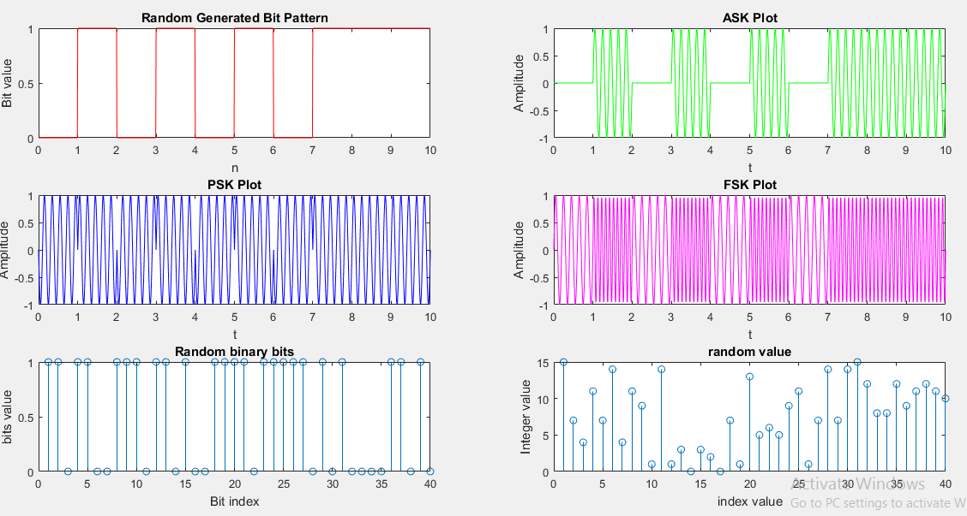

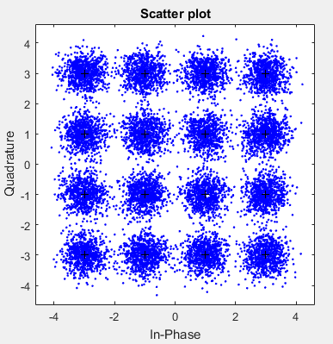

Q7. Design a High pass filter

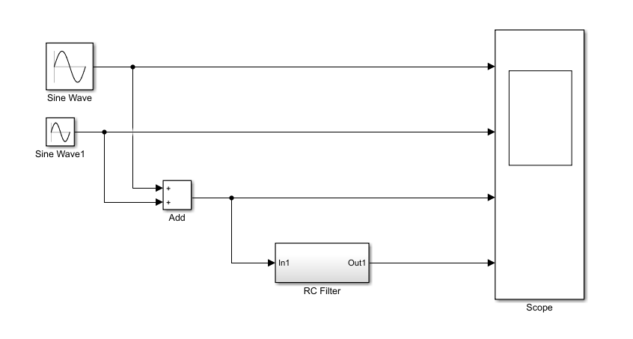

High Pass Filter

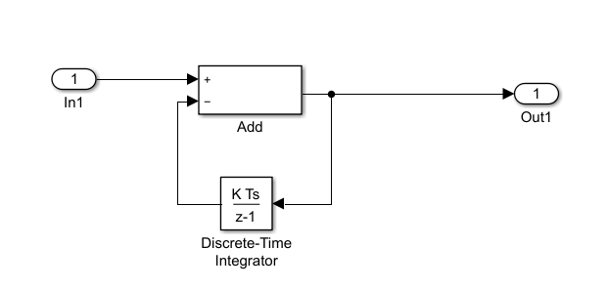

RC Filter(Internal Architecture)

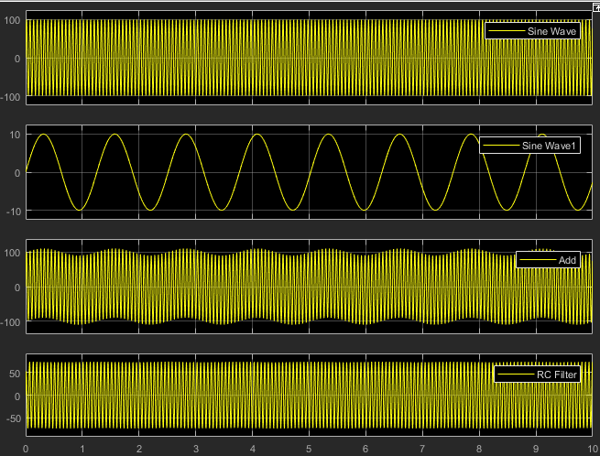

Q8. Gaussian Distributions

a = -100; b = 100;

x=-100:100;

mu = (a + b)/2;

p1 = @(s)-0.5 * ((x - mu)/s) .^ 2;

p2 = @(s)(s * sqrt(2*pi));

f=@(s)exp(p1(s)) ./ p2(s);

%%

X = 100.*f(30); %sigma=30

subplot(4,2,1)

plot(x,X,'r')

grid on

title('X: Gauss Distribution:Bell Curve')

xlabel('Randomly produced numbers')

ylabel('Gauss Distribution')

%%

Y = 100.*f(10);

subplot(4,2,2)

plot(x,Y,'g')

grid on

title('Y: Gauss Distribution:Bell Curve')

xlabel('Randomly Variables')

ylabel('Gaussian Distribution')

%%

X2=X.^2;

subplot(4,2,3)

plot(x,X2,'b')

grid on

title('X^2, X: Gaussian')

xlabel('Randomly Variables')

ylabel('Gaussian Distribution')

%%

Y2=Y.^2;

subplot(4,2,4)

plot(x,Y2,'c')

grid on

title('Y^2, Y: Gaussian')

xlabel('Randomly Variables')

ylabel('Distribution')

%%

Z2=X2+Y2;

subplot(4,2,5)

plot(x,Z2,'m')

grid on

title('X^2+Y^2, X & Y: Gaussian')

xlabel('Randomly Variables')

ylabel('Distribution')

%%

Z=Z2.^0.5;

subplot(4,2,6)

plot(x,Z,'y')

grid on

title('Z=(X^2+Y^2)^0^.^5, X: Gaussian')

xlabel('Randomly Variables')

ylabel('Distribution')

%%

P=exp(X); %sigma=30

subplot(4,2,7)

plot(x,P,'k')

grid on

title('P= e^X, X: Gaussaian Distribution')

xlabel('Randomly Variables')

ylabel('Distribution')

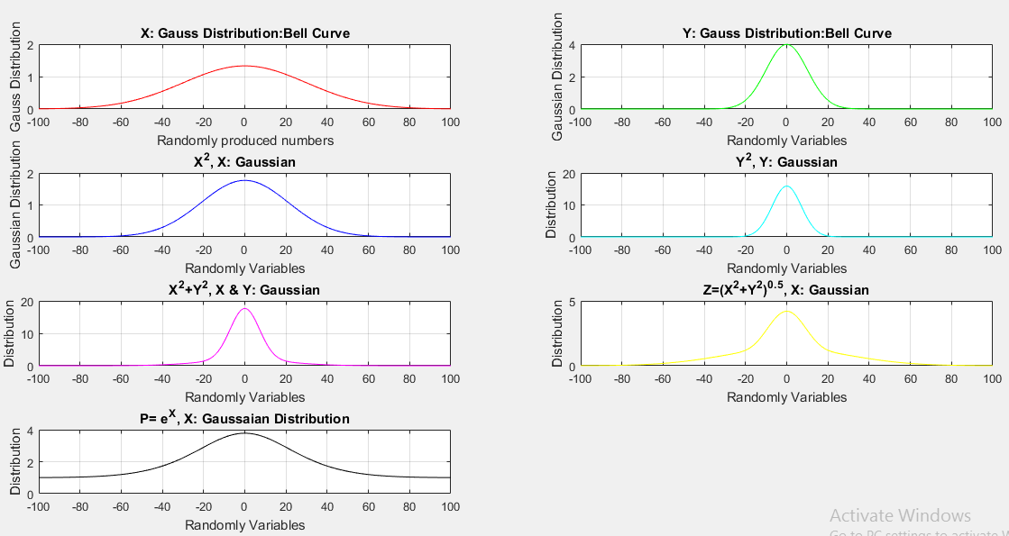

Q9. Different Distribution

%Nakagami-m Distribution

clc; clear all; close all;

colors=['r','g','b'] ;

m = 1;

x = [0:0.05:3];

subplot(411)

for w = 1:3

for ii = 1:length(x)

y(ii)=((2*m^m)/(gamma(m)*w^m))*x(ii)^(2*m-1)*exp(-((m/w)*x(ii)^2));

end

plot(x,y,colors(w))

hold on

end

xlabel('Support');

ylabel('PDF');

title('Nakagami-m Distribution:Probability Density Function')

hleg1 = legend('w=1','w=2','w=3');

set(hleg1,'Location','NorthEast')

axis([0 3 0 2]);

grid on

%%

x = (10:1000:125010)';

y = lognpdf(x,log(20000),1.0);

subplot(412)

plot(x,y)

title('Log Normal Distribution')

h = gca;

h.XTick = [0 30000 60000 90000 120000];

h.XTickLabel = {'0','$30,000','$60,000','$90,000','$120,000'};

% Compute the Lognormal Distribution pdf

% Suppose the income of a family of four in the United States follows

% a lognormal distribution with mu = log(20,000) and sigma = 1.

% Compute and plot the income density

%%

mu = 1:5;

y = gampdf(1,1,mu);

%y = [0.3679 0.3033 0.2388 0.1947 0.1637]

y1 = exppdf(1,mu);

subplot(413)

plot(mu,y,mu,y1)

title("Gamma Distribution Function")

%%

%Rician

x = linspace(0, 8, 100);

subplot(4, 1, 4)

plot(x, ricepdf(x, 0, 1), x, ricepdf(x, 1, 0.50), x, ricepdf(x, 1, 1.00))

title('Rice PDF with s = 1')

function y = ricepdf(x, v, s)

s2 = s.^2; % (neater below)

try

y = (x ./ s2) .*...

exp(-0.5 * (x.^2 + v.^2) ./ s2) .*...

besseli(0, x .* v ./ s2);

% besseli(0, ...) is the zeroth order modified Bessel function of

% the first kind. (see help bessel)

y(x <= 0) = 0;

catch

error('ricepdf:InputSizeMismatch','Non-scalar arguments must match in size.');

end

end

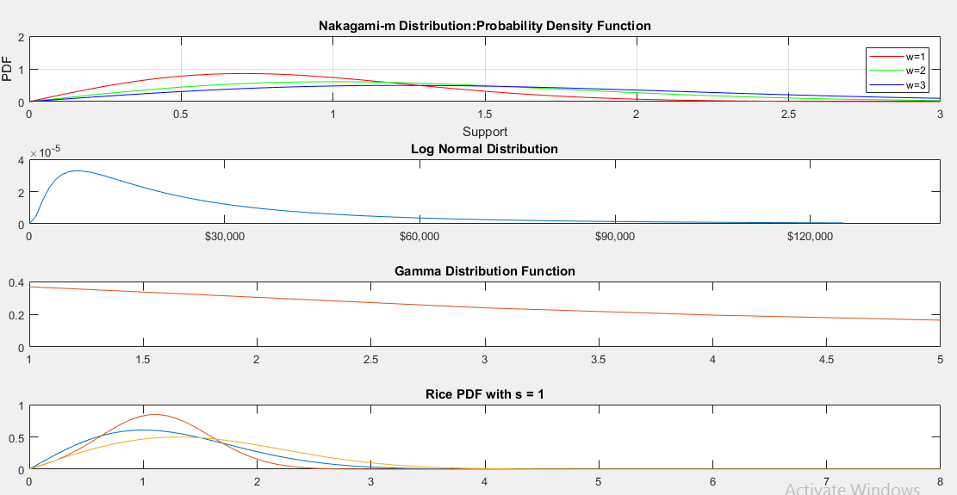

## Project: Virtual Mobile



