AI Assisted Coding
Assignment 4.5

Name: Vivek Hallticket:2303A52009 Task-01:
Prompt:
write a python code for leap year checking. The function should be accepting a year form user, checks whether the given year is a leap year or not.

Code:
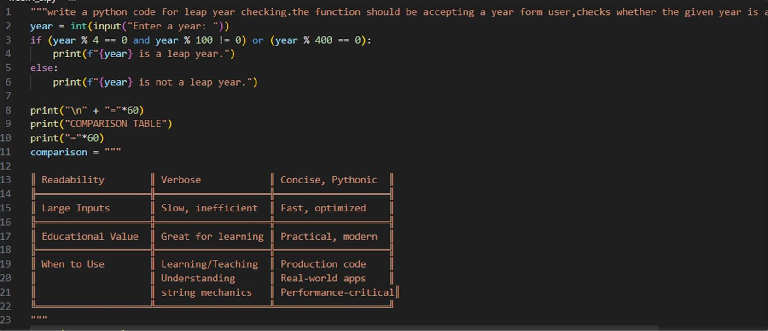
Output:
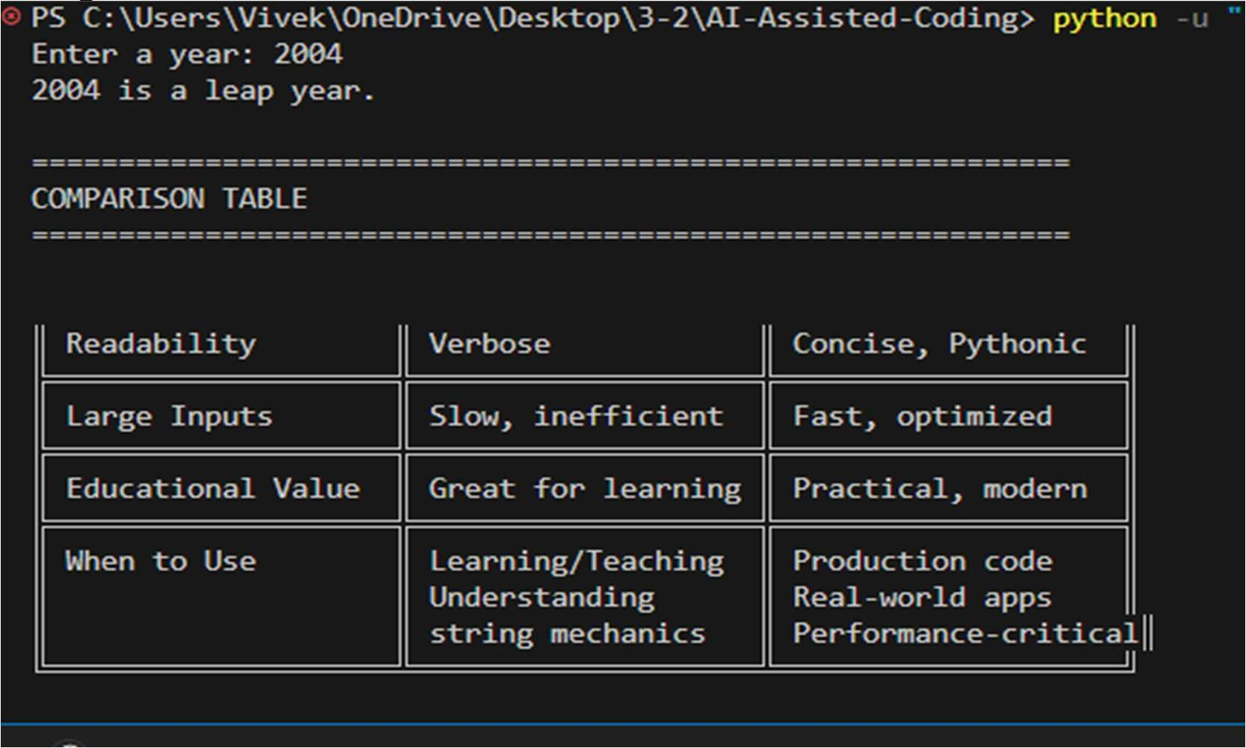

Task02:
Prompt:
write a python code for converting centimetres to inches by using mathematical formula. Example when user gave input 10cm and output should be 3.93 inches
Code
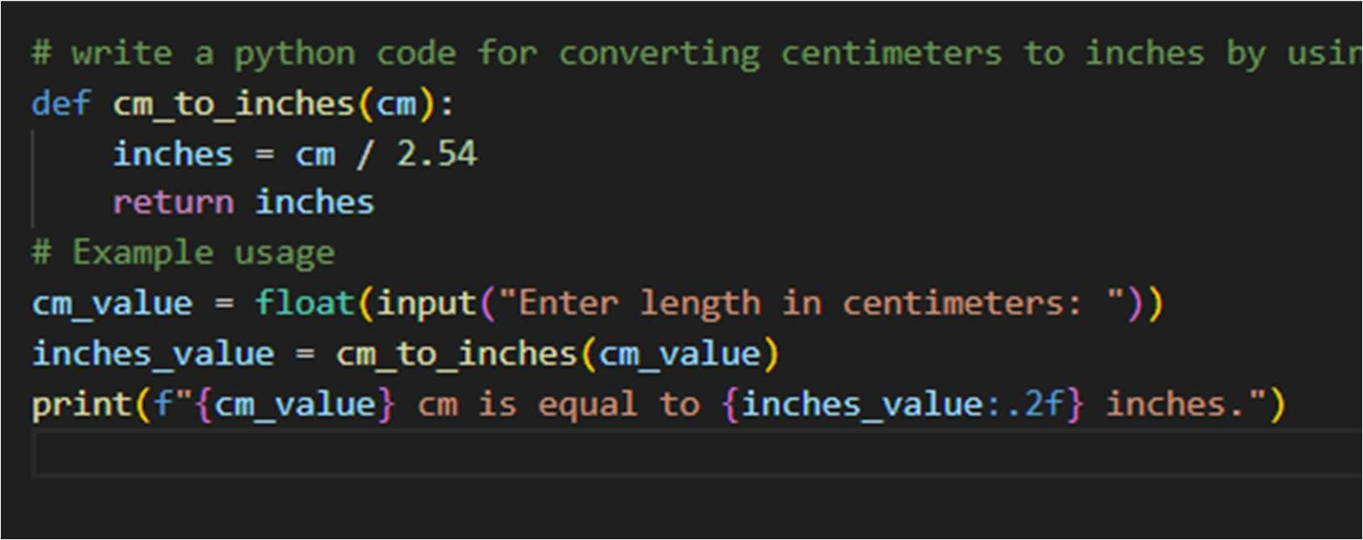

Output:
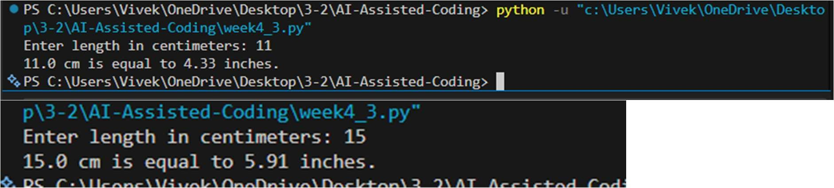

Task_03
Prompt: write a python code for name formating function that accepts first name and last name from user and returns the full name as "Last Name, First Name" example input : first name = john , last name = smith output : smith, john example 2: first name = anitha , last name = Rao output : Rao, Anitha

Code:
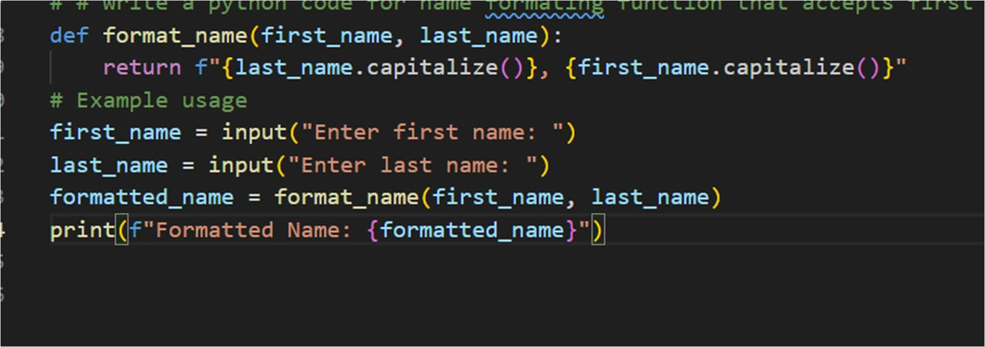

Output:
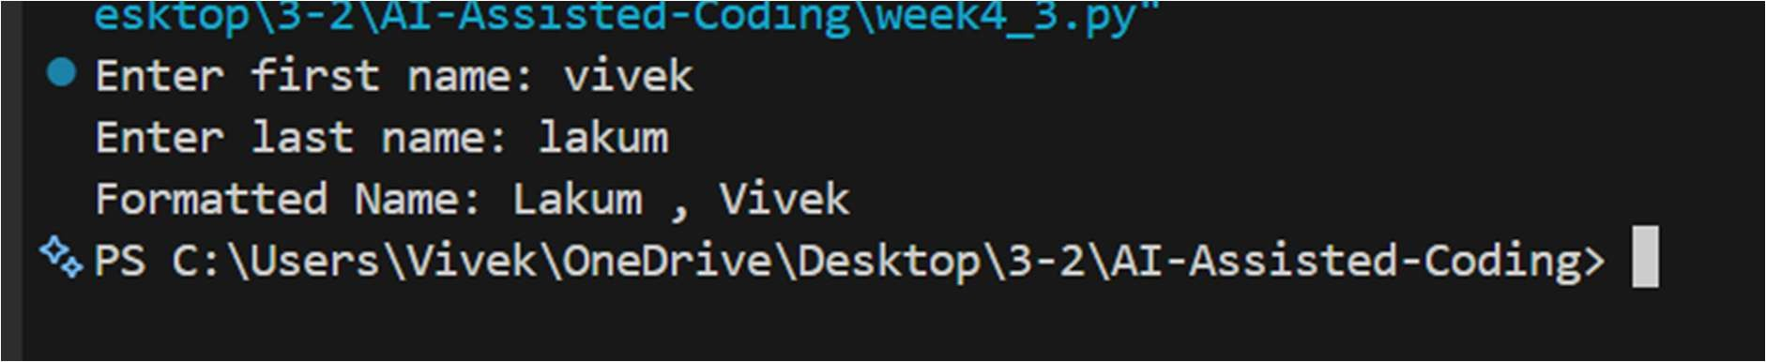

Task_04
Prompt: # Write a function in Python that takes a string as input and returns the number of vowels in the string. Consider both uppercase and lowercase vowels.
Code:

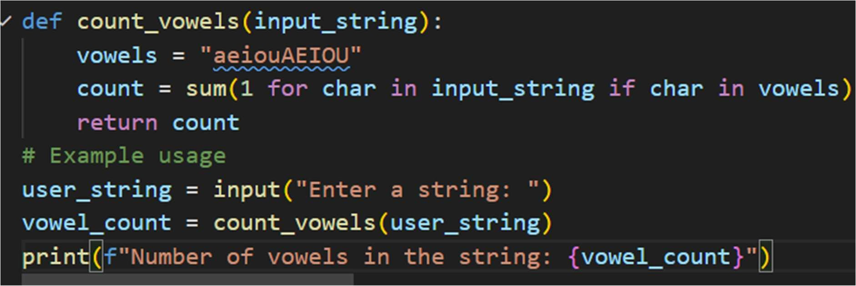

Output:
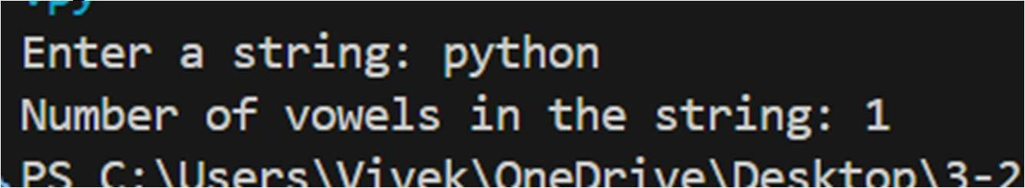

Few Shot:
# Example 1:Input: "apple"Output: 2 Example 2:Input: "HELLO"Output: 2 Now write a Python function that takes a string as input and returns the number of vowels in it.Count both uppercase and lowercase vowels.

Code:
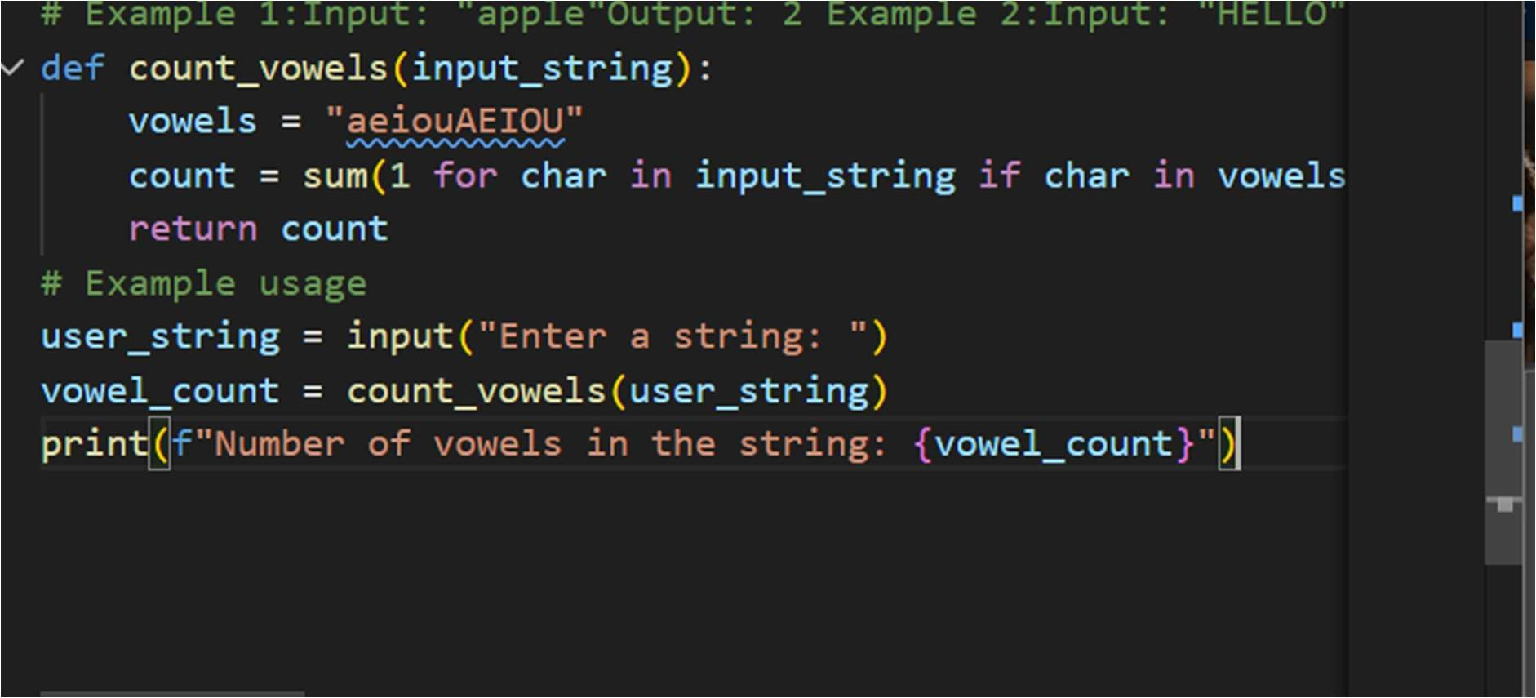

Output:
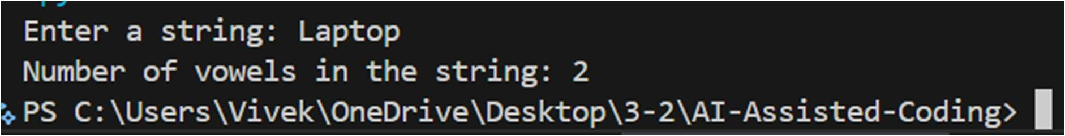

Task_05:
Prompt: content (sample1.txt): Hello
Welcome to Python File handling example Output:
Number of lines = 3 Example 2:
File content (sample2.txt):
This is line one This is line two Output:
Number of lines = 2
Now write a Python function that:
- Reads a .txt file
- Counts the total number of lines in the file
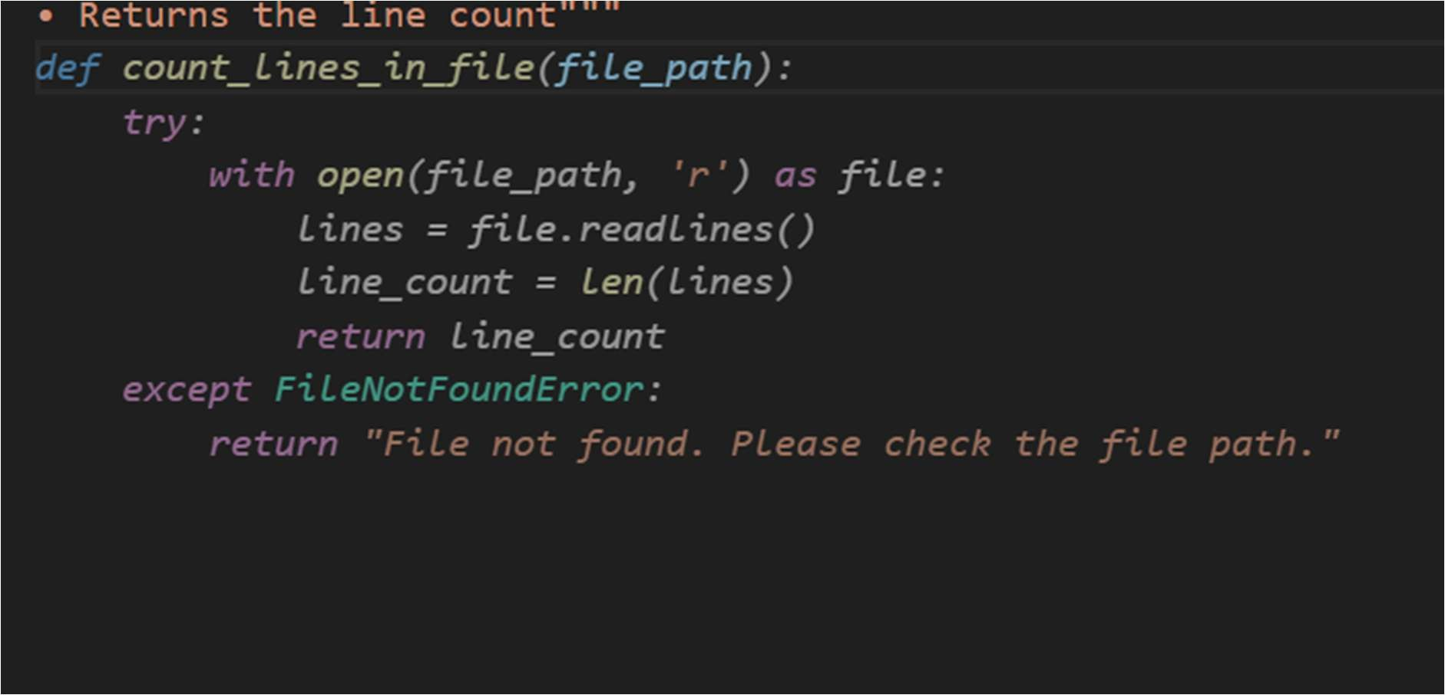
- Returns the line count""" Code:

Output:

