AI Assisted Coding
Assignment 5.5
Name: Vivek
Hallticket:2303A52009 Task-01:
Use AI to generate two solutions for checking prime numbers:
- Naive approach(basic)
- Optimized approach
Prompt: Hallticket:2303A52009
Generate Python code for two prime-checking methods and explain how the optimized version improves performance."""
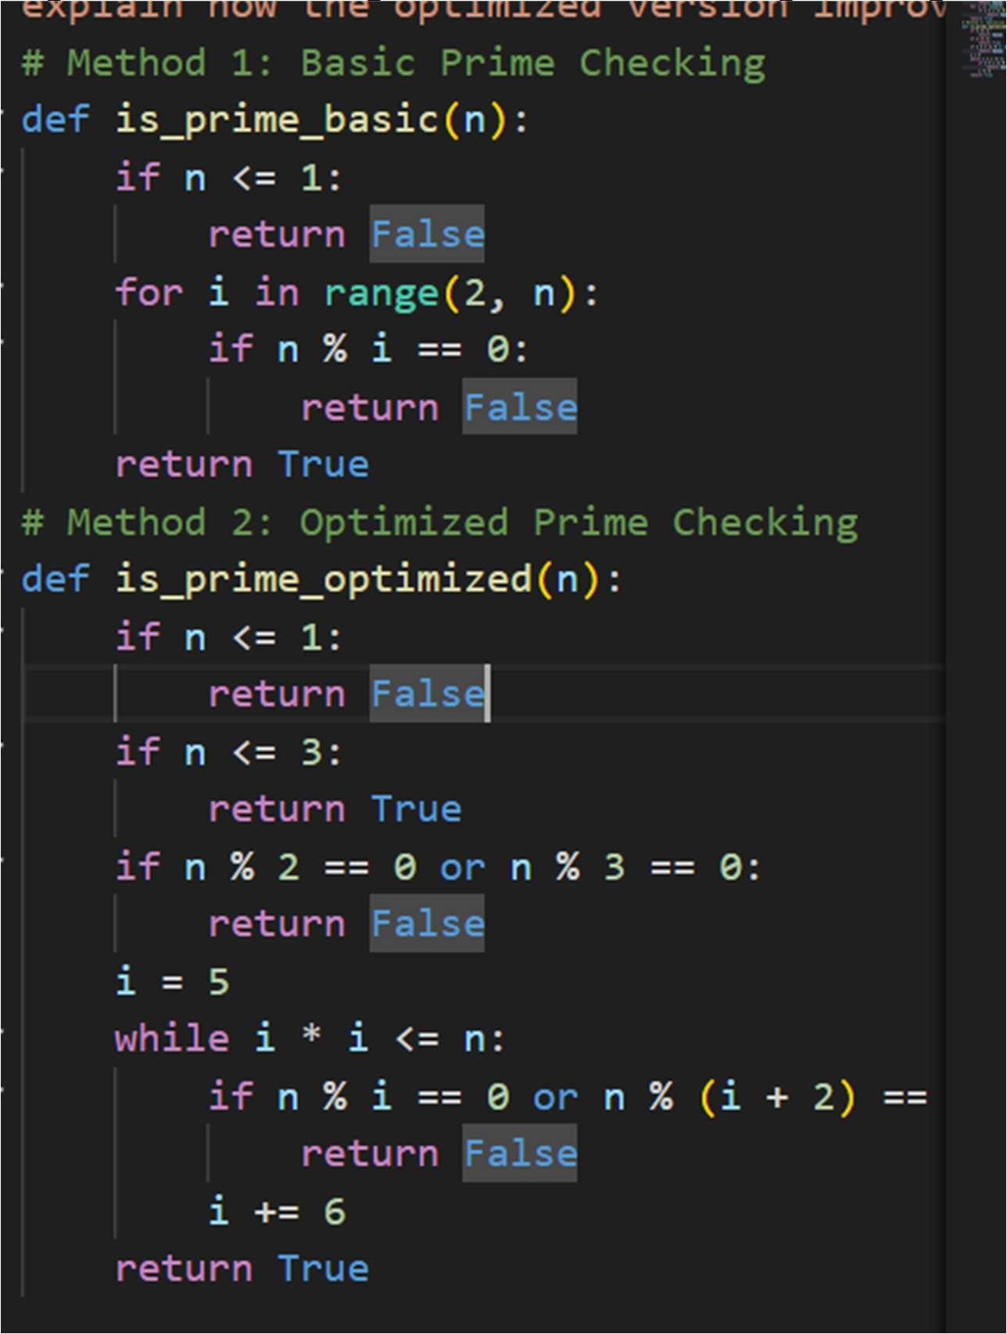

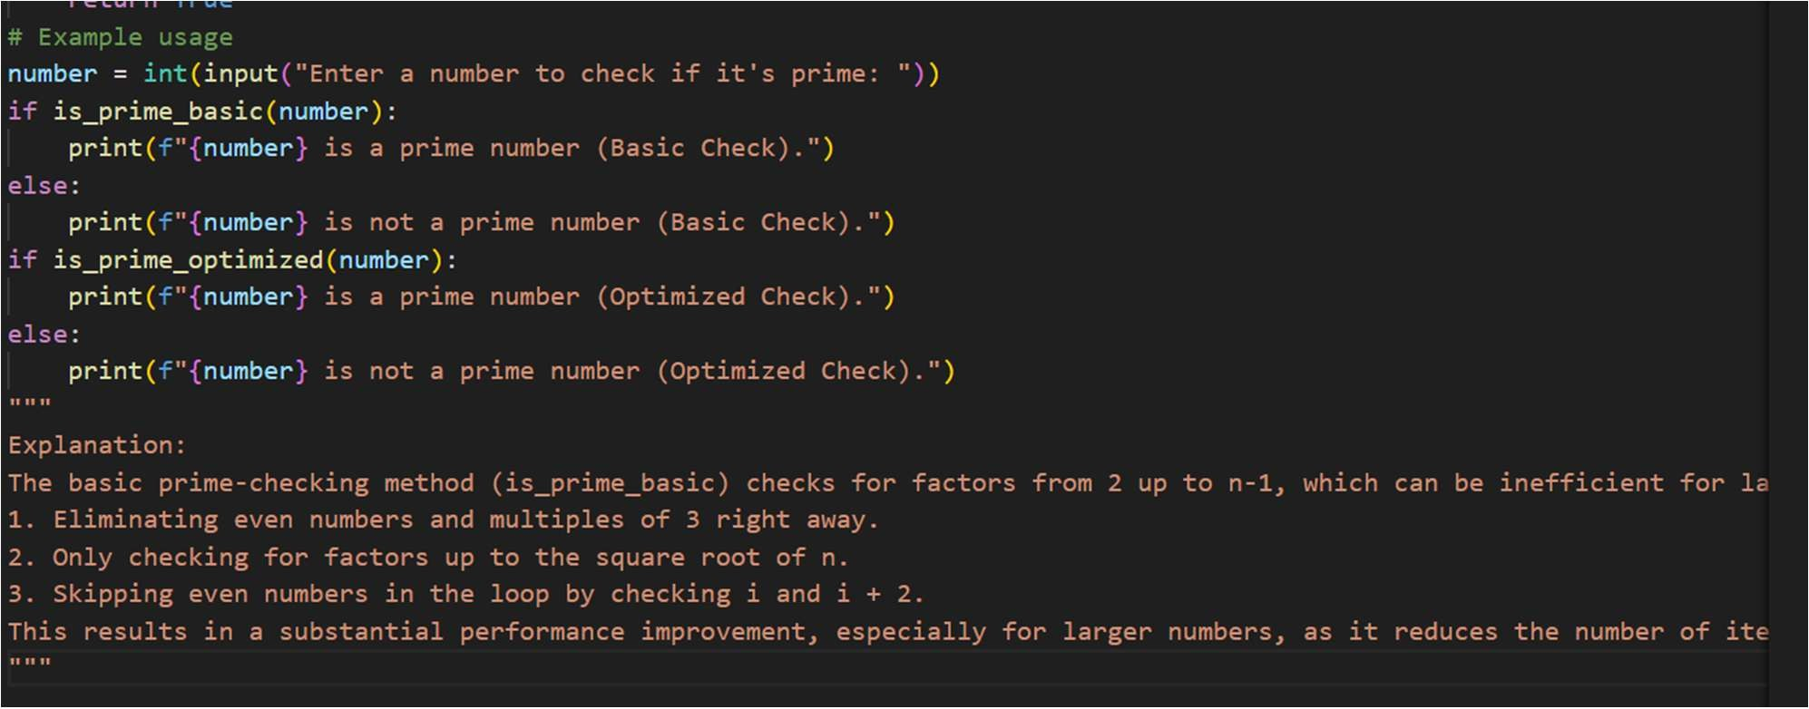

Output:
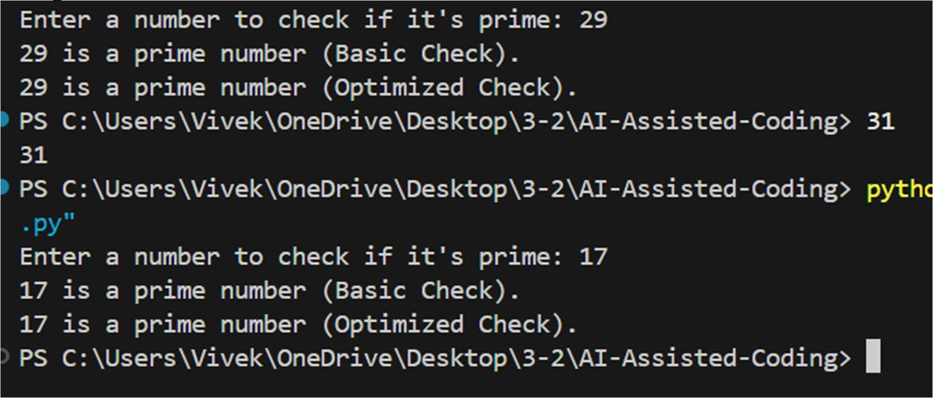

Task-02:
Prompt: Hallticket-2303A52009 Generate a recursive function to calculate Fibonacci numbers.
which should have the following features:
- Write the code clearly and correctly.
- Add detailed comments explaining: what recursion is
how the function calls itself
- Clearly explain:
the base cases
the recursive case
- After the code, give a step-by-step explanation of how the function executes for n = 5. Do not skip explanations.
Do not give vague theory.
The explanation must directly follow the code logic.
Code:
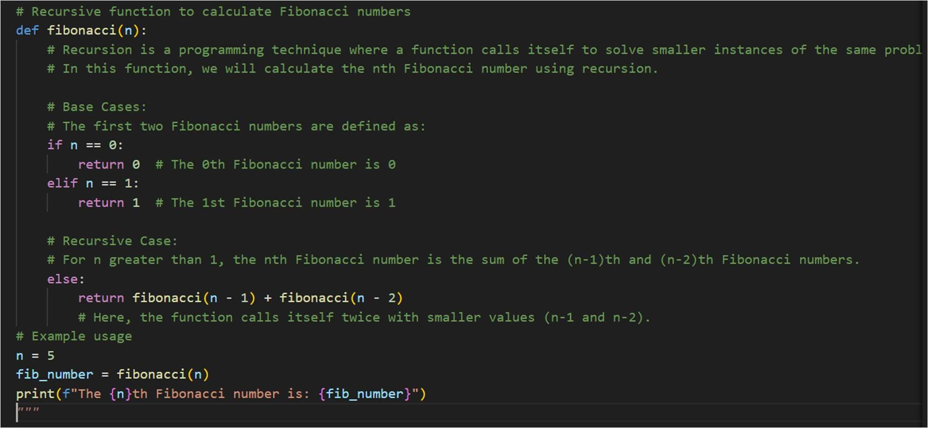

Output:
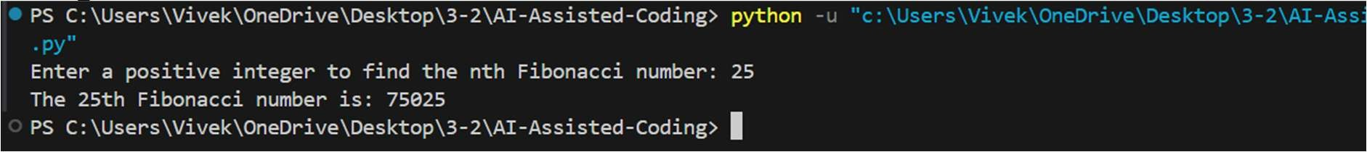
Justification:
The provided code effectively demonstrates robust error handling by specifically catching FileNotFoundError and IOError exceptions. Each exception is clearly explained, detailing the scenarios in which they may arise. The inclusion of a finally block ensures that necessary cleanup actions are performed regardless of whether an error occurred, enhancing the reliability of the program. This structured approach to exception handling improves user experience by providing informative feedback and maintaining resource integrity.

Task-03:
Use AI to generate a Python program that reads a file and processes data. Prompt:
“Generate code with proper error handling and clear explanations for each exception.”
Expected Output:
- Code with meaningful exception handling.
- Clear comments explaining each error scenario.
- Validation that explanations align with runtime behavior.
Prompt:
Generate code to read the file and process its data use proper error handling like (try, except,finally,etc) and handle it properly. also say the possible explanation for each step in the code with comments
give comments explaining each error scenario dd clear comments explaining: why each exception occurs when it will be triggered at runtime After the code, explain each exception scenario in simple terms. Verify that the explanation matches the actual runtime behavior of the program.

Code:
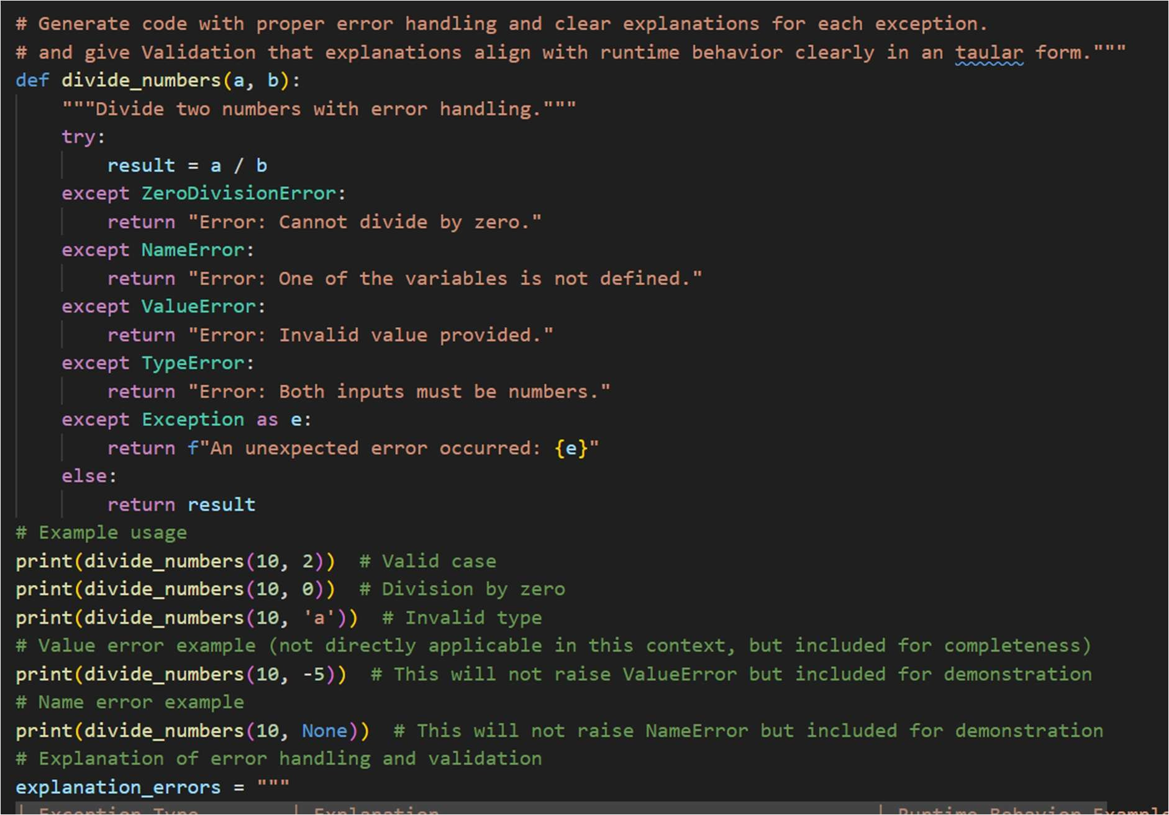
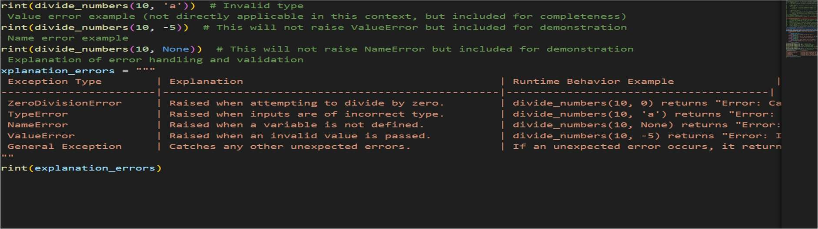

Output:
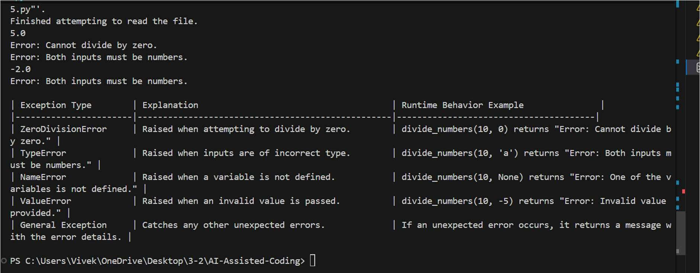

Justification :
The provided code demonstrates robust error handling by catching specific exceptions that may arise during division operations.
Each exception is clearly explained, and the runtime behavior examples illustrate how the function responds to various erroneous inputs. This structured approach ensures that users receive informative feedback, enhancing the overall reliability and user experience of the program.
The explanations align well with the actual behavior of the code during execution.

Task_04:
Task: Use an AI tool to generate a Python-based login system. Analyze: Check whether the AI uses secure password handling practices.
Expected Output:
- Identification of security flaws (plain-text passwords, weak validation).
- Revised version using password hashing and input validation.

Prompt:
"""2303A52009 - Task04: Use an AI tool to generate a Python-based login system. Analyze: Check whether the AI uses secure password handling practices.
Implement login verification logic.
Do not use external authentication services. Keep the system simple and readable.
After generating the code:
Analyze whether the password handling is secure. Identify and clearly explain any security flaws, including:
plain-text password storage lack of hashing or salting weak input validation
vulnerability to brute-force attempts
Clearly state why each practice is insecure in real-world systems. The analysis must directly reference the generated code. Avoid generic cybersecurity theory.
"""

Code
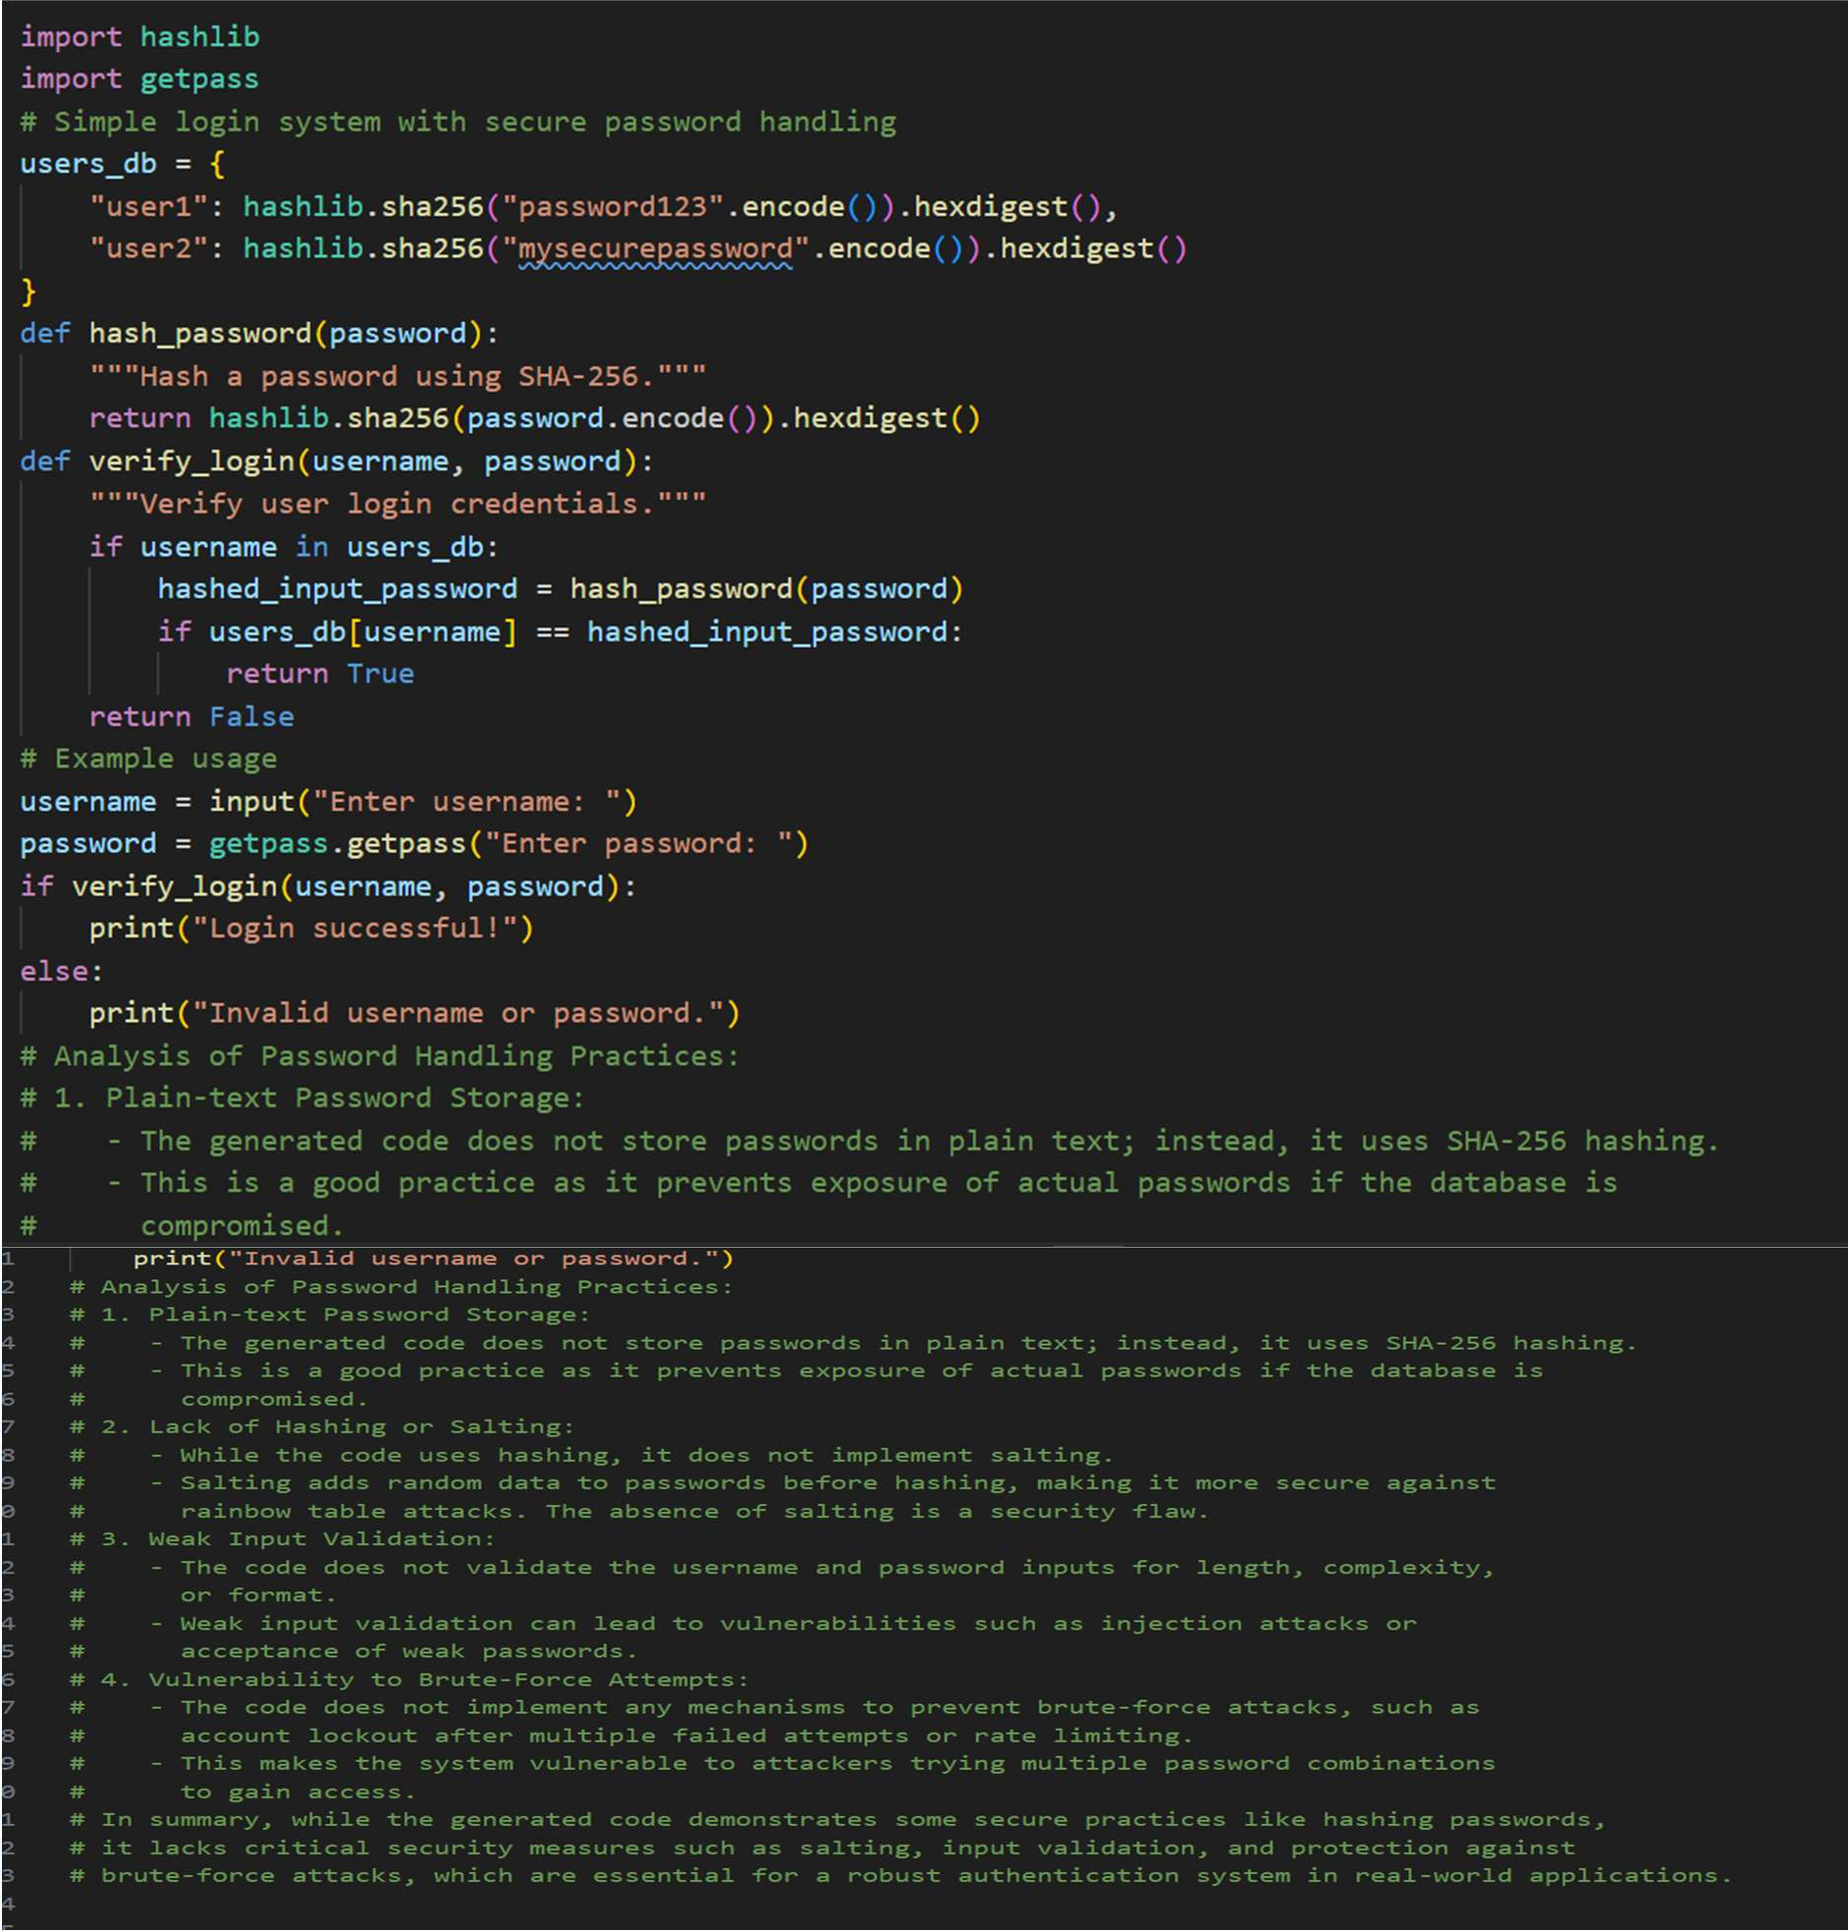

Output:
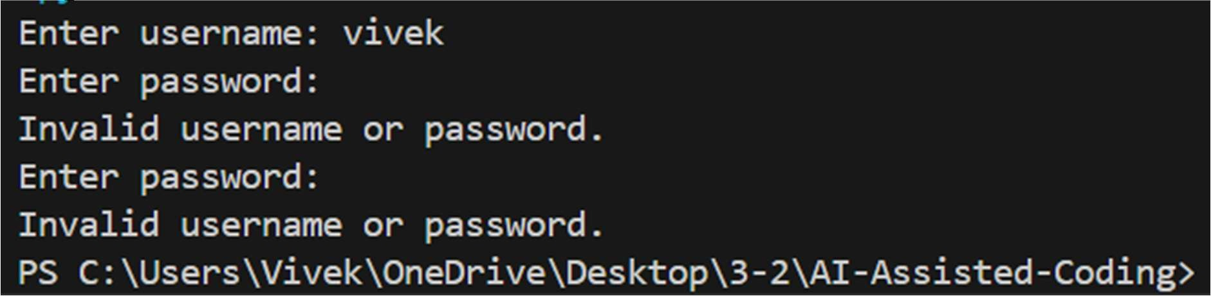

Justification:

The analysis highlights that while hashing passwords is a positive step, the absence of salting leaves
The system vulnerable to rainbow table attacks. Salting ensures that even identical passwords produce
Different hash values, significantly improving security. Additionally, weak input validation and lack of brute-force protection expose the system to various attacks, emphasizing the need for comprehensive security measures in authentication systems.

Task-05:
Task: Use an AI tool to generate a Python script that logs user activity (username, IP address, timestamp).
Analyze: Examine whether sensitive data is logged unnecessarily or insecurely. Expected Output:
- Identified privacy risks in logging.
- Improved version with minimal, anonymized, or masked logging.
- Explanation of privacy-aware logging principles.
Prompt:
2303A52009 - Task05: Create a Python program that logs user activity such as:
- username
- IP address
- date and time of login

Then analyze the program and identify:
- what personal or sensitive data is being logged
- why logging this data can create privacy or security risks After that, modify the program to:
- reduce unnecessary data logging
- mask or anonymize the IP address
- follow basic privacy rules

Code:

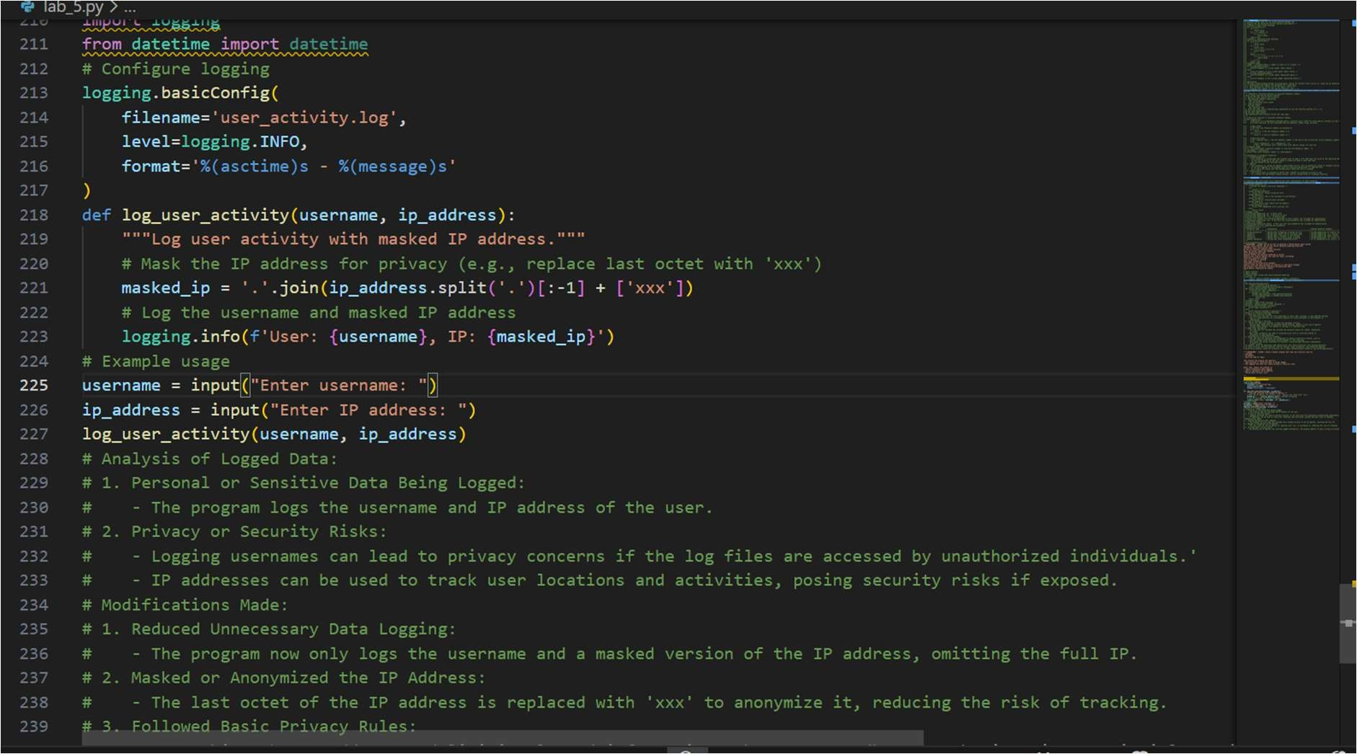

Output:
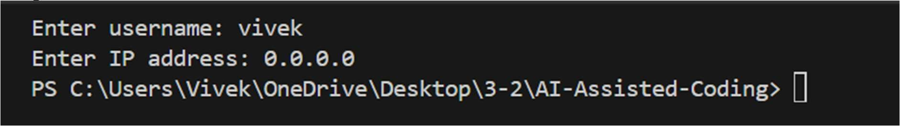

Justification:
The modifications enhance user privacy by limiting the amount of sensitive information logged. Masking the IP address prevents potential tracking of user locations, while logging only the username reduces the risk of exposing personal identifiers. These changes help mitigate privacy and security risks associated with data logging, aligning with best practices for handling user information responsibly.

