Linux basic commands Assignment

Assignment Part -3

1. Created a file using the command **touch file1.txt** and to open the file in the terminal, **nano/vim file1.txt** is used.
2. The entered data from file1.txt is to be copied and it can be done using the command, **cp file1.txt file2.txt**. This copies all the data from file1 to file2. To view the data in the file2, use **cat file2.txt**.

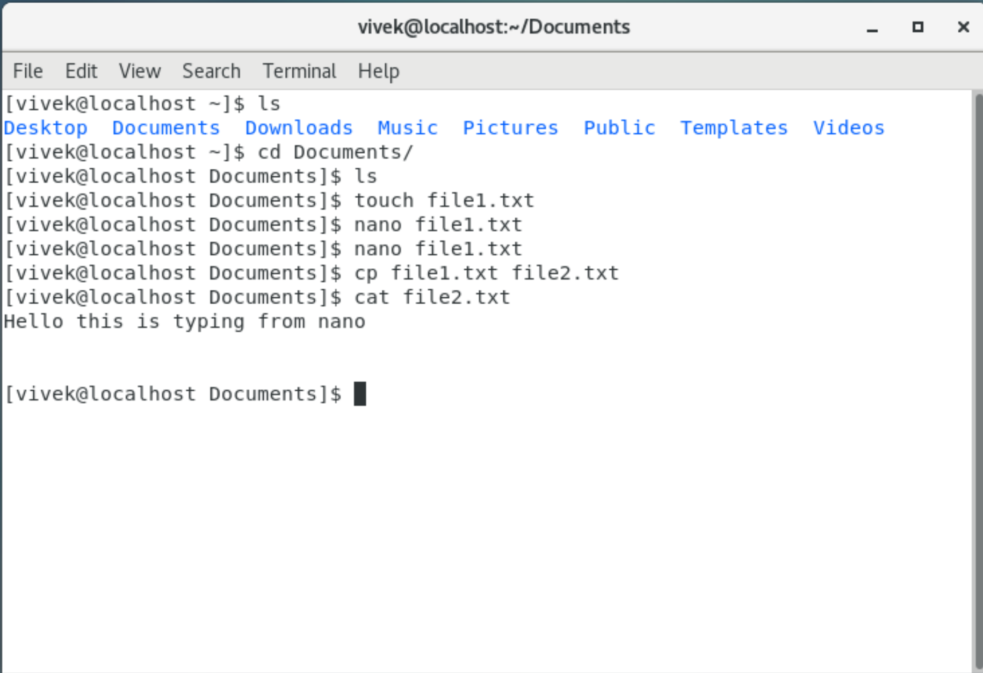

1. To move a file from one dir to another we use **mv file2.txt /home**, here /home is the destination directory. Running this command, does not move the file to the destination directory. If a user needs to move the files to the other directories permissions has to be changed using the command **chmod 467 file2.txt** and execute the command to move or it can be also be done by changing to the root user by command **su –** and the respective files can be moved the specified location.

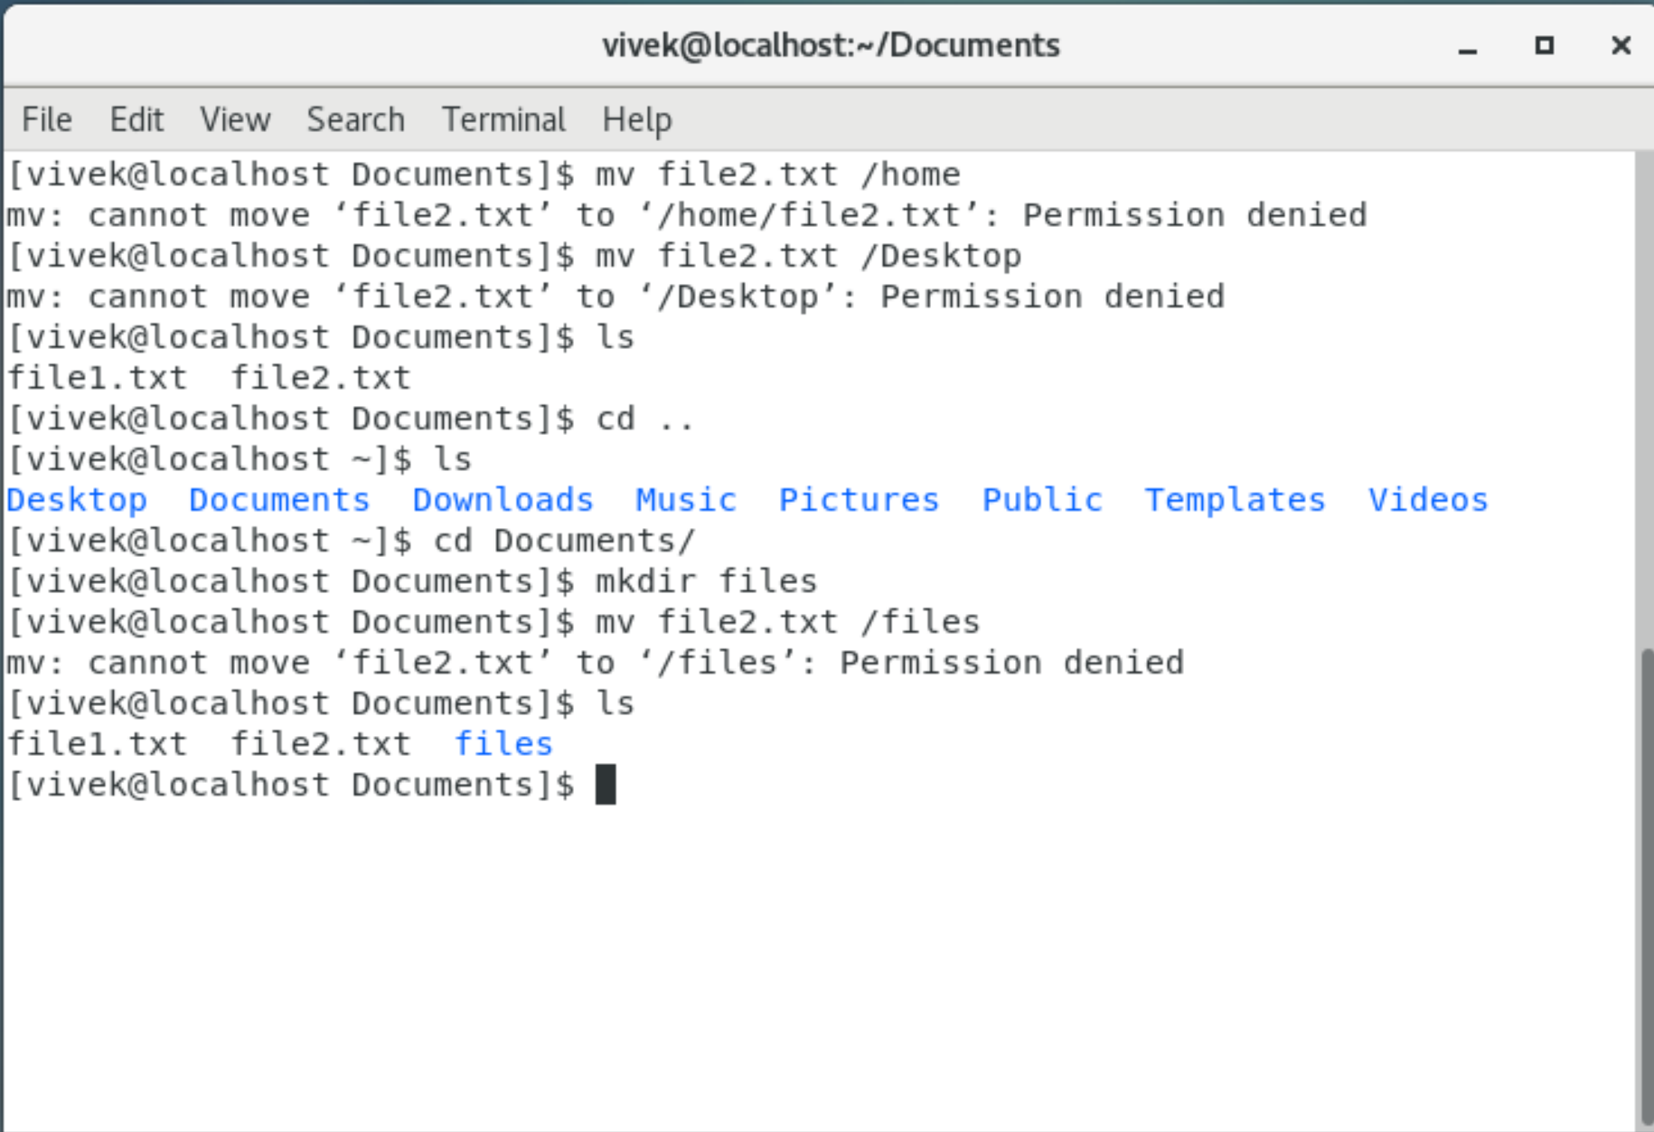

1. To create multiple files in a single line use **touch file3.txt file4.txt**, now the files are created. Adding the content can be done using **echo** command. The question asked is about using **> and >>,** these are called **Redirection.** When > is given like **echo “This is line 1” > file3.txt**, this command executes the content and saves in files.txt. The second time if you run the same command like **echo “This is line 2” > file3.txt**, the **previously written line 1 is erased and this new line 2 is written**. But when we use **echo “This is line 1” > file3.txt** and now use command **echo “This is line 2” >> file3.txt**, this line 2 is appended to the previously saved line.

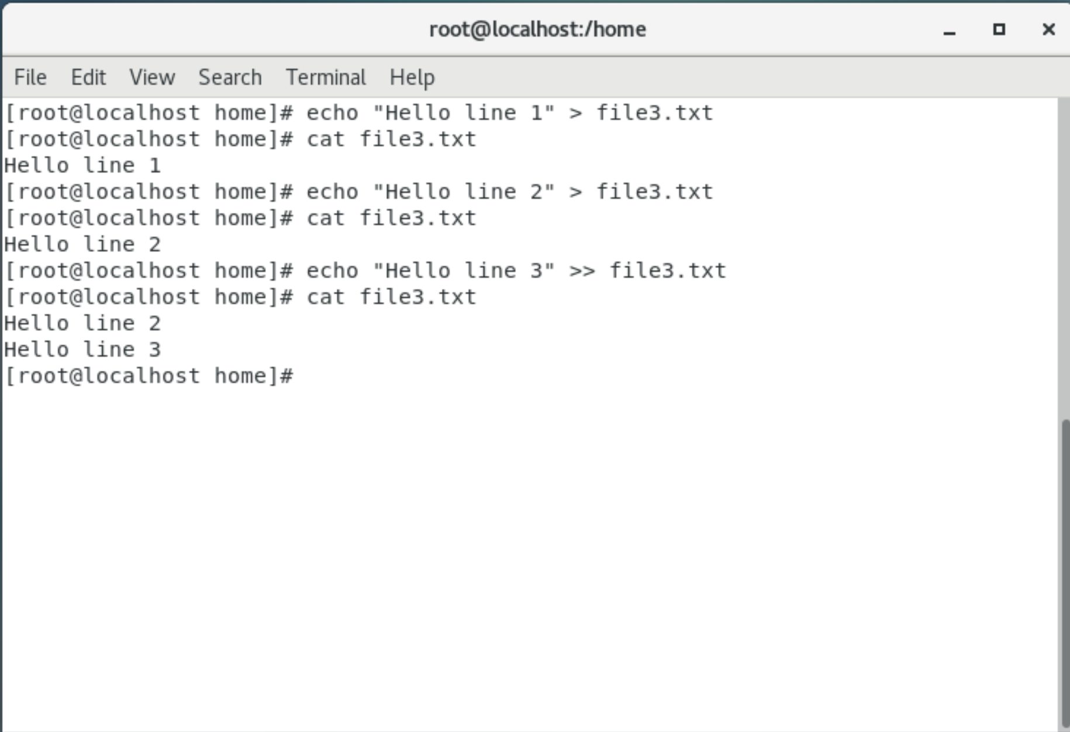

1. Removing the files from the home directory only root user can perform. To remove a files **rm file3.txt** command is used. Same as the file, the directory can be removed only by the root user if the folder is in /home directory, to remove directory, **rmdir foldername** command is used.