Introduction to Machine Learning Assignment 4

Name: Vivekanand Reddy Malipatel

CWID: A20524971

**Question 1 Answer:**

1. (The Python code for this is in the file: 1_a.py)

Output Screenshot:



Answer:

Area Under the cure: 0.5

1. (The Python code for this is in the file: 1_b.py)

Output Screenshot:

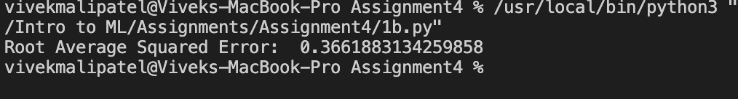

Answer:

Root Average Squared Error: 0.3661883134259858

1. Based on the AUC value, its and Inconclusive scenario as AUC=0.5.

But, based on the RASE value, the current model that we are using can be considered as RASE < 0.5.

**Question 2 Answers:**

1. (The Python code for this is in the file: 2_a.py)

Kolmogorov–Smirnov curve :

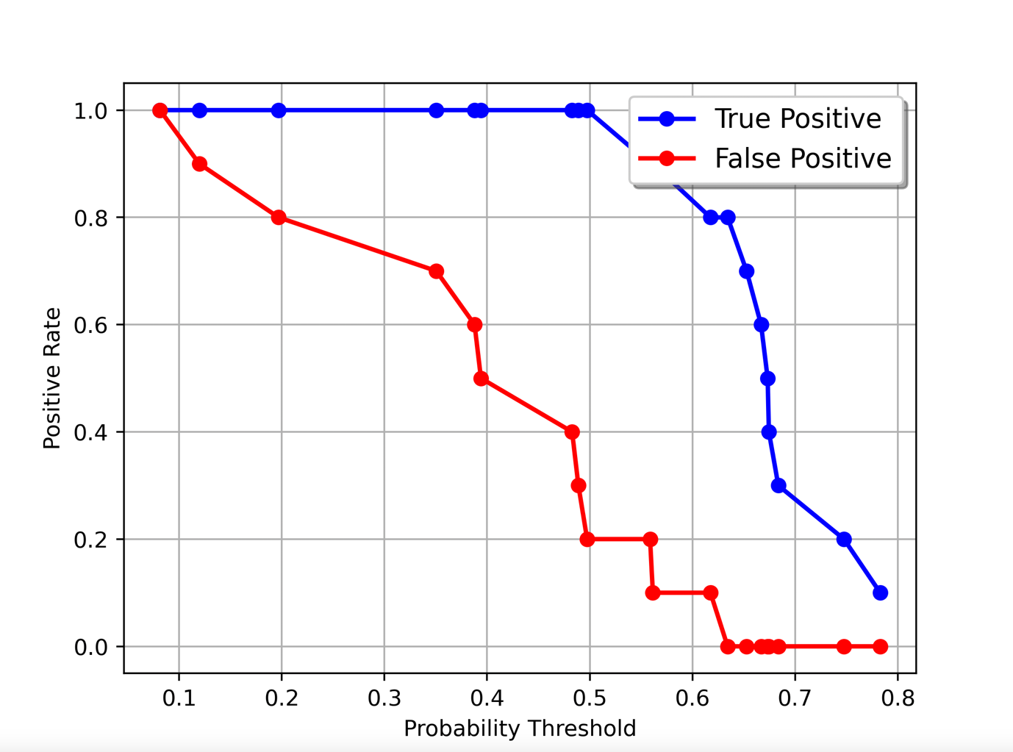

Output Screenshot :



Answer :

Probability threshold that yields the highest Kolmogorov–Smirnov statistic = 0.6342

1. (The Python code for this is in the file: 2_b.py)

Precision-Recall curve:

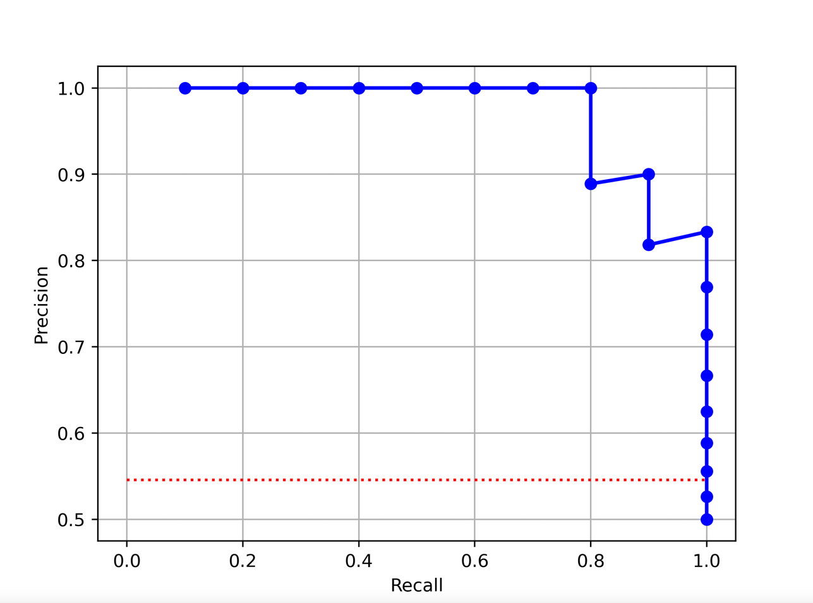

Output Screenshot :



Answer :

the probability threshold that yields the highest F1 Score = 0.4974

1. (The Python code for this is in the file: 2_b.py)

Output Screenshot :



Answer :

Misclassification Rate for parts (a) : 0.1000000000000

Misclassification Rate for parts (b) : 0.1000000000000

**Question 3 Answers:**

1. (The Python code for this is in the file: 3_a.py)

Grid search results :

|  |  |  |  |  |  |  |  |  |  |
| --- | --- | --- | --- | --- | --- | --- | --- | --- | --- |
|  | Activation Function | nLayer | nHiddenNeuron | N Iteration | Loss | RMSE | RelErr | Pearson Corr | Time Elapsed |
| 0 | tanh | 1 | 1 | 118 | 0.31533211341420664 | 0.783079377960233 | 0.999052672182146 | 0.05015052795516559 | 0.43929481506347656 |
| 1 | tanh | 1 | 2 | 85 | 0.3173777007865542 | 0.785109245648044 | 1.0042387955159695 | 0.044387581424687315 | 0.40544795989990234 |
| 2 | tanh | 1 | 3 | 221 | 0.2999522146521302 | 0.76833331363654 | 0.9617808800487773 | 0.1978464231407235 | 0.8341319561004639 |
| 3 | tanh | 1 | 4 | 292 | 0.2992578813580631 | 0.7675641441371821 | 0.9598561887303981 | 0.20357385194097677 | 1.137714147567749 |
| 4 | tanh | 1 | 5 | 206 | 0.30014169552798176 | 0.7685956443570557 | 0.9624377505468734 | 0.1986699123978676 | 0.843228816986084 |
| 5 | tanh | 2 | 1 | 125 | 0.31553620523303527 | 0.783532434108009 | 1.0002090246621123 | 0.05266538302803618 | 0.6229720115661621 |
| 6 | tanh | 2 | 2 | 97 | 0.315328702634997 | 0.7831481711035345 | 0.9992282124771333 | 0.050387619994524485 | 0.5292670726776123 |
| 7 | tanh | 2 | 3 | 70 | 0.31499796833609506 | 0.7833387649748217 | 0.9997146337055791 | 0.02170411581871677 | 0.3781890869140625 |
| 8 | tanh | 2 | 4 | 62 | 0.3147206289234413 | 0.7824071777401085 | 0.997338222260634 | 0.05381238373220904 | 0.36490392684936523 |
| 9 | tanh | 2 | 5 | 66 | 0.31514937830139905 | 0.7827786371741086 | 0.9982854493447485 | 0.043069796986000455 | 0.40416908264160156 |
| 10 | tanh | 3 | 1 | 106 | 0.3155550943041755 | 0.7835662899774408 | 1.000295463145744 | 0.05079051406764694 | 0.654545783996582 |
| 11 | tanh | 3 | 2 | 77 | 0.31550963959267514 | 0.7833515682880988 | 0.9997473137281127 | 0.030917965412143363 | 0.5277819633483887 |
| 12 | tanh | 3 | 3 | 70 | 0.3152464997072601 | 0.782909843506716 | 0.9986201348963949 | 0.052923467541131905 | 0.4722731113433838 |
| 13 | tanh | 3 | 4 | 65 | 0.31544618865230545 | 0.7833353724527929 | 0.999705974497776 | 0.05531691960432784 | 0.4654059410095215 |
| 14 | tanh | 3 | 5 | 63 | 0.3154045054597091 | 0.7832606548573706 | 0.9995152718516556 | 0.030753164529941163 | 0.49004316329956055 |
| 15 | tanh | 4 | 1 | 174 | 0.3155648180162011 | 0.7835669976418036 | 1.0002972699457051 | 0.054264075236291905 | 1.306441068649292 |
| 16 | tanh | 4 | 2 | 78 | 0.315549966774727 | 0.7835317843488349 | 1.0002073657780841 | 0.013610125148253572 | 0.6479709148406982 |
| 17 | tanh | 4 | 3 | 82 | 0.3155351497142769 | 0.783525506493875 | 1.0001913380131802 | 0.0034434394573788414 | 0.6872949600219727 |
| 18 | tanh | 4 | 4 | 66 | 0.31551080909514845 | 0.7834359932676126 | 0.9999628189958858 | 0.04998070688644822 | 0.5818607807159424 |
| 19 | tanh | 4 | 5 | 42 | 0.314748728376034 | 0.7826540671737967 | 0.9979677438839673 | 0.059832074469460796 | 0.4161851406097412 |
| 20 | tanh | 5 | 1 | 142 | 0.3155666693749828 | 0.7835821319593695 | 1.0003359110900865 | 0.1940099300389375 | 1.254729986190796 |
| 21 | tanh | 5 | 2 | 72 | 0.3155505886135017 | 0.7835256433945083 | 1.0001916875278762 | 0.0001496110401403852 | 0.6909518241882324 |
| 22 | tanh | 5 | 3 | 91 | 0.31555081042490185 | 0.7835288556226804 | 1.0001998885370686 | 0.02067844512026198 | 0.8888709545135498 |
| 23 | tanh | 5 | 4 | 78 | 0.31554939036470214 | 0.7835236950564756 | 1.0001867133216116 | 0.024386048928807243 | 0.8292250633239746 |
| 24 | tanh | 5 | 5 | 52 | 0.3155357293218343 | 0.7835112294857371 | 1.000154888377132 | -0.0006436003780331517 | 0.5948829650878906 |
| 25 | tanh | 6 | 1 | 134 | 0.31555617013439174 | 0.7835631699329939 | 1.000287497106032 | 0.045077737855740936 | 1.349133014678955 |
| 26 | tanh | 6 | 2 | 107 | 0.31554805083074383 | 0.7835376499462364 | 1.000222341139142 | 0.0420112573354923 | 1.1747541427612305 |
| 27 | tanh | 6 | 3 | 76 | 0.3155467329665885 | 0.783522182170936 | 1.0001828508562796 | 0.013874168965070512 | 0.8574769496917725 |
| 28 | tanh | 6 | 4 | 57 | 0.31554842058208765 | 0.7834998838242168 | 1.0001259230317838 | 0.0415032721819759 | 0.7164762020111084 |
| 29 | tanh | 6 | 5 | 36 | 0.31547503322704484 | 0.7834023122002686 | 0.9998768410950362 | 0.09193863077880188 | 0.48912477493286133 |
| 30 | tanh | 7 | 1 | 103 | 0.31555322983483214 | 0.7835647256306674 | 1.0002914690805622 | 0.1272434150072123 | 1.1822130680084229 |
| 31 | tanh | 7 | 2 | 112 | 0.3155589295851626 | 0.7835435684692659 | 1.0002374517373858 | -0.013230295798643493 | 1.389359951019287 |
| 32 | tanh | 7 | 3 | 62 | 0.31554557177173165 | 0.7835177501239469 | 1.0001715356824241 | 0.046597330939867995 | 0.7979061603546143 |
| 33 | tanh | 7 | 4 | 63 | 0.3155511766367429 | 0.7835074561340672 | 1.0001452550065084 | 0.024238254846972406 | 0.8934657573699951 |
| 34 | tanh | 7 | 5 | 60 | 0.3155530106418405 | 0.7835109380292028 | 1.0001541442866522 | 0.06167439390857064 | 0.885059118270874 |
| 35 | tanh | 8 | 1 | 121 | 0.3155625552618586 | 0.7835786611059053 | 1.000327049194106 | 0.20632771210184395 | 1.5800082683563232 |
| 36 | tanh | 8 | 2 | 117 | 0.31555441592025774 | 0.7835379751230741 | 1.0002231713461025 | 0.0060640309424415395 | 1.6155250072479248 |
| 37 | tanh | 8 | 3 | 82 | 0.3155531260711233 | 0.7835359388150518 | 1.000217972466441 | 0.018053926493098293 | 1.176151990890503 |
| 38 | tanh | 8 | 4 | 61 | 0.3155538035173822 | 0.7834983716488891 | 1.0001220624969782 | 0.008847605290762237 | 0.9476892948150635 |
| 39 | tanh | 8 | 5 | 58 | 0.3155523991968624 | 0.7834983861985049 | 1.000122099641642 | -0.019603088494064756 | 0.9648950099945068 |
| 40 | tanh | 9 | 1 | 123 | 0.3155570227805494 | 0.7835643454459201 | 1.0002904984001455 | -1.4427724050047989e-16 | 1.7517168521881104 |
| 41 | tanh | 9 | 2 | 110 | 0.3155572610970273 | 0.7835478047862857 | 1.000248267560694 | -0.02292442755979576 | 1.6739957332611084 |
| 42 | tanh | 9 | 3 | 78 | 0.3155594147435575 | 0.7835235225131832 | 1.0001862728103914 | 0.01544922488162228 | 1.2706449031829834 |
| 43 | tanh | 9 | 4 | 73 | 0.31555411870879424 | 0.7835160467399771 | 1.0001671868994928 | 0.019862033232332942 | 1.2985150814056396 |
| 44 | tanh | 9 | 5 | 53 | 0.31555217671023345 | 0.7835019216339157 | 1.0001311255059606 | 0.05294120608798859 | 1.0030791759490967 |
| 45 | tanh | 10 | 1 | 136 | 0.3155619291883922 | 0.7835627135312389 | 1.0002863318321809 | NA | 2.0865039825439453 |
| 46 | tanh | 10 | 2 | 91 | 0.31555221340007644 | 0.7835365824575066 | 1.0002196157427319 | -0.027060885040669454 | 1.526183843612671 |
| 47 | tanh | 10 | 3 | 58 | 0.3155524076972048 | 0.7835091917324931 | 1.0001496859852803 | 0.018193089928132154 | 1.0103490352630615 |
| 48 | tanh | 10 | 4 | 49 | 0.31555249937270313 | 0.7834944092957511 | 1.0001119467726431 | 0.0014434264387457585 | 0.9183828830718994 |
| 49 | tanh | 10 | 5 | 54 | 0.31555264531312305 | 0.7835020719628482 | 1.0001315092922785 | 0.07097480761596586 | 1.0705928802490234 |
| 50 | identity | 1 | 1 | 138 | 0.2985652970232447 | 0.7658590706777552 | 0.9555964600337773 | 0.2128571877122628 | 0.4863290786743164 |
| 51 | identity | 1 | 2 | 113 | 0.298602149150826 | 0.766110349222166 | 0.9562236257580647 | 0.21251900245065283 | 0.3992431163787842 |
| 52 | identity | 1 | 3 | 100 | 0.298619036891336 | 0.7657972508128356 | 0.9554421954645148 | 0.21254346923723805 | 0.35068631172180176 |
| 53 | identity | 1 | 4 | 114 | 0.2986709491429931 | 0.7657633452268945 | 0.955357593148962 | 0.2126629531638918 | 0.4196019172668457 |
| 54 | identity | 1 | 5 | 108 | 0.2987039893548591 | 0.7659746396410231 | 0.9558848828754483 | 0.21200392936675816 | 0.45456933975219727 |
| 55 | identity | 2 | 1 | 112 | 0.29849985276735125 | 0.7658333446887988 | 0.9555322621884466 | 0.2124739172956907 | 0.5303018093109131 |
| 56 | identity | 2 | 2 | 78 | 0.2986019485906115 | 0.7657477777850018 | 0.9553187500188036 | 0.21302808676115667 | 0.4002189636230469 |
| 57 | identity | 2 | 3 | 74 | 0.2986906469453911 | 0.7657420582518563 | 0.9553044791139237 | 0.2136436484892981 | 0.36892008781433105 |
| 58 | identity | 2 | 4 | 59 | 0.29870207073396465 | 0.766065018240551 | 0.9561104690222794 | 0.21152620456015508 | 0.36860179901123047 |
| 59 | identity | 2 | 5 | 57 | 0.2987112627914421 | 0.7660665144264596 | 0.9561142037455043 | 0.21223956178570816 | 0.36226987838745117 |
| 60 | identity | 3 | 1 | 89 | 0.2985254282334371 | 0.7663350852973818 | 0.9567847184641475 | 0.21274908576841006 | 0.5945918560028076 |
| 61 | identity | 3 | 2 | 56 | 0.2985929705353363 | 0.7658689121659452 | 0.9556210195175284 | 0.2127993323487475 | 0.3982360363006592 |
| 62 | identity | 3 | 3 | 68 | 0.2986767513447491 | 0.7660208104387046 | 0.9560001224548956 | 0.21198419541295413 | 0.417478084564209 |
| 63 | identity | 3 | 4 | 45 | 0.2987083318065687 | 0.7661565844777676 | 0.9563390466706856 | 0.2124848099959701 | 0.3236401081085205 |
| 64 | identity | 3 | 5 | 45 | 0.29884053296249274 | 0.7663939484405872 | 0.956931707738056 | 0.21325166889710356 | 0.32068800926208496 |
| 65 | identity | 4 | 1 | 98 | 0.2985823981811197 | 0.7658054530637332 | 0.9554626625491534 | 0.2127854226192168 | 0.7372000217437744 |
| 66 | identity | 4 | 2 | 61 | 0.29852702565059236 | 0.7658882185656004 | 0.9556691996527238 | 0.21245326585590135 | 0.5726079940795898 |
| 67 | identity | 4 | 3 | 50 | 0.29870871725632386 | 0.7660470921741813 | 0.9560657232140648 | 0.21133620187007782 | 0.3754720687866211 |
| 68 | identity | 4 | 4 | 50 | 0.2987740823980069 | 0.7668438703348484 | 0.9580555968449135 | 0.21233498723189356 | 0.41500186920166016 |
| 69 | identity | 4 | 5 | 48 | 0.2987241724512554 | 0.7662926687508599 | 0.9566788055778526 | 0.21191239979077153 | 0.4681861400604248 |
| 70 | identity | 5 | 1 | 93 | 0.298565019263076 | 0.766494953603621 | 0.9571839576744384 | 0.21235745113729868 | 0.8182389736175537 |
| 71 | identity | 5 | 2 | 53 | 0.29854489169747256 | 0.765712515509315 | 0.9552307682094359 | 0.2129652811292437 | 0.553459882736206 |
| 72 | identity | 5 | 3 | 54 | 0.29870351729414957 | 0.7660707832226377 | 0.9561248593947296 | 0.2120678915557676 | 0.481334924697876 |
| 73 | identity | 5 | 4 | 48 | 0.29886648000447125 | 0.7655605817238269 | 0.9548517292749642 | 0.21410385077851296 | 0.49864888191223145 |
| 74 | identity | 5 | 5 | 45 | 0.2988653524099244 | 0.7679364056315171 | 0.9607874572106437 | 0.21217716773115364 | 0.49895691871643066 |
| 75 | identity | 6 | 1 | 94 | 0.29851082540950336 | 0.7668268794856724 | 0.9580131423155335 | 0.21214321620392718 | 0.9223818778991699 |
| 76 | identity | 6 | 2 | 124 | 0.2987842226241544 | 0.7660078120018325 | 0.9559676784229821 | 0.2114992923849458 | 1.2192142009735107 |
| 77 | identity | 6 | 3 | 56 | 0.2985842462857493 | 0.7656714676861247 | 0.9551283561633768 | 0.21301971463234368 | 0.5737218856811523 |
| 78 | identity | 6 | 4 | 56 | 0.29860720079504927 | 0.7670114275808294 | 0.9584743175298401 | 0.2126331805735973 | 0.6209120750427246 |
| 79 | identity | 6 | 5 | 38 | 0.2990443659259695 | 0.7659163135174428 | 0.9557393142515599 | 0.2134837121277995 | 0.4699287414550781 |
| 80 | identity | 7 | 1 | 102 | 0.2985097451534188 | 0.7666725393711777 | 0.9576275403444315 | 0.21214161630168035 | 1.1161859035491943 |
| 81 | identity | 7 | 2 | 65 | 0.29855168821848965 | 0.7669211232526822 | 0.9582486382741596 | 0.21309306976165368 | 0.76473069190979 |
| 82 | identity | 7 | 3 | 75 | 0.29877380143063414 | 0.7658874447011007 | 0.9556672684098203 | 0.21196404233109445 | 0.8542468547821045 |
| 83 | identity | 7 | 4 | 51 | 0.29870003586608695 | 0.7656876801496924 | 0.9551688047063122 | 0.21355999863499328 | 0.6160969734191895 |
| 84 | identity | 7 | 5 | 34 | 0.29900661520062 | 0.7658496950349675 | 0.9555730633631329 | 0.21206965319113488 | 0.45745086669921875 |
| 85 | identity | 8 | 1 | 102 | 0.298412534127674 | 0.7660585147549139 | 0.9560942353497823 | 0.21255242701425775 | 1.2102992534637451 |
| 86 | identity | 8 | 2 | 51 | 0.29874959949576024 | 0.7664437221385427 | 0.9570560082405732 | 0.21267726018924782 | 0.6895689964294434 |
| 87 | identity | 8 | 3 | 42 | 0.29876681895204427 | 0.7659823869997219 | 0.9559042193394264 | 0.21258396446148795 | 0.5656900405883789 |
| 88 | identity | 8 | 4 | 55 | 0.29898683568677403 | 0.7657570410189968 | 0.9553418630983401 | 0.2134333095143217 | 0.7521641254425049 |
| 89 | identity | 8 | 5 | 73 | 0.29891929142036855 | 0.7700876614896054 | 0.9661779939306843 | 0.2102094383662067 | 1.0065650939941406 |
| 90 | identity | 9 | 1 | 98 | 0.29853238204441956 | 0.7662448436944941 | 0.9565593948307177 | 0.21209949066535755 | 1.2861220836639404 |
| 91 | identity | 9 | 2 | 59 | 0.29874146056190365 | 0.7663951904867295 | 0.9569348094178165 | 0.21237472653065617 | 0.8043279647827148 |
| 92 | identity | 9 | 3 | 45 | 0.29899123789829857 | 0.7687928650666146 | 0.9629317346341147 | 0.21276175941220182 | 0.6349887847900391 |
| 93 | identity | 9 | 4 | 42 | 0.2990944094538129 | 0.7681078397154486 | 0.961216477378172 | 0.2109335383172656 | 0.6276748180389404 |
| 94 | identity | 9 | 5 | 37 | 0.29896275023122476 | 0.7660781035984932 | 0.9561431324497268 | 0.2110536927436313 | 0.591890811920166 |
| 95 | identity | 10 | 1 | 89 | 0.29865703095775165 | 0.7660193442873889 | 0.9559964629211678 | 0.2117739059209286 | 1.2702288627624512 |
| 96 | identity | 10 | 2 | 52 | 0.29867507351284106 | 0.7660514944549409 | 0.9560767117861118 | 0.21333182313281954 | 0.7965550422668457 |
| 97 | identity | 10 | 3 | 42 | 0.2987788889820793 | 0.7658440901267961 | 0.9555590765986093 | 0.21271552761741666 | 0.6372270584106445 |
| 98 | identity | 10 | 4 | 89 | 0.29929707237355235 | 0.7693769260468344 | 0.9643953915264967 | 0.21162082110689928 | 1.4117071628570557 |
| 99 | identity | 10 | 5 | 46 | 0.29894316645213986 | 0.7670523916137575 | 0.9585766993733367 | 0.21345361714394115 | 0.7828869819641113 |
| 100 | relu | 1 | 1 | 215 | 0.3155734652881302 | 0.7836239139982705 | 1.0004425934315235 | -1.4188854446570373e-16 | 0.7830021381378174 |
| 101 | relu | 1 | 2 | 113 | 0.29859266722634387 | 0.7661099375128302 | 0.9562225980051086 | 0.21252755948604724 | 0.42545080184936523 |
| 102 | relu | 1 | 3 | 96 | 0.2986308937941356 | 0.7659731688360013 | 0.9558812119472911 | 0.21191577091783648 | 0.349822998046875 |
| 103 | relu | 1 | 4 | 114 | 0.29875335996212454 | 0.7658380352750692 | 0.9555439671377458 | 0.21231830243944538 | 0.44362306594848633 |
| 104 | relu | 1 | 5 | 172 | 0.30177005577380595 | 0.7688400178092256 | 0.9630498581670398 | 0.20488783288436213 | 0.6829769611358643 |
| 105 | relu | 2 | 1 | 64 | 0.3155395503234133 | 0.7834969365355351 | 1.0001183987057949 | 1.4188854446570373e-16 | 0.33887195587158203 |
| 106 | relu | 2 | 2 | 77 | 0.29864232518281447 | 0.7661493196480264 | 0.9563209104109436 | 0.21253396204304567 | 0.4005091190338135 |
| 107 | relu | 2 | 3 | 74 | 0.2986791207294031 | 0.765754524498872 | 0.9553355839968879 | 0.21347018919606187 | 0.38022398948669434 |
| 108 | relu | 2 | 4 | 164 | 0.2987682837607044 | 0.7690901418559991 | 0.9636765714099207 | 0.2158400874274702 | 0.8897619247436523 |
| 109 | relu | 2 | 5 | 117 | 0.3006682138712166 | 0.7688263251803584 | 0.9630155556683168 | 0.20778295615015607 | 0.6784451007843018 |
| 110 | relu | 3 | 1 | 31 | 0.3155362585538044 | 0.7834704099470323 | 1.0000506785173031 | 1.4188854446570373e-16 | 0.21844196319580078 |
| 111 | relu | 3 | 2 | 98 | 0.2984334612678004 | 0.76637250572271 | 0.9568781610480596 | 0.21247874817134046 | 0.6455790996551514 |
| 112 | relu | 3 | 3 | 72 | 0.2986731074532195 | 0.7669606339047174 | 0.9583473759477855 | 0.2090019383368617 | 0.47777390480041504 |
| 113 | relu | 3 | 4 | 94 | 0.2989415816491247 | 0.7657907842884973 | 0.9554260596945874 | 0.2147587856000856 | 0.6651530265808105 |
| 114 | relu | 3 | 5 | 96 | 0.30048931323869127 | 0.7670441279066336 | 0.958556045361913 | 0.21182920430293384 | 0.7040770053863525 |
| 115 | relu | 4 | 1 | 34 | 0.3155447836664146 | 0.7835002244524598 | 1.0001267926457227 | -1.4188854446570373e-16 | 0.29251885414123535 |
| 116 | relu | 4 | 2 | 61 | 0.2984376440039889 | 0.7657576384303559 | 0.9553433537338103 | 0.21346865809160065 | 0.5027382373809814 |
| 117 | relu | 4 | 3 | 57 | 0.298721890316823 | 0.7662777283071014 | 0.9566415011192955 | 0.210507709159109 | 0.45961999893188477 |
| 118 | relu | 4 | 4 | 67 | 0.29801692044966394 | 0.7665721248940456 | 0.9573767073835892 | 0.21128583045033064 | 0.598656177520752 |
| 119 | relu | 4 | 5 | 99 | 0.29726151829873126 | 0.7723335263538937 | 0.9718216873624557 | 0.19991824290320567 | 0.865847110748291 |
| 120 | relu | 5 | 1 | 241 | 0.31558070829630214 | 0.7836210345132331 | 1.0004352410418522 | NA | 2.071146011352539 |
| 121 | relu | 5 | 2 | 118 | 0.29851104110864446 | 0.7674501179127926 | 0.9595710252079488 | 0.20920033855686312 | 1.0654511451721191 |
| 122 | relu | 5 | 3 | 56 | 0.31546872159795564 | 0.7833254486334816 | 0.9996806447629982 | 0.04408740175683556 | 0.536348819732666 |
| 123 | relu | 5 | 4 | 96 | 0.2990190034845715 | 0.765831284429764 | 0.9555271210142161 | 0.2134737374621291 | 0.9474108219146729 |
| 124 | relu | 5 | 5 | 77 | 0.29731900876791495 | 0.7685629058518457 | 0.9623557617859944 | 0.20010627802034925 | 0.8133368492126465 |
| 125 | relu | 6 | 1 | 236 | 0.3155804084427203 | 0.7836294324456782 | 1.000456684143094 | -1.4188854446570373e-16 | 2.325836658477783 |
| 126 | relu | 6 | 2 | 81 | 0.29963364960534383 | 0.7670255156257615 | 0.958509527313617 | 0.20619127361497208 | 0.9195270538330078 |
| 127 | relu | 6 | 3 | 31 | 0.3155421314677829 | 0.7834941001697717 | 1.0001111575889035 | 0.0013458795942382523 | 0.34677910804748535 |
| 128 | relu | 6 | 4 | 66 | 0.2978247480152131 | 0.7666890851551775 | 0.9576688744697474 | 0.20941151067402378 | 0.77457594871521 |
| 129 | relu | 6 | 5 | 79 | 0.29781834351708375 | 0.7664368157625705 | 0.9570387603757965 | 0.2119226669423488 | 0.9558956623077393 |
| 130 | relu | 7 | 1 | 62 | 0.3155362792542208 | 0.7834976376922497 | 1.0001201887320519 | NA | 0.7229173183441162 |
| 131 | relu | 7 | 2 | 261 | 0.3155783481722726 | 0.7836326982064435 | 1.000465022928901 | NA | 3.055535078048706 |
| 132 | relu | 7 | 3 | 96 | 0.29864441868598973 | 0.7680859444276649 | 0.9611616782722608 | 0.20114256791829058 | 1.2059850692749023 |
| 133 | relu | 7 | 4 | 89 | 0.29768526794627836 | 0.7694676809272712 | 0.9646229230460501 | 0.19599891976755898 | 1.1735360622406006 |
| 134 | relu | 7 | 5 | 65 | 0.29879496471465794 | 0.7711239058953282 | 0.9687799578515978 | 0.20981373630642497 | 0.8915572166442871 |
| 135 | relu | 8 | 1 | 88 | 0.3155363438920715 | 0.7835085090655631 | 1.000147943137014 | 1.4188854446570373e-16 | 1.1211779117584229 |
| 136 | relu | 8 | 2 | 83 | 0.29828088069314096 | 0.7712307281648886 | 0.969048382785528 | 0.20854652909994345 | 1.1099047660827637 |
| 137 | relu | 8 | 3 | 252 | 0.3155836216349373 | 0.7836359682337204 | 1.0004733726436283 | -1.4188854446570373e-16 | 3.5067572593688965 |
| 138 | relu | 8 | 4 | 66 | 0.29797379795588047 | 0.7675527702264893 | 0.9598277422799887 | 0.20477850252515223 | 0.9839968681335449 |
| 139 | relu | 8 | 5 | 76 | 0.2968774089319817 | 0.7674889737522455 | 0.9596681934295519 | 0.20639693596189027 | 1.172457218170166 |
| 140 | relu | 9 | 1 | 196 | 0.315580947686317 | 0.7836371875319811 | 1.0004764860188218 | NA | 2.7114219665527344 |
| 141 | relu | 9 | 2 | 74 | 0.2983337418144435 | 0.7672377988015247 | 0.9590401579103892 | 0.20565045963019574 | 1.0919759273529053 |
| 142 | relu | 9 | 3 | 98 | 0.2982200929150964 | 0.7674684565736098 | 0.9596168847560778 | 0.20368231541334794 | 1.5254368782043457 |
| 143 | relu | 9 | 4 | 42 | 0.29877205571610954 | 0.7664601772381531 | 0.9570971035501137 | 0.20963772092790275 | 0.7037339210510254 |
| 144 | relu | 9 | 5 | 57 | 0.2989891554652955 | 0.7674843104072836 | 0.9596565313721366 | 0.20516895231473165 | 0.9646749496459961 |
| 145 | relu | 10 | 1 | 61 | 0.31553541809681074 | 0.7834976713494402 | 1.0001202746576114 | 1.4427724050047989e-16 | 0.9482662677764893 |
| 146 | relu | 10 | 2 | 215 | 0.3155720648521556 | 0.783615167991043 | 1.0004202617257962 | -1.4188854446570373e-16 | 3.3939547538757324 |
| 147 | relu | 10 | 3 | 32 | 0.31554206031281046 | 0.7834859068537946 | 1.0000902405612464 | 1.4188854446570373e-16 | 0.5491220951080322 |
| 148 | relu | 10 | 4 | 228 | 0.31557724028737233 | 0.7836335946135934 | 1.0004673118188738 | -1.4188854446570373e-16 | 3.925055980682373 |
| 149 | relu | 10 | 5 | 44 | 0.2990752921195134 | 0.7669512719807163 | 0.9583239799085488 | 0.2115919631630373 | 0.8268890380859375 |

1. (The Python code for this is in the file: 3_b.py)

Output Screenshot :

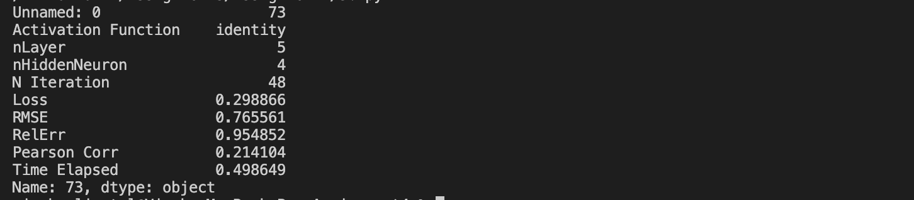

Answer :   
  
The Network Structure that has lowest RMSE is,

Activation Function : Identity

nLayer : 5

nHiddenNeuron : 4

1. (The Python code for this is in the file: 3_c.py)

Output Screenshot:

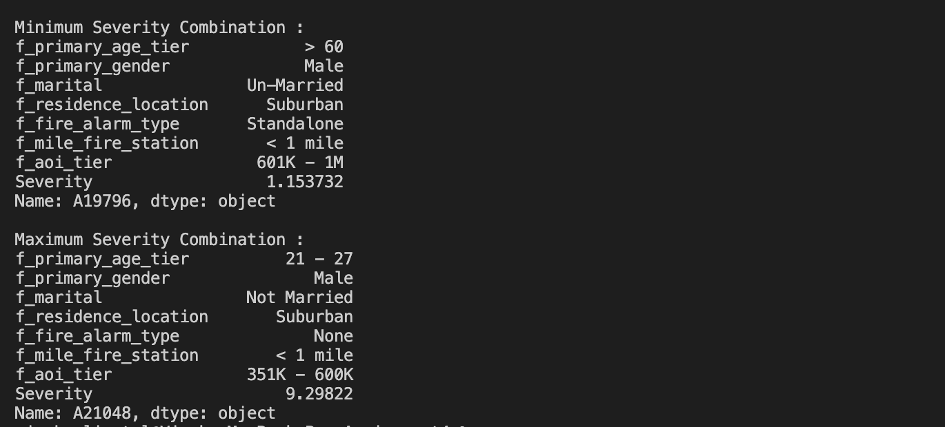

Answer :

Minimum Severity Combination :

f_primary_age_tier > 60

f_primary_gender Male

f_marital Un-Married

f_residence_location Suburban

f_fire_alarm_type Standalone

f_mile_fire_station < 1 mile

f_aoi_tier 601K - 1M

Severity 1.153732

Maximum Severity Combination :

f_primary_age_tier 21 - 27

f_primary_gender Male

f_marital Not Married

f_residence_location Suburban

f_fire_alarm_type None

f_mile_fire_station < 1 mile

f_aoi_tier 351K - 600K

Severity 9.29822