Introduction to Machine Learning Assignment 3

Name: Vivekanand Reddy Malipatel

CWID: A20524971

**Question 1 Answer:**

1. (The Python code for this is in the file: 1_a.py)

Output Screenshot :

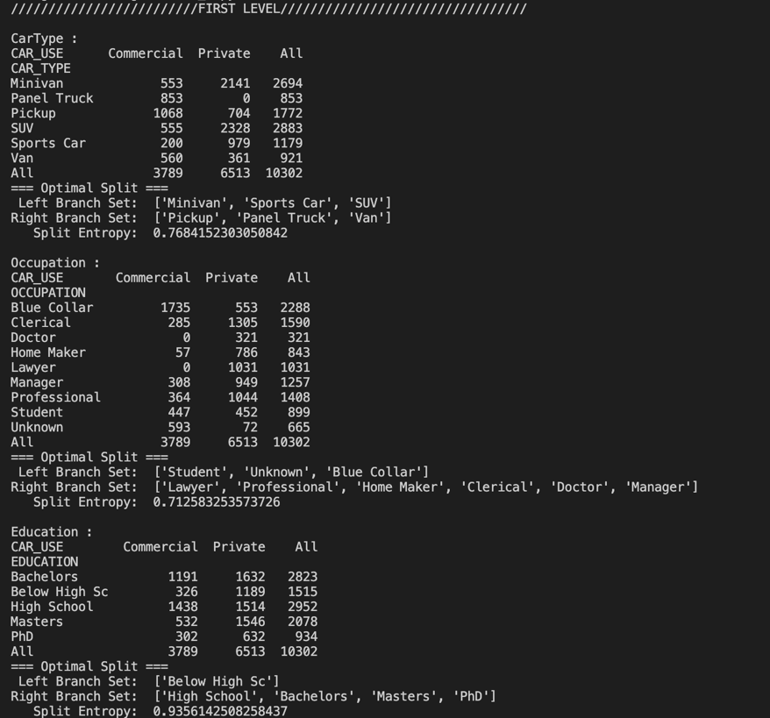

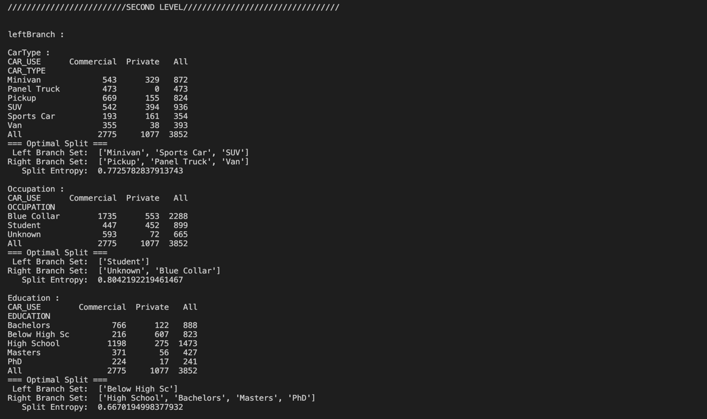

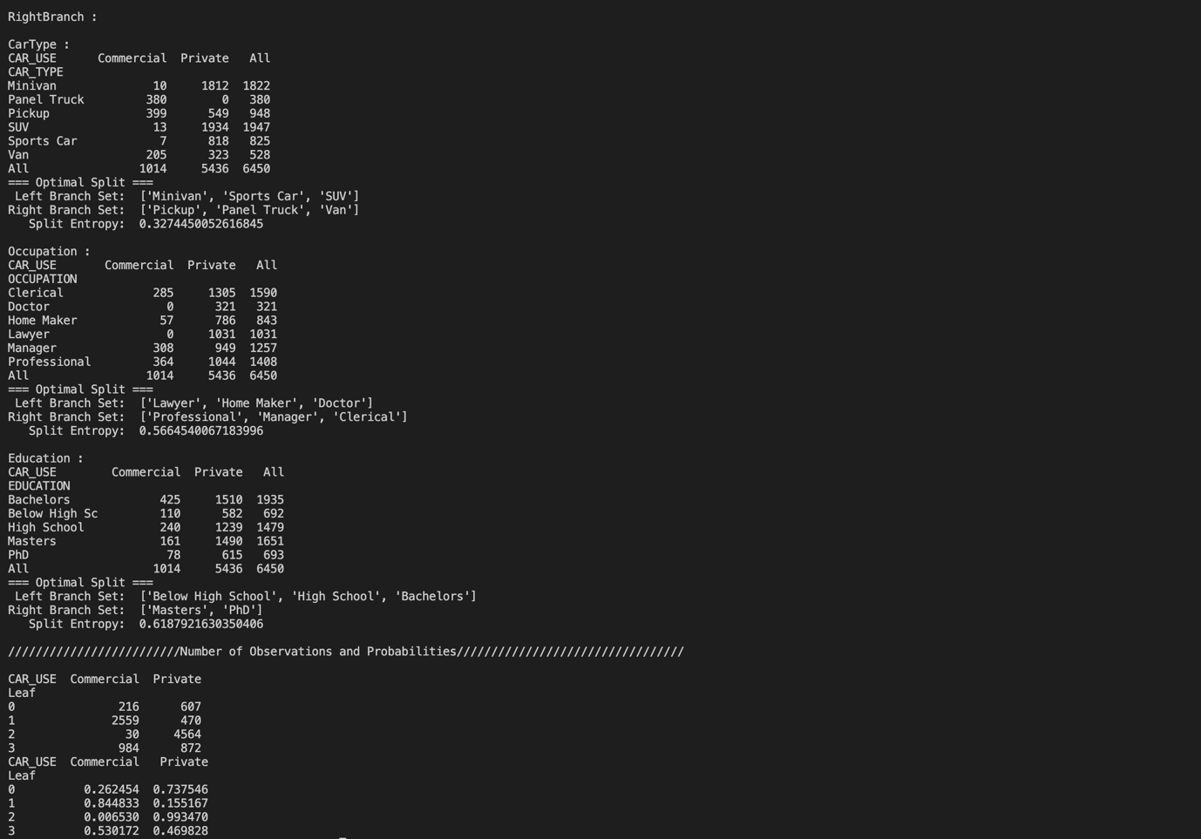

Answer :

Description of the leaf nodes of the classification tree :

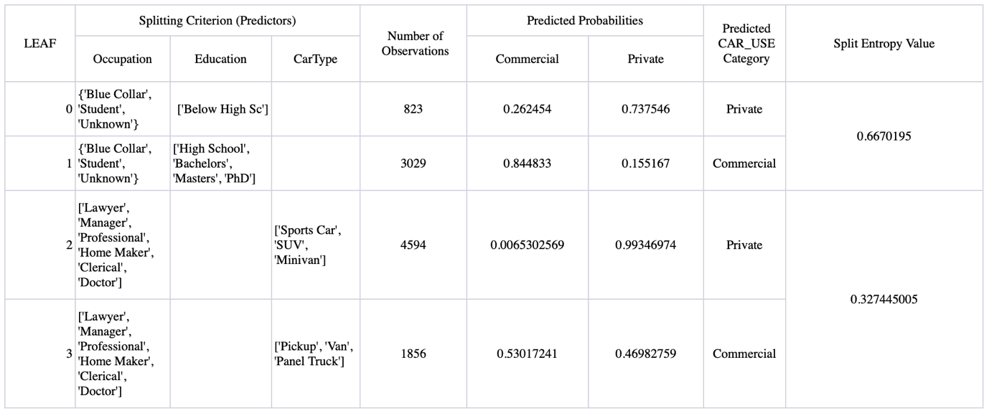

1. Answer :

As per the Above classification output, The predicted CAR_USE probability for the The person works in a *Professional* occupation, has an education level of *Doctors*, and owns a *Minivan* is **“Private”**.  
Probabilities : ['Commercial' 'Private'] = [‘0.006530’ ‘0.993470’]

1. Answer:

As per the Above classification output, The predicted CAR_USE probability for The person is a *Student*, has a *Below High School* level of education, and owns a *Sports Car* is **“Private”.**

Probabilities : ['Commercial' 'Private'] = [‘0.262454’ ‘0.737546’]

1. (The Python code for this is in the file: 1_d.py)

Histogram :

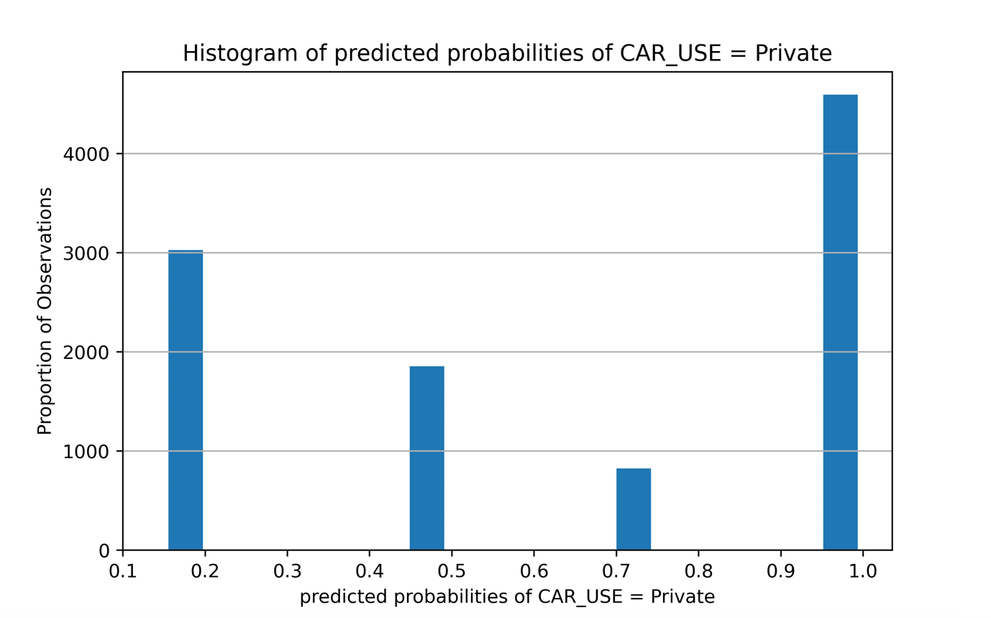

1. (The Python code for this is in the file: 1_e.py)

Output Screenshot:



Answer :

The misclassification rate of the Classification Tree model is 15.414482624733061.

**Question 2 Answers:**

1. (The Python code for this is in the file: 2_a.py)

Output Screenshot :

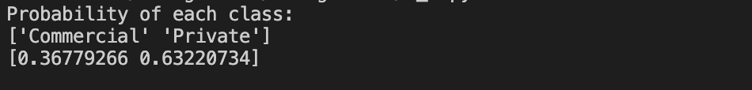

Answer:

['Commercial' 'Private']

[0.36779266 0.63220734]

1. (The Python code for this is in the file: 2_b.py)

The Below screenshot has the the frequency counts and the row probabilities in each label class.

Output Screenshot :

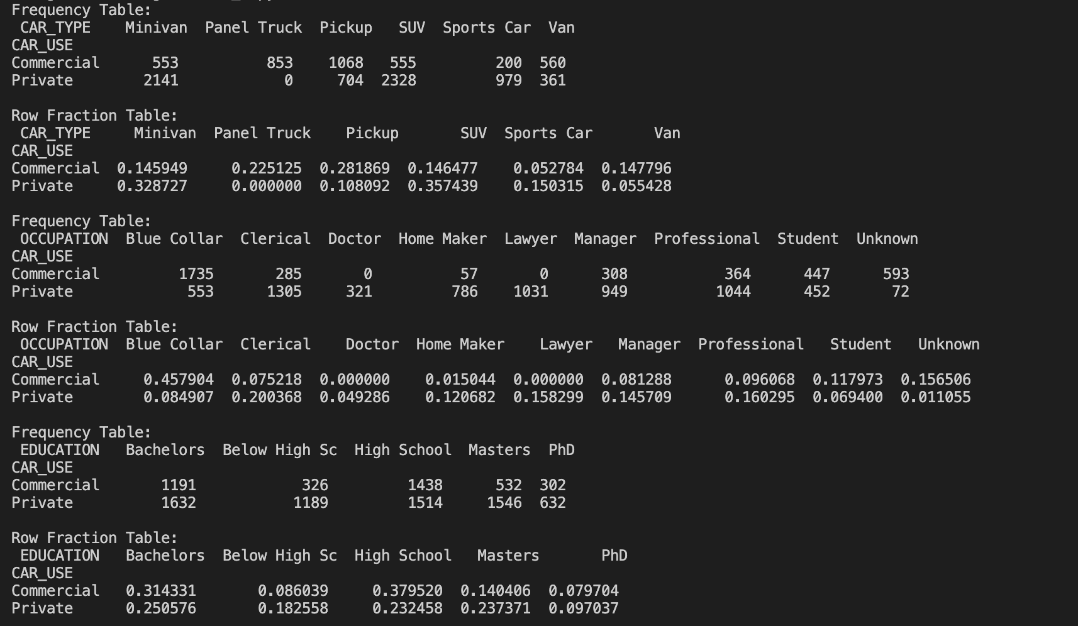

1. (The Python code for this is in the file: 2_c.py)

Output Screenshot:



Answer:

The car usage probabilities are

['Commercial' 'Private']

[[0.11280832 0.88719168]]

1. (The Python code for this is in the file: 2_d.py)

Output Screenshot:



Answer:

The car usage probabilities are

['Commercial' 'Private']

[[0.14065359 0.85934641]]

1. (The Python code for this is in the file: 2_e.py)

Histogram of the predicted probabilities of CAR_USE = *Private*:

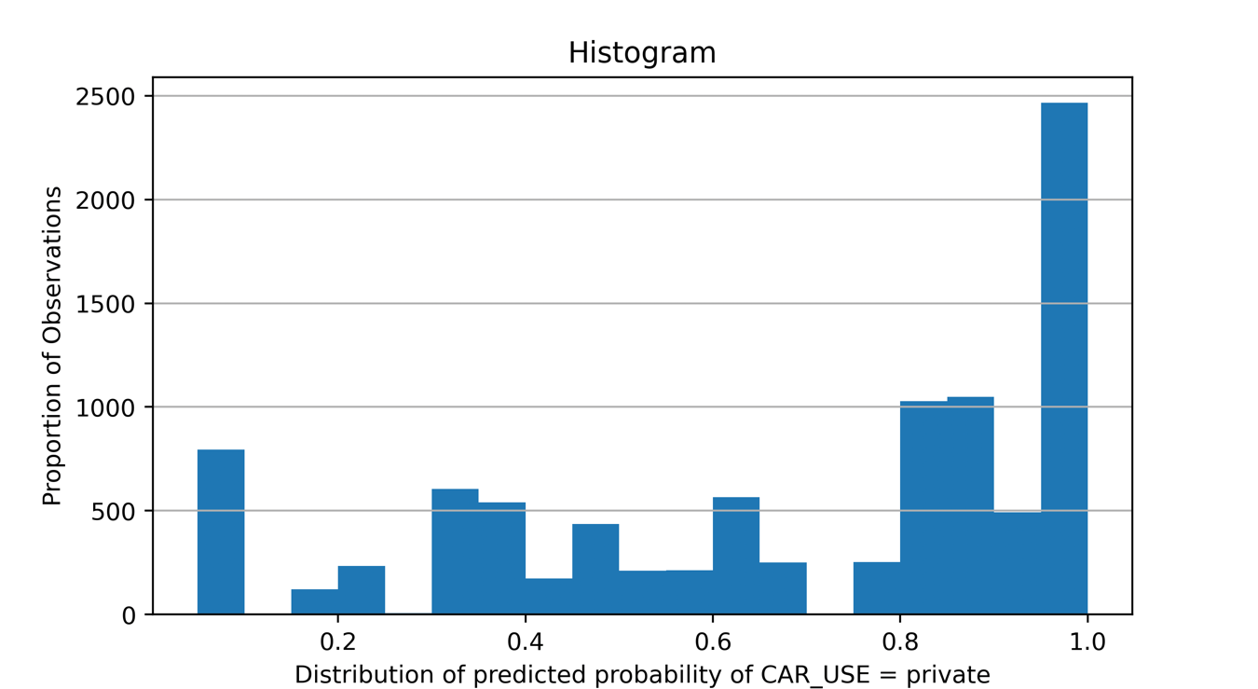

1. (The Python code for this is in the file: 2_f.py)

Output Screenshot:

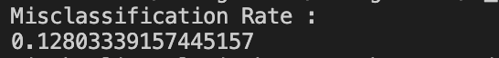

Answer :

the misclassification rate of the Naïve Bayes model is 0.12803339157445157.