Setup to run DeepStream samples on Jetson TX2

Author: Vivek Maran

Professor: Kaikai Liu

Revision: 1

**Contents**

**1. INTRODUCTION** **3**

**2. HOST PC SETUP** **3**

2.1 VMware image 3

2.2 VMware WorkStation 14 Player installation 3

2.3 Starting the Virtual Machine 7

**3. JETPACK** **9**

3.1 JetPack installer 9

3.2 Host-JetsonTX2 Connections 9

3.3 Host installation 9

3.3 Target installation 15

**3. RUNNING DEEPSTREAM** **19**

# 1. INTRODUCTION

Following figure shows the Jetson-TX2 development environment

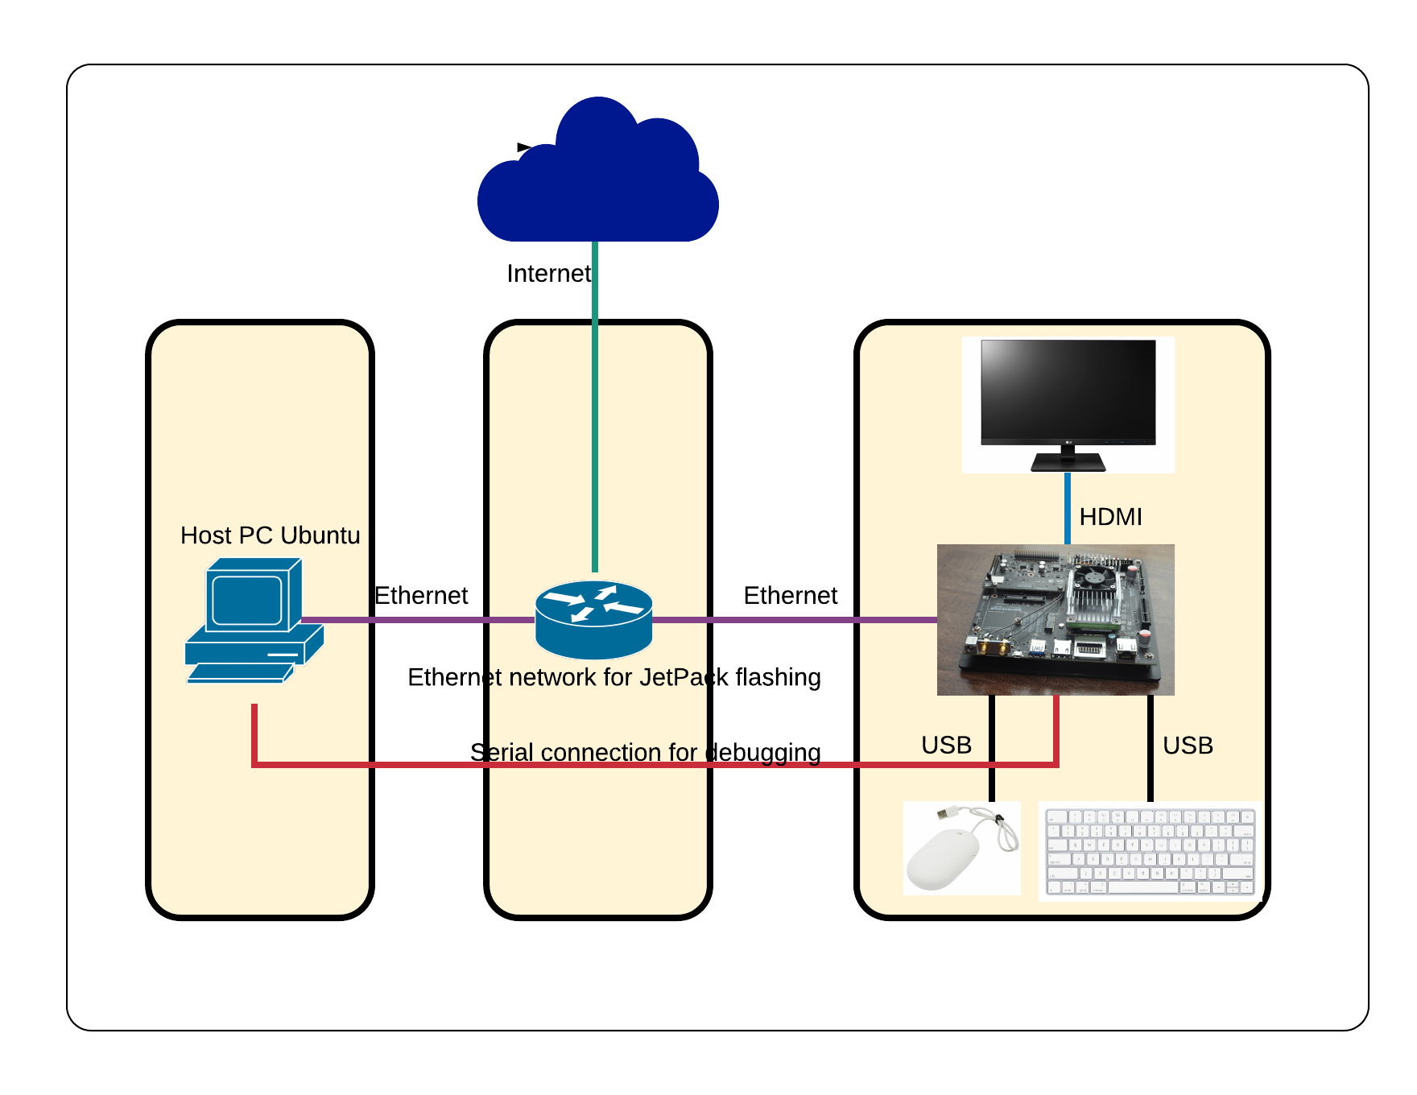

The Jetson TX2 comes pre-flashed with a Linux environment.. On top of which, JetPack should be installed. JetPack includes host (Ubuntu Desktop) and target (Jetson) development tools, APIs, and packages (OS images, tools, middleware, samples, and documentation) for developing on the NVIDIA Jetson Embedded platform. The components and dependencies required for DeepStream SDK are also installed as a part of JetPack. In this tutorial, Ubuntu 16.04 LTS is used on VMWare WorkStation 14 Player as the Host PC

# 2. HOST PC SETUP

## 2.1 VMware image

<https://drive.google.com/drive/folders/1R4RTHtMpMmQxLIqNvzxfM5d8xJnB7Alg?ogsrc=32>

## 2.2 VMware WorkStation 14 Player installation

Download the installer from [Link](https://my.vmware.com/en/web/vmware/free#desktop_end_user_computing/vmware_workstation_player/14_0) and follow the on screen instructions. Following are the installation screenshots for your reference.

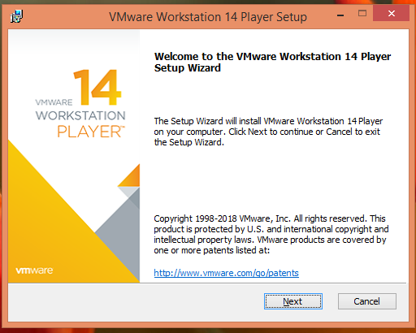

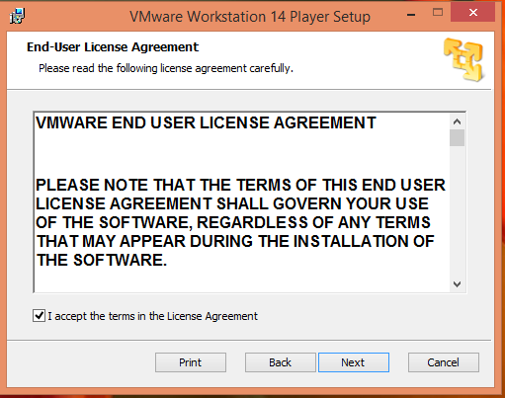

## 

## 

## 

## 

## 

## 2.3 Starting the Virtual Machine

Open VMware player

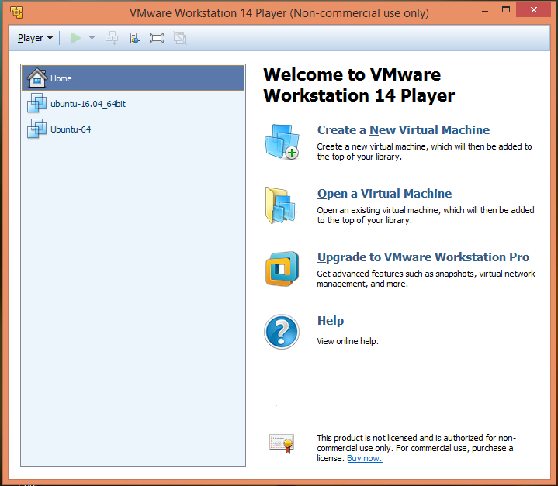

Browse and load the vmx image

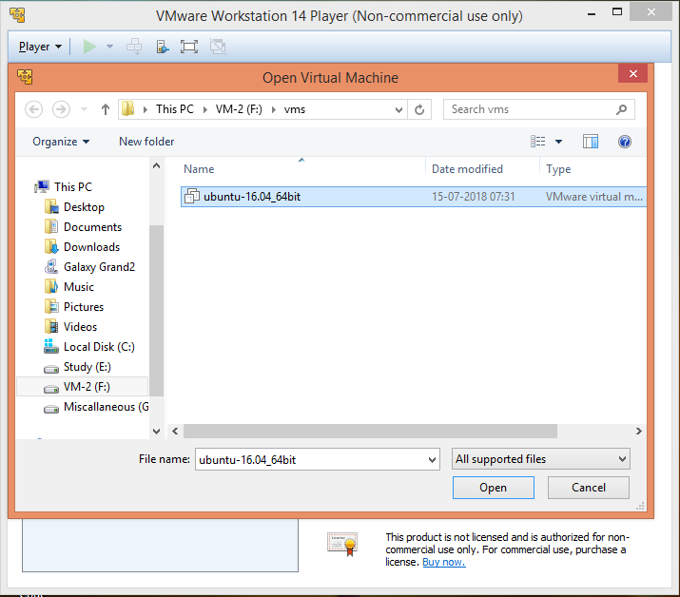

Launch the virtual machine which will prompt for VMware tools installation

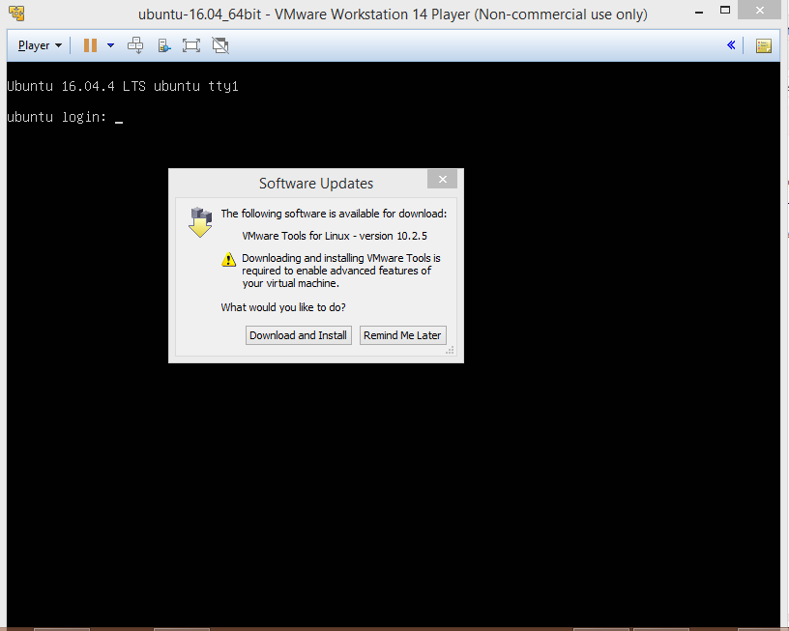

# 3. JETPACK

## 3.1 JetPack installer

JetPack installer is the software which is responsible for JetPack installation in the host and the target device. This installer is already present in the shared virtual machine. For your reference: <https://developer.nvidia.com/embedded/jetpack>

## 3.2 Host-JetsonTX2 Connections

1. Connect the Ethernet Port of Jetson-TX2 to a router (Should be in the same network as your host)
2. Connect USB keyboard and mouse to Jetson-TX2
3. Connect the power cable.
4. Press and release the PWR button twice.
5. Wait for the Ethernet LED to become solid green
6. Connect HDMI cable to display (There are display issues if HDMI cable is connected while boot)

## 3.3 Host installation

cd /home/jetson-dev/JetPack

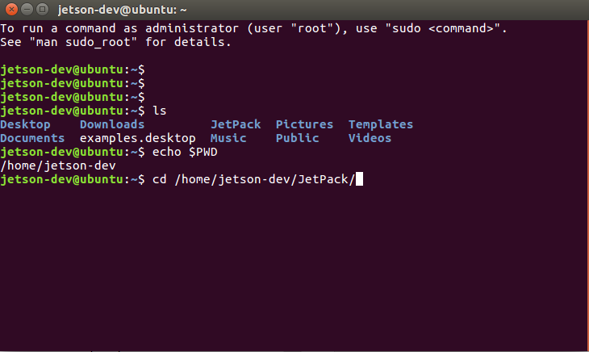

Change the permission of JetPack-L4T-3.2.1-linux-x64_b23.run

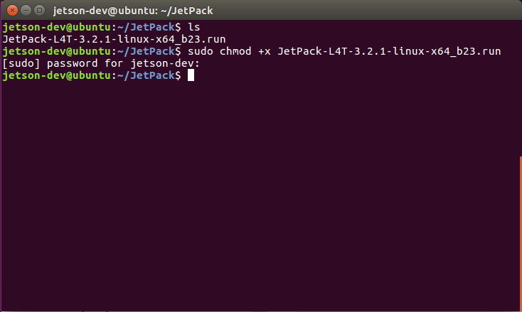

Launch JetPack installer

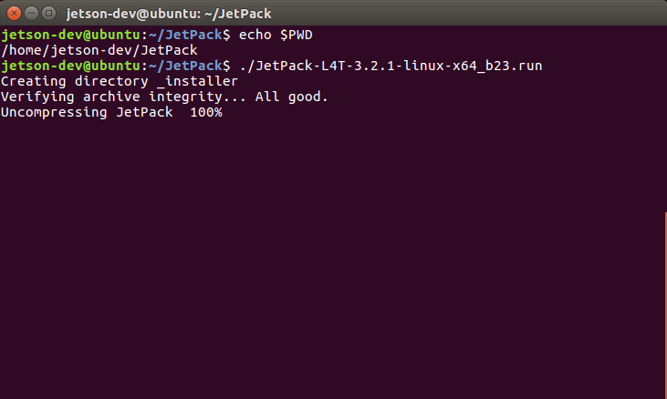

## 

Follow onscreen instructions as shown below

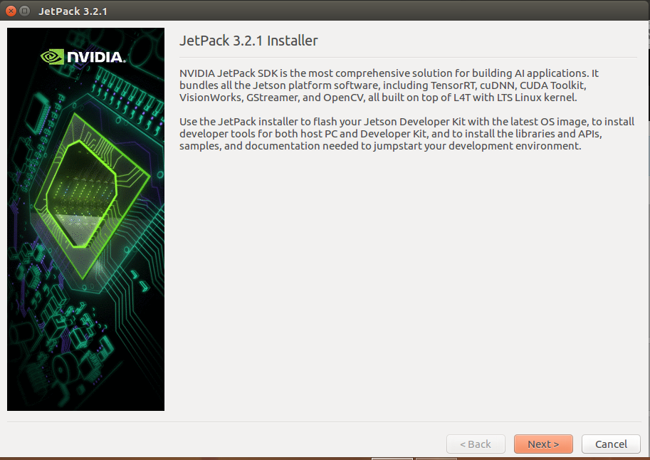

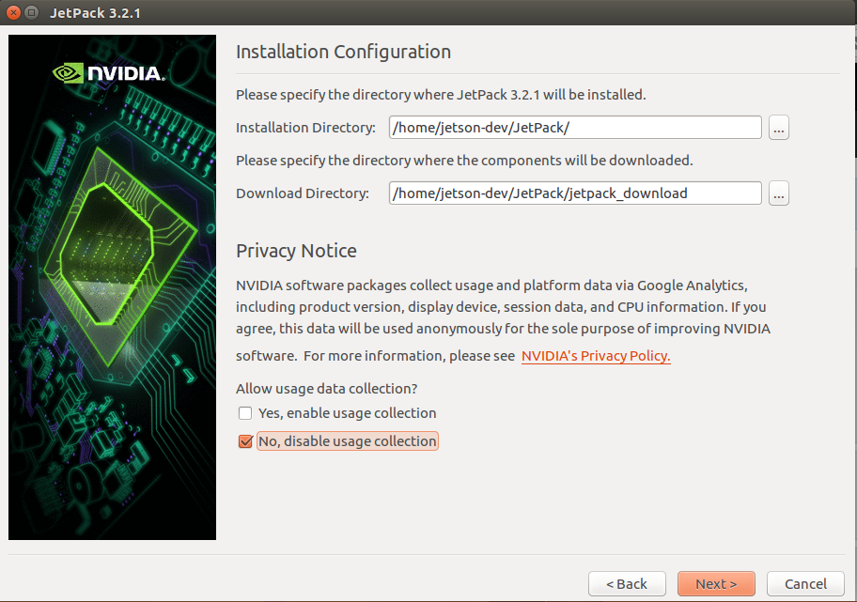

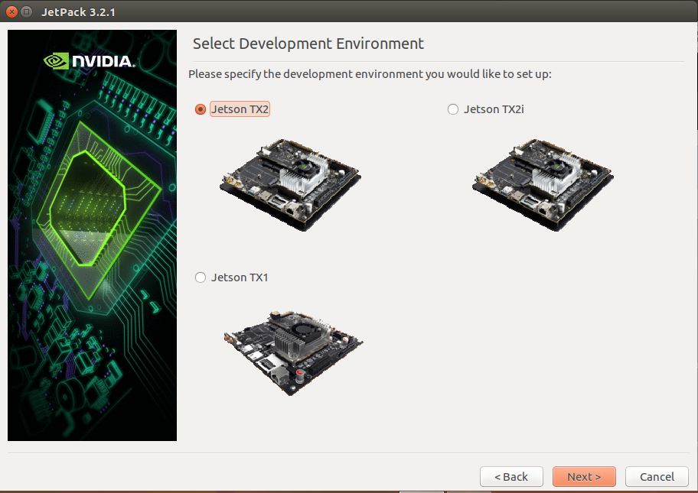

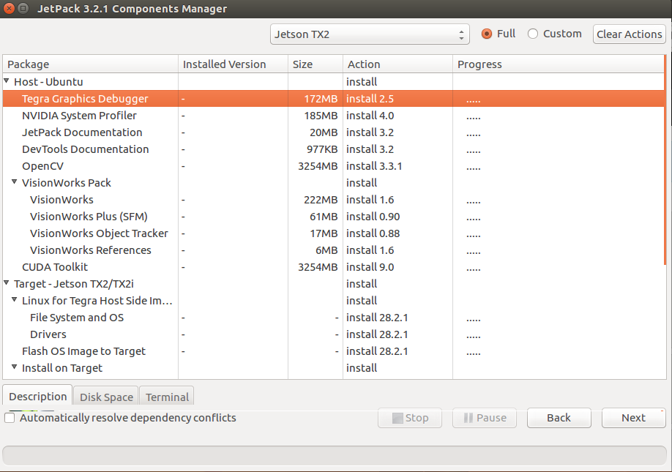

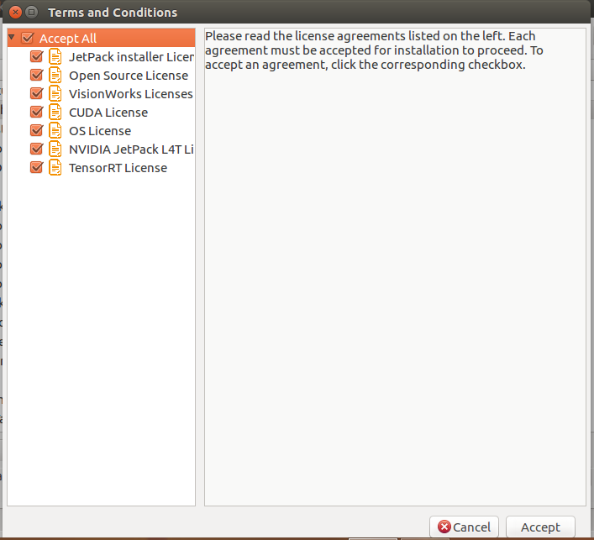

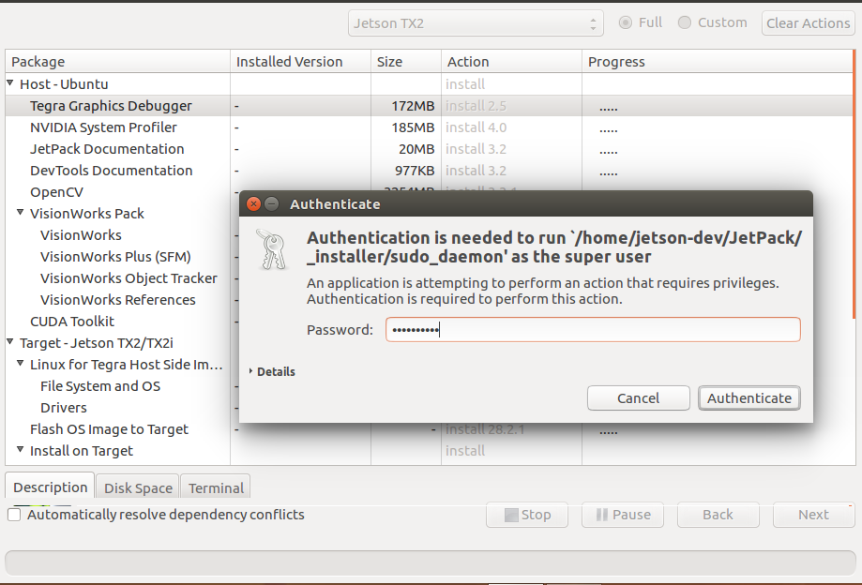

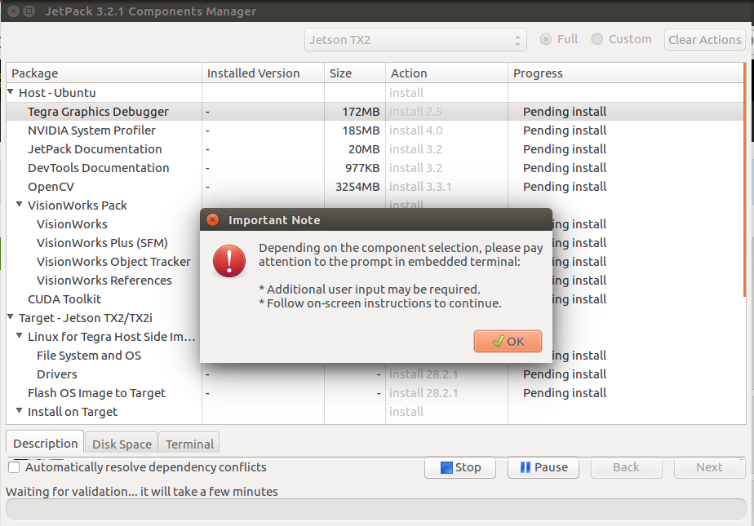

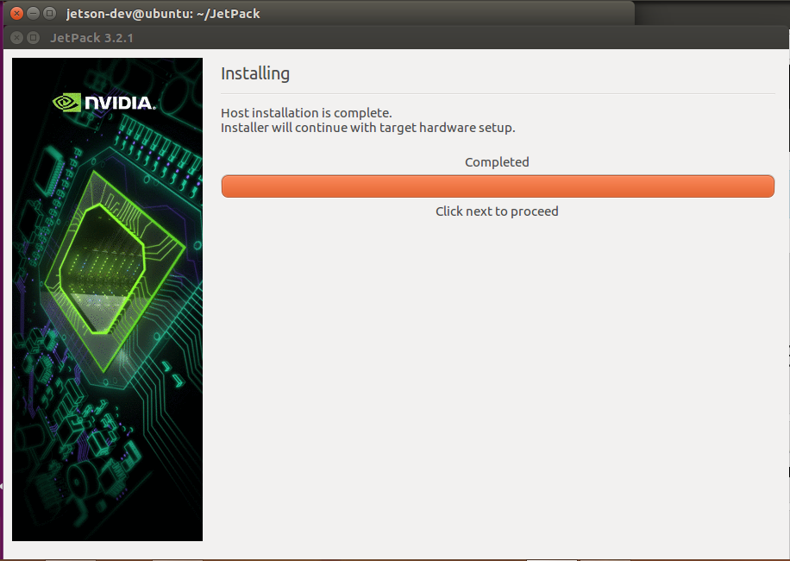

## 3.3 Target installation

At this point host installation is complete,follow the below instructions for target installation

Select the setup

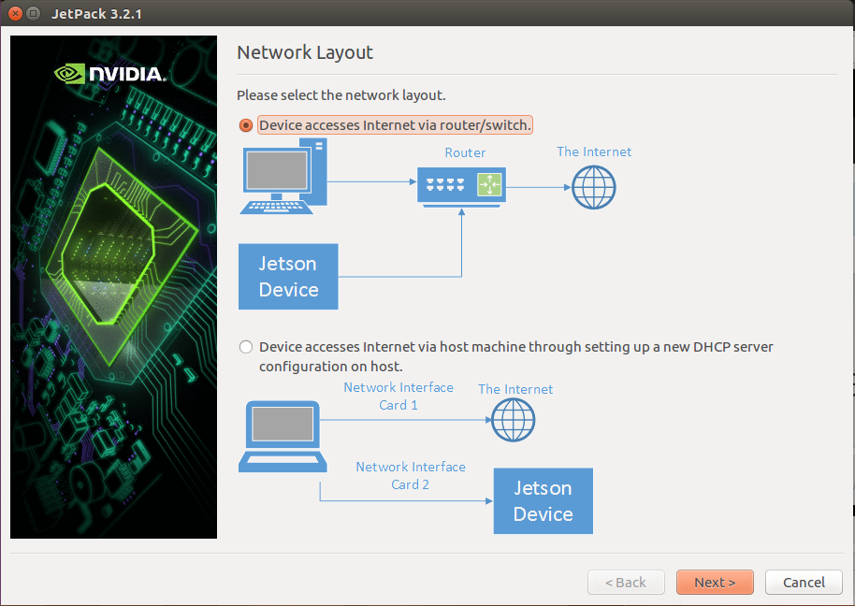

Select the network interface on host which is connected to Jetson TX2’s network. If you are using the virtual machine shared in this tutorial, then use the same as mentioned in the below screenshot

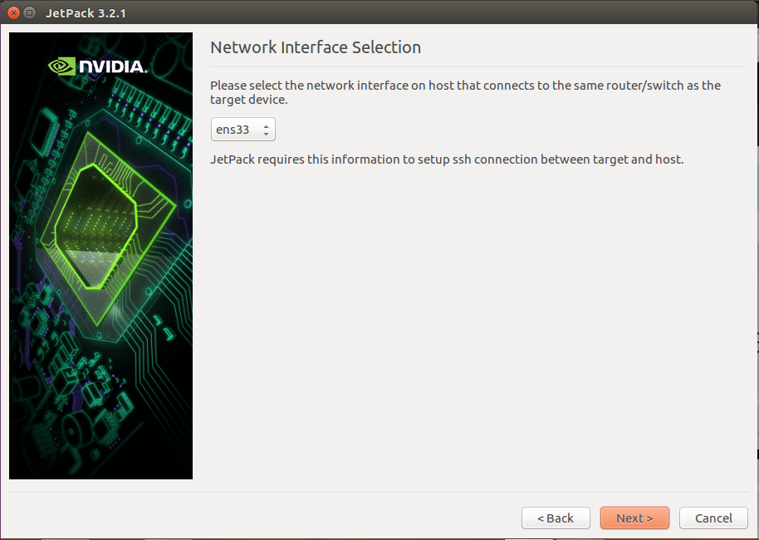

Target installation begins

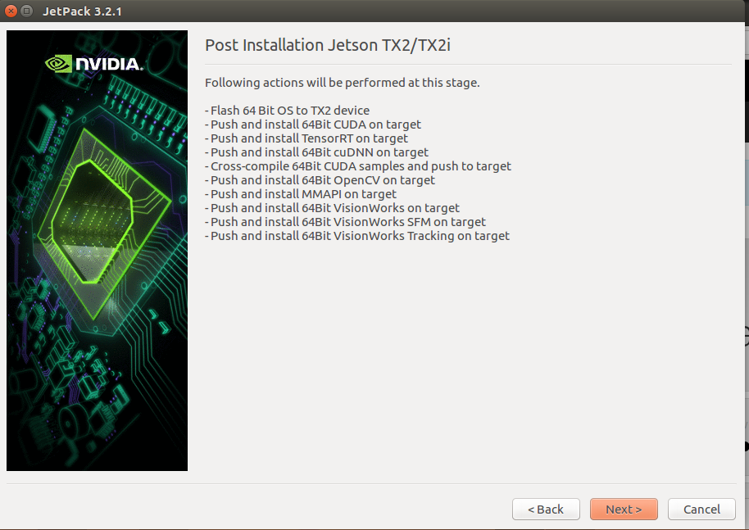

Setup the Jetson TX2 in recovery mode to install the target

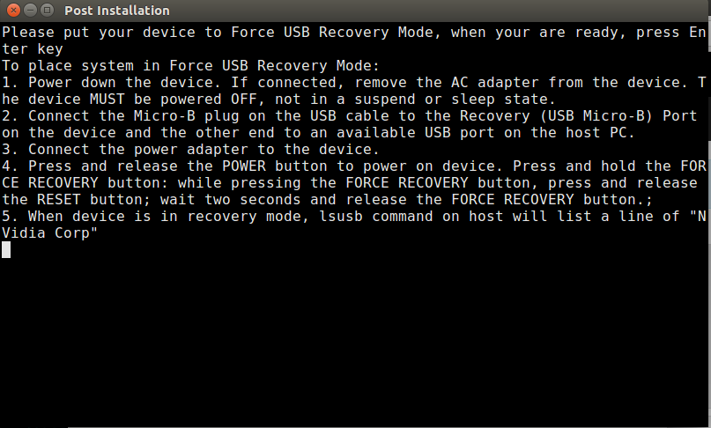

Steps to put into recovery, and verify if it is successful

1. Power down, disconnect the power cable from Jetson TX2
2. Connect Micro-B plug on the USB cable to USB-Micro-B port on the device and the other end to an available USB port on the Host PC
3. Disconnect HDMI cable
4. Connect back the power cable.
5. Press and release the power button twice
6. Wait for the Jetson-TX2 to come up (Indicated by Ethernet link LED, it should turn solid green)
7. Press and hold the FORCE RECOVERY button, while the FORCE RECOVERY button is pressed, press and release the RESET button.
8. Wait for two seconds, and release the FORCE RECOVERY button
9. If the Jetson TX2 is in recovery mode, it should be listed as an USB device in the Host PC. It can be verified by typing lsusb in the terminal

Verifying if USB is connected to the guest OS

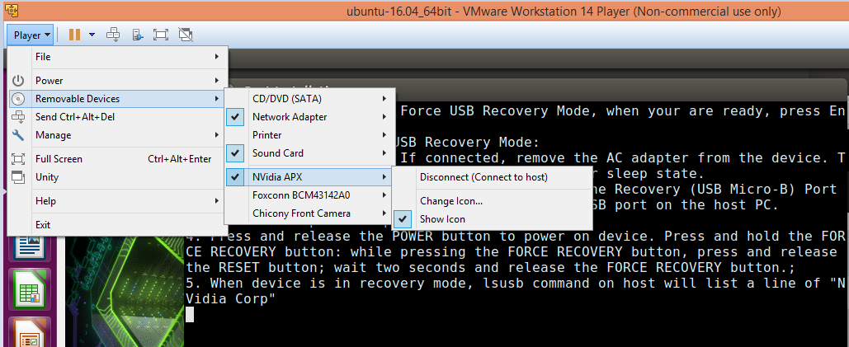

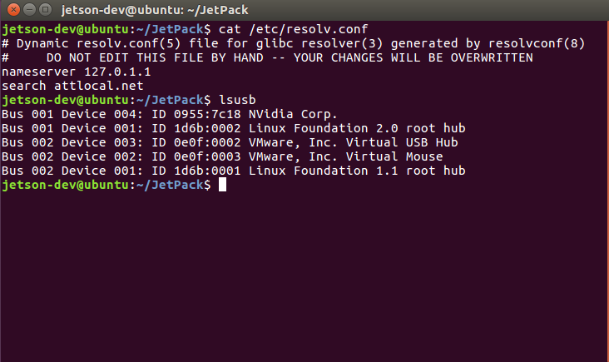

Press enter on the XTERM prompt after the Jetson-TX2 is in recovery mode. This will begin the installation on target. Below are the screenshots after the installation of OS and completion of total install. It takes ~20-30 minutes (Depending on your host PC’s speed) to reach this screen.

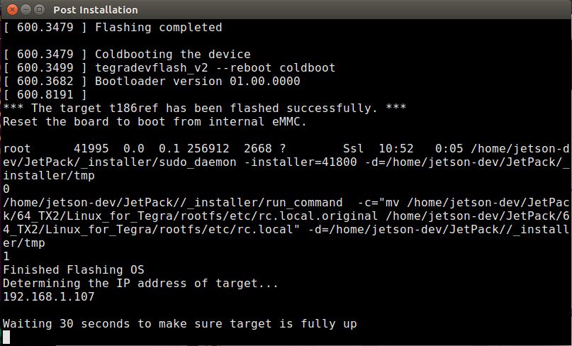

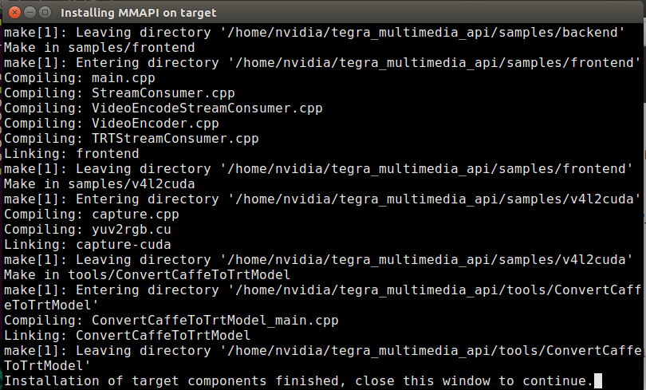

# 3. RUNNING DEEPSTREAM

1. Open Chrominum browser in the Jetson TX2, and download the DeepStream SDK from <https://developer.nvidia.com/deepstream-jetson-download-survey>
2. Open terminal
3. mkdir -p /home/nvidia/DeepStream
4. cd /home/nvidia/DeepStream/
5. cp /home/nvidia/Downloads/DeepStream_SDK_on_Jetson_1.5_pre-release.tbz2 .
6. tar -xvf DeepStream_SDK_on_Jetson_1.5_pre-release.tbz2
7. sudo tar xpvf deepstream_sdk_on_jetson.tbz2 -C /
8. sudo tar xpvf deepstream_sdk_on_jetson_models.tbz2 -C /
9. sudo ldconfig
10. nvgstiva-app -c ${HOME}/configs/PGIE-FP16-CarType-CarMake-CarColor.txt
11. Sample output placed at:[Link](https://github.com/VivekMaran27/jetson/tree/master/experiments/deepstream_samples/nvgstiva)