Webcam streaming using VLC

Author: Vivek Maran

Professor: Kaikai Liu

Revision: 1

**Contents**

**1. INTRODUCTION** **2**

**2. SETUP-SCREENSHOTS** **2**

# 

# 1. INTRODUCTION

This document explains how to use VLC to for Webcam video streaming.

# 2. SETUP-SCREENSHOTS

1. Open VLC player, and select Media-> Open Capture device. Select ‘Stream’ (in the ‘Play’ dropdown) from the below window

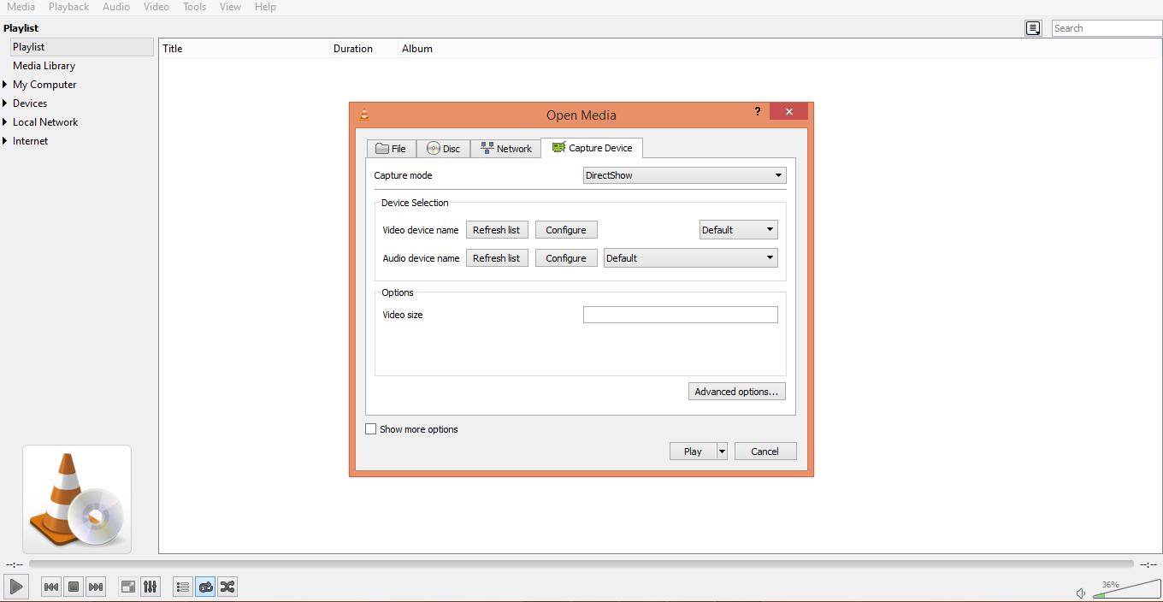

2. Configure ‘Destination Setup’ by selecting HTTP in the ‘New Destination’ drop down and click ‘Add’

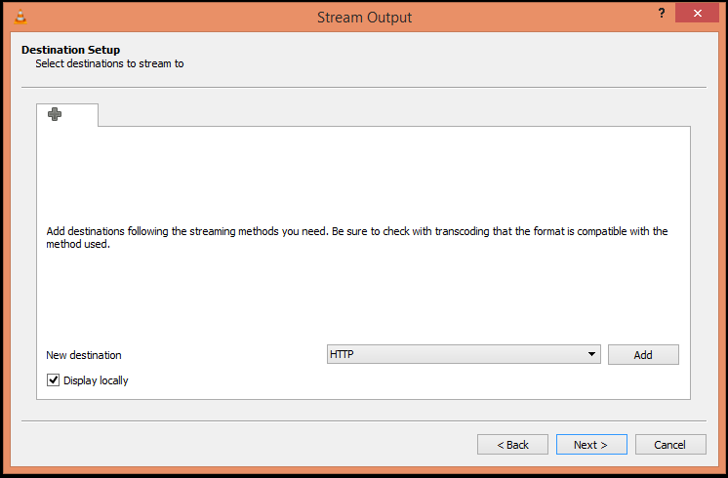

3. Set HTTP parameters

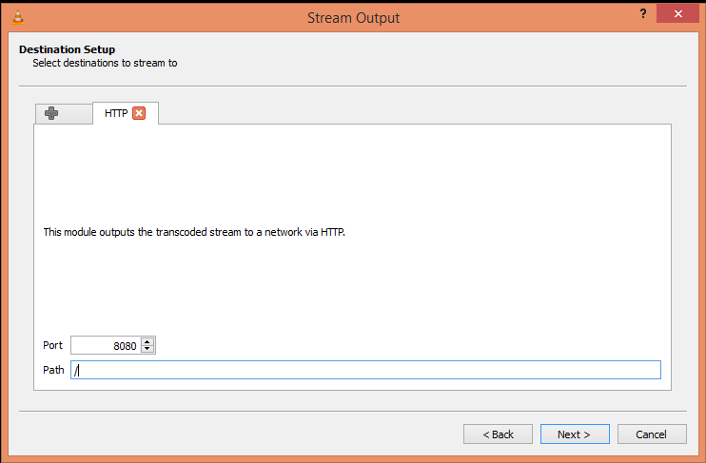

4. Activate transcoding, and chose ‘Video - H.264 + MP3(TS)’

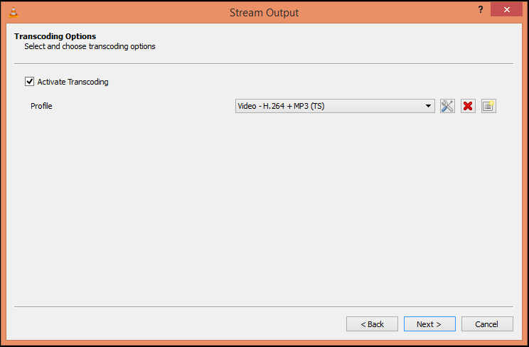

5. Check ‘Stream all elementary streams’ and click ‘Stream’

