Documentation of the beneficiary’s membership in associations in the field for which classification is sought, which require outstanding achievements of their members, as judged by recognized national or international experts in their disciplines or fields.
My elevation to the position of Senior Member within the Institute of Electrical and Electronics Engineers (IEEE) underscores my status as an industry expert and leader in the field of Finance and Artificial Intelligence (AI) applications. This recognition is a testament to my unwavering dedication to research and innovation, as well as my contributions and leadership abilities.
Achieving acknowledgment as an IEEE Senior Member (Membership Number: 100495418) involves a rigorous evaluation process that considers various essential factors. With over 10 years of professional experience and notable achievements, I have demonstrated technical leadership, valuable contributions, and professional accomplishments. The process requires validation from three references who are current Senior Members within IEEE, further attesting to my expertise and accomplishments.
Being recognized as a Senior Member is significant because it is limited to the top 10% of IEEE's 400,000 members, highlighting the exclusivity and prestige of this honor. It reflects my commitment to advancing research and innovation in my field. Receiving the acknowledgment letter from Robert E. Kahn, the 2024 IEEE President and CEO, was a proud moment for me and underscores the importance of this achievement.
My professional and research achievements over the past 5 years have demonstrated significant performance, leading to the attainment of IEEE Senior membership. This recognition is not only a personal milestone but also a testament to the hard work and dedication required to reach this level within the IEEE community.
https://drive.google.com/drive/folders/1lMiMgpDHPDqvhqXAT3Hyg75ScH7qxyTA?usp=sharing

Published material in professional or major trade publications or major media about the beneficiary relating to the beneficiary's work in the field for which classification is sought. This evidence must include the title, date, and author of such published material and any necessary translation
- News about Vivek in Rajasthan Patrika.
Rajasthan Patrika (lit. 'The Rajasthan Newsletter') is an Indian Hindi-language daily newspaper. It was founded by Karpoor Chandra Kulish in 1956 and published as Rajasthan Patrika in Delhi and Rajasthan, and as Patrika in 9 other states
Language: Hindi
Total Readership: 25.9 million
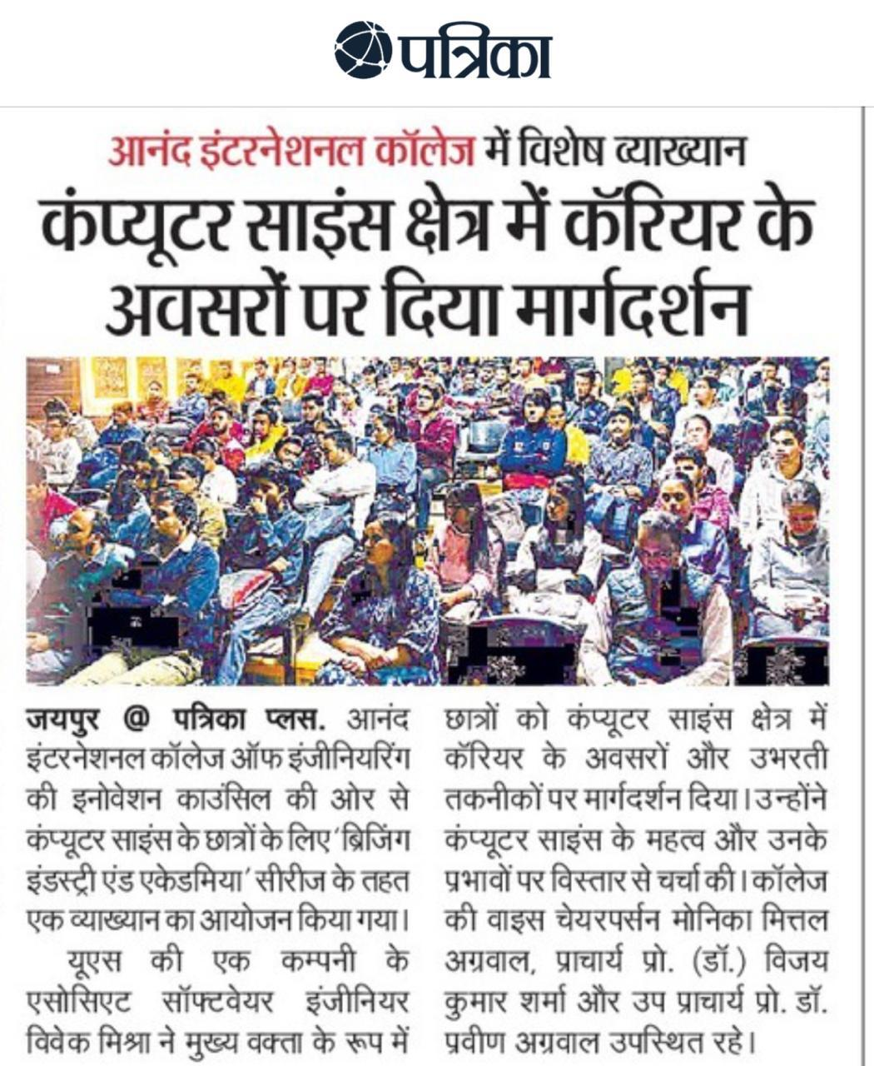

Translated above from google translate.
Special Lecture at Anand International College
Guidance given on career opportunities in computer science field
Jaipur @ Patrika Plus A lecture was organized under the 'Bridging Industry and Academia' series for Computer Science students by the Innovation Council of Anand International College of Engineering.
Vivek Mishra, associate software engineer of a US company, served as the keynote speaker. Gave guidance to students on career opportunities and emerging technologies in Computer Science field. He discussed in detail the importance of computer science and its implications. College Vice Chairperson Monica Mittal Aggarwal, Principal Prof. (Dr.) Vijay Kumar Sharma and Vice Principal Prof. Dr. Praveen Aggarwal was present.
E-newspaper link below:
https://epaper.patrika.com/article/JaipurCity?OrgId=812d22635f4&eid=20&imageview=0&device=desktop
- News about Vivek in First India newspaper. It has 4.4+ million subscriber on YouTube.
e-newspaper: https://firstindia.co.in/article-view/jaipur/08122024/20987
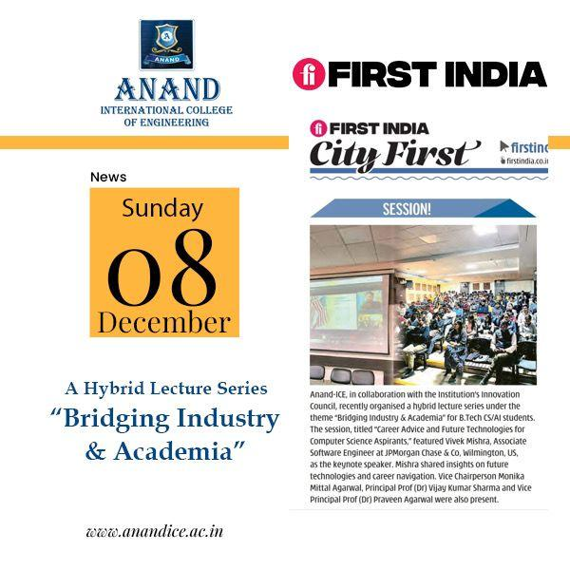
- News About Vivek in Dainik Bhaskar.
Dainik Bhaskar is a leading Hindi daily newspaper in India . It has 65 editions published in 12 states (and union territories ) of India . ^{[ 1 ]} Bhaskar Group also publishes Divya Bhaskar (Gujarati) and DNA (English) and the magazine Aha Zindagi. In 2015, it became the most read newspaper in the country.
Language: Hindi
Total Readership: 63 million
e-news paper : https://www.bhaskar.com/epaper/detail-page/jaipur/14/2024-12-14?pid=13
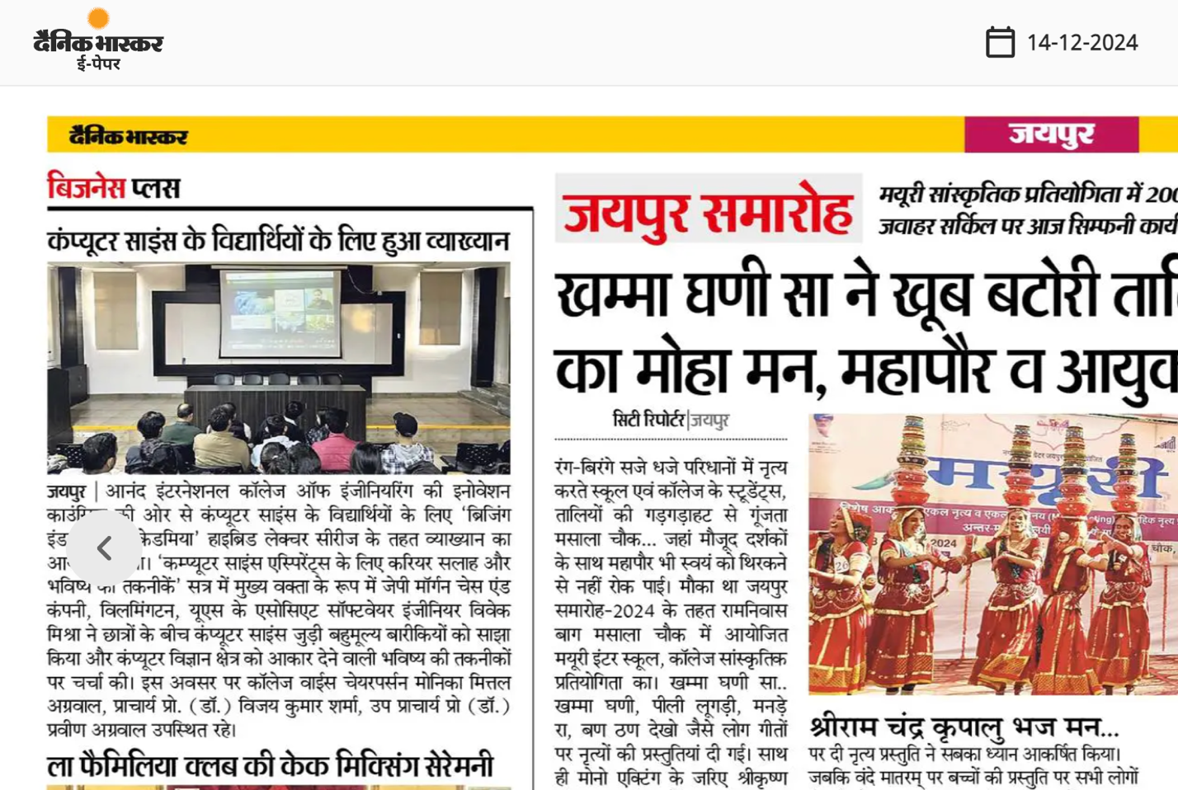
Translated above using google translate.
Jaipur A lecture was organized under the 'Bridging Industry and Academia' Hybrid Lecture Series for Computer Science students on behalf of the Innovation Council of Anand International College of Engineering. Vivek Mishra, Associate Software Engineer, JPMorgan Chase & Co., Wilmington, US, as the keynote speaker in the session 'Career Advice and Future Technologies for Computer Science Aspirants' shared valuable information related to Computer Science among the students and instilled in them a deep understanding of Computer Science. shaping the area and discussed future technologies. On this occasion, College Vice Chairperson Monica Mittal Aggarwal, Principal Prof. (Dr.) Vijay Kumar Sharma, Vice Principal Prof. (Dr.) Praveen Aggarwal were present.
- Interview published in TechBullion: https://techbullion.com/techbullion-exclusive-an-interview-with-vivek-mishra-on-backend-engineering-mentorship-and-driving-cloud-innovation/
TechBullion.com is a versatile tech niche blog that welcomes tech articles. With a robust monthly visitor count of 230.9K from across the globe, TechBullion.com receives a significant amount of traffic, primarily from the US (accounting for more than 28.28% of the total traffic).
Language: US English
Total Readership: 230K
- Got Featured on IEEE Transmitter page as impact creator:
IEEE Impact Creators inspire a global community to innovate for a better tomorrow. IEEE Impact Creators from around the globe share insights on engineering, computing and technology.
https://transmitter.ieee.org/author/vivekmishra/
https://transmitter.ieee.org/impact-creators/
- My name has been prominently featured in Dice Insights
Dice.com is a career website based in New York City with primary sales and development operations in Urbandale, Iowa and Denver. It serves information technology and engineering professionals, as well as contract and permanent engineering staffing firms. Dice.com is owned by DHI Group, Inc. (NYSE: DHX). Dice.com typically has approximately 80,000 tech job listings. The website claims to have 3 million registered technology professionals and approximately 2.4 million unique visitors each month. Of those registered users, 75% have a bachelor's degree or higher and 65% have 10 or more years of experience in their field
https://www.dice.com/career-advice/database-administrators-and-ai-what-to-know-how-to-grow

- Featured by award-winning Journalist Mary K. Pratt in TechTarget twice
Mary K. Pratt is an award-winning freelance journalist with a focus on covering enterprise IT and cybersecurity management and strategy. In past positions she also has covered various other subjects, ranging from community news to fashion to health and fitness. Her work has appeared in numerous publications, including newspapers, magazines and trade journals. She also has written 12 nonfiction books for elementary, middle and high school students. In addition to her work, she enjoys spending time with her family and engaging in outdoor pursuits, including hiking, running, skiing and snowboarding.
https://www.techtarget.com/searchenterpriseai/feature/The-future-of-generative-AI-Trends-to-follow

https://www.techtarget.com/sustainability/feature/Generative-AIs-sustainability-problems-explained
Daily Readership : 1.4+ Million

- Got Featured on IEEE X (twitter) page twice.
IEEE is the world’s largest technical professional organization and is a public charity dedicated to advancing technology for humanity. IEEE has 342.9 K followers.
https://x.com/IEEEorg/status/1885055454377595129
https://x.com/IEEEorg/status/1961166714051371080
- Quoted by Nathan Eddy (American Filmmaker and journalist) in www.vktr.com
https://www.vktr.com/ai-technology/do-ai-coding-tools-really-increase-developer-productivity-studies-say-no/
VKTR covers the business of enterprise AI. We give AI users and leaders at enterprises the practical examples, tools and knowledge they need to thrive in the fast-changing AI era.
VKTR is produced by San Francisco, California-based Simpler Media Group, which also produces CMSWire, the leading community of CX professionals, and Reworked, your guide to the r/evolution of work.
Simpler Media Group (SMG's digital ecosystem) reaches over 7 million readers.
VKTR has 500k reach every year
- IEEE TV Page for Vivek.
IEEE.tv is an award-winning, Internet-based television network. We produce and deliver special interest programming about technology and engineering for the benefit of IEEE's members and the general public.
Built upon the foundation of IEEE's rich history and mission of fostering technological innovation and excellence for the benefit of humanity, IEEE.tv was launched in August 2006. Leveraging the strength of IEEE and its members, we have achieved much since then — producing award-winning content and live-streaming of key IEEE events.
Our ever-growing library of programs includes videos on wind power, biomedical engineering, and on recycling computer and electronic products. New programs, recorded in high definition, are added weekly.
"IEEE.tv is truly a collaborative, IEEE member-produced initiative that is strongly in accordance with IEEE's mission of educating the public on important technology and engineering issues," said Pedro Ray, 2010 IEEE President. "The IEEE.tv viewer can also be launched from any Web site, allowing us a greater opportunity to syndicate the network."
https://ieeetv.ieee.org/speaker/vivek-mishra

Evidence of the beneficiary's participation on a panel, or individually, as a judge of the work of others in the same or in an allied field of specialization for which classification is sought
- Invited to Judge Senior Member Application Virtual Review Panel - June 2025
To become a judge for the IEEE Senior Member Application Virtual Review Panel, you typically need to meet the following criteria, as established by IEEE and its Membership Development team
You must already be an IEEE Senior Member or Fellow in good standing.
Relevant Technical Background
Your technical expertise should match the fields in which the applicant has applied.
This ensures you can competently review and assess professional accomplishments.
Familiarity with IEEE Senior Member Requirements
Understanding the IEEE Senior Member qualifications:
At least 10 years of professional experience.
At least 5 years of significant performance.
Good Standing and Ethical Conduct
You should not have any ethical violations or unresolved disputes with IEEE.
Professional and unbiased judgment is expected.

- Evaluated 4 profiles for IEEE senior members.
An IEEE Senior Member application is judged by a panel of reviewers typically composed of existing IEEE Senior Members, Life Senior Members, and Fellows within the relevant section or society, signifying that the evaluation is done by established professionals in the field who assess the candidate's significant contributions and professional maturity to determine if they qualify for the Senior Member grade; this designation is considered a mark of respect within the IEEE community for demonstrating substantial technical achievements and experience in their field
- Reviewed research paper through OpenReview
a. Nominated by the program chair committee of ICLR 2025 FM-Wild Workshop to serve as Reviewer.
ICLR is a major global conference that attracts top-tier researchers, practitioners, and thought leaders from around the world. Like NeurIPS, it draws attention not only from academia but also from the tech industry, with major players like Google, OpenAI, Microsoft, and others closely following the advancements presented there. ICLR is known for its highly competitive and selective paper acceptance process, with only about 20-30% of submitted papers typically being accepted.
I have been invited to serve as a reviewer for ICLR 2025, one of the leading conferences in the field of deep learning and representation learning. This invitation reflects the high level of recognition of my expertise in these domains. As a reviewer, I am responsible for evaluating cutting-edge research in AI and deep learning, helping to shape the direction of future innovations in the field. The research presented at ICLR has a significant influence on both academic theory and real-world AI applications, and my involvement demonstrates my leadership and sustained contributions to advancing the field of machine learning and AI.
b. Served as a Reviewer for the Annual Conference on Neural Information Processing Systems (NeurIPS) and reviewed 4 research papers.
NeurIPS (Conference on Neural Information Processing Systems) is one of the most prestigious and influential academic conferences in the field of machine learning, artificial intelligence (AI), and computational neuroscience. Established in 1987, it has grown into a flagship conference where cutting-edge research on algorithms, systems, and theory related to machine learning, deep learning, AI, data science, and computational neuroscience is presented.
I have been invited to serve as a reviewer for NeurIPS, one of the most prestigious conferences in machine learning and artificial intelligence, where only the top 20-25% of submissions are accepted. This invitation reflects the high level of recognition of my expertise and standing in the field. My role as a reviewer involves evaluating cutting-edge research in AI, and my feedback helps shape the direction of new innovations that will influence the future of AI and machine learning. This acknowledgment from the global research community serves as evidence of my significant contributions to the advancement of the field.
- Reviewed one Research paper for Microsoft CMT.

- 11 peer Reviewed Research paper for Informatica.si
Informatica (print edition ISSN: 0350-5596, online edition ISSN: 1854-3871) is an international refereed journal with its base in Europe. It publishes papers addressing all issues of interest to computer and informatics professionals and cognitive scientists: from scientific and technical to educational, commercial and industrial. It also publishes critical examinations of existing publications, news about major practical achievements and innovations in the computer and information industry, as well as conference announcements and reports.
- 2 Peer Review Research paper for www.virtusinterpress.org
Virtus Interpress is a distinguished publishing house specializing in corporate governance with a global perspective. Its mission is to advance best practices in corporate governance worldwide by conducting research and publishing periodicals and books on related issues. Virtus Interpress is dedicated to fostering discussions on corporate governance by uniting experts to address pressing challenges in the field. The organization utilizes journals, discussion events, and book publishing as key instruments to promote dialogue and development in corporate governance. With a focus on uniting academics and practitioners, Virtus Interpress aims to uphold high ethical standards and enhance the academic rigor of its editorial and publishing processes
- Mentored and reviewed peers at Rutgers University Health Hack 2024
Website: https://ruhealthhack.com/mentors
Scale of Event: National
Who were Evaluated: Bachelors, Masters, PhD and Working professional were Evaluated.
Sponsors: AWS, Oracle, Microsoft, Nokia Bell Labs, CloudForce, Johnson & Johnson, Bristol Myers Squibb, and the Rutgers Center for Advanced Biotechnology and Medicine
How did Jury Evaluated: Participants present their hackathon project in front of the panel and mentored one by one in the review room, and mentors reviewed them accordingly.
- Judge at Claro Award 2024: https://claroawards.com/
Scale of Event: International
Who were Evaluated: Working professional in Tech Industry in AI, Data Analytics, Technology.
How did Jury Evaluated: Online.
- Judge at the Morgan State University's Hackathon – MorganHacks 2024 in Baltimore, MD.
MorganHacks is a weekend-long hackathon that would bring together hundreds of students from around the globe.
Scale of Event: International
Who were Evaluated : Bachelors, Masters, PhD professional were Evaluated.
Sponsors: Microsoft, M&T bank, Goldman Sachs.
How did Jury Evaluated: Participants present their hackathon project in front of the judges one by one as they arrive at their stalls, and judges score them accordingly.
- Judge at Drexel University's hackathon DragonHacks. 2024. DragonHacks is Drexel University's 24-hour hackathon, organized by the Drexel University IEEE student chapter. https://dragonhacks.org/
Scale of Event: National
Who were Evaluated: Bachelors, Masters, PhD professional were Evaluated.
Sponsors: IEEE Philadelphia Section, Pennoni Honors College, Drexel College of Engineering
How did Jury Evaluated: Participants present their hackathon project in front of the judges one by one as they arrive at their stalls, and judges score them accordingly.
- Judge at PennApps XXV 2024 at University of Pennsylvania: https://2024f.pennapps.com/
Scale of Event: International
Who were Evaluated : Bachelors, Masters, PhD professional were Evaluated.
Sponsors: SIG, Bloomberg, DE Shaw & Co, Cerebras, Capital One, Telora, Roboflow, M&T, Tune, etc
How did Jury Evaluated: Participants present their hackathon project in front of the judges one by one as they arrive at their stalls, and judges score them accordingly.
Please find Evidence in below google drive for above judging and peer review.
https://drive.google.com/drive/folders/1lOullfOG43OJJo1Az8DtnGiJBvKWVibZ?usp=sharing
Evidence of the beneficiary's original scientific, scholarly, or business-related contributions of major significance in the field.
- LOR Profiles.
  - Modin Bude Shaik (Senior Software Development Manager at Oracle)
  - Corey Grahan (Executive Director at JPMC) https://www.linkedin.com/in/corey-graham-aa7878/
  - Ram Gajavelli (Executive Director at JPMC)
  - Maxim Dulebenets (Associate Professor at Florida A&M University-Florida State University) https://sites.google.com/site/maximdulebenets/
  - Prashant Singh https://www.linkedin.com/in/prashant-singh-phd-pe-c-engg-661970b/
  - Shailesh Chandra (Associate Professor at CSULB) https://www.csulb.edu/college-of-engineering/dr-shailesh-chandra
  - Rahul Vishwakarma. https://www.linkedin.com/in/rahulvishwakarma/
  - Sinchan (Director Enterprise Architect) https://www.linkedin.com/in/sinchan-tech/
  - Praveen Aggarwal (Top 2% Scientists, Vice Principal, Int.-Collaboration, R&D, Ranking and Accreditation Expert (NAAC,ABET,NIRF,QS),Academic Administrator, Editor(50+Journal),Speaker(300+talks),325 high impact Journal papers,12+Books) https://www.linkedin.com/in/praveenagarwal1/
  - Ashish Kalvakota (GlobalLogic logo GlobalLogic GlobalLogic Vice President - APAC | Regional Partner) https://www.linkedin.com/in/ashish-kalvakota/

- Delivered a talk at Engineering College for computer science students.
LinkedIn Post.
https://www.linkedin.com/posts/anand-college-of-engineering_anandice-industryknowledge-hybridlectureseries-activity-7265909167196954624-uyYe?utm_source=share&utm_medium=member_desktop
https://www.linkedin.com/posts/anand-college-of-engineering_ai-machinelearning-fdp2025-activity-7316862944720367616-6E2J?utm_source=share&utm_medium=member_desktop&rcm=ACoAAA5MBBEBT2_IbHsfj2eSfXiW5lqxKeCrgaM

- Citation of my research work in some government research projects in Florida, Italy, Iran and Colombia

Towards improving sustainability of rail transport by reducing traffic delays at level crossings: A case study for the State of Florida

Review of Financing Mechanisms to Promote Decarbonization Alternatives in Rail and Inland Waterway Transport

The Effects of High-Speed Rail on the Real Estate Market for Residential Use: A Comparison of Medium-Sized and Metropolitan Cities in Italy

Do rail transit stations transform hosting neighbourhoods? Comparative evidence from high-income and low-income neighbourhoods in Tehran

Evidence of the beneficiary's authorship of scholarly articles in the field, in professional journals, or other major media.
Google Scholar: https://scholar.google.com/citations?user=BvG76iMAAAAJ&hl=en
The research projects I have worked on, funded by the U.S. Department of Transportation and the California State University Transportation, explore various facets of intelligent transport systems (ITS) through lens of computer science, AI, and financial considerations. Conducted at an R2 Doctoral University, these studies focus on optimizing transportation infrastructure and services using advanced computational models, AI-driven methodologies, and innovative financing mechanisms. For example, research on high-speed rail projects and multimodal transportation access employs optimization algorithms and data analytics to improve connectivity and accessibility, addressing challenges such as funding, social distancing, and economic sustainability. Additionally, a framework for assessing rail transport inequality uses AI techniques to analyze and mitigate disparities in rail services, ensuring equitable access while considering investment impacts. Collectively, these studies contribute to the development of smarter, more efficient, and financially sustainable transportation systems, highlighting the transformative potential of computer science, AI, and financial strategies in ITS. Below are my researches in brief.
Evaluating Financing Mechanisms and Evaluating Financing Mechanisms and Economic Benefits economic Benefits to Fund Grade Separation Projects : 2021
As a graduate student in the Department of Computer Science and Computer Engineering at California State University, Long Beach, I had the opportunity to contribute significantly to the research on evaluating financing mechanisms and economic benefits for grade separation projects. My role involved leveraging large datasets related to traffic volumes, property values, and employment statistics around at-grade crossings. By applying AI and machine learning algorithms, I was able to model complex relationships between these variables, providing a data-driven basis for decision-making. I conducted a robust benefits-to-cost analysis (BCA), simulating scenarios to estimate potential savings from reduced travel times, improved safety, decreased emissions, and increased property tax revenues. Additionally, I used computational tools to visualize data and results, making it easier for stakeholders to understand the potential benefits of the projects. This research, funded by the Mineta Transportation Institute, with support from the U.S. Department of Transportation and the California State University Transportation Consortium, aimed to prioritize economically feasible grade separation projects. It was a rewarding experience to see how technology can address complex infrastructure challenges and support informed policy decisions.
The above research was cited 5 times in the research below:

Towards improving sustainability of rail transport by reducing traffic delays at level crossings: A case study for the State of Florida

Multi-criteria prioritization of highway-rail grade crossings for improvements: a case study

A new form of train detection as a solution to improve level crossing closing time

Data Envelopment Analysis for the Selection of Highway–Rail Grade Separation Projects

Resource Allocation Approaches for Improving Safety and Operations at Level Crossings: State of the Art, Existing Challenges, and Future Research Needs

Cleaner Logistics and Supply Chains

Evaluating Innovative Financing Mechanisms for the California High-Speed Rail Project : 2021
As a graduate student in the Department of Computer Science and Computer Engineering at California State University, Long Beach, I had the opportunity to contribute to the research on the California High-Speed Rail (HSR) project by applying computer science and artificial intelligence (AI) techniques. My focus was on optimizing the financial aspects of the project, particularly in identifying HSR stations that could maximize revenue potential through real estate taxes and enhance accessibility, thereby stimulating economic activity around the stations. By leveraging AI, I was able to process large datasets, model complex relationships, and identify patterns that might not be immediately apparent through traditional analysis methods.
In this research, I utilized tools such as Python, along with libraries like NumPy and Pandas, for data analysis and processing. These tools enabled me to efficiently handle and analyze spatial and economic data related to property taxes and employment, providing insights into the potential impacts of station development on economic growth and property values. The use of these technologies allowed for a comprehensive evaluation of the data, supporting the identification of key stations that could drive economic activity and generate additional funding for the HSR project.
The research was funded by the Mineta Transportation Institute, which receives support from the U.S. Department of Transportation and the California State University Transportation Consortium. This funding, provided in 2021, had a significant impact on the ground level by enabling research that identifies potential financial benefits and sustainable funding sources for large-scale infrastructure projects like the HSR. My work, supported by this funding, provided a data-driven foundation for sustainable funding strategies, offering valuable insights for decision-makers seeking to enhance the economic vitality of areas surrounding the proposed HSR stations.
The above research was cited four times in below researches.

Review of Financing Mechanisms to Promote Decarbonization Alternatives in Rail and Inland Waterway Transport

The Effects of High-Speed Rail on the Real Estate Market for Residential Use: A Comparison of Medium-Sized and Metropolitan Cities in Italy

Do rail transit stations transform hosting neighbourhoods? Comparative evidence from high-income and low-income neighbourhoods in Tehran

Job Creation and Economic Output

Framework for Rail Transport Inequality Assessment: A Case Study of the Indian Railway Zones with Superfast Express (SE) Trains : 2024
In our research paper, 'Framework for Rail Transport Inequality Assessment: A Case Study of the Indian Railway Zones with Superfast Express (SE) Trains,' we developed a novel framework to evaluate inequalities in rail transport services. The study focused on assessing connectivity and accessibility across different zones of the Indian Railways, particularly during favorable (daytime) and unfavorable (nighttime) travel periods. By introducing an inequality-to-investment ratio, we classified zones as 'winners' or 'losers' based on their performance relative to the investments they received. The research underscored the importance of selecting appropriate metrics to identify zones that require policy interventions to ensure equitable access to transportation.
As for my contributions, I played a key role in implementing the computational aspects of the study. I worked with a large dataset that included train schedules, population data, and investment figures. Using programming and algorithms, I developed scripts to efficiently process and analyze this data, enabling us to calculate essential metrics such as connectivity, accessibility, and the inequality-to-investment ratio. By coding these algorithms, I systematically applied the given formulas across all stations and zones, ensuring accuracy and consistency in my results. Additionally, I utilized programming libraries to create visualizations that effectively communicated our findings, highlighting disparities and suggesting policy interventions. Through simulation and modeling, I explored different investment scenarios, providing insights into their potential impact on reducing inequalities. Overall, my contributions in programming and algorithm development were crucial in transforming raw data into actionable insights, ultimately guiding investment decisions and policy recommendations for more equitable rail transport services.
The outcome of the research was a comprehensive assessment of rail transport inequalities, which provided valuable insights into which zones were performing well and which required further investment and policy attention. This framework can serve as a tool for policymakers and stakeholders to make informed decisions about resource allocation and infrastructure development, promoting a more balanced and sustainable railway system.
The above research was cited four times in the research below:

Examining Transit Service Improvements with Internet-of-Things (IoT): A Disparity Analysis
- Connectivity evaluations of Indian Railways zones with superfast express (SE) trains
- Rail Transport Services In Romania: Perceptions, Problems And Perspectives
- AI-Driven Predictive Analytics for Marketing Campaigns

Evaluating Innovative Financing Mechanisms for the California High-Speed Rail Project : 2022
This research paper, authored by Shailesh Chandra and Vivek Mishra, explores the financial challenges and potential solutions for funding the California High-Speed Rail (HSR) project. The study proposes a multiobjective optimization approach to identify key HSR stations that could be developed to enhance revenue generation, accessibility, and workforce-centric access measures. The research highlights the importance of alternative funding sources, such as public-private partnerships, to overcome the financial hurdles associated with large-scale infrastructure projects like HSR.
Vivek Mishra played a crucial role in this study by utilizing Python scripts along with the NumPy and Pandas frameworks to analyze large datasets related to property values, accessibility metrics, and workforce demographics. The algorithms used in the research included multiobjective optimization techniques, specifically the Technique for Order of Preference by Similarity to Ideal Solution (TOPSIS), to evaluate and prioritize HSR stations for development. The outcome of the research suggests that stations like San Francisco Transbay Terminal, University City, and Downtown Merced should be prioritized for development to attract economic growth and partially fund the HSR project.
The research was partially funded by the SB-1 TRANSPORT initiative and U.S. Department of Transportation and the California State University Transportation Consortium (CSUTC) funded by the State of California through Senate Bill 1, which supports transportation-related studies in California. The findings provide valuable insights for policymakers and planners to focus on sustainable funding strategies for the California HSR project.

Optimizing Multimodal Transportation Access to Support Commuting Among Low-Income Transit Riders with Social Distancing : 2022
In this study, Vivek Mishra addresses the challenges faced by low-income commuters during the COVID-19 pandemic, particularly in maintaining social distancing on public transit. The research focuses on optimizing the accessibility of fixed-route transit (FRT) services to support commuting among low-income transit riders in Los Angeles. The study evaluates the impact of social distancing on FRT accessibility and proposes a model to determine the optimal number of stops to maximize accessibility.
Vivek Mishra's contribution involved using Python, along with NumPy and Pandas, to process and analyze ridership data from LA Metro's A Line. The research employed accessibility modeling techniques to assess the impact of social distancing on transit performance. The findings indicate that social distancing measures can affect FRT accessibility, and the study provides recommendations for optimizing the number of stops to enhance service efficiency.
The research was funded by the Mineta Transportation Institute and the California State University Transportation Consortium, supported by the State of California through Senate Bill 1. The study offers practical insights for transit authorities to improve FRT services and ensure safe and efficient commuting for low-income riders during and after the pandemic.

Integrating Solar Photovoltaic Systems into the Grid: An Overview of AI Application 2024

The photovoltaic (PV) system business is seeing an increase in the number of applications for artificial intelligence (AI) as a result of the expansion of powerful computer resources, helpful tools, and an explosion of data. It has been shown that the methods that are currently used for a variety of jobs in the solar photovoltaic (PV) industry, such as design, forecasting, control, and maintenance, provide results that are not totally accurate. Additionally, artificial intelligence (AI) has enhanced the accuracy and precision of these professions, which has allowed them to become a topic of discussion at the present time. Within the context of this specific paradigm, the objective of this study is to investigate the impact that AI techniques have had on the PV value chain. In the course of the study, a cataloging of the current artificial intelligence systems, the compilation of a list of prospective applications of AI in the future, and an analysis of the benefits and drawbacks of these systems in contrast to more conventional approaches are all included.

Evidence that the beneficiary has been employed in a critical or essential capacity for organizations and establishments that have a distinguished reputation.
As of now Vivek is working as backend developer with JP Morgan Chase & Co. with Chase Shopping Hub Project.
The Chase Shopping Hub project is a transformative initiative aimed at consolidating all shopping experiences into a single, cohesive platform for Chase's 80 million customers. This ambitious project seeks to position Chase as a premier destination for retail shopping by offering unparalleled value and convenience through a seamless user experience. The Shopping Hub integrates various shopping solutions, including Shop-through-Chase, Apple Store, Gift Cards, Offers, and Pay with Points, into a unified landing page. This consolidation not only simplifies the shopping process for users but also enhances engagement by displaying deals, offers, and products directly within the hub.
The project aims to create a more engaging shopping experience by consolidating multiple shopping services into a single platform. This approach enhances user convenience and ensures that Chase becomes a top-of-mind destination for retail shopping needs. By focusing on high-equity brands and offering the highest value-per-dollar ratio through bundling, discounts, and UR points redemptions, the Shopping Hub maximizes value for customers. The seamless user experience, coupled with multiple Chase payment and lending products, further enhances convenience.
Chase Shopping Hub is designed to be a headless commerce solution, where brands and merchants are responsible for fulfillment, customer support, and logistics. This model allows Chase to offer a wide range of products while maintaining a focus on value and convenience. The Shopping Hub is accessible via mobile-responsive web, native iOS, and native Android platforms, ensuring a broad reach and accessibility for Chase's diverse customer base.
Vivek plays a pivotal role in the success of the Chase Shopping Hub project through his technical expertise and leadership. His contributions are critical in several key areas.
Vivek's work in developing an API from scratch and successfully bringing it to a live environment is commendable. He meticulously navigated the entire process, ensuring that all necessary approvals were obtained from Level 2 (L2) management and the site reliability team. His attention to detail and adherence to protocol were instrumental in achieving a seamless deployment. Furthermore, Vivek demonstrated foresight by setting up backend alerts for the application, which are designed to promptly notify the team of any adverse scenarios or positive developments. This proactive approach not only enhances the application's reliability but also ensures that potential issues are addressed swiftly, maintaining optimal performance and user satisfaction. Vivek's work on integrating various services, such as the rewards settlement and redemption services, is essential for creating a seamless and cohesive shopping experience. His efforts ensure that the Shopping Hub functions smoothly and efficiently, directly impacting on the user experience for 84 million customers.
Additionally, Vivek is working with multiple external vendors to set up ingress and egress proxies and policies, with security as the top priority for the project. This collaboration ensures that data flows securely between Chase and its partners, safeguarding customer information and maintaining the integrity of the Shopping Hub.
By addressing critical bugs and optimizing system functionalities, Vivek ensures the reliability and satisfaction of Shopping Hub's services. His proactive problem-solving approach is crucial for maintaining the platform's stability and performance. Vivek's involvement in developing a comprehensive infrastructure repository and pioneering service deployment provides a scalable foundation for the Shopping Hub. This strategic development supports the project's long-term goals of stability, performance, and resilience.
Vivek's commitment to fostering a collaborative and inclusive work environment through mentoring and knowledge sharing empowers his colleagues and enhances the team's overall capabilities. His leadership ensures that the project is delivered successfully and aligns with Chase's strategic objectives. In summary, Vivek's role is critical to the Chase Shopping Hub project as he drives technical excellence, ensures system reliability, and fosters a collaborative culture. His contributions have a direct impact on enhancing the shopping experience for 84 million customers, positioning Chase as a leading destination for retail shopping.
Below is Project Media where I worked.
https://media.chase.com/news/Announcing-The-Shops-at-Chase

The person has commanded a high salary, or other significantly high remuneration for services, in relation to others in the field
In the year 2018, I have commanded a high salary of Indian Rupees 1,100,000 plus bonus and stocks options up to 25% which makes it around 1,375,000. As of PayScale in 2025, average salary of software developer in India is 786,225. My salary was almost more than 100% of employees in the same field considering inflation in the last 7 years. Even in 2025 it’s 57% higher higher than other people in this field.
https://www.payscale.com/research/IN/Job=Software_Engineer/Salary
`

